Supplementary information
Comparative Study of Commercial Non-Conventional Yeasts Applied in Beer
Danae Macarena Romero Rojas¹, Clara Bruzone¹, Andrea Trochine¹, Diego Libkind¹, Julieta Amalia Burini^{1,}*
¹Centro de Referencia en Levaduras y Tecnología Cervecera (CRELTEC), Instituto Andino Patagónico de Tecnologías Biológicas y Geoambientales (IPATEC), CONICET - Universidad Nacional del Comahue, San Carlos de Bariloche, Argentina.
*Corresponding author: juliburini@comahue-conicet.gob.ar. Centro de Salmonicultura, Camino Cerro Catedral, Bariloche (8400), Argentina. ORCID 0000-0002-1581-4010

Journal: European Food Research and Technology

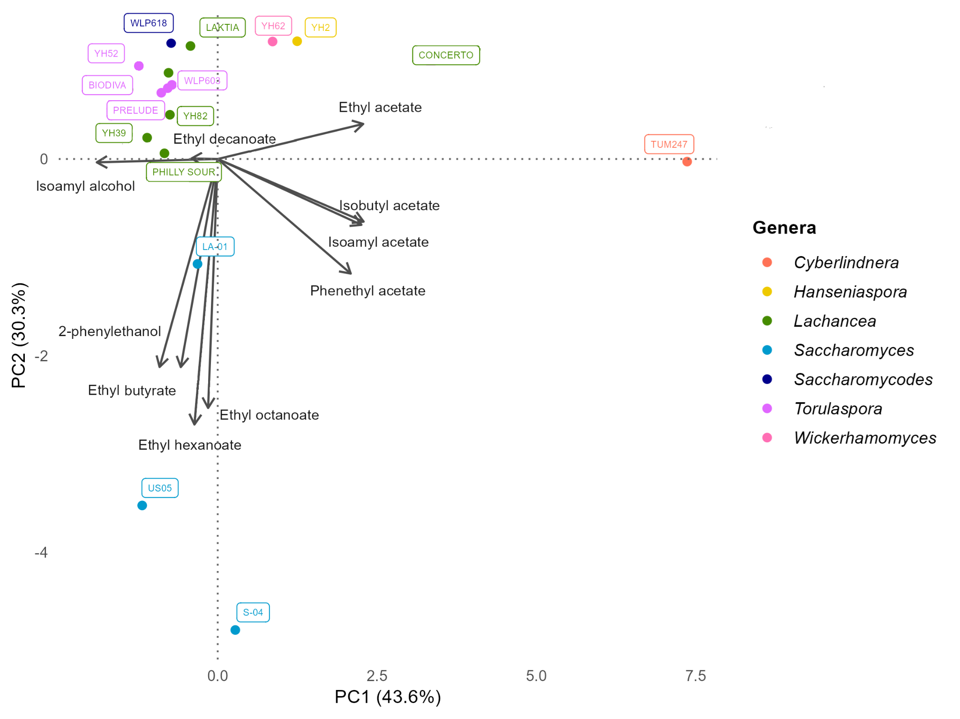
Fig. S1 Principal component analysis (PCA) of volatile compounds in non-conventional and reference strains

