LIST OF SUPPLEMENTARY MATERIALS
Figuress S1–S4 description and figures included below
Table S1: List of marker genes, DEGs, and upstream pathway analyses for xenotransplanted human microglia. Related to Figure 3.
Table S2: List of marker genes and DEGs for hippocampal mouse astrocytes and oligodendrocytes. Related to Figure 4.
Table S3: List of marker genes and DEGs for thalamic mouse astrocytes and oligodendrocytes. Related to Figure 4.
Table S4: List of marker genes and DEGs for thalamic mouse excitatory neurons and inhibitory neurons. Related to Figure 5.
Table S5: Human control and FTD patient information, and lists of marker genes and DEGs for human patient excitatory neurons and inhibitory neurons. Related to Figure 5.

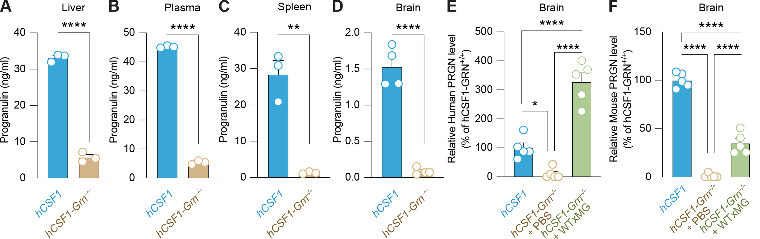

Figure S1. Progranulin protein levels within peripheral organs and the brain. Levels of murine progranulin within the liver (t=27.60, ****p < 0.0001) (A), plasma (t=96.25, ****p < 0.0001) (B), and spleen (t=7.07, **p = 0.0021) (C) of hCSF1-WT and hCSF1-Grn–/– littermates were measured by ELISA. N = 3 mice/group, all unpaired two-tailed t-test. (D) Progranulin levels measured within the brain (t=10.31, ****p < 0.0001). N = 4–5 mice/group, respectively, unpaired two-tailed t-test. (E) Progranulin levels measured within the brain using a human-targeted ELISA, n = 5 samples/group, one-way ANOVA with Tukey’s multiple comparisons test (F2,12=1.803, ****p < 0.0001). (F) Progranulin levels measured within the brain using a mouse-targeted ELISA, n = 5 samples/group, one-way ANOVA with Tukey’s multiple comparisons test (F2,12=2.80, ****p <0.0001).

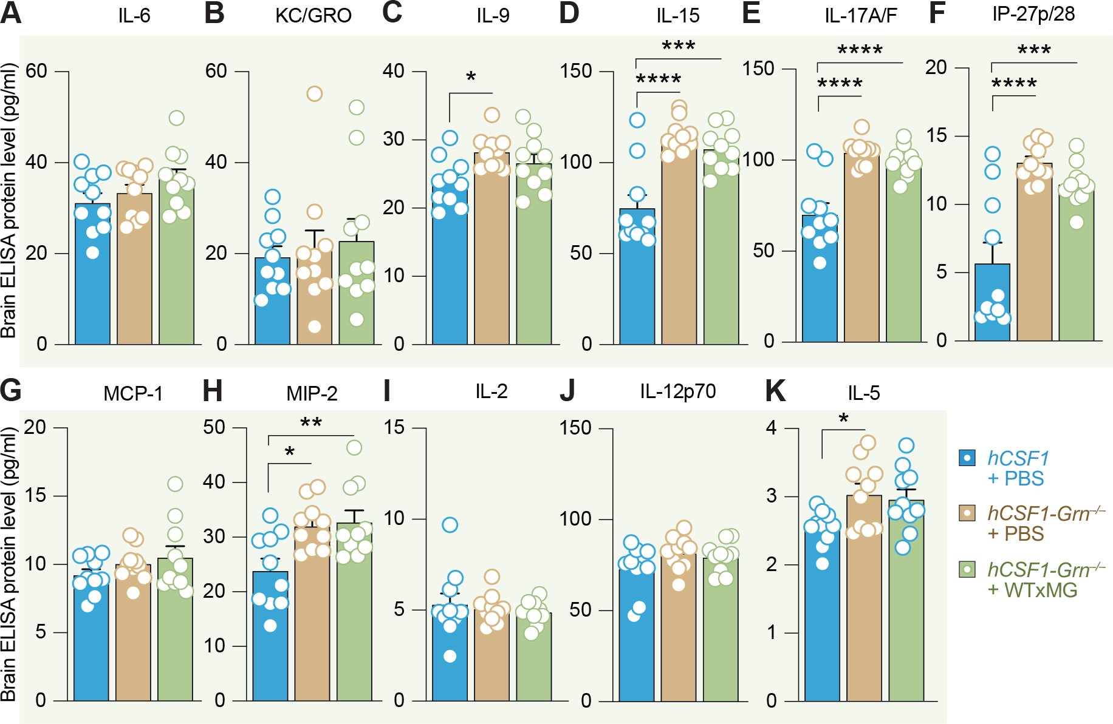

Figure S2. Mouse cytokine levels in the brain. A multiplex ELISA was used to concurrently examine protein levels of several murine cytokines and chemokines within the brains of hCSF1-PBS, hCSF1-Grn–/– +PBS, and hCSF1-Grn–/– +xMG engrafted mice. For each analyte, N = 10 mice/group were compared by one-way ANOVA with Tukey’s multiple comparisons test. No significant (ns) differences in IL-6 (A) or KC/GRO (B) were detected. (C) IL-9 levels in the brain, *p = 0.018. (D) IL-15 levels (F2,27 = 1.238, ***p = 0.0002 and ****p < 0.0001). (E) IL-17A/F levels in brain (F2,27 = 3.026, ****p < 0.0001). (F) IP-27p/28 levels in brain (F2,27 = 3.685, ***p = 0.0006 and ****p < 0.0001). (G) MCP-1 levels in brain, ns = nonsignificant. (H) MIP-2 levels in brain (F2,27 = 1.12, *p = 0.0156 and **p = 0.0083). (I) IL-2 levels in brain, ns = nonsignificant. (J) IL-12p70 levels in the brain, ns = nonsignificant. (K) IL-5 levels in the brain (F2,27 = 2.819, *p = 0.0367).

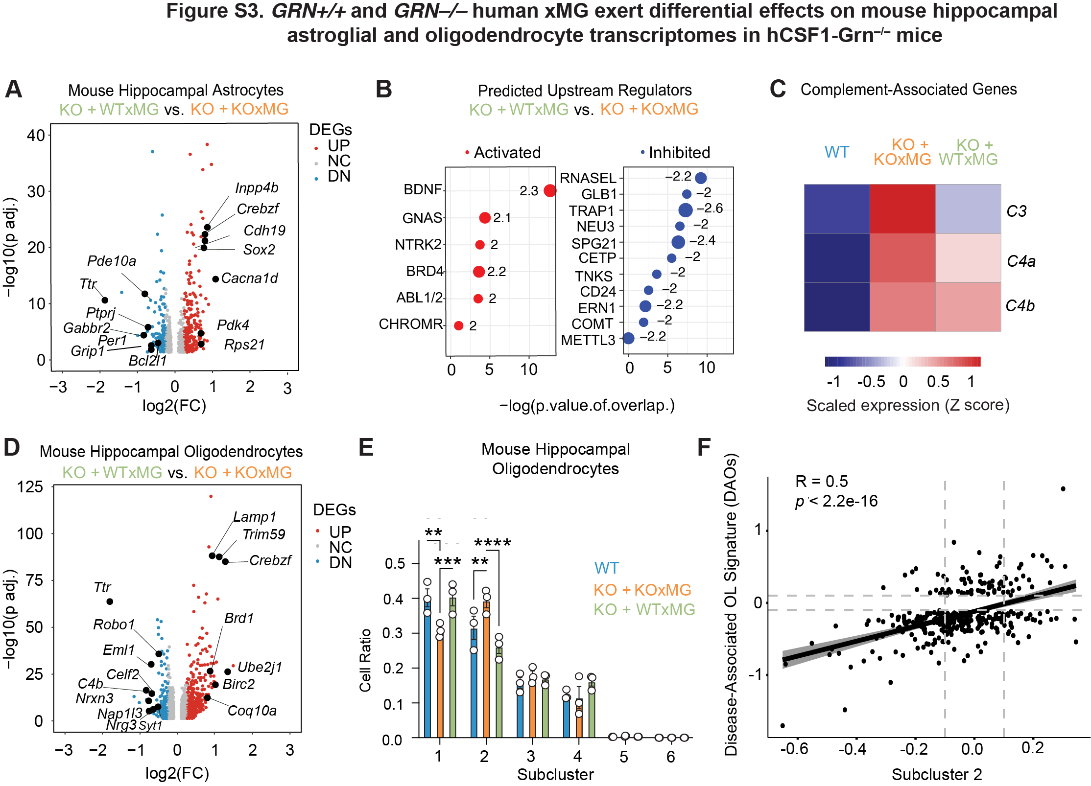

Figure S3. Xenografted human KOxMG or WTxMG exert differential effects on mouse hippocampal astrocyte and oligodendrocyte transcriptomes. (A) Volcano plot of pseudobulk differentially expressed genes (DEGs) in hippocampal astrocytes between WTxMG and KOxMG groups shows significant upregulation and downregulation of multiple genes in the KOxMG group. (B) Top predicted upstream regulators identified using Ingenuity Pathway Analysis (IPA). (C) Heatmap of complement related genes. (D) Volcano plot of pseudobulk DEGs in hippocampal oligodendrocytes between WTxMG and KOxMG groups highlights significant transcriptional differences in the KOxMG group. (E) Quantification of average cell ratios in each subcluster by group in hippocampal oligodendrocytes. (F) Correlation between Subcluster 2 and Disease Associated Oligodendrocyte genes, R=0.5, p<2.2 e-16.

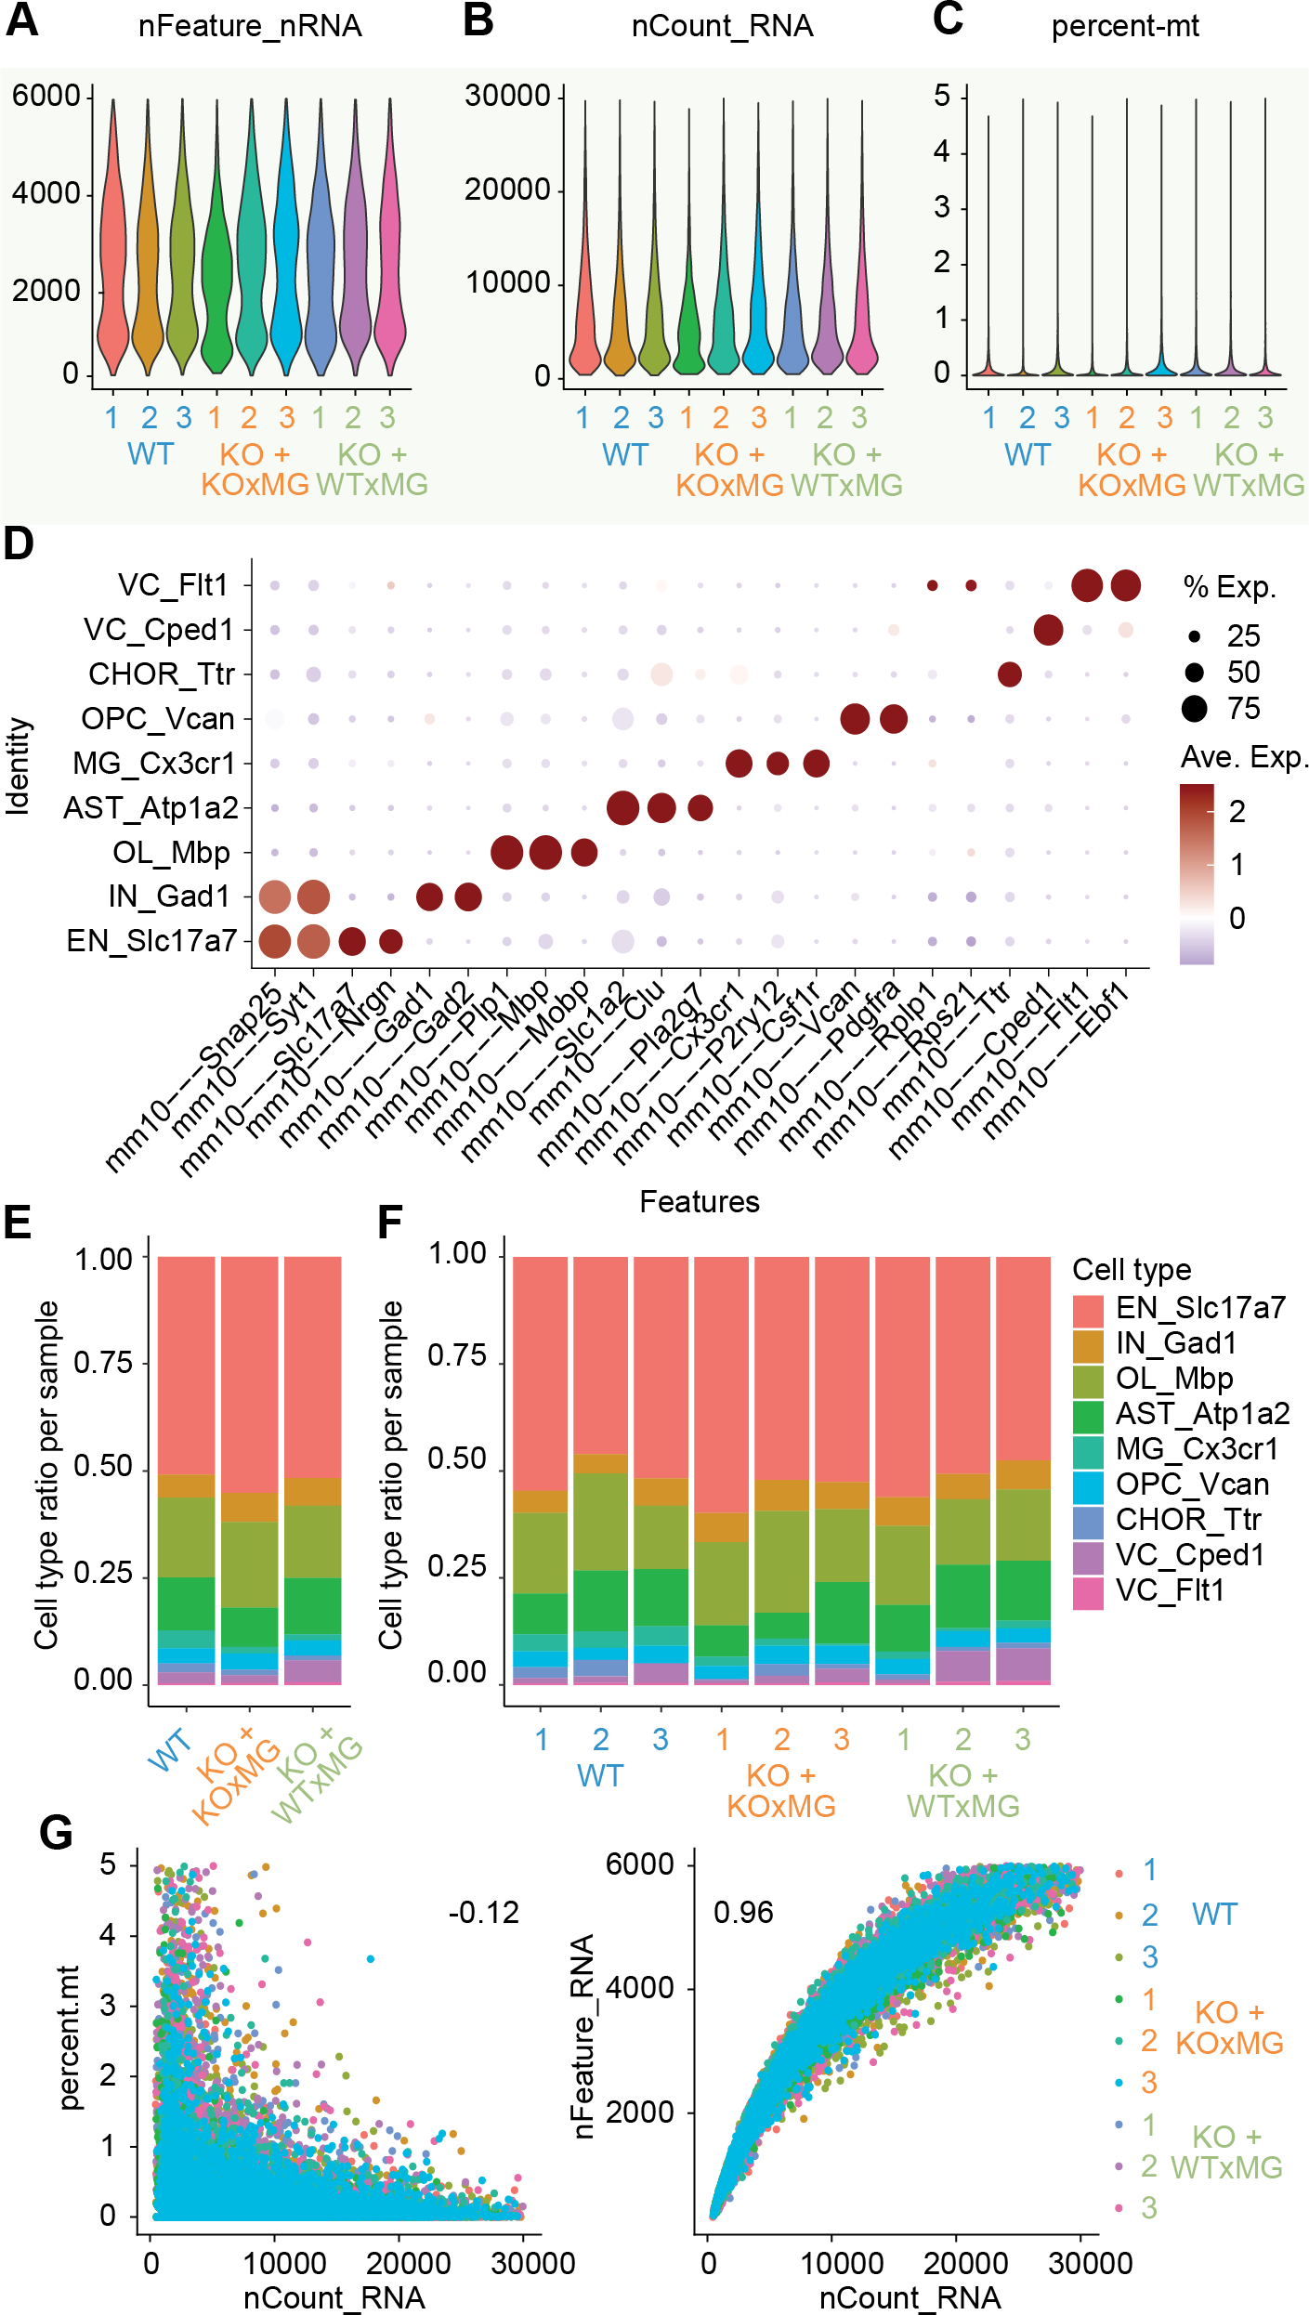
Figure S4. QC of snRNAseq analysis of hippocampus engrafted with GRN–/– or GRN^{+/+}
human microglia. (A), (B) Quality-control plots showing equivalent amounts of total RNA features and total number of RNA counts, respectively. (C) Violin plot showing percentage of mitochondrial genes detected per nucleus for each individual sample. (D) Dot plot showing expression of identity markers for each cell type. (E) Proportion of each cell type within each genotype. (F) Proportion of each cell type within individual samples. (G) Correlation between UMI counts and percentage of mitochondrial genes detected (left) or total gene counts (right) per nucleus for each individual sample.

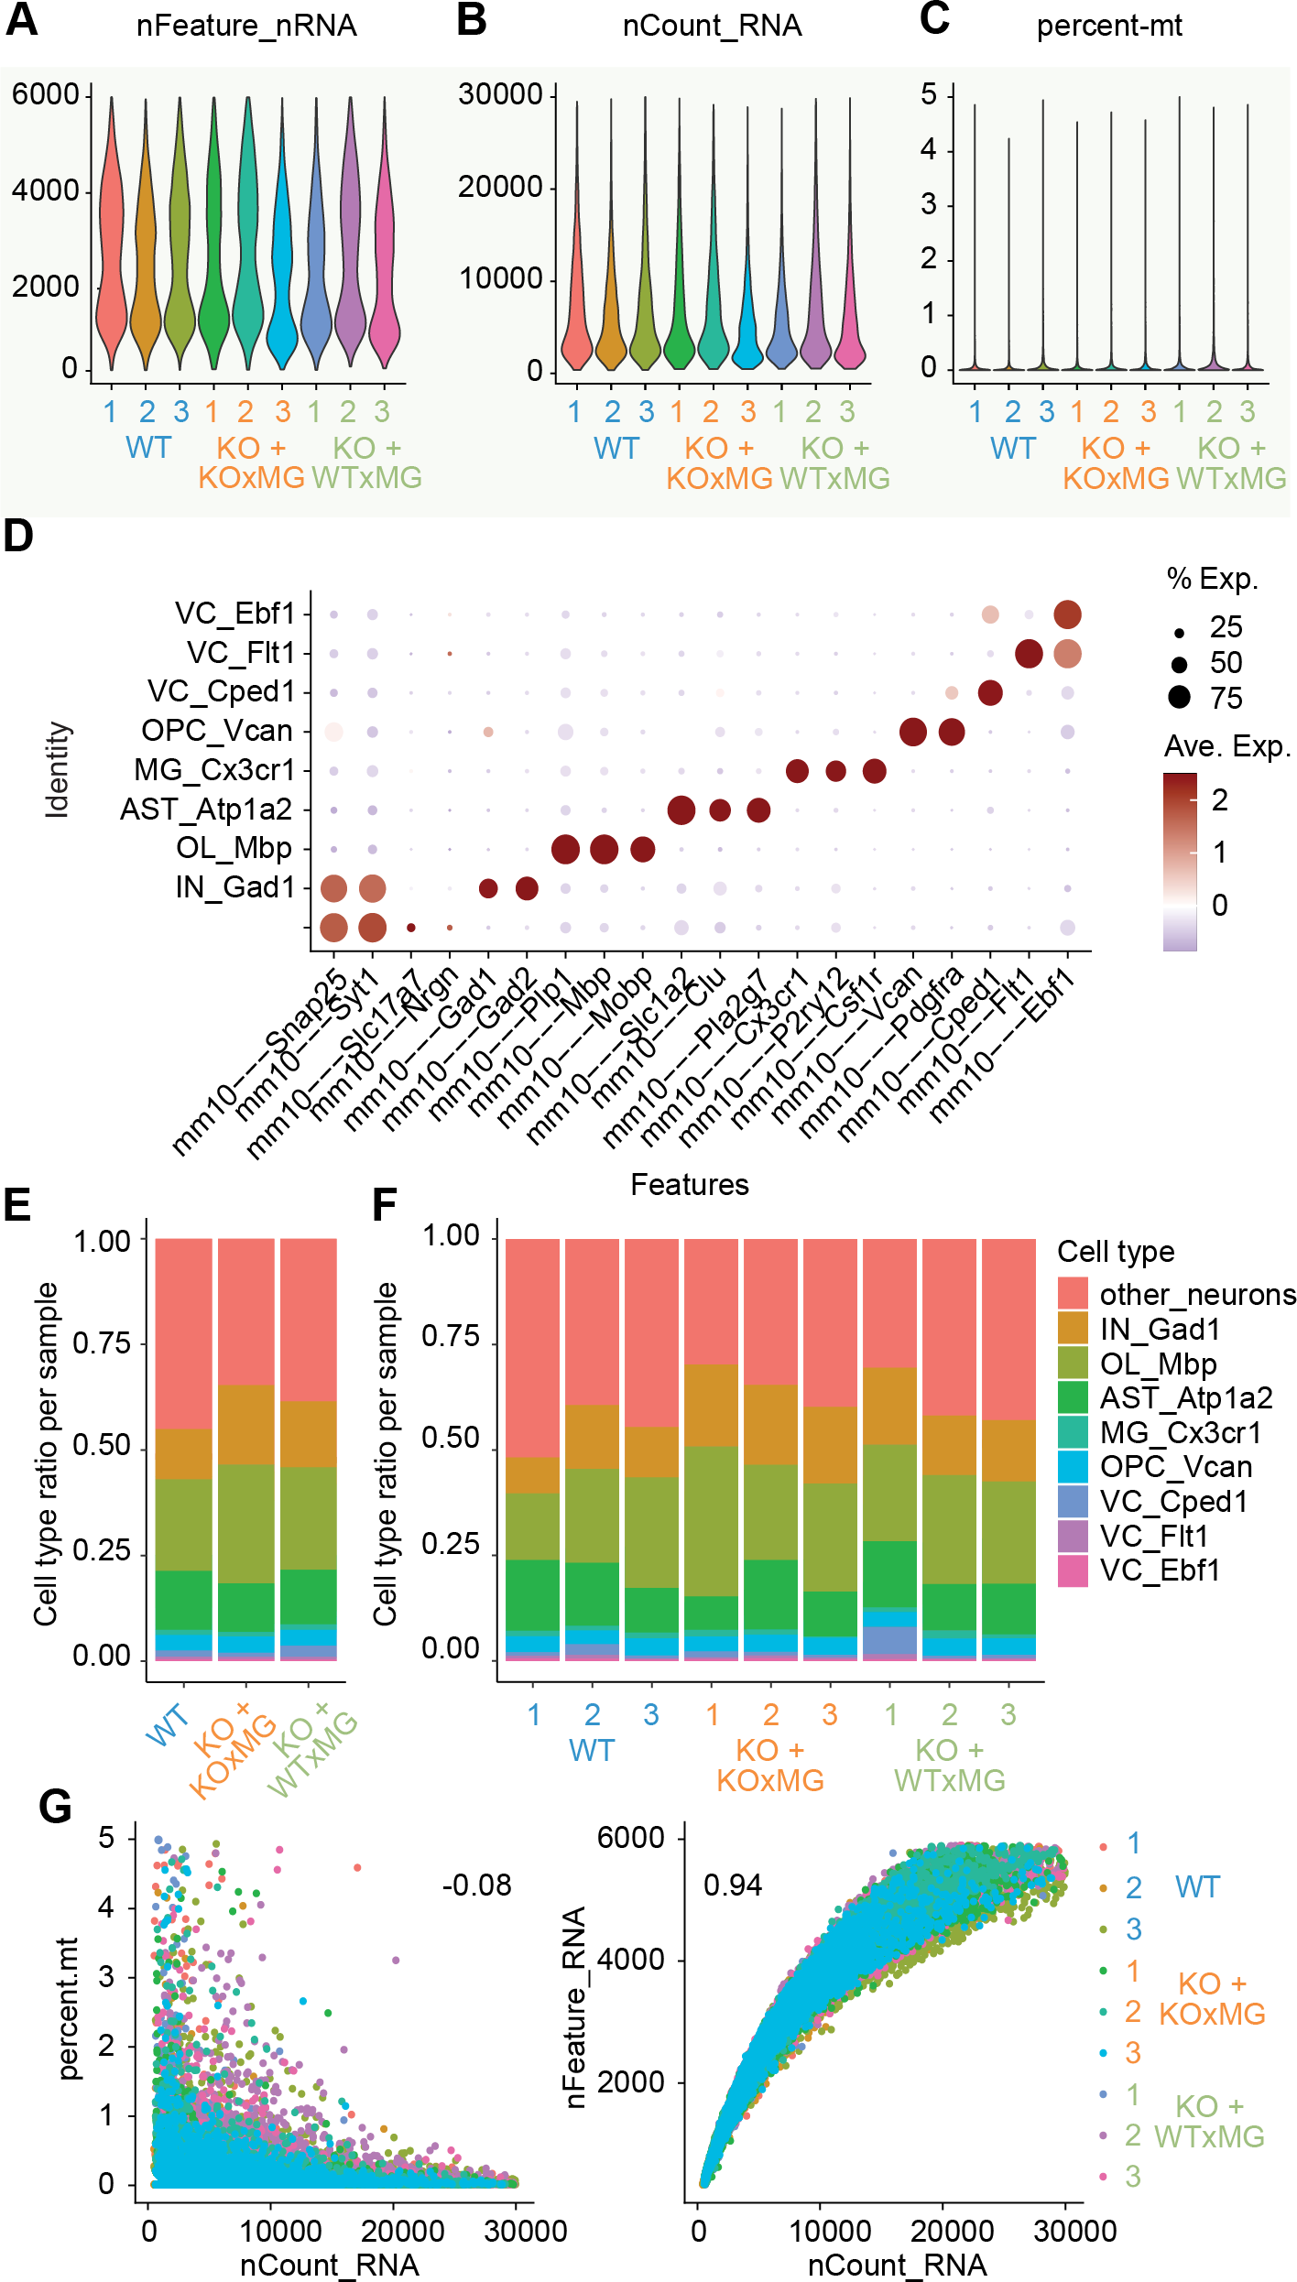
Figure S5. QC of snRNAseq analysis of thalamus engrafted with GRN–/– or GRN^{+/+}
human microglia. (A), (B) Quality-control plots showing equivalent amounts of total RNA features and total number of RNA counts, respectively. (C) Violin plot showing percentage of mitochondrial genes detected per nucleus for each individual sample. (D) Dot plot showing expression of identity markers for each cell type. (E) Proportion of each cell type within each genotype. (F) Proportion of each cell type within individual samples. (G) Correlation between UMI counts and percentage of mitochondrial genes detected (left) or total gene counts (right) per nuclei for each individual sample.

