Exploring Root-mediated Erwinia amylovora Invasion Mechanism in Korla fragrant pear (Pyrus sinkiangensis)
Lili Han ^{1#}, Yue Sun ^{2#}, Xin Deng², Jiehua Wang ⁴, Feng Zhang ⁵, Weimin Chen ^{1*}, Rong Lei ^{3*}
¹ Yili vocational and technical college, Yining, Xinjiang 835000
² Department of Biomedical Sciences, City University of Hong Kong, Hong Kong, China
³ Chinese Academy of Quality and Inspection & Testing, Beijing, 100176, China
⁴ Yili Institute of Agricultural Sciences, Yining, Xinjiang 83500
⁵ Korla Research Center of Fragrant Pea,841000
* Correspondence: Weimin Chen, cwm3998@163.com; leir@caqit.org.cn
# Contribute equally to this work

Table S1. The disease severity rating of the inoculated plants grown in the greenhouse.
Severity degree | Description
0 | No disease spots, healthy leaves
1 | The ratio of the disease spot area to the whole branch is 1%–5%; leaves became dark brown, but do not abscise
3 | The ratio of the disease spot area to the whole branch is 5.1%–15%; leaves became dark brown, individual leaves abscise
5 | The ratio of the disease spot area to the whole branch is 15.1%–30%; leaves became dark brown, about 1/4 of leaves abscise
7 | The ratio of the disease spot area to the whole branch is 30.1%–50%; leaves became dark brown, about 1/3 of leaves abscise
9 | The ratio of the disease spot area to the whole branch is more than 50.1%; leaves became dark brown, about 1/2 of leaves abscise

Table S2. The disease severity rating of plants in field according to symptoms on branches, flowers, and fruits.
Severity degree | Description
0 | No symptoms
1 | The ratio of diseased branches, flower rot, and fruit rot to the whole plant is 1.00%–10.0%
3 | The ratio of diseased branches, flower rot, and fruit rot to the whole plant is 11.00%–20.0%
5 | The ratio of diseased branches, flower rot, and fruit rot to the whole plant is 21.00%–35.00%
7 | The ratio of diseased branches, flower rot, and fruit rot to the whole plant is 36.00%–50.0%
9 | The ratio of diseased branches, flower rot, and fruit rot to the whole plant is more than 51.00%

Table S3. The disease severity rating of the plants in field according to the necrosis area of the trunk and branches.
Severity degree | Description
0 | No necrosis
1 | The ratio of trunk and branches necrosis to the whole plant is 1.00%–5.00%; no bacterial ooze droplets on branches
3 | The ratio of trunk and branches necrosis to the whole plant is 6.00%–15.00%; occasional bacterial ooze droplets on branches
5 | The ratio of trunk and branches necrosis to the whole plant is 16.00%–30.0%; a few bacterial ooze droplets on branches
7 | The ratio of trunk and branches necrosis to the whole plant is 31.00%–50.0%; more bacterial ooze droplets on branches
9 | The ratio of trunk and branches necrosis to the whole plant is more than 51.00%; plenty of bacterial ooze droplets on the trunk and branches

Table S4. The disease incidence (I) and disease severity (DS) of fire blight in potted trees with root irrigation of E. amylovora bacterium suspension in 2019.
Treatment | Ea Con. | Avg. (Incidence%) ± SD and Avg. (disease severity%) ± SD
Treatment | Ea Con. | May 26 (15d) |  | June 13 (33d) |  | July 2 (52d) |  | Aug. 3 (84d)
Treatment | Ea Con. | Iª | DSª | Iª | DSª | Iª | DS ª | Iª | DS ª
No wounded roots | 10⁴ | 0±0e | 0±0f | 0±0f | 0±0i | 0±0g | 0±0m | 0±0h | 0±0Ll
No wounded roots | 10⁵ | 0±0e | 0±0f | 0±0f | 0±0i | 0±0g | 0±0m | 0±0h | 0±0Ll
No wounded roots | 10⁶ | 0±0e | 0±0f | 0±0f | 0±0i | 0±0g | 0±0m | 0±0h | 0±0Ll
No wounded roots | 10⁷ | 0±0e | 0±0f | 0±0f | 0±0i | 0±0g | 0±0m | 0±0h | 0±0Ll
No wounded roots | 10⁸ | 0±0e | 0±0f | 0±0f | 0±0i | 0±0g | 0±0m | 18.1±1.7g | 6.5±0.9k
No wounded roots | 10⁹ | 0±0e | 0±0f | 0±0f | 0±0i | 0±0g | 0±0m | 17.5±0.1g | 6.5±0.8k
No wounded roots | 0(NC) | 0±0e | 0±0f | 0±0f | 0±0i | 0±0g | 0±0m | 0±0Gh | 0±0l
wound fibrous roots | 10⁴ | 0±0e | 0±0f | 0±0f | 0±0i | 17.6±0.9f | 4.3±1.2l | 34.6±2.4f | 13.3±1.6j
wound fibrous roots | 10⁵ | 0±0e | 0±0f | 0±0f | 0±0i | 17.6±2.3f | 5.8±0.5l | 51.3±1.7e | 15.14±0.6j
wound fibrous roots | 10⁶ | 0±0e | 0±0f | 0±0f | 0±0i | 35.1±1.4e | 10.6±0.4k | 50.6±1.8e | 23.5±2.6i
wound fibrous roots | 10⁷ | 0±0e | 0±0f | 0±0f | 0±0i | 34.3±1.7e | 15.5±2.5j | 72.5±1.4d | 30.4±1.5h
wound fibrous roots | 10⁸ | 0±0e | 0±0f | 18.1±1.1e | 5.0±0.8h | 50.9±2.2d | 29.9±2.3gh | 88.6±3.9c | 38.3±1.4g
wound fibrous roots | 10⁹ | 0±0e | 0±0f | 18.1±0.7e | 5.9±0.6h | 52.8±2.4d | 32.1±1.0fg | 90.6±1.10c | 45.0±0.8f
wound fibrous roots | 0(NC) | 0±0e | 0±0f | 0±0f | 0±0i | 0±0Gg | 0±0m | 0±0h | 0±0l
wound lateral roots | 10⁴ | 0±0e | 0±0f | 17.1±2.7e | 1.2±0.15i | 35.1±1.5e | 18.3±1.5j | 52.3±3.4e | 21.9±3.5i
wound lateral roots | 10⁵ | 0±0e | 0±0f | 17.6±1.6e | 2.0±0.1i | 34.3±2.2e | 21.9±0.7i | 69.3±1.8d | 35.7±5.0g
wound lateral roots | 10⁶ | 17.2±1.1d | 0.8±0.3f | 36.2±2.8d | 10.4±1.7g | 55.1±2.3d | 28.4±2.5h | 67.5±0.5d | 39.8±0.3Ffg
wound lateral roots | 10⁷ | 17.3±1.3d | 1.0±0.2f | 53.5±3.1c | 16.8±1.5f | 51.3±3.4d | 31.7±0.9fg | 86.2±2.3c | 59.4±4.4d
wound lateral roots | 10⁸ | 34.2±0.4c | 6.8±1.1e | 70.0±1.1b | 29.3±3.9c | 69.2±1.3c | 49.5±2.2d | 100.0±0.0a | 75.3±2.7c
wound lateral roots | 10⁹ | 36.1±1.7c | 10.1±1.3d | 72.1±0.5b | 31.8±0.5c | 84.8±3.8b | 53.9±1.1c | 100.0±0.0ab | 100.0±0.0a
wound lateral roots | 0(NC) | 0±0e | 0±0f | 0±0Ff | 0±0i | 0±0g | 0±0m | 0±0h | 0±0l
wound taproots | 10⁴ | 17.0±3.0d | 0.7±0.2f | 34.6±1.4d | 9.1±0.1g | 34.6±1.1e | 16.4±2.1j | 53.4±2.0e | 27.6±2.4hi
wound taproots | 10⁵ | 17.7±0.6d | 0.8±0.4f | 35.7±2.0d | 11.1±0.4g | 54.7±2.2d | 33.0±3.2f | 67.5±1.6d | 42.0±3.6f
wound taproots | 10⁶ | 36.2±2.0c | 8.2±0.2e | 49.5±1.9c | 21.4±3.4e | 73.8±0.5c | 42.5±2.2e | 68.5±0.9d | 48.7±3.6e
wound taproots | 10⁷ | 54.6±0.8b | 13.0±3.0c | 54.1±2.3c | 27.3±0.8d | 68.0±1.9c | 51.7±2.8d | 86.8±0.7c | 56.5±5.7d
wound taproots | 10⁸ | 68.0±1.8a | 24.8±3.8b | 71.4±1.8b | 35.2±0.8b | 90.3±4.3b | 65.2±3.4b | 100.0±0.0ab | 74.6±2.0c
wound taproots | 10⁹ | 69.1±2.6a | 30.0±0.9a | 85.9±3.1a | 46.6±1.4a | 100.0±0.0a | 76.4±1.4a | 100.0±0.0b | 84.3±4.3b
wound taproots | 0(NC) | 0±0e | 0±0f | 0±0f | 0±0i | 0±0g | 0±0m | 0±0h | 0±0l
ª The lowercase letters indicate the difference significant as p<0.05. Values within columns for a given treatment by the same letter are not significantly different, while the different letter are significantly different.

Table S5. The disease incidence (I) and disease severity (DS) of fire blight in potted trees with root irrigation of E. amylovora bacterium suspension in 2020.
Treatment | Ea Con. | Avg. (Incidence%) ± SD and Avg. (disease severity%) ± SD
Treatment | Ea Con. | June 13 (15d) |  | June 29 (31d) |  | July 16 (48d) |  | Sep. 3 (97d)
Treatment | Ea Con. | Iª | DSª | Iª | DSª | Iª | DSª | Iª | DSª
No root wound | 10⁴ | 0±0e | 0±0h | 0±0g | 0±0g | 0±0g | 0±0m | 0±0g | 0±0o
No root wound | 10⁵ | 0±0e | 0±0h | 0±0g | 0±0g | 0±0g | 0±0m | 0±0g | 0±0o
No root wound | 10⁶ | 0±0e | 0±0h | 0±0g | 0±0g | 0±0g | 0±0m | 0±0g | 0±0o
No root wound | 10⁷ | 0±0e | 0±0h | 0±0g | 0±0g | 0±0g | 0±0m | 17.1±0.41f | 5.7±0.9n
No root wound | 10⁸ | 0±0e | 0±0h | 0±0g | 0±0g | 0±0g | 0±0m | 18.2±0.6f | 17.4±1.1l
No root wound | 10⁹ | 0±0e | 0±0h | 0±0g | 0±0g | 0±0g | 0±0m | 35.9±2.0e | 11.5±2.6m
No root wound | 0(NC) | 0±0e | 0±0h | 0±0g | 0±0g | 0±0g | 0±0m | 0±0g | 0±0o
wound fibrous roots | 10⁴ | 0±0e | 0±0h | 0±0g | 0±0g | 17.6±0.8f | 7.4±1.0l | 35.9±2.6e | 10.2±0.4m
wound fibrous roots | 10⁵ | 0±0e | 0±0h | 0±0g | 0±0g | 36.2±2.3e | 8.0±0.8l | 50.4±3.1d | 36.7±3.7i
wound fibrous roots | 10⁶ | 0±0e | 0±0h | 0±0g | 0±0g | 54.8±1.3d | 16.0±1.6k | 72.7±3.1c | 43.9±4.3h
wound fibrous roots | 10⁷ | 0±0e | 0±0h | 0±0g | 0±0g | 54.4±0.5d | 35.8±2.4h | 85.6±0.8b | 434±3.4h
wound fibrous roots | 10⁸ | 0±0e | 0±0h | 17.0±1.7f | 6.6±0.6f | 73.0±1.9c | 38.9±1.2h | 100.0±0.0a | 60.0±2.3e
wound fibrous roots | 10⁹ | 0±0e | 0±0h | 18.6±2.1f | 7.8±0.8f | 66.3±3.9c | 44.5±2.5f | 100.0±0.0a | 86.4±4.6c
wound fibrous roots | 0(NC) | 0±0e | 0±0h | 0±0g | 0±0g | 0±0g | 0±0Lm | 0±0g | 0±0o
wound lateral roots | 10⁴ | 0±0e | 0±0h | 18.1±1.2f | 0.9±0.2g | 34.7±4.0e | 15.3±2.4Jk | 51.4±4.5d | 24.9±1.3k
wound lateral roots | 10⁵ | 0±0e | 0±0h | 17.2±1.9f | 0.9±0.5g | 52.9±0.5d | 25.2±0.6i | 71.2±3.9c | 44.8±1.3g
wound lateral roots | 10⁶ | 17.6±1.1d | 1.0±0.2g | 33.79±1.7e | 8.9±0.4ef | 70.8±2.9c | 37.1±2.6h | 89.4±2.0b | 73.6±1.8d
wound lateral roots | 10⁷ | 17.9±1.5d | 1.3±0.2g | 35.1±1.9e | 9.7±8.24ef | 67.8±1.4c | 36.1±1.5h | 98.7±6.3a | 78.8±2.7d
wound lateral roots | 10⁸ | 17.0±0.5d | 1.6±0.1fg | 35.5±1.1e | 3.3±1.2g | 83.8±1.4b | 51.3±0.7e | 98.9±31.1a | 78.4±6.1d
wound lateral roots | 10⁹ | 36.1±2.5c | 7. 7±0.3d | 34.2±3.1de | 16.9±1.6d | 88.4±3.1b | 50.8±0.7d | 100.0±0.0a | 100.0±0.0a
wound lateral roots | 0(NC) | 0±0e | 0±0h | 0±0g | 0±0Hg | 0±0g | 0±0m | 0±0g | 0±0o
wound taproots | 10⁴ | 17.9±0.3d | 1.4±0.2g | 35.2±2.7d | 11.0±0.7e | 34.9±1.88e | 20.0±1.2j | 53.9±0.46d | 29.2±1.1j
wound taproots | 10⁵ | 17.4±0.7d | 1.9±0.4f | 36.4±0.5de | 17.1±1.0d | 54.9±3.05d | 37.8±1.5h | 53.1±3.05d | 45.0±2.5g
wound taproots | 10⁶ | 17.4±1.6d | 2.7±0.3e | 51.0±1.7c | 17.4±1.2d | 72.6±3.22c | 41.9±1.71g | 71.3±6.5c | 55.4±0.4f
wound taproots | 10⁷ | 34.2±1.3c | 10.1±0.7c | 67.8±1.5b | 34.0±2.2c | 91.2±1.65b | 52.50±1.6c | 86.2±3.13b | 58.45±1.1e
wound taproots | 10⁸ | 52.9±3.8b | 12.7±1.1b | 68.1±1.7b | 40.7±2.4b | 86.8±2.11b | 83.1±1.6b | 99.5±2.7a | 85.34±2.5c
wound taproots | 10⁹ | 70.8±0.2a | 30.2±0.6a | 91.6±2.8a | 62.9±3.2a | 100.0±0.0a | 98.3±1.4a | 100.0±0.0a | 97.7±3.2b
wound taproots | 0(NC) | 0±0e | 0±0h | 0±0g | 0±0g | 0±0g | 0±0m | 0±0g | 0±0o
ª The lowercase letters indicate the difference significant as p<0.05. Values within columns for a given treatment by the same letter are not significantly different, while the different letter are significantly different.

Table S6. The disease incidence (I) and disease severity (DS) of fire blight in potted trees with root irrigation of E. amylovora bacterium suspension in 2021.
Treatment | Ea Con. | Avg. (Incidence%) ± SD and Avg. (disease severity%) ± SD
Treatment | Ea Con. | June 3 (15d) |  | June 19 (31d) |  | July 5 (47d) |  | Aug. 5 (78d)
Treatment | Ea Con. | Iª | DSª | Iª | DSª | Iª | DSª | Iª | DSª
No root wound | 10⁴ | 0±0f | 0±0g | 0±0f | 0±0k | 0±0e | 0±0j | 0±0e | 0±0n
No root wound | 10⁵ | 0±0f | 0±0g | 0±0f | 0±0k | 0±0e | 0±0j | 0±0e | 0±0n
No root wound | 10⁶ | 0±0f | 0±0g | 0±0f | 0±0k | 0±0e | 0±0j | 0±0e | 0±0n
No root wound | 10⁷ | 0±0f | 0±0g | 0±0f | 0±0k | 0±0e | 0±0j | 35.0±0.6d | 3.7±0.6m
No root wound | 10⁸ | 0±0f | 0±0g | 0±0f | 0±0k | 0±0e | 0±0j | 51.8±3.0c | 14.3±0.6k
No root wound | 10⁹ | 0±0f | 0±0g | 0±0f | 0±0k | 0±0e | 0±0j | 51.9±1.7c | 7.6±1.0l
No root wound | 0(NC) | 0±0f | 0±0g | 0±0f | 0±0k | 0±0e | 0±0j | 0±0e | 0±0n
wound fibrous roots | 10⁴ | 0±0f | 0±0g | 49.3±2.2e | 21.8±0.9j | 100.0±0.0ab | 44.2±0.9g | 100.0±0.0a | 42.7±1.6i
wound fibrous roots | 10⁵ | 0±0f | 0±0g | 51.3±1.4e | 32.0±1.0gh | 73.1±1.7d | 42.5±2.2g | 100.0±0.0a | 48.1±3.5h
wound fibrous roots | 10⁶ | 0±0f | 0±0g | 87.6±2.5c | 24.5±1.4i | 100.0±0.0ab | 37.0±1.3h | 100.0±0.0a | 84.9±2.7d
wound fibrous roots | 10⁷ | 0±0f | 0±0g | 70.8±1.6d | 27.7±0.2i | 83.0±3.2c | 52.6±3.1f | 87.8±3.7b | 81.39±1.3e
wound fibrous roots | 10⁸ | 36.8±1.9d | 3.8±0.4e | 100.0±0.0ab | 55.4±1.0b | 100.0±0.0ab | 86.4±1.4a | 100.0±0.0a | 100.0±0.0ab
wound fibrous roots | 10⁹ | 17.5±1.6e | 1.3±0.3f | 100.0±0.0ab | 32.2±2.6h | 100.0±0.0ab | 45.1±0.8g | 100.0±0.0a | 99.6±4.4b
wound fibrous roots | 0(NC) | 0±0f | 0±0g | 0±0f | 0±0k | 0±0e | 0±0j | 0±0e | 0±0n
wound lateral roots | 10⁴ | 53.2±2.5c | 7.8±0.2b | 67.8±2.9d | 34.8±1.8fg | 100.0±0.0b | 35.0±0.8h | 100.0±0.0a | 35.9±2.2j
wound lateral roots | 10⁵ | 67.6±2.2b | 7.8±0.2b | 69.28±1.9d | 19.89±2.07j | 84.72±2.93c | 32.3±1.1i | 100.0±0.0a | 77.2±2.9e
wound lateral roots | 10⁶ | 69.4±2.1b | 7.8±0.2b | 100.0±0.0a | 50.16±0.63d | 100.0±0.0b | 76.6±1.8b | 100.0±0.0a | 86.8±1.9c
wound lateral roots | 10⁷ | 86.5±4.0a | 8.8±0.3a | 100.0±0.0ab | 43.30±4.01e | 100.0±0.0ab | 71.3±4.6c | 100.0±0.0a | 78.3±1.1d
wound lateral roots | 10⁸ | 51.9±5.5c | 5.9±0.7c | 100.0±0.0ab | 72.76±3.24a | 100.0±0.0a | 70.8±0.4c | 100.0±0.0a | 100.0±0.0ab
wound lateral roots | 10⁹ | 50.8±1.5c | 5.6±0.3c | 100.0±0.0ab | 69.87±4.45a | 100.0±0.0ab | 74.9±1.2bc | 100.0±0.0a | 99.9±0.6ab
wound lateral roots | ck | 0±0f | 0±0g | 0±0f | 0±0k | 0±0e | 0±0j | 0±0e | 0±0n
wound taproots | 10⁴ | 18.1±0.9e | 1.5±0.3f | 100.0±0.0b | 55.1±0.8c | 88.0±1.4c | 59.0±4.5e | 100.0±0.0a | 74.5±0.1e
wound taproots | 10⁵ | 33.9±2.1d | 3.9±0.4e | 53.8±3.4e | 36.6±2.9f | 88.0±0.9c | 58.4±3.1e | 100.0±0.0a | 58.1±3.7g
wound taproots | 10⁶ | 34.4±2.7d | 4.1±0.2e | 71.8±1.1d | 30.7±1.1h | 89.3±3.6c | 42.4±4.1g | 100.0±0.0a | 69.5±2.6f
wound taproots | 10⁷ | 17.6±1.2e | 4.1±0.3e | 88.1±3.9c | 58.7±1.16b | 100.0±0.0ab | 62.4±3.2e | 100.0±0.0a | 88.7±2.1c
wound taproots | 10⁸ | 51.4±3.8c | 4.8±0.3d | 100.0±0.0b | 49.7±1.4d | 100.0±0.0ab | 66.8±2.2d | 100.0±0.0a | 100±0.0a
wound taproots | 10⁹ | 34.2±3.2d | 5.7±0.4c | 100.0±0.0ab | 48.7±1.3d | 100.0±0.0ab | 72.6±0.8d | 100.0±0.0a | 99.4±2.4b
wound taproots | 0(NC) | 0±0f | 0±0g | 0±0f | 0±0k | 0±0e | 0±0j | 0±0e | 0±0n
ª The lowercase letters indicate the difference significant as p<0.05. Values within columns for a given treatment by the same letter are not significantly different, while the different letter are significantly different.

Table S7. The disease incidence (I) and disease severity (DS) of fire blight in potted trees with buried E. amylovora-infected branches in 2019.
Treatment |  | Avg. (Incidence%) ± SD and Avg. (disease severity%) ± SD
 |  | May 26 (15d) |  | June 13 (33d) |  | July 2 (52d) |  | Aug. 3 (84d)
 |  | Iª | DS ª | Iª | DS ª | I ª | DS ª | I ª | DS ª
Wound fibrous roots | Embedding | 0±0b | 0±0c | 0±0b | 0±0c | 34.2±2.13c | 8.2±0.7c | 64.2±3.3C | 23.5±1.4c
Wound fibrous roots | No embedding | 0±0b | 0±0c | 0±0b | 0±0c | 0±0e | 0±0d | 0±0e | 0±0e
Wound lateral roots | Embedding | 0±0b | 0±0c | 18.1±0.7a | 2.1±0.3b | 49.5±3.6b | 23.8±1.3b | 85.1±0.6b | 46.3±1.9b
Wound lateral roots | No embedding | 0±0b | 0±0c | 0±0b | 0±0c | 0±0e | 0±0d | 0±0e | 0±0e
Wound taproots | Embedding | 0±0b | 0±0c | 17.7±2.1a | 6.0±0.7a | 70.2±1.1a | 38.7±6.9a | 100.0±0.0a | 59.7±2.1a
Wound taproots | No embedding | 0±0b | 0±0c | 0±0b | 0±0c | 0±0e | 0±0d | 0±0e | 0±0e
No wounded root | embedding | 0±0b | 0±0c | 0±0b | 0±0c | 17.1±0.5d | 1.9±0.4d | 17.2±0.7d | 2.1±0.2d
No wounded root | No embedding | 0±0b | 0±0c | 0±0b | 0±0c | 0±0e | 0±0d | 0±0e | 0±0e
ª The lowercase letters indicate the difference significant as p<0.05. Values within columns for a given treatment by the same letter are not significantly different, while the different letters are significantly different.

Table S8. The disease incidence (I) and disease severity (DS) of fire blight in potted trees with buried E. amylovora-infected branches in 2020.
Treatment |  | Avg. (Incidence%) ± SD and Avg. (disease severity%) ± SD
 |  | June 17 (17d) |  | July 2 (32d) |  | Aug. 6 (67d) |  | Sep. 4 (96d)
 |  | I ª | DS ª | I ª | DS ª | I ª | DS ª | I ª | DS ª
Wound fibrous roots | Embedding | 0±0b | 0±0b | 17.29±0.7c | 2.0±0.3c | 34.6±1.3c | 3.7±0.5c | 50.0±3.0c | 25.6±2.3c
Wound fibrous roots | No embedding | 0±0b | 0±0b | 0±0d | 0±0d | 0±0d | 0±0d | 0±0e | 0±0e
Wound lateral roots | Embedding | 0±0b | 0±0b | 34.1±2.7b | 8.0±0.7b | 52.6±2.6b | 13.8±1.7b | 68.2±1.9b | 39.4±0.2b
Wound lateral roots | No embedding | 0±0b | 0±0b | 0±0d | 0±0d | 0±0d | 0±0d | 0±0e | 0±0e
Wound taproots | Embedding | 17.4±0.9a | 1.9±0.2a | 67.5±2.3a | 12.1±1.1a | 69.7±1.6a | 27.2±1.4a | 100.0±0.0a | 64.1±1.3a
Wound taproots | No embedding | 0±0b | 0±0b | 0±0d | 0±0d | 0±0d | 0±0d | 0±0e | 0±0e
No wounded root | embedding | 0±0b | 0±0b | 16.9±2.7c | 2.1±0.3c | 34.6±2.0c | 3.8±0.3c | 34.6±2.4d | 19.5±2.0d
No wounded root | No embedding | 0±0b | 0±0b | 0±0d | 0±0d | 0±0d | 0±0d | 0±0e | 0±0e

ª The lowercase letters indicate the difference significant as p<0.05. Values within columns for a given treatment by the same letter are not significantly different, while the different letter are significantly different.

Table S9. The disease incidence (I) and disease severity (DS) of fire blight in potted trees with buried E. amylovora-infected branches in 2021.
Treatment |  | Avg. (Incidence%) ± SD and Avg. (disease severity%) ± SD
 |  | June 3 (16d) |  |  | July 19 (32d) |  |  | July 5 (48d) |  |  | Aug. 5 (79d)
 |  | Iª | DSª |  | Iª | DS ª |  | Iª | DSª |  | Iª |  | DSª
Wound fibrous roots | Embedding | 0±0c | 0±0c | 50.9±1.3c |  |  | 21.6±0.8c | 90.9±1.6a |  | 35.5±1.7c | 100.0±0.0a | 64.5±2.0b
Wound fibrous roots | No embedding | 0±0c | 0±0c | 0±0e |  |  | 0±0d | 0±0c |  | 0±0d | 0±0c | 0±0d
Wound lateral roots | Embedding | 16.9±0.6b | 2.1±0.1b | 68.5±0.9b |  |  | 38.4±0.5b | 89.6±3.2a |  | 54.5±3.5b | 100.0±0.0a | 63.8±1.3b
Wound lateral roots | No embedding | 0±0c | 0±0c | 0±0e |  |  | 0±0d | 0±0c |  | 0±0d | 0±0c | 0±0d
Wound taproots | Embedding | 35.8±4.1a | 4.0±0.3a | 69.4±1.9a |  |  | 42.3±3.1a | 90.8±0.9a |  | 65.6±4.1a | 100.0±0.0a | 86.6±1.4a
Wound taproots | No embedding | 0±0c | 0±0c | 0±0e |  |  | 0±0d | 0±0c |  | 0±0d | 0±0c | 0±0d
No wounded root | embedding | 0±0c | 0±0c | 17.6±1.7d |  |  | 2.0±0.1d | 16.9±1.4b |  | 1.9±0.1d | 34.6±2.0b | 7.6±0.3c
No wounded root | No embedding | 0±0c | 0±0c | 0±0e |  |  | 0±0d | 0±0c |  | 0±0d | 0±0c | 0±0d

ª The lowercase letters indicate the difference significant as p<0.05. Values within columns for a given treatment by the same letter are not significantly different, while the different letter are significantly different.
Table S10. The disease incidence (I) and disease severity (DS) of fire blight in Korla fragrant pear plants with embedding E. amylovora infected branches from 2019 to 2021.
Year | Treatment | Avg. (incidence%) ± SD and Avg. (disease severity%) ± SD
Year | Treatment | 9d after burying branches |  | 15d after burying branches |  | 30d after burying branches |  | 60d after burying branches |  | 90d after burying branches |  | 120d after burying branches
Year | Treatment | I | DS | I | DS | I | DS | I | DS | I | DS | I | DS
2019 | 40-1 | 11.8±1.3a | 2.8±0.1a | 56.5±2.4a | 14.6±0.8a | 67.6±3.3a | 29.5±0.9a | 83.1±1.2a | 36.4±1.7a | 90.3±1.8a | 47.2±2.5a | 100.0±0a | 54.1±1.2a
2019 | 40-2 | 0±0b | 0±0b | 35.7±2.1c | 9.9±03c | 43.9±1.0c | 19.4±1.3c | 61.1±0.8c | 28.69±0.9c | 71.0±0.2d | 38.4±1.1c | 77.9±3.3c | 45.5±1.8b
2019 | 40-3 | 0±0b | 0±0b | 46.5±3.2d | 9.1±0.2d | 60.2±3.2b | 16.8±1.1d | 59.0±0.6c | 25.0±0.6d | 81.2±1.3c | 34.6±0.9d | 91.9±2.4b | 44.3±3.2b
2019 | 40-4 | 0±0b | 0±0b | 46.5±1.5b | 10.8±0.6b | 61.0±1.2b | 25.1±2.4b | 65.9±1.0b | 32.9±1.7b | 80.5±3.0b | 42.9±0.9b | 89.3±3.2b | 44.0±1.0b
2019 | 40-NC | 0±0b | 0±0b | 0±0d | 0±0e | 0±0d | 0±0e | 0±0d | 0±0e | 0±0e | 0±0e | 0±0d | 0±0c
2019 | 20-1 | 0±0b | 0±0b | 0±0d | 0±0e | 0±0d | 0±0e | 0±0d | 0±0e | 0±0e | 0±0e | 0±0d | 0±0c
2019 | 20-2 | 0±0b | 0±0b | 0±0d | 0±0e | 0±0d | 0±0e | 0±0d | 0±0e | 0±0e | 0±0e | 0±0d | 0±0c
2019 | 20-3 | 0±0b | 0±0b | 0±0d | 0±0e | 0±0d | 0±0e | 0±0d | 0±0e | 0±0e | 0±0e | 0±0d | 0±0c
2019 | 20-4 | 0±0b | 0±0b | 0±0d | 0±0e | 0±0d | 0±0e | 0±0d | 0±0e | 0±0e | 0±0e | 0±0d | 0±0c
2019 | 20-NC | 0±0b | 0±0b | 0±0d | 0±0e | 0±0d | 0±0e | 0±0d | 0±0e | 0±0e | 0±0e | 0±0d | 0±0c
2020 | 40-1 | 11.8±0.8a | 1.3±0.12a | 46.0±0.9a | 5.1±0.2a | 78.8±0.6a | 31.0±1.0a | 96.5±1.1a | 32.0±0.9a | 92.9±1.2a | 41.8±0.6a | 100.0±0b | 54.8±1.4a
2020 | 40-2 | 0±0b | 0±0b | 33.8±0.4c | 2.8±0.1c | 59.0±0.7c | 20.1±1.0c | 67.8±0.7c | 25.7±1.1c | 79.3±4.0b | 31.4±0.6c | 91.4±0.4c | 26.5±1.3c
2020 | 40-3 | 0±0b | 0±0b | 22.6±1.5d | 2.2±0.1d | 33.1±2.0d | 11.4±0.6d | 56.1±0.6d | 21.0±1.2d | 74.9±4.8c | 23.6±1.0d | 92.2±0.8c | 26.5±0.5c
2020 | 40-4 | 0±0b | 0±0b | 34.0±0.8b | 4.2±0.2b | 73.0±4.9b | 27.5±1.6b | 79.1±0.4b | 30.3±3.0b | 89.3±1.5a | 35.2±0.4b | 100.0±0a | 45.8±2.8b
2020 | 40-NC | 0±0b | 0±0b | 0±0e | 0±0e | 0±0e | 0±0e | 0±0e | 0±0e | 0±0d | 0±0e | 0±0d | 0±0d
2020 | 20-1 | 0±0b | 0±0b | 0±0e | 0±0e | 0±0e | 0±0e | 0±0e | 0±0e | 0±0d | 0±0e | 0±0d | 0±0d
2020 | 20-2 | 0±0b | 0±0b | 0±0e | 0±0e | 0±0e | 0±0e | 0±0e | 0±0e | 0±0d | 0±0e | 0±0d | 0±0d
2020 | 20-3 | 0±0b | 0±0b | 0±0e | 0±0e | 0±0e | 0±0e | 0±0e | 0±0e | 0±0d | 0±0e | 0±0d | 0±0d
2020 | 20-4 | 0±0b | 0±0b | 0±0e | 0±0e | 0±0e | 0±0e | 0±0e | 0±0e | 0±0d | 0±0e | 0±0d | 0±0d
2020 | 20-NC | 0±0b | 0±0b | 0±0e | 0±0e | 0±0e | 0±0e | 0±0e | 0±0e | 0±0d | 0±0Ee | 0±0d | 0±0d
2021 | 40-1 | 11.8±0.4a | 3.9±0.1a | 46.5±0.9a | 11.5±0.9a | 83.8±0. 9a | 31.3±0.5a | 88.0±6.4a | 35.5±1.63a | 92.4±1.0b | 44.0±2.0a | 100.0±0a | 70.6±1.9a
2021 | 40-2 | 0±0b | 0±0b | 47.7±2.7a | 9.8±0.3bc | 74.0±4.2b | 24.8±1.6c | 84.1±0.4b | 33.1±0.9c | 91.5±1.1b | 42.2±3.4b | 100.0±0b | 49.0±3.2c
2021 | 40-3 | 0±0b | 0±0b | 46.6±3.4a | 9.7±0.3c | 57.5±2.0c | 21.2±0.5d | 85.9±1.5b | 32.0±1.1d | 96.2±2.3a | 38.0±0.4c | 100.0±0b | 49.6±4.0c
2021 | 40-4 | 0±0b | 0±0b | 33.6±1.6b | 9.8±0.2b | 70.7±1.2b | 27.6±1.2b | 89.4±0.4a | 34.8±1.7b | 92.7±1.2b | 41.2±0.6b | 100.0±0b | 53.4±0.8b
2021 | 40-NC | 0±0b | 0±0b | 0±0c | 0±0d | 0±0d | 0±0e | 0±0c | 0±0e | 0±0c | 0±0d | 0±0c | 0±0d
2021 | 20-1 | 0±0b | 0±0b | 0±0c | 0±0d | 0±0d | 0±0e | 0±0c | 0±0e | 0±0c | 0±0d | 0±0c | 0±0d
2021 | 20-2 | 0±0b | 0±0b | 0±0c | 0±0d | 0±0d | 0±0e | 0±0c | 0±0e | 0±0c | 0±0d | 0±0c | 0±0d
2021 | 20-3 | 0±0b | 0±0b | 0±0c | 0±0d | 0±0d | 0±0e | 0±0c | 0±0e | 0±0c | 0±0d | 0±0c | 0±0d
2021 | 20-4 | 0±0b | 0±0b | 0±0c | 0±0d | 0±0d | 0±0e | 0±0c | 0±0e | 0±0c | 0±0d | 0±0c | 0±0d
2021 | 20-NC | 0±0b | 0±0b | 0±0c | 0±0d | 0±0d | 0±0e | 0±0c | 0±0e | 0±0c | 0±0d | 0±0c | 0±0d

ª The lowercase letters indicate the difference significant as p<0.05. Values within columns for a given treatment by the same letter are not significantly different, while the different letters are significantly different. NC, negative control, means the plants were not embedded with E. amylovora-infected branches.

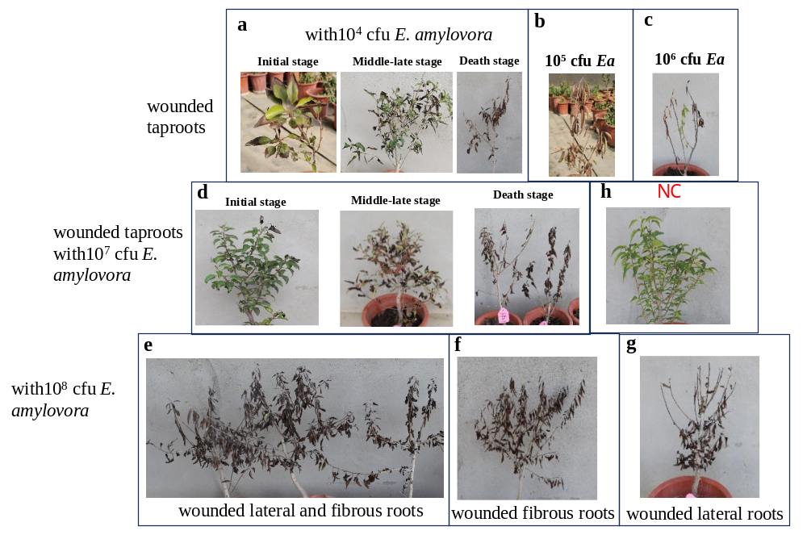
Figure S1. Characteristic symptoms of the diseased potted trees with E. amylovora bacterium suspension. a, The symptoms of pear potted trees with wounded taproots after irrigation of 10⁴ cfu E. amylovora bacteria at initial, middle-late, and death stage; b: The death symptoms of pear potted trees with wounded taproots after irrigation of 10⁵ cfu E. amylovora bacteria; c, The death symptoms of pear potted trees with wounded taproots after irrigation of 10⁶ cfu E. amylovora bacteria; d, The symptoms of pear potted trees with wounded taproots after irrigation of 10⁷ cfu E. amylovora bacteria at initial, middle-late, and death stage; e, The death symptoms of pear potted trees with wounded lateral and fibrous root after irrigation of 10⁸ cfu E. amylovora bacteria (33 dpi); f: The death symptoms of pear potted trees with wounded fibrous roots after irrigation of 10⁸ cfu E. amylovora bacteria; g: The death symptoms of pear potted trees with wounded lateral roots after irrigation of 10⁸ cfu E. amylovora bacteria; h, The pear potted trees with wounded taproots after irrigation of sterile water.

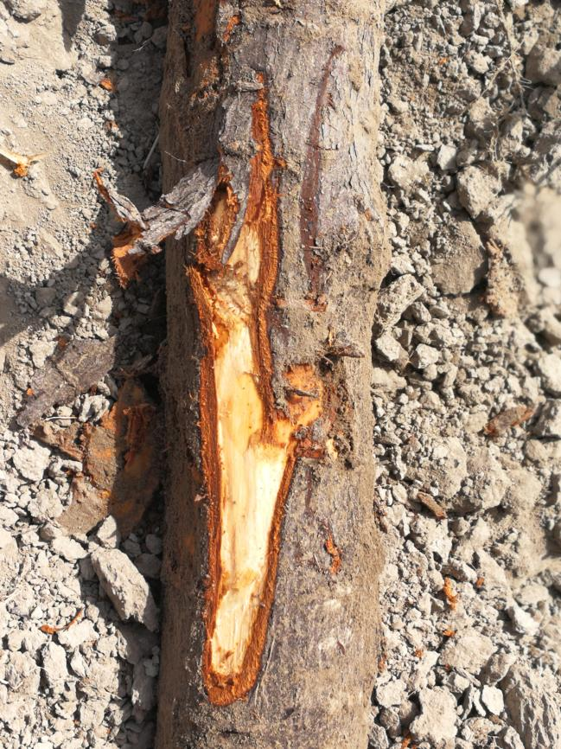
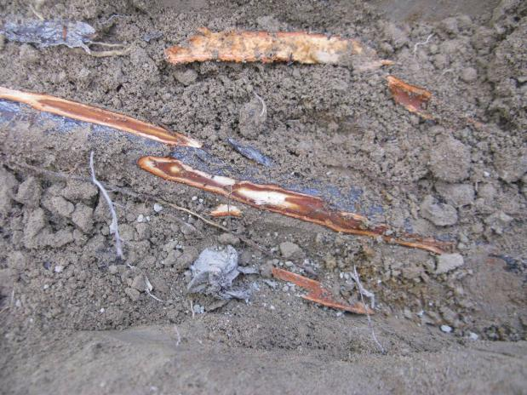

a

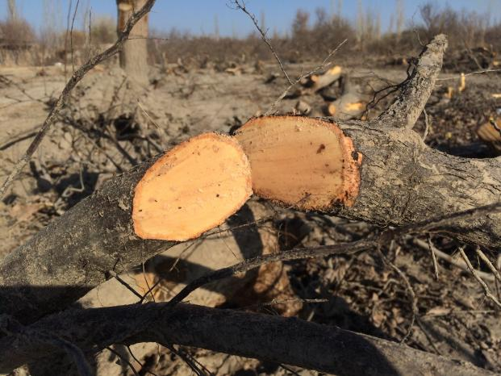

b
c
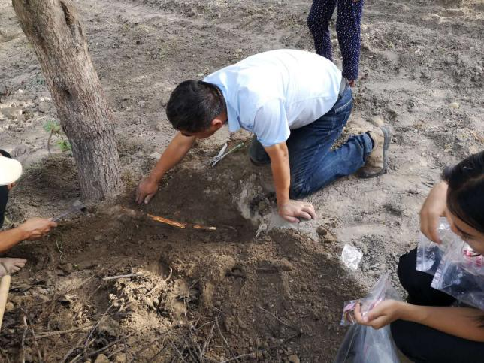
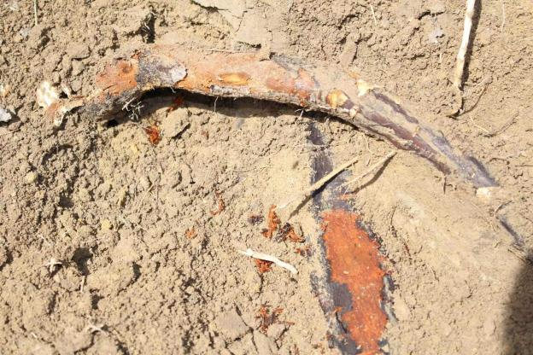

d
e

Figure S2. Characteristic symptoms of root in diseased pear trees. a: Picture of reddish-brown necrosis in the phloem of Ea infected peer tree; b: Picture of reddish-brown necrosis in the phloem of the main root of Ea infected fragrant pear; c: Picture of reddish-brown necrosis on the lateral root cross-section of Ea infected fragrant pear; d: The phloem of the infected and endangered fragrant pear tree roots shows reddish brown decay and necrosis; e: Observing the incidence of root disease.
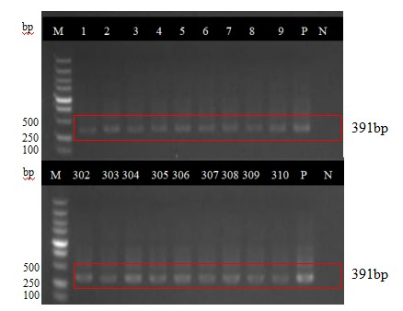
Figure S3. Characteristic gel electrophoresis results of nested PCR of bacterial ooze in potted pear trees with root irrigation of E. amylovora suspension in 2019. M, marker 2000；1-3, wound lateral roots; 4-6, wound taproots; 7-9, wound fibrous roots; 302-304, wound fibrous roots; 305-307, wound taproots; 308-310, wound lateral roots; P, positive control; N, negative control.

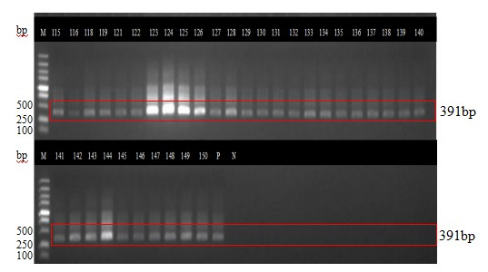
Figure S4. Characteristic gel electrophoresis results of nested PCR of bacterial ooze in pear potted trees with root irrigation of E. amylovora suspension in 2020. M, marker 2000; 115-128, wound lateral roots; 129-140, wound taproots; 141-150, wound fibrous roots; P, positive control; N, negative control.
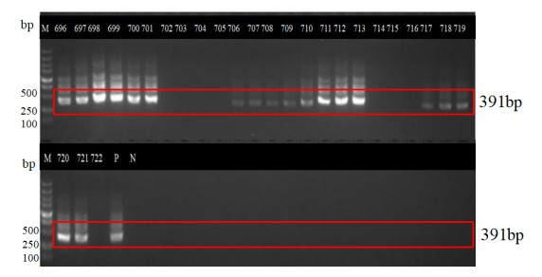
Figure S5. Characteristic gel electrophoresis results of nested PCR of bacterial ooze in potted pear trees with root irrigation of E. amylovora suspension in 2021. M, marker 2000；696,697: the leaves and branches of potted pear trees with wounded taproots, respectively; 698,701, the leaves and branches of potted pear trees with wounded fibrous roots, respectively; 710, 711: the leaves and branches of potted pear trees with wounded taproots, respectively; 720, 721: the leaves and branches of potted pear trees with wounded lateral roots, respectively; P, positive control; N, negative control.

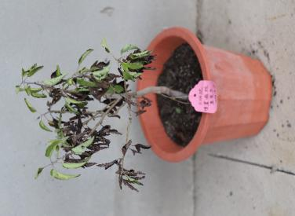
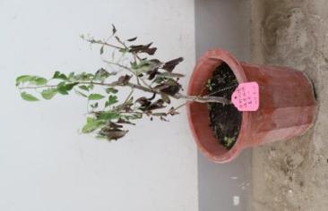
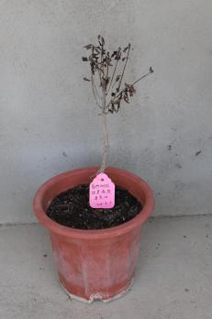
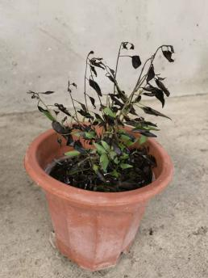
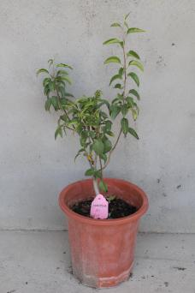
d
c
b
a
e

Figure S6. Characteristic symptoms of the diseased potted pear trees with different treatments after embedding E. amylovora infected branches. a, potted pear trees without wounded roots at 84 days after embedding E. amylovora infected branches; b, potted pear trees with wounded fibrous root at 84 days after embedding E. amylovora infected branches; c, potted pear trees with wounded lateral roots at 52 days after embedding E. amylovora infected branches; d, potted pear trees with wounded taproots at 33 days after embedding E. amylovora infected branches; e, potted pear trees with wounded fibrous roots without embedding E. amylovora infected branches (negative control).

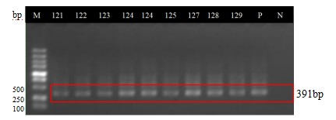
Figure S7. Characteristic gel electrophoresis results of nested PCR of bacterial ooze in potted pear trees with embedded E. amylovora infected branches in 2019. M: marker 2000; 121, Branches of diseased potted pear trees with wounded fibrous roots; 122, Leaves of diseased potted pear trees with wounded fibrous roots; 123, Leaves of diseased potted pear trees with wounded fibrous roots; 124, Branches of diseased potted pear trees without wounded roots; 125, Leaves of diseased potted pear trees with wounded taproots; 126, Leaves of diseased potted pear trees with wounded taproots; 129, Leaves of diseased potted pear trees with wounded lateral roots; P, positive control; N, negative control.

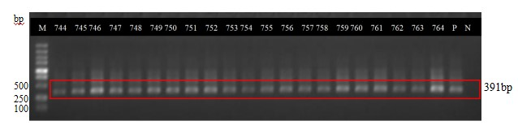
Figure S8. Characteristic gel electrophoresis results of nested PCR of bacterial ooze in potted pear trees with embedded E. amylovora infected branches in 2020. M, marker 2000; 744, Branches of diseased potted pear trees with wounded fibrous roots; 745, Leaves of diseased potted pear trees with wounded fibrous roots; 746, Leaves of diseased potted pear trees with wounded lateral roots; 747, Branches of diseased potted pear trees without wounded lateral roots; 749, Leaves of diseased potted pear trees with wounded taproots; 750, Branches of diseased potted pear trees with wounded taproots; 754, Branches of diseased potted pear trees without wounded roots; 755, Leaves of diseased potted pear trees without wounded roots; P, positive control; N, negative control.

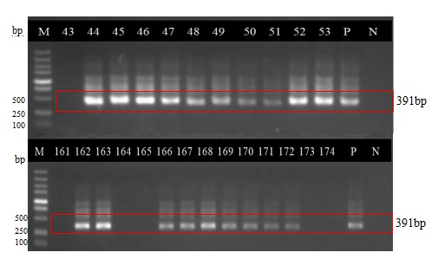
Figure S9. Characteristic gel electrophoresis results of nested PCR of bacterial ooze in potted pear trees with embedded E. amylovora infected branches in 2021. M, marker 2000; 46, Leaves of diseased potted pear trees with wounded taproots; 48, Branches of diseased potted pear trees with wounded lateral roots; 51, Branches of diseased potted pear trees with wounded taproots; 53, Leaves of diseased potted pear trees with wounded fibrous roots; 166, Leaves of diseased potted pear trees with wounded lateral roots; 167, Branches of diseased potted pear trees with wounded fibrous roots; 170, Leaves of diseased potted pear trees with wounded taproots; 171, Branches of diseased potted pear trees with wounded lateral roots; P, positive control; N, negative control.

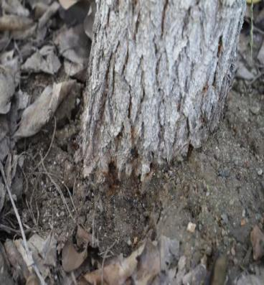
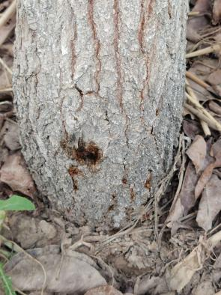
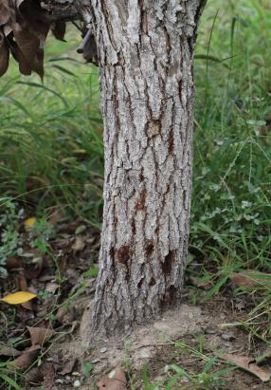
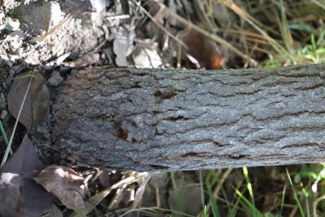
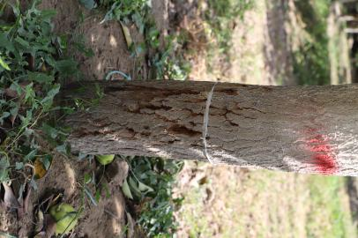
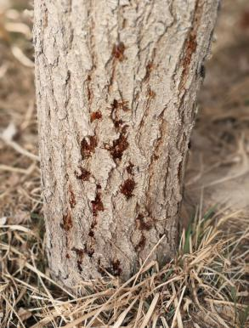
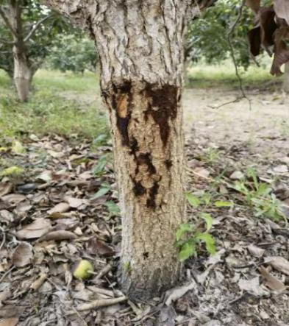
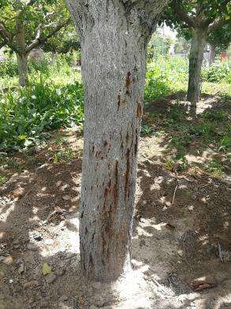
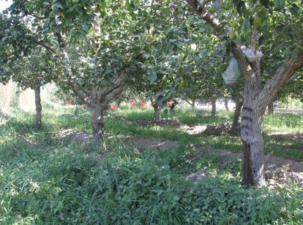
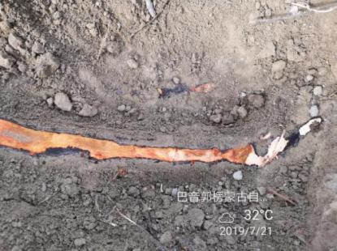
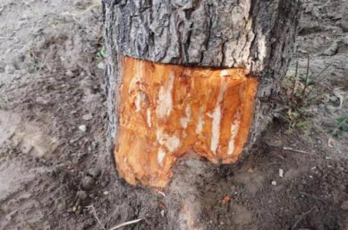
a
b
d
c
f
e
h
g
k
j

i

Figure S10. Characteristic symptoms of the Korla fragrant pear plants with wounded taproots in orchard with embedded E. amylovora infected branches. a-d, the branches of pear at 9, 15, 30 and 60 days after embedding E. amylovora infected branches, respectively; e-f, the branches of pear at 90 days after embedding E. amylovora infected branches; g-i, the branches of pear at 120 days after embedding E. amylovora infected branches; j, the typical reddish-brown necrosis of phloem in the main stem where bacterial ooze appeared; k, the typical reddish-brown necrosis of phloem and xylem of the root.
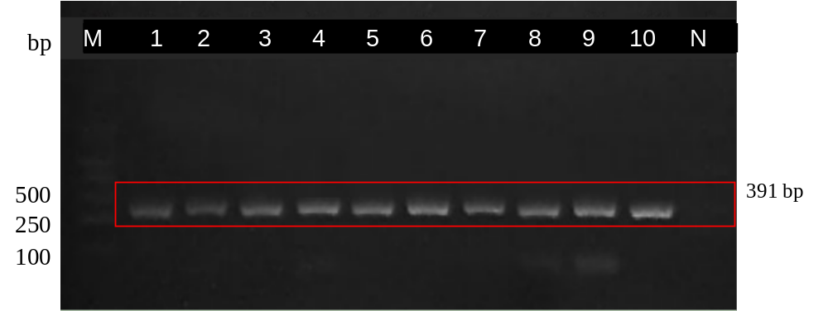
Figure S11. Characteristic gel electrophoresis results of nested PCR of pear plants with embedded E. amylovora infected branches in 2019. M, marker 2000; 1, Leaves of treatment 40-1; 2, Leaves of treatment 40-3; 3, branches of treatment 40-1; 4, branches of treatment 40-2; 5, branches of treatment 40-4; 6, branches of treatment 40-4; 7, bark of treatment 40-1; 8, bark of treatment 40-2; 9, bark of treatment 40-3; 10, bark of treatment 40-4; N, negative control.

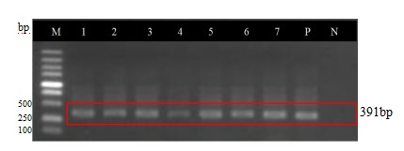
Figure S12. Characteristic gel electrophoresis results of nested PCR of pear plants with embedded E. amylovora infected branches in 2020. M, marker 2000; 1, Leaves of treatment 40-1; 2, Leaves of treatment 40-3; 3, branches of treatment 40-2; 4, branches of treatment 40-4; 5, bark of treatment 40-1; 6, bark of treatment 40-2; 7, bark of treatment 40-3; N, negative control.
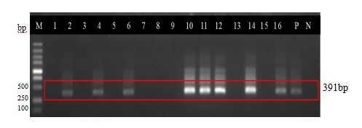
Figure S13. Characteristic gel electrophoresis results of nested PCR of pear plants with embedded E. amylovora infected branches in 2021. M, marker 2000; 4, Leaves of treatment 40-2; 6, Leaves of treatment 40-3; 10, branches of treatment 40-1; 11, branches of treatment 40-4; 14, bark of treatment 40-2; 16, bark of treatment 40-3; P, positive control; N, negative control.
图6-1 巢氏PCR检测结果

