Supporting Information
Dual-Mechanism Synergistic Enhancement of Room-Temperature Phosphorescence in Carbazole Derivatives
Wangen Zhuª, Chi Zhangª, Delong Maª, Jiaying Yan^{*ab}, Yong Qi^{*a}, Nuonuo Zhang^{*ab}
ªCollege of Materials and Chemical Engineering, Key Laboratory of Inorganic Nonmetallic Crystalline and Energy Conversion Materials, China Three Gorges University, Yichang, Hubei 443002, P. R. China
^{b}Hubei Three Gorges Laboratory, Yichang, Hubei 443007, P. R. China
*Corresponding Email: yanjiaying327@126.com, qiyong@ctgu.edu.cn and nnzhang2015@ctgu.edu.cn.
Content
1. Materials and methods 2
2. Computational method 2
3. Synthesis 2
4. NMR and HRMS spectra of K-CN, K-Br₂, K-Cl, K-Br 5
5.Single Crystal analysis 10
6. Phosphorescence Spectra and Phosphorescence Lifetime 12
References 13

1. Materials and methods
All reagents and solvents were obtained from commercial sources and used without further purification, unless otherwise noted. All chromatographic separations were carried out on silica gel (300-400 mesh). ¹H NMR and 13C NMR spectra were recorded on Bruker 400 MHz spectrometer at 298 K. Chloroform-d was used as solvent and TMS as internal reference. The chemical shifts were reported in parts per million (δ) relative to the appropriate reference signal: Chloroform-d (the quintet centered at 7.26 ppm). High resolution mass spectra were measured on Bruker APCI or SYNAPT G2 analysis instrument. Both the phosphorescence spectrum and phosphorescence lifetime are measured by Steady-state Transient Fluorescence Spectrometer.

2. Computational method
DFT calculations on the B3LYP/6-311G+(d,p) level within IEFPCM for toluene have been performed to gain an improved understanding of the electronic characteristics of dyes K-CN, K-Br₂，K-Cl and K-Br with the Gaussian 16 package^{[S1]}. Vertical electronic transitions were calculated by TD-DFT with the same functional and basis set. The spin-orbit coupling (SOC) values associated with transitions between individual orbitals were determined independently with the ORCA program^{[S2]}.

3. Synthesis
The synthesis procedure and characterization of K-CN, K-Br₂, K-Cl, K-Br.
Under the action of the activator EDCI and the catalyst DMAP, the activated intermediate undergoes a condensation reaction with the N-H bond on the parent carbazole, yielding a series of products with different substituents (-CN, -Br₂, -Cl, -Br,) with a yield of 68.5-79%. The results indicate that the reaction conditions are mild, the yield is relatively high, and the methyl group on the pyrrole ring also increases the solubility of the products in this system, which is beneficial for the application of room temperature phosphorescent materials. At room temperature, N-methyl-2-pyrrolecarboxylic acid (1.5 mmol, 188 mg), 3-cyano carbazole (1 mmol, 325 mg), 1-ethyl-3-(3-dimethylaminopropyl)carbodiimide EDCI (3 mmol, 576 mg), and 4-dimethylaminopyridine DMAP (2 mmol, 448 mg) were added to a reaction flask in 10 mL of dichloromethane and reacted at 50°C for 12 hours, monitoring the reaction process by thin-layer chromatography. The reaction solution was extracted with dichloromethane and evaporated to obtain the crude product. Finally, the obtained crude product was subjected to column chromatography (silica gel, dichloromethane/petroleum ether (1:1, v/v)) to yield a white solid K-CN (yield 68.5%). Other products were synthesized by the same method. Using 3,6-dibromocarbazole, 3-chlorocarbazole, 3-bromocarbazol, the respective reaction products K-Br₂, K-Cl, K-Br, were obtained.
Scheme S1. Synthetic routes of the target compound K-CN, K-Br₂, K-Cl, K-Br.
K-CN: Yield: 68.5%; white solid. ¹HNMR(400MHz,Chloroform-d)δ8.32(dd, J = 1.7, 0.7 Hz, 1H), 8.04 (m, 1H), 7.83 (dd, J = 8.7, 0.7 Hz, 1H), 7.72 (dt, J = 8.3, 0.9 Hz, 1H), 7.61 (dd, J = 8.6, 1.6 Hz, 1H), 7.45 (ddd, J = 8.4, 7.2, 1.4 Hz, 1H), 7.39 (td, J = 7.5, 1.1 Hz, 1H), 7.04 (t, J = 2.1 Hz, 1H), 6.68 (dd, J = 4.1, 1.7 Hz, 1H), 6.19 (dd, J = 4.1, 2.5 Hz, 1H), 4.05 (s, 3H).¹³C NMR (101 MHz, Chloroform-d) δ 160.4, 141.6, 140.3, 132.2, 129.6, 127.8, 125.6, 125.5, 124.7, 123.8, 123.3, 121.7, 120.4, 119.8, 115.4, 114.9, 109.2, 105.6, 36.8. HRMS(ESI) Calcd for C₁₉H₁₃N₃O [M+Na]⁺:322.0956, found 322.0957.
K-Br₂: Yield: 72.5%; white solid. ¹HNMR(400MHz,Chloroform-d) δ 7.90 (d, J = 1.7 Hz, 2H), 7.82 (d, J = 8.3 Hz, 2H), 7.44 (dd, J = 8.3, 1.7 Hz, 2H), 7.03 (t, J = 2.1 Hz, 1H), 6.70 (dd, J = 4.2, 1.7 Hz, 1H), 6.21 (dd, J = 4.2, 2.5 Hz, 1H), 4.04 (s, 3H).¹³C NMR (101 MHz, Chloroform-d) δ 160.3, 140.4, 132.1, 126.2, 125.2, 123.6, 121.5, 121.0, 120.4, 118.0, 109.2, 36.8. HRMS(ESI) Calcd for C₁₈H₁₂Br₂N₂O [M+Na]⁺:452.9214, found 452.9213.
K-Cl: Yield: 71.3%; white solid. ¹HNMR(400MHz,Chloroform-d) δ 7.97 (m, 2H), 7.71 (m, 2H), 7.39 (ddd, J = 8.3, 7.2, 1.5 Hz, 1H), 7.35 (m, 1H), 7.32 (m, 1H), 6.98 (t, J = 2.1 Hz, 1H), 6.69 (dd, J = 4.1, 1.7 Hz, 1H), 6.19 (dd, J = 4.1, 2.5 Hz, 1H), 3.99 (s, 3H).¹³C NMR (101 MHz, Chloroform-d) δ 160.9, 140.1, 138.0, 131.1, 128.3, 127.2, 126.9, 126.5, 126.0, 124.5, 123.0, 120.8, 120.1, 119.7, 116.1, 115.1, 108.9, 36.6.HRMS(ESI) Calcd for C₁₈H₁₃ClN₂O [M+Na]⁺:331.0614, found 331.0617.
K-Br: Yield: 79%; white solid. ¹HNMR(400MHz,Chloroform-d)δ8.13 (d, J = 2.0 Hz, 1H), 7.97 (dd, J = 7.4, 1.4 Hz, 1H), 7.72 (m, 1H), 7.64 (d, J = 8.8 Hz, 1H), 7.45 (dd, J = 8.8, 2.0 Hz, 1H), 7.39 (ddd, J = 8.4, 7.3, 1.5 Hz, 1H), 7.34 (td, J = 7.4, 1.2 Hz, 1H), 6.98 (t, J = 2.1 Hz, 1H), 6.69 (dd, J = 4.1, 1.7 Hz, 1H), 6.18 (dd, J = 4.1, 2.5 Hz, 1H), 3.99 (s, 3H).¹³C NMR (101 MHz, Chloroform-d) δ 160.9, 140.0, 138.4, 131.1, 129.2, 127.4, 127.2, 125.9, 124.3，123.0, 122.8, 120.8, 120.1, 116.5, 115.8, 115.0, 108.9, 36.6.HRMS(ESI) Calcd for C₁₈H₁₃BrN₂O [M+Na]⁺:375.0109, found 375.0117.

4. NMR and HRMS spectra of K-CN, K-Br₂, K-Cl, K-Br
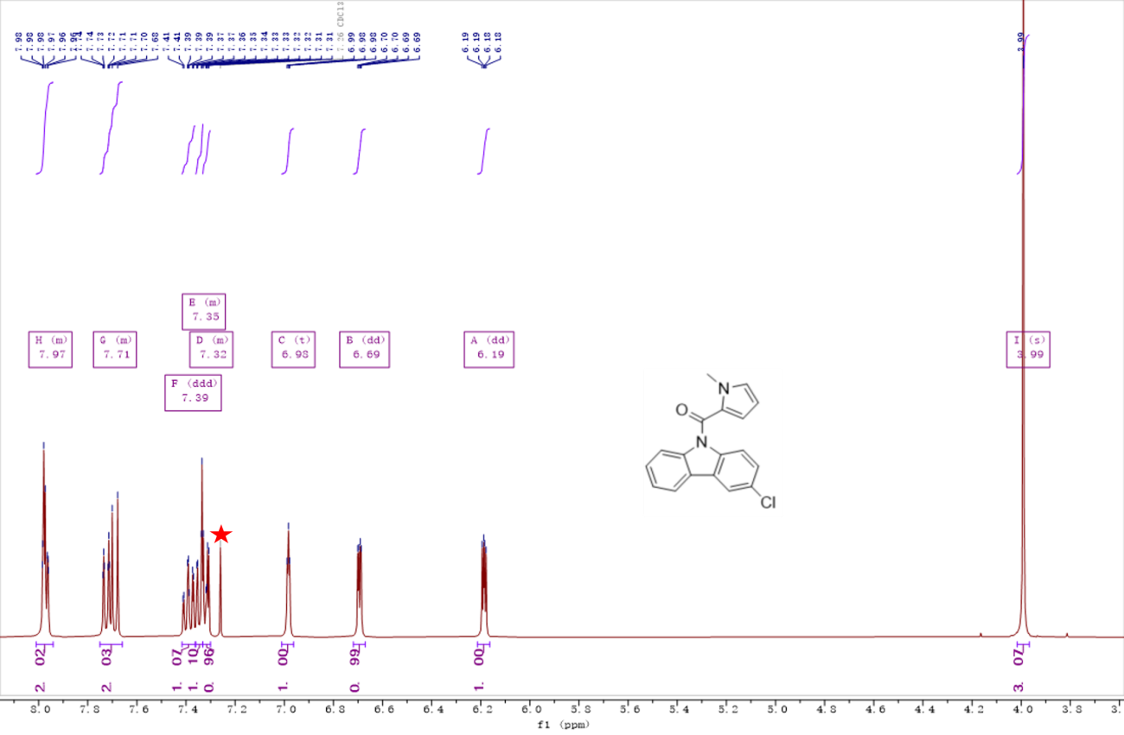
Figure S1. ¹H NMR spectra of K-Cl in Chloroform-d (red star denotes the solvent residual peak of Chloroform-d)
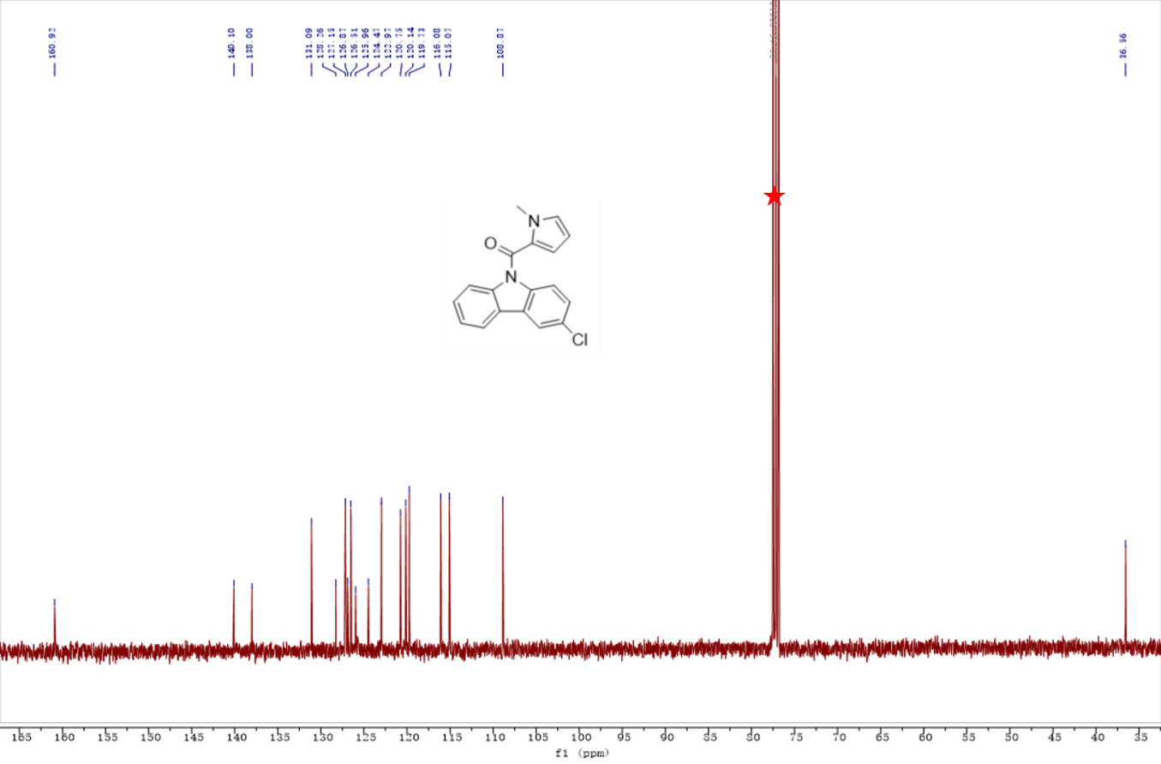
Figure S2. ¹³C NMR spectra of K-Cl in Chloroform-d (red star denotes the solvent residual peak of Chloroform-d)
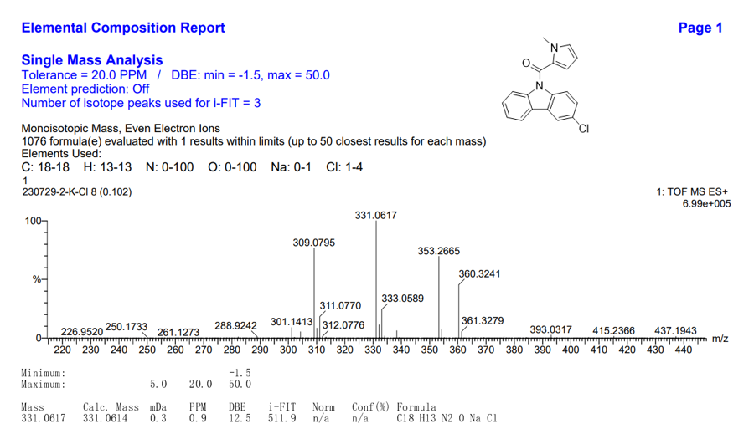
Figure S3. HR-MS spectra of K-Cl.

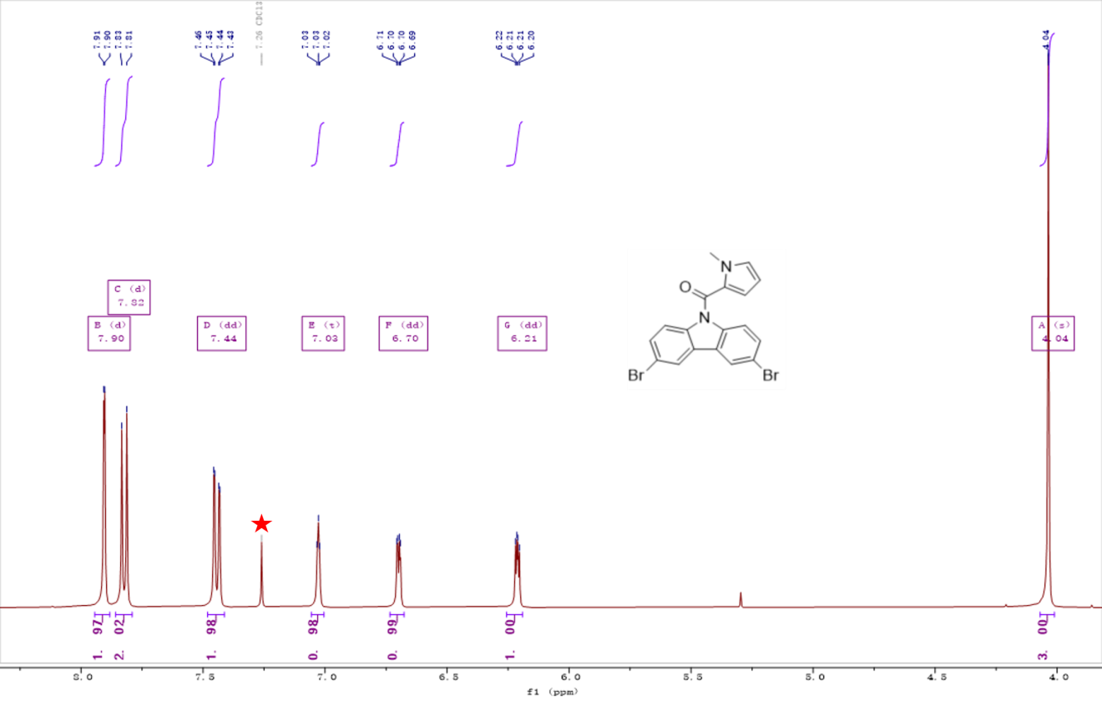
Figure S4. ¹H NMR spectra of K-Br₂ in Chloroform-d (red star denotes the solvent residual peak of Chloroform-d )
Figure S5. ¹³C NMR spectra of K-Br₂ in Chloroform-d (red star denotes the solvent residual peak of Chloroform-d)

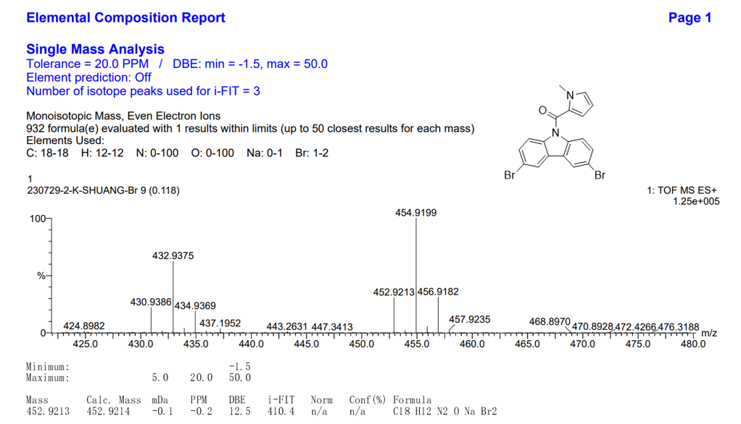
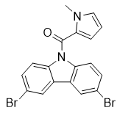
Figure S6. HR-MS spectra of K-Br₂
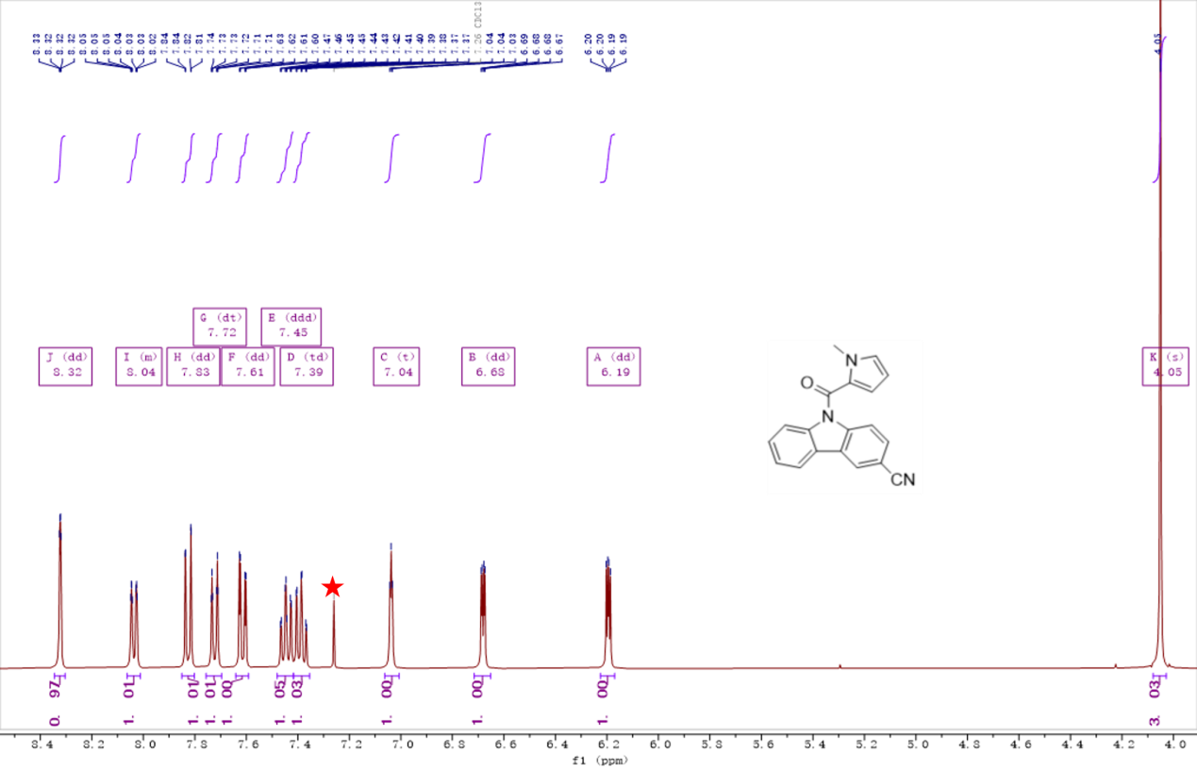
Figure S7. ¹H NMR spectra of K-CN in Chloroform-d ( red star denotes the solvent residual peak of Chloroform-d )

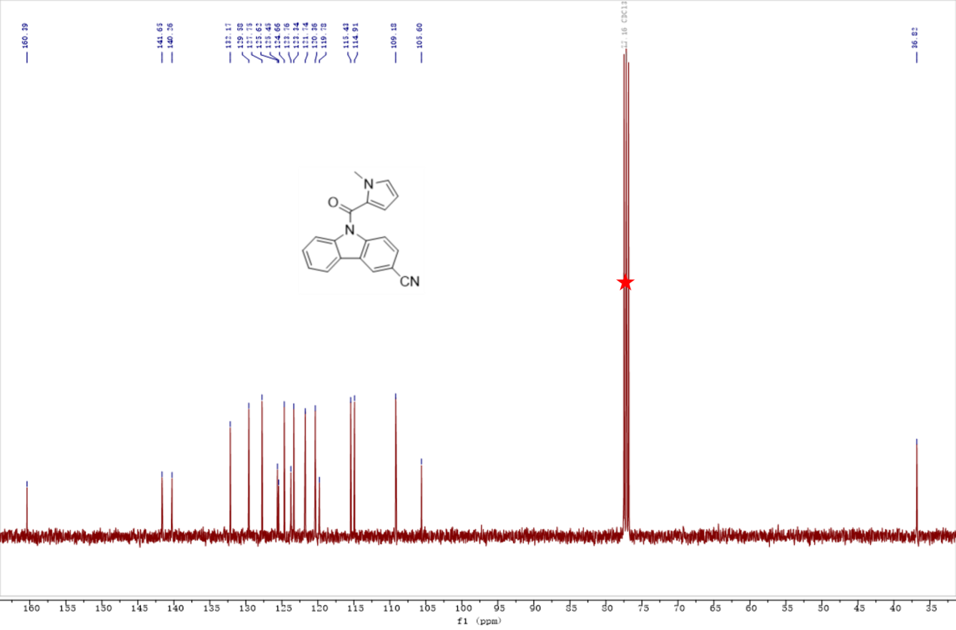
Figure S8. ¹³C NMR spectra of K-CN in Chloroform-d (red star denotes the solvent residual peak of Chloroform-d )
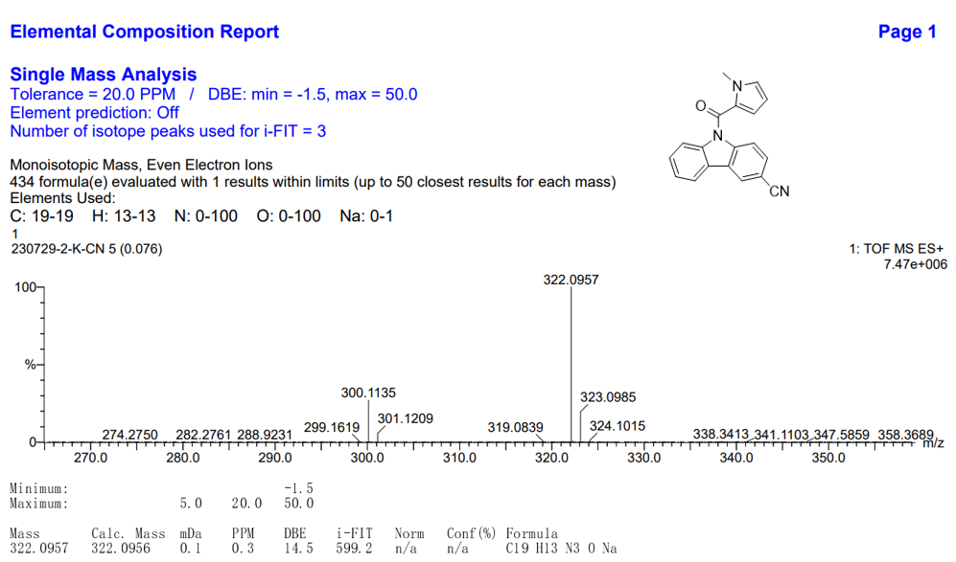
Figure S9. HR-MS spectra of K-CN
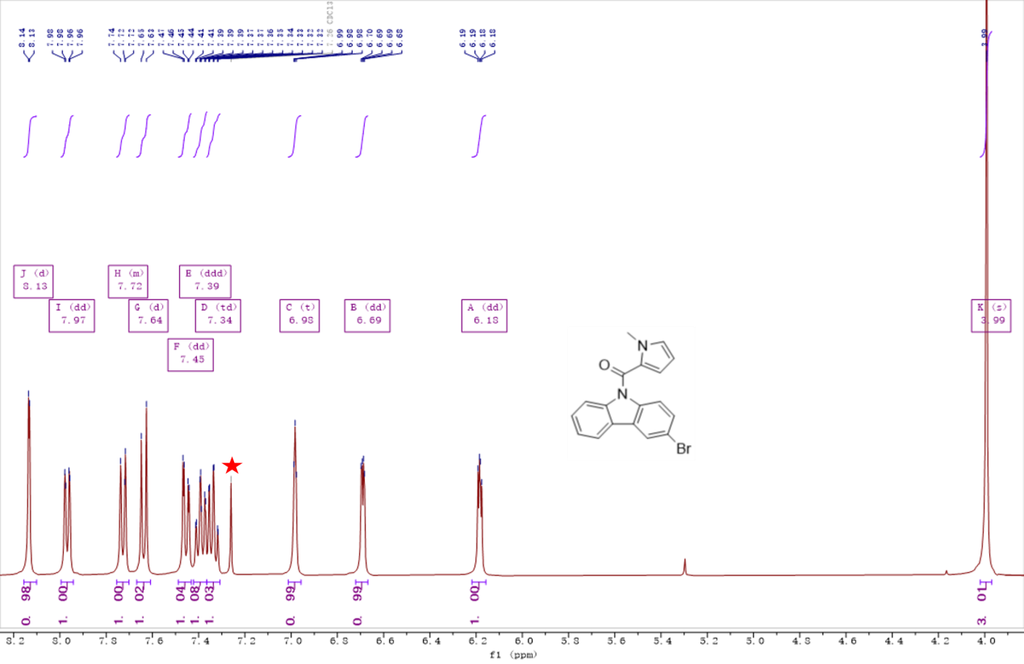
Figure S10. ¹H NMR spectra of K-Br in Chloroform-d ( red star denotes the solvent residual peak of Chloroform-d )

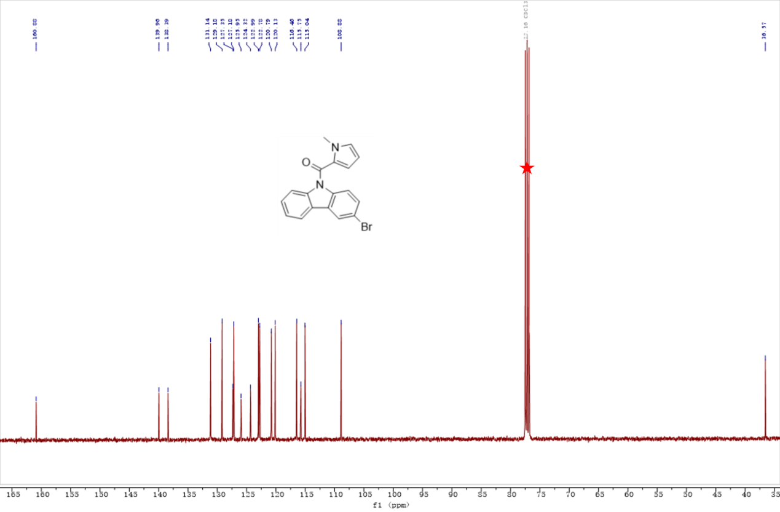
Figure S11. ¹³C NMR spectra of K-Br in Chloroform-d (red star denotes the solvent residual peak of Chloroform-d )

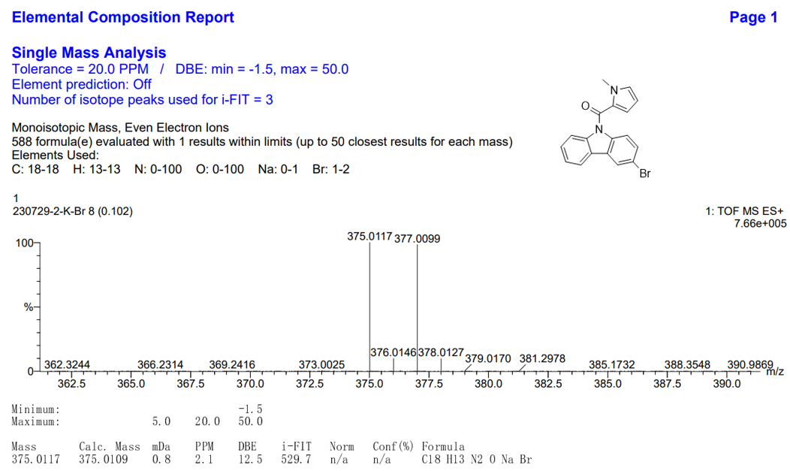
Figure S12. HR-MS spectra of K-Br

5.Single Crystal analysis
Table S1. The crystal structures of K-CN were determined by single-crystal X-ray diffraction (SCXRD) measurements
Identification code | K-CN
Empirical formula | C₁₉H₁₃N₃O
Formula weight | 299.32
Temperature/K | 169.99(10)
Crystal system | triclinic
Space group | P-1
a/Å | 7.8000(5)
b/Å | 14.0790(12)
c/Å | 14.1389(15)
α/° | 96.097(8)
β/° | 97.381(7)
γ/° | 99.809(7)
Volume/Å³ | 1504.2(2)
Z | 4
ρ_{calc}g/cm³ | 1.322
μ/mm⁻¹ | 0.085
F(000) | 624.0
Crystal size/mm³ | 0.14 × 0.13 × 0.11
adiation | Mo Kα (λ = 0.71073)
2Θ range for data collection/° | 4.43 to 58.67
Index ranges | -10 ≤ h ≤ 10, -18 ≤ k ≤ 19, -18 ≤ l ≤ 11
Reflections collected | 11569
Independent  reflections | 6872 [R_{int} = 0.0238, R_{sigma} = 0.0473]
Data/restraints/parameters | 6872/0/418
Goodness-of-fit on F² | 1.011
Final R indexes  [I>=2σ (I)] | R₁ = 0.0494,  wR₂ = 0.1049
Final R indexes  [all data] | R₁ = 0.0655,  wR₂ = 0.1161
Largest diff. peak/hole  / e Å⁻³ | 0.25/-0.21
CCDC | 2522423

6. Phosphorescence Spectra and Phosphorescence Lifetime
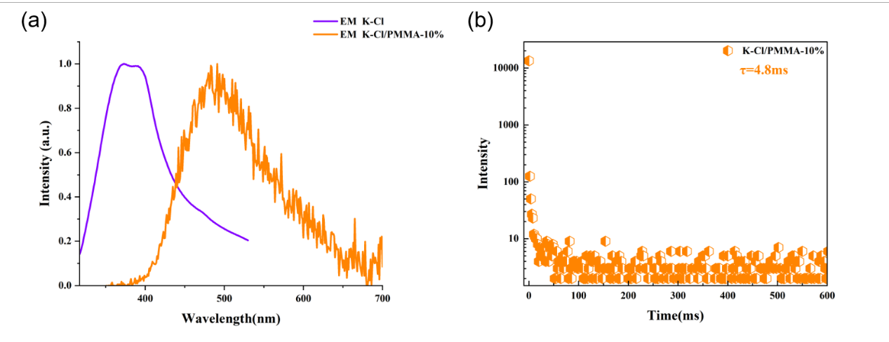
Figure S13. (a) Overlaid spectra of room-temperature phosphorescence (RTP) for K-Cl@PMMA-10% (delay time: 0.1 ms) and solid-state fluorescence for K-Cl
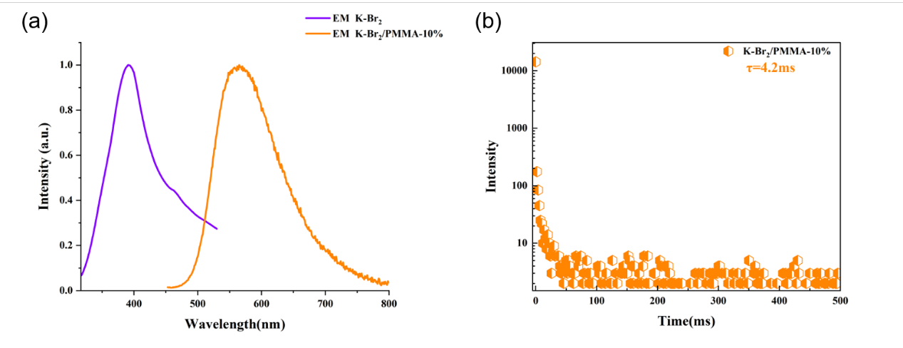
Figure S14. (a) Overlaid spectra of room-temperature phosphorescence (RTP) for K-Br₂@PMMA-10% (delay time: 0.1 ms) and solid-state fluorescence for K-Br₂
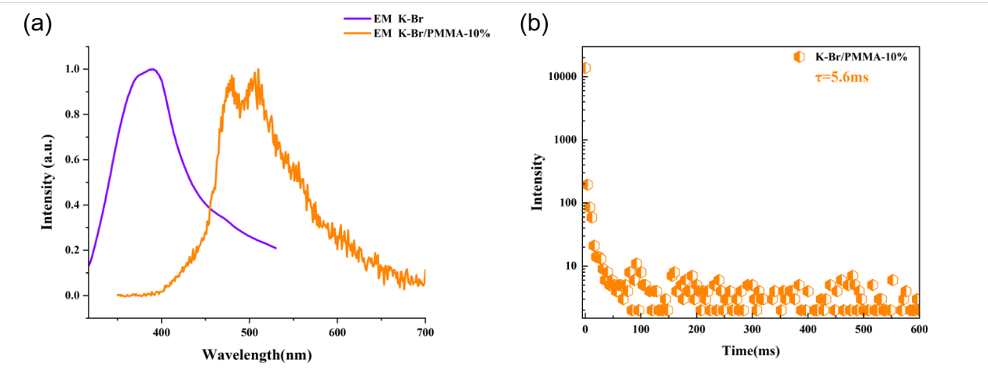
Figure S15. (a) Overlaid spectra of room-temperature phosphorescence (RTP) for K-Br@PMMA-10% (delay time: 0.1 ms) and solid-state fluorescence for K-Br
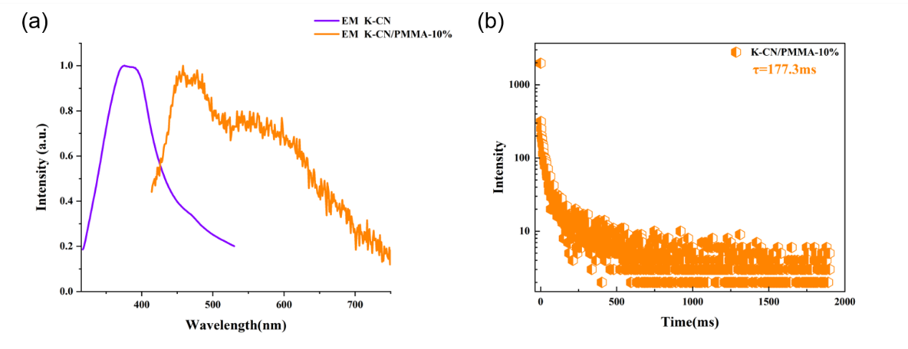
Figure S16. (a) Overlaid spectra of room-temperature phosphorescence (RTP) for K-CN@PMMA-10% (delay time: 0.1 ms) and solid-state fluorescence for K-CN

References
[S₁] Gaussian 16, Revision B.01, Frisch, M. J.; Trucks, G. W.; Schlegel, H. B.; Scuseria, G. E.; Robb, M. A.; Cheeseman, J. R.; Scalmani, G.; Barone, V.; Petersson, G. A.; Nakatsuji, H.; Li, X.; Caricato, M.; Marenich, A. V.; Bloino, J.; Janesko, B. G.; Gomperts, R.; Mennucci, B.; Hratchian, H. P.; Ortiz, J. V.; Izmaylov, A. F.; Sonnenberg, J. L.; Williams-Young, D.; Ding, F.; Lipparini, F.; Egidi, F.; Goings, J.; Peng, B.; Petrone, A.; Henderson, T.; Ranasinghe, D.; Zakrzewski, V. G.; Gao, J.; Rega, N.; Zheng, G.; Liang, W.; Hada, M.; Ehara, M.; Toyota, K.; Fukuda, R.; Hasegawa, J.; Ishida, M.; Nakajima, T.; Honda, Y.; Kitao, O.; Nakai, H.; Vreven, T.; Throssell, K.; Montgomery, J. A., Jr.; Peralta, J. E.; Ogliaro, F.; Bearpark, M. J.; Heyd, J. J.; Brothers, E. N.; Kudin, K. N.; Staroverov, V. N.; Keith, T. A.; Kobayashi, R.; Normand, J.; Raghavachari, K.; Rendell, A. P.; Burant, J. C.; Iyengar, S. S.; Tomasi, J.; Cossi, M.; Millam, J. M.; Klene, M.; Adamo, C.; Cammi, R.; Ochterski, J. W.; Martin, R. L.; Morokuma, K.; Farkas, O.; Foresman, J. B.; Fox, D. J. Gaussian, Inc., Wallingford CT, 2016.
[S₂] Neese, F. The ORCA program system Wiley Interdiscip. Rev.: Comput. Mol. Sci., 2012, 2, 1, 73–78 (DOI: 10.1002/wcms.81)

