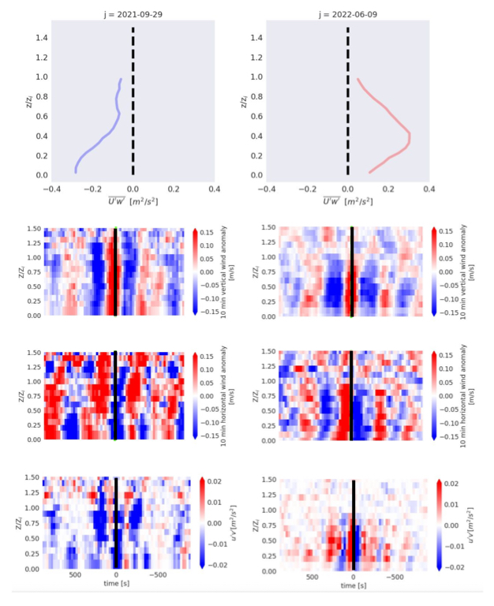
Supporting Material, accompanying the manuscript: Doppler Lidar Observations of Submesoscale Flow and Momentum Flux in Convective Boundary Layers,
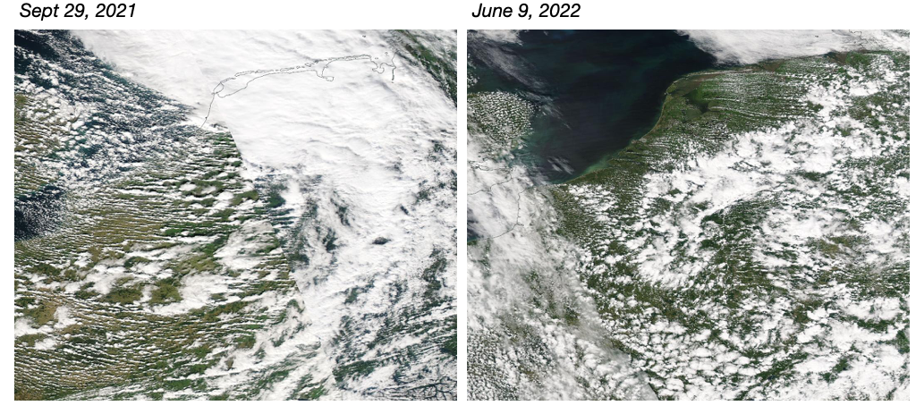
by Nuijens and Dias Neto.

