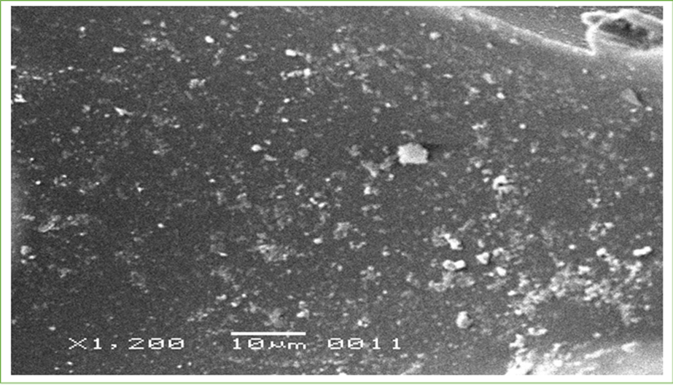
Image 1: Untreated surface of polyurethane

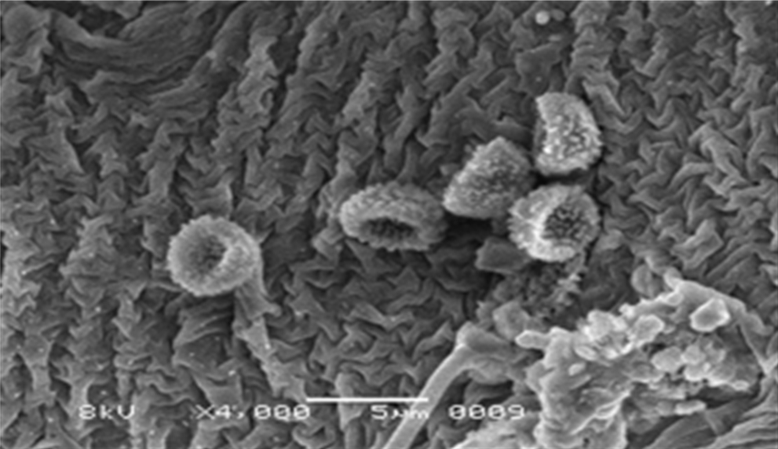
Image 2: Aspergillus flavus treated surface of polystyrene

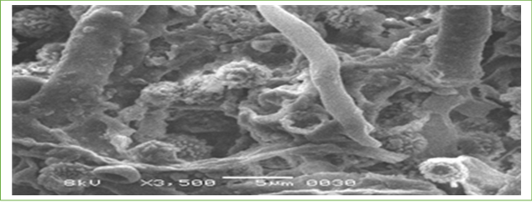
Image 3: Aspergillus flavus treated surface of polyurethane

