Supplementary Table:
Table S1. Eigenvalues and percentage of variance explained by each principal component obtained from principal component analysis (PCA).
Sl No | PC | igenvalue | Variance Percent | Cumulative Variance
1 | PC1 | 4.175 | 46.39 | 46.39
2 | PC2 | 1.994 | 22.16 | 68.55
3 | PC3 | 1.187 | 13.19 | 81.74
4 | PC4 | 0.645 | 7.16 | 88.91
5 | PC5 | 0.405 | 4.49 | 93.4
6 | PC6 | 0.304 | 3.38 | 96.78
7 | PC7 | 0.206 | 2.29 | 99.07
8 | PC8 | 0.065 | 0.72 | 99.79
9 | PC9 | 0.019 | 0.21 | 100

Supplementary Figures:

Fig S1: Spatial distribution and variability of the geoaccumulation index (Igeo) across and within the sampling locations.

Fig S2: Distribution and variations of Enrichment Factor between and within the sampling locations.

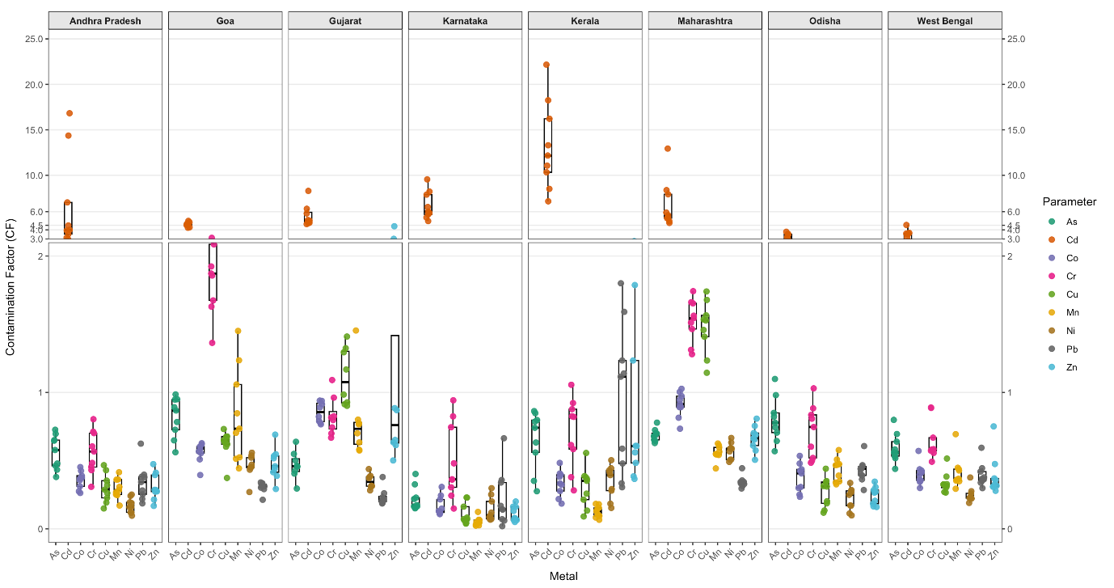
Fig S3: Distribution and variations of contamination Factor between and within the sampling locations.

