Supplementary Information

A pure nanoICG-based homogeneous lipiodol formulation: Toward precise surgical navigation of hepatocellular carcinoma after long-term transcatheter arterial embolization

Zhang et al

Table of Contents:

-Supplementary Figures 1-10

A pure nanoICG-based homogeneous lipiodol formulation: Toward precise surgical navigation of hepatocellular carcinoma after long-term transcatheter arterial embolization
Yang Zhang ^{a,1}, Hongwei Cheng ^{a,1}, Hu Chen ^{a,1}, Peiyao Xu ^{c,1}, En Ren ª, Yonghe Jiang ª, Dengfeng Li ª, Xing Gao ª, Yating Zheng ª, Pan He ª, Huirong Lin ª, Biaoqi Chen ^{c}, Gan Lin ª, Aizheng Chen ^{c}, Chengchao Chu ^{a,d,*}, Jingsong Mao ^{a,b,*}, Gang Liu ^{a,*}
ª State Key Laboratory of Molecular Vaccinology and Molecular Diagnostics, Center for Molecular Imaging and Translational Medicine, School of Public Health, Xiamen University, Xiamen 361102, China.
^{b} Department of Radiology, Xiang’an Hospital of Xiamen University, Xiamen 361102, China.
^{c} Fujian Provincial Key Laboratory of Biochemical Technology, Institute of Biomaterials and Tissue Engineering, Huaqiao University, Xiamen 361021, China.
^{d} Amoy Hopeful Biotechnology Co., Ltd., Xiamen 361027, China.
* Corresponding author. E-mail addresses: Chuchengchao0225@163.com (C. Chu), maojingsong163@163.com (J. Mao), gangliu.cmitm@xmu.edu.cn (G. Liu)
¹ Y. Zhang, H. Cheng, H. Chen and P. Xu contributed equally to this work.

Fig. S1. Laser irradiation induced temperature rise of saline, free ICG, and nanoICG group, respectively.

Fig. S2. The fluorescence intensities of SHIFT nanoICG in different pH conditions were detected by IVIS Lunima LT at the 745 nm excitation.

Fig. S3. NanoICG released from SHIFT nanoICG in the condition of saline (37 ℃) with pH 6.5 and pH 7.4 for lasting 7 days, respectively.

Fig. S4. The quantitative analysis of PA imaging signal.

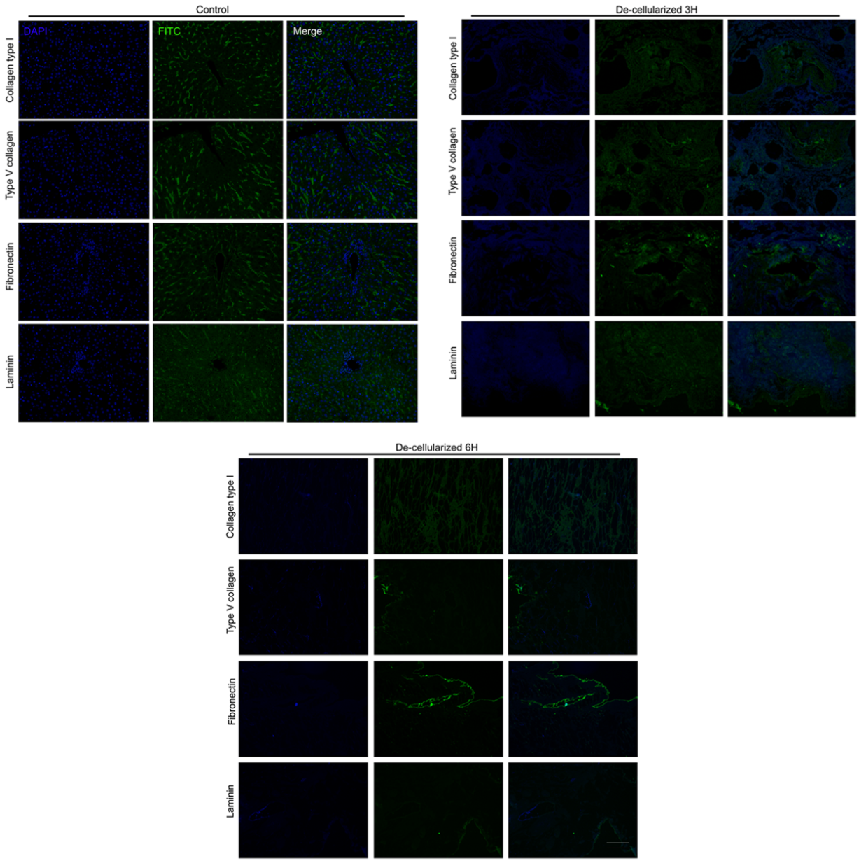

Fig. S5. Immunofluorescent staining of liver tissue with different processing times to verify decellularized effect. Scale bar is 100 μm.

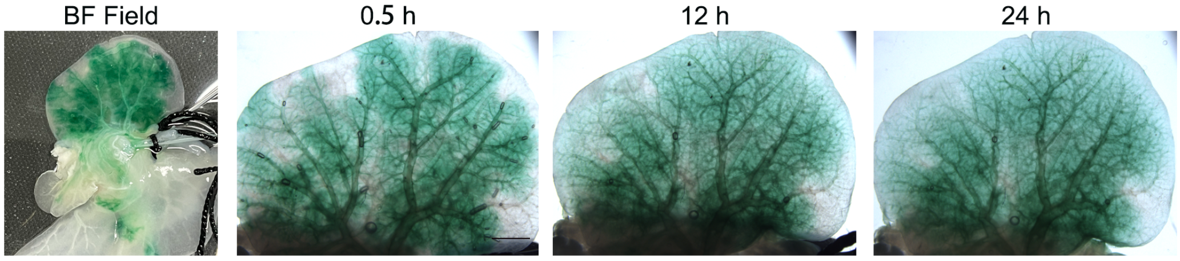

Fig. S6. Images of nanoICG solution after injected in decellularized liver model with different times. Scale bar is 500 mm.

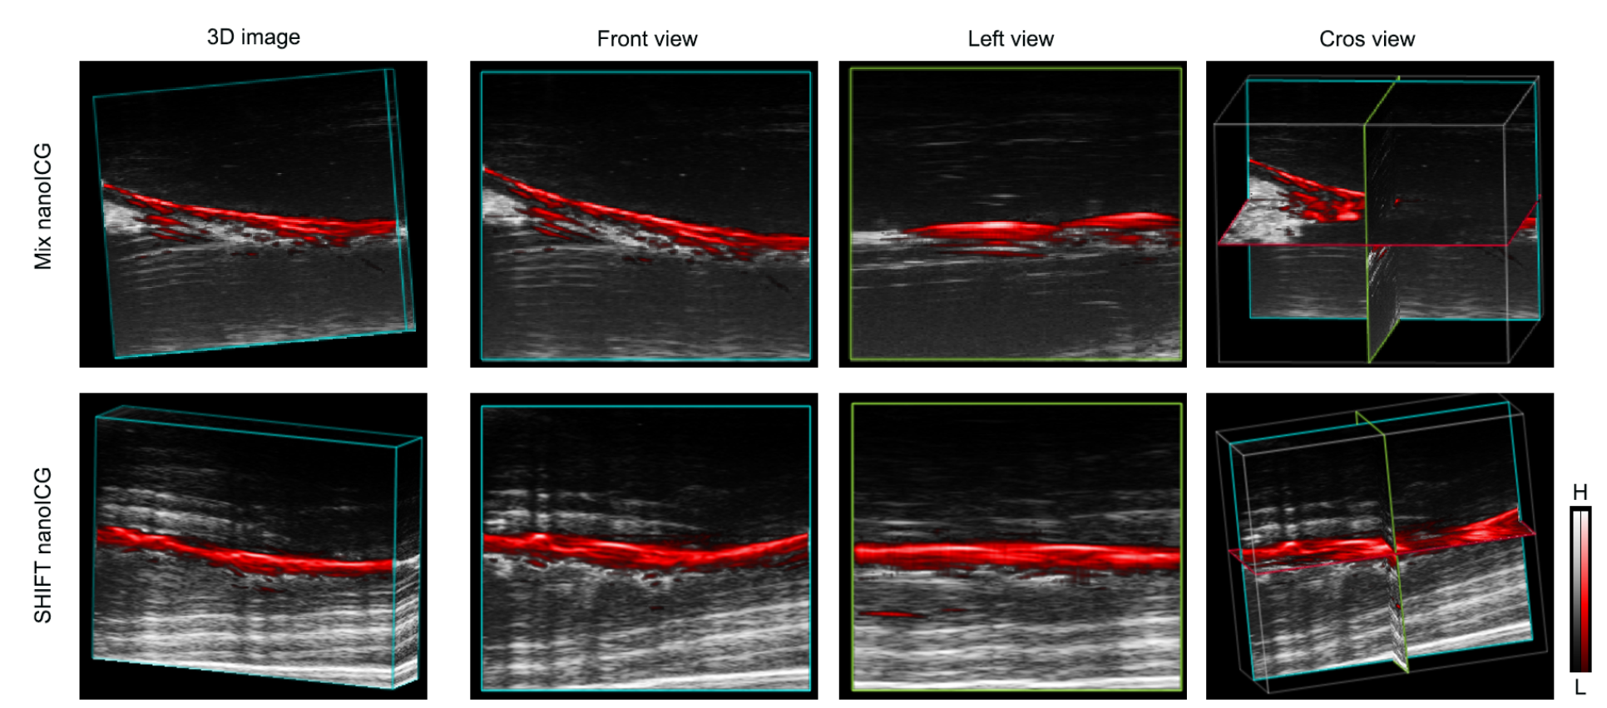
Fig. S7. Three dimensional images of mix nanoICG and SHIFT nanoICG after injected in decellularized liver model.

Fig. S8. The liver, kidney, and cardiac function of SHIFT nanoICG, SHIFT ICG, and mix nanoICG groups were measured.

Fig. S9. Fluorescence guided navigation capacities of free ICG and nanoICG were measured, the result showed that nanoICG exhibited an obviously better imaging capacity than that of free ICG.

Fig. S10. The quantitative analysis of CT value for embolic lesion and surrounding liver tissue.

