Mechanism of moisture adsorption in plant fibers surface-modified with glycerol evaluated by LF-NMR relaxation technique
Lili Fu, Ke Zhang, Mingjian Zhang, Le Wang, Songjin Zheng, Ze Liu, Shanzhai Shang, Yue Sun, Feng Huang, Shuang Wang, Qi Zhang, Bing Wang, Bin Li, Yan Cao, Zhongya Guo*

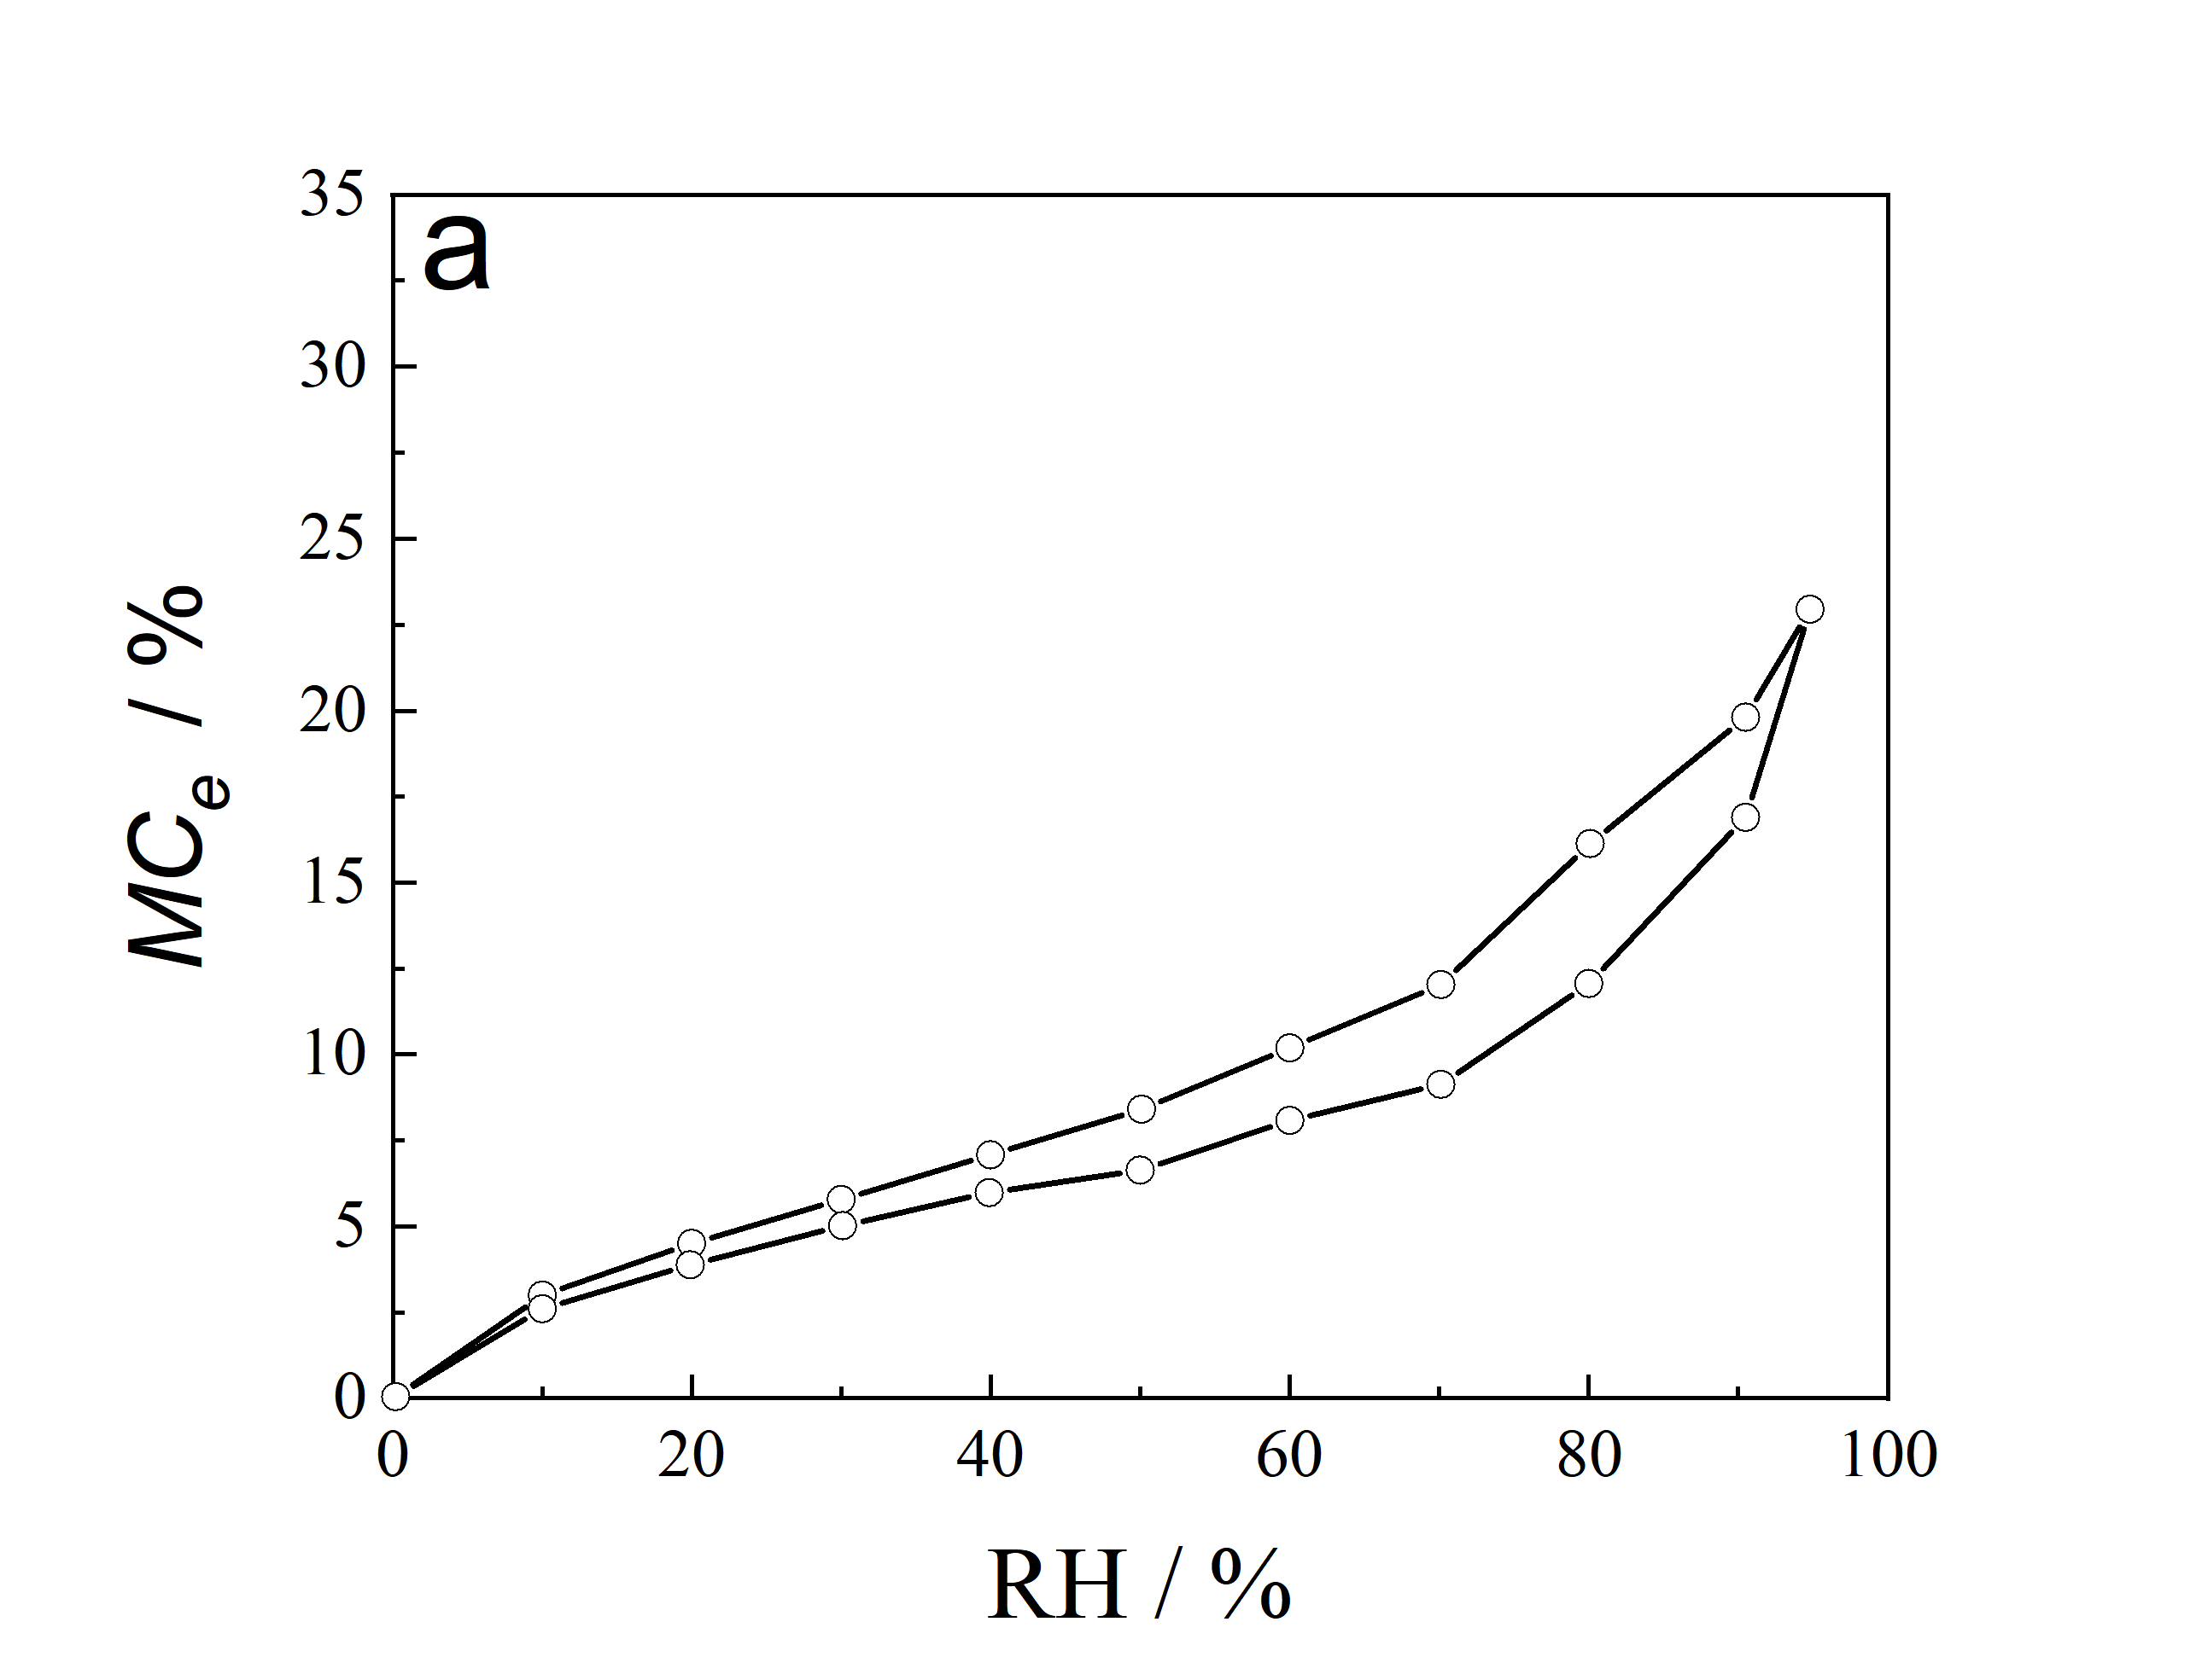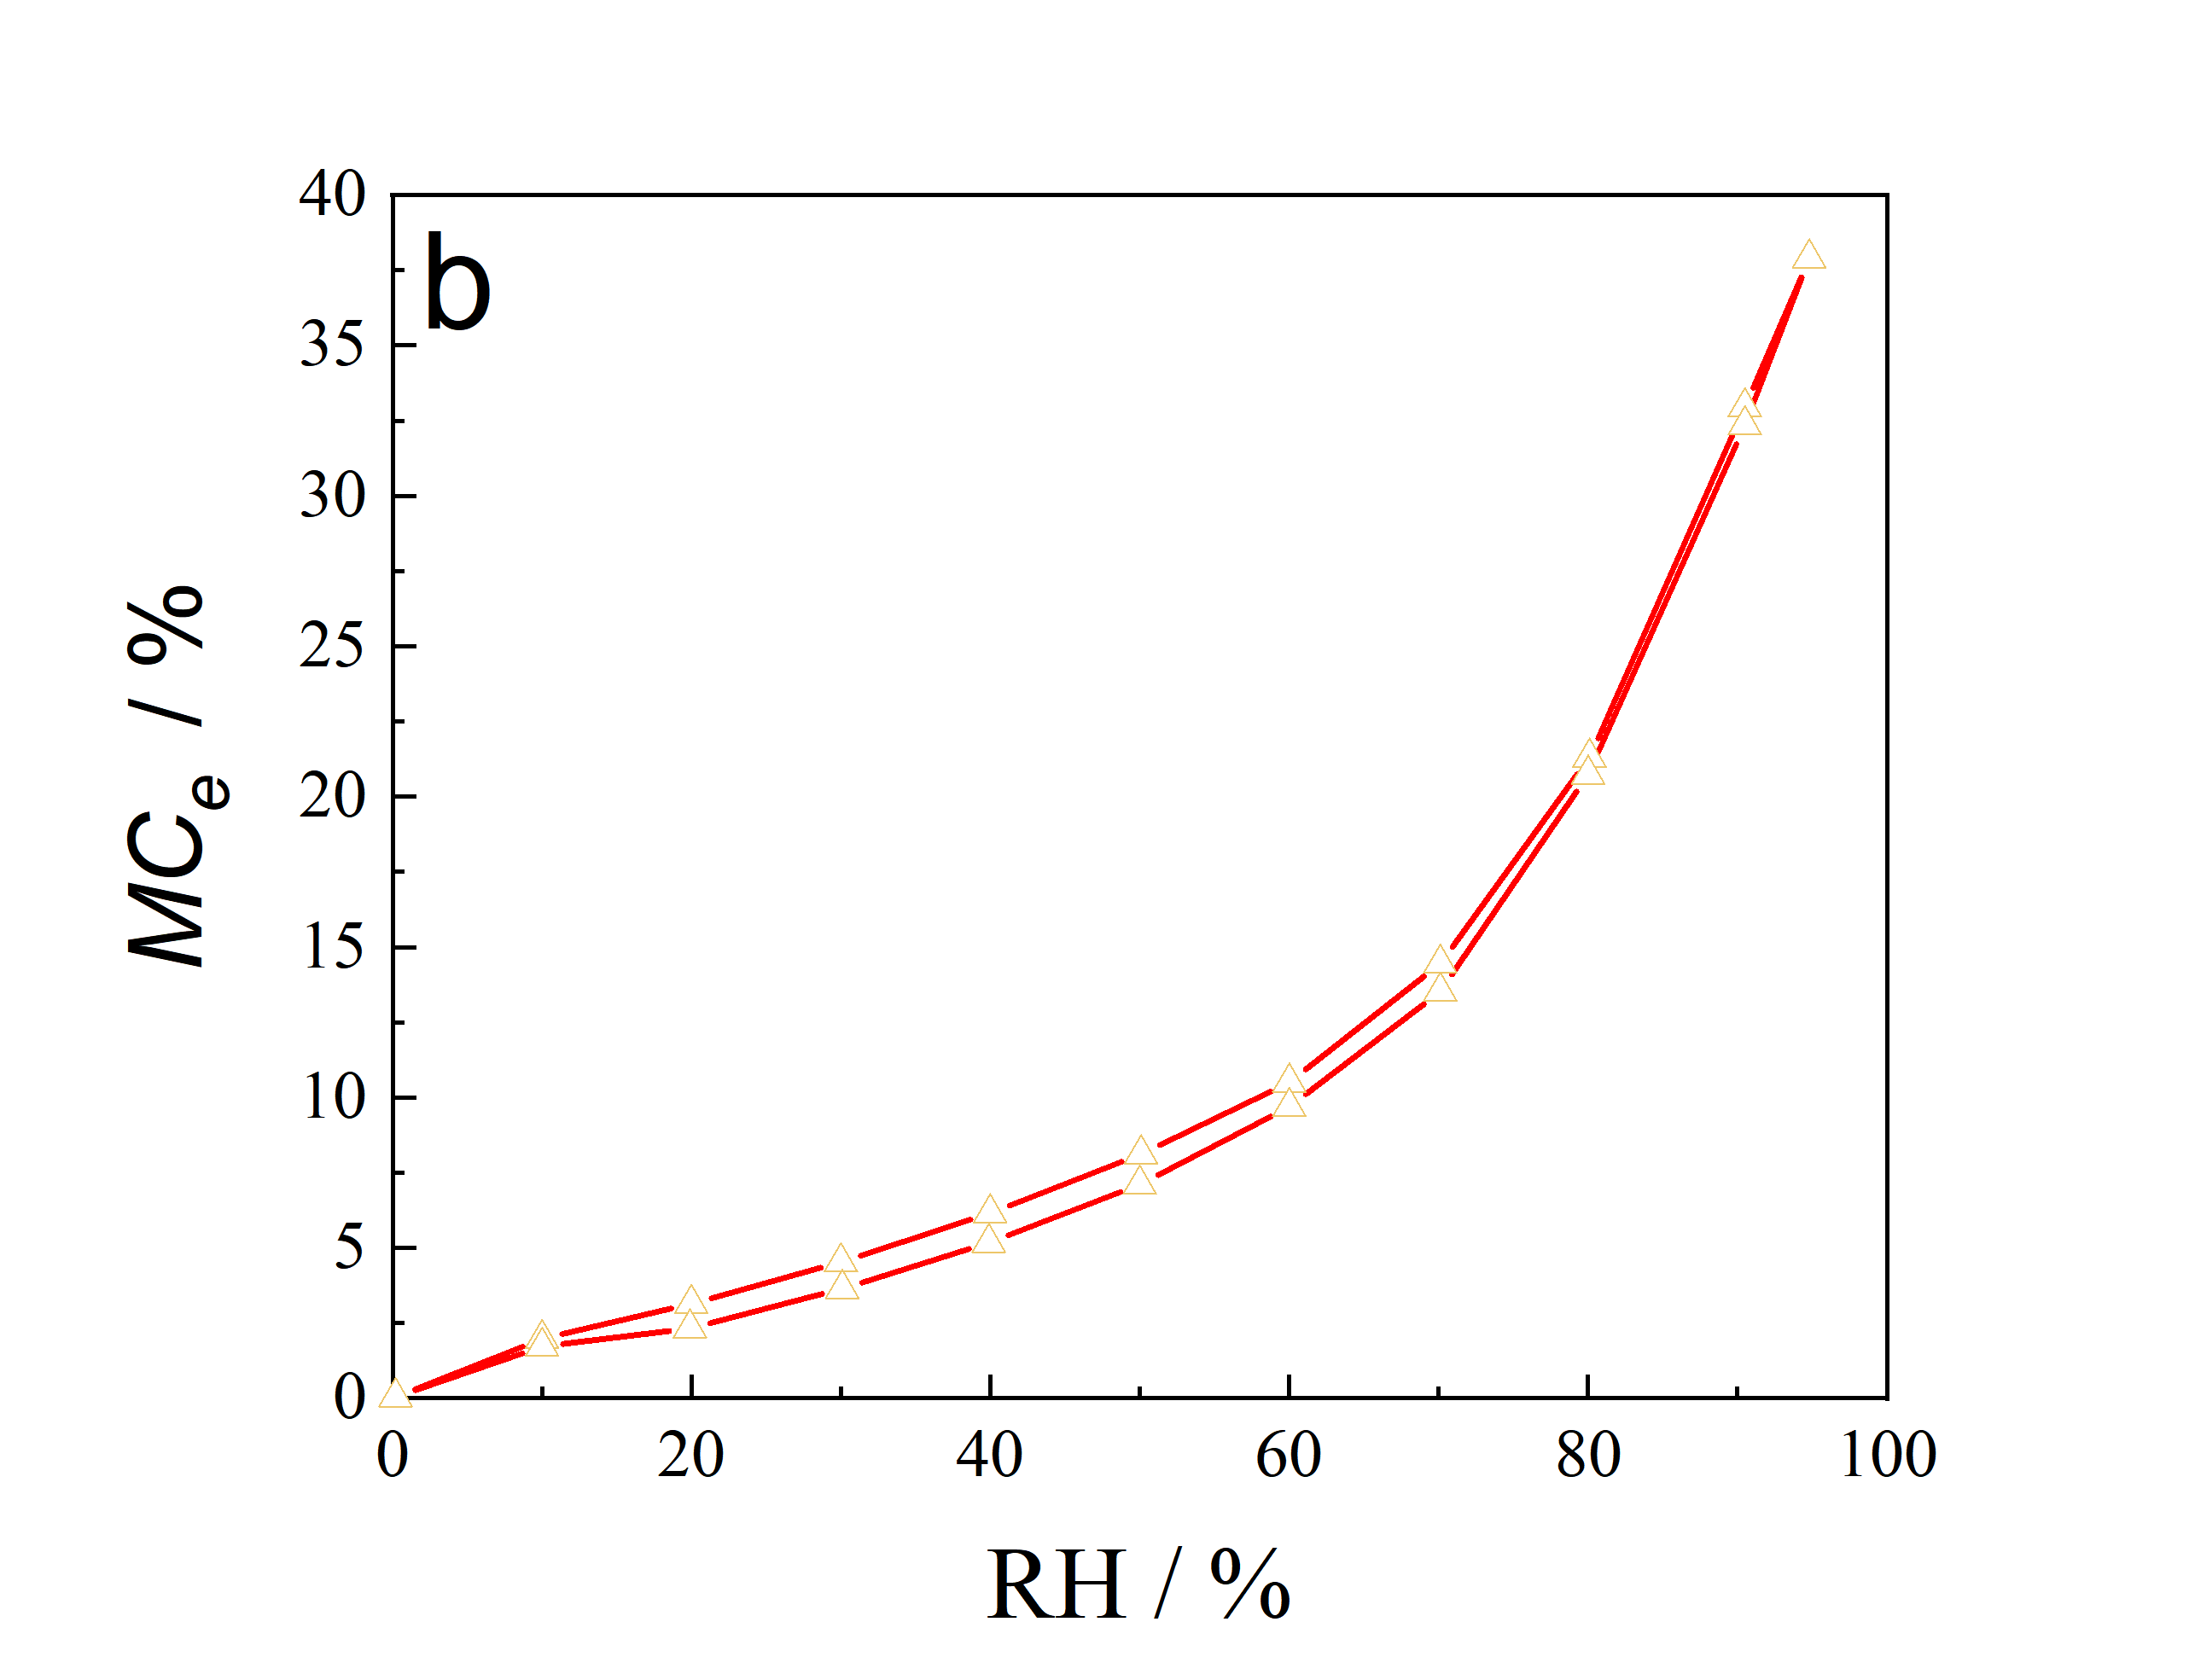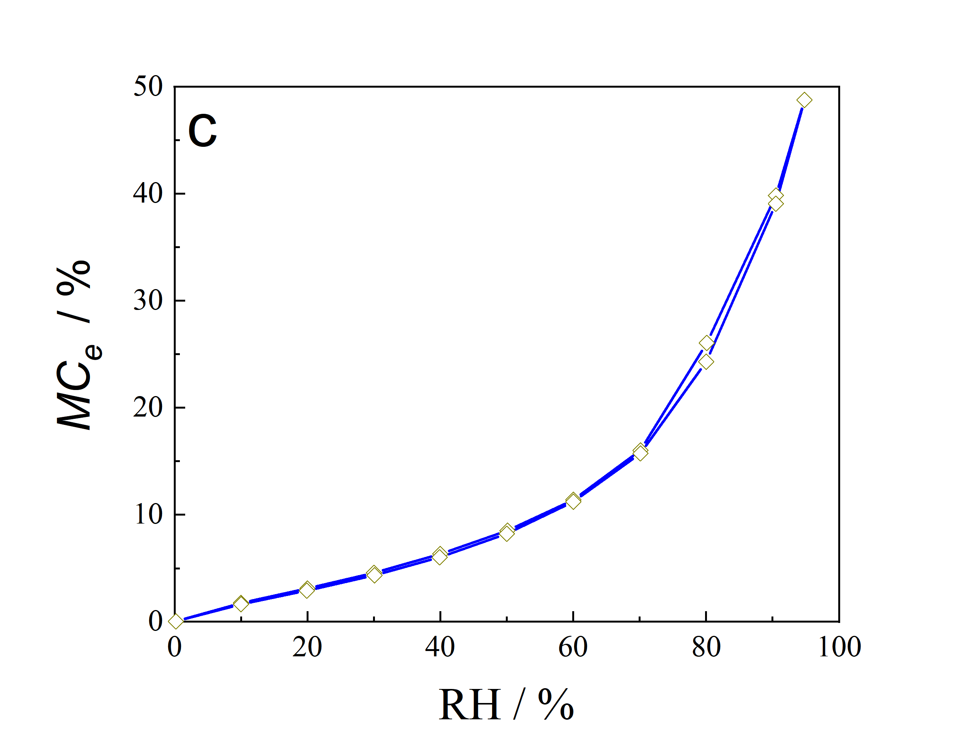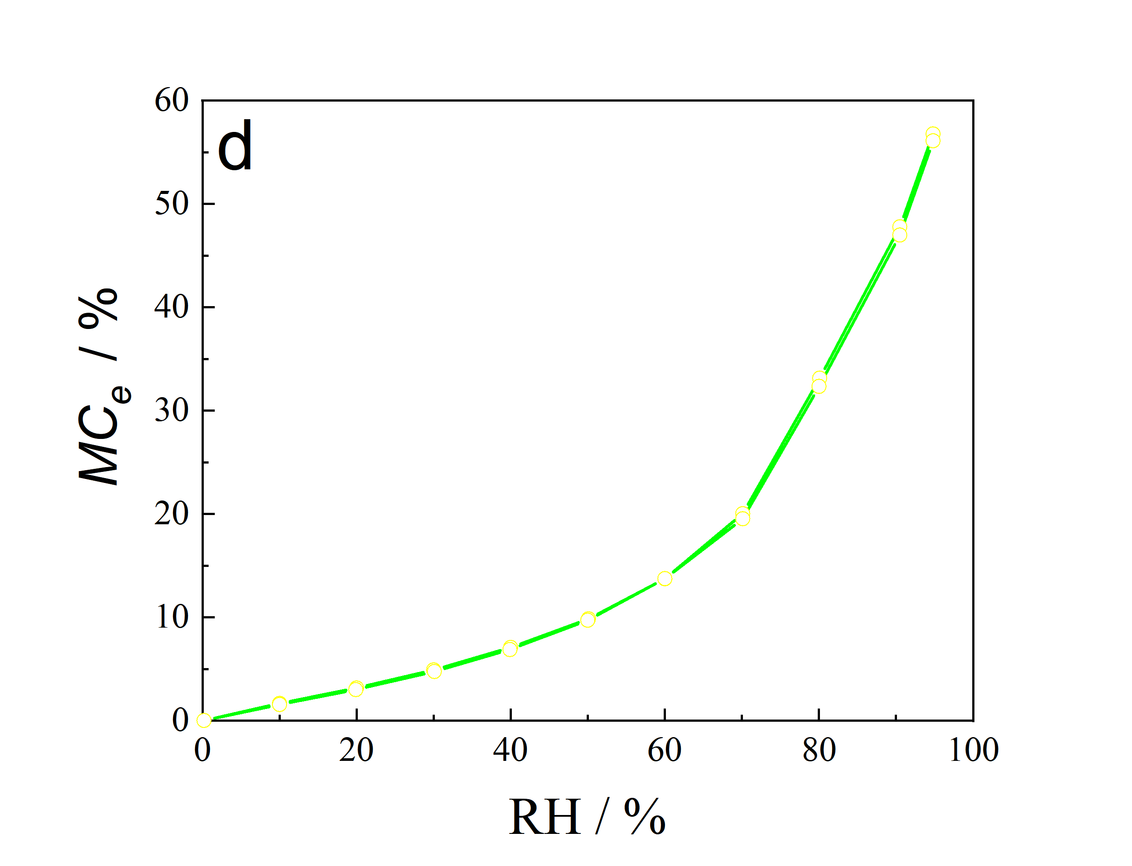
Fig. S1 Adsorption isotherms of the samples (a. ZZP0; b. ZZP1; c. ZZP2; d. ZZP3) at 0-95 % RH for the cycle of adsorption-desorption

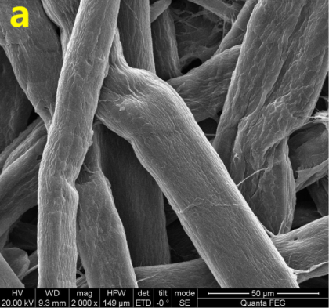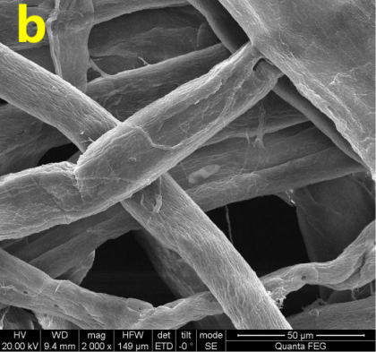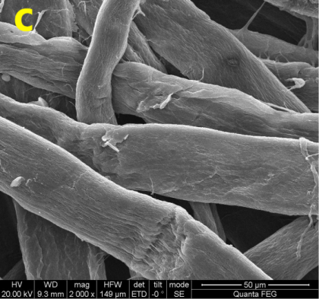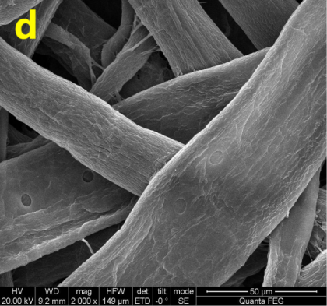
Fig. S2 SEM photograph of the samples (a) ZZP0, (b) ZZP1, (c) ZZP2, (d) ZZP3

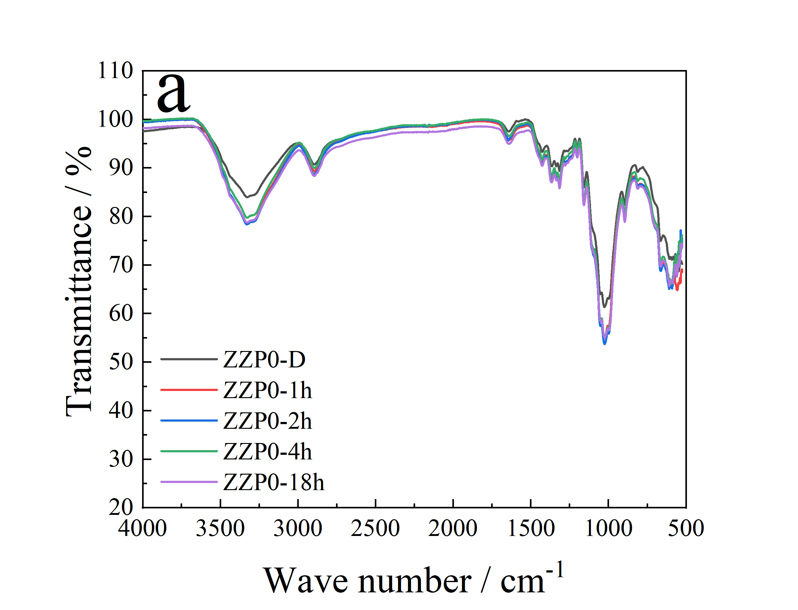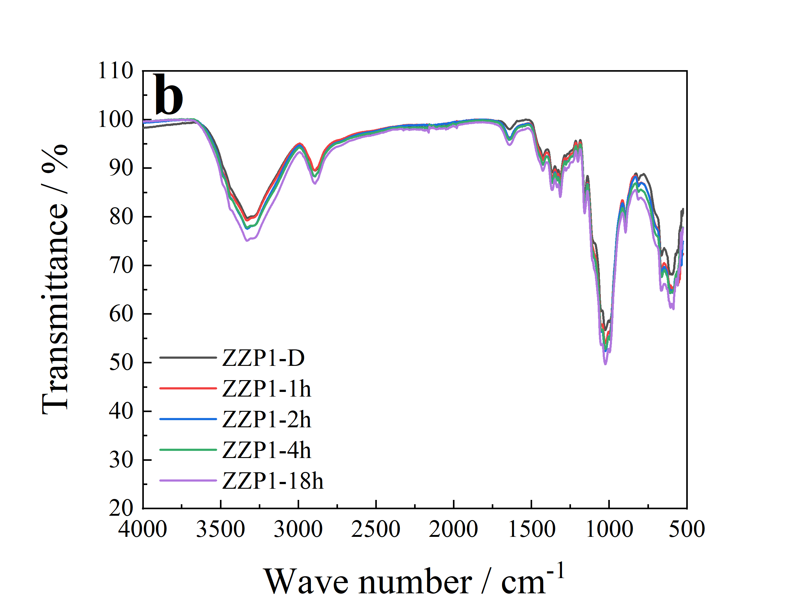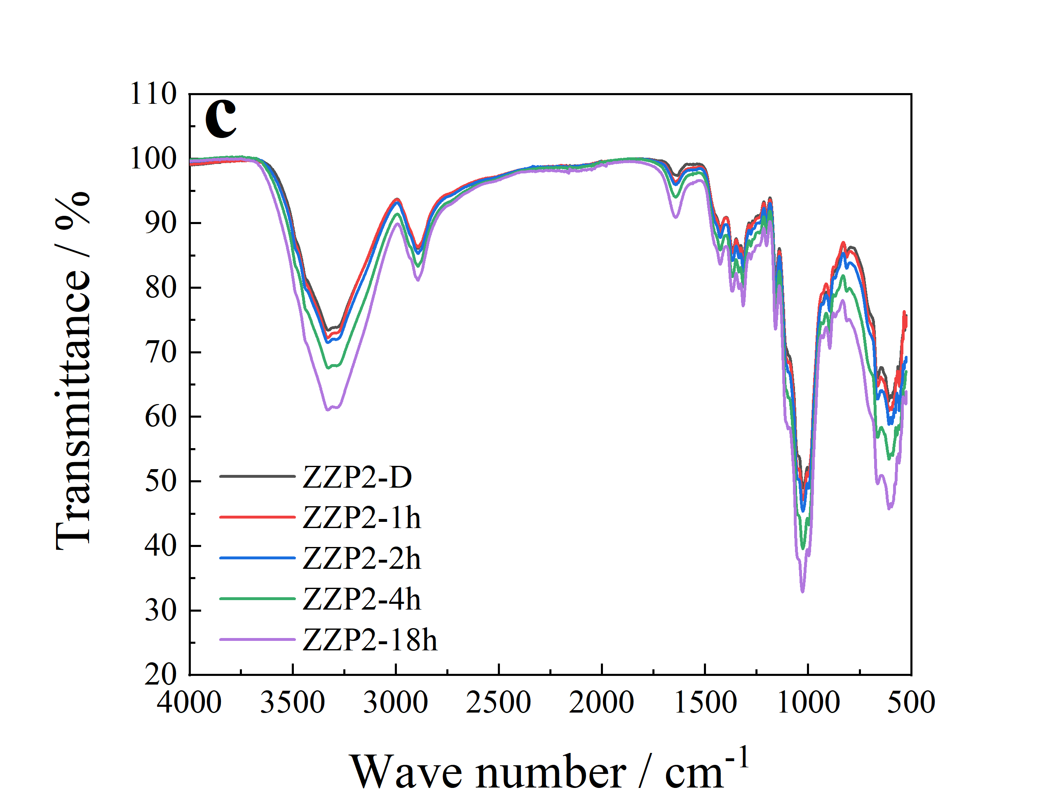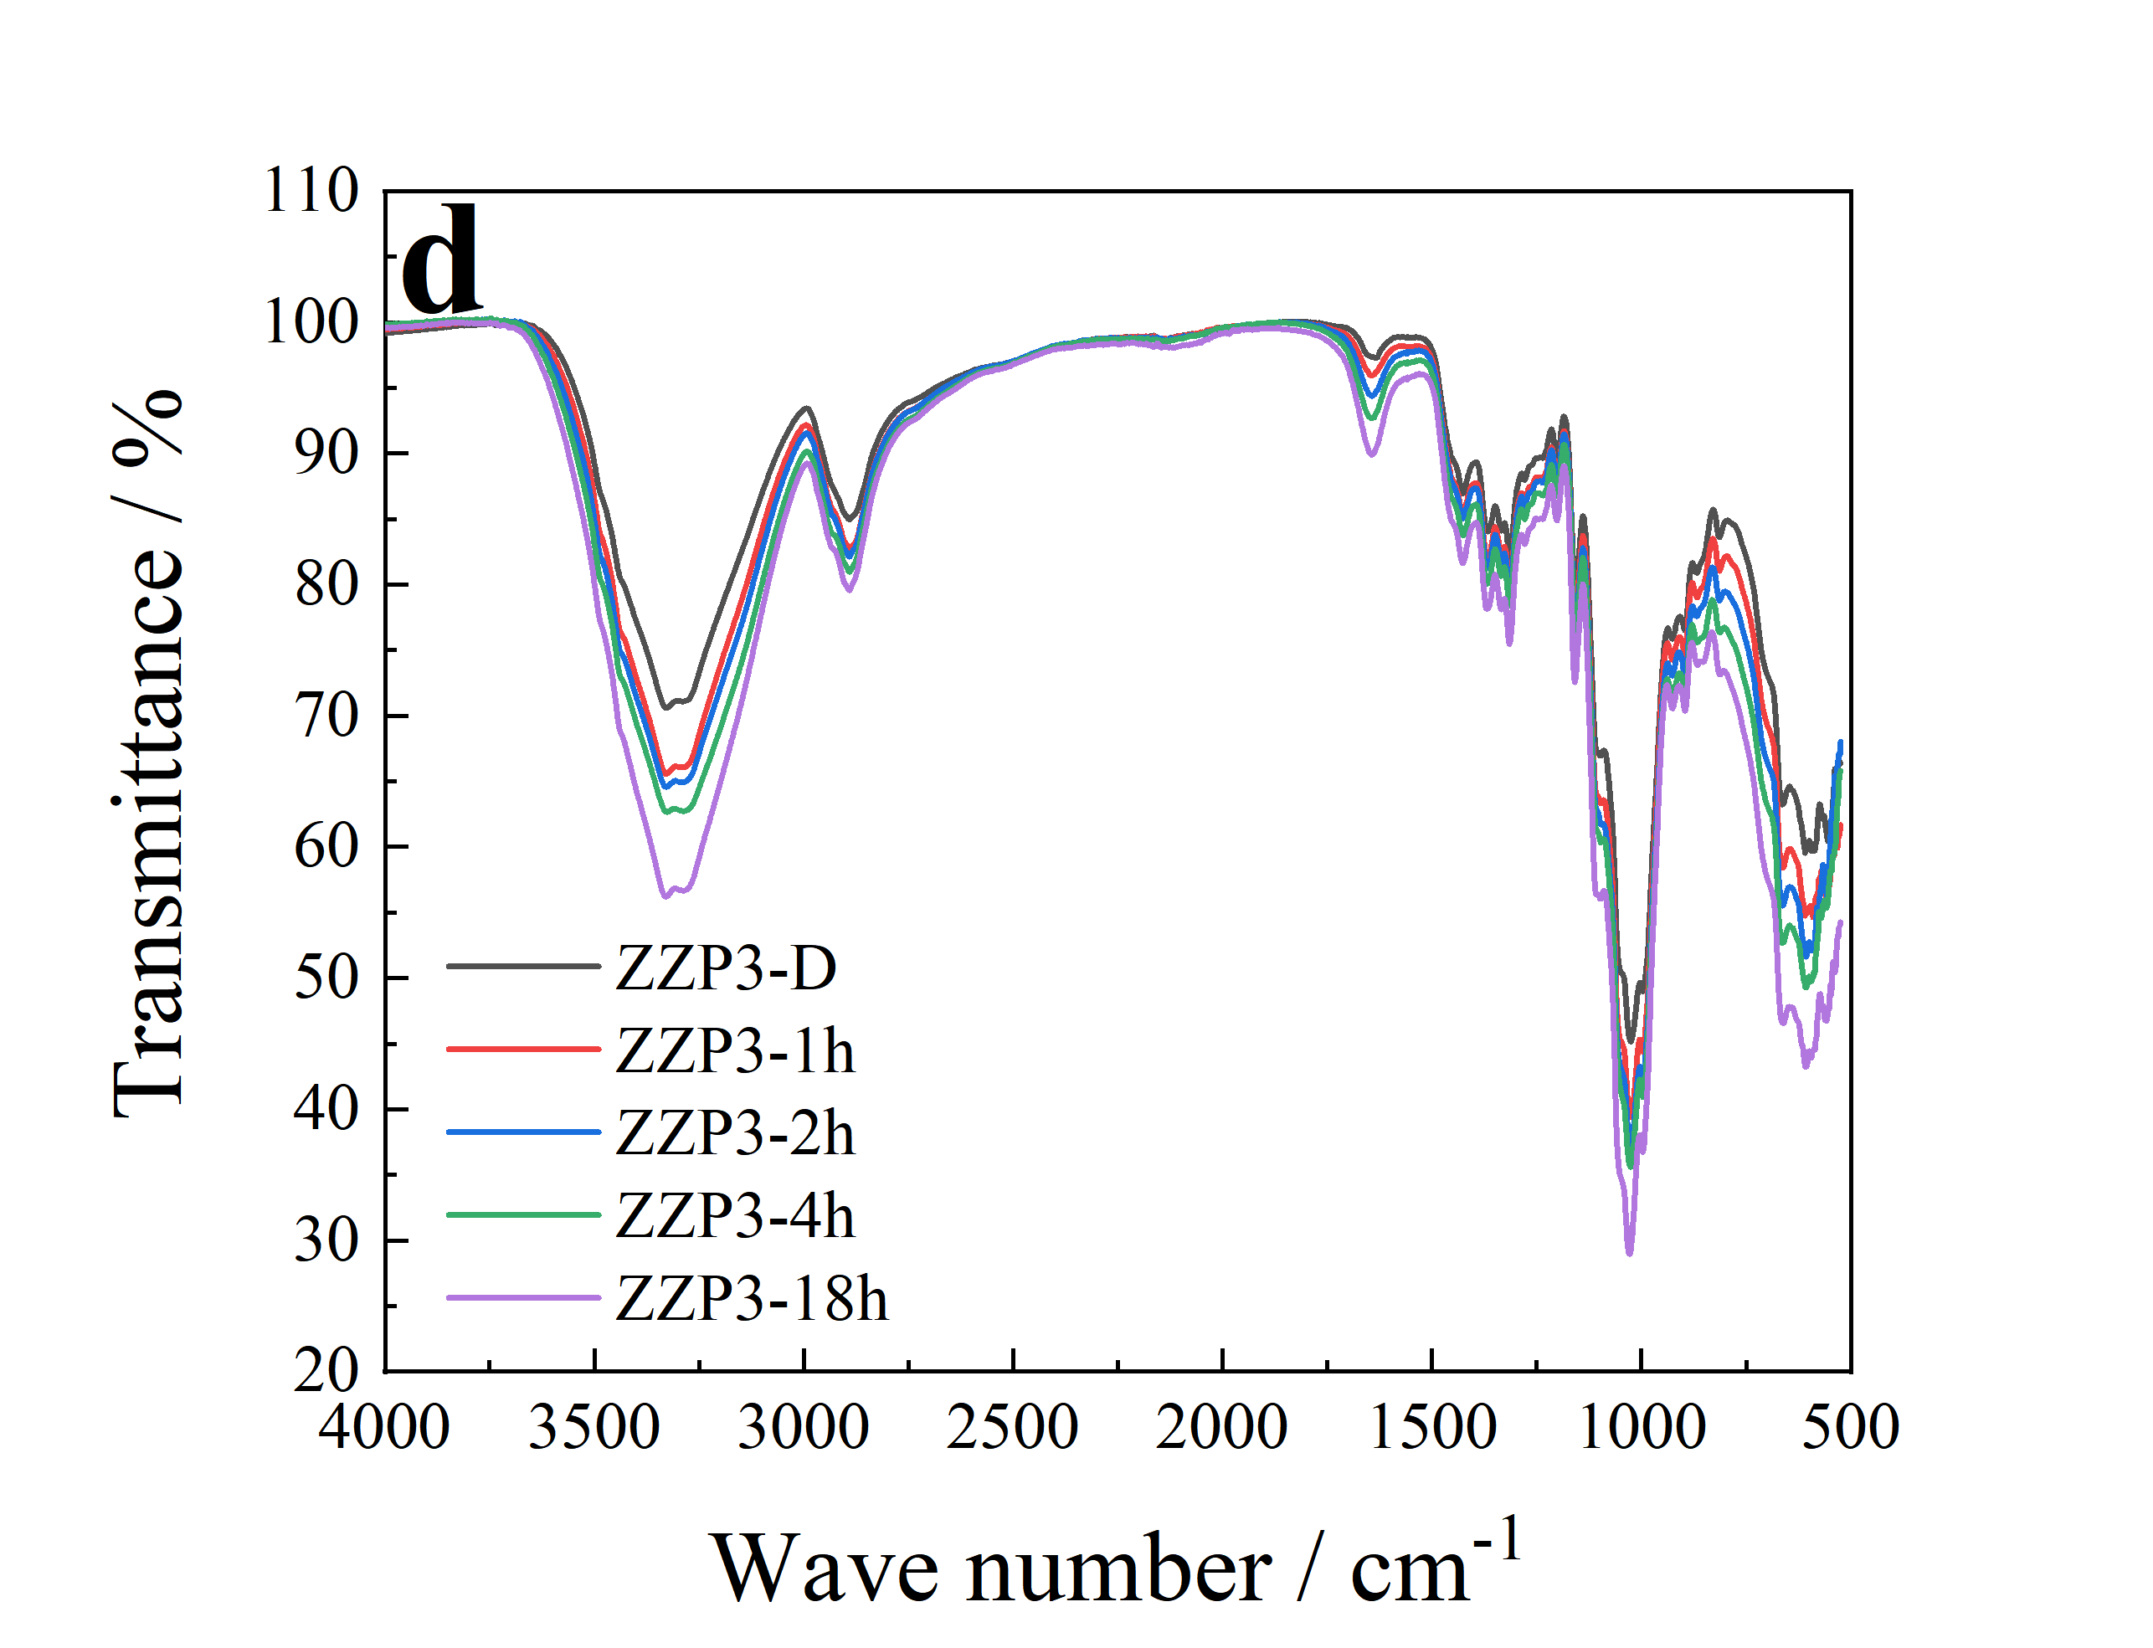
Fig. S3 IR spectra of hygroscopic samples: (a) ZZP0; (b) ZZP1; (c) ZZP2; (d) ZZP3

Table S1 Element content of the plant fiber samples
Element | Content /At%
Element | ZZP0 | ZZP1 | ZZP2 | ZZP3
C | 42.97 | 46.39 | 48.22 | 47.45
N | 14.17 | 4.98 | 4.61 | 4.11
O | 42.86 | 48.64 | 47.17 | 48.44

*Corresponding authors, https://orcid.org/0000-0001-8160-4866, E-mail address: zhongyaguo@126.com Phone numbers: +86-0371-67672972 Zhengzhou Tobacco Research Institute of CNTC, 450001, Zhengzhou, China Lili Fu, Ke Zhang, Mingjian Zhang, Le Wang, Yue Sun, Feng Huang, Shuang Wang, Qi Zhang, Bing Wang, Bin Li, Zhongya Guo China Tobacco Hebei Industrial Co. Ltd, 050051, Shijiazhuang, China Songjin Zheng China Tobacco Yunnan Industrial Co. Ltd, 650202, Kunming, China Ze Liu, Shanzhai Shang Guangzhou Institute of Energy Conversion, Chinese Academy of Sciences, 510640, Guangzhou,China Yan Cao

