Supplementary materials

FigureS1
Sample size and grouping information

FigureS2
Colloidal stability of PEG-CeNPs and normal CeNPs

FigureS3
Representative images of CD1632/Iba1 and CD206/Iba1 double immunostaining at 7 days post ICH. Scale bar: 100μm.

FigureS4
Representative images of CD1632/Iba1 and CD206/Iba1 double immunostaining at 21 days post ICH. Scale bar: 100μm.

FigureS5
Representative images of olig2 and CC1 double immunostaining at 3, 21 days post ICH. Scale bar: 100μm.

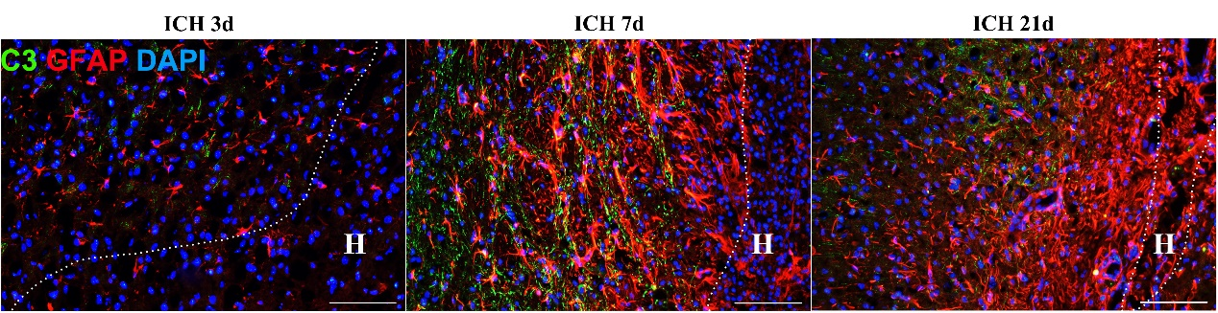
FigureS6
Representative images of GFAP and C3 double immunostaining in brain sections at 7 days post ICH. Scale bar: 100μm.

FigureS7
Representative images of GFAP and C3 double immunostaining in cultured astrocytes (control group). Scale bar: 50μm.

FigureS8
Representative images of NF-κB p65 and GFAP double immunostaining in cultured astrocytes (control group). Scale bar: 25μm.

