WB-DNMT1

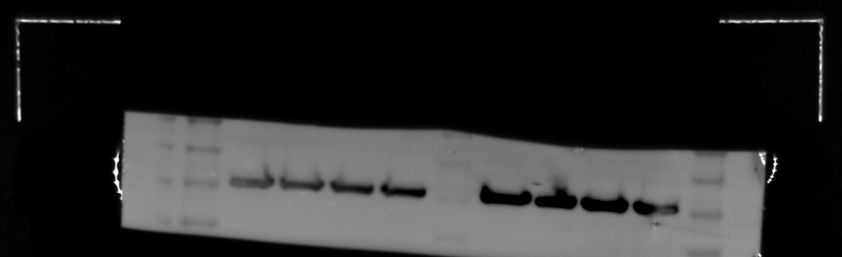
DNMT1 β-actin
