Supplementary Figures:
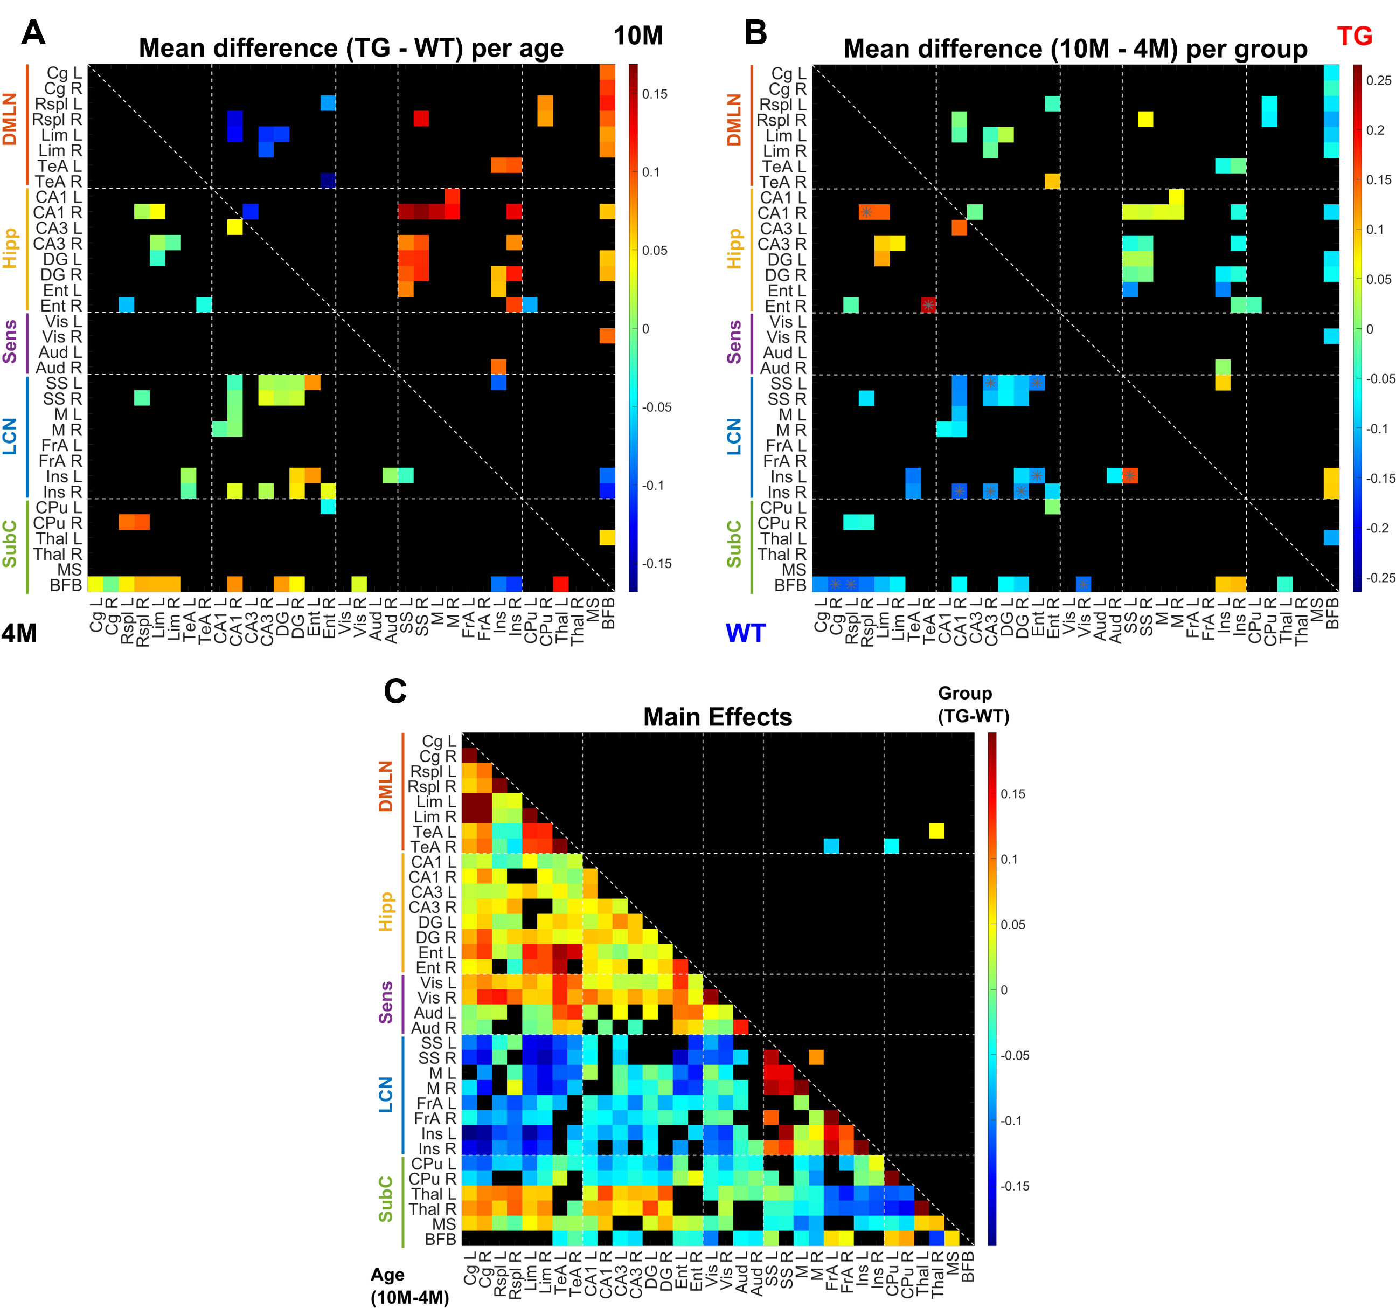
Supplementary Figure 1: A, B: Inter-genotype difference (A; 4M/10M: below/above the diagonal) and inter-age difference (B; WT/TG: below/above the diagonal) in FC for ROI-pairs that showed a significant genotype*age interaction effect (p < 0.05, repeated measures two-way ANOVA). C: Inter-age difference (below the diagonal) and inter-genotypic group difference (above the diagonal) in FC for ROI-pairs that showed a significant (p < 0.05, repeated measures two-way ANOVA) main effect of age and genotype respectively. Asterisk: p < 0.05, FDR corrected for all ROI pairs found to be significant for each effect.

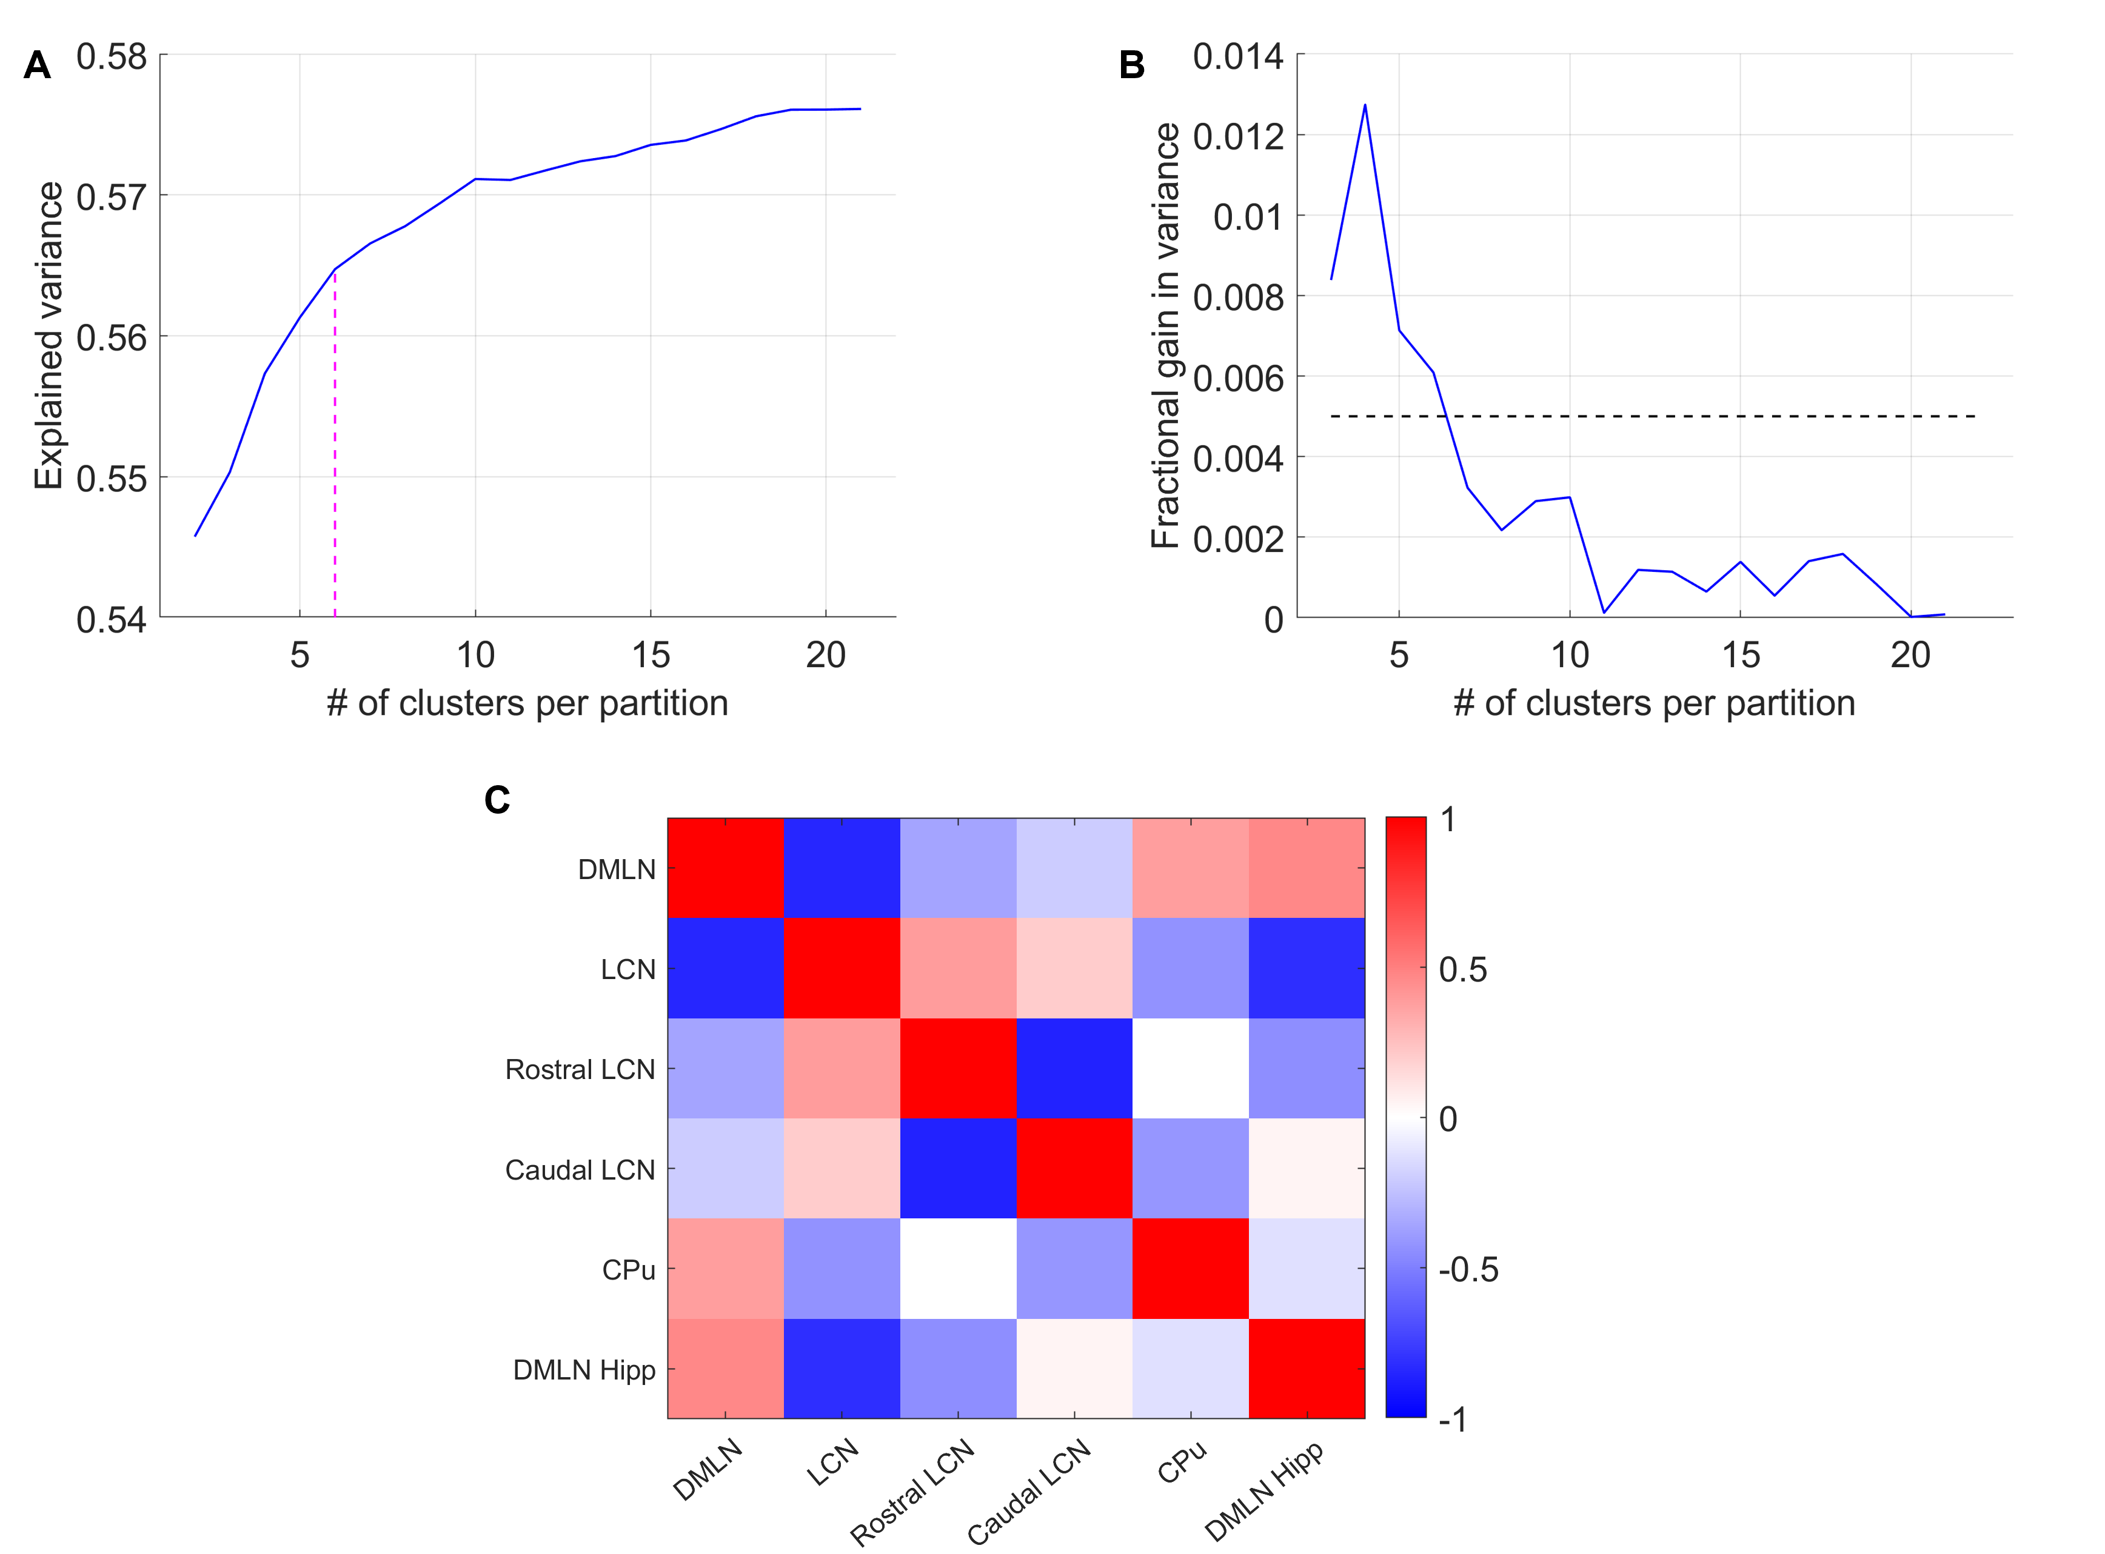
Supplementary Figure 2: A: Variance in the concatenated image-series explained by different numbers of clusters. Magenta vertical line shows the optimal number of clusters corresponding to the elbow point of this curve. B: Fractional gain in variance in going from k-1 to k clusters as a function of number of clusters. C: Pearson’s correlation between spatial patterns of every pair of CAPs shows the first four CAPs forming two anticorrelated pairs while the last two CAPs do not show high anticorrelation.

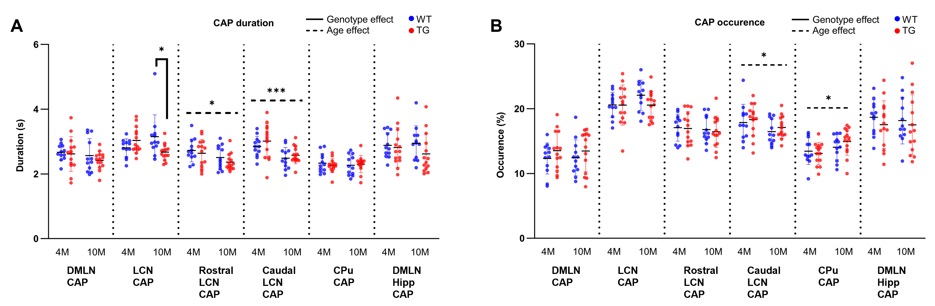
Supplementary Figure 3: Age, genotypic group, and interaction effects on CAP duration (A), and occurrence (B) using repeated measures two-way ANOVA followed by appropriate post-hoc comparisons. *: p < 0.05; ***: p < 0.001.

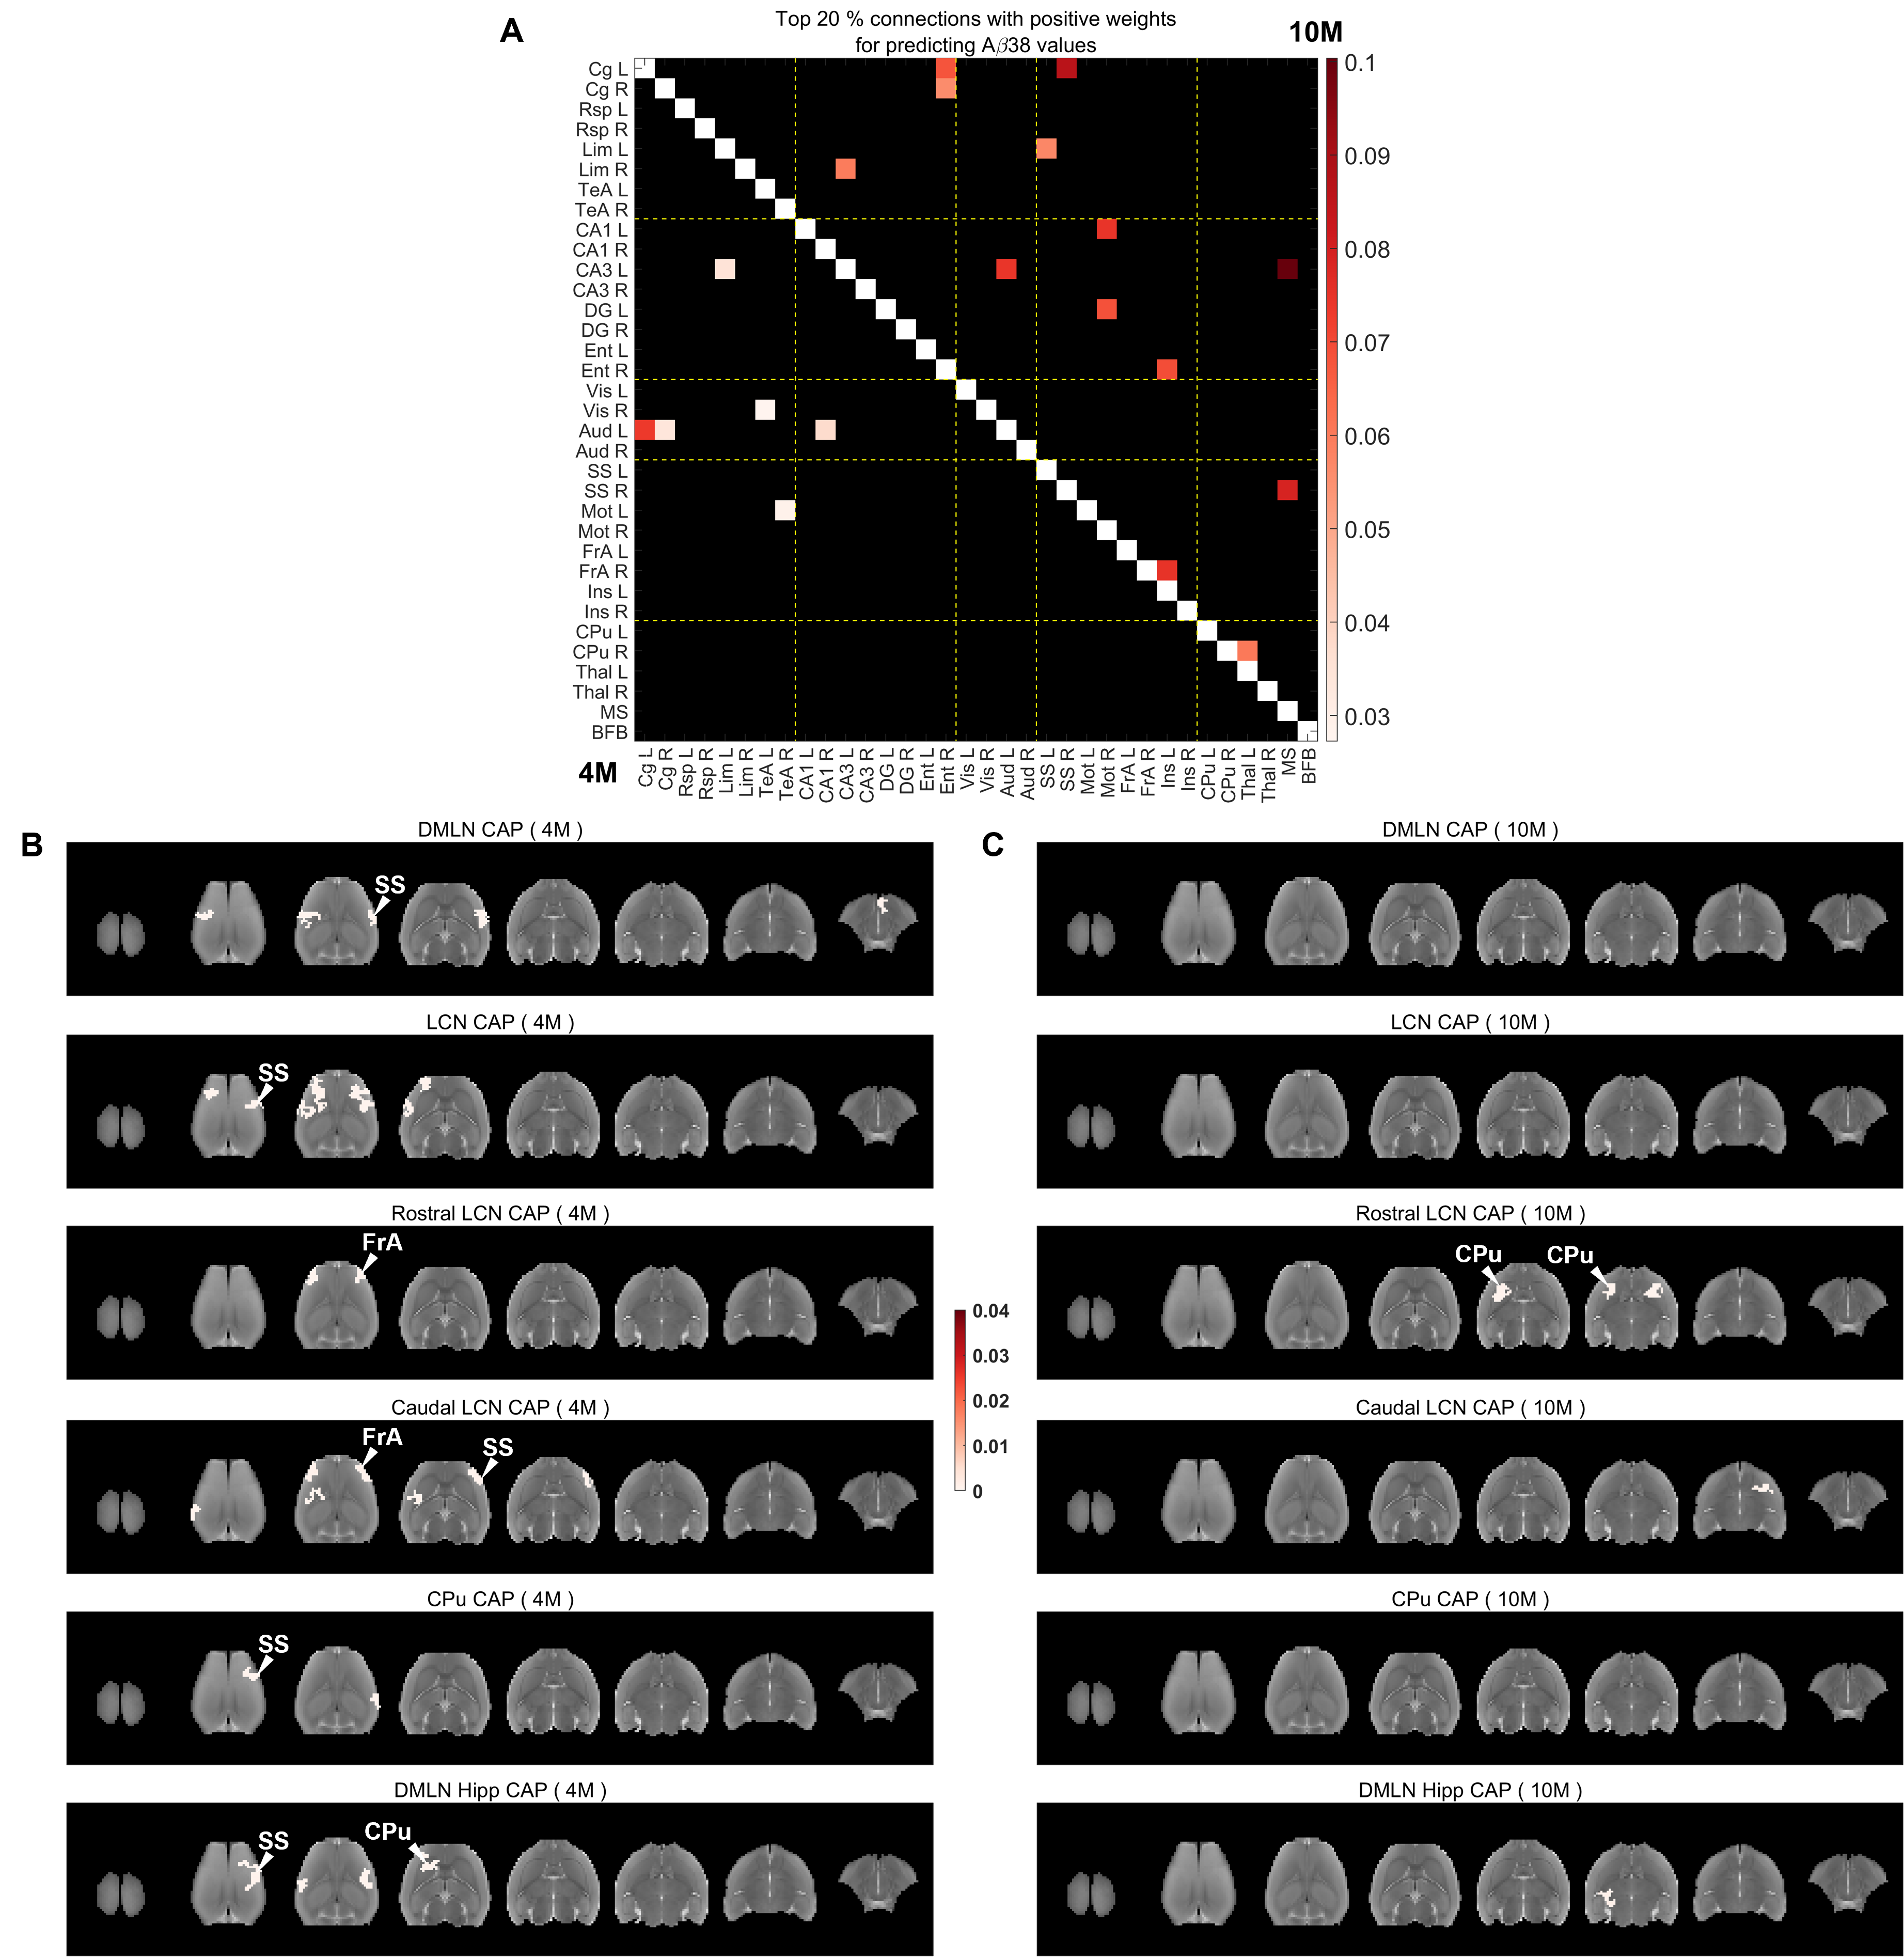
Supplementary Figure 4: Salient functional connections (A) and voxel-clusters (B-C) within CAPs with positive beta weights at pre-plaque and plaque stages that explain $Aβ38$ values in the TG animals. A: Top 20% highest positive beta weights of functional connections with significant 95% FWER-corrected confidence intervals at 4M (below the diagonal) and 10M (above the diagonal). B, C: Positive beta weights for salient clustered voxels (cluster-size: 20 voxels, in plane), for which FWER corrected 95% confidence intervals do not cross zero, in each CAP at 4M (B) and 10M (C).
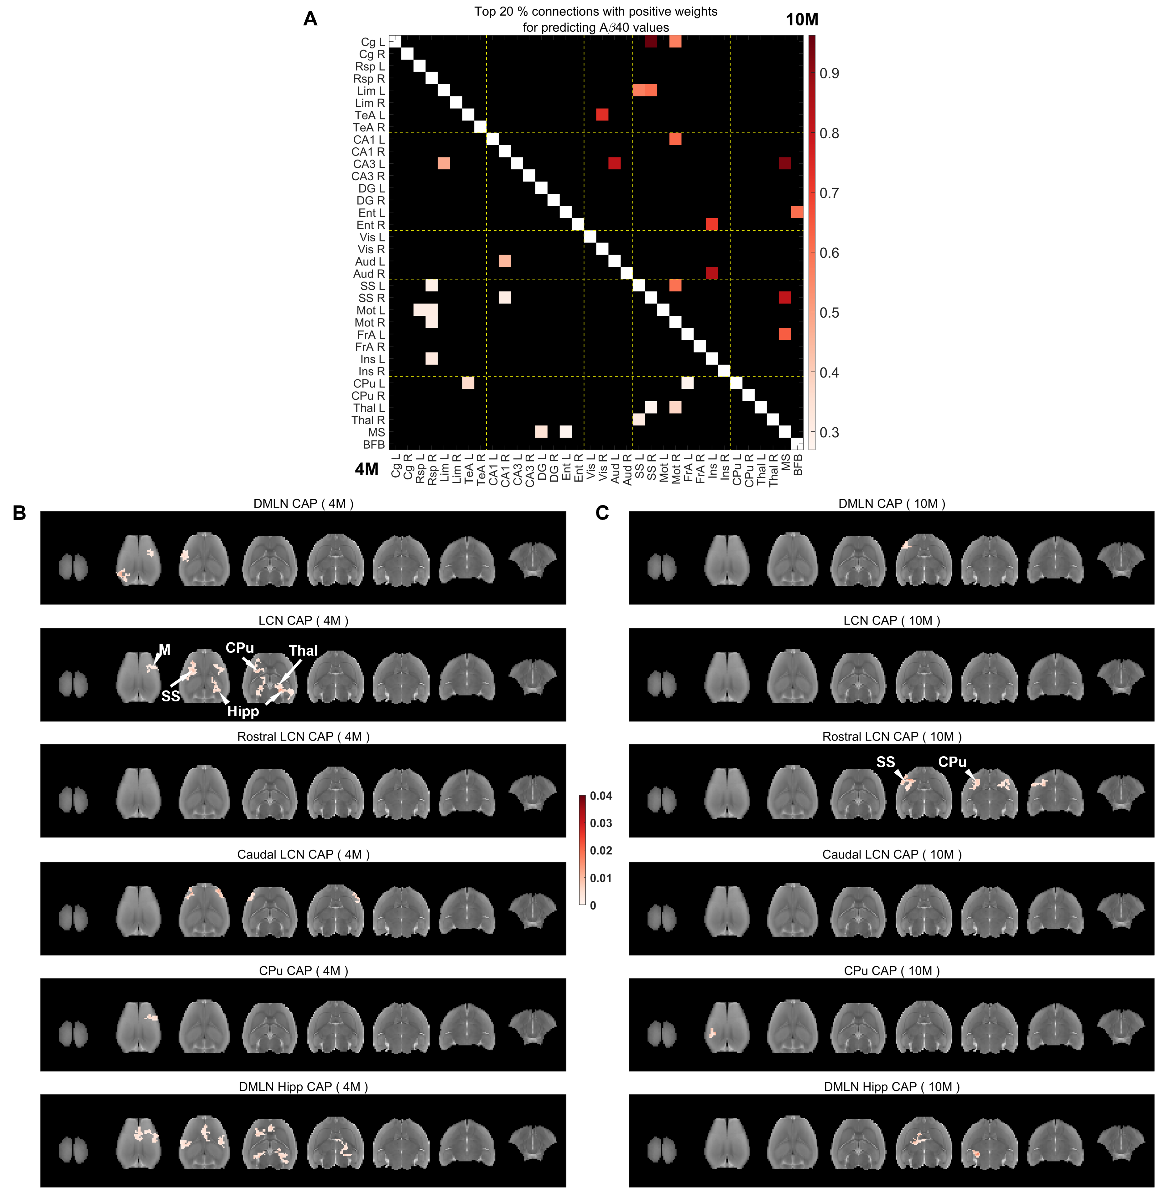
Supplementary Figure 5: Salient functional connections (A) and voxel-clusters (B-C) within CAPs with positive beta weights at pre-plaque and plaque stages that explain $Aβ40$ values in the TG animals. A: Top 20% highest positive beta weights of functional connections with significant 95% FWER-corrected confidence intervals at 4M (below the diagonal) and 10M (above the diagonal). B, C: Positive beta weights for salient clustered voxels (cluster-size: 20 voxels, in plane), for which FWER corrected 95% confidence intervals do not cross zero, in each CAP at 4M (B) and 10M (C).

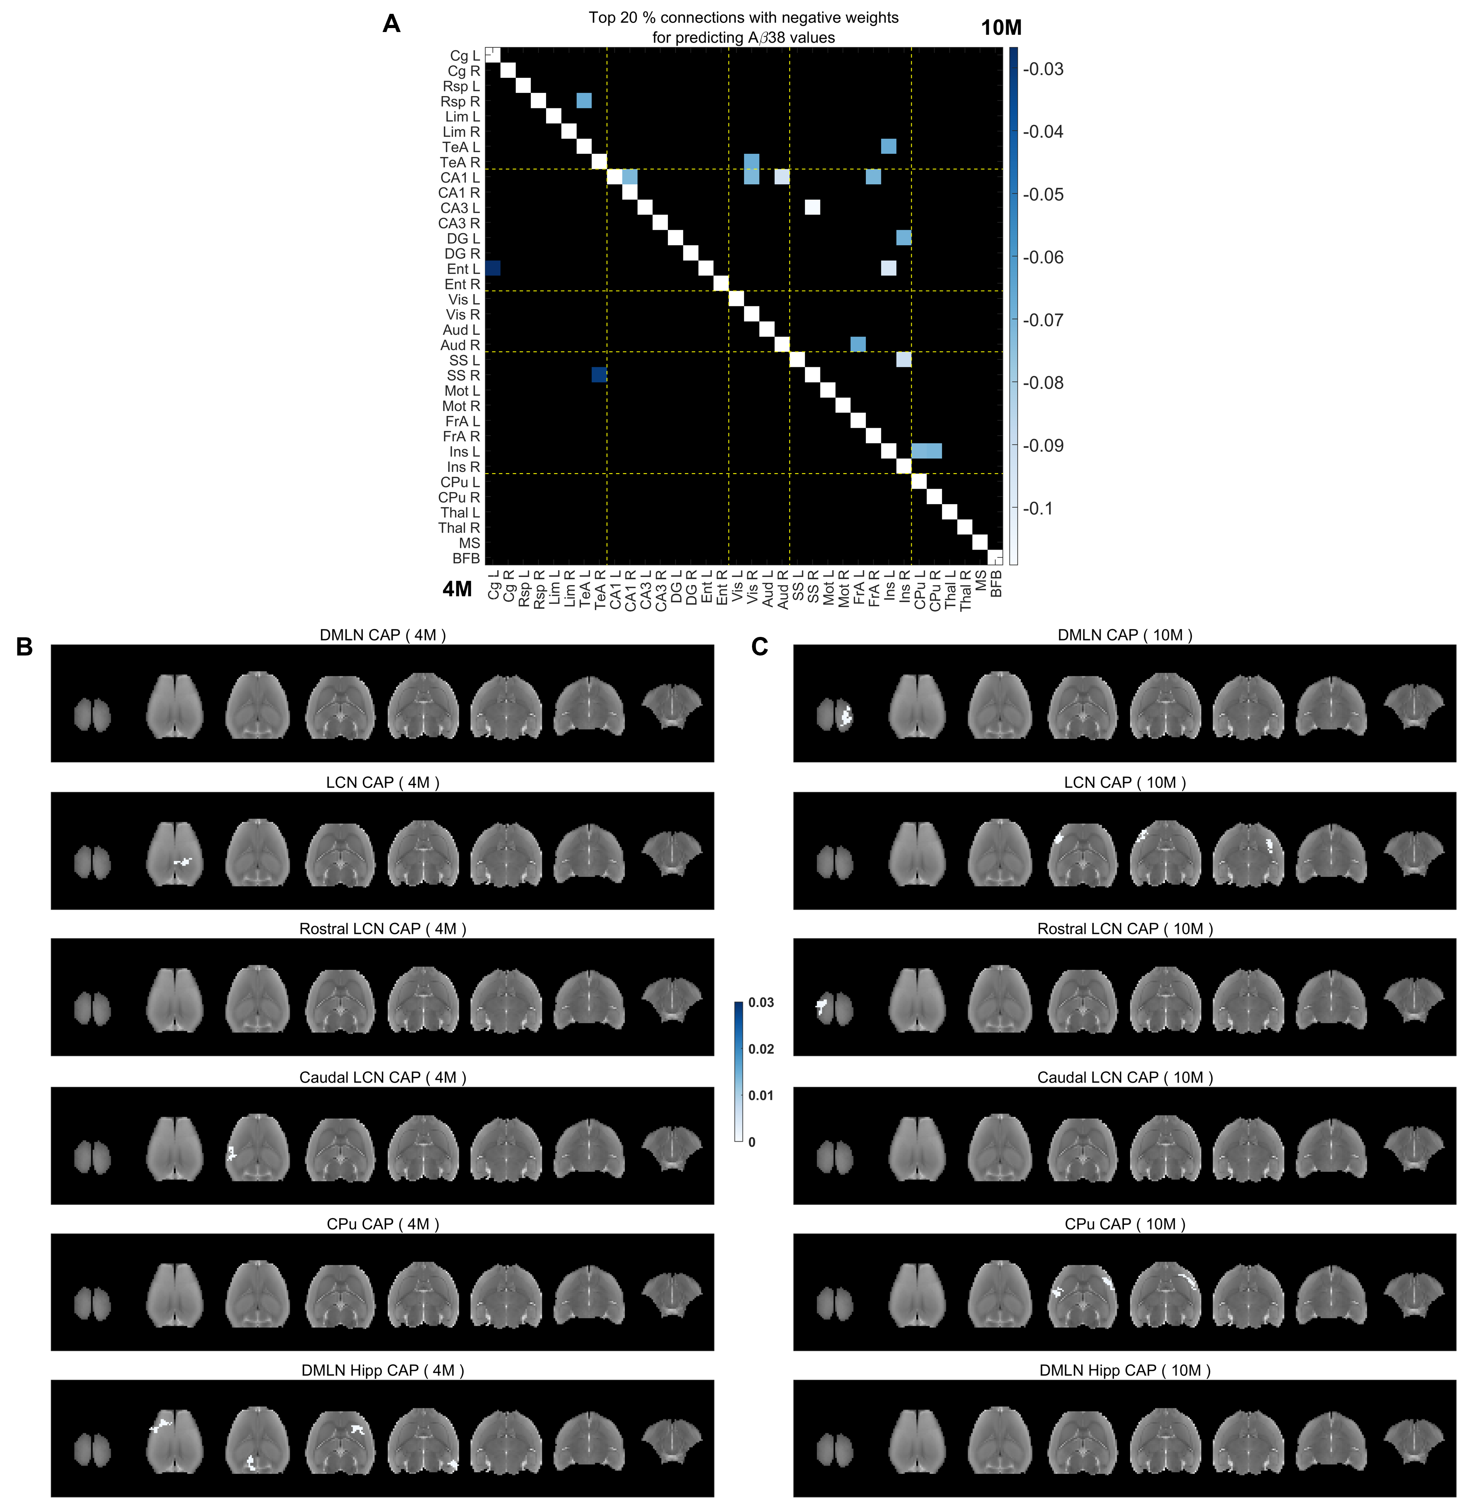
Supplementary Figure 6: Salient functional connections (A) and voxel-clusters (B-C) within CAPs with negative beta weights at pre-plaque and plaque stages that explain $Aβ38$ values in the TG animals. A: Top 20% highest negative beta weights of functional connections with significant 95% FWER-corrected confidence intervals at 4M (below the diagonal) and 10M (above the diagonal). B, C: Negative beta weights for salient clustered voxels (cluster-size: 20 voxels, in plane), for which FWER corrected 95% confidence intervals do not cross zero, in each CAP at 4M (B) and 10M (C).

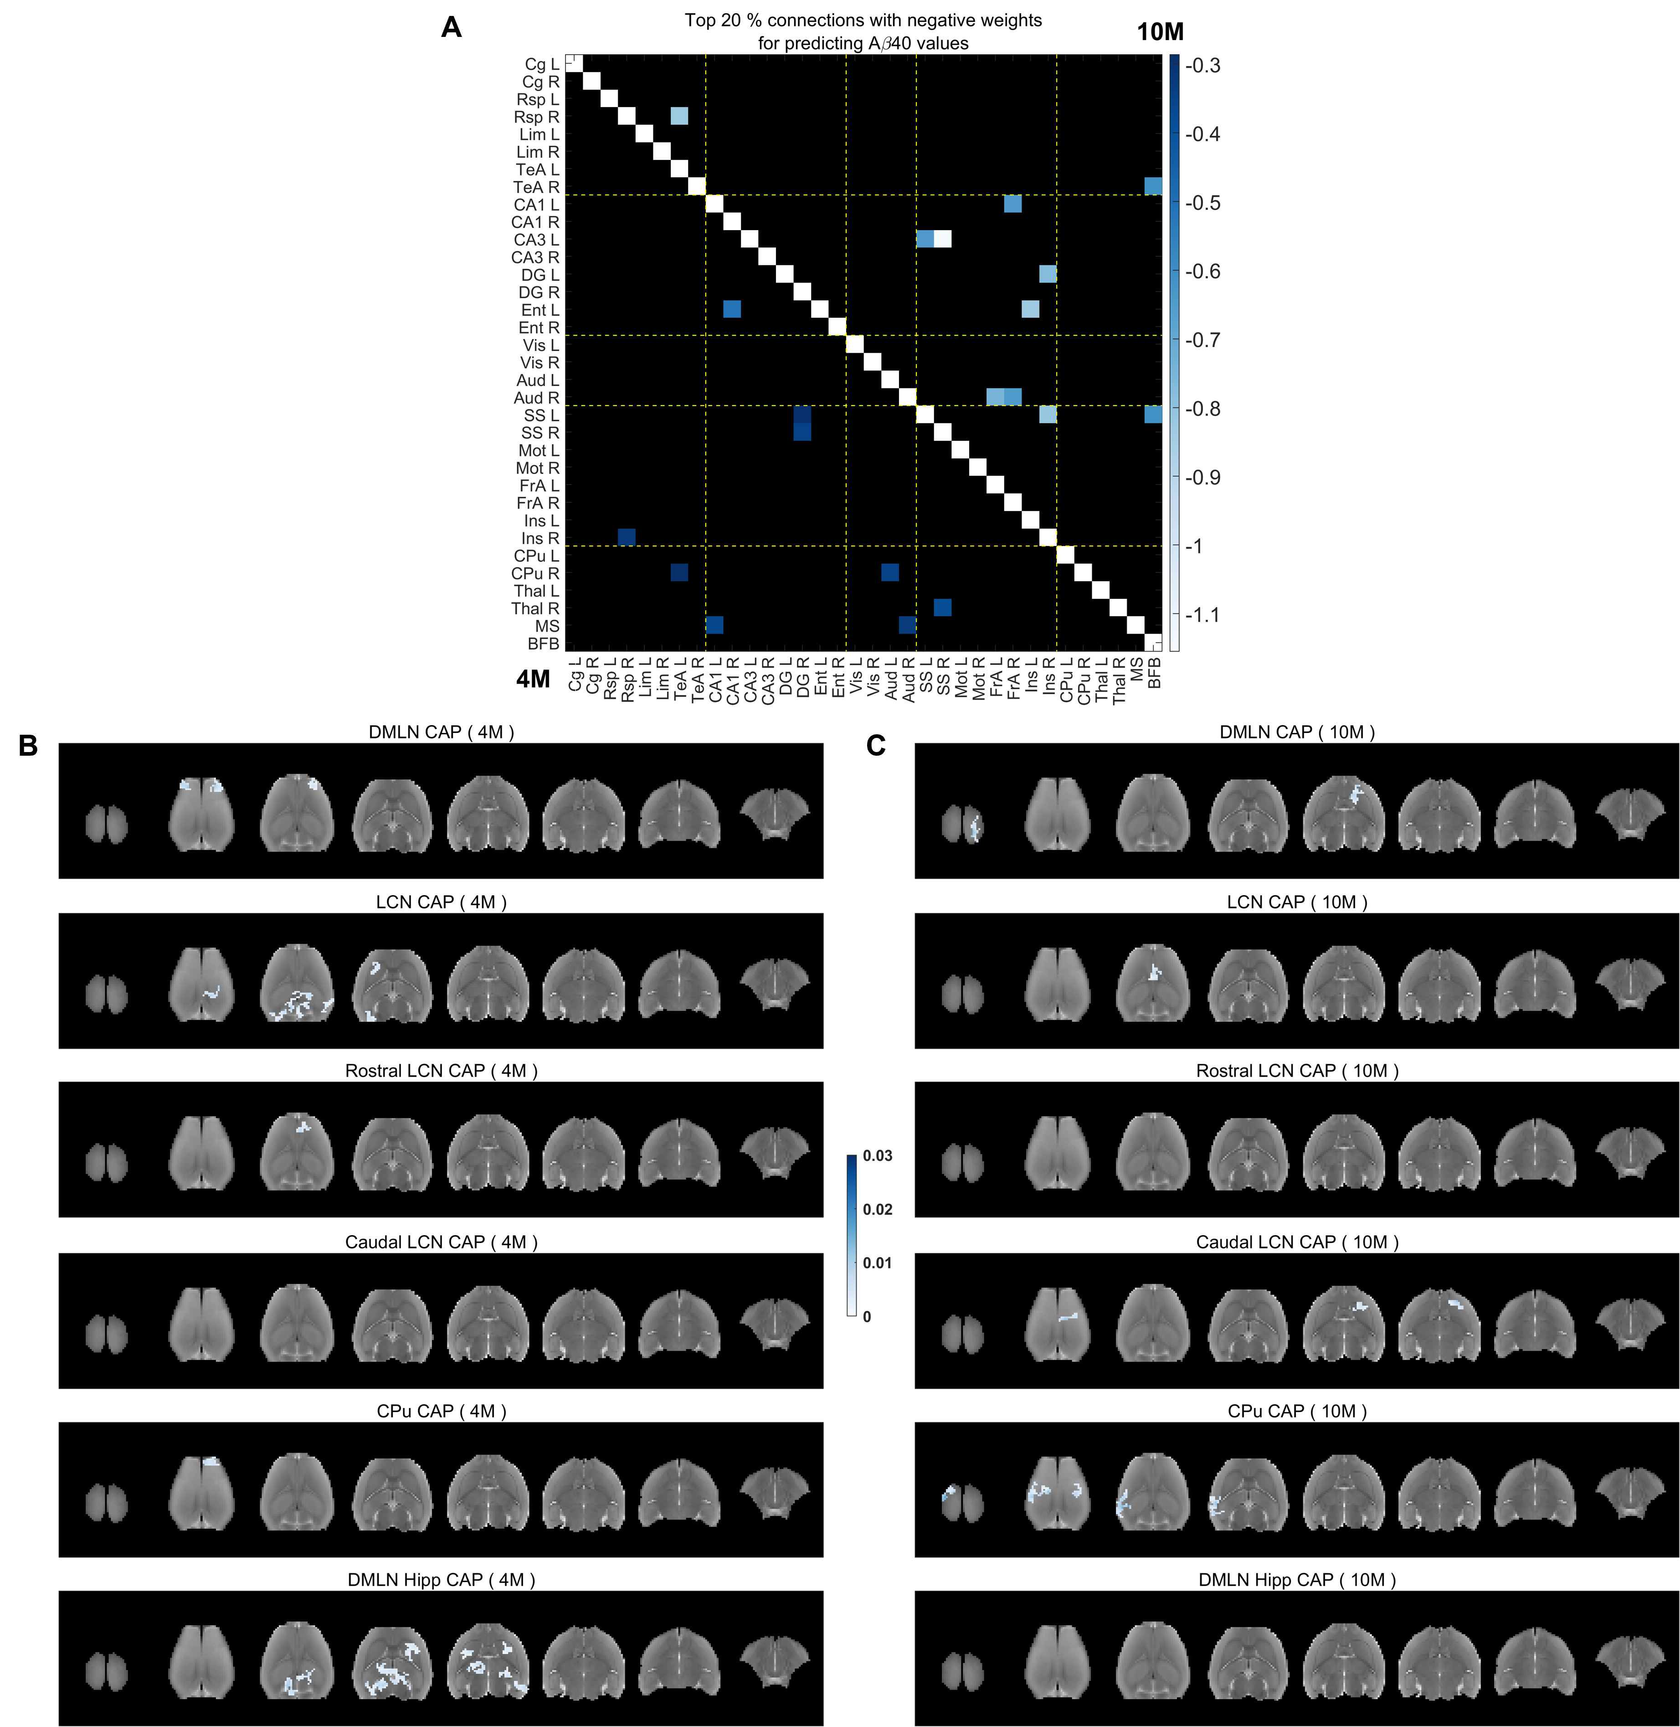
Supplementary Figure 7: Salient functional connections (A) and voxel-clusters (B-C) within CAPs with negative beta weights at pre-plaque and plaque stages that explain $Aβ40$ values in the TG animals. A: Top 20% highest negative beta weights of functional connections with significant 95% FWER-corrected confidence intervals at 4M (below the diagonal) and 10M (above the diagonal). B, C: Negative beta weights for salient clustered voxels (cluster-size: 20 voxels, in plane), for which FWER corrected 95% confidence intervals do not cross zero, in each CAP at 4M (B) and 10M (C).
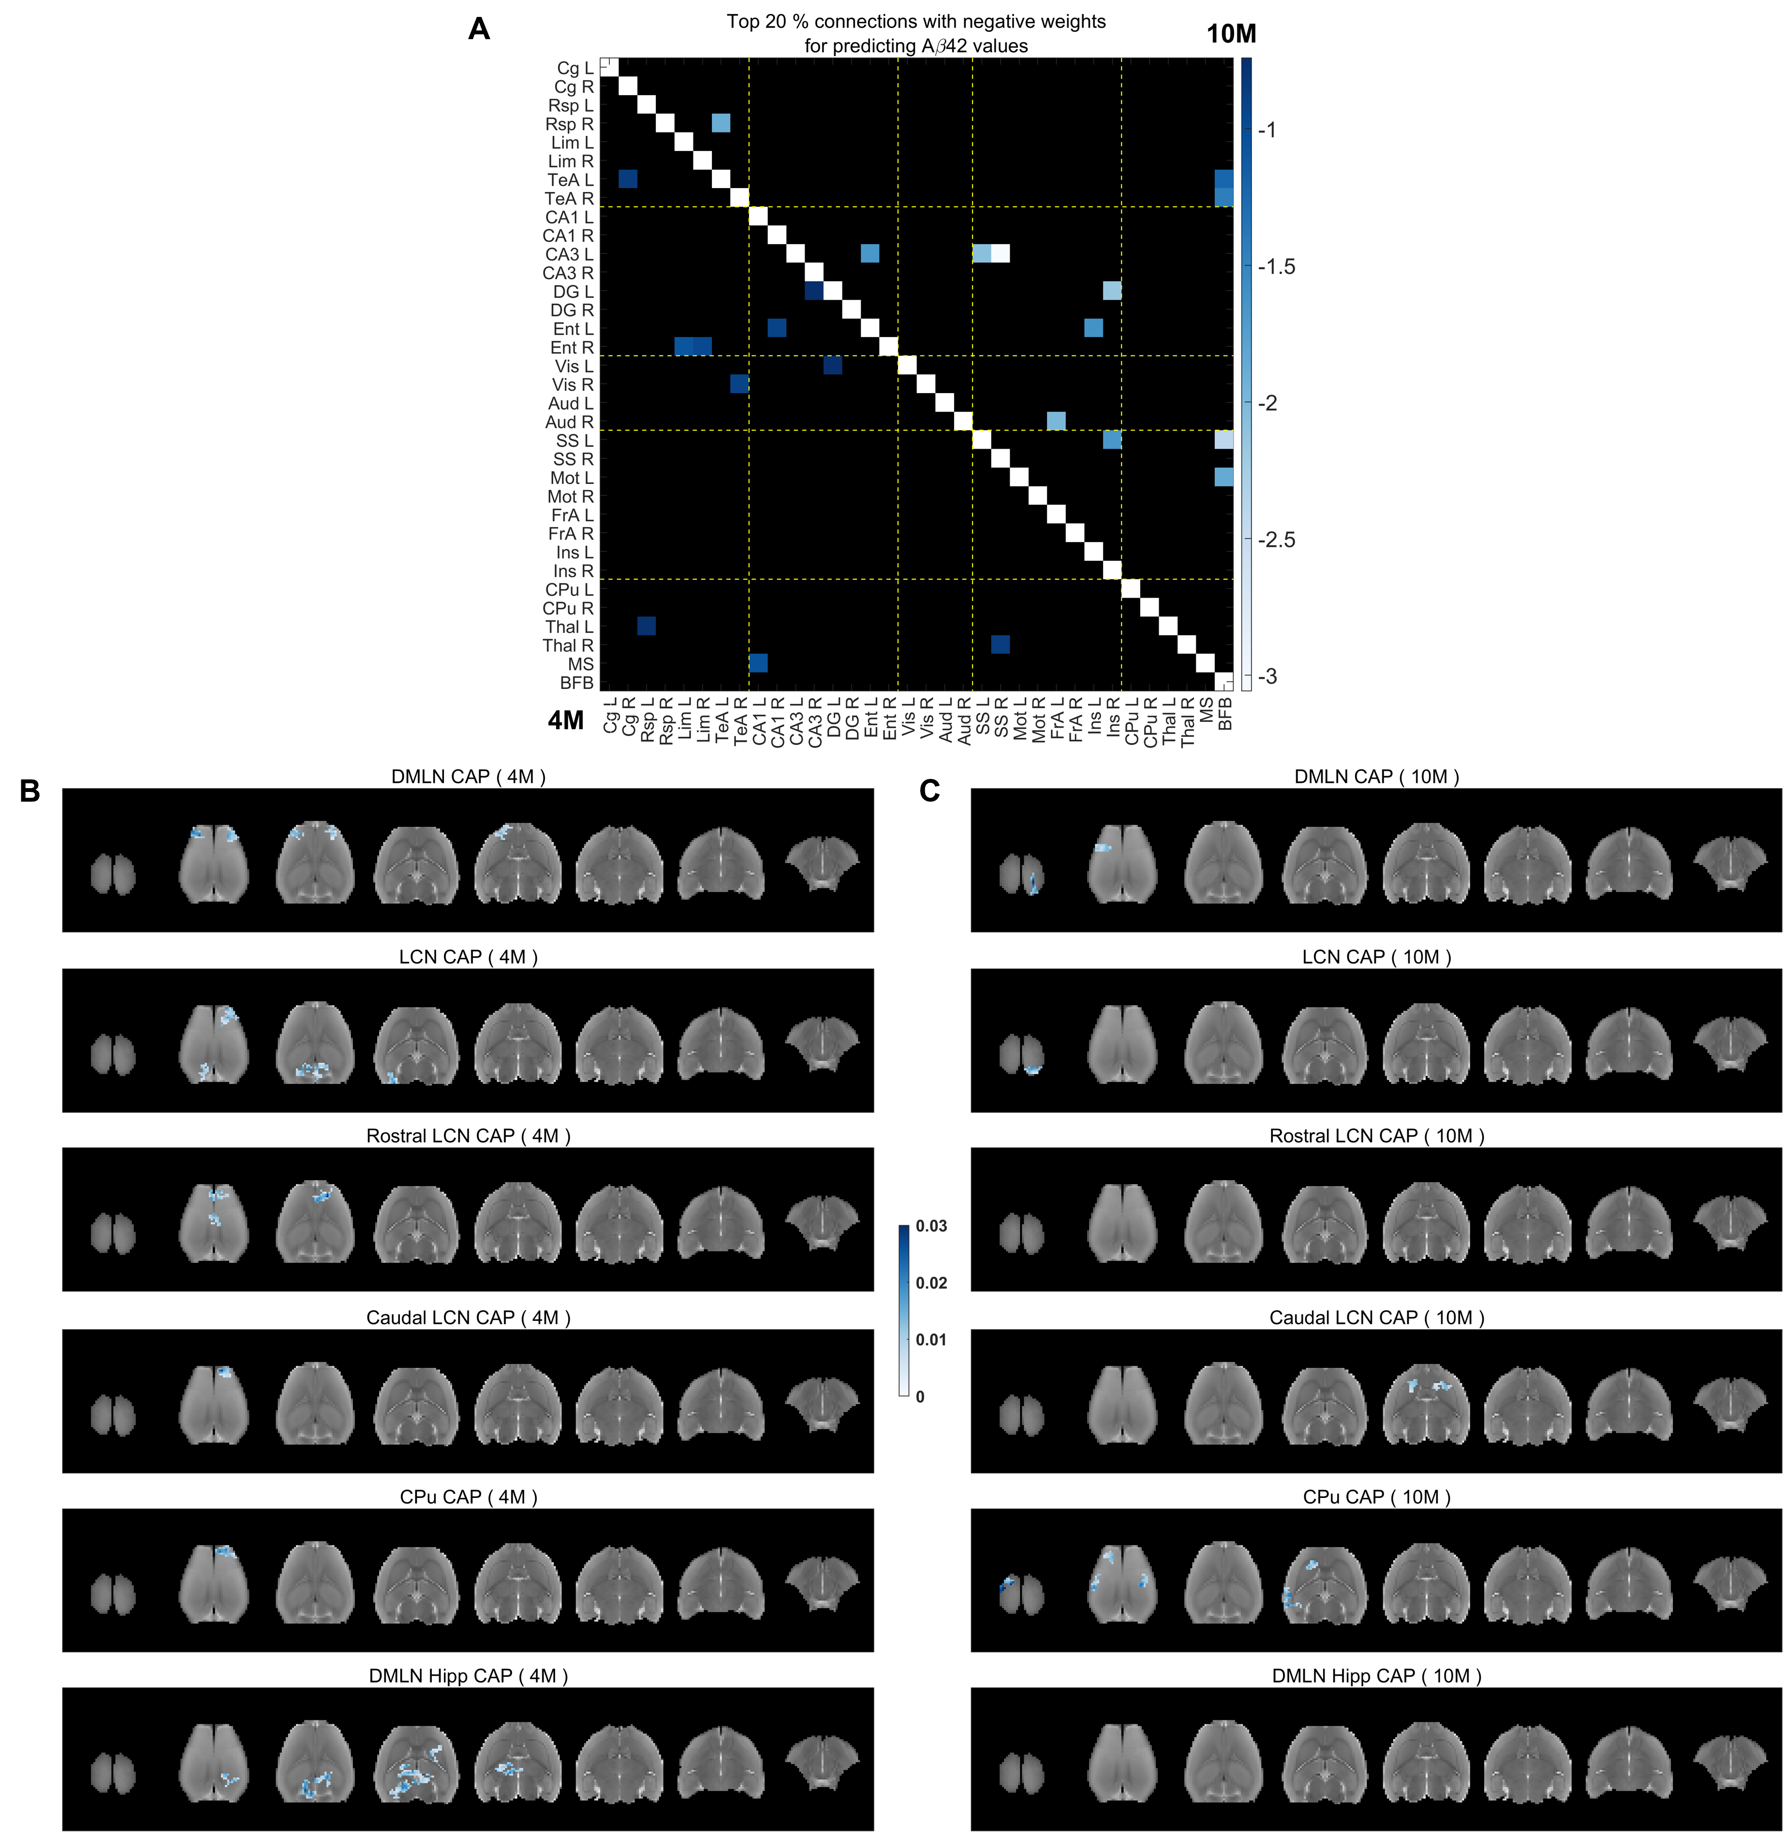
Supplementary Figure 8: Salient functional connections (A) and voxel-clusters (B-C) within CAPs with negative beta weights at pre-plaque and plaque stages that explain $Aβ42$ values in the TG animals. A: Top 20% highest negative beta weights of functional connections with significant 95% FWER-corrected confidence intervals at 4M (below the diagonal) and 10M (above the diagonal). B, C: Negative beta weights for salient clustered voxels (cluster-size: 20 voxels, in plane), for which FWER corrected 95% confidence intervals do not cross zero, in each CAP at 4M (B) and 10M (C).

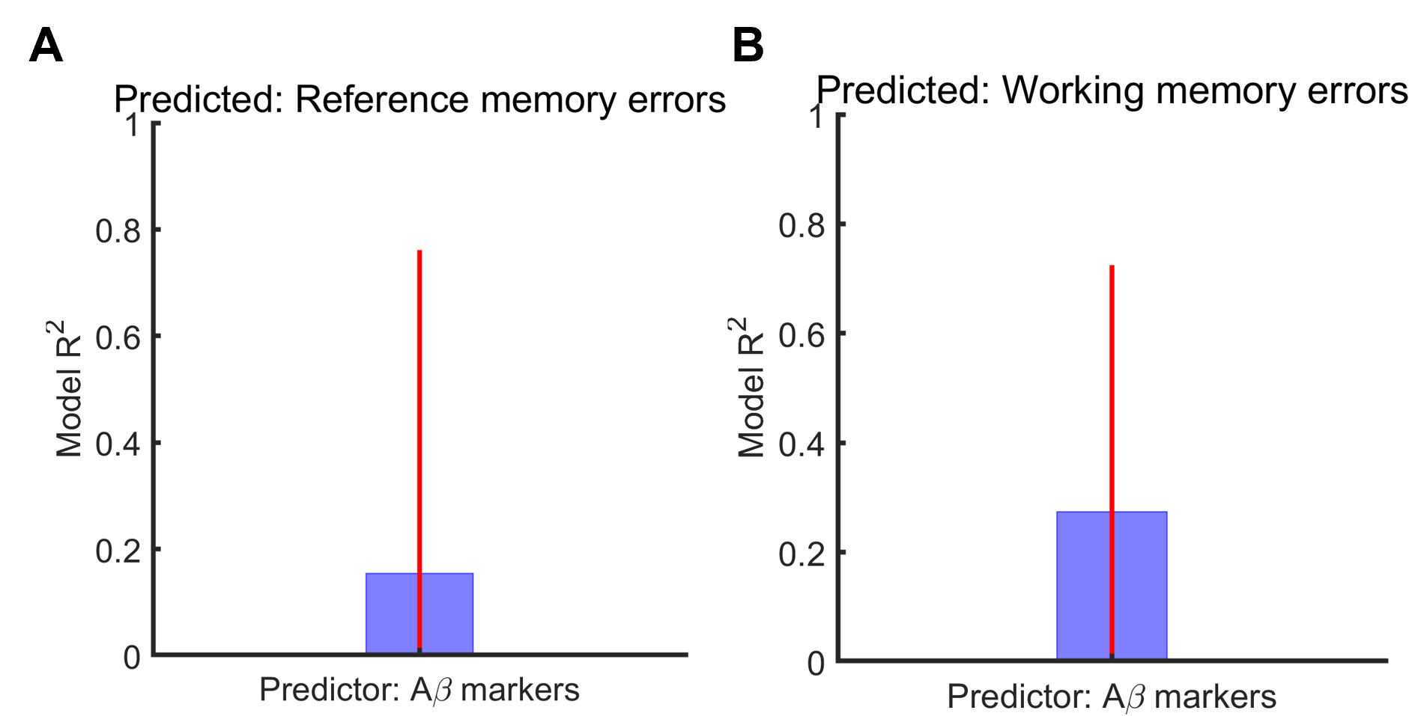
Supplementary Figure 9: PLSR model R² for predicting the performance on memory tasks (reference and working memory errors) on acquisition day 10 measured during the plaque stage (10.5M) using plasma levels of $Aβ38$, $Aβ40$, $Aβ42$ at the plaque (11M) stage. Here we used WT-normalized values for each amyloid marker to explain the WT-normalized values of reference memory errors (A), and working memory errors (B) in each individual TG subject respectively. Red vertical lines: family-wise error (FWE) - corrected 95% confidence intervals.

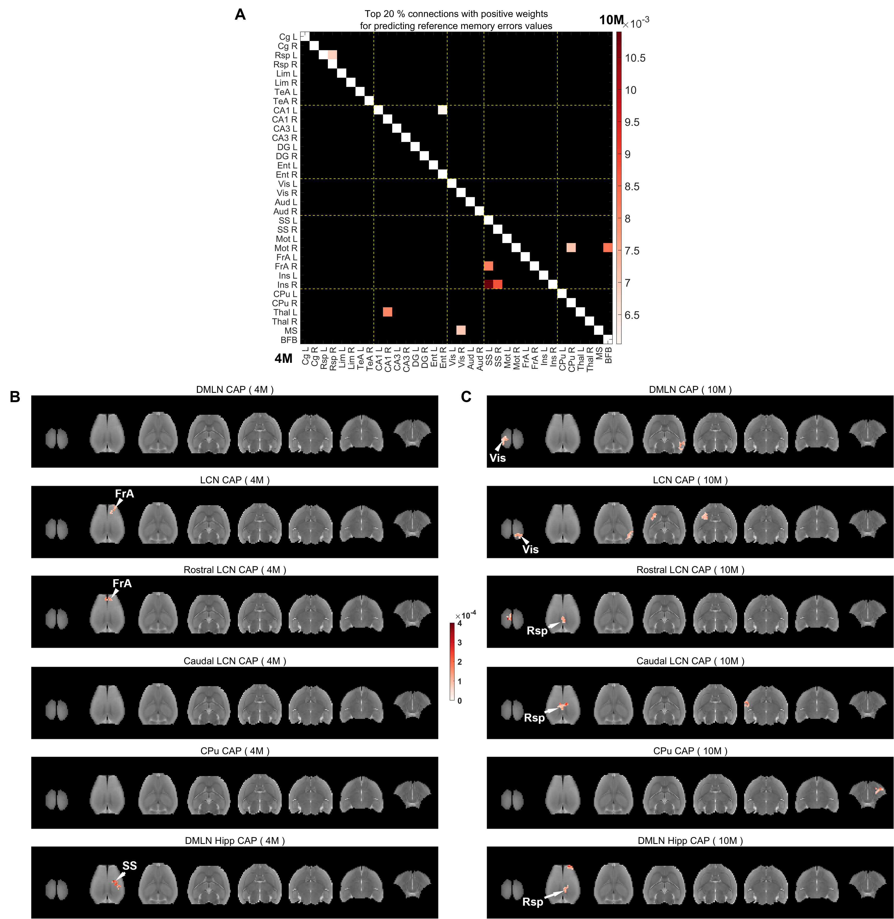
Supplementary Figure 10: Salient functional connections (A) and voxel-clusters (B-C) within CAPs with positive beta weights at pre-plaque and plaque stages that explain WT-normalized reference memory errors in the TG animals. A: Top 20% highest positive beta weights of functional connections with significant 95% FWER-corrected confidence intervals at 4M (below the diagonal) and 10M (above the diagonal). B, C: Positive beta weights for salient clustered voxels (cluster-size: 20 voxels, in plane), for which FWER corrected 95% confidence intervals do not cross zero, in each CAP at 4M (B) and 10M (C).
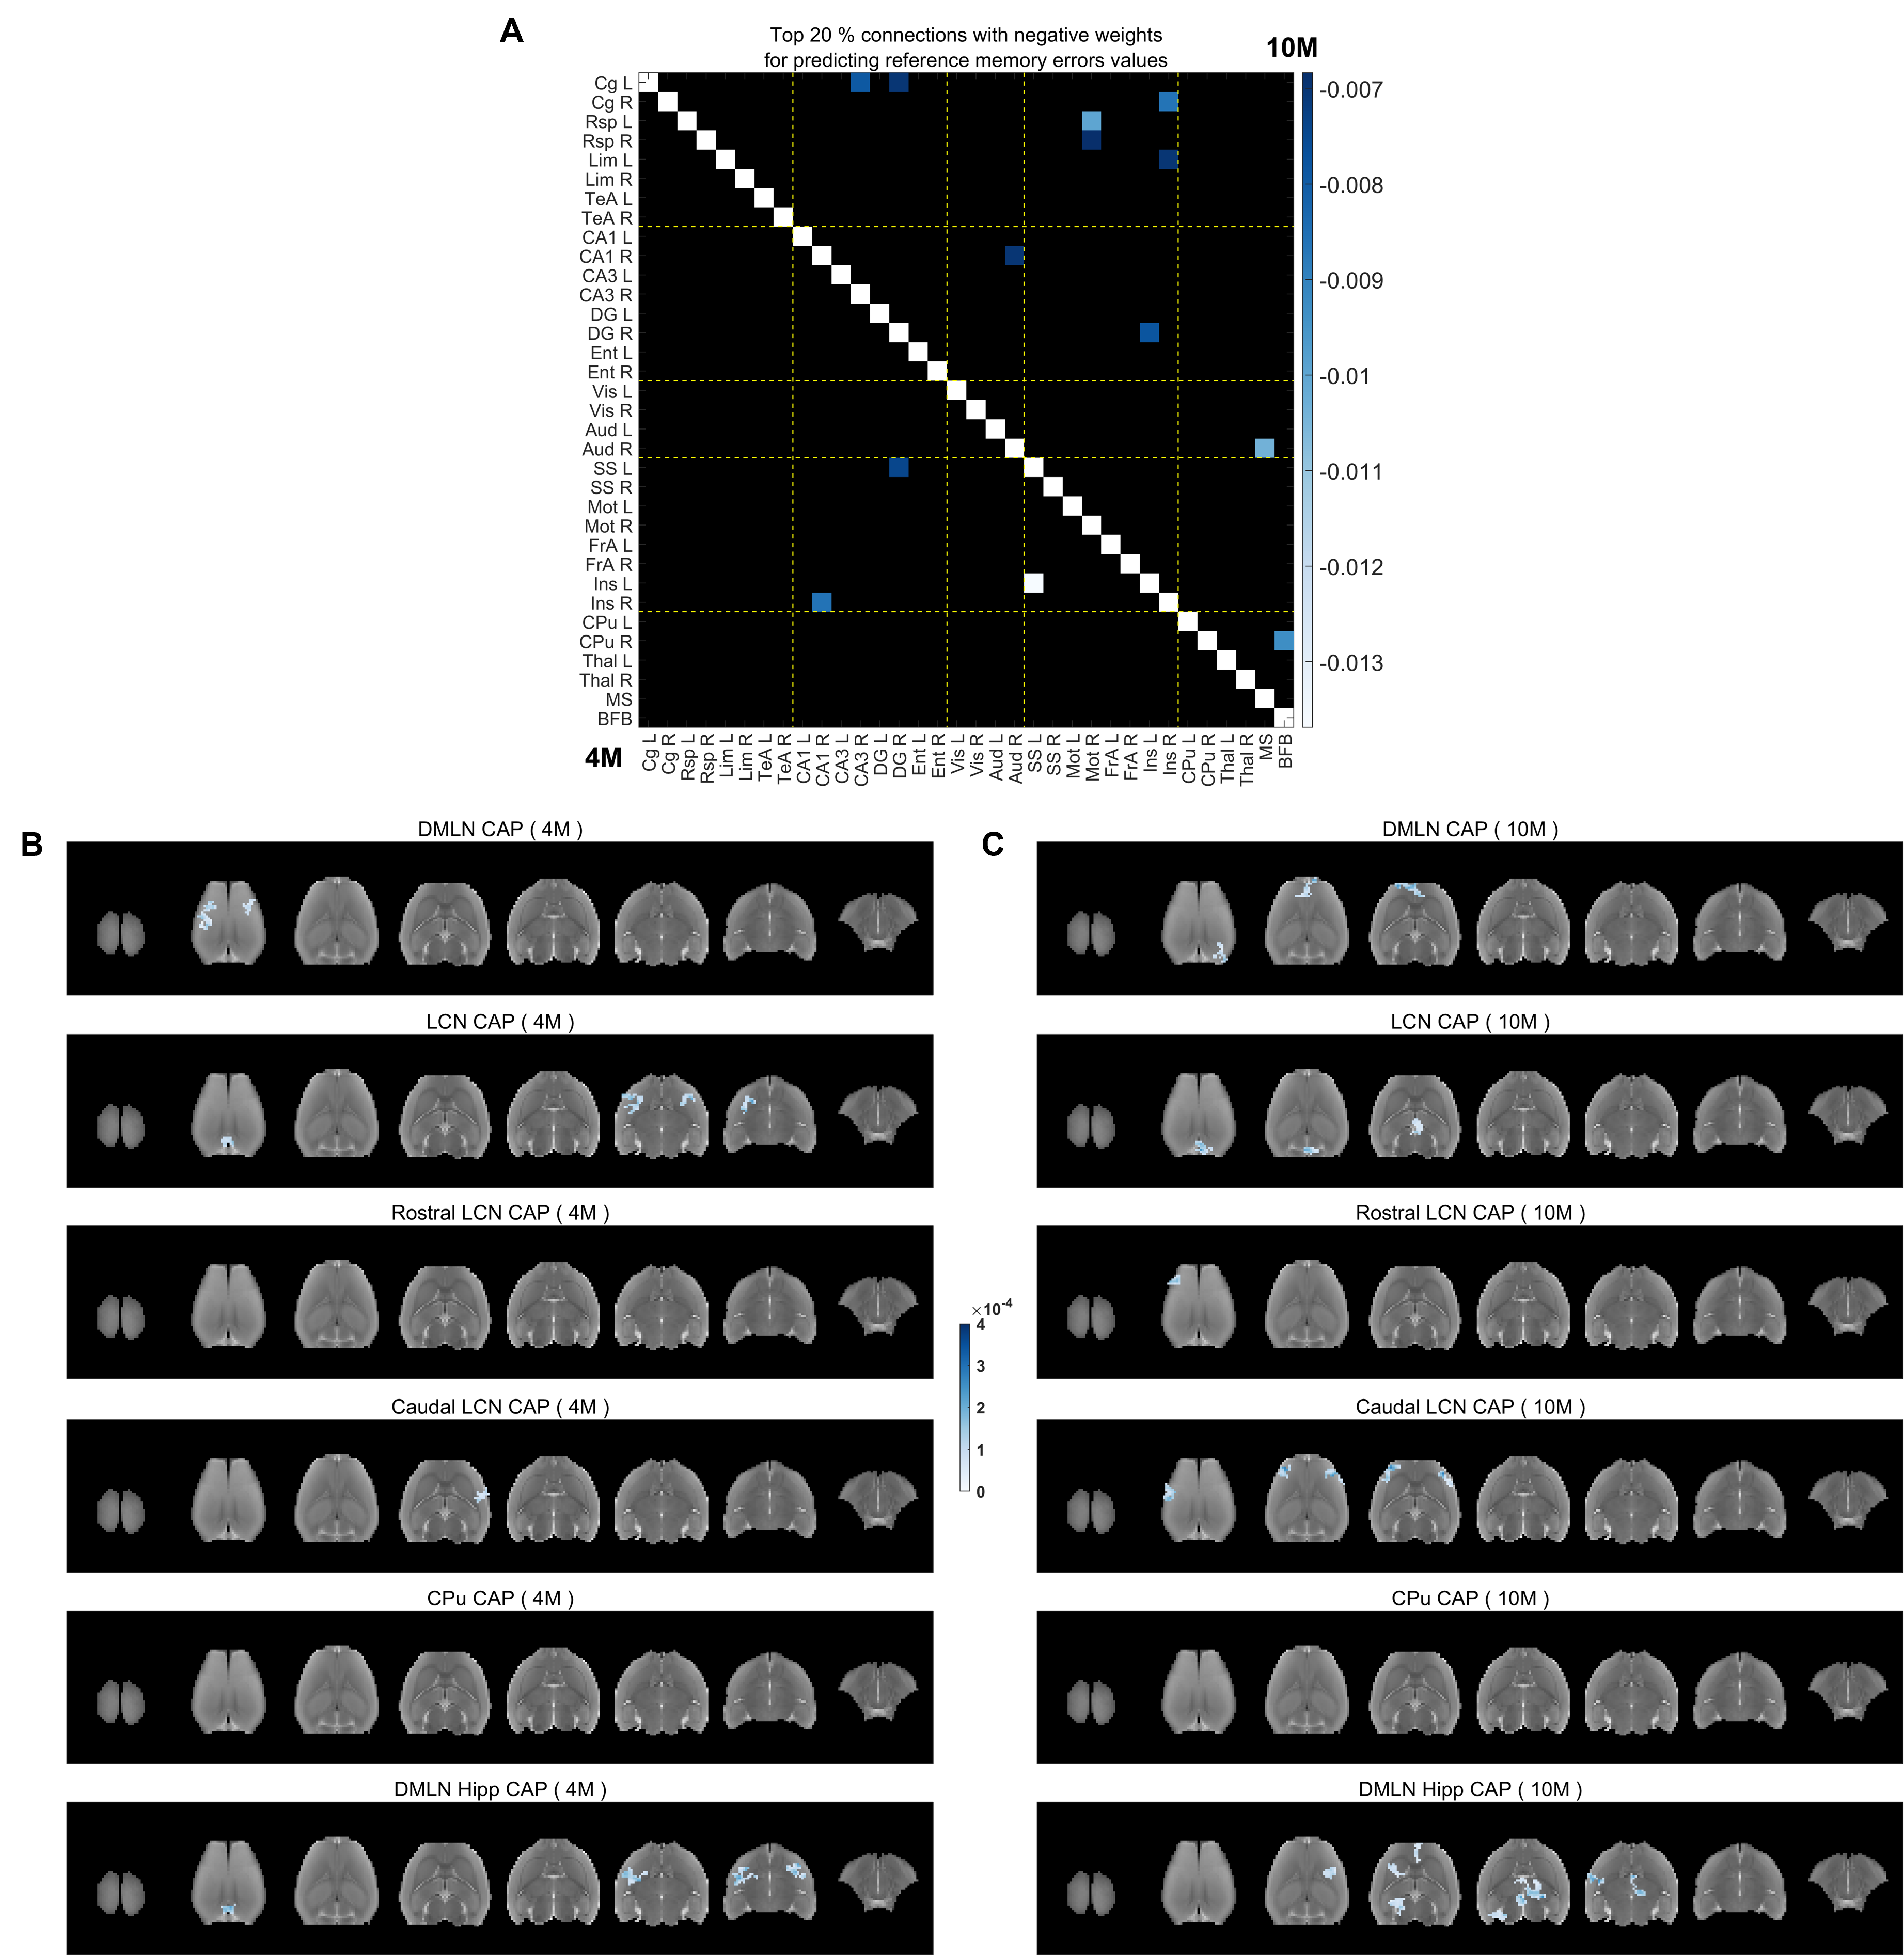
Supplementary Figure 11: Salient functional connections (A) and voxel-clusters (B-C) within CAPs with negative beta weights at pre-plaque and plaque stages that explain WT-normalized reference memory errors in the TG animals. A: Top 20% highest negative beta weights of functional connections with significant 95% FWER-corrected confidence intervals at 4M (below the diagonal) and 10M (above the diagonal). B, C: Negative beta weights for salient clustered voxels (cluster-size: 20 voxels, in plane), for which FWER corrected 95% confidence intervals do not cross zero, in each CAP at 4M (B) and 10M (C).
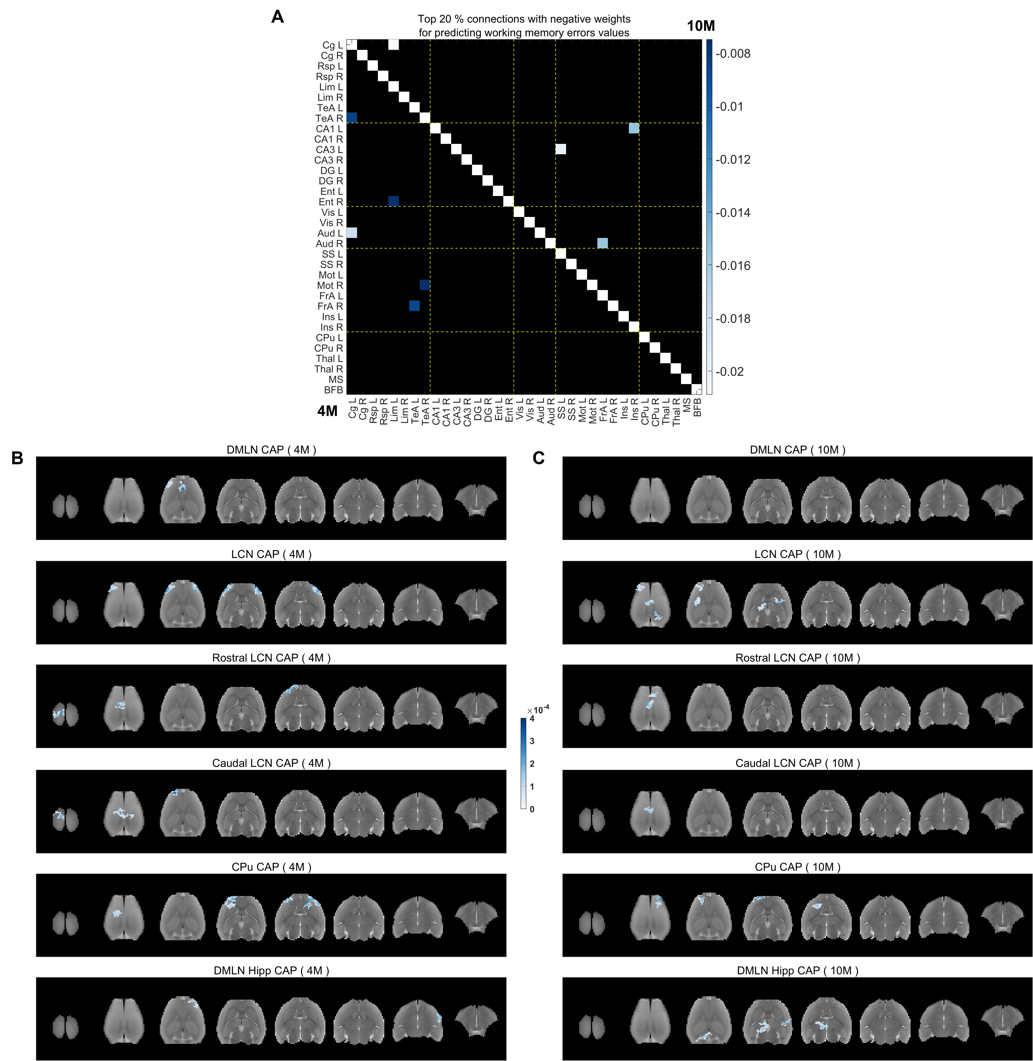
Supplementary Figure 12: Salient functional connections (A) and voxel-clusters (B-C) within CAPs with negative beta weights at pre-plaque and plaque stages that predict WT-normalized working memory errors in the TG animals. A: Top 20% highest negative beta weights of functional connections with significant 95% FWER-corrected confidence intervals at 4M (below the diagonal) and 10M (above the diagonal). B, C: Negative beta weights for salient clustered voxels (cluster-size: 20 voxels, in plane), for which FWER corrected 95% confidence intervals do not cross zero, in each CAP at 4M (B) and 10M (C).

