Supplementary data
The following are the Supplementary data to this article:

Fig.S1. Distribution of putative targets of top 39 ranked natural compounds was categorized in the pie chart.
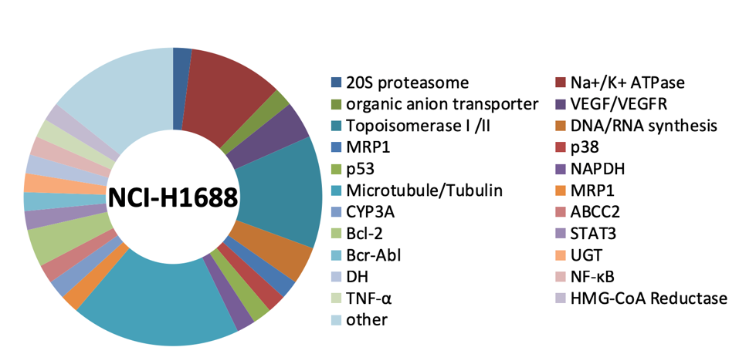

Table S1. Targets of top 39 ranked natural compounds and their inhibition ratio(%) of NCI-H1688
Compounds | Target | Inhibition ratio(%)
Dioscin | other | 78.63%
Sanguinarine chloride | VEGF | 99.48%
Docetaxel trihydrate | Microtubule/Tubulin; Bcl-2 | 82.87%
Digitoxin | Na+/K+ ATPase; organic anion transporter | 99.52%
Colchicine | Microtubule/Tubulin | 80.31%
Podophyllotoxin | Microtubule/Tubulin; Topoisomerase II | 80.21%
Gramicidin | MRP1 | 87.32%
Ouabain octahydrate | Na+/K+ ATPase | 99.72%
Digoxin | Na+/K+ ATPase | 99.64%
Lovastatin | HMG-CoA Reductase | 50.52%
Actidione | DNA/RNA synthesis | 88.85%
Vincristine sulfate | Microtubule/Tubulin | 83.32%
4'-Demethylepipodophyllotoxin | Microtubule/Tubulin; Topoisomerase II | 77.51%
10-Hydroxycamptothecin | Topoisomerase I | 99.00%
Digitonin | other | 68.04%
(+)-Camptothecin | Topoisomerase I | 98.89%
Rotenone | p53; NAPDH | 83.86%
Cepharanthine | TNF-α | 54.55%
Tanshinone IIA | VEGFR | 86.58%
Cryptotanshinone | STAT3 | 69.29%
Thiostrepton | DNA synthesis | 86.66%
Nocodazole | Microtubule/Tubulin; Bcr-Abl | 78.26%
Vinblastine sulfate | Microtubule/Tubulin;MRP1; CYP3A; ABCC2 | 93.45%
Gossypol acetic acid | Bcl-2 | 76.57%
Cephalomannine | Microtubule/Tubulin | 83.03%
Mycophenolic acid | UGT; DH | 50.30%
Lanatoside C | Na+/K+ ATPase | 74.35%
Combretastatin A4 | Microtubule/Tubulin | 75.72%
Pseudolaric Acid B | p38 | 99.40%
Ellipticine | Topoisomerase II | 75.75%
Hydroxy Camptothecine | Topoisomerase I | 73.31%
Dihydrotanshinone I | other | 55.63%
Celastrol | 20S proteasome | 98.90%
Schisantherin A | NF-κB | 90.71%
Deacetyltaxol | other | 99.73%
Triptolide (PG490) | other | 68.13%
Lycorine chloride | other | 72.11%
Evodiamine | other | 92.34%
Bufalin | Na+/K+ ATPase | 99.40%

Table S2. 47 genes related to cell cycle
Gene | log2(Fold_change) | p-value | q-value
ANAPC15 | -1.14836 | 2.73E-21 | 1.1E-19
APBB1 | 1.057434 | 3.89E-16 | 1.06E-14
ASNS | 2.593907 | 1.77E-78 | 8.05E-76
BCL6 | 1.433106 | 1.16E-19 | 4.18E-18
BRSK1 | 1.199042 | 2.98E-32 | 2.31E-30
BTC | 1.581284 | 7.68E-12 | 1.37E-10
CCNA1 | 3.548786 | 7.19E-07 | 6.79E-06
CCNF | -1.20259 | 2.6E-75 | 1.08E-72
CCPG1 | 1.097689 | 8.22E-23 | 3.68E-21
CDC45 | -1.11224 | 2.26E-33 | 1.89E-31
CDK15 | 2.413198 | 4.62E-05 | 0.000323
CDK5R2 | 2.694795 | 2.44E-08 | 2.85E-07
CDKN1A | 1.192303 | 1.3E-132 | 1.6E-129
CDKN1C | 4.727126 | 1.11E-11 | 1.96E-10
CEBPA | 1.10728 | 2.51E-13 | 5.34E-12
CITED2 | 1.27018 | 2.88E-61 | 7.77E-59
CYP1A1 | 1.072847 | 7.46E-05 | 0.000504
DDIT3 | 1.051116 | 6.33E-16 | 1.69E-14
E2F8 | -1.09844 | 1.99E-41 | 2.52E-39
EPGN | 1.61123 | 2.26E-19 | 7.96E-18
GADD45G | 3.725523 | 3.05E-08 | 3.52E-07
HBP1 | 1.034905 | 9.5E-19 | 3.2E-17
HECW2 | 1.353249 | 0.006166 | 0.02697
HSPA8 | -1.06486 | 1.4E-108 | 1.1E-105
INCENP | -1.00097 | 1E-65 | 3.24E-63
INHBA | 2.875963 | 1.7E-213 | 3E-210
KLHL13 | -1.02318 | 2.68E-17 | 8.06E-16
MAPK15 | 1.623543 | 2.37E-16 | 6.6E-15
MIR221 | 1.070525 | 0.009907 | 0.040832
MKI67 | -1.11508 | 9.8E-124 | 1.1E-120
MLXIPL | 1.497609 | 0.000752 | 0.004133
MN1 | 1.369662 | 4.8E-09 | 6.19E-08
MUC1 | 1.022082 | 4.44E-13 | 9.23E-12
MYBL2 | -1.03617 | 1.68E-17 | 5.15E-16
NANOS3 | 1.851899 | 0.007804 | 0.03316
NEK11 | 1.248903 | 8.12E-09 | 1.01E-07
NPM2 | 1.817897 | 4.17E-07 | 4.1E-06
NUPR1 | 2.773266 | 6.6E-159 | 9.2E-156
PSRC1 | -1.08329 | 5.01E-25 | 2.64E-23
RANBP1 | -1.01412 | 6.53E-62 | 1.81E-59
RPS6KA2 | 1.131193 | 2.49E-46 | 3.96E-44
TGFB1 | 1.322829 | 4.85E-93 | 2.88E-90
THBS1 | -1.07686 | 1E-100 | 6.62E-98
TP53INP1 | 1.873413 | 9.79E-75 | 4.01E-72
TRIM36 | 1.010466 | 0.000807 | 0.004403
TSPYL2 | 1.028489 | 2.8E-14 | 6.49E-13
ZWINT | -1.21332 | 5.46E-91 | 3.18E-88

