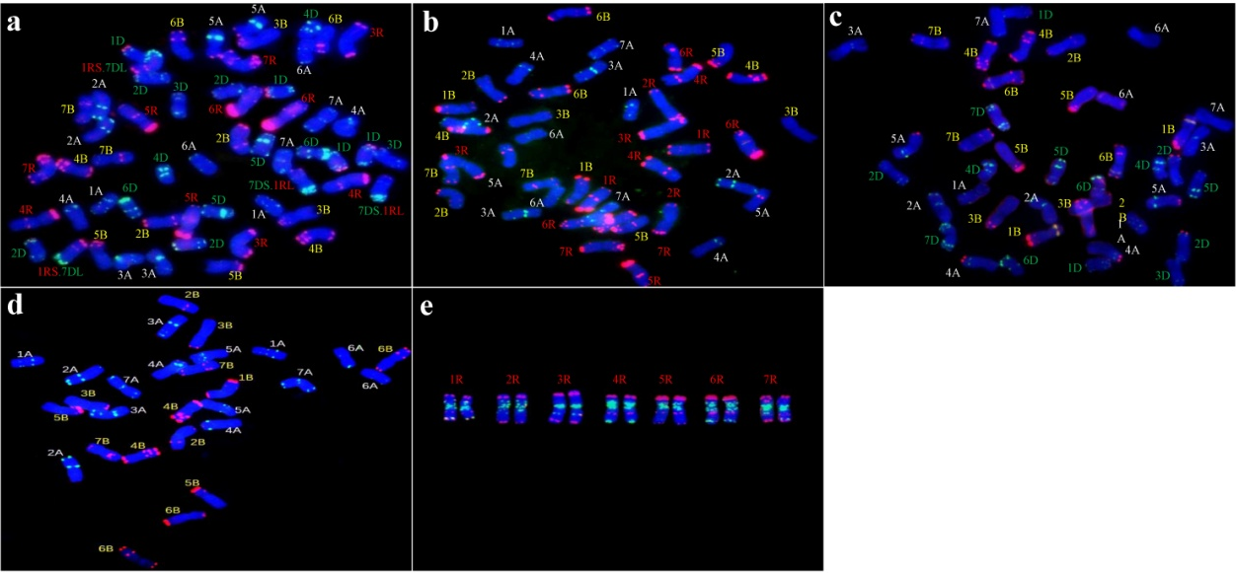
Fig. S1 Chromosome constitutions of five ploidy species identified by fluorescent in situ hybridization (FISH). (a) Octaploid triticale (AABBDDRR), (b) hexaploid triticale (AABBRR), (c) hexaploid wheat (AABBDD), (d) tetraploid wheat (AABB), (e) rye (RR).

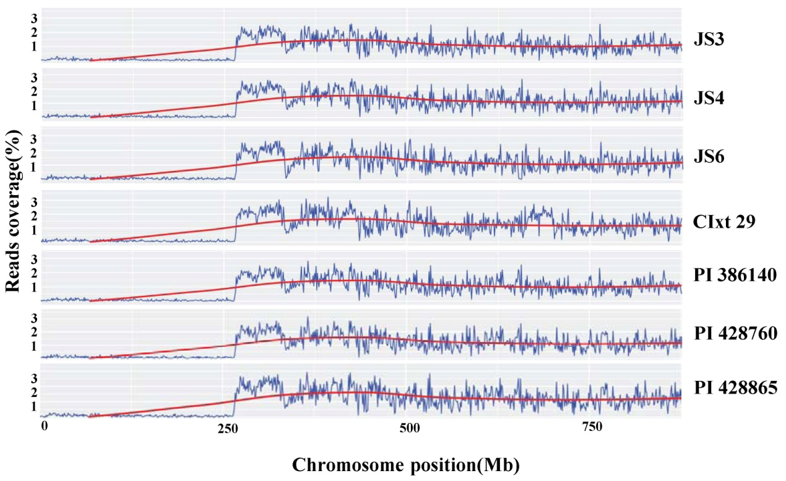
Fig. S2 Partial deletion of the short arm of chromosome 5R in triticale accessions based on read coverage.

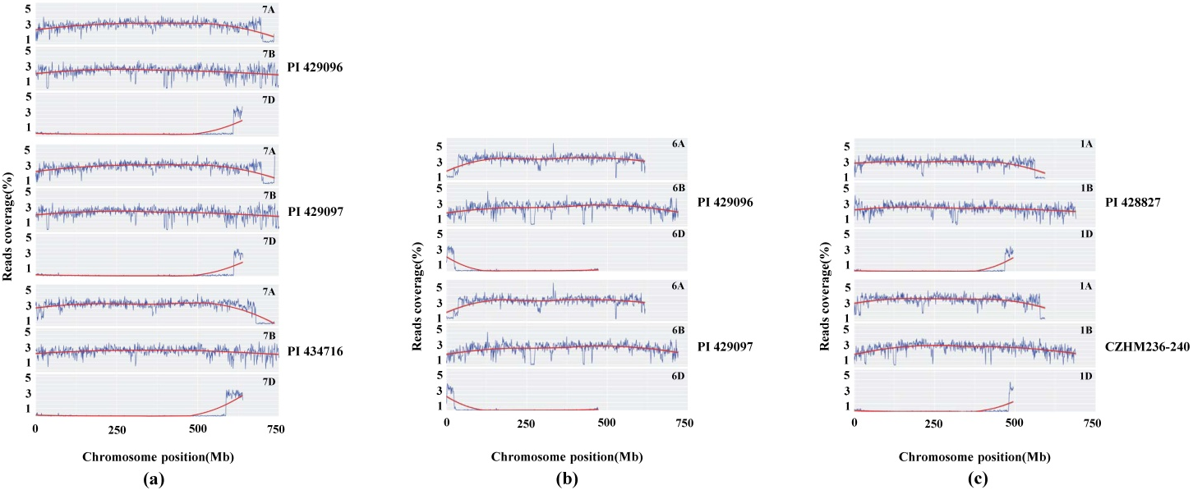
Fig. S3 Chromosomal translocations in triticale accessions based on read coverage. (a) Long arm of 7D/7A. (b) Short arm of 6D/6A. (c) Long arm of 1D/1A.

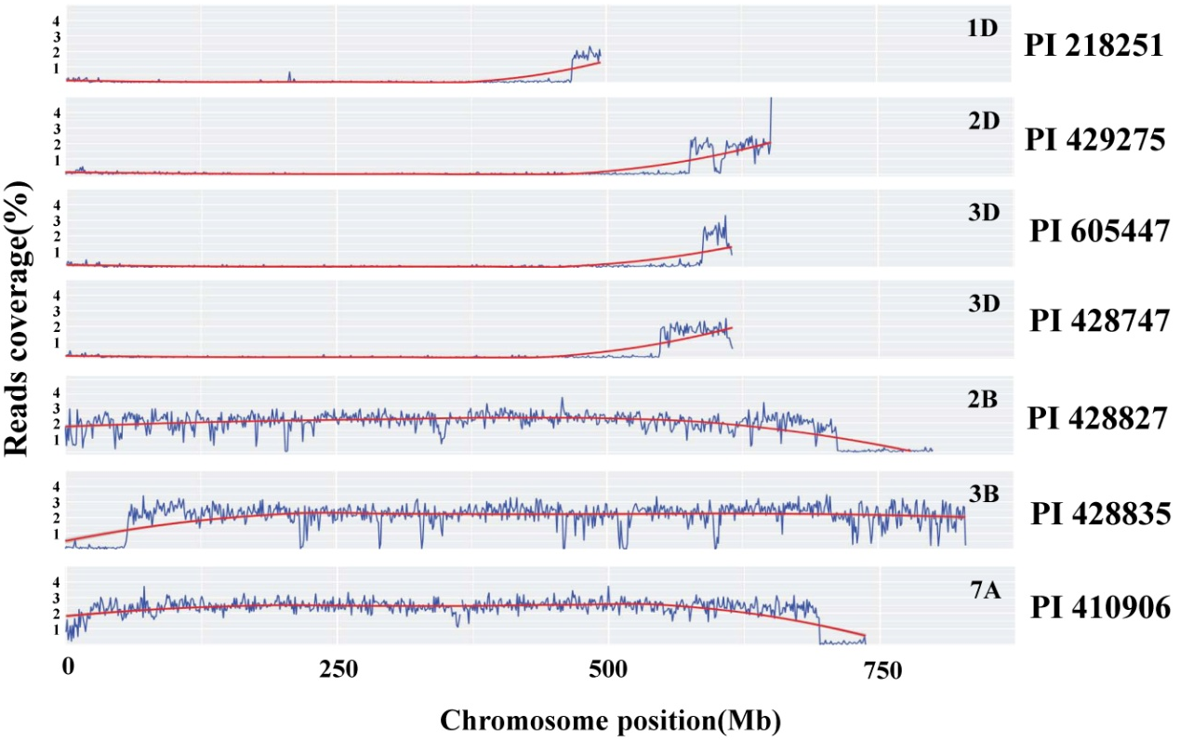
Fig. S4 Insertion and deletion of seven chromosome segments in triticale accessions.

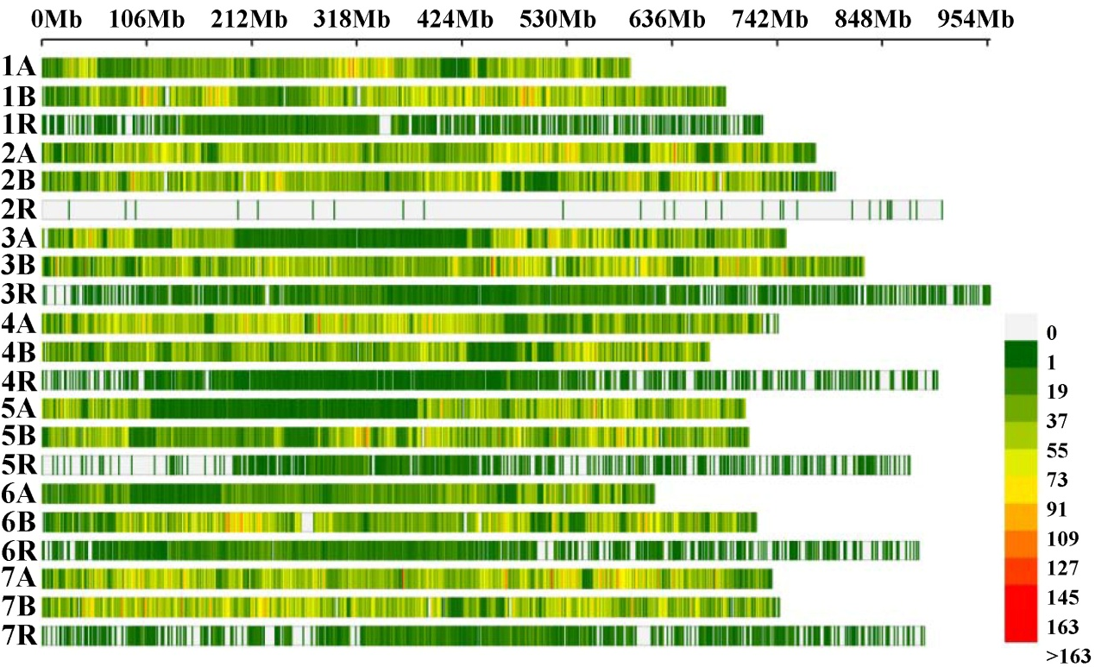
Fig. S5 Distribution of 434,304 reliable SNPs used in genetic diversity analysis in the wheat and rye genomes. X-axis shows the position of SNPs on the chromosomes. Different colors represent the density of SNPs within a sliding window of 1 Mb.

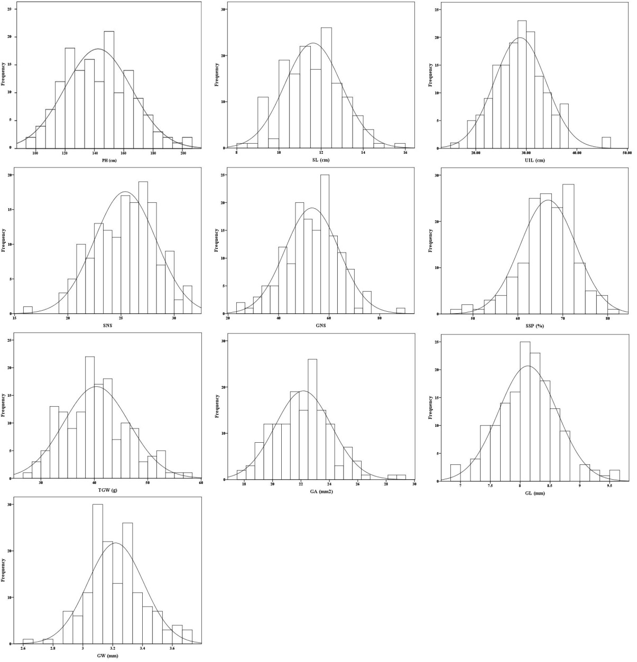
Fig. S6 Frequency distribution of 10 agronomic traits in 153 hexaploid triticale accessions.

