Supplementary Materials

Evidence of impact of tire wear particles on a roadside plant community at environmentally relevant concentrations

Shin Woong Kim*¹, Yooeun Chae¹, Hyun-Sook Jeong, Chang-Beom Park

Korea Institute of Toxicology, 17 Jegok-gil, Jinju 52834, Republic of Korea

* Corresponding author: shinwoong.kim@kitox.re.kr
¹ These authors contributed equally to this work

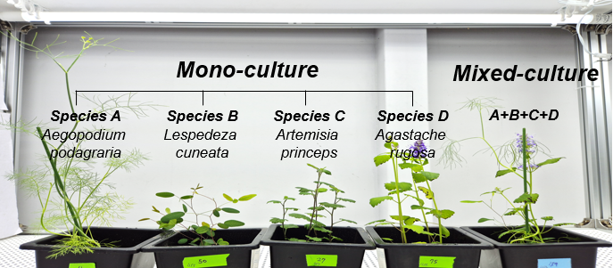
Fig. S1. Experimental design for mono- and mixed-culture conditions.
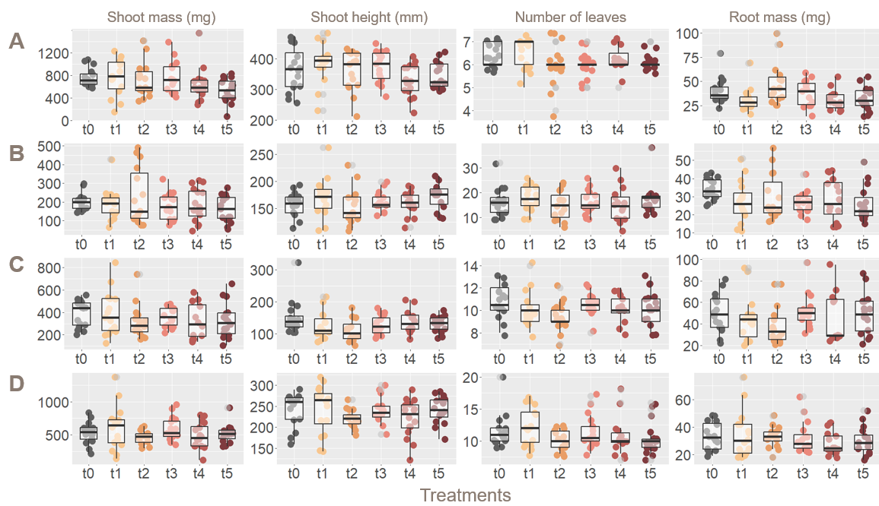
Fig. S2. Effects of TWPs on each plant species (A, Aegopodium podagraria; B, Lespedeza cuneata; C, Artemisia princeps; D, Agastache rugosa) in the mono-culture condition: Shoot mass, shoot height, number of leaves, and root mass of each treatment (t0, 0 mg kg⁻¹; t1, 1 mg kg⁻¹; t2, 10 mg kg⁻¹; t3, 100 mg kg⁻¹; t4, 1,000 mg kg⁻¹; t5, 10,000 mg kg⁻¹). Replicates of each treatment (n = 16) are represented by dots. The central line indicates the median value (50th percentile), and each box contains 25th to 75th percentiles of dataset.
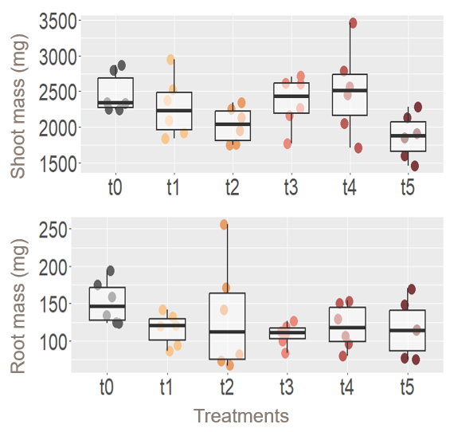
Fig. S3. Effects of TWPs on shoot mass and root mass in each mixed-culture pot. Replicates of each treatment (n = 6) are represented by dots. The central line indicates the median value (50th percentile), and each box contains 25th to 75th percentiles of dataset.
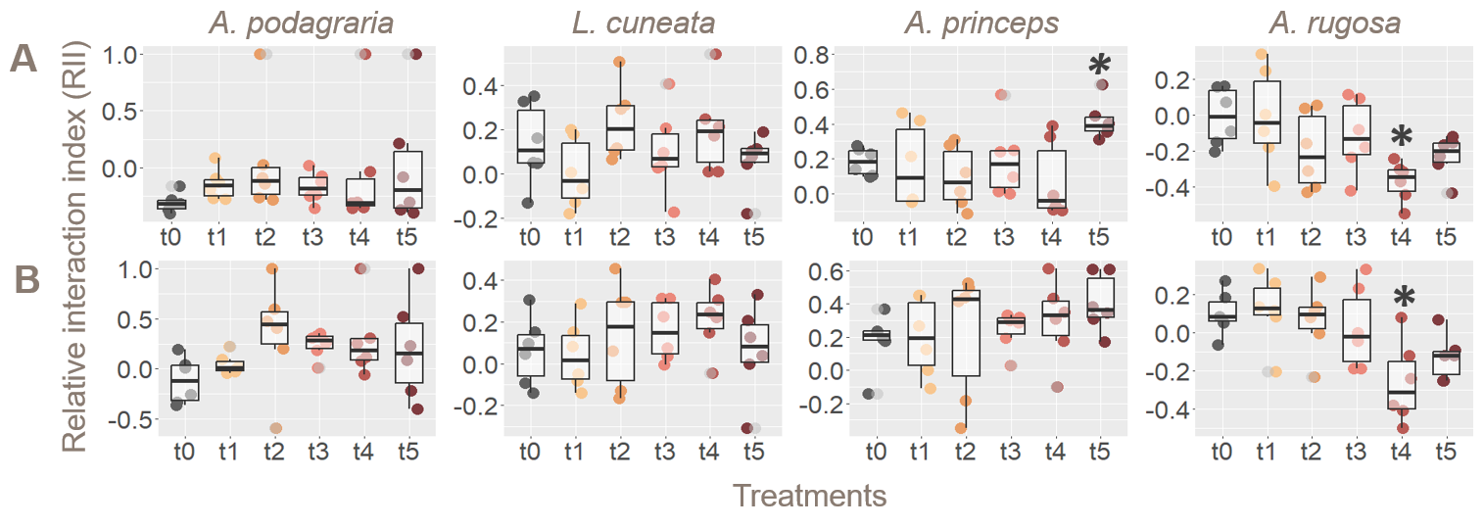
Fig. S4. Effects of TWPs on relative interaction index (RII) of (A) shoot and (B) root mass in each mixed-culture pot. Replicates of each treatment (n = 6) are represented by dots. The central line indicates the median value (50th percentile), and each box contains 25th to 75th percentiles of dataset. The asterisks indicate significant differences compared to each control group (p < 0.05).

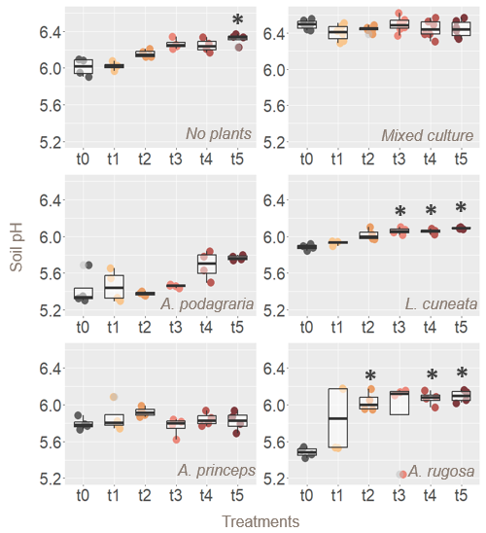
Fig. S5. Effects of TWPS on soil pH in the no plant, mono (Aegopodium podagraria, Lespedeza cuneata, Artemisia princeps, and Agastache rugosa), and mixed-culture condition. Replicates of each treatment (n = 6) are represented by dots. The central line indicates the median value (50th percentile), and each box contains 25th to 75th percentiles of dataset. The asterisks indicate significant differences of soil pH compared to each control group (p < 0.05).
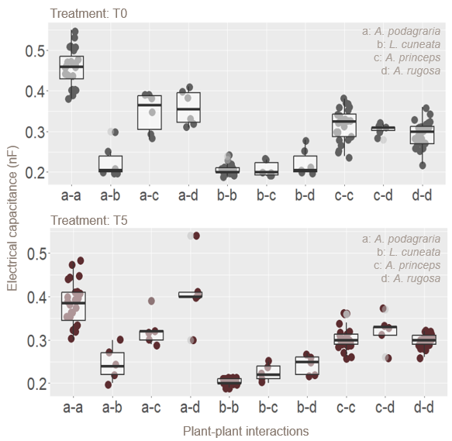
Fig. S6. Electrical capacitance between plants (a: Aegopodium podagraria, b: Lespedeza cuneata, c: Artemisia princeps, d: Agastache rugosa) in the mono- and mixed-culture conditions (control and t5 treatment). Replicates of mono- (n = 16) and mixed (n = 6) culture treatments are represented by dots. The central line indicates the median value (50th percentile), and each box contains 25th to 75th percentiles of dataset.

