Engineering edge-rich, highly dispersed, and stable MoS₂ sites for the catalytic splitting of H₂S for H₂ production
Hend Mohamed^{1,8}, Vijay K. Velisoju^{1,8}, M. Obaid², Rafia Ahmed³, Yuma Hirayama⁴, Mohamed Ben Hassine⁵, Gontzal Lezcano¹, Ildar Mukhambetov³, Zainab Alaithan⁶, Muhammad Arief Shafarifky¹, Ali Almofleh⁶, Polina Tolstova³, Omar El Tall⁵, Takato Mitsudome⁴, Huabin Zhang³, Luigi Cavallo³, Noreddine Ghaffour², Hassan Aljama⁶, Pedro Castaño^{1,7,}*
¹ Multiscale Reaction Engineering, KAUST Catalysis Platform (KCP), King Abdullah University of Science and Technology (KAUST), Thuwal, 23955-6900, Saudi Arabia.
² Water Desalination and Reuse Platform (WDRP), Division of Biological and Environmental Science and Engineering (BESE), King Abdullah University of Science and Technology (KAUST), Thuwal 23955-6900, Saudi Arabia.
³ KAUST Catalysis platform, King Abdullah University of Science and Technology (KAUST), Thuwal, 23955-6900, Saudi Arabia.
⁴ Department of Materials Engineering Science, Graduate School of Engineering Science, The University of Osaka, 1-3 Machikaneyama, Toyonaka, Osaka, 560-8531, Japan.
⁵ KAUST Core Labs, King Abdullah University of Science and Technology (KAUST), Thuwal 23955-6900, Saudi Arabia.
⁶ Research and Development Center, Dhahran 31311, Saudi Aramco.
⁷ Chemical Engineering Program, Physical Science and Engineering (PSE) Division, KAUST, Thuwal, Saudi Arabia.
⁸ These authors contributed equally: Hend Mohamed and Vijay K. Velisoju
*Corresponding authors: pedro.castano@kaust.edu.sa

Synthesis methods: A hydrothermal method was employed to generate a structurally distinct bulk reference. In this route, ammonium heptamolybdate and thiourea precursors were reacted in an aqueous solution (473–493 K) under autogenous pressure, with organic complexing agents used to modulate the nucleation kinetics. The high diffusion mobility and isotropic environment favor thermodynamically driven layer stacking, yielding a MoS₂–HT catalyst with well-crystallized 2H-phase lamellae, a low surface area, and limited edge exposure. This system represents the equilibrium growth regime of MoS₂ and was used as a baseline to assess how non-equilibrium synthesis influenced defect generation and catalytic function.
To disentangle the effects of dispersion and interfacial electronic coupling, a hybrid electrospinning–hydrothermal route was also developed. Pre-carbonized CNF mats were first fabricated via the electrospinning of PAN, followed by thermal treatment under reducing conditions. Subsequent hydrothermal deposition of Mo precursors onto the CNFs produced MoS₂–HT/CNF, in which few-layered to multilayer MoS₂ platelets nucleated and grew on the carbon surface. Although this hybrid architecture incorporated conductive CNFs, the absence of strong kinetic confinement allowed partial restacking, resulting in lower dispersion and fewer accessible edge sites compared to its electrospun counterpart. It was thus employed as an intermediate structural model between the entirely confined electrospun system and the freely grown hydrothermal analogue. For benchmarking, a commercial 2H–MoS₂ (MoS₂/CM) catalyst was used as a representative benchmark for industrial desulfurization catalysts. This material exhibited the thick-layered stacking and low defect density typical of the bulk MoS₂ used in hydrotreating (Figs. S1–S9).
Together, MoS₂|CNF–ES, MoS₂–HT, MoS₂–HT/CNF, and MoS₂–Comm represented a controlled structural continuum ranging from dense, inactive lamellae to atomically thin, edge-rich monolayers forming a close interface with conductive carbon. This series was employed to provide a direct correlation between synthesis dynamics, structural hierarchy, and catalytic behavior, illustrating how kinetic confinement and interfacial charge transfer, which are absent in equilibrium-grown MoS₂, enhance active-site accessibility, vacancy stability, and catalytic turnover during high-temperature H₂S splitting (Fig. 1 and Table S1).
Catalyst synthesis and optimization using hydrothermal and electrospinning methods
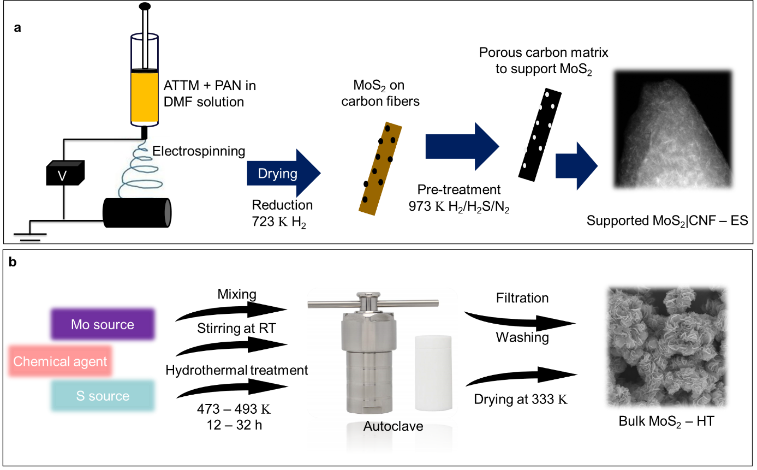
Fig. S1. Schematic of the fabrication of (a) a supported MoS₂ catalyst using electrospinning after a series of pre-treatment steps and (b) a bulk MoS₂ catalyst using a hydrothermal method.

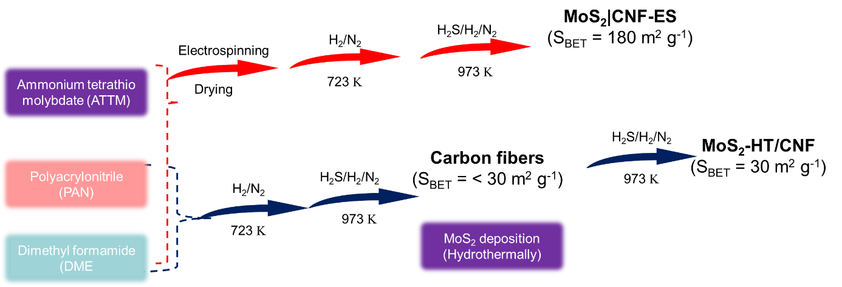
Fig. S2. Overview of the pre-treatment processes used for the fabrication of electrospun fibers with and without ATTM under a gaseous H₂/N₂ or H₂/H₂S/N₂ atmosphere over a temperature range of 723–973 Κ.

Simulations and rate constant calculations
To evaluate the thermodynamic limitations of the H₂S decomposition process, Aspen Plus software was employed to simulate the equilibrium conversion of H₂S under the investigated experimental conditions using a Gibbs reactor model, with the WILSON method used as the thermodynamic basis. Because H₂S decomposition is a thermodynamically controlled reaction, the maximum achievable conversion solely governed by the reaction equilibrium needs to be determined first. These simulations thus provided a reference for distinguishing kinetic effects from thermodynamic constraints.
By comparing the experimental conversion under differential flow conditions (i.e., intrinsic regime with low conversion) against these equilibrium values, we were able to estimate the apparent reaction rates and rate constants. This modeling approach supported the development of a predictive kinetic framework for catalyst performance under various conditions. Using the experimental testing data, we adopted a kinetic model to predict the rate for the intrinsic regime. In this model, the rate equation was integrated as a function of the catalyst weight ($w$):
$\frac{∂F_{H2S}}{∂m_{cat}}=-r=k_{ref}{ e}^{\left(\frac{-E_{a}}{R} \left(\frac{1}{T}-\frac{1}{T_{ref}}\right)\right)}(P_{H_{2}S}-\frac{1}{K_{eq}}P_{H_{2}}{P_{S_{2}}}^{\frac{1}{2}})$ (2)
where $K_{eq}$ is the equilibrium rate constant obtained from Aspen Plus. In addition, $k_{ref}$, T_{ref}, and $E_{a}$ are the rate constant at the reference temperature, the reference temperature (973 Κ), and the activation energy, respectively. Both $k_{ref}$ and $E_{a}$ were determined by minimizing the difference between the theoretical and experimental conversion values.
The TOF per active site was calculated as follows, in line with standard practices:
$TOF \left(s^{-1}\right)=\frac{X_{H_{2}S }× F_{H_{2}S_{in}} }{m_{cat} × AS}$ (3)
where F_{i,o} is the molar flow rate of H₂S at the entrance of the reactor, m_{cat} is the catalyst weight, and AS is the active site. However, this is equation only holds true for differential reactors. Because we intended to design a catalyst with very high activity approaching equilibrium under integral differential reaction conditions, the optimal approach was to calculate the TOF as follows:
$TOF \left(s^{-1}\right)={\left.\frac{∂F_{H2S}}{∂m_{cat}}\right|}_{0}×\frac{1 }{AS}$ (4)
where ${\left.\frac{∂F_{H2S}}{∂m_{cat}}\right|}_{0}$is the initial reaction rate, calculated using Eq. (2) under the assumption of lower conversion compared to that at equilibrium.

Results
Optimization of carbon-supported MoS₂ using electrospinning: Three carbon-supported MoS₂ catalysts were synthesized via electrospinning using 5%, 10%, and 15% PAN, followed by two-stage thermal treatment (Fig. S1a). XRD patterns (Fig. S3a) confirmed the formation of 2H-MoS₂ in all samples, with broad (100) and (110) reflections observed at 32.3° and 57.0°, while the (002) peak at 14.5° was absent or faint, indicating a monolayered MoS₂ structure. TGA profiles (Fig. S3b) revealed a weight loss of ~30% up to 873 Κ, which was attributed to PAN decomposition, with no major differences between samples, suggesting that they had comparable carbon content. Raman spectra (Fig. S3c) displayed characteristic D and G bands, confirming the presence of both graphitic and amorphous carbon supporting highly dispersed MoS₂.
According to subsequent catalytic testing (Fig. S3d), the sample prepared with 10% PAN demonstrated the highest H₂S decomposition activity, with s higher rate observed for MoS₂|CNF–ES (Table S2). The lower activity with 5% PAN was attributed to insufficient structural support, while 15% PAN led to thicker carbon layers forming during electrospinning, which likely hindered active site accessibility. These results highlight the importance of the polymer concentration in balancing dispersion and accessibility in electrospun MoS₂/C_{x} (C = 5, 10, and 15% PAN) catalysts.
Fig. S3. (a) Powder XRD patterns, (b) thermogravimetric analysis (TGA), (c) Raman spectra, and (d) H₂S decomposition activity for the three carbon-supported catalysts prepared using different concentrations of PAN during electrospinning. Reaction conditions: pre-treatment: 973 Κ in H₂S/H₂ for 2 h; H₂S feed: 2 vol% H₂S in N₂; reaction temperature: 973 Κ; and space time: 1.5 g_{cat} h mol_{H2S}⁻¹.

Various procedures were employed to evaluate the impact of the preparation and pre-treatment methods on the catalyst properties. As a reference, a catalyst was synthesized via a conventional two-step method (Fig. S2). First, electrospun CNF mats were produced and carbonized under an H₂S/H₂/N₂ atmosphere at 973 Κ, yielding a material with a relatively low surface area (~30 m² g⁻¹). Subsequently, MoS₂ was deposited hydrothermally, resulting in MoS₂-HT/CNF. These results indicate that incorporating MoS₂ during the electrospinning step, followed by sequential pre-treatment under H₂ and H₂S gas at a controlled temperature, significantly affect the textural properties of the final catalyst.

Optimization of bulk MoS₂ using the hydrothermal method: Based on our previously established hydrothermal synthesis protocol for MoS_{2,}¹ we systematically explored the role of organic complexing agents and synthesis conditions in enhancing the catalytic performance for H₂S decomposition. Our previous study fabricated and assessed two representative systems, one in which MoS₂ was synthesized with OA and the other without a complexing agent,¹ highlighting the beneficial role of OA in improving MoS₂ dispersion and catalytic activity. To refine this approach, we prepared two different MoS₂ catalysts in the present study at a crystallization temperature of 473 Κ with OA (473-OA) and CA (473-CA) as the chemical agents. We also prepared a MoS₂ catalyst at a crystallization temperature of 493 Κ (MoS₂-HT).
XRD patterns (Fig. S4a) confirmed the formation of well-crystallized 2H-phase MoS₂ in all cases, while the corresponding Raman spectra (Fig. S4c) contained characteristic E_{2g}¹ and A_{1g} modes, verifying the preservation of the desired layered structure. The OA-assisted MoS₂ synthesized at 493 Κ (MoS₂-HT) exhibited the highest BET surface area (42 m² g⁻¹, Fig. S4b) and the most pronounced catalytic activity for H₂S decomposition (Fig. S4d), followed by the sample synthesized at 473 Κ with OA under otherwise identical conditions. In contrast, the CA-based sample had a lower surface area and catalytic performance. The corresponding rate constants are given in Table S2. These trends directly correlated with improvements in structural quality and active site accessibility. Overall, the results demonstrate that the careful selection of chemical agents and crystallization temperature can be used to tune the surface and catalytic properties of bulk MoS₂, with optimized OA-based synthesis producing a material that significantly outperforms commercial MoS₂.

Fig. S4. (a) Powder XRD patterns, (b) N₂-physisorption analysis, (c) Raman spectra, and (d) H₂S decomposition activity of MoS₂-Comm and other bulk MoS₂ catalysts prepared using a hydrothermal method with different chemical agents. Reaction conditions: pre-treatment: 973 Κ in H₂S/H₂ for 2 h; H₂S feed: 2 vol% H₂S in N₂; reaction temperature: 973 Κ; and space time: 0.03 g.s.mL⁻¹.

Fig. S5. (a) N₂-physisorption analysis of all three MoS₂ catalysts after reduction–sulfidation thermal treatment. (b) Thermogravimetric (TG) analysis of as-synthesized samples before pre-treatment.

Fig. S6. Scanning electron microscopic images of MoS₂|CNF–ES (a) after reduction at 723 Κ in a flow of H₂/Ar and (b) after sulfidation at 923 Κ in a flow of H₂S/H₂/N₂.

Fig. S7. Scanning electron microscopic images of (a) MoS₂–HT showing a multilayer morphology and of (b) MoS₂–HT/CNF showing a few-layered morphology.

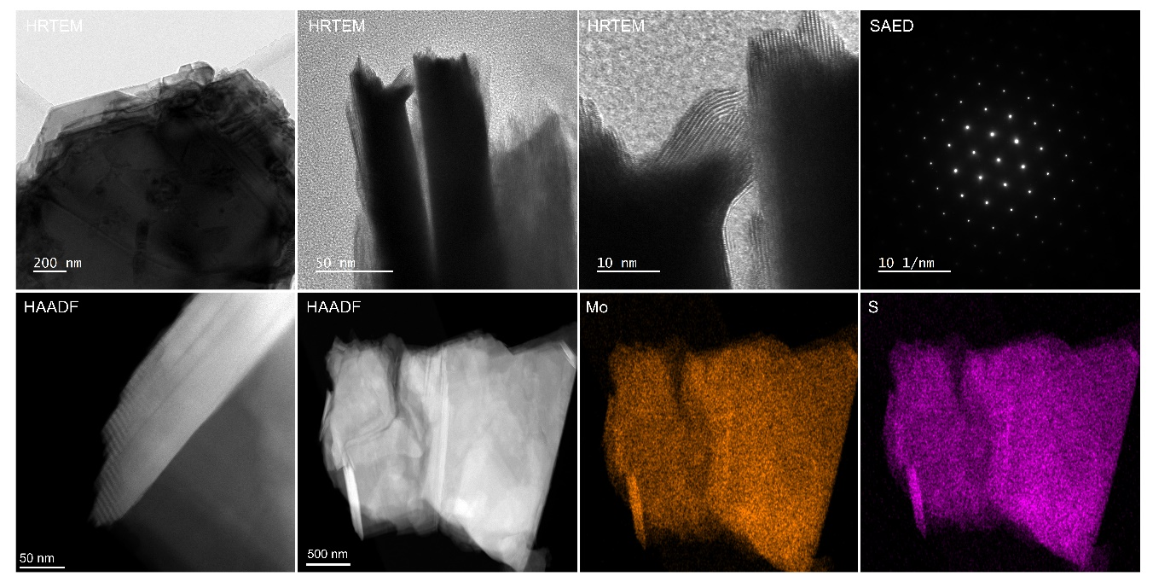
Fig. S8. HRTEM, SAED pattern, and HAADF-STEM-EDX images of MoS₂-Comm at different resolutions, confirming its thick layered morphology.

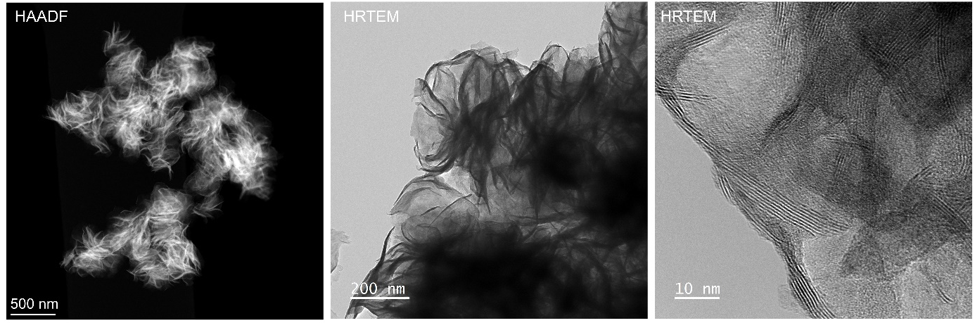
Fig. S9. HAADF and HRTEM images of MoS₂-HT taken at different resolutions, confirming the dispersed multilayer morphology after heat treatment at 973 Κ in a H₂S/H₂/N₂ atmosphere.

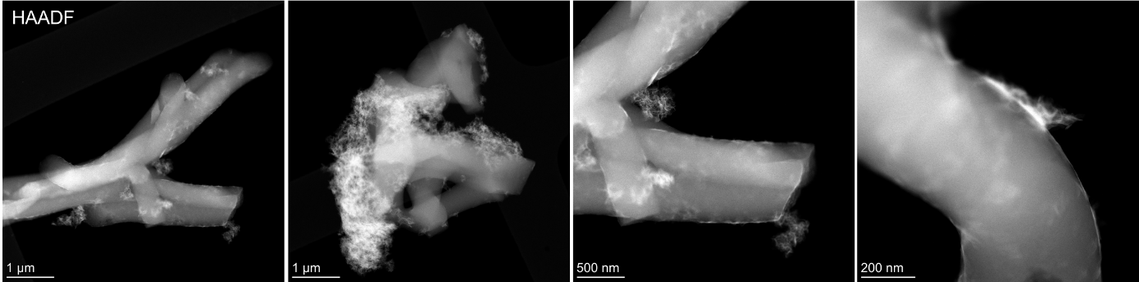
Fig. S10. HAADF-STEM images of MoS₂-HT/CNF at different resolutions, confirming the few-layered morphology on the CNFs after heat treatment at 973 Κ in a H₂S/H₂/N₂ atmosphere.

Fig. S11. HAADF-STEM images of MoS₂|CNF–ES taken at different resolutions (a) before and (b) after sulfidation at 973 Κ in a H₂S/H₂/N₂ atmosphere, confirming the presence of a dispersed few-layered and monolayer morphology, respectively.

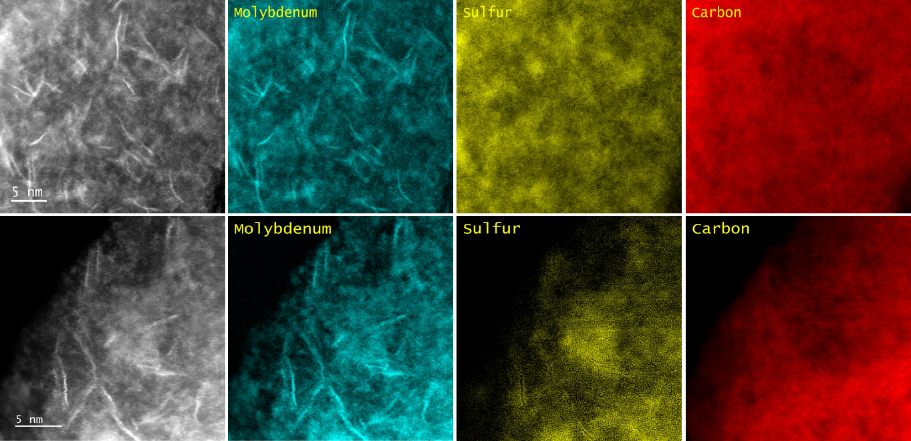
Fig. S12. HAADF-STEM-EELS images of MoS₂|CNF–ES taken at different resolutions, confirming its dispersed single-layered morphology after heat treatment at 973 Κ in a H₂S/H₂/N₂ atmosphere.

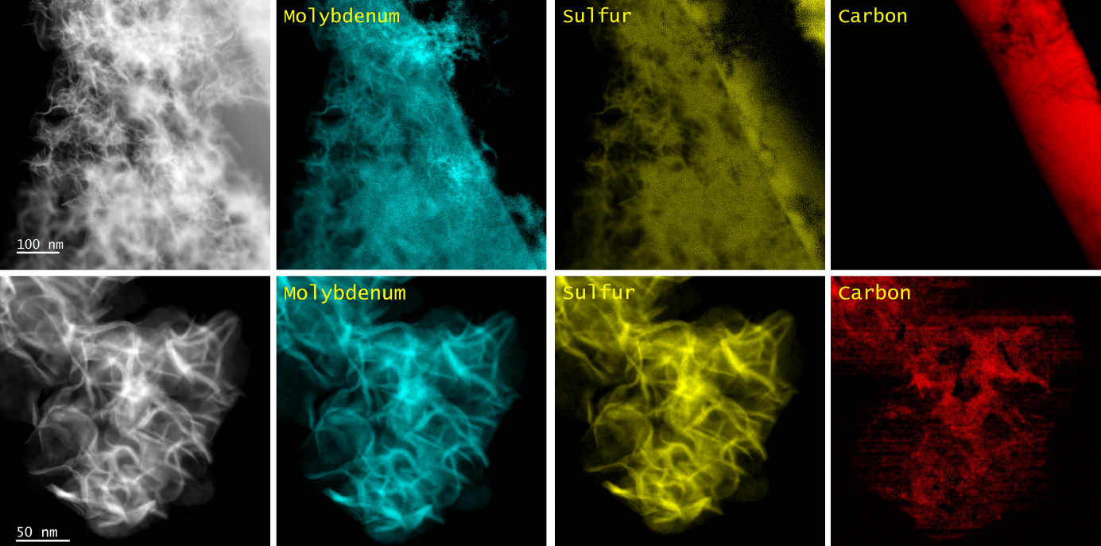
Fig. S13. HAADF-STEM-EELS images of MoS₂-HT/CNF taken at different resolutions, confirming its dispersed monolayer morphology after heat treatment at 973 Κ in a H₂S/H₂/N₂ atmosphere.

Fig. S14. S 2p XPS spectra for (a) MoS₂-HT and (b) MoS₂/C-ES.

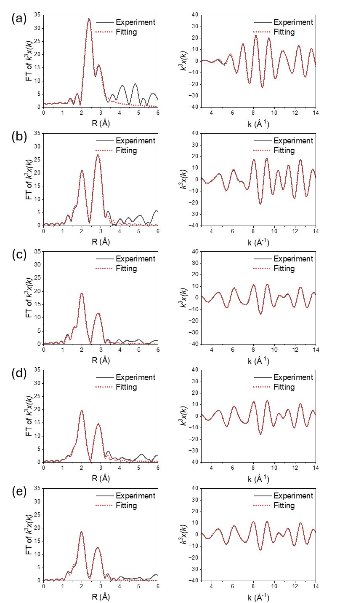
Fig. S15. Extended X-ray absorption fine structure (EXAFS) fitting curves in R-space (left panel) and k-space (right panel) for (a) Mo foil, (b) commercial MoS₂, (c) MoS₂-HT, (d) MoS₂-HT/CNF, and (e) MoS₂|CNF–ES.

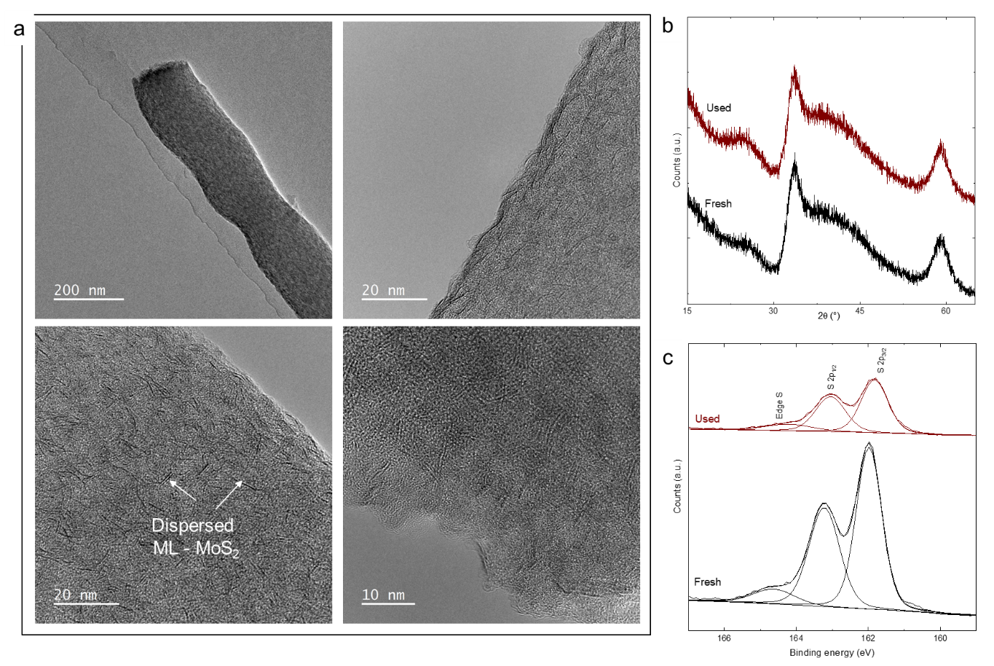
Fig. S16. (a) HR TEM images of MoS₂|CNF–ES after stability testing over 50 h and (b) XRD and (c) S 2p XPS spectra of MoS₂|CNF–ES before and after 50 h of the H₂S decomposition reaction

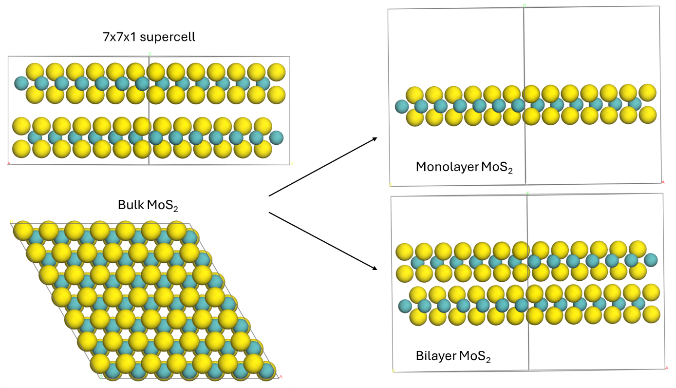
Fig. S17. Simulated bulk MoS₂ catalyst models showing both monolayer and bilayer MoS₂, representing monolayer and multilayer MoS₂ phases observed experimentally for MoS₂–HT and MoS₂|CNF–ES.

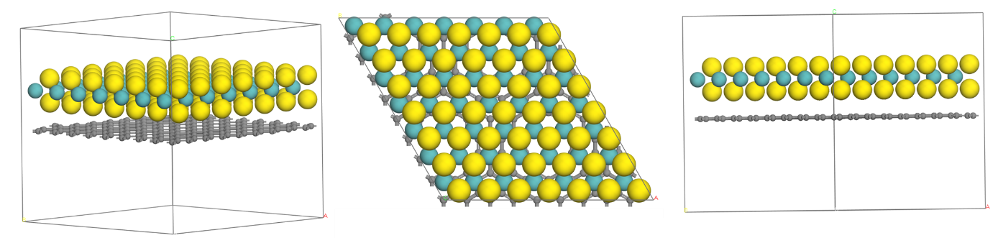
Fig. S18. Simulated supported MoS₂ catalyst models with a 7×7×1 supercell for MoS₂ and a 9×9×1 supercell of graphene representing the monolayer morphology of MoS₂|CNF–ES.

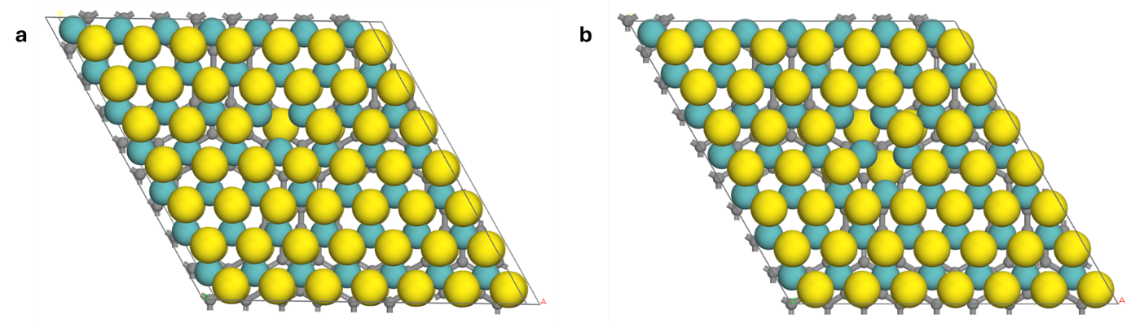
Fig. S19. Simulated supported MoS₂ catalyst models showing (a) a single S vacancy and (b) double S vacancies on the MoS₂/graphene, corresponding to MoS₂|CNF–ES.

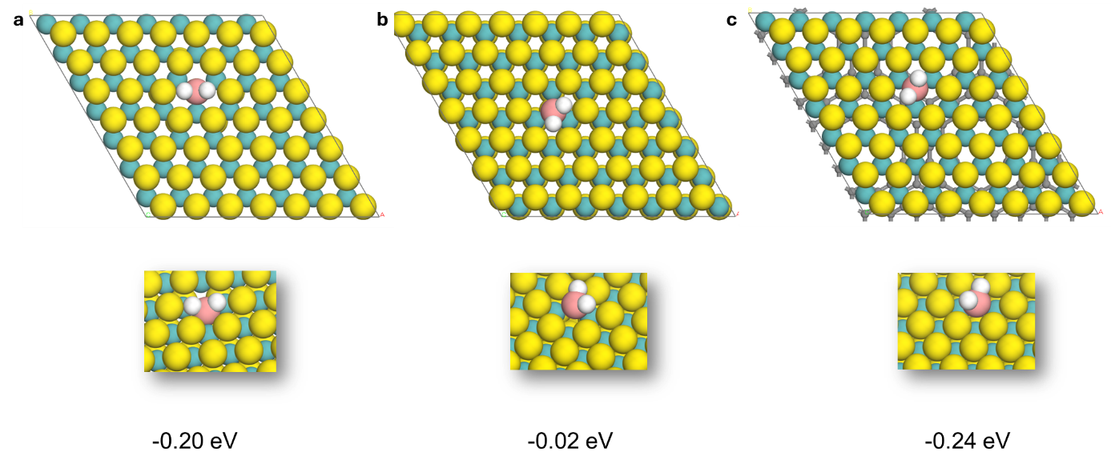
Fig. S20. H₂S adsorption on single S vacancies on (a) monolayer MoS₂, (b) bilayer MoS₂, and (c) monolayer MoS₂ supported on graphene, corresponding to MoS₂|CNF–ES.

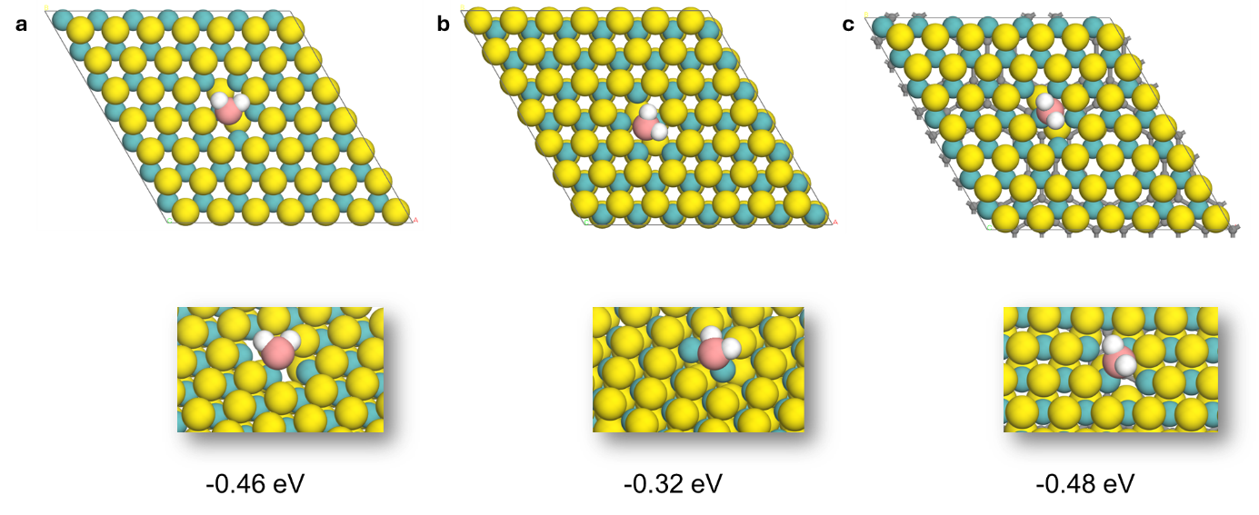
Fig. S21. H₂S adsorption on double S vacancies on (a) monolayer MoS₂, (b) bilayer MoS₂, and (c) monolayer MoS₂ supported on graphene, corresponding to MoS₂|CNF–ES.

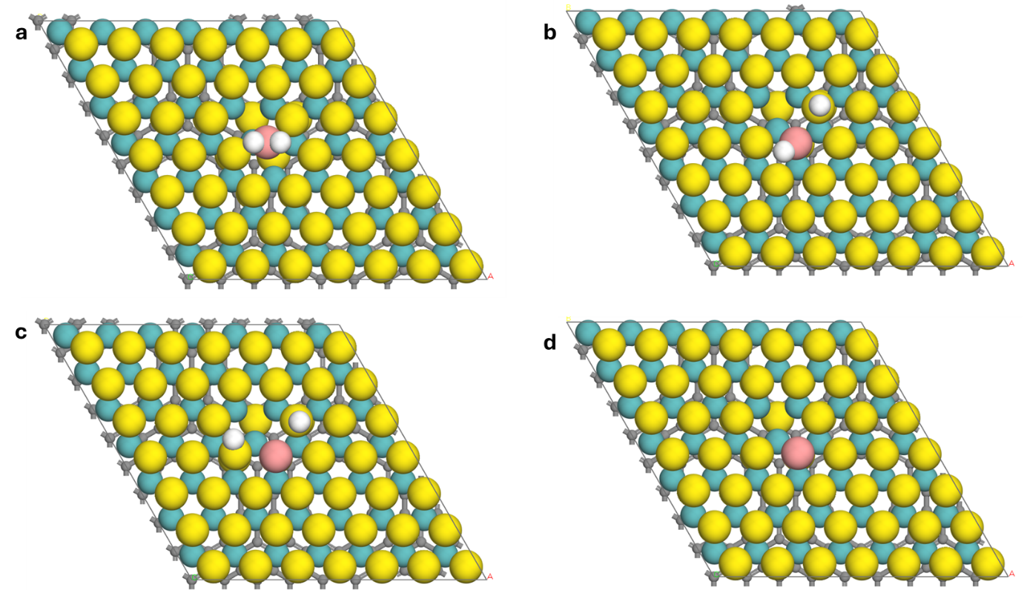

Fig. S22. Analysis of H₂S dissociation intermediates on monolayer MoS₂ supported on graphene, corresponding to MoS₂|CNF–ES: (a) H₂S*, (b) HS* + H*, (c) H* + H* + S, and (d) S*.

H₂S decomposition testing
The thermo-catalytic decomposition of H₂S was tested in a fixed-bed quartz reactor (I.D: 8 mm, length: 300 mm) equipped with ultra-torr fittings and Kalrez O-rings. The reactor operated within a temperature range of 773–973 Κ at atmospheric pressure (1 bar). Because our initial tests indicated that the thermocouple became active with H₂S above 773 Κ, it was wrapped around the exterior of the quartz reactor and positioned close to the catalytic bed. Additionally, temperature calibration was conducted to ensure an accurate isothermal zone within the catalyst-reactor zone. A dedicated sulfur trap, designed and fabricated in-house, was installed downstream immediately after the reactor to prevent sulfur sublimation and facilitate efficient sulfur removal before gas analysis. This trap was maintained at 5 Κ to condense sulfur vapor using a 50/50 mixture of water and ethylene glycol, while the reactor outlet was held at room temperature, allowing most of the produced sulfur to be trapped. This setup maximized sulfur capture before the gas stream entered the gas chromatograph (GC), minimizing contamination and ensuring accurate compositional analysis with no pressure buildup during the reaction due to elemental S allowing reactions to be carried out for a longer duration.
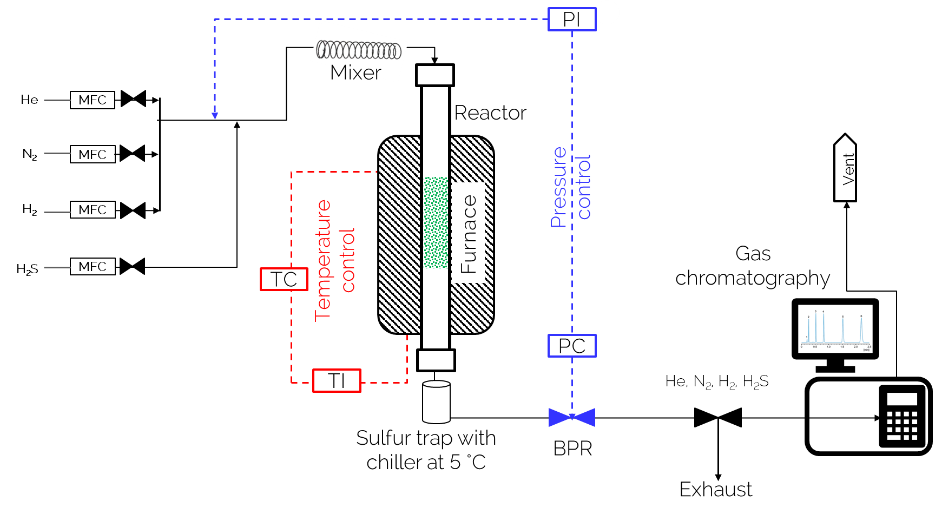
Fig. S23. Schematic diagram of the packed bed reactor fabricated for H₂S decomposition testing.

Table S1. Physicochemical properties of the catalysts.
Catalyst | BET surface area  (m² g⁻¹)ª | Mo  (wt.%)^{b} | O₂ uptake  (µmol g_{cat}⁻¹)^{c} | NO uptake  (µmol g_{cat}⁻¹)^{d}
MoS₂ – Comm. | 2.5 | 52.0 | 1.3 | -
MoS₂–HT | 42 | 49.0 | 19.4 | 22.2
MoS₂–HT/CNF | 30 | 14.5 | 12.4 | 18.3
MoS₂|CNF–ES | 180 | 14.0 | 91.5 | 131.8
ª Measured using N₂ physosorption.
^{b} Determined using ICP-OES analysis.
^{c} Determined from oxygen pulse chemisorption experiments at 313 Κ.
^{d} Determined from NO pulse chemisorption experiments at 313 Κ.

Table S2. Curve fitting of Mo K-edge EXAFS for Mo foil and MoS₂ samples.
Sample | Shell | CN^{[a]} | R^{[b]} [Å] | DW^{[c]} | R factor [%] | Mo–Mo/Mo–S  ratio
Mo Foil | Mo–Mo | 8 (set) | 2.729±0.004 | 0.0040±0.0001 | 5.5 | -
Mo Foil | Mo–Mo | 6 (set) | 3.148±0.005 | 0.0039±0.0003 | 5.5 | -
MoS₂-Comm. | Mo–S | 5.5±0.4 | 2.404±0.003 | 0.0031±0.0005 | 4.0 | 1.46
MoS₂-Comm. | Mo–Mo | 8.1±0.6 | 3.169±0.003 | 0.0037±0.0003 | 4.0 | 1.46
MoS₂-HT | Mo–S | 5.2±0.3 | 2.414±0.003 | 0.0031±0.0003 | 4.1 | 0.94
MoS₂-HT | Mo–Mo | 4.9±0.5 | 3.165±0.003 | 0.0054±0.0005 | 4.1 | 0.94
MoS₂-HT/CNF | Mo–S | 5.6±0.3 | 2.411±0.003 | 0.0032±0.0004 | 5.0 | 0.87
MoS₂-HT/CNF | Mo–Mo | 4.8±0.6 | 3.167±0.003 | 0.0042±0.0005 | 5.0 | 0.87
MoS₂|CNF–ES | Mo–S | 5.4±0.5 | 2.403±0.005 | 0.0036±0.0006 | 7.0 | 0.70
MoS₂|CNF–ES | Mo–Mo | 3.8±0.7 | 3.163±0.008 | 0.0037±0.0008 | 7.0 | 0.70
[a] Coordination number. [b] Bond distance. [c] Debye‒Waller factor.

Table S3. H₂S decomposition activity measurements for model refinement using the three catalysts.
Temperature  (Κ) | Space velocity  (mL g_{cat}⁻¹ h⁻¹) | Catalyst | Equilibrium  conversion (%) | Experimental  conversion (%)
973 | 72,000 | MoS₂–Comm. | 13.0 | 8.4
973 | 96,000 | MoS₂–Comm. | 13.0 | 7.4
973 | 120,000 | MoS₂–Comm. | 13.0 | 6.5
773 | 56,250 | MoS₂–Comm. | 2.0 | 1.5
873 | 56,250 | MoS₂–Comm. | 5.8 | 4.6
973 | 56,250 | MoS₂–Comm. | 13.0 | 12.6
773 | 26,400 | MoS₂–Comm. | 1.6 | 0.7
873 | 26,400 | MoS₂–Comm. | 4.5 | 2.1
973 | 26,400 | MoS₂–Comm. | 10.1 | 8.4
973 | 120,000 | MoS₂–HT | 13.0 | 12.8
773 | 120,000 | MoS₂–HT | 2.0 | 1.9
873 | 120,000 | MoS₂–HT | 5.8 | 5.8
973 | 93,600 | MoS₂–HT | 10.9 | 10.8
973 | 21,600 | MoS₂–HT | 6.8 | 6.6
773 | 750,000 | MoS₂|CNF–ES | 2.0 | 1.7
873 | 750,000 | MoS₂|CNF–ES | 5.8 | 5.4
973 | 390,000 | MoS₂|CNF–ES | 10.9 | 10.1
973 | 750,000 | MoS₂|CNF–ES | 13.0 | 11.4
973 | 90,000 | MoS₂|CNF–ES | 6.8 | 6.8
973 | 96,000 | MoS₂–HT/CNF | 13.0 | 12.5

Table S4. Rate constants for the catalysts determined using the developed kinetic model.
Catalyst | Rate constant (k_{ref}) at 973 Κ  (mol_{H2S} atm⁻¹ g_{cat}⁻¹ s⁻¹)
MoS₂-Comm. | 0.00012
MoS₂-HT | 0.00063
MoS₂-HT-200-CA | 0.00024
MoS₂-HT-200-OA | 0.00040
MoS₂|CNF–ES (5%PAN) | 0.00130
MoS₂|CNF–ES | 0.00190
MoS₂|CNF–ES (15%PAN) | 0.00098
MoS₂-HT/CNF | 0.00042

Table S5. Intrinsic rate and turnover frequency (TOF) for the catalysts determined using the developed kinetic model.
Catalyst | Rate  (mol H₂S g^{–1} s^{–1}) | TOF  (s⁻¹)ª | TOF  (s⁻¹)^{b}
MoS₂-HT | 1.2×10^{–5} | 0.9 | 1.7
MoS₂-HT/CNF | 8.2×10^{–6} | 0.7 | 1.3
MoS₂|CNF–ES | 3.8×10^{–5} | 0.4 | 0.9
ª Net TOF per exposed Mo.
^{b} Net TOF per exposed sulfur vacancies.

All of the catalysts were pretreated in situ using H₂ at 573 Κ for 3 h. Reaction activity tests were conducted using a tubular fixed-bed reactor at 1 bar with 2vol% H₂S in N₂ within a temperature range of 773–973 Κ. The net TOF for H₂S decomposition using these catalysts was calculated based on NO chemisorption experiments, with the corresponding rate constant obtained from the model. The stoichiometric factors of 0.5–1 and 0.25–0.5 for exposed Mo atoms and sulfur vacancies, respectively, and the average net TOF are reported in Table S5.²

Although MoS₂-HT exhibited a lower NO uptake and overall H₂S conversion rate compared to MoS₂/C₁₀-ES, its TOF was notably higher. This discrepancy arose from its very low Mo dispersion (~0.43%), meaning that only a small fraction of Mo atoms were exposed at the surface. These few accessible sites operated with exceptionally high intrinsic activity, inflating the TOF value. In contrast, MoS₂/C₁₀-ES had substantially higher site accessibility, enabling more Mo atoms to participate in the reaction. As a result, while its intrinsic TOF was lower, its overall activity per gram of catalyst was significantly higher, making it more effective and practical for H₂S conversion.

Table S6. Comparison of H₂S decomposition results with previously reported studies.
Catalyst | Space velocity  (mL h⁻¹ g_{cat}⁻¹) | X_{H2S}  (%) | Temperature  (Κ) | H₂S  (vol%) | Stability  (h) | Ref.
MoS₂-Comm. | 120,000 | 6.5 | 973 | 2 | - | This study
MoS₂-HT | 120,000 | 12.8 | 973 | 2 | - | This study
MoS₂|CNF–ES | 750,000 | 10.1 | 973 | 2–15 | 50 | This study
NiAlMo | 24,000 | 43 | 1073 | 0.1 | 7 | ³
MoS₂@SiO₂ | 48,000 | 54.7 | 1073 | 0.25 | 30 | ⁴
CoS_{x}-MoS_{x} | 120,000 | 10 | 1073 | 5 | 8 | ⁵
20% Co/CeO₂ | 13,500 | 15 | 973 | 1 | 24 | ⁶
LaSr_{0.5}Mo_{0.5}O₃ | 45,000 | 16 | 1073 | 1 | - | ⁷
10%Fe/activated carbon | 60,000 | 13 | 973 | 1 | 1 | ⁸
La_{0.9}Sr_{0.1}Cr_{0.25}Co_{0.75}O₃ | 45,000 | 8 | 973 | 1 | - | ⁹

Table S7. Vacancy clustering energy for the simulated catalyst models.
System | S-vacancy type | ΔES_{vac}(μS₂) (eV) | ΔES_{vac} (H₂-assisted) (eV) | ΔES_{vac} (H₂-assisted, 700 °C) (eV) | ΔES_{vac} (H₂-assisted, 800 °C) (eV)
ML7×7–MoS₂ | Single | 1.83 | 0.01 | –0.79 | –0.88
BL7×7–MoS₂ | Single | 1.91 | 0.17 | –0.63 | –0.72
ML–MoS₂–graphene | Single | 1.82 | –0.03 | –0.83 | –0.92
ML7×7–MoS₂ | Double | 3.64 | –0.52 | –2.11 | –2.29
BL7×7–MoS₂ | Double | 3.81 | –0.20 | –1.79 | –1.97
ML–MoS₂–graphene | Double | 3.60 | –0.62 | –2.21 | –2.39

References:
1. Almofleh, A. et al. Designing sulfide catalysts for H₂S dissociation to H₂ based on reaction descriptors and microkinetics. Appl. Catal. B Environ. Energy 361, 124605 (2025).
2. Hu, J. et al. Sulfur vacancy-rich MoS₂ as a catalyst for the hydrogenation of CO₂ to methanol. Nat. Catal. 2021 43 4, 242–250 (2021).
3. Jiang, G. et al. Thermal Decomposition of H₂S at Low Temperature on Mo-Containing Catalysts Derived from MAlO (M = Mg, Co, and Ni) Layered Double Hydroxides. Ind. Eng. Chem. Res. 62, 7224–7234 (2023).
4. Kwok, K. M., Ong, S. W. D., Chen, L. & Zeng, H. C. Constrained Growth of MoS₂ Nanosheets within a Mesoporous Silica Shell and Its Effects on Defect Sites and Catalyst Stability for H₂S Decomposition. ACS Catal. 8, 714–724 (2018).
5. Xu, J. et al. Solution combustion synthesis of CoS_{x}, MoS_{x}, CoS_{x}-MoS_{x} and their catalytic activity in H₂ production from H₂S decomposition. Int. J. Hydrogen Energy 48, 8807–8818 (2023).
6. Kraia, T., Kaklidis, N., Konsolakis, M. & Marnellos, G. E. Hydrogen production by H₂S decomposition over ceria supported transition metal (Co, Ni, Fe and Cu) catalysts. Int. J. Hydrogen Energy 44, 9753–9762 (2019).
7. Guldal, N. O., Figen, H. E. & Baykara, S. Z. New catalysts for hydrogen production from H₂S: Preliminary results. Int. J. Hydrogen Energy 40, 7452–7458 (2015).
8. Dogan, M. Y., Tasdemir, H. M., Arbag, H., Yasyerli, N. & Yasyerli, S. H₂ production via H₂S decomposition over activated carbon supported Fe- and W- catalysts. Int. J. Hydrogen Energy 75, 483–495 (2024).
9. Guldal, N. O., Figen, H. E. & Baykara, S. Z. Perovskite catalysts for hydrogen production from hydrogen sulfide. Int. J. Hydrogen Energy 43, 1038–1046 (2018).

