Supplementary methods
Next generation sequencing
After collection of bone marrow or peripheral blood of the patients into tubes containing ethylene diamine tetraacetic acid (EDTA) as anticoagulant and isolation of mononuclear cells, 1 μg of DNA was extracted for construction of a whole genomic DNA library. The target genome (325 hematological tumor-related genes, Supplementary Table S4) was amplified using PCR primers, the target region DNA was enriched, and sequencing was performed using the Ion Torrent sequencing platform, with an average gene coverage rate of 98.1% and an average sequencing depth of 1314 × and more than 20 × for 95% of the target region DNA.
The NGS bioinformatics pipeline comprised: Raw data quality control by FastQC followed by adapter and low-quality base trimming using Trimmomatic; Alignment to the GRCh37.p13 reference genome using BWA-MEM; PCR duplicate marking with Picard; Germline variant detection by GATK HaplotypeCaller and somatic variant detection by Mutect2; Variant annotation for population frequency with dbSNP v155, cancer mutations using COSMIC v96, and clinical pathogenicity via ClinVar 2024 release; Germline variants filtered by GATK VQSR, somatic variants filtered at depth ≥1314× and VAF ≥2%; Functional impact prediction through ANNOVAR or SnpEff; Final reporting prioritized ClinVar pathogenic/likely pathogenic variants, COSMIC driver mutations, and ACMG-classified variants.

Detection of cytokine levels
Peripheral blood (PB) samples were collected at the time of the first visit to the Department of Hematology, the Second Hospital of Tianjin Medical University, and tested within 2 hours. Several inflammatory biomarkers, including interleukin (IL) - 1β, IL - 2, IL - 4, IL - 5, IL - 6, IL - 8, IL - 10, IL - 12, IL - 17A, IL - 17F, IL - 22, tumor necrosis factor (TNF) - α, TNF - β, and interferon (IFN) - γ, were captured by microspheres of known volume and fluorescence intensity using liquid chip multifactor flow detection technology. The corresponding fluorescence was detected by flow cytometry, and the content of corresponding cytokines of the sample to be tested was obtained based on the fluorescence intensity. All flow cytometry analyses were performed using a Beckman CytoFLEX LX flow cytometer.
Monocyte isolation
Fresh human peripheral blood was collected, and human peripheral blood mononuclear cells (PBMCs) were isolated and extracted. The PBMCs were resuspended in phosphate-buffered saline (PBS) containing 2% fetal bovine serum (FBS), and the cell concentration was adjusted to 1×10⁶-5×10⁶ cells/mL. Subsequently, anti-human CD45-FITC and anti-human CD14-PE antibodies were added, followed by incubation at 4°C for 20 minutes in the dark. After incubation, the cells were washed with PBS. A flow cytometer (BD FACSAria) was used to sort CD45⁺ leukocytes, and finally, CD45⁺CD14⁺ cells (i.e., monocytes) were isolated for subsequent co-culture experiments.
Cell Co-Culture Model
A cell co-culture model was established using Trans-well chambers (Corning Inc., New York, USA). Monocytes in 6-well plates were placed in the lower chamber, while human atrial fibroblasts were seeded in the upper chamber. After 24 hours of co-culture, the fibroblasts were collected for subsequent experiments.
Western blot analysis
Fibroblasts in the co-culture system were collected, and RIPA lysis buffer containing protease and phosphatase inhibitors was added to the cells on ice for protein extraction. Protein samples were separated in a 12.5% polyacrylamide gel for 1 hour, then transferred to a polyvinylidene fluoride (PVDF) membrane overnight at 4°C. At room temperature, the membrane was blocked with Tris-buffered saline (TBS) containing 5% bovine serum albumin (BSA) for 1 hour. Primary antibody was added, and the membrane was incubated overnight at 4°C. After incubation, the membrane was washed 3 times with TBS containing Tween (TBST), 10 minutes each time. Subsequently, the corresponding fluorescently labeled secondary antibody (anti-mouse or anti-rabbit secondary antibody selected according to the species of the primary antibody) was added, and the membrane was incubated at 4°C for 2-3 hours. Finally, the membrane was washed again 3 times with TBST, 10 minutes each time.β-actin were used as internal references. Images were acquired, and densitometric analysis was performed using Image J software.

Supplementary Table S1. Baseline characteristics of hematologic malignancy patients stratified by AF status
 | AF (n=164) | non-AF (n=1569) | P-value
Follow-up time, y media (range) | 3 (1-21) | 4 (1-29) | 0.091
Age, media (range) | 70 (15-88) | 61 (3-92) | <0.001***
Age, years |  |  | <0.001***
≤40 | 4 (2.4%) | 255(16.3%)
41-50 | 6 (3.7%) | 182 (11.6%)
51-60 | 23 (14.0%) | 346 (22.1%)
61-70 | 53 (32.3%) | 478 (30.5%)
＞70 | 78 (47.6%) | 308 (19.6%)
Male, n (%) | 100 (61.0%) | 834 (53.2%) | 0.059
Diagnosis
Ph⁻MPN (n=440), n (%) | 69 (42.1%) | 467 (29.8%)
CML (n=38), n (%) | 2 (1.2%) | 48 (3.1%)
AML (n=173), n (%) | 18 (11.0%) | 279 (17.8%)
MDS (n=168), n (%) | 28 (17.1%) | 373 (23.8%)
MDS/MPN (n=27), n (%) | 5 (3.0%) | 37 (2.4%)
Lymphoid Malignancy (n=328), n (%) | 42 (25.6%) | 365 (23.3%)
At the time of diagnosis
HB, g/L media (range) | 108.5 (28-214) | 105 (21-261) | 0.878
WBC, ×10⁹/L media (range) | 7.55 (0.01-181) | 6.70 (0.01-498.7) | 0.276
Monocytes, ×10⁹/L media (range) | 0.47 (0.01-6.87) | 0.35 (0.01-75.8) | 0.072
PLT, ×10⁹/L media (range) | 247 (6-1670) | 175.5 (1-2433) | 0.044*
Anthracycline drug exposure, n (%) | 30 (18.3%) | 220 (14%) | 0.160
Hypertension, n (%) | 68 (41.5%) | 493(31.4%) | 0.011*
Hyperlipidemia, n (%) | 8 (4.9%) | 96 (6.1%) | 0.608
Diabetes, n (%) | 35 (21.3%) | 230 (14.7%) | 0.030*
Smoking | 44 (26.8%) | 273 (17.4%) | 0.004**
Death, n (%) | 72 (43.9%) | 267 (17.0%) | <0.001***
Ph⁻ MPN, philadelphia negative myeloproliferative neoplasm; CML, chronic myeloid leukemia; AML, acute myeloid leukemia; MDS, myelodysplastic syndrome; HB, hemoglobin; WBC, white blood cell; PLT, platelet count; AF, atrial fibrillation. * P < 0.05; ** P < 0.01; *** P < 0.001.

Supplementary Table S2. Baseline characteristics stratified by spliceosome gene mutation status after PSM
 | PSM 1 (gender, age, hypertension, smoking, diabetes and hyperlipidemia) |  |  | PSM 2 (gender, age, hypertension, smoking, diabetes, hyperlipidemia, and exposure to anthracycline drugs)
 | Spliceosome (n=147) | no-spliceosome (n=147) | P-value | Spliceosome (n=142) | no-spliceosome (n=142) | P-value
Age, media (range) | 68 (20-91) | 69 (15-89) | 0.919 | 68 (20-91) | 68 (15-89) | 0.705
Male, n (%) | 96 (65.3%) | 100 (68.0%) | 0.711 | 92 (64.8%) | 95 (66.9%) | 0.802
Anthracycline drug exposure, n (%) | 21 (14.3%) | 19 (12.9%) | 0.865 | 21 (14.8%) | 16 (11.3%) | 0.481
Hypertension, n (%) | 58 (39.5%) | 58 (39.5%) | 1.000 | 57 (40.1%) | 56 (39.4%) | 1.000
Hyperlipidemia, n (%) | 1 (0.7%) | 2 (1.4%) | 1.000 | 1 (0.7%) | 1 (0.7%) | 1.000
Diabetes, n (%) | 30 (20.4%) | 22 (15.0%) | 0.285 | 28 (19.7%) | 20 (14.1%) | 0.268
Smoking | 40 (27.2%) | 46 (31.3%) | 0.522 | 40 (28.2%) | 49 (34.5%) | 0.306
ACS, n (%) | 22 (15.0%) | 24 (16.3%) | 0.873 | 22 (15.5%) | 20 (14.1%) | 0.867
PSM1, Propensity Score Matching; ACS, acute coronary syndrome.

Supplementary Table S3. Causal mediation analysis of LAD in spliceosome gene-associated AF risk
Effect Type | Group | Estimate | 95% CI (Lower ~ Upper) | P-value
ACME  (Average Causal Mediation Effect) | No-spliceosome gene mutation | 0.011 | 0.002 ~ 0.020 | 0.006**
ACME  (Average Causal Mediation Effect) | spliceosome gene mutation | 0.013 | 0.003 ~ 0.030 | 0.006**
ACME  (Average Causal Mediation Effect) | Average | 0.012 | 0.003 ~ 0.020 | 0.006**
ADE  (Average Direct Effect) | No-spliceosome gene mutation | 0.036 | -0.023 ~ 0.100 | 0.214
ADE  (Average Direct Effect) | spliceosome gene mutation | 0.038 | -0.024 ~ 0.110 | 0.214
ADE  (Average Direct Effect) | Average | 0.037 | -0.023 ~ 0.100 | 0.214
Total Effect | - | 0.049 | -0.012~ 0.120 | 0.106
Proportion Mediated | No-spliceosome gene mutation | 0.219 | -0.868~ 1.890 | 0.112
Proportion Mediated | spliceosome gene mutation | 0.266 | -0.747 ~ 1.800 | 0.112
Proportion Mediated | Average | 0.242 | -0.807 ~ 1.850 | 0.112
AF, atrial fibrillation. *P<0.05, ** P<0.01.

Supplementary Table S4. List of 325 Genes Included in the Next-Generation Sequencing Panel

ABCB1 | ABL1 | AKT1 | AKT3 | ALK | AMER1 | ANKRD26 | APC | ARAF | ARC
ARID1A | ARID1B | ARID2 | ASXL1 | ASXL2 | ATG2B | ATM | ATRX | B2M | BCL2
BCL6 | BCOR | BCORL1 | BCR | BIRC3 | BLM | BLNK | BRAF | BRCA1 | BRCA2
BRCC3 | BRINP3 | BTG1 | BTG2 | BTK | CACNA1E | CALR | CARD11 | CASP8 | CBFB
CBL | CBLB | CBLC | CCND1 | CCND2 | CCND3 | CCR4 | CD274 | CD28 | CD58
CD79A | CD79B | CDC25C | CDKN1A | CDKN1B | CDKN2A | CDKN2B | CDKN2C | CEBPA | CHD8
CIITA | CNOT3 | COL12A1 | CRBN | CREBBP | CRLF2 | CROCC | CSF1R | CSF3R | CSMD1
CSNK1A1 | CTCF | CTLA4 | CUL4B | CUX1 | CXCR4 | CXCR5 | CYLD | DDR2 | DDX11
DDX3X | DDX41 | DHX15 | DIS3 | DKC1 | DNAH9 | DNM2 | DNMT3A | DNMT3B | DOT1L
DPYD | DUSP22 | EBF1 | ECT2L | EED | EGFR | EGR1 | EGR2 | EIF2A | ELANE
EP300 | EPCAM | EPHA7 | EPOR | EPPK1 | ERBB2 | ERBB3 | ERBB4 | ERG | ETNK1
ETV6 | EZH2 | FAM46C | FAS | FAT1 | FBXW7 | FGFR1 | FGFR2 | FGFR3 | FLT3
FOXO1 | FOXO3 | GATA1 | GATA2 | GATA3 | GFI1 | GNA13 | GNAS | GSKIP | GSTM1
GSTP1 | HAX1 | HRAS | ID3 | IDH1 | IDH2 | IFNLR1 | IGLL5 | IKZF1 | IKZF3
IL7R | INPP5D | IRF4 | IRF8 | ITK | JAK1 | JAK2 | JAK3 | KDM5A | KDM6A
KIT | KLF2 | KLHL6 | KMT2A | KMT2B | KMT2C | KMT2D | KRAS | LMO2 | LTB
LYN | LYST | MAF | MAFA | MAFB | MALT1 | MAP2K1 | MAP2K4 | MAPK1 | MAX
MDM2 | MECOM | MED12 | MEF2B | MET | MIR142 | MLH1 | MPL | MS4A1 | MSH2
MSH6 | MTHFR | MTOR | MTRR | MUC16 | MUM1 | MYBBP1A | MYC | MYD88 | MYH11
MYOM2 | NARS | NCOR1 | NCOR2 | NF1 | NF2 | NFKB1 | NFKB2 | NFKBIE | NOTCH1
NOTCH2 | NPM1 | NQO1 | NRAS | NT5C2 | NTRK1 | NTRK2 | NTRK3 | NUDT15 | P2RY8
PAX5 | PBRM1 | PBX1 | PCLO | PDCD1LG2 | PDGFRA | PDGFRB | PHF6 | PIGA | PIK3CA
PIM1 | PLCG1 | PLCG2 | PML | PMS2 | POT1 | PPM1D | PRDM1 | PRKCB | PRPF40B
PRPF8 | PRPS1 | PTEN | PTK2B | PTPN1 | PTPN11 | PTPRD | PTPRT | RAD21 | RAF1
RARA | RB1 | RBBP6 | REL | RELN | RET | RHOA | ROBO1 | ROBO2 | ROS1
RPL10 | RPS15 | RPS6KB1 | RUNX1 | SAMD9 | SAMD9L | SAMHD1 | SETBP1 | SETD2 | SF1
SF3A1 | SF3B1 | SGK1 | SH2B3 | SLCO1B1 | SMAD4 | SMARCA2 | SMARCA4 | SMARCB1 | SMC1A
SMC1B | SMC2 | SMC3 | SMN1 | SMO | SOCS1 | SOD2 | SOS1 | SPEN | SRP72
SRSF2 | STAG2 | STAT1 | STAT2 | STAT3 | STAT4 | STAT5A | STAT5B | STAT6 | SUFU
SUZ12 | SYK | TAL1 | TBL1XR1 | TCF3 | TERC | TERT | TET1 | TET2 | TNFAIP3
TNFRSF14 | TP53 | TP63 | TP73 | TPMT | TRAF2 | TRAF3 | TSC1 | TTN | TYK2
U2AF1 | U2AF2 | UNC13D | USP7 | VEGFA | VPREB1 | WAC | WHSC1 | WT1 | XPO1
ZAP70 | ZBTB7A | ZMYM3 | ZNF292 | ZRSR2

Figure S1. Incidence of AF and CHIP in hematologic malignancies
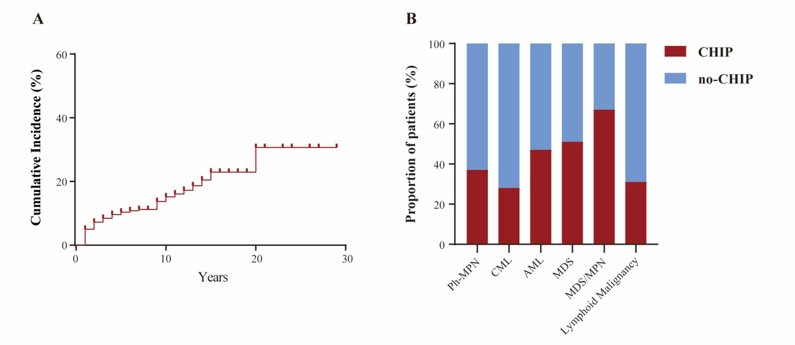
- Incidence of AF in patients with hematologic malignancies. (B) Incidence of CHIP in different types of hematologic malignancies.

Figure S2. Spliceosome gene mutations are associated with AF risk in hematologic malignancies
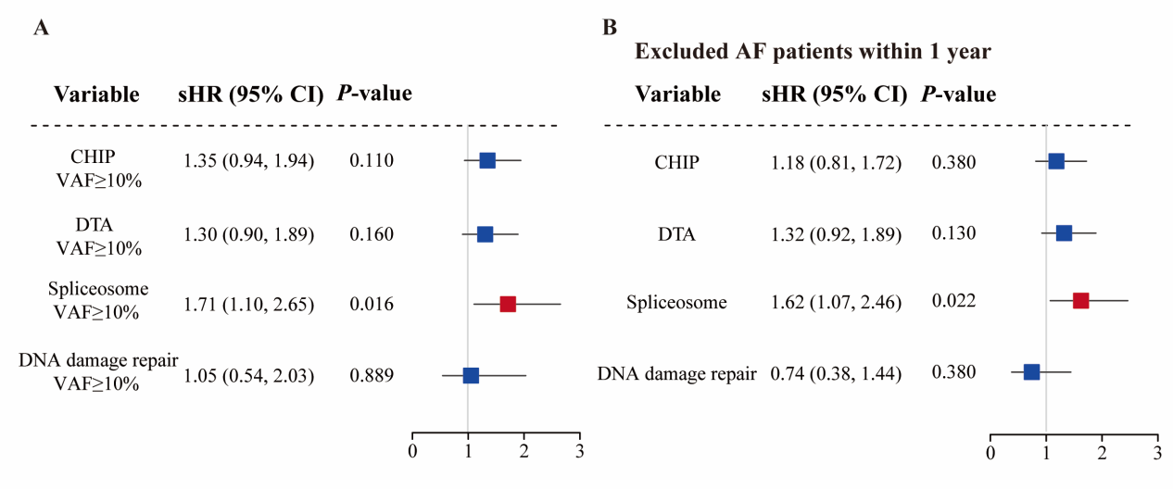In patients with hematologic malignancies, (A) Association between CHIP-related gene mutation burden ≥ 10% and AF risk. (B) Association between CHIP-related gene mutations and AF risk, excluding AF patients within 1 year. Adjustments were made for gender, age, hypertension, smoking, diabetes, hyperlipidemia, and exposure to anthracycline drugs. HR, hazard ratio; AF, atrial fibrillation; CHIP, Clonal Hematopoiesis of Indeterminate Potential; DTA, DNMT3A, TET2, or ASXL1 mutations.

Figure S3. Cardiac structural changes by spliceosome gene mutations and AF status in patients with hematologic malignancies
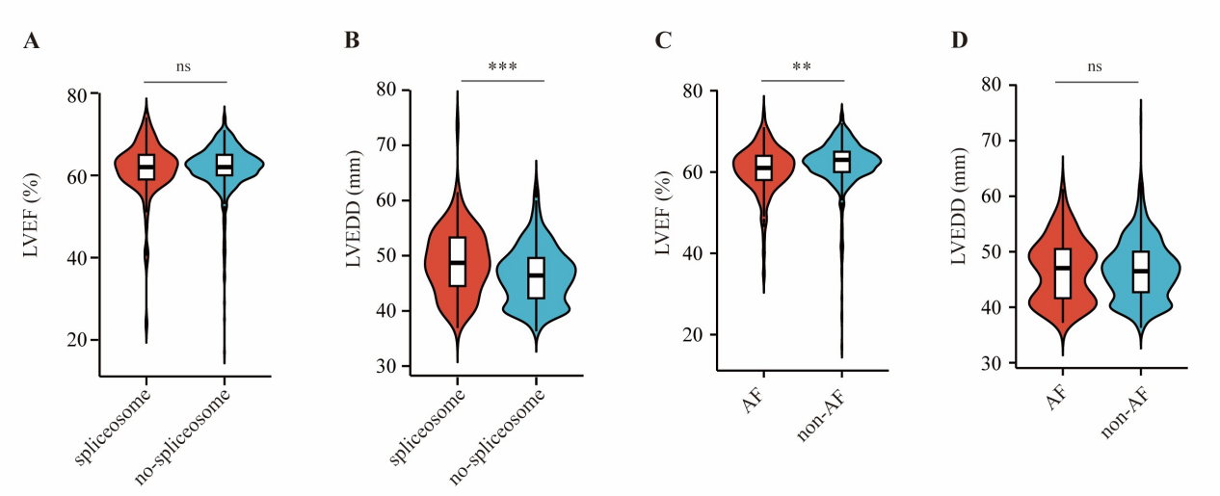(A-B) Comparison of LVEF and LVEDD between patients with spliceosome gene mutations and those without. (C-D) Comparison of LVEF and LVEDD between the AF group and the non-AF group. LVEF, left ventricular ejection fraction; LVEDD, Left ventricular end-diastolic diameter; AF, atrial fibrillation. ** P < 0.01; *** P < 0.001.

Figure S4
