Supplementary Online Content

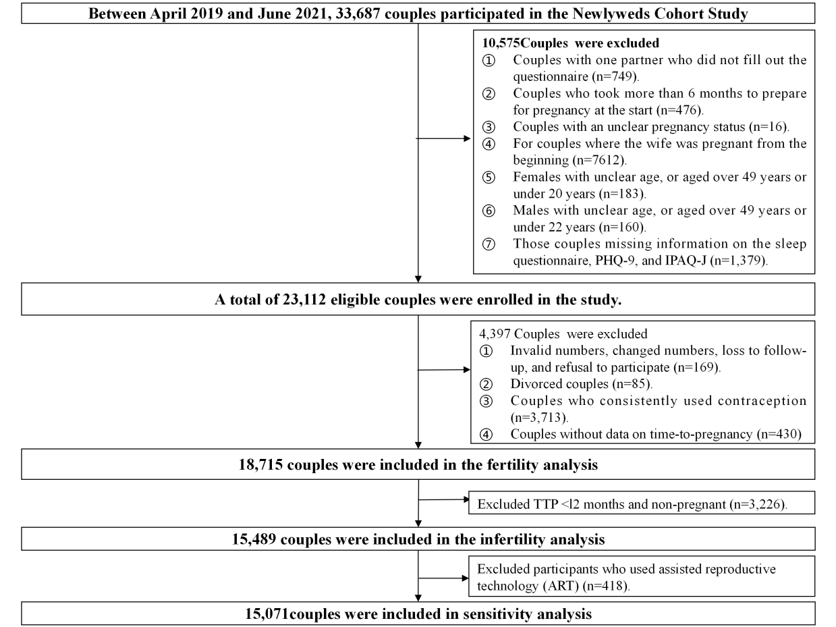
eFigure 1. Flowchart of Participants Included in the Study

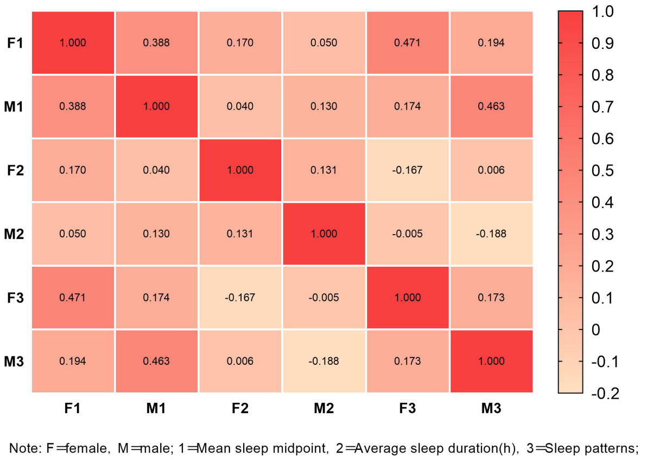
eFigure 2. Spearman's Correlation Analysis between Husbands and Wives Sleep Characteristics

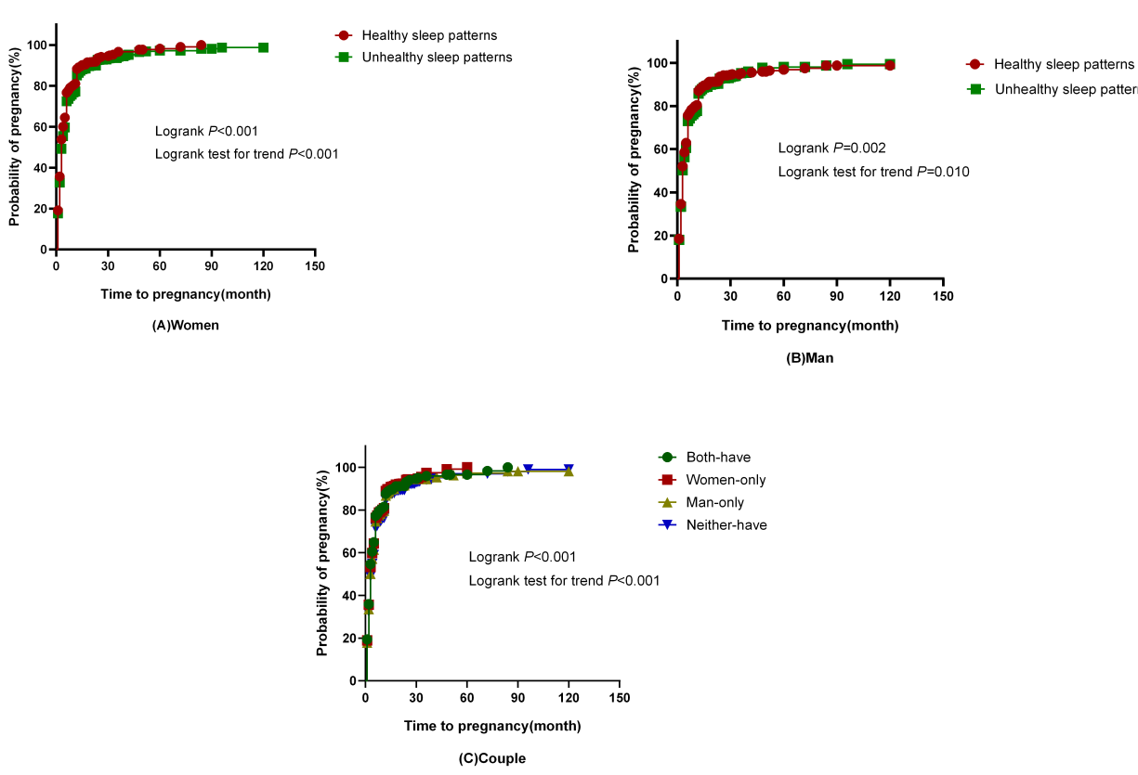

eFigure 3. Kaplan–Meier Survival Curves for Probability of Pregnancy.

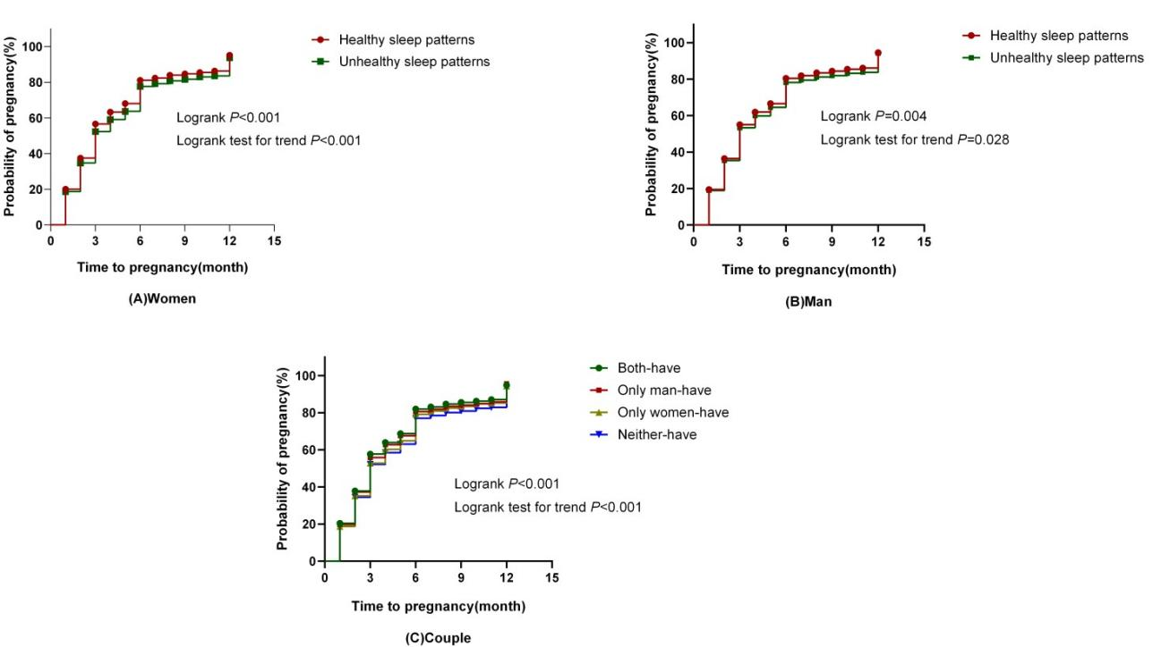
eFigure 4. Kaplan-Meier Survival Curve of Pregnancy Probability after Removing 5% Extreme Values

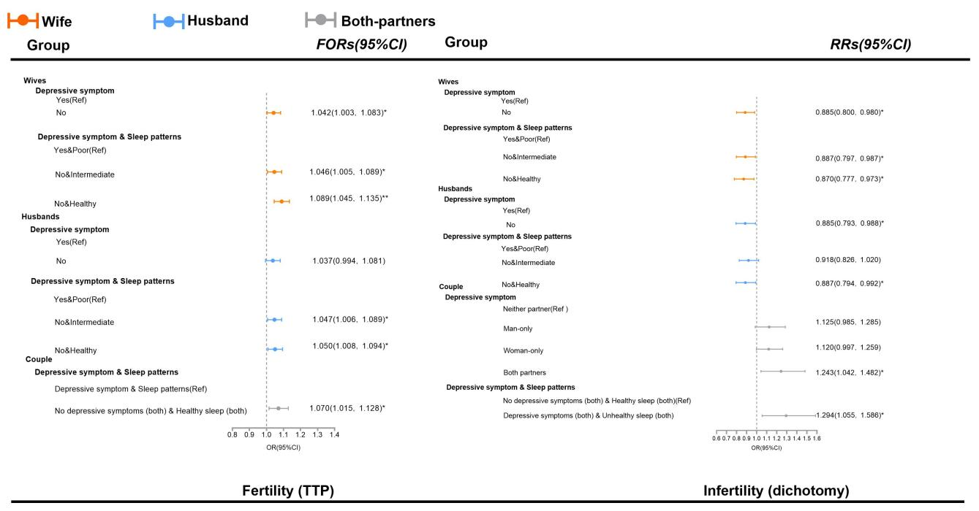
eFigure 5. Interactive Effects of Preconception Sleep and Depressive Symptoms on Fertility Outcomes
Adjusted fertility odds ratios (FORs; 95% CIs) for time to pregnancy (TTP) and adjusted risk ratios (RRs; 95% CIs) for infertility (defined as TTP >12 months or requiring ART) in relation to depressive symptoms and sleep pattern&depressive symptoms.
FORs were estimated from a Cox proportional hazards model (left panel) and represent continuous TTP: a FOR <1 indicates shorter TTP (higher fecundability), and a FOR >1 indicates longer TTP (lower fecundability). RRs were estimated from a logistic regression model (right panel) and indicate dichotomous infertility risk: an RR >1 corresponds to elevated risk and an RR <1 to reduced risk.
All models were adjusted for regional areas, both partners' ages, BMI, socioeconomic status, marital status, age of sexual debut, unhealthy lifestyle scores, wives' adverse pregnancy history, and live birth history. Statistical significance is indicated as * P<0.05, ** P<0.01. The horizontal dashed line at 1.0 represents the null association.

eTable 1. Sleep Characteristics of Childbearing Age Couples by Pregnancy Status Based on the Follow-Up of 24 Months (n=18 715) ª.
Sleep characteristics | Total  (N=18 715) | No-pregnant  (N=4 163) | Pregnant  (N=14 552) | χ^{2 b} | φ/V ^{c}
Wives
Average sleep duration(h) |  |  |  | 11.92** | 0.03**
＜7 | 5154(27.5) | 1211(29.1) | 3943(27.1)
7～8 | 9391(50.2) | 1992(47.9) | 7399(50.8)
≥8 | 4170(22.3) | 960(23.1) | 3210(22.1)
Workday sleep duration(h) |  |  |  | 9.41** | 0.02**
＜7 | 7176(38.3) | 1656(39.8) | 5520(37.9)
7～8 | 8505(45.4) | 1805(43.4) | 6700(46.0)
≥8 | 3034(16.2) | 702(16.9) | 2332(16.0)
Weekend sleep duration(h) |  |  |  | 2.90 | 0.01
＜7 | 2816(15.0) | 661(15.9) | 2155(14.8)
7～8 | 6049(32.3) | 1334(32.0) | 4715(32.4)
≥8 | 9850(52.6) | 2168(52.1) | 7682(52.8)
Mean sleep midpoint |  |  |  | 24.13** | 0.04**
earlier than 2:30 | 3105(16.6) | 687(16.5) | 2418(16.6)
2:30～3:30 | 10051(53.7) | 2116(50.8) | 7935(54.5)
After 3:30 | 5559(29.7) | 1360(32.7) | 4199(28.9)
Social jet lag(h) |  |  |  | 2.14 | -0.01
<1 | 15851(84.7) | 3496(84.0) | 12355(84.9)
≥1 | 2864(15.3) | 667(16.0) | 2197(15.1)
Difficulty falling asleep |  |  |  | 8.71** | -0.02**
No | 15215(81.3) | 3319(79.7) | 11896(81.7)
Yes | 3500(18.7) | 844(20.3) | 2656(18.3)
Sleep quality |  |  |  | 8.23** | -0.02**
Good | 16291(87.0) | 3569(85.7) | 12722(87.4)
Poor | 2424(13.0) | 594(14.3) | 1830(12.6)
Snoring |  |  |  | 61.22** | 0.06**
Never | 11296(60.4) | 2367(56.9) | 8929(61.4)
Occasionally | 6013(32.1) | 1374(33.0) | 4639(31.9)
Frequently | 1406(7.50) | 422(10.1) | 984(6.80)
Night awakenings |  |  |  | 7.86* | 0.02*
Never | 5029(26.9) | 1129(27.1) | 3900(26.8)
Occasionally | 12129(64.8) | 2646(63.6) | 9483(65.2)
Frequently | 1557(8.3) | 388(9.3) | 1169(8.0)
Chronotype |  |  |  | 27.94** | 0.04**
Intermediate types | 6174(33.0) | 1265(30.4) | 4909(33.7)
Early types | 6180(33.0) | 1349(32.4) | 4831(33.2)
Late types | 6361(34.0) | 1549(37.2) | 4812(33.1)
Sleep characteristics | Total  (N=18 715) | No-pregnant  (N=4 163) | Pregnant  (N=14 552) | χ^{2 b} | φ/V ^{c}
Excessive daytime sleepiness |  |  |  | 0.06 | 0.00
No | 12262(65.5) | 2734(65.7) | 9528(65.5)
Yes | 6453(34.5) | 1429(34.3) | 5024(34.5)
Nap |  |  |  | 10.82** | -0.02**
Yes | 11549(61.7) | 2478(59.5) | 9071(62.3)
No | 7166(38.3) | 1685(40.5) | 5481(37.7)
Sleep problem score |  |  |  | 57.89** | 0.06**
0 | 2381(12.7) | 453(10.9) | 1928(13.2)
1 | 4280(22.9) | 866(20.8) | 3414(23.5)
2 | 4427(23.7) | 959(23.0) | 3468(23.8)
3 | 3722(19.9) | 876(21.0) | 2846(19.6)
≥4 | 3905(20.9) | 1009(24.2) | 2896(19.9)
Sleep patterns |  |  |  | 52.50** | 0.05**
Healthy | 6661(35.6) | 1319(31.7) | 5342(36.7)
Intermediate | 8149(43.5) | 1835(44.1) | 6314(43.4)
Poor | 3905(20.9) | 1009(24.2) | 2896(19.9)
Husbands
Average sleep duration(h) |  |  |  | 11.83** | 0.03**
＜7 | 5547(29.6) | 1317(31.6) | 4230(29.1)
7～8 | 9586(51.2) | 2045(49.1) | 7541(51.8)
≥8 | 3582(19.1) | 801(19.2) | 2781(19.1)
Workday sleep duration(h) |  |  |  | 9.81** | 0.02**
＜7 | 7572(40.5) | 1764(42.4) | 5808(39.9)
7～8 | 8583(45.9) | 1824(43.8) | 6759(46.4)
≥8 | 2560(13.7) | 575(13.8) | 1985(13.6)
Weekend sleep duration(h) |  |  |  | 20.73** | 0.03**
＜7 | 2772(14.8) | 694(16.7) | 2078(14.3)
7～8 | 6464(34.5) | 1470(35.3) | 4994(34.3)
≥8 | 9479(50.6) | 1999(48.0) | 7480(51.4)
Mean sleep midpoint |  |  |  | 7.12* | 0.02*
earlier than 2:30 | 3380(18.1) | 781(18.8) | 2599(17.9)
2:30～3:30 | 9593(51.3) | 2058(49.4) | 7535(51.8)
After 3:30 | 5742(30.7) | 1324(31.8) | 4418(30.4)
Social jet lag(h) |  |  |  | 1.30 | -0.01
<1 | 15959(85.3) | 3527(84.7) | 12432(85.4)
≥1 | 2756(14.7) | 636(15.3) | 2120(14.6)
Difficulty falling asleep |  |  |  | 12.07** | -0.03**
No | 15710(83.9) | 3422(82.2) | 12288(84.4)
Yes | 3005(16.1) | 741(17.8) | 2264(15.6)
Sleep quality |  |  |  | 10.39** | -0.03**
Good | 17044(91.1) | 3739(89.8) | 13305(91.4)
Sleep characteristics | Total  (N=18 715) | No-pregnant  (N=4 163) | Pregnant  (N=14 552) | χ^{2 b} | φ/V ^{c}
Poor | 1671(8.90) | 424(10.2) | 1247(8.60)
Snoring |  |  |  | 8.21* | 0.02*
Never | 5449(29.1) | 1155(27.7) | 4294(29.5)
Occasionally | 7771(41.5) | 1719(41.3) | 6052(41.6)
Frequently | 5495(29.4) | 1289(31.0) | 4206(28.9)
Night awakenings |  |  |  | 0.42 | 0.01
Never | 6664(35.6) | 1465(35.2) | 5199(35.7)
Occasionally | 11245(60.1) | 2516(60.4) | 8729(60.0)
Frequently | 806(4.30) | 182(4.40) | 624(4.30)
Chronotype |  |  |  | 2.35 | 0.01
Intermediate types | 6520(34.8) | 1410(33.9) | 5110(35.1)
Early types | 6129(32.7) | 1375(33.0) | 4754(32.7)
Late types | 6066(32.4) | 1378(33.1) | 4688(32.2)
Excessive daytime sleepiness |  |  |  | 0.16 | 0.00
No | 13405(71.6) | 2992(71.9) | 10413(71.6)
Yes | 5310(28.4) | 1171(28.1) | 4139(28.4)
Nap |  |  |  | 0.90 | -0.01
Yes | 12079(64.5) | 2661(63.9) | 9418(64.7)
No | 6636(35.5) | 1502(36.1) | 5134(35.3)
Sleep problem score |  |  |  | 22.12** | 0.03**
0 | 2215(11.8) | 441(10.6) | 1774(12.2)
1 | 4255(22.7) | 910(21.9) | 3345(23.0)
2 | 4449(23.8) | 997(23.9) | 3452(23.7)
3 | 3768(20.1) | 824(19.8) | 2944(20.2)
≥4 | 4028(21.5) | 991(23.8) | 3037(20.9)
Sleep patterns |  |  |  | 19.94** | 0.03**
Healthy | 6470(34.6) | 1351(32.5) | 5119(35.2)
Intermediate | 8217(43.9) | 1821(43.7) | 6396(44.0)
Poor | 4028(21.5) | 991(23.8) | 3037(20.9)
Couple
sleep deficiency |  |  |  | 19.10** | 0.03**
Neither partner | 9852(52.6) | 2114(50.8) | 7738(53.2)
Man-only | 3709(19.8) | 838(20.1) | 2871(19.7)
Woman-only | 3314(17.7) | 732(17.6) | 2582(17.7)
Both partners | 1840(9.80) | 479(11.5) | 1361(9.40)
Sleep midpoint after 3:30 |  |  |  | 22.86** | 0.04**
Neither partner | 10187(54.4) | 2165(52.0) | 8022(55.1)
Man-only | 2969(15.9) | 638(15.3) | 2331(16.0)
Woman-only | 2786(14.9) | 674(16.2) | 2112(14.5)
Both partners | 2773(14.8) | 686(16.5) | 2087(14.3)
Sleep characteristics | Total  (N=18 715) | No-pregnant  (N=4 163) | Pregnant  (N=14 552) | χ^{2 b} | φ/V ^{c}
Social jet lag |  |  |  | 3.21 | 0.01
Neither partner | 13686(73.1) | 3002(72.1) | 10684(73.4)
Man-only | 2165(11.6) | 494(11.9) | 1671(11.5)
Woman-only | 2273(12.1) | 525(12.6) | 1748(12.0)
Both partners | 591(3.20) | 142(3.40) | 449(3.10)
Difficulty falling asleep |  |  |  | 20.28** | 0.03**
Neither partner | 12905(69.0) | 2755(66.2) | 10150(69.7)
Man-only | 2310(12.3) | 564(13.5) | 1746(12.0)
Woman-only | 2805(15.0) | 667(16.0) | 2138(14.7)
Both partners | 695(3.7) | 177(4.3) | 518(3.6)
Poor sleep quality |  |  |  | 19.07** | 0.03**
Neither partner | 14936(79.8) | 3224(77.4) | 11712(80.5)
Man-only | 1355(7.2) | 345(8.3) | 1010(6.9)
Woman-only | 2108(11.3) | 515(12.4) | 1593(10.9)
Both partners | 316(1.7) | 79(1.9) | 237(1.6)
Frequently snoring |  |  |  | 63.34** | 0.06**
Neither partner | 12357(66.0) | 2637(63.3) | 9720(66.8)
Man-only | 4952(26.5) | 1104(26.5) | 3848(26.4)
Woman-only | 863(4.6) | 237(5.7) | 626(4.3)
Both partners | 543(2.9) | 185(4.4) | 358(2.5)
Frequently night awakenings |  |  |  | 7.08 | 0.02
Neither partner | 16475(88.0) | 3623(87.0) | 12852(88.3)
Man-only | 683(3.6) | 152(3.7) | 531(3.6)
Woman-only | 1434(7.7) | 358(8.6) | 1076(7.4)
Both partners | 123(0.7) | 30(0.7) | 93(0.6)
Chronotype(Late types) |  |  |  | 25.02** | 0.04**
Neither partner | 9165(49.0) | 1931(46.4) | 7234(49.7)
Man-only | 3189(17.0) | 683(16.4) | 2506(17.2)
Woman-only | 3484(18.6) | 854(20.5) | 2630(18.1)
Both partners | 2877(15.4) | 695(16.7) | 2182(15.0)
Excessive daytime sleepiness |  |  |  | 0.74 | 0.01
Neither partner | 9050(48.4) | 2033(48.8) | 7017(48.2)
Man-only | 3212(17.2) | 701(16.8) | 2511(17.3)
Woman-only | 4355(23.3) | 959(23.0) | 3396(23.3)
Both partners | 2098(11.2) | 470(11.3) | 1628(11.2)
No nap |  |  |  | 13.90** | 0.03**
Neither partner | 8169(43.6) | 1769(42.5) | 6400(44.0)
Man-only | 3380(18.1) | 709(17.0) | 2671(18.4)
Woman-only | 3910(20.9) | 892(21.4) | 3018(20.7)
Both partners | 3256(17.4) | 793(19.0) | 2463(16.9)
Sleep characteristics | Total  (N=18 715) | No-pregnant  (N=4 163) | Pregnant  (N=14 552) | χ^{2 b} | φ/V ^{c}
Sleep problem score≥4 |  |  |  | 48.37** | 0.05**
Neither partner | 11985(64.0) | 2492(59.9) | 9493(65.2)
Man-only | 2825(15.1) | 662(15.9) | 2163(14.9)
Woman-only | 2702(14.4) | 680(16.3) | 2022(13.9)
Both partners | 1203(6.4) | 329(7.9) | 874(6.0)
Healthy Sleep patterns
Neither partner | 8450(45.2) | 2048(49.2) | 6402(44.0) | 42.98** | 0.05**
Man-only | 3604(19.3) | 796(19.1) | 2808(19.3)
Woman-only | 3795(20.3) | 764(18.4) | 3031(20.8)
Both partners | 2866(15.3) | 555(13.3) | 2311(15.9)
- The participants were couples who underwent premarital examinations between April 2019 and June 2021.The final analysis comprised 18,715 couples who had been trying to conceive for no more than 6 months at enrollment and were followed up for 24 months or until pregnancy outcomes were known.
- Included the central, northern, and southern parts of Anhui Province
- SES was categorized into low, medium, and high levels based on a composite score derived from education, income, and employment status.
- * P＜0.05, ** P＜0.01. Pregnant and non-pregnant groups were compared using the Chi-square test for the categorical variables.
- The phi coefficient and Cramer's V quantify the strength of association between categorical variables, with phi applied exclusively to 2×2 contingency tables and Cramer's V suitable for tables of any dimension.

eTable 2. The Relationship between Sleep Characteristics of Wives/Husbands and Fecundability
Sleep characteristics | Wives |  |  | Husbands
Sleep characteristics | Unadjusted Model  FOR(95% CI) | Model 1ª  FOR(95% CI) | Model 2^{b}  FOR(95% CI) | Unadjusted  FOR(95% CI) | Model 1ª  FOR(95% CI) | Model 2^{b}  FOR(95% CI)
Average sleep duration(h)
7～8 | 1.000 | 1.000 | 1.000 | 1.000 | 1.000 | 1.000
＜7 | 0.959(0.922，0.997)* | 0.991(0.953，1.030) | 0.994(0.956，1.034) | 0.971(0.935，1.008) | 1.003(0.966，1.042) | 1.006(0.969，1.045)
≥8 | 0.946(0.908，0.987)** | 0.949(0.910，0.989)* | 0.948(0.909，0.988)* | 0.984(0.942，1.028) | 0.986(0.944，1.030) | 0.985(0.943，1.029)
Workday sleep duration(h)
7～8 | 1.000 | 1.000 | 1.000 | 1.000 | 1.000 | 1.000
＜7 | 0.963(0.929，0.998)* | 0.988(0.954，1.024) | 0.992(0.957，1.028) | 0.97(0.937，1.005) | 0.993(0.959，1.029) | 0.997(0.962，1.033)
≥8 | 0.939(0.896，0.984)** | 0.951(0.907，0.998)* | 0.951(0.907，0.997)* | 0.974(0.926，1.024) | 0.978(0.930，1.029) | 0.978(0.930，1.028)
Weekend sleep duration(h)
7～8 | 1.000 | 1.000 | 1.000 | 1.000 | 1.000 | 1.000
＜7 | 0.962(0.914，1.012) | 0.999(0.949，1.052) | 1.002(0.952，1.054) | 0.967(0.919，1.018) | 0.997(0.947，1.049) | 0.999(0.949，1.052)
≥8 | 0.987(0.952，1.024) | 0.971(0.937，1.007) | 0.971(0.936，1.007) | 1.035(0.998，1.072) | 1.016(0.980，1.053) | 1.016(0.980，1.054)
Mean sleep midpoint
2:30～3:30 | 1.000 | 1.000 | 1.000 | 1.000 | 1.000 | 1.000
earlier than 2:30 | 0.922(0.881，0.965)** | 0.985(0.941，1.032) | 0.985(0.940，1.032) | 0.907(0.867，0.948)** | 0.976(0.932，1.021) | 0.975(0.932，1.021)
After 3:30 | 0.906(0.873，0.941)** | 0.916(0.882，0.952)** | 0.918(0.884，0.954)** | 0.975(0.939，1.012) | 0.976(0.940，1.013) | 0.978(0.942，1.016)
Social jet lag(h)
<1 | 1.000 | 1.000 | 1.000 | 1.000 | 1.000 | 1.000
≥1 | 0.994(0.950，1.040) | 0.992(0.948，1.038) | 0.993(0.949，1.040) | 0.982(0.938，1.028) | 1.004(0.958，1.051) | 1.006(0.961，1.054)
Difficulty falling asleep
No | 1.000 | 1.000 | 1.000 | 1.000 | 1.000 | 1.000
Yes | 0.929(0.891，0.969)** | 0.958(0.918，0.999)* | 0.961(0.921，1.004) | 0.911(0.871，0.952)** | 0.947(0.906，0.991)* | 0.951(0.909，0.995)*
Sleep quality
Good | 1.000 | 1.000 | 1.000 | 1.000 | 1.000 | 1.000
Poor | 0.945(0.899，0.992)* | 0.978(0.930，1.027) | 0.990(0.940，1.041) | 0.948(0.895，1.005) | 0.965(0.911，1.023) | 0.974(0.918，1.034)
Snoring
Never | 1.000 | 1.000 | 1.000 | 1.000 | 1.000 | 1.000
Occasionally | 0.941(0.908，0.975)** | 0.963(0.930，0.998)* | 0.965(0.931，1.000) | 0.976(0.939，1.015) | 0.990(0.951，1.030) | 0.991(0.953，1.031)
Frequently | 0.796(0.745，0.850)** | 0.875(0.818，0.935)** | 0.877(0.820，0.938)** | 0.944(0.904，0.985)** | 0.989(0.946，1.033) | 0.992(0.949，1.037)
Sleep characteristics | Wives |  |  | Husbands
Sleep characteristics | Unadjusted Model  FOR(95% CI) | Model 1ª  FOR(95% CI) | Model 2^{b}  FOR(95% CI) | Unadjusted  FOR(95% CI) | Model 1ª  FOR(95% CI) | Model 2^{b}  FOR(95% CI)
Night awakenings
Never | 1.000 | 1.000 | 1.000 | 1.000 | 1.000 | 1.000
Occasionally | 1.002(0.965，1.040) | 1.001(0.964，1.039) | 1.006(0.969，1.045) | 0.987(0.954，1.022) | 1.002(0.968，1.037) | 1.005(0.971，1.041)
Frequently | 0.908(0.851，0.969)** | 0.963(0.902，1.029) | 0.971(0.909，1.038) | 0.938(0.864，1.02) | 1.000(0.920，1.087) | 1.007(0.926，1.095)
Chronotype
Intermediate types | 1.000 | 1.000 | 1.000 | 1.000 | 1.000 | 1.000
Early types | 0.939(0.903，0.977)** | 0.980(0.941，1.020) | 0.980(0.941，1.020) | 0.954(0.917，0.992)* | 0.989(0.951，1.030) | 0.989(0.950，1.029)
Late types | 0.917(0.881，0.954)** | 0.923(0.887，0.961)** | 0.924(0.888，0.962)** | 0.988(0.949，1.028) | 0.982(0.944，1.022) | 0.984(0.946，1.024)
Excessive daytime sleepiness
No | 1.000 | 1.000 | 1.000 | 1.000 | 1.000 | 1.000
Yes | 0.989(0.956，1.024) | 0.980(0.947，1.014) | 0.987(0.953，1.023) | 1.011(0.975，1.048) | 1.015(0.979，1.052) | 1.024(0.986，1.062)
Nap
Yes | 1.000 | 1.000 | 1.000 | 1.000 | 1.000 | 1.000
No | 0.926(0.895，0.957)** | 0.951(0.919，0.985)** | 0.952(0.920，0.985)** | 0.959(0.927，0.992)* | 0.969(0.936，1.003) | 0.970(0.937，1.004)
Sleep problem score
0 | 1.000 | 1.000 | 1.000 | 1.000 | 1.000 | 1.000
1 | 0.963(0.911，1.018) | 0.978(0.925，1.034) | 0.980(0.926，1.036) | 0.979(0.924，1.037) | 0.984(0.929，1.042) | 0.986(0.930，1.044)
2 | 0.938(0.887，0.992)* | 0.960(0.908，1.016) | 0.963(0.910，1.019) | 0.957(0.904，1.014) | 0.966(0.912，1.023) | 0.969(0.915，1.027)
3 | 0.896(0.845，0.949)** | 0.915(0.863，0.971)** | 0.919(0.867，0.975)** | 0.963(0.908，1.022) | 0.976(0.920，1.036) | 0.982(0.925，1.042)
≥4 | 0.840(0.793，0.890)** | 0.880(0.829，0.935)** | 0.886(0.834，0.942)** | 0.913(0.861，0.969)** | 0.938(0.884，0.996)* | 0.947(0.892，1.006)
P trend | 0.958(0.947，0.970)** | 0.968（0.955，0.980）** | 0.969（0.957，0.982）** | 0.980(0.968，0.992)** | 0.988(0.976，1.000) | 0.989(0.976，1.002)
Sleep patterns
Poor | 1.000 | 1.000 | 1.000 | 1.000 | 1.000 | 1.000
Intermediate | 1.093(1.046，1.142)** | 1.070(1.024，1.119)** | 1.070(1.023，1.119)** | 1.051(1.007，1.097)* | 1.034(0.990，1.080) | 1.029(0.985，1.075)
Healthy | 1.161(1.110，1.215)** | 1.122(1.071，1.177)** | 1.120(1.067，1.175)** | 1.080(1.032，1.129)** | 1.054(1.007，1.103)* | 1.046(0.998，1.096)
Abbreviations: FOR, Fecundability Odds Ratio; CI, Confidence Interval .
Data were analyzed using Cox proportional hazards regression models.
ªModel 1 was adjusted for regional areas, both partners' ages, BMI, socioeconomic status, marital status, age of sexual debut, unhealthy lifestyle scores, wives' adverse pregnancy history and live birth history.
^{b}Model 2 was additionally adjusted for depressive symptoms based on Model 1.
* P＜0.05, ** P＜0.01.

eTable 3. The Relationship between Sleep Characteristics of Wives/Husbands and Infertility
Sleep characteristics | Wives |  |  | Husbands
Sleep characteristics | Unadjusted  RR(95% CI) | Model 1ª  RR(95% CI) | Model 2^{b}  RR(95% CI) | Unadjusted  RR(95% CI) | Model 1ª  RR(95% CI) | Model 2^{b}  RR(95% CI)
Average sleep duration(h)
7～8 | 1.000 | 1.000 | 1.000 | 1.000 | 1.000 | 1.000
＜7 | 1.049(0.946，1.164) | 0.974(0.877，1.083) | 0.967(0.871，1.075) | 1.082(0.979，1.195) | 1.008(0.911，1.116) | 0.998(0.901，1.105)
≥8 | 1.119(1.003，1.248)* | 1.115(0.998，1.247) | 1.118(1.000，1.251)* | 1.036(0.922，1.164) | 1.021(0.907，1.150) | 1.025(0.910，1.154)
Workday sleep duration(h)
7～8 | 1.000 | 1.000 | 1.000 | 1.000 | 1.000 | 1.000
＜7 | 1.057(0.961，1.163) | 1.001(0.908，1.104) | 0.993(0.901，1.095) | 1.095(0.997，1.201) | 1.039(0.945，1.142) | 1.027(0.934，1.130)
≥8 | 1.148(1.015，1.299)* | 1.114(0.982，1.264) | 1.119(0.986，1.269) | 0.958(0.836，1.099) | 0.935(0.813，1.075) | 0.940(0.817，1.080)
Weekend sleep duration(h)
7～8 | 1.000 | 1.000 | 1.000 | 1.000 | 1.000 | 1.000
＜7 | 1.130(0.987，1.294) | 1.036(0.902，1.189) | 1.028(0.895，1.181) | 1.077(0.942，1.231) | 0.999(0.872，1.145) | 0.988(0.862，1.133)
≥8 | 1.113(1.009，1.227)* | 1.172(1.060，1.295)** | 1.171(1.060，1.295)** | 0.994(0.903，1.094) | 1.030(0.934，1.136) | 1.030(0.934，1.136)
Mean sleep midpoint
2:30～3:30 | 1.000 | 1.000 | 1.000 | 1.000 | 1.000 | 1.000
earlier than 2:30 | 1.379(1.227，1.550)** | 1.148(1.017，1.297)* | 1.150(1.018，1.298)* | 1.333(1.190，1.492)** | 1.078(0.958，1.214) | 1.081(0.960，1.217)
After 3:30 | 1.247(1.129，1.377)** | 1.206(1.088，1.337)** | 1.198(1.080，1.328)** | 1.050(0.950，1.162) | 1.045(0.943，1.158) | 1.035(0.933，1.148)
Social jet lag(h)
<1 | 1.000 | 1.000 | 1.000 | 1.000 | 1.000 | 1.000
≥1 | 1.003(0.888，1.132) | 1.008(0.890，1.141) | 1.003(0.886，1.135) | 1.075(0.953，1.213) | 1.016(0.898，1.149) | 1.008(0.891，1.140)
Difficulty falling asleep
No | 1.000 | 1.000 | 1.000 | 1.000 | 1.000 | 1.000
Yes | 1.181(1.060，1.316)** | 1.053(0.942，1.178) | 1.034(0.923，1.157) | 1.175(1.047，1.317)** | 1.046(0.930，1.177) | 1.031(0.916，1.160)
Sleep quality
Good | 1.000 | 1.000 | 1.000 | 1.000 | 1.000 | 1.000
Poor | 1.163(1.025，1.318)* | 1.079(0.948，1.228) | 1.035(0.905，1.184) | 1.085(0.933，1.262) | 1.035(0.888，1.207) | 0.999(0.853，1.169)
Snoring
Never | 1.000 | 1.000 | 1.000 | 1.000 | 1.000 | 1.000
Occasionally | 1.104(1.005，1.214)* | 1.045(0.948，1.151) | 1.040(0.944，1.146) | 0.984(0.885，1.093) | 0.980(0.879，1.092) | 0.975(0.874，1.086)
Frequently | 1.494(1.277，1.748)** | 1.194(1.013，1.407)* | 1.186(1.006，1.397)* | 1.080(0.965，1.209) | 0.984(0.873，1.108) | 0.973(0.863，1.097)
Sleep characteristics | Wives |  |  | Husbands
Sleep characteristics | Unadjusted  RR(95% CI) | Model 1ª  RR(95% CI) | Model 2^{b}  RR(95% CI) | Unadjusted  RR(95% CI) | Model 1ª  RR(95% CI) | Model 2^{b}  RR(95% CI)
Night awakenings
Never | 1.000 | 1.000 | 1.000 | 1.000 | 1.000 | 1.000
Occasionally | 1.019(0.922，1.127) | 1.004(0.906，1.112) | 0.988(0.891，1.095) | 1.055(0.962，1.157) | 1.024(0.932，1.125) | 1.014(0.922，1.114)
Frequently | 1.267(1.074，1.494)** | 1.077(0.909，1.277) | 1.046(0.881，1.242) | 1.256(1.018，1.549)* | 1.064(0.858，1.318) | 1.037(0.836，1.286)
Chronotype
Intermediate types | 1.000 | 1.000 | 1.000 | 1.000 | 1.000 | 1.000
Early types | 1.317(1.183，1.466)** | 1.173(1.050，1.310)** | 1.175(1.052，1.313)** | 1.174(1.057，1.304)** | 1.044(0.937，1.163) | 1.046(0.940，1.166)
Late types | 1.220(1.094，1.361)** | 1.208(1.080，1.350)** | 1.203(1.076，1.345)** | 1.038(0.932，1.156) | 1.050(0.941，1.172) | 1.044(0.936，1.165)
Excessive daytime sleepiness
No | 1.000 | 1.000 | 1.000 | 1.000 | 1.000 | 1.000
Yes | 1.050(0.958，1.149) | 1.059(0.965，1.162) | 1.033(0.939，1.136) | 1.011(0.918，1.113) | 1.001(0.908，1.104) | 0.973(0.880，1.076)
Nap
Yes | 1.000 | 1.000 | 1.000 | 1.000 | 1.000 | 1.000
No | 1.272(1.165，1.389)** | 1.154(1.053，1.264)** | 1.152(1.051，1.262)** | 1.138(1.041，1.245)** | 1.052(0.958，1.155) | 1.048(0.954，1.151)
Sleep problem score
0 | 1.000 | 1.000 | 1.000 | 1.000 | 1.000 | 1.000
1 | 1.159(0.991，1.357) | 1.086(0.925，1.274) | 1.078(0.919，1.266) | 1.015(0.865，1.190) | 0.986(0.838，1.159) | 0.977(0.831，1.148)
2 | 1.120(0.957，1.311) | 1.032(0.879，1.212) | 1.020(0.868，1.199) | 1.106(0.945，1.293) | 1.045(0.891，1.227) | 1.029(0.876，1.208)
3 | 1.254(1.068，1.473)** | 1.143(0.969，1.348) | 1.122(0.950，1.325) | 1.166(0.994，1.368) | 1.081(0.918，1.273) | 1.056(0.896，1.245)
≥4 | 1.486(1.270，1.738)** | 1.287(1.091，1.517)** | 1.249(1.056，1.477)* | 1.176(1.004，1.379)* | 1.061(0.901，1.249) | 1.021(0.864，1.206)
P trend | 1.091(1.056，1.128)** | 1.059(1.022，1.097)** | 1.051(1.014，1.089)** | 1.048(1.014，1.083)** | 1.022(0.988，1.058) | 1.013(0.978，1.049)
Sleep patterns
Poor | 1.000 | 1.000 | 1.000 | 1.000 | 1.000 | 1.000
Intermediate | 0.794(0.710，0.888)** | 0.842(0.750，0.945)** | 0.856(0.761，0.962)** | 0.963(0.861，1.078) | 1.001(0.892，1.123) | 1.020(0.908，1.146)
Healthy | 0.741(0.659，0.833)** | 0.823(0.727，0.932)** | 0.845(0.744，0.960)* | 0.858(0.762，0.967)* | 0.934(0.825，1.056) | 0.964(0.850，1.094)
Abbreviations: RR, Risk Ratio; CI, Confidence Interval .
Data were analyzed using logistic regression models.
ªModel 1 was adjusted for regional areas, both partners' ages, BMI, socioeconomic status, marital status, age of sexual debut, unhealthy lifestyle scores, wives' adverse pregnancy history and live birth history.
^{b}Model 2 was additionally adjusted for depressive symptoms based on Model 1.
* P＜0.05, ** P＜0.01.

eTable 4. The Relationship between Sleep Characteristics of Wives/Husbands and Fecundability by Age , Marriage and Weight
Sleep characteristics | Wives [Adjusted FOR (95%CI)]ª |  | Husbands [Adjusted FOR (95%CI)]ª
 | <30 years | ≥30 years | <30 years | ≥30 years
Sleep patterns
Poor | 1.000 | 1.000 | 1.000 | 1.000
Intermediate | 1.052(1.002，1.104)* | 1.167(1.031，1.320)* | 1.021(0.974，1.070) | 1.081(0.958，1.220)
Healthy | 1.102(1.046，1.160)** | 1.205(1.056，1.376)** | 1.052(1.001，1.106)* | 0.989(0.868，1.126)
 | Normal weight | Overweight and obesity | Normal weight | Overweight and obesity
Sleep patterns
Poor | 1.000 | 1.000 | 1.000 | 1.000
Intermediate | 1.065(1.012，1.120)* | 1.093(0.992，1.203) | 1.022(0.973，1.074) | 1.068(0.969，1.177)
Healthy | 1.107(1.049，1.169)** | 1.173(1.053，1.307)** | 1.037(0.984，1.092) | 1.084(0.975，1.205)
 | Newlyweds | Remarriage | Newlyweds | Remarriage
Sleep patterns
Poor | 1.000 | 1.000 | 1.000 | 1.000
Intermediate | 1.079(1.029，1.131)** | 0.976(0.842，1.132) | 1.017(0.971，1.064) | 1.164(1.003，1.351)*
Healthy | 1.134(1.078，1.193)** | 1.006(0.859，1.178) | 1.035(0.986，1.087) | 1.173(1.002，1.373)*
Abbreviations: FOR, Fecundability Odds Ratio; CI, Confidence Interval.
Data were analyzed using Cox proportional hazards regression models.
ªModel was adjusted for regional areas, both partners' ages, BMI, socioeconomic status, marital status, age of sexual debut, unhealthy lifestyle scores, depressive symptoms, wives' adverse pregnancy history and live birth history.
* P＜0.05, ** P＜0.01.

eTable 5. The Relationship between Sleep Characteristics of Wives/Husbands and Infertility by Age , Marriage and Weight
Sleep characteristics | Wives [Adjusted RR (95%CI)]ª |  | Husbands [Adjusted RR (95%CI)]ª
 | <30 years | ≥30 years | <30 years | ≥30 years
Sleep patterns
Poor | 1.000 | 1.000 | 1.000 | 1.000
Intermediate | 0.864(0.758，0.985)* | 0.816(0.629，1.059) | 1.084(0.950，1.236) | 0.795(0.613，1.030)
Healthy | 0.856(0.742，0.988)* | 0.795(0.599，1.056) | 0.987(0.855，1.138) | 0.872(0.659，1.153)
 | Normal weight | Overweight and obesity | Normal weight | Overweight and obesity
Sleep patterns
Poor | 1.000 | 1.000 | 1.000 | 1.000
Intermediate | 0.866(0.754，0.995)* | 0.816(0.655，1.017) | 1.019(0.889，1.169) | 1.014(0.809，1.269)
Healthy | 0.858(0.739，0.996)* | 0.807(0.630，1.034) | 0.963(0.831，1.116) | 0.964(0.752，1.235)
 | Newlyweds | Remarriage | Newlyweds | Remarriage
Sleep patterns
Poor | 1.000 | 1.000 | 1.000 | 1.000
Intermediate | 0.837(0.738，0.949)** | 1.005(0.728，1.388) | 1.064(0.937，1.208) | 0.807(0.592，1.099)
Healthy | 0.794(0.692，0.912)** | 1.240(0.882，1.742) | 1.002(0.873，1.149) | 0.784(0.563，1.091)
Abbreviations: RR, Risk Ratio; CI, Confidence Interval.
Data were analyzed using logistic regression models.
ªModel was adjusted for regional areas, both partners' ages, BMI, socioeconomic status, marital status, age of sexual debut, unhealthy lifestyle scores, depressive symptoms, wives' adverse pregnancy history and live birth history.
* P＜0.05, ** P＜0.01.

eTable 6. The Interaction Between Sleep Patterns and Depressive Symptom on Fecundability
Variables | Unadjusted  FOR(95% CI) | Multivariate adjustedª  FOR(95% CI)
Wives
Depressive symptom
Yes | 1.000 | 1.000
No | 1.047(1.008，1.087)* | 1.042(1.003，1.083)*
Depressive symptom & Sleep patterns
Yes&Poor | 1.000 | 1.000
No&Intermediate | 1.051(1.010，1.093)* | 1.046(1.005，1.089)*
No&Healthy | 1.112(1.068，1.156)** | 1.089(1.045，1.135)**
Husbands
Depressive symptom
Yes | 1.000 | 1.000
No | 1.044(1.002，1.089)* | 1.037(0.994，1.081)
Depressive symptom & Sleep patterns
Yes&Poor | 1.000 | 1.000
No&Intermediate | 1.059(1.018，1.101)** | 1.047(1.006，1.089)*
No&Healthy | 1.069(1.027，1.114)** | 1.050(1.008，1.094)*
Couple
Depressive symptom
Neither partner | 1.000 | 1.000
Man-only | 0.953(0.907，1.002) | 0.965(0.918，1.015)
Woman-only | 0.953(0.912，0.995)* | 0.958(0.917，1.001)
Both partners | 0.934(0.871，1.000) | 0.947(0.884，1.016)
Depressive symptom & Sleep patterns
Depressive symptoms (both) & Unhealthy sleep (both) | 1.000 | 1.000
No depressive symptoms (both) & Healthy sleep (both) | 1.104(1.049，1.162)** | 1.070(1.015，1.128)*
Abbreviations: FOR, Fecundability Odds Ratio; CI, Confidence Interval.
Data were analyzed using Cox proportional hazards regression models.
ªModel was adjusted for regional areas, both partners' ages, BMI, socioeconomic status, marital status, age of sexual debut, unhealthy lifestyle scores, wives' adverse pregnancy history and live birth history.
* P＜0.05, ** P＜0.01.

eTable 7. The Interaction Between Sleep Patterns and Depressive Symptom on Infertility
Variables | Unadjusted  RR(95% CI) | Multivariate adjusted RR(95% CI)
Wives
Depressive symptom
Yes | 1.000 | 1.000
No | 0.850(0.770，0.937)** | 0.885(0.800，0.980)*
Depressive symptom & Sleep patterns
Yes&Poor | 1.000 | 1.000
No&Intermediate | 0.857(0.772，0.950)** | 0.887(0.797，0.987)*
No&Healthy | 0.802(0.721，0.891)** | 0.870(0.777，0.973)*
Husbands
Depressive symptom
Yes | 1.000 | 1.000
No | 0.859(0.771，0.956)** | 0.885(0.793，0.988)*
Depressive symptom & Sleep patterns
Yes&Poor | 1.000 | 1.000
No&Intermediate | 0.897(0.809，0.995)* | 0.918(0.826，1.020)
No&Healthy | 0.830(0.744，0.925)** | 0.887(0.794，0.992)*
Couple
Depressive symptom
Neither partner | 1.000 | 1.000
Man-only | 1.143(1.002，1.303)* | 1.125(0.985，1.285)
Woman-only | 1.160(1.036，1.299)* | 1.120(0.997，1.259)
Both partners | 1.341(1.129，1.591)** | 1.243(1.042，1.482)*
Depressive symptom & Sleep patterns
No depressive symptoms (both) & Healthy sleep (both) | 1.000 | 1.000
Depressive symptoms (both) & Unhealthy sleep (both) | 1.428(1.171，1.741)** | 1.294(1.055，1.586)*
Abbreviations: RR, Risk Ratio; CI, Confidence Interval.
Data were analyzed using logistic regression models.
ªModel was adjusted for regional areas, both partners' ages, BMI, socioeconomic status, marital status, age of sexual debut, unhealthy lifestyle scores, wives' adverse pregnancy history and live birth history.
* P＜0.05, ** P＜0.01.

eTable 8. The Interaction Between Sleep Patterns and Depressive Symptom on Infertility, Adjusted Model Excluding Couples Undergoing Assisted Reproductive Technology
Variables | Unadjusted  RR(95% CI) | Multivariate adjusted RR(95% CI)
Wives
Depressive symptom
Yes | 1.000 | 1.000
No | 0.863(0.775，0.960)** | 0.902(0.807，1.007)
Depressive symptom & Sleep patterns
Yes&Poor | 1.000 | 1.000
No&Intermediate | 0.867(0.776，0.970)* | 0.898(0.800，1.008)
No&Healthy | 0.780(0.695，0.875)** | 0.848(0.751，0.958)**
Husbands
Depressive symptom
Yes | 1.000 | 1.000
No | 0.855(0.761，0.960)** | 0.879(0.781，0.990)*
Depressive symptom & Sleep patterns
Yes&Poor | 1.000 | 1.000
No&Intermediate | 0.883(0.790，0.988)* | 0.901(0.804，1.010)
No&Healthy | 0.806(0.717，0.907)** | 0.864(0.765，0.975)*
Couple
Depressive symptom
Neither partner | 1.000 | 1.000
Man-only | 1.150(0.998，1.325) | 1.134(0.982，1.309)
Woman-only | 1.142(1.009，1.292)* | 1.099(0.968，1.248)
Both partners | 1.328(1.103，1.600)** | 1.233(1.019，1.491)*
Depressive symptom & Sleep patterns
No depressive symptoms (both) & Healthy sleep (both) | 1.000 | 1.000
Depressive symptoms (both) & Unhealthy sleep (both) | 1.424(1.149，1.764)** | 1.289(1.035，1.606)*
Abbreviations: RR, Risk Ratio; CI, Confidence Interval.
Data were analyzed using logistic regression models.
ªModel was adjusted for regional areas, both partners' ages, BMI, socioeconomic status, marital status, age of sexual debut, unhealthy lifestyle scores, wives' adverse pregnancy history and live birth history.
* P＜0.05, ** P＜0.01.

eTable 9. The Relationship between Sleep Characteristics of Wives/Husbands and Infertility, Adjusted Model Excluding Couples Undergoing Assisted Reproductive Technology
Sleep characteristics | Wives |  |  | Husbands
Sleep characteristics | Unadjusted  RR(95% CI) | Model 1ª  RR(95% CI) | Model 2^{b}  RR(95% CI) | Unadjusted  RR(95% CI) | Model 1ª  RR(95% CI) | Model 2^{b}  RR(95% CI)
Average sleep duration(h)
7～8 | 1.000 | 1.000 | 1.000 | 1.000 | 1.000 | 1.000
＜7 | 1.078(0.964，1.206) | 0.997(0.889，1.117) | 0.990(0.884，1.110) | 1.109(0.996，1.235) | 1.026(0.919，1.145) | 1.015(0.909，1.133)
≥8 | 1.144(1.016，1.287)* | 1.153(1.021，1.301)* | 1.155(1.024，1.304)* | 1.016(0.894，1.153) | 1.008(0.885，1.148) | 1.011(0.888，1.152)
Workday sleep duration(h)
7～8 | 1.000 | 1.000 | 1.000 | 1.000 | 1.000 | 1.000
＜7 | 1.076(0.970，1.193) | 1.014(0.912，1.127) | 1.007(0.906，1.120) | 1.127(1.019，1.247)* | 1.064(0.960，1.179) | 1.051(0.948，1.166)
≥8 | 1.155(1.010，1.321)* | 1.133(0.988，1.300) | 1.138(0.992，1.305) | 0.992(0.856，1.150) | 0.977(0.840，1.136) | 0.981(0.843，1.140)
Weekend sleep duration(h)
7～8 | 1.000 | 1.000 | 1.000 | 1.000 | 1.000 | 1.000
＜7 | 1.141(0.988，1.319) | 1.041(0.898，1.207) | 1.034(0.892，1.199) | 1.121(0.973，1.292) | 1.038(0.898，1.200) | 1.028(0.889，1.188)
≥8 | 1.054(0.948，1.171) | 1.113(0.999，1.240) | 1.113(0.998，1.240) | 0.941(0.848，1.044) | 0.980(0.881，1.090) | 0.980(0.881，1.090)
Mean sleep midpoint
2:30～3:30 | 1.000 | 1.000 | 1.000 | 1.000 | 1.000 | 1.000
earlier than 2:30 | 1.337(1.177，1.518)** | 1.111(0.973，1.268) | 1.111(0.973，1.269) | 1.372(1.214，1.550)** | 1.113(0.980，1.265) | 1.117(0.983，1.269)
After 3:30 | 1.242(1.116，1.383)** | 1.201(1.075，1.343)** | 1.194(1.068，1.335)** | 1.076(0.965，1.200) | 1.071(0.958，1.198) | 1.060(0.948，1.186)
Social jet lag(h)
<1 | 1.000 | 1.000 | 1.000 | 1.000 | 1.000 | 1.000
≥1 | 1.022(0.897，1.165) | 1.033(0.903，1.180) | 1.029(0.900，1.176) | 1.081(0.949，1.232) | 1.023(0.895，1.169) | 1.015(0.888，1.160)
Difficulty falling asleep
No | 1.000 | 1.000 | 1.000 | 1.000 | 1.000 | 1.000
Yes | 1.208(1.075，1.357)** | 1.075(0.953，1.212) | 1.058(0.937，1.195) | 1.231(1.089，1.391)** | 1.100(0.970，1.247) | 1.084(0.955，1.230)
Sleep quality
Good | 1.000 | 1.000 | 1.000 | 1.000 | 1.000 | 1.000
Poor | 1.144(0.997，1.311) | 1.054(0.916，1.213) | 1.015(0.877，1.175) | 1.074(0.911，1.266) | 1.023(0.866，1.210) | 0.984(0.829，1.168)
Snoring
Never | 1.000 | 1.000 | 1.000 | 1.000 | 1.000 | 1.000
Occasionally | 1.133(1.022，1.256)* | 1.064(0.958，1.182) | 1.061(0.955，1.179) | 1.002(0.893，1.123) | 0.987(0.877，1.111) | 0.982(0.873，1.105)
Frequently | 1.688(1.433，1.988)** | 1.325(1.116，1.573)** | 1.317(1.109，1.563)** | 1.106(0.979，1.250) | 0.989(0.869，1.126) | 0.979(0.860，1.115)
Sleep characteristics | Wives |  |  | Husbands
Sleep characteristics | Unadjusted  RR(95% CI) | Model 1ª  RR(95% CI) | Model 2^{b}  RR(95% CI) | Unadjusted  RR(95% CI) | Model 1ª  RR(95% CI) | Model 2^{b}  RR(95% CI)
Night awakenings
Never | 1.000 | 1.000 | 1.000 | 1.000 | 1.000 | 1.000
Occasionally | 1.005(0.901，1.120) | 0.988(0.884，1.103) | 0.973(0.871，1.088) | 1.069(0.967，1.182) | 1.035(0.935，1.147) | 1.024(0.925，1.135)
Frequently | 1.235(1.032，1.478)* | 1.038(0.863，1.249) | 1.011(0.839，1.219) | 1.280(1.021，1.605)* | 1.078(0.855，1.358) | 1.049(0.831，1.324)
Chronotype
Intermediate types | 1.000 | 1.000 | 1.000 | 1.000 | 1.000 | 1.000
Early types | 1.250(1.112，1.404)** | 1.110(0.985，1.252) | 1.112(0.986，1.254) | 1.142(1.019，1.280)* | 1.013(0.901，1.139) | 1.015(0.903，1.141)
Late types | 1.217(1.083，1.368)** | 1.207(1.070，1.361)** | 1.202(1.066，1.355)** | 1.037(0.923，1.165) | 1.049(0.931，1.181) | 1.042(0.925，1.173)
Excessive daytime sleepiness
No | 1.000 | 1.000 | 1.000 | 1.000 | 1.000 | 1.000
Yes | 1.035(0.938，1.143) | 1.041(0.941，1.152) | 1.018(0.918，1.130) | 0.984(0.886，1.093) | 0.968(0.870，1.077) | 0.938(0.840，1.046)
Nap
Yes | 1.000 | 1.000 | 1.000 | 1.000 | 1.000 | 1.000
No | 1.270(1.155，1.397)** | 1.156(1.047，1.277)** | 1.154(1.045，1.275)** | 1.162(1.055，1.281)** | 1.084(0.980，1.199) | 1.080(0.976，1.195)
Sleep problem score
0 | 1.000 | 1.000 | 1.000 | 1.000 | 1.000 | 1.000
1 | 1.177(0.990，1.399) | 1.096(0.920，1.307) | 1.091(0.915，1.301) | 1.079(0.905，1.285) | 1.049(0.878，1.254) | 1.040(0.870，1.244)
2 | 1.173(0.987，1.394) | 1.073(0.900，1.280) | 1.064(0.891，1.270) | 1.150(0.967，1.367) | 1.083(0.908，1.293) | 1.068(0.894，1.275)
3 | 1.316(1.104，1.569)** | 1.193(0.995，1.429) | 1.176(0.981，1.411) | 1.266(1.062，1.509)** | 1.172(0.980，1.403) | 1.148(0.958，1.375)
≥4 | 1.557(1.312，1.849)** | 1.338(1.117，1.602)** | 1.308(1.089，1.572)** | 1.268(1.065，1.510)** | 1.140(0.952，1.364) | 1.098(0.915，1.319)
P trend | 1.104(1.066，1.145)** | 1.064(1.026，1.103)** | 1.070(1.030，1.112)** | 1.070(1.030，1.112)** | 1.036(0.999，1.075) | 1.027(0.989，1.067)
Sleep patterns
Poor | 1.000 | 1.000 | 1.000 | 1.000 | 1.000 | 1.000
Intermediate | 0.794(0.704，0.896)** | 0.844(0.745，0.956)** | 0.854(0.753，0.969)* | 0.949(0.840，1.071) | 0.987(0.872，1.118) | 0.936(0.816，1.074)
Healthy | 0.714(0.629，0.811)** | 0.797(0.696，0.912)** | 0.813(0.708，0.933)** | 0.829(0.729，0.943)** | 0.907(0.794，1.036) | 1.007(0.888，1.142)
Abbreviations: RR, Risk Ratio; CI, Confidence Interval .
Data were analyzed using logistic regression models.
ªModel 1 was adjusted for regional areas, both partners' ages, BMI, socioeconomic status, marital status, age of sexual debut, unhealthy lifestyle scores, wives' adverse pregnancy history and live birth history.
^{b}Model 2 was additionally adjusted for depressive symptoms based on Model 1.
* P＜0.05, ** P＜0.01.

eTable 10. The Relationship between Sleep Characteristics of Couples and Fecundability
Sleep characteristics | Couple
Sleep characteristics | Unadjusted Model  FOR(95% CI) | Model 1ª  FOR(95% CI) | Model 2^{b}  FOR(95% CI)
Sleep deficiency
Neither partner | 1.000 | 1.000 | 1.000
Man-only | 0.992(0.950，1.035) | 1.023(0.980，1.068) | 1.027(0.983，1.072)
Woman-only | 0.993(0.950，1.038) | 1.024(0.980，1.071) | 1.028(0.983，1.075)
Both partners | 0.938(0.885，0.993)* | 0.993(0.937，1.052) | 0.999(0.942，1.058)
Sleep midpoint after 3:30
Neither partner | 1.000 | 1.000 | 1.000
Man-only | 1.038(0.991，1.087) | 1.016(0.970，1.064) | 1.019(0.973，1.068)
Woman-only | 0.931(0.888，0.977)** | 0.931(0.887，0.978)** | 0.933(0.889，0.980)**
Both partners | 0.932(0.889，0.978)** | 0.914(0.870，0.960)** | 0.917(0.873，0.964)**
Social jet lag
Neither partner | 1.000 | 1.000 | 1.000
Man-only | 0.988(0.938，1.040) | 1.008(0.957，1.062) | 1.010(0.959，1.064)
Woman-only | 1.001(0.952，1.053) | 0.995(0.946，1.047) | 0.996(0.947，1.048)
Both partners | 0.961(0.874，1.056) | 0.985(0.896，1.083) | 0.989(0.900，1.088)
Difficulty falling asleep
Neither partner | 1.000 | 1.000 | 1.000
Man-only | 0.91(0.865，0.957)** | 0.942(0.896，0.992)* | 0.946(0.898，0.995)*
Woman-only | 0.929(0.887，0.974)** | 0.963(0.919，1.009) | 0.968(0.923，1.015)
Both partners | 0.863(0.790，0.942)** | 0.935(0.856，1.022) | 0.943(0.862，1.031)
Poor sleep quality
Neither partner | 1.000 | 1.000 | 1.000
Man-only | 0.938(0.880，1.000) | 0.956(0.897，1.020) | 0.964(0.902，1.029)
Woman-only | 0.938(0.890，0.988)* | 0.962(0.913，1.014) | 0.971(0.919，1.025)
Both partners | 0.952(0.837，1.083) | 0.982(0.863，1.117) | 0.996(0.874，1.134)
Frequently snoring
Neither partner | 1.000 | 1.000 | 1.000
Man-only | 0.974(0.938，1.011) | 1.004(0.966，1.043) | 1.006(0.968，1.045)
Woman-only | 0.857(0.790，0.929)** | 0.922(0.849，1.000) | 0.923(0.851，1.002)
Both partners | 0.733(0.659，0.814)** | 0.814(0.732，0.906)** | 0.816(0.733，0.908)**
Frequently night awakenings
Neither partner | 1.000 | 1.000 | 1.000
Man-only | 0.961(0.881，1.048) | 1.001(0.917，1.092) | 1.005(0.921，1.097)
Woman-only | 0.913(0.857，0.971)** | 0.943(0.886，1.004) | 0.947(0.889，1.008)
Both partners | 0.832(0.678，1.02) | 0.905(0.738，1.110) | 0.909(0.741，1.115)
Sleep characteristics | Couple
 | Unadjusted Model  FOR(95% CI) | Model 1ª  FOR(95% CI) | Model 2^{b}  FOR(95% CI)
Chronotype(Late types)
Neither partner | 1.000 | 1.000 | 1.000
Man-only | 1.034(0.988，1.082) | 1.003(0.958，1.050) | 1.005(0.960，1.052)
Woman-only | 0.952(0.910，0.995)* | 0.935(0.893，0.978)** | 0.936(0.894，0.979)**
Both partners | 0.958(0.914，1.005) | 0.932(0.888，0.979)** | 0.934(0.890，0.981)**
Excessive daytime sleepiness
Neither partner | 1.000 | 1.000 | 1.000
Man-only | 1.021(0.975，1.068) | 1.032(0.986，1.080) | 1.039(0.992，1.088)
Woman-only | 0.996(0.956，1.037) | 0.991(0.951，1.033) | 0.998(0.957，1.041)
Both partners | 0.993(0.94，1.048) | 0.982(0.931，1.037) | 0.997(0.943，1.054)
No nap
Neither partner | 1.000 | 1.000 | 1.000
Man-only | 0.988(0.945，1.034) | 0.992(0.948，1.038) | 0.993(0.948，1.039)
Woman-only | 0.945(0.905，0.987)* | 0.970(0.928，1.013) | 0.971(0.929，1.015)
Both partners | 0.896(0.855，0.938)** | 0.922(0.879，0.968)** | 0.924(0.880，0.969)**
Sleep problem score≥4 | 0.948(0.931，0.964)** | 0.962(0.945，0.980)** | 0.965(0.948，0.983)**
Neither partner | 1.000 | 1.000 | 1.000
Man-only | 0.950(0.907，0.995)* | 0.973(0.928，1.019) | 0.977(0.932，1.025)
Woman-only | 0.893(0.851，0.937)** | 0.923(0.879，0.970)** | 0.928(0.883，0.975)**
Both partners | 0.856(0.799，0.917)** | 0.891(0.831，0.956)** | 0.900(0.838，0.966)**
Healthy sleep patterns
Neither partner | 1.000 | 1.000 | 1.000
Man-only | 1.050(1.005，1.098)* | 1.040(0.995，1.088) | 1.036(0.991，1.084)
Woman-only | 1.108(1.061，1.157)** | 1.085(1.039，1.134)** | 1.081(1.034，1.130)**
Both partners | 1.113(1.061，1.167)** | 1.076(1.025，1.130)** | 1.068(1.016，1.122)**
Abbreviations: FOR, Fecundability Odds Ratio; CI, Confidence Interval .
Data were analyzed using Cox proportional hazards regression models.
ªModel 1 was adjusted for regional areas, both partners' ages, BMI, socioeconomic status, marital status, age of sexual debut, unhealthy lifestyle scores, wives' adverse pregnancy history and live birth history.
^{b}Model 2 was additionally adjusted for depressive symptoms based on Model 1.
* P＜0.05, ** P＜0.01.

eTable 11. The Relationship between Sleep Characteristics of Couples and Infertility
Sleep characteristics | Couple
Sleep characteristics | Unadjusted  RR(95% CI) | Model 1ª  RR(95% CI) | Model 2^{b}  RR(95% CI)
sleep deficiency
Neither partner | 1.000 | 1.000 | 1.000
Man-only | 1.074(0.959，1.203) | 0.999(0.890，1.121) | 0.986(0.878，1.107)
Woman-only | 1.012(0.898，1.141) | 0.935(0.827，1.056) | 0.926(0.819，1.046)
Both partners | 1.073(0.923，1.248) | 0.955(0.818，1.113) | 0.939(0.805，1.096)
Sleep midpoint after 3:30
Neither partner | 1.000 | 1.000 | 1.000
Man-only | 0.931(0.820，1.057) | 0.996(0.875，1.134) | 0.985(0.865，1.122)
Woman-only | 1.174(1.038，1.329)* | 1.184(1.042，1.345)** | 1.175(1.034，1.335)*
Both partners | 1.086(0.957，1.233) | 1.145(1.003，1.306)* | 1.130(0.990，1.289)
Social jet lag
Neither partner | 1.000 | 1.000 | 1.000
Man-only | 1.074(0.938，1.230) | 1.007(0.877，1.156) | 1.000(0.871，1.148)
Woman-only | 0.996(0.869，1.142) | 0.998(0.868，1.147) | 0.995(0.866，1.143)
Both partners | 1.077(0.843，1.376) | 1.049(0.817，1.347) | 1.033(0.804，1.327)
Difficulty falling asleep
Neither partner | 1.000 | 1.000 | 1.000
Man-only | 1.179(1.034，1.345)* | 1.066(0.932，1.220) | 1.051(0.919，1.203)
Woman-only | 1.186(1.051，1.338)** | 1.071(0.945，1.212) | 1.051(0.927，1.192)
Both partners | 1.321(1.064，1.641)* | 1.043(0.834，1.304) | 1.011(0.808，1.265)
Poor sleep quality
Neither partner | 1.000 | 1.000 | 1.000
Man-only | 1.122(0.950，1.326) | 1.075(0.907，1.273) | 1.040(0.874，1.236)
Woman-only | 1.192(1.043，1.362)* | 1.107(0.965，1.270) | 1.064(0.923，1.226)
Both partners | 1.053(0.749，1.482) | 0.946(0.668，1.339) | 0.880(0.619，1.251)
Frequently snoring
Neither partner | 1.000 | 1.000 | 1.000
Man-only | 1.054(0.953，1.165) | 0.970(0.874，1.077) | 0.962(0.867，1.069)
Woman-only | 1.313(1.076，1.602)** | 1.077(0.877，1.322) | 1.069(0.871，1.313)
Both partners | 1.731(1.370，2.187)** | 1.305(1.024，1.664)* | 1.293(1.014，1.649)*
Frequently night awakenings
Neither partner | 1.000 | 1.000 | 1.000
Man-only | 1.184(0.949，1.477) | 1.035(0.825，1.297) | 1.014(0.809，1.272)
Woman-only | 1.235(1.057，1.444)** | 1.069(0.910，1.254) | 1.050(0.894，1.233)
Both partners | 1.543(0.960，2.481) | 1.158(0.711，1.885) | 1.129(0.693，1.839)
Sleep characteristics | Couple
Sleep characteristics | Unadjusted  RR(95% CI) | Model 1ª  RR(95% CI) | Model 2^{b}  RR(95% CI)
Chronotype(Late types)
Neither partner | 1.000 | 1.000 | 1.000
Man-only | 0.916(0.809，1.037) | 0.993(0.875，1.128) | 0.986(0.868，1.120)
Woman-only | 1.038(0.923，1.167) | 1.097(0.971，1.238) | 1.091(0.966，1.232)
Both partners | 1.028(0.906，1.167) | 1.132(0.992，1.291) | 1.121(0.982，1.279)
Excessive daytime sleepiness
Neither partner | 1.000 | 1.000 | 1.000
Man-only | 0.981(0.868，1.110) | 0.993(0.875，1.128) | 0.939(0.827，1.066)
Woman-only | 1.027(0.921，1.146) | 1.097(0.971，1.238) | 1.007(0.899，1.128)
Both partners | 1.080(0.937，1.244) | 1.132(0.992，1.291) | 1.033(0.890，1.199)
No nap
Neither partner | 1.000 | 1.000 | 1.000
Man-only | 1.107(0.978，1.252) | 1.030(0.908，1.170) | 1.024(0.902，1.163)
Woman-only | 1.263(1.126，1.416)** | 1.146(1.019，1.290)* | 1.142(1.015，1.285)*
Both partners | 1.370(1.215，1.544)** | 1.188(1.047，1.348)** | 1.184(1.043，1.344)**
Sleep problem score≥4 | 1.118(1.070，1.169)** | 1.075(1.026，1.126)** | 1.062(1.012，1.114)*
Neither partner | 1.000 | 1.000 | 1.000
Man-only | 1.131(0.999，1.280) | 1.068(0.941，1.212) | 1.043(0.917，1.186)
Woman-only | 1.372(1.216，1.548)** | 1.260(1.112，1.428)** | 1.238(1.090，1.406)**
Both partners | 1.235(1.035，1.474)* | 1.111(0.925，1.334) | 1.065(0.884，1.283)
Healthy sleep patterns
Neither partner | 1.000 | 1.000 | 1.000
Man-only | 0.851(0.756，0.959)** | 0.893(0.791，1.009) | 0.909(0.803，1.027)
Woman-only | 0.835(0.743，0.938)** | 0.889(0.788，1.003) | 0.904(0.800，1.021)
Both partners | 0.811(0.712，0.923)** | 0.906(0.792，1.038) | 0.937(0.817，1.075)
Abbreviations: RR, Risk Ratio; CI, Confidence Interval .
Data were analyzed using logistic regression models.
ªModel 1 was adjusted for regional areas, both partners' ages, BMI, socioeconomic status, marital status, age of sexual debut, unhealthy lifestyle scores, wives' adverse pregnancy history and live birth history.
^{b}Model 2 was additionally adjusted for depressive symptoms based on Model 1.
* P＜0.05, ** P＜0.01.

eTable 12.The Relationship between Sleep Characteristics of Couple and Fertility Outcomes by Age, Marriage and Weight
Sleep characteristics | fecundability [Adjusted FOR (95%CI)]ª |  | Infertility [Adjusted RR (95%CI)]ª
 | <30 years | ≥30 years | <30 years | ≥30 years
Sleep problem score≥4
Neither partner | 1.000 | 1.000 | 1.000 | 1.000
Man-only | 0.974(0.925，1.025) | 0.991(0.869，1.131) | 0.991(0.857，1.147) | 1.291(0.977，1.706)
Woman-only | 0.937(0.888，0.988)* | 0.866(0.756，0.991)* | 1.224(1.061，1.411)** | 1.321(0.995，1.754)
Both partners | 0.916(0.848，0.989)* | 0.800(0.657，0.975)* | 1.018(0.826，1.255) | 1.293(0.852，1.961)
Healthy sleep patterns
Neither partner | 1.000 | 1.000 | 1.000 | 1.000
Man-only | 1.049(1.000，1.101) | 0.955(0.841，1.084) | 0.908(0.789，1.046) | 1.044(0.786，1.385)
Woman-only | 1.073(1.023，1.126)** | 1.136(1.003，1.288)* | 0.937(0.813，1.079) | 0.956(0.713，1.282)
Both partners | 1.079(1.024，1.138)** | 1.007(0.875，1.160) | 0.955(0.811，1.124) | 1.092(0.787，1.515)
Sleep characteristics | fecundability [Adjusted FOR (95%CI)]ª |  | Infertility [Adjusted RR (95%CI)]ª
 | Normal weight | Overweight and obesity | Normal weight | Overweight and obesity
Sleep problem score≥4
Neither partner | 1.000 | 1.000 | 1.000 | 1.000
Man-only | 0.993(0.942，1.047) | 0.909(0.814，1.014) | 1.025(0.882，1.190) | 1.098(0.854，1.412)
Woman-only | 0.947(0.895，1.002) | 0.867(0.779，0.964)* | 1.201(1.032，1.397)* | 1.349(1.063，1.711)*
Both partners | 0.891(0.822，0.967)** | 0.902(0.776，1.047) | 1.084(0.871，1.349) | 1.048(0.737，1.491)
Healthy sleep patterns
Neither partner | 1.000 | 1.000 | 1.000 | 1.000
Man-only | 1.028(0.977，1.081) | 1.060(0.959，1.170) | 0.960(0.829，1.112) | 0.867(0.679，1.106)
Woman-only | 1.066(1.015，1.120)* | 1.133(1.022，1.255)* | 0.972(0.839，1.126) | 0.847(0.655，1.096)
Both partners | 1.063(1.007，1.123)* | 1.082(0.958，1.221) | 0.966(0.815，1.144) | 1.070(0.798，1.434)
Sleep characteristics | fecundability [Adjusted FOR (95%CI)]ª |  | Infertility [Adjusted RR (95%CI)]ª
 | Newlyweds | Remarriage | Newlyweds | Remarriage
Sleep problem score≥4
Neither partner | 1.000 | 1.000 | 1.000 | 1.000
Man-only | 0.990(0.942，1.040) | 0.846(0.716，1.000) | 0.804(0.982，0.853) | 1.458(1.048，2.029)*
Woman-only | 0.917(0.870，0.966)** | 1.019(0.867，1.197) | 1.270(1.108，1.456)** | 1.044(0.738，1.477)
Both partners | 0.897(0.832，0.967)** | 0.926(0.737，1.163) | 1.089(0.892，1.329) | 0.870(0.518，1.463)
Healthy sleep patterns
Neither partner | 1.000 | 1.000 | 1.000 | 1.000
Man-only | 1.035(0.988，1.086) | 1.062(0.913，1.236) | 0.938(0.819，1.074) | 0.913(0.648，1.285)
Woman-only | 1.089(1.040，1.141)** | 1.008(0.864，1.175) | 0.887(0.772，1.018) | 1.305(0.929，1.834)
Both partners | 1.073(1.018，1.130)** | 1.048(0.884，1.243) | 0.956(0.816，1.120) | 1.152(0.782，1.698)
Abbreviations: RR, Risk Ratio; FOR, Fecundability Odds Ratio; CI, Confidence Interval.
Data were analyzed using Cox proportional hazards regression models and logistic regression models.
ªModel was adjusted for regional areas, both partners' ages, BMI, socioeconomic status, marital status, age of sexual debut, unhealthy lifestyle scores, depressive symptoms, wives' adverse pregnancy history and live birth history.
* P＜0.05, ** P＜0.01.

eTable 13. The Relationship between Sleep Characteristics of Couples and Infertility, Adjusted Model Excluding Couples Undergoing Assisted Reproductive Technology
Sleep characteristics | Couple
Sleep characteristics | Unadjusted  RR(95% CI) | Model 1ª  RR(95% CI) | Model 2^{b}  RR(95% CI)
sleep deficiency
Neither partner | 1.000 | 1.000 | 1.000
Man-only | 1.083(0.958，1.225) | 0.997(0.879，1.130) | 0.984(0.867，1.116)
Woman-only | 1.007(0.884，1.147) | 0.921(0.807，1.053) | 0.914(0.800，1.044)
Both partners | 1.150(0.981，1.350) | 1.009(0.857，1.189) | 0.994(0.844，1.171)
Sleep midpoint after 3:30
Neither partner | 1.000 | 1.000 | 1.000
Man-only | 0.946(0.825，1.086) | 1.012(0.879，1.165) | 1.000(0.869，1.152)
Woman-only | 1.177(1.030，1.346)* | 1.185(1.032，1.361)* | 1.178(1.026，1.353)*
Both partners | 1.103(0.961，1.264) | 1.162(1.008，1.340)* | 1.148(0.995，1.325)
Social jet lag
Neither partner | 1.000 | 1.000 | 1.000
Man-only | 1.070(0.924，1.239) | 1.006(0.866，1.169) | 1.000(0.860，1.162)
Woman-only | 1.007(0.869，1.167) | 1.017(0.875，1.182) | 1.014(0.873，1.179)
Both partners | 1.125(0.866，1.461) | 1.097(0.840，1.432) | 1.082(0.828，1.413)
Difficulty falling asleep
Neither partner | 1.000 | 1.000 | 1.000
Man-only | 1.242(1.079，1.430)** | 1.127(0.976，1.301) | 1.111(0.961，1.283)
Woman-only | 1.216(1.067，1.385)** | 1.096(0.958，1.253) | 1.079(0.943，1.236)
Both partners | 1.392(1.104，1.753)** | 1.101(0.868，1.397) | 1.071(0.843，1.360)
Poor sleep quality
Neither partner | 1.000 | 1.000 | 1.000
Man-only | 1.099(0.916，1.318) | 1.051(0.874，1.264) | 1.013(0.839，1.223)
Woman-only | 1.164(1.006，1.346)* | 1.074(0.925，1.247) | 1.036(0.887，1.209)
Both partners | 1.078(0.747，1.554) | 0.962(0.662，1.397) | 0.895(0.613，1.305)
Frequently snoring
Neither partner | 1.000 | 1.000 | 1.000
Man-only | 1.059(0.950，1.181) | 0.964(0.860，1.080) | 0.957(0.854，1.073)
Woman-only | 1.458(1.184，1.794)** | 1.176(0.949，1.458) | 1.169(0.943，1.449)
Both partners | 1.966(1.544，2.502)** | 1.446(1.125，1.860)** | 1.434(1.115，1.844)**
Frequently night awakenings
Neither partner | 1.000 | 1.000 | 1.000
Man-only | 1.186(0.934，1.506) | 1.032(0.808，1.317) | 1.011(0.791，1.291)
Woman-only | 1.209(1.020，1.434)* | 1.036(0.870，1.234) | 1.020(0.856，1.216)
Both partners | 1.608(0.972，2.661) | 1.191(0.710，1.999) | 1.162(0.692，1.951)
Sleep characteristics | Couple
Sleep characteristics | Unadjusted  RR(95% CI) | Model 1ª  RR(95% CI) | Model 2^{b}  RR(95% CI)
Chronotype(Late types)
Neither partner | 1.000 | 1.000 | 1.000
Man-only | 0.940(0.822，1.076) | 1.018(0.887，1.168) | 1.010(0.880，1.159)
Woman-only | 1.081(0.952，1.227) | 1.142(1.001，1.301)* | 1.136(0.997，1.295)
Both partners | 1.052(0.918，1.207) | 1.162(1.007，1.340)* | 1.151(0.997，1.328)
Excessive daytime sleepiness
Neither partner | 1.000 | 1.000 | 1.000
Man-only | 0.943(0.824，1.078) | 0.917(0.800，1.052) | 0.892(0.776，1.025)
Woman-only | 1.004(0.892，1.131) | 1.003(0.889，1.131) | 0.983(0.869，1.112)
Both partners | 1.052(0.902，1.227) | 1.051(0.898，1.229) | 0.997(0.848，1.172)
No nap
Neither partner | 1.000 | 1.000 | 1.000
Man-only | 1.122(0.982，1.282) | 1.053(0.918，1.208) | 1.046(0.912，1.200)
Woman-only | 1.249(1.102，1.414)** | 1.136(0.999，1.292) | 1.132(0.995，1.287)
Both partners | 1.397(1.228，1.590)** | 1.227(1.070，1.406)** | 1.222(1.066，1.401)**
Sleep problem score≥4
Neither partner | 1.000 | 1.000 | 1.000
Man-only | 1.153(1.009，1.318)* | 1.085(0.946，1.243) | 1.059(0.922，1.217)
Woman-only | 1.389(1.219，1.582)** | 1.269(1.109，1.453)** | 1.253(1.092，1.437)**
Both partners | 1.286(1.064，1.554)** | 1.150(0.946，1.400) | 1.107(0.907，1.351)
Healthy sleep patterns
Neither partner | 1.000 | 1.000 | 1.000
Man-only | 0.831(0.730，0.946)** | 0.877(0.768，1.001) | 0.892(0.780，1.019)
Woman-only | 0.803(0.707，0.912)** | 0.859(0.753，0.979)* | 0.870(0.762，0.993)*
Both partners | 0.772(0.670，0.889)** | 0.866(0.747，1.004) | 0.892(0.768，1.037)
Abbreviations: RR, Risk Ratio; CI, Confidence Interval .
Data were analyzed using logistic regression models.
ªModel 1 was adjusted for regional areas, both partners' ages, BMI, socioeconomic status, marital status, age of sexual debut, unhealthy lifestyle scores, wives' adverse pregnancy history and live birth history.
^{b}Model 2 was additionally adjusted for depressive symptoms based on Model 1.
* P＜0.05, ** P＜0.01.

