Table 1. Cellular differentiation-related gene expression as assessed with RNA-seq

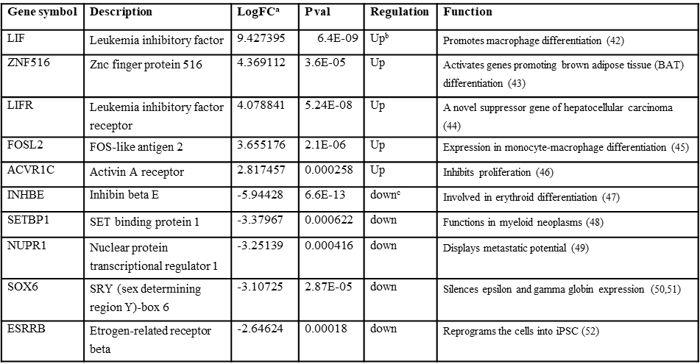
ªLogFC is Log2 Fold-Change
^{b}upregulated in TRIM28-K304Q K562 cells
^{c}downregulated in TRIM28-K304Q K562 cells

Table 2. ZNFs associated with each of wild-type and TRIM28-K304Q in K562 cells
