Graphical abstract. Proposed Pathophysiological Mechanisms Linking Epicardial Fat Thickness to Nighttime Systolic Blood Pressure Variability
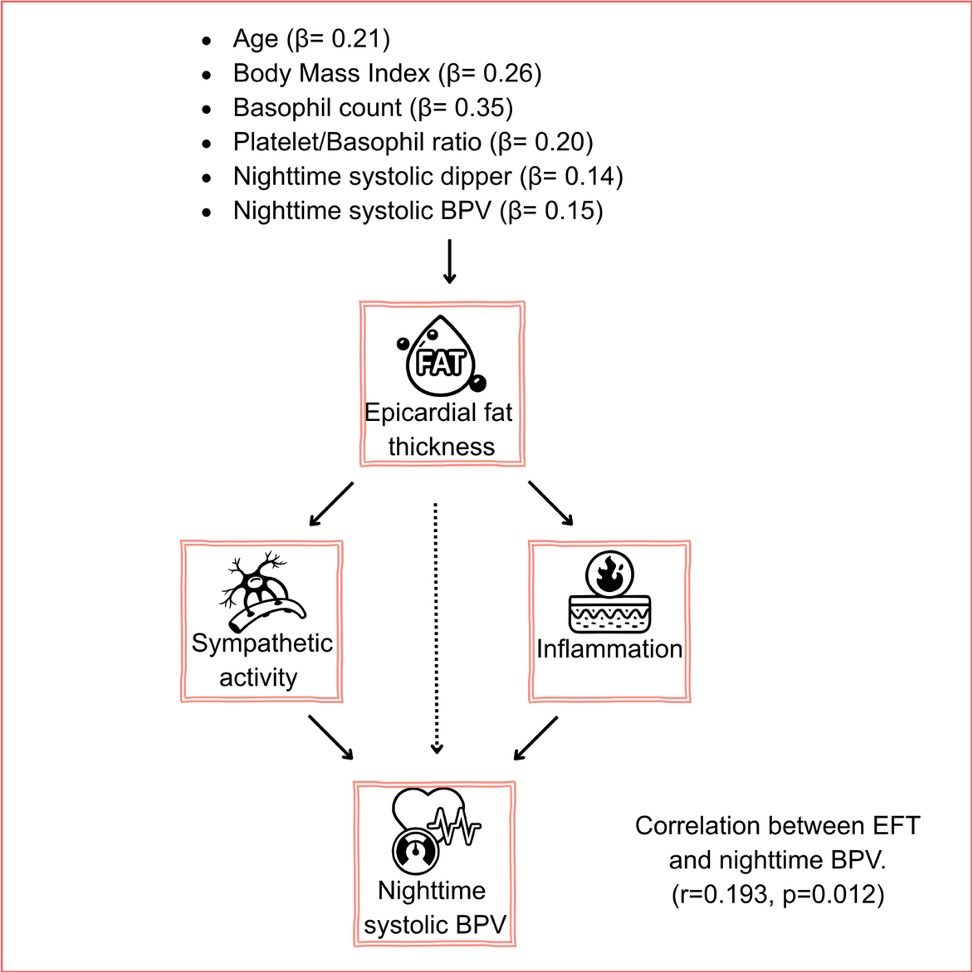
Caption: Schematic of how epicardial fat thickness (EFT) affects nighttime systolic blood pressure variability (BPV) in healthy young adults. EFT increases BPV via inflammatory pathways and sympathetic overactivity. Key predictors of EFT include basophil count (β=0.348, p<0.001), BMI (β=0.262, p=0.001), and nighttime systolic BPV (β=0.147, p=0.035) (r=0.193, p=0.012 for EFT vs. nighttime systolic BPV). Gender was not an independent predictor of EFT (β = -0.019, p = 0.804). Abbreviations: EFT: Epicardial fat thickness, BPV: Blood pressure variability, BMI: Body mass index

