Supplementary Table 1 Identity between vaccine strain GC_0817560 and mouse challenge strain FA1090. In FA1090, lbpA is disrupted and lbpB is absent.

 | Nucleotide level |  |  | Protein level
Protein | Coverage (%) (%) | Identity |  | Coverage (%) | Identity
MtrE | 100 | 1397/1404(99.5%) |  | 100 | 464/467(99.4%)
TbpA | 100 | 2684/2745(97.8%) |  | 100 | 881/914(96.4%)
TbpB | 100 | 1921/2126(90.4%) |  | 100 | 584/707(82.6%)
PorB | 100 | 1008/1050(96.0%) |  | 100 | 326/349(93.4%)

Supplementary Table 2 Identity between vaccine strain GC_0817560 and the 4CMenB NZ98/254 strain.

 | Nucleotide level |  |  | Protein level
Protein | Coverage (%) | Identity |  | Coverage (%) | Identity
MtrE | 100 | 1327/1404(94.5%) |  | 100 | 451/467(96.6%)
TbpA | 100 | 2616/2751(95.1%) |  | 100 | 855/916(93.3%)
TbpB | 72 | 1009/1312(76.9%) |  | 100 | 441/729(60.5%)
PorB | 100 | 823/1053(78.2%) |  | 100 | 236/350(67.4%)
LbpA | 100 | 2720/2835(95.9%) |  | 100 | 904/944(95.8%)
LbpB | 96 | 1772/2202(80.5%) |  | 100 | 520/768(67.7%)

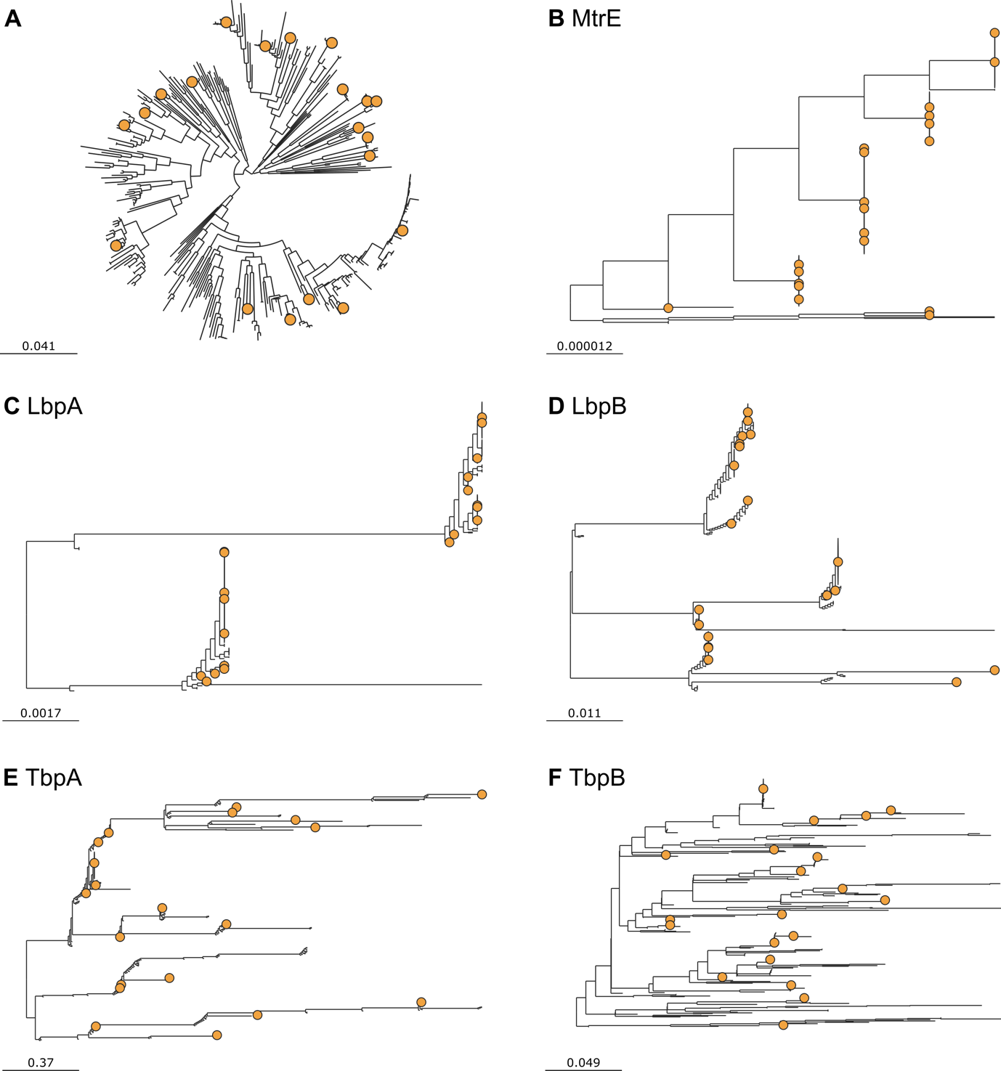

Supplementary Fig. 1 Mapping of the 20 selected Neisseria gonorrhoeae strains on the phylogenetic reconstruction of (A) the core genome of a set of 362 N. gonorrhoeae strains and the protein-based trees of the five key antigens, (B) MtrE, (C) LbpA, (D) LbpB, (E) TbpA and (F) TbpB, on this strain set. The scale bars represent, for A) the expected number of nucleotide substitutions per variable site along each branch, and for B-F) the expected number of amino acid substitutions per site along each branch.
Supplementary Fig. 2 Growth curve of N. gonorrhoeae GC_0817560 wild-type and genetically modified strains. Liquid medium was inoculated to an initial OD₆₀₀ of 0.1 from which sampled to measure the OD₆₀₀ value were collected every hour. The experiment was repeated on three different days. Results represent mean±SD.

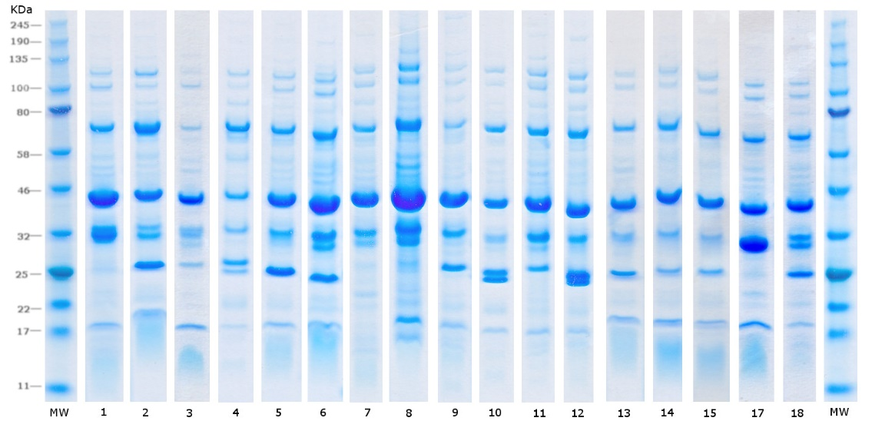

Supplementary Fig. 3 SDS-PAGE analysis of nOMV generated from 18 of the panel of 20 strains used for screening of vaccine production strain. Strain shown in table 1. MW molecular weight.

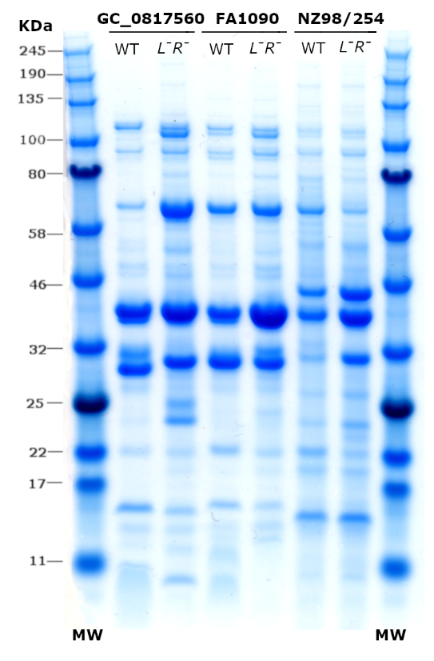
Supplementary Fig. 4 SDS-PAGE analysis of Neisserial nOMV derived from corresponding wild type (WT) and lpxL1⁻rmp⁻ (L⁻R⁻) variants of N. gonorrhoeae GC_0817560 and FA1090, and N. meningitidis NZ98/254. 8 µg nOMV were loaded into each lane of a 4-12% polyacrylamide gradient gels using MES buffer. Gels were stained with Coomassie Blue.

Supplementary Fig. 5 Time course of the serum anti-gonococcal IgG of mice immunised with nOMV GC_0817560 lpxL1⁻rmp⁻, nOMV FA1090 lpxL1⁻rmp⁻, nOMV NZ98/254 lpxL1⁻rmp⁻ and 4CMenB. The same dataset as Fig.10 is graphed per day post immunisation to illustrate the time course. Six-week-old female BALB/c mice were immunized with the four vaccines formulated in Al(OH)₃ or Al(OH)₃ alone (adjuvant control, black circles) at 0, 3 and 6 weeks. Mice were bled 3 weeks after each immunisation (Days 20, 41 and 62). Serum anti-gonococcal IgG levels were determined by ELISA for 10 mice per group. ELISA coating substrate was GC_0817560 nOMV. Data within each group were analysed independently using Kruskal-Wallis and Dunn’s correction for multiple comparison to characterises the changes in titre after two or three doses versus one dose, all significant results are indicated with the adjusted P value (n=10 mice per group).

