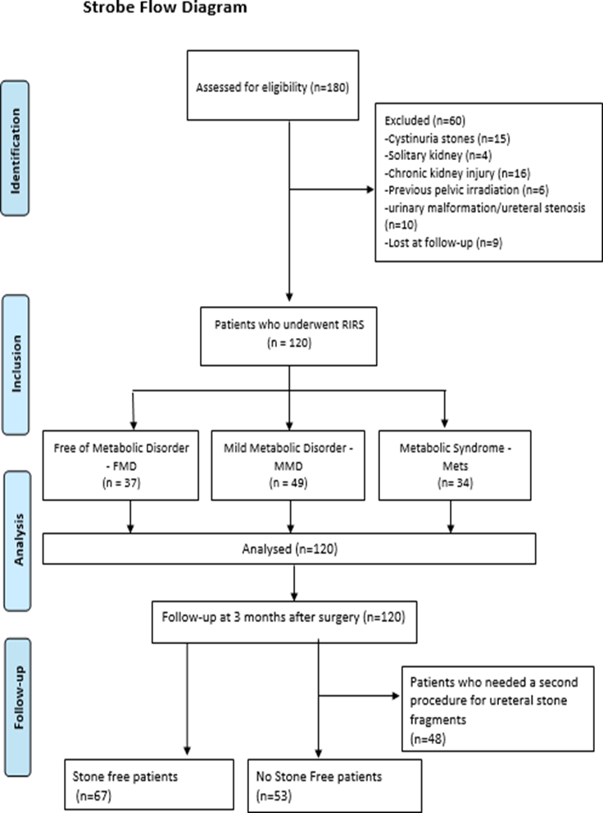

Suppl. Fig. 1 STROBE Flow-chart STROBE, Strengthening the reporting of observational studies STROBE, Strengthening the reporting of observational studies

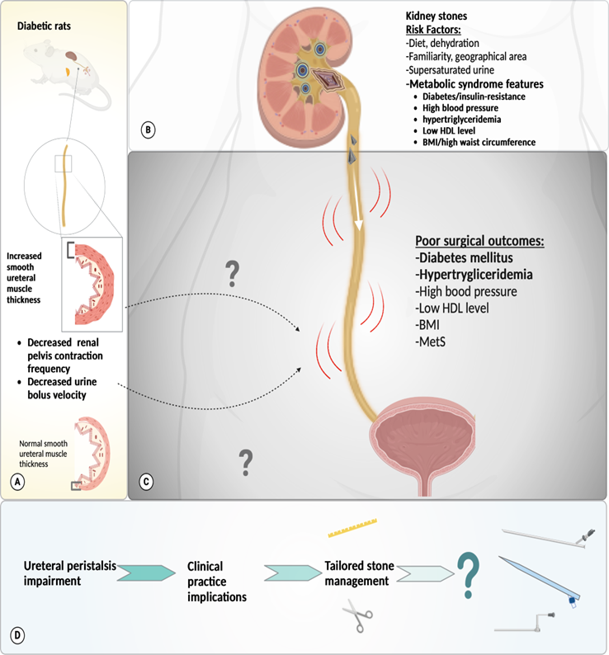

Suppl. Fig. 2 Comprehensive hypothetical hypothesis on surgical outcomes and future directions to precision medicine. 2A. Putative ureteral remodelling process in diabetic-induced rats from basic research studies. 2B. Stone disease formation and already recognized risk factors. 2C. Metabolic factors investigated concerning surgical outcomes after RIRS. Dotted arrows indicate possible altered mechanisms behind impaired ureteral peristalsis and stone fragment expulsion in humans. 2D. Practical implications and speculation on individualized stone management Created with BioRender.com

