SUPPLEMENTARY MATERIAL

SEWAGE EFFECTS AT THE END OF THE WORLD: IMPACT ON THE INTERTIDAL MACROBENTHIC COMMUNITY IN THE BEAGLE CHANNEL.

Facundo Manuel Llompart1, Sergio Matías Delpiani2, Julieta Sánchez1, Lourdes Higueras2, Cecilia Paula Alonso2, Antia Hervias2, Melina Pellegrino2, Sebastián Poljak2.

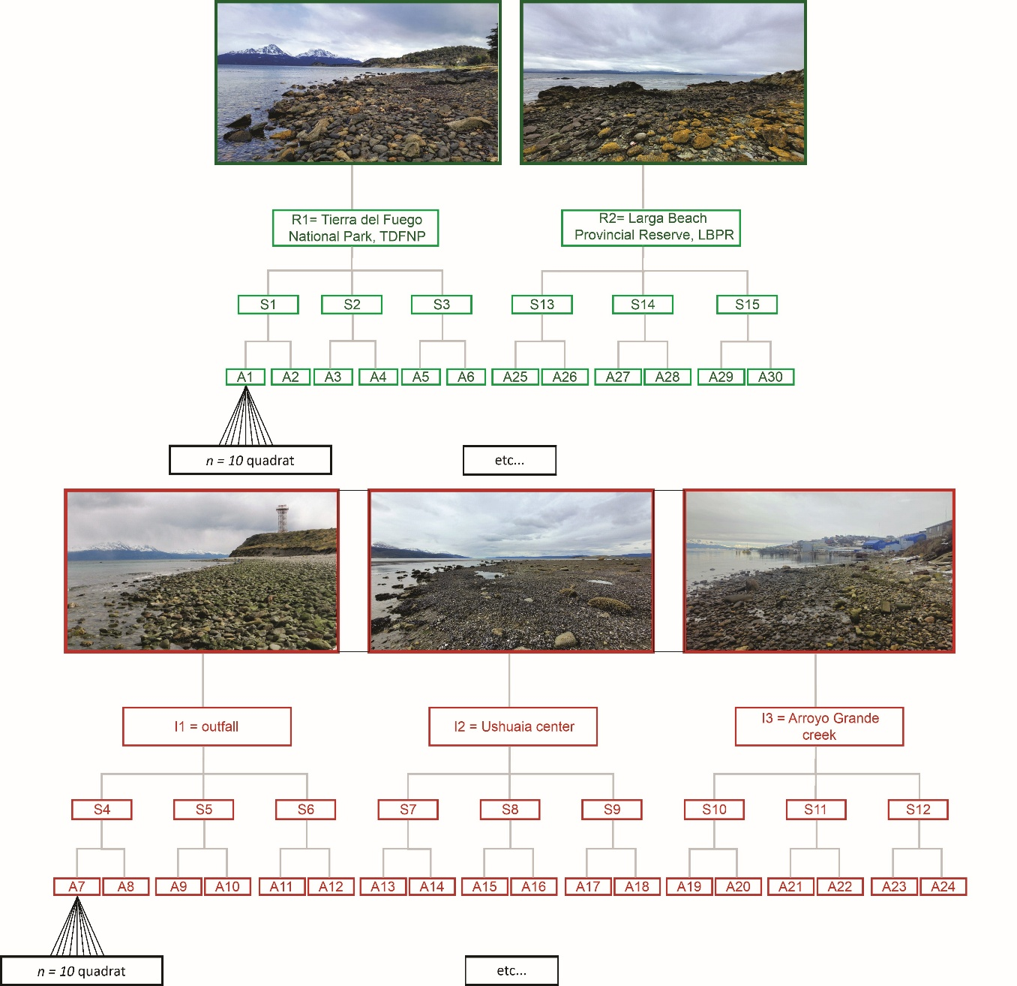

S 1. Hierarchical sampling design was used to assess the effects of a sewage outfall on the intertidal community in the Beagle Channel. The diagram illustrates the spatial structure of the sampling approach, with representative photographs of each condition: reference locations (R1 and R2, shown in green) and impact locations (I1, I2, and I3, shown in red) adjacent to the sewage discharge. The design incorporates nested spatial scales, including locations, sites (S), and areas (A), with 10 quadrats sampled per area.

S 2. List of marine invertebrate and fish species recorded in this study
Phyla | Class | Species/taxon
Annelida | Polychaeta | Hermadion magalhaensis
Annelida | Polychaeta | Nereididae
Annelida | Polychaeta | Serpulidae
Annelida | Polychaeta | Spionidae
Annelida | Polychaeta | Capitella capitata
Annelida | Polychaeta | Eulalia sp.
Annelida | Polychaeta | Terebellidae
Annelida | Polychaeta | Glyceridae
Annelida | Polychaeta | Timarete sp.
Annelida | Polychaeta | Sabellidae
Annelida | Polychaeta | Urechis chilensis
Annelida | Sipuncula | Golfingia (Golfingia) margaritacea
Arthropoda | Malacostraca | Amphipoda
Arthropoda | Malacostraca | Isopoda
Arthropoda | Malacostraca | Halicarcinus planatus
Arthropoda | Thecostraca | Balanus laevis
Arthropoda | Thecostraca | Notobalanus flosculus
Cnidaria | Hexacorallia | Parantheopsis cruentata
Cnidaria | Hexacorallia | Isoparactis fionae
Cnidaria | Hexacorallia | Bunodactis octoradiata
Cnidaria | Hexacorallia | Antholoba achates
Ecihnodermata | Asteroidea | Anasterias antarctica
Ecihnodermata | Asteroidea | Asterina fimbriata
Ecihnodermata | Asteroidea | Ophiactis asperula
Ecihnodermata | Echinoidea | Loxechinus albus
Ecihnodermata | Echinoidea | Pseudechinus magellanicus
Ecihnodermata | Echinoidea | Ophiophragmus chilensis
Ecihnodermata | Echinoidea | Psolus patagonicus
Ecihnodermata | Echinoidea | Pentactella leonina
Ecihnodermata | Holothuroidea | Chiridota pisanii
Mollusca | Bivalvia | Retrotapes exalbidus
Mollusca | Bivalvia | Tawera elliptica
Mollusca | Bivalvia | Hiatella arctica
Mollusca | Polyplacophora | Tonicia sp.
Mollusca | Polyplacophora | Ischnochiton stramineus
Mollusca | Polyplacophora | Plaxiphora aurata
Mollusca | Gastropoda | Acanthina monodon
Mollusca | Gastropoda | Argeneuthria cerealis
Mollusca | Gastropoda | Austrolittorina araucana
Mollusca | Gastropoda | Fissurella oriens
Mollusca | Gastropoda | Fissurella picta
Mollusca | Gastropoda | Margarella violacea
Mollusca | Gastropoda | Nacella deaurata
Mollusca | Gastropoda | Nacella flammea
Mollusca | Gastropoda | Nacella magellanica
Mollusca | Gastropoda | Nacella mytilina
Mollusca | Gastropoda | Nacella sp. juv.
Mollusca | Gastropoda | Pareuthria fuscata
Mollusca | Gastropoda | Savatieria areolata
Mollusca | Gastropoda | Siphonaria lessonii
Mollusca | Gastropoda | Trophon geversianus
Mollusca | Gastropoda | Xymenopsis muriciformis
Nematoda | - | Nematoda
Nemertea | Pilidiophora | Parborlasia corrugata
Porifera | Demospongiae | Clionaopsis platei
Porifera | Demospongiae | Crambe chilensis
Porifera | Demospongiae | Haliclona (Reniera) porcelana
Chordata | Actinopterygii | Austrolycus depressiceps
Chordata | Actinopterygii | Harpagifer bispinis
Chordata | Actinopterygii | Patagonotothen cornucola

S 3. Sample completeness measures of a macrobenthic survey.
For q = 0 (rare species), the sample completeness profile for the Beagle Channel (BC) reached the maximum (Table S1A, Figure S1A). In addition, it was higher in the reference localities compared to the impacted localities (Table S1A, Figure S1B). The diversities for q = 1 (abundant species) and q = 2 (highly abundant species) were fully recorded in each case (Table S1A, Figure S1A and S1d). Size-based rarefaction curves demonstrated that richness in R2 was higher than in R1, with both surpassing all impacted localities in terms of the number of registered individuals; however, extrapolation in I1 and I2 experienced a sharp increase (Figure S1D). Species richness can be accurately inferred in the BC (Table S1a, Figure S1C); however, data on localities allows for inference and significance testing up to a standardised coverage value of Cmax = 98.6% (Table S1a). Below this fraction, q = 1 and q = 2 were higher in reference localities than in impacted ones. In contrast, the richness centred on q = 0 was nearly the same in R2 and I1, exceeding those in I2, R1, and I3 in decreasing order. Indeed, the main difference between localities lies in the rare species found in I1 and I2 (Table S1B, Figure F). The evenness profile and Pielou measure consistently indicated that evenness among the reference localities was higher than in the impacted ones (Table S1A).

- Sample completeness profiles
Region | q = 0 | q = 1 | q = 2 | Locality | q = 0 | q = 1 | q = 2
BC | 100% | 100% | 100% | R1 | 99% | 100% | 100%
 |  |  |  | R2 | 99% | 100% | 100%
 |  |  |  | I1 | 43% | 100% | 100%
 |  |  |  | I2 | 75% | 100% | 100%
 |  |  |  | I3 | 90% | 100% | 100%
Non-asymptotic coverage-based rarefaction and extrapolation
Cmax = 100 |  |  |  | Cmax = 98.6
Region | q = 0 | q = 1 | q = 2 | Locality | q = 0 | q = 1 | q = 2
BC | 60 | 11.7 | 6.7 | R1 | 40.5 | 31.1 | 26.6
 |  |  |  | R2 | 50.9 | 32.5 | 26
 |  |  |  | I1 | 50.5 | 26.4 | 20.3
 |  |  |  | I2 | 45.9 | 22.2 | 17.3
 |  |  |  | I3 | 34.1 | 21.5 | 17.7
Evenness
Region | Pielou J | q = 1 | q = 2 | Locality | Pielou J | q = 1 | q = 2
BC | 0.6 | 0.18 | 0.1 | R1 | 0.93 | 0.76 | 0.65
 |  |  |  | R2 | 0.89 | 0.64 | 0.51
 |  |  |  | I1 | 0.83 | 0.51 | 0.39
 |  |  |  | I2 | 0.81 | 0.47 | 0.36
 |  |  |  | I3 | 0.87 | 0.62 | 0.5

- Asymptotic análisis
Localities | qTD | TD:obs | TD:asy | Difference
BC | q = 0 | 60 | 60 | 0
BC | q = 1 | 11.78 | 11.78 | 0
BC | q = 2 | 6.77 | 6.77 | 0
R1 | q = 0 | 44 | 44.5 | 0.5
R1 | q = 1 | 9.24 | 9.26 | 0.02
R1 | q = 2 | 4.74 | 4.74 | 0
R2 | q = 0 | 54 | 54.67 | 0.67
R2 | q = 1 | 9.45 | 9.47 | 0.02
R2 | q = 2 | 5.77 | 5.78 | 0.01
I1 | q = 0 | 45 | 105.49 | 60.49
I1 | q = 1 | 6.79 | 6.82 | 0.03
I1 | q = 2 | 4.06 | 4.06 | 0
I2 | q = 0 | 37 | 49.25 | 12.25
I2 | q = 1 | 8.39 | 8.41 | 0.02
I2 | q = 2 | 5.16 | 5.16 | 0
I3 | q = 0 | 37 | 41 | 4
I3 | q = 1 | 8.69 | 8.7 | 0.01
I3 | q = 2 | 5.61 | 5.61 | 0

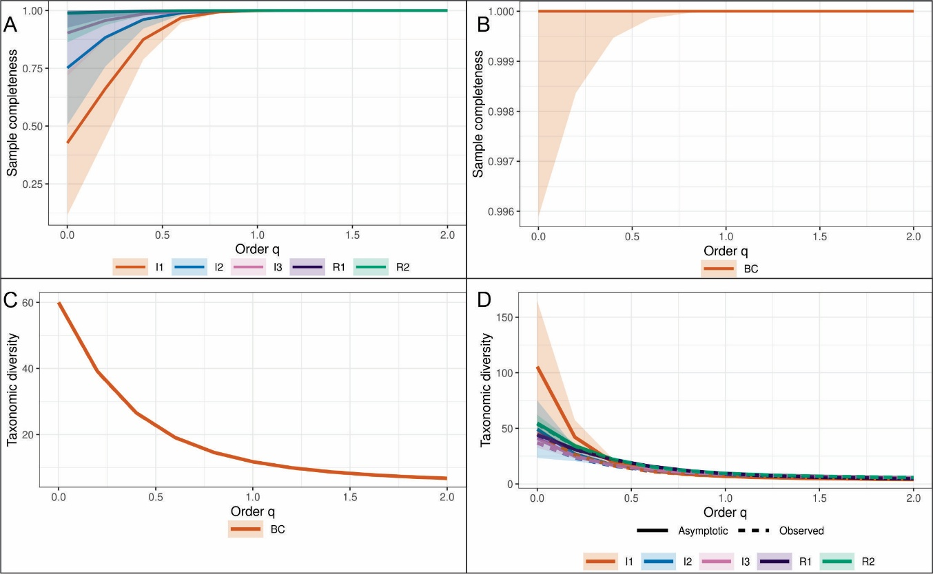

S 4. Size-based rarefaction (solid lines) and extrapolation curves (dashed lines) for the Beagle Channel (A) and at each locality (B). BC = Beagle Channel, I1 = impact locality 1 (brown), I2 = impact locality 2 (blue), I3 = impact locality 3 (pink), R1 = reference locality 1 (violet), R2 = reference locality 2 (green). Y axis refer to the estimated asymptotic diversities.

S 5. Environmental variables used to assess spatial gradient across sampling sites (S). Smoothed line plots illustrate site-wise trends for salinity (ppt), temperature (°C), pH, turbidity (Turb), total organic matter (TOM), nitrogen/phosphorus ratio (N/P), fecal coliforms (Fec-Col), and total dissolved solids (TDS). Green and red line segments represent distinct site groupings: reference sites (S1–S3 and S13–S15, shown in green) and impacted sites (S4–S12, shown in red). Overall, variables such as TOM, Fec-Col, TDS and Turb showed highest values in impacted sites while N/P displayed an opposite pattern.
