Supplementary Material for Designing & Printing Dispersion Strengthened Ti-6Al-4V via Laser Powder Bed Fusion Additive Manufacturing
Venkata Satya Surya Amaranth Karra^{1,*}, Tirthesh Ingale², Sivaji Karna¹, Shreya Mukherjee², Ravi Sankar Haridas², Rajarshi Banerjee², Anthony D. Rollett³, Rajiv S Mishra², and Hector R. Siller^{1,*}
¹Department of Mechanical Engineering, University of North Texas, Denton, TX 76207
²Department of Materials Science and Engineering, University of North Texas, Denton, TX 76207
³Department of Materials Science and Engineering, Carnegie Mellon University, Pittsburgh, PA 15213
*Corresponding authors: Amaranth.Karra@unt.edu ; hector.siller@unt.edu

Scanning Electron Microscopy
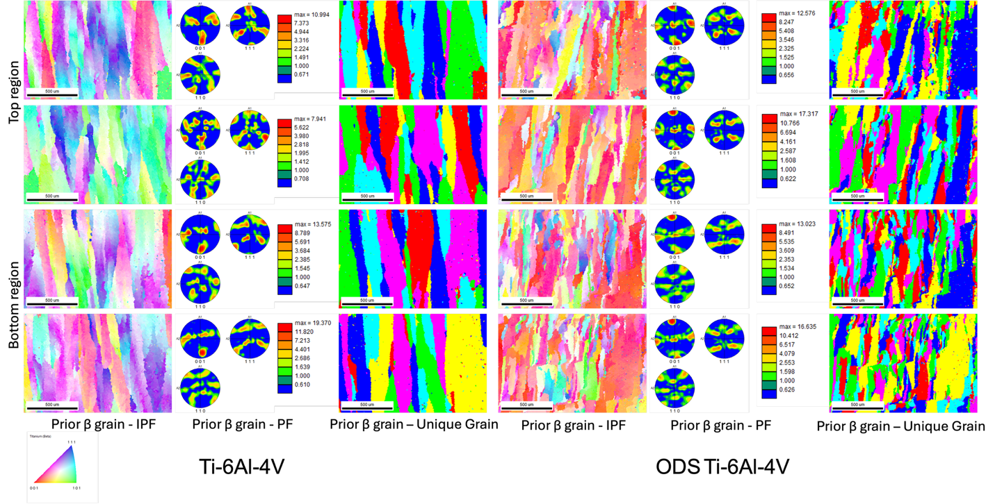
Figure S1: Different regions of Ti-6Al-4V and ODS Ti-6Al-4V showing IPF, PF and Unique grain of the reconstructed prior β grains showing difference in grain size.

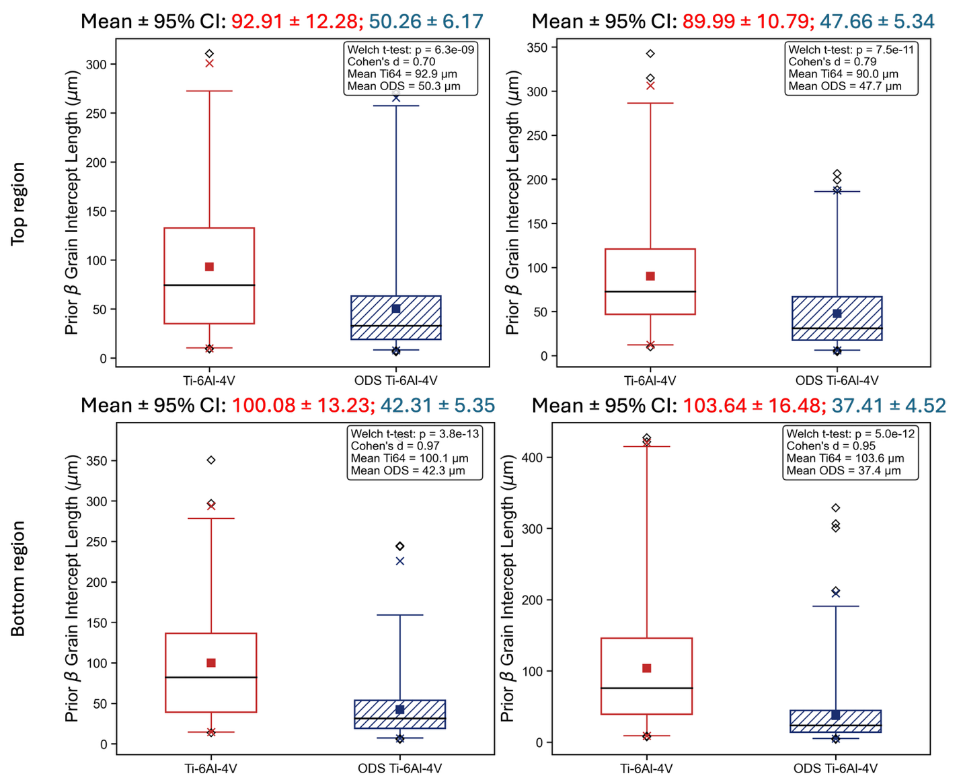
Figure S2: Prior β grain intercept length as calculated from the methods described in the paper. ODS Ti-6Al-4V consistently shows lower mean ± 95% CI for different regions shown in Figure S1.
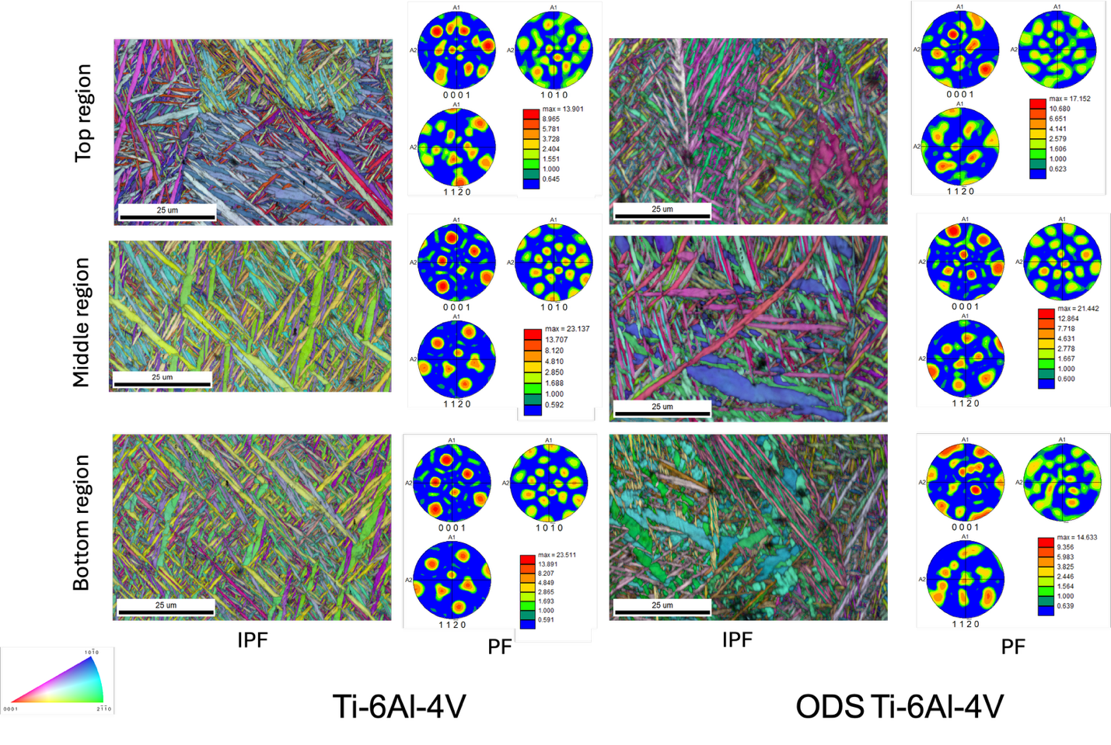
Figure S3: Different regions of Ti-6Al-4V and ODS Ti-6Al-4V showing IPF and PF maps showing all the alpha variants within the Ti-6Al-4V owing to the lack of bias in {0001} pole figure.

