Table 1. EDS semiquantitative data (wt %) with emphasis to dolomite compositions.
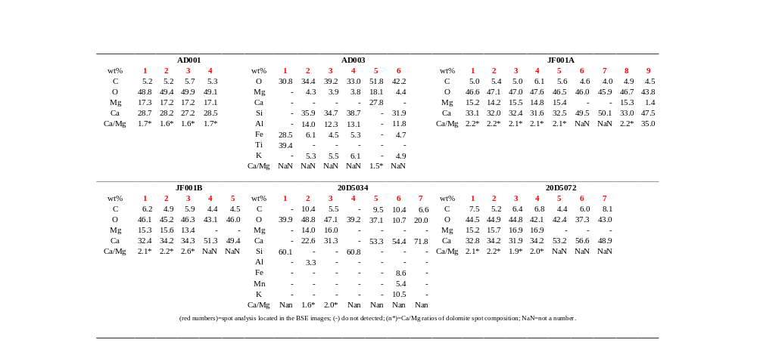

Table 2. Integration of WDXRF chemical analysis and XRD phase quantification (wt%), in addition to lattice parameters and structural factors by Rietveld refinement.
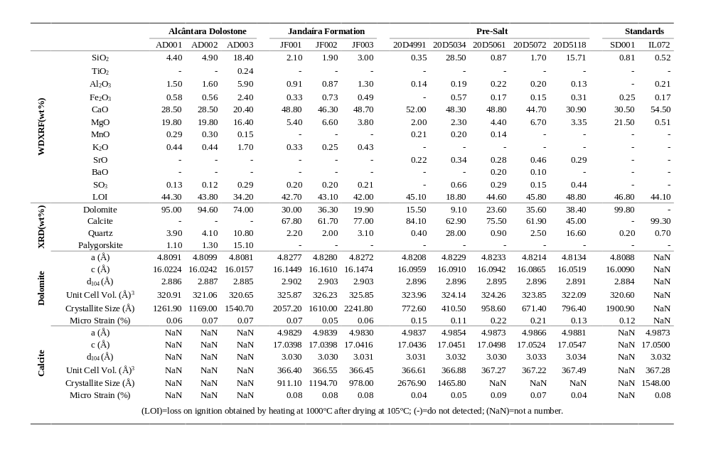

Table 3. Porosity and permeability measurements of all cores drilled from AD, FJ and 20D carbonates.
