Supporting information
Defect-rich TiO₂ in situ evolved from MXene for efficiently oxidative dehydrogenation of ethane
Yanliang Zhou,^{1,2} Xiaoyu Li,¹ Yicong Chai,^{1,3} Zihao Wu,⁴ Jian Lin,^{1*} Xiaoli Pan,¹ Yujia Han,^{1,3} Lin Li,¹ Haifeng Qi,^{1,3} Yang Su,¹ Leilei Kang,¹ Xiaodong Wang^{1*}

¹CAS Key Laboratory of Science and Technology on Applied Catalysis, Dalian Institute of Chemical Physics, Chinese Academy of Sciences, 116023.
²National Engineering Research Center of Chemical Fertilizer Catalyst, Fuzhou University, 350002 Fuzhou, Fujian, China.
³University of Chinese Academy of Sciences, Beijing 100049, P. R. China.
⁴School of Materials Science and Engineering, Zhejiang University, Hangzhou 310027, PR China

Table S1. Performances in terms of ethane conversion, ethylene selectivity and ethylene production rate on M-TiO₂ compared with previously reported catalysts for the ODH of ethane.
No. | Catalyst | Space velocityª (g_{ethane} g_{cat}⁻¹ h⁻¹) | T  (ºC) | X(C₂H₆)^{b}  (%) | S(C₂H₄)^{c}  (%) | Productivity  (g_{C2H4} g_{cat}⁻¹ h⁻¹) | Ref.
1 | Ni-Sn-O^{d} | 0.55 | 350 | 26 | 75 | 0.10 | 1
2 | Ni_{0.85}Nb_{0.15}O^{e} | 0.80 | 330 | 40 | 70 | 0.21 | 2
3 | P/NiO^{f} | 1.61 | 425 | 20 | 65 | 0.18 | 3
4 | MoVTeNb  Oxide^{g} | 0.86 | 440 | 45 | 92 | 0.33 | 4
5 | Na₂WO₄/SiO₂^{h} | 1.21 | 800 | 88 | 67 | 0.71 | 5
6 | 5%Mo-TiO₂^{i} | 1.34 | 650 | 64 | 89 | 0.63 | 6
7 | Pt/α-Al₂O₃^{j} | 35 | 950 | 57 | 77 | 14 | 7
8 | LiCl/MgO^{k} | 0.35 | 620 | 75 | 77 | 0.19 | 8
9 | Li-K-Cl/MgO  +Dy₂O₃^{l} | 0.19 | 625 | 80 | 90 | 0.13 | 9
10 | BNOH^{m} | 32 | 610 | 32 | 90 | 9.0 | 10
11 | M-TiO₂^{n} | 55 | 600 | 47 | 64 | 15.4 | This work

ªWeight hourly space velocity of ethane; ^{b}The conversion of ethane; ^{c}The selectivity of ethylene; ^{d}Feed composition: C₂H₆:O₂:He = 3:1:29; ^{e}Feed composition: C₂H₆:O₂:He = 1:1:8; ^{f}Feed composition: C₂H₆:O₂:He = 1:1:4; ^{g}Feed composition: C₂H₆:O₂:N₂ = 9:7:84; ^{h}Feed composition: C₂H₆:O₂:H₂O:He = 20:20:2.3:57.7; ^{i}Feed composition: C₂H₆:O₂:He = 1:1:8; ^{j}Feed composition: C₂H₆:O₂:H_{2:}N₂=2:1:2:4; ^{k}Feed composition: C₂H₆:O₂:N₂:He = 38:38:10:14; ^{l}Feed composition: C₂H₆:O_{2:}He = 7:7:86; ^{m}Feed composition: C₂H₆:O₂:N₂ = 1:1:4; ^{n}Feed composition: C₂H₆:O₂:He = 4:2:4, flow rate = 60 mL min⁻¹.
Table S2. Catalytic performance for the oxidative dehydrogenation of ethane over different TiO₂ catalysts.
No. | Catalyst | T  (°C) | X(C₂H₆)  (%) | S(C₂H₄)  (%) | Yield  (%)
1 | M-TiO₂ | 590 | 41 | 70 | 28.7
2 | P25 | 590 | 12 | 55 | 6.6
3 | H-TiO₂ | 590 | 11 | 46 | 5.1

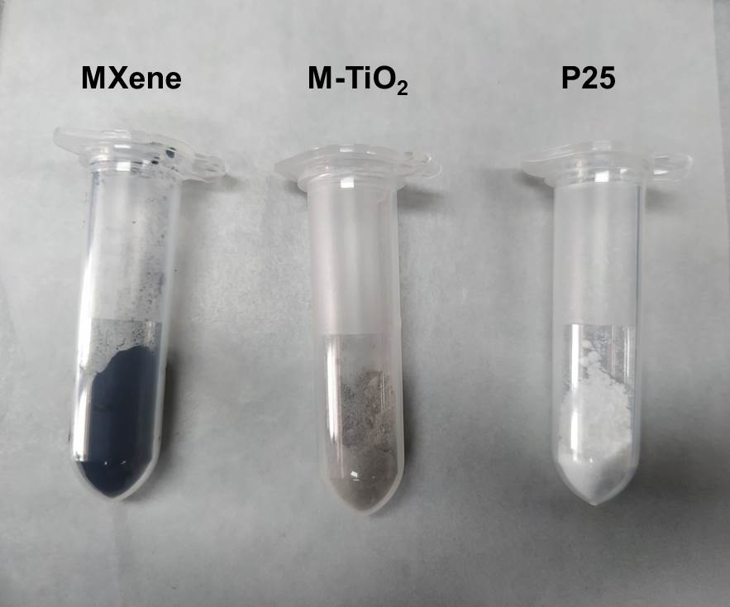

Figure S1. Pictures of MXene, M-TiO₂, and P25 catalysts.

Figure S2. (a) Ethane conversion and (b) ethylene selectivity as a function of reaction temperature on M-TiO₂, P25, R-TiO₂, and A-TiO₂ catalysts. C₂H₆:O₂:He = 10:5:85, W/F = 0.2 g s mL⁻¹.

Figure S3. Products selectivity as a function of reaction temperature on M-TiO₂. C₂H₆:O₂:He = 10:5:85, W/F = 0.2 g s mL⁻¹.

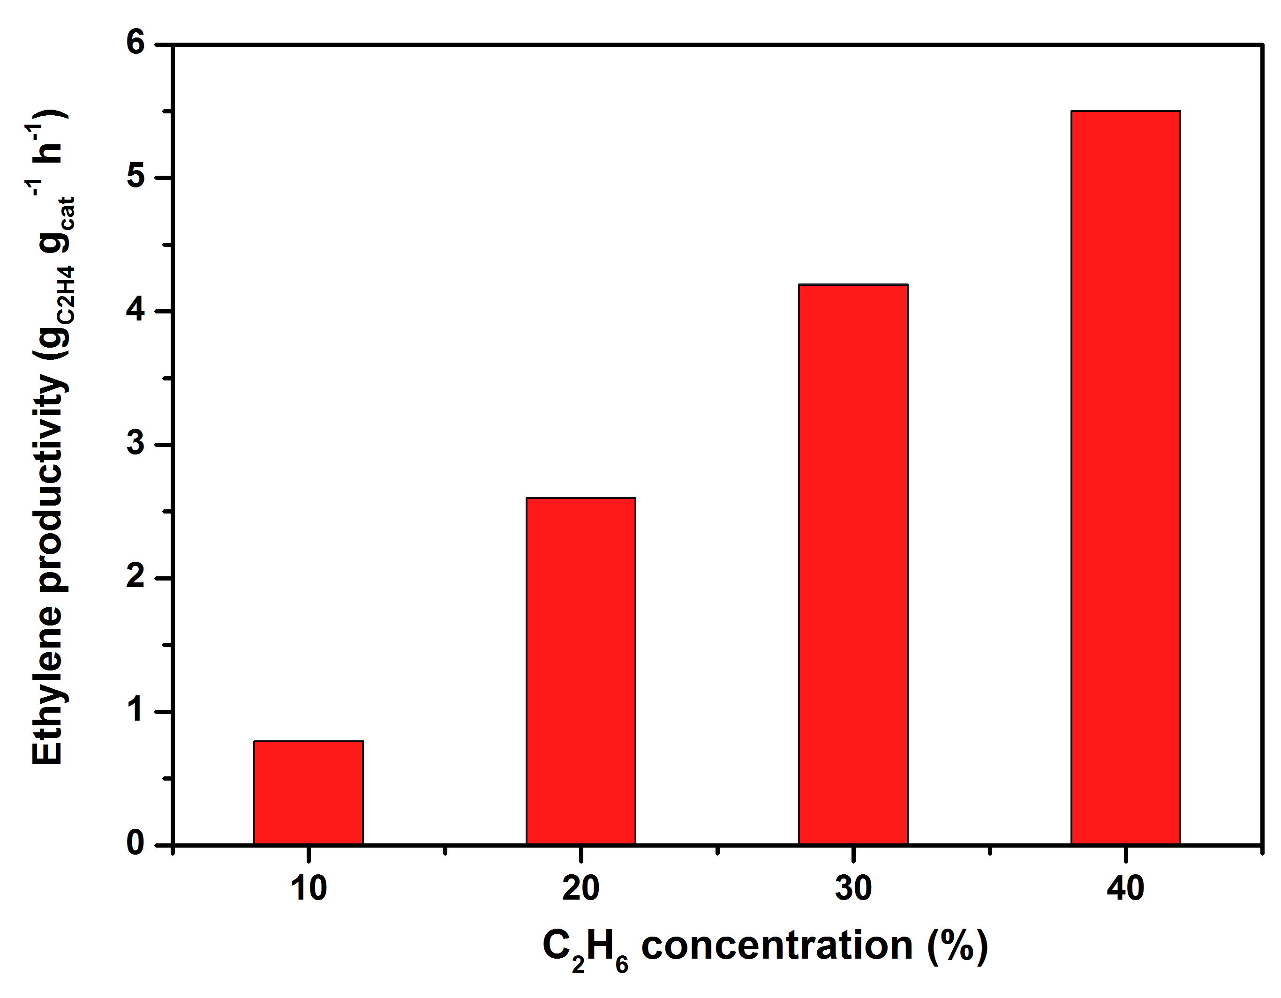
Figure S4. Effects of reactant gas concentration on the productivity over M-TiO₂. Space velocity = 60 mL min⁻¹, C₂H₆:O₂ = 2:1, T = 600 °C.

Figure S5. The stability test on M-TiO₂ at 590 °C. C₂H₆:O₂:He = 10:5:85, W/F = 0.2 g s mL⁻¹.

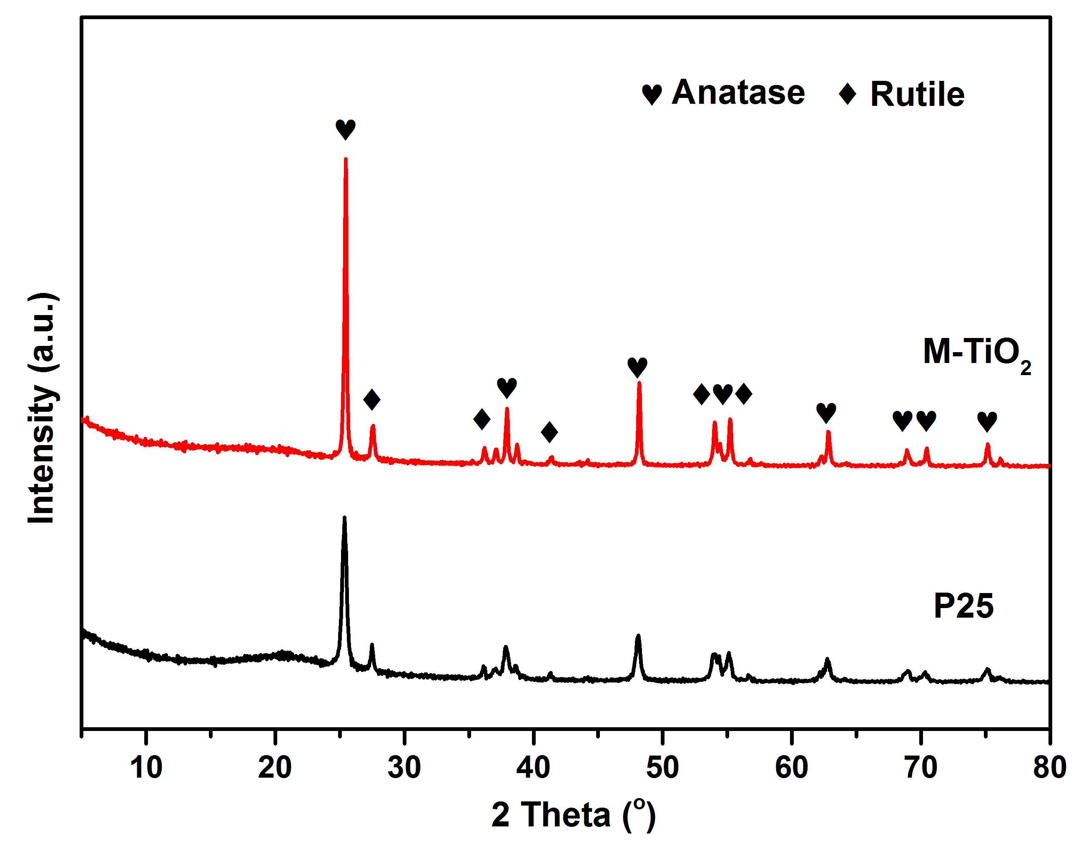
Figure S6. X-ray diffraction patterns of M-TiO₂ and P25.

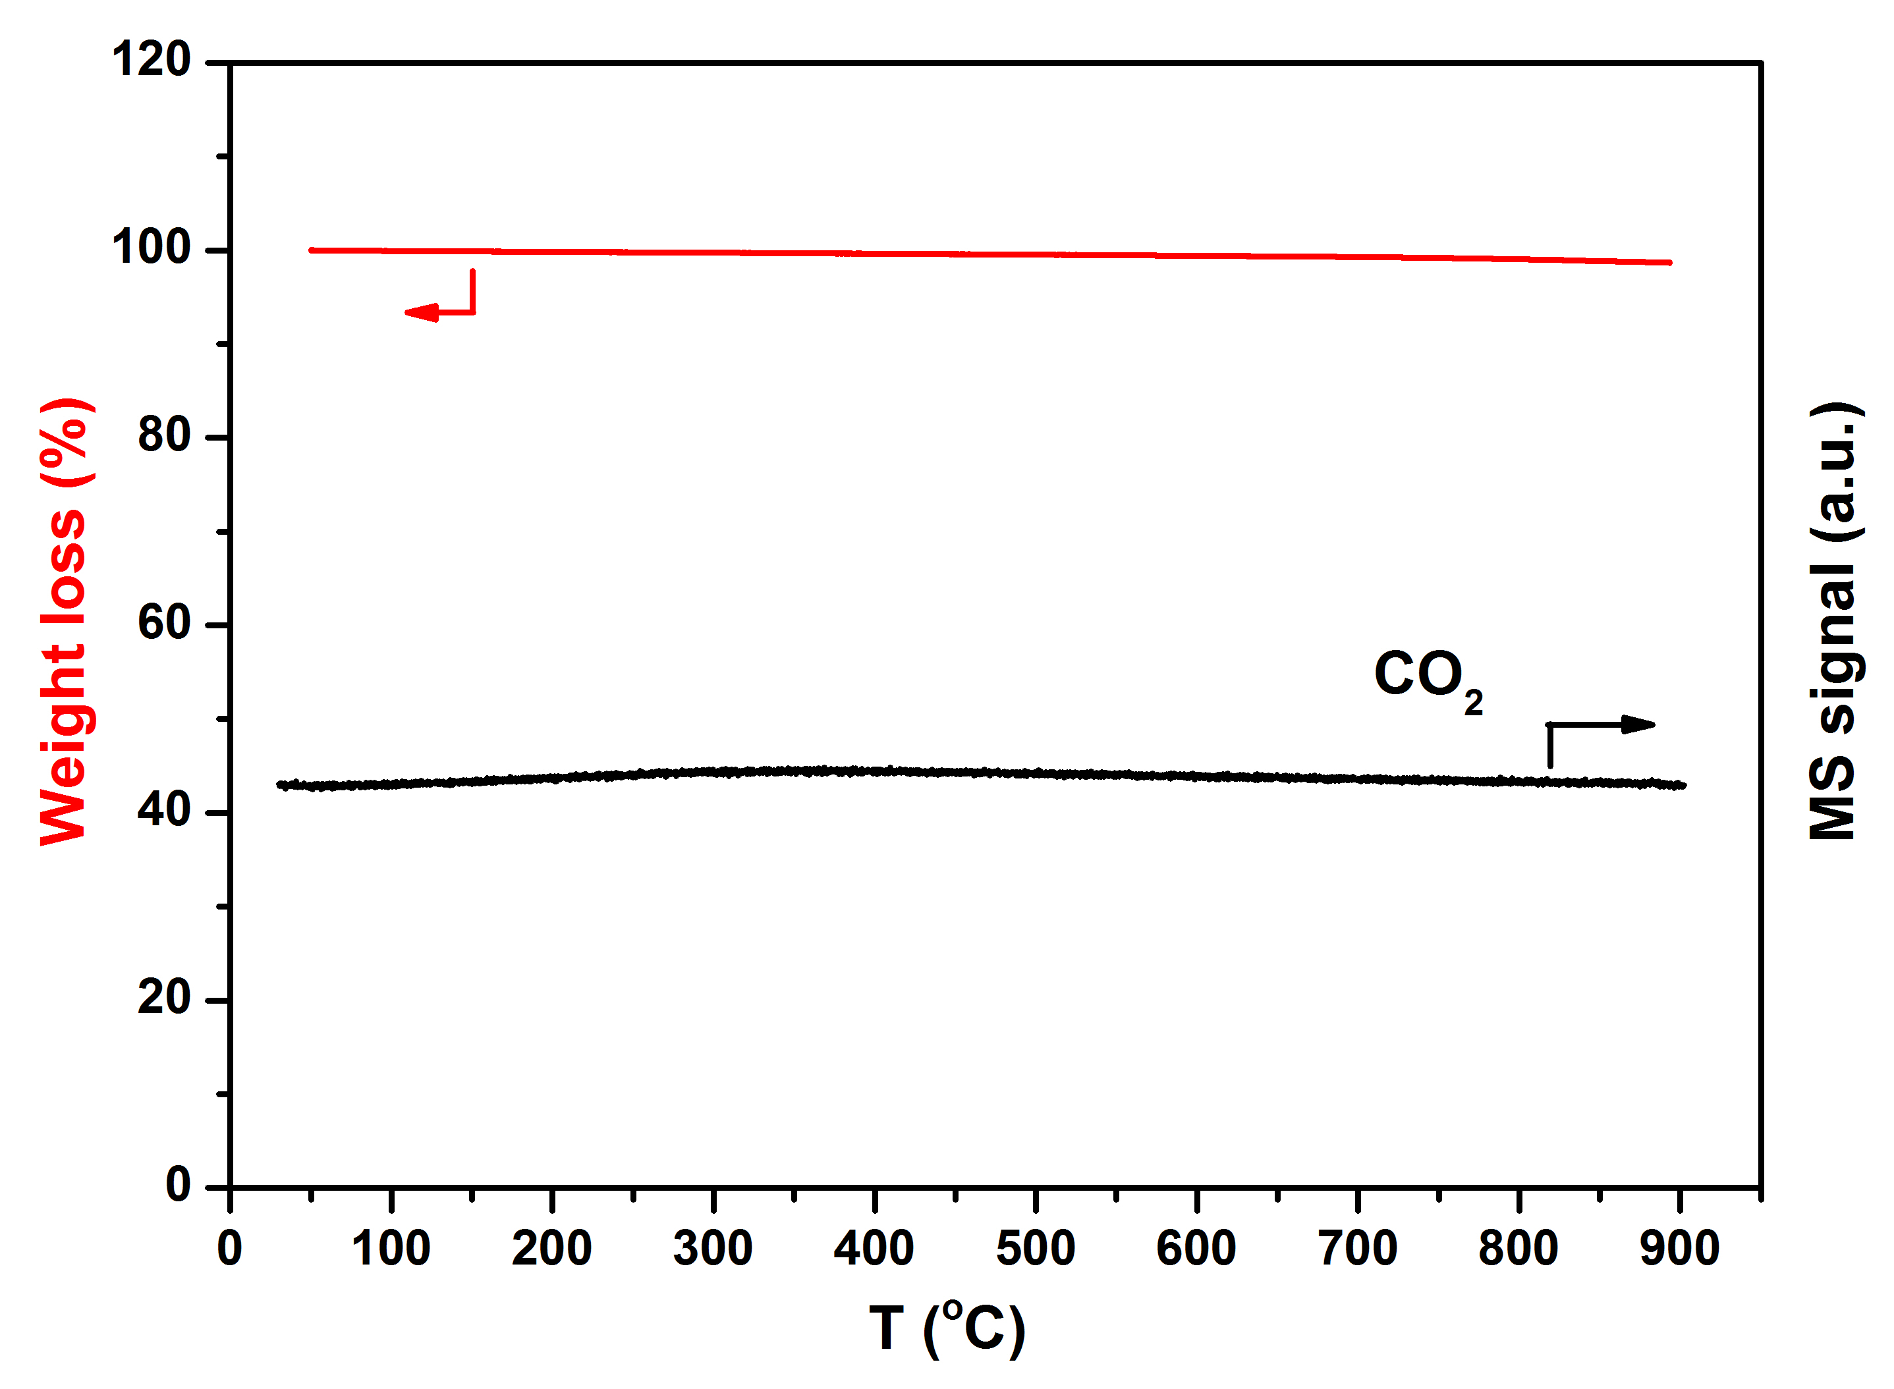
Figure S7. Thermogravimetric analysis and the product signal by on-line Mass spectrometer on M-TiO₂. CO₂: m/z=44; H₂O: m/z=18.

Figure S8. HRTEM images of M-TiO₂ with defect structure.

Figure S9. H₂-TPR profiles of the M-TiO₂ and P25 catalysts. The data shows the consumption amount of H₂ per gram of catalyst.

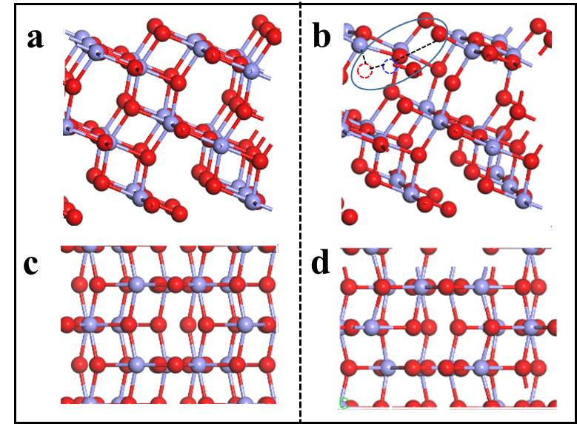
Figure S10. The models of (a, c) pure crystal face and (b, d) the crystal face with Ti and oxygen vacancies of anatase TiO₂(101) systems from top and side views. White, red, gray, and light blue balls represent H, O, and C, and Ti atoms, respectively. The red and light blue circles with the dotted line represent O and Ti vacancies, respectively.

Figure S11. DFT calculations of the first step in the oxidative dehydrogenation of ethane on the oxygen vacancy defects of anatase TiO₂(101) systems. IS, TS, and FS represent initial state, transition state, and final state, respectively. White, red, gray, and light blue balls represent H, O, C, and Ti atoms, respectively. The red circles with the dotted line represent O vacancy.

References

1. Solsona B, et al. Selective oxidative dehydrogenation of ethane over SnO₂-promoted NiO catalysts. J. Catal. 295, 104-114 (2012).
2. Zhu H, Rosenfeld DC, Anjum DH, Caps V, Basset JM. Green synthesis of Ni-Nb oxide catalysts for low-temperature oxidative dehydrogenation of ethane. ChemSusChem 8, 1254-1263 (2015).
3. Ivan S-B, Popescu I, Fechete I, Garin F, Pârvulescu VI, Marcu I-C. The effect of phosphorus on the catalytic performance of nickel oxide in ethane oxidative dehydrogenation. Catal. Sci. Technol. 6, 6953-6964 (2016).
4. Valente JS, et al. Chemical, structural, and morphological changes of a MoVTeNb catalyst during oxidative dehydrogenation of ethane. ACS Catal. 4, 1292-1301 (2014).
5. Takanabe K, Shahid S. Dehydrogenation of ethane to ethylene via radical pathways enhanced by alkali metal based catalyst in oxysteam condition. AIChE J. 63, 105-110 (2017).
6. Sarkar B, Goyal R, Sivakumar Konathala LN, Pendem C, Sasaki T, Bal R. MoO₃ Nanoclusters decorated on TiO₂ nanorods for oxidative dehydrogenation of ethane to ethylene. Appl. Catal. B-Environ. 217, 637-649 (2017).
7. Michael BC, Nare DN, Schmidt LD. Catalytic partial oxidation of ethane to ethylene and syngas over Rh and Pt coated monoliths: Spatial profiles of temperature and composition. Chem. Eng. Sci. 65, 3893-3902 (2010).
8. Liu Z, et al. Ultrathin high-temperature oxidation-resistant coatings of hexagonal boron nitride. Nat. Commun. 4, 3541-3549 (2013).
9. Gartner CA, van Veen AC, Lercher JA. Oxidative dehydrogenation of ethane on dynamically rearranging supported chloride catalysts. J. Am. Chem. Soc. 136, 12691-12701 (2014).
10. Shi L, Yan B, Shao D, Jiang F, Wang D, Lu A-H. Selective oxidative dehydrogenation of ethane to ethylene over a hydroxylated boron nitride catalyst. Chin. J. Catal. 38, 389-395 (2017).

