Extended Data Figures
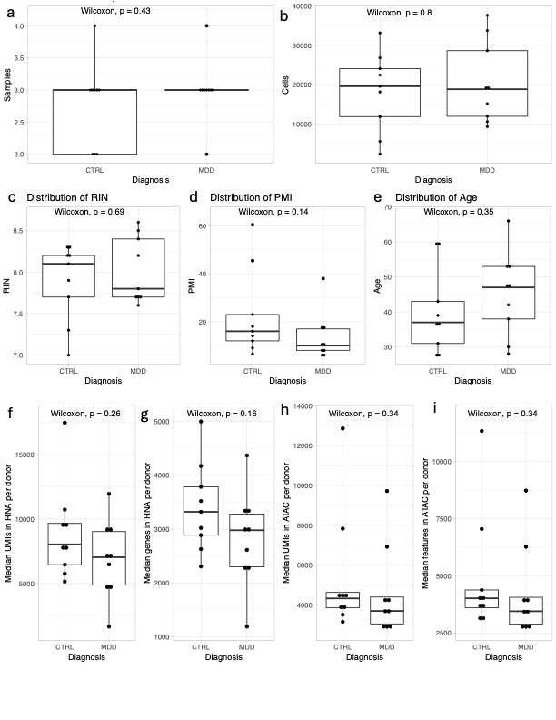

Extended Data Fig. 1 | Post-mortem human sample characteristics. a-i Boxplots show no significant differences between MDDs and CTRL. Center line represents median, box limits are first and third quartiles, and whiskers represent 1.5x interquartile range. a. Number of samples per donor. b. Number of cells retained after filtering per donor. c. RNA integrity number (RIN) in each donor. d. Post-mortem interval (PMI) of each donor. e. Age at death. f. Median number of unique molecular identifiers (UMIs, i.e. transcripts) per cell per donor in RNA modality. g. Median number of unique genes expressed per cell per donor. h. Median number of UMIs (i.e. accessible chromatin regions) per cell per donor. i. median number of unique accessible chromatin regions per cell per donor

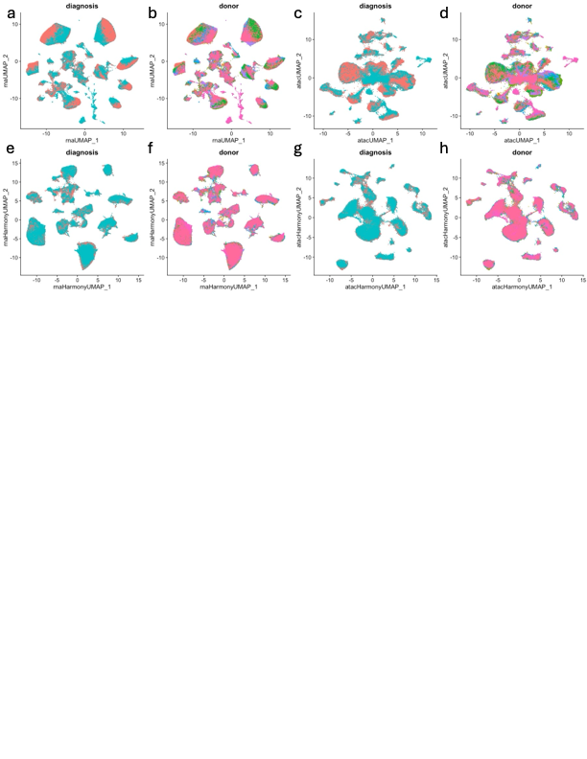

Extended Data Fig. 2 | UMAP plots with uncorrected and corrected principle component analysis (PCA) in RNA and ATAC modalities. a,b,e,f. RNA modality. b,d,g,h. ATAC modality. a-d UMAP projection constructed with uncorrected PCA (a,b) or latent semantic indexing (LSI) (c,d) components. e-h. UMAP projection constructed with Harmony-corrected PCA (e,f) or LSI (g-h) components using sample, donor, and batch as covariates. a,c,e,g. Colored by diagnosis. Cells from donors with MDD are blue. Cells from neurotypical controls are pink. b,d,f,h. Colored by donor identity. All cells that are the same color are form the same donor.

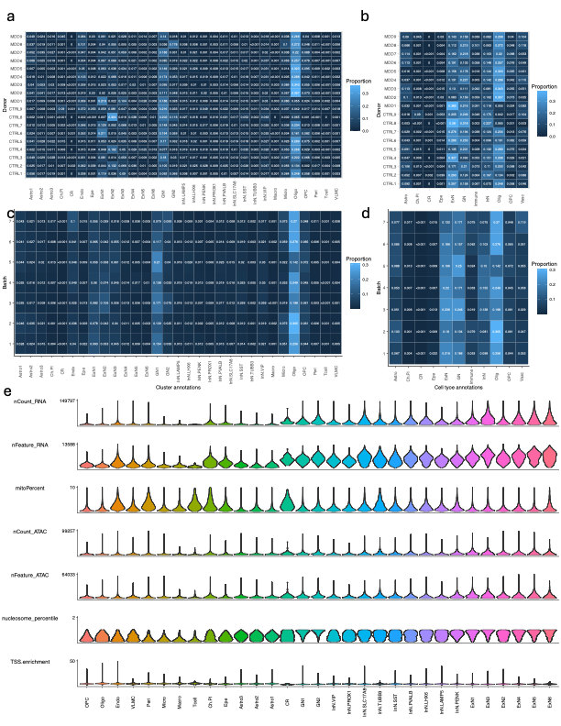

Extended Data Fig. 3 | Cluster level quality. a-d. Values in each row add to 1. Value of 0 indicates that donor does not have any cells in that cluster. Value of <0.001 indicates that the proportion of cells in that cluster is in between 0-0.001. Text values are rounded to the thousandths place. a. Proportion of cells in each cluster per donor. b. Proportion of cells in each cell type per donor. c. Proportion of cells in each cluster per batch. d. Proportion of cells in each cell type per batch. e. Violin plots depicting parameters used for filtering in each cluster on post-filtered data.

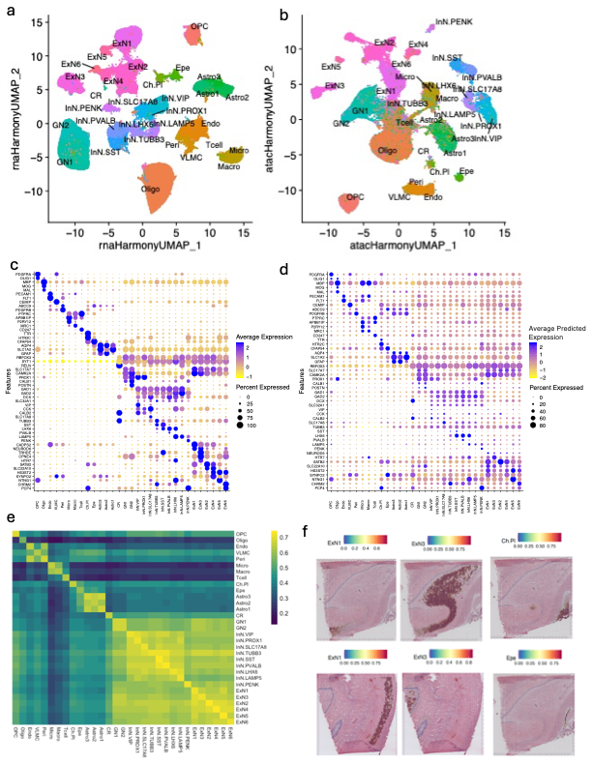

Extended Data Fig. 4 | Further characterization of unsupervised clusters. a-b. UMAPs calculated using batch-corrected (a) Principal component analysis (PCA) in RNA or (b) latent semantic indexing (LSI) components and ATAC data colored by cluster, corresponding to WNN UMAP in Fig. 1d. c. Dotplot of gene expression in unsupervised clusters corresponds to Fig. 1f that shows a subset of these genes in cell types. d. Dotplot of predicted gene activity based on ATAC peaks in clusters. Corresponds to Fig. 1g that shows a subset of these genes in cell types. e. Pearson’s correlation of natural log1p of the average gene expression and average predicted gene activity calculated from accessible chromatin in each cluster. Corresponds to Fig. 1e that shows same analysis in cell types that shows the same analysis in cell types.

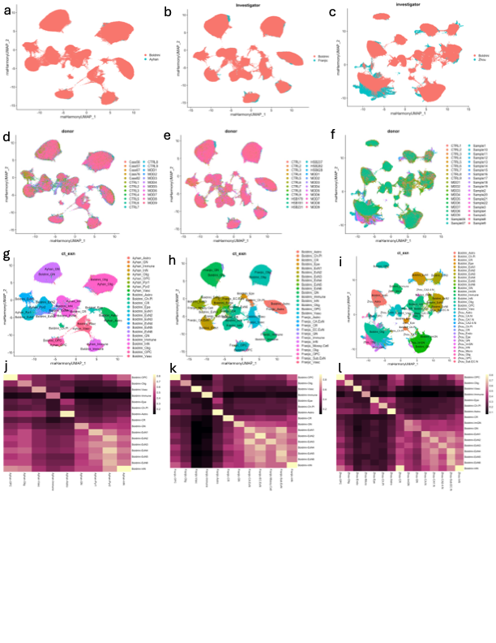

Extended Data Fig. 5 | Integration with previously published datasets. a-c. UMAPs colored by investigator. d-f. UMAPs colored by sample identifiers. CTRL1-9 and MDD1-9 are new contributions from this study. g-i. UMAPs colored by cell type. j-m. Correlation matrix showing Pearson’s correlation of gene expression for top 2000 variably expressed genes. a,d,g,j. Harmony corrected UMAP embedding and correlation matrix of integration with Ayhan et al 2021 data. b,e,h,k. Harmony corrected UMAP embedding and correlation matrix of integration with Franjic et al 2022 data. c,f,i,l. Shows Harmony corrected UMAP embedding and correlation matrix of integration with Zhou et al 2023 data.

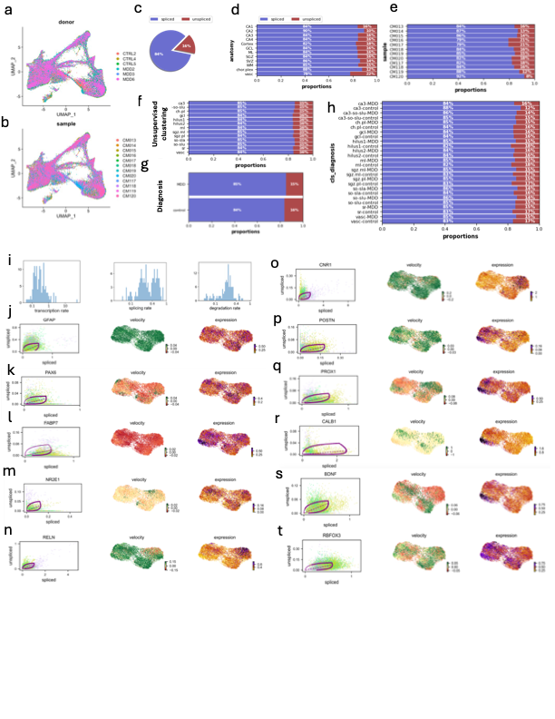

Extended Data Fig 6 | Further characterization of RNA splicing dynamics in Visium spots. a. Integrated Visium UMAP colored by donor. b. integrated Visium UMAP colored by sample. c. Pie graph showing the proportion of spliced and unspliced RNA in spatial dataset. d-h. Bar graphs showing percentage of spliced and unspliced RNA (d) in manually annotated anatomy based on Hematoxylin & Eosin stain of the same section, (e). in each sample, (f) in each cluster, (g) by diagnosis, and (h) in each cluster split by diagnosis. i. From left to right: transcription rate (fit_alpha), splicing rate (fit_beta * fit_scaling), and degradation rate (fit_gamma) in genes with gene likelihood > 0.1. j-t. (From left to right) phase plot showing spliced vs unspliced RNA with steady state fit, UMAP embedding colored by velocity, and UMAP embedding colored by gene expression level. j. GFAP k. PAX6 l. FABP7 m. NR2E1 n. RELN o. CNR1 p. POSTN q. PROX1 r. CALB1 s. BDNF t. RBFOX3

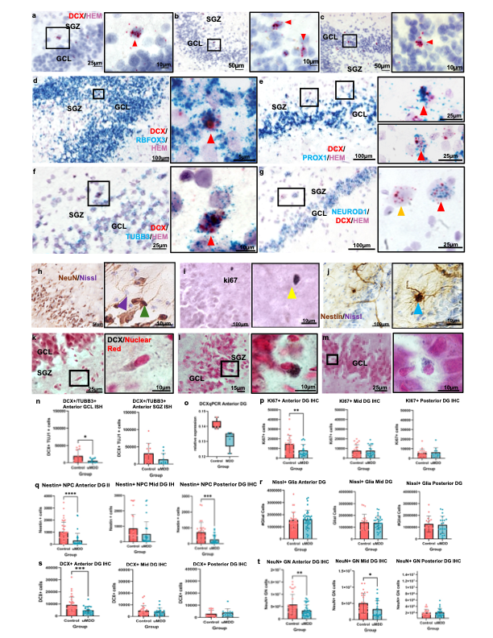

Extended Data. Fig. 7 | Validation and quantification of RNA protein expression in cell types identified by LASSO Regression. a-c. DCX mRNA+ cells (red) in dentate gyrus (a) SGZ and (b-c) GCL d-e. DCX mRNA (red) co-localizes with mRNAs for (d) mature neurons (RBFOX3; blue), (e) granule neuron-specific PROX1 (blue) and (f-g) immature neurons (NEUROD1 and TUBB3; blue). a-g. Nuclei are counterstained with hematoxylin. n. Cells positive for DCX and TUBB3 mRNA are fewer in the GCL but not SGZ in MDD compared to CTRL. o. Relative expression of DCX quantified using qPRC is lower in MDD compared to CTRL in anterior dentate gyrus (DG). p. The number of Ki67 protein positive cells is lower in anterior but not mid or posterior DG in MDD compared to CTRL. q. The number of Nestin protein positive cells in anterior and posterior but not mid DG is lower in MDD compared to CTRL. r. The number of Nissl-stained glia is not significantly different between groups in anterior, mid, or posterior DG. s. The number of DCX protein positive cells is significantly lower in anterior but not mid or posterior DG in MDD compared to CTRL. t. The number of cells positive for NeuN protein is significantly lower in anterior and mid but not posterior DG in MDD compared to CTRL. n-t. Error bars represent one standard deviation.

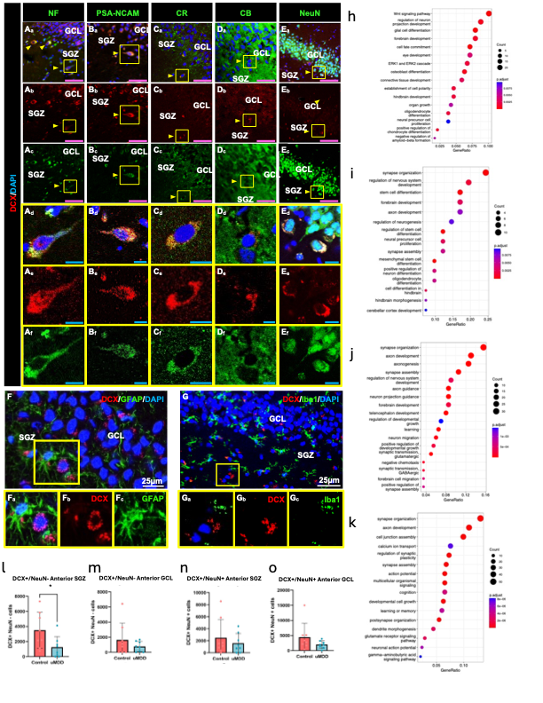

Extended Data Fig 8 | Validation and quantification of protein expression in cell types identified by LASSO Regression. Immunofluorescence staining shows that DCX co-localizes with (A_{a}-A_{f}) neurofilament (NF), which labels dendrites of DCX+ cells, (B_{a}-B_{f}) polysialylated cell adhesion molecule (PSA-NCAM), a neuroblast and plasticity marker, (C_{a}-C_{f}) calretinin, a neuroblast marker (D_{a}-D_{f}) calbindin, and (E_{a}-E_{f}) neuronal nuclear marker (NeuN), which are expressed in mature granule neurons. Cells shown in triple and single channels at low and high magnification (yellow boxes). A_{d}-A_{f}. DCX+/NF+ cell with neurite extending towards the granule cell layer (GCL) in triple and single channels; B_{d}-B_{f} DCX/CB+ cell, C_{d}-C_{f} DCX/CR+ cell in the inner polymorphic layer/ subgranular zone (SGZ); D_{d}-D_{f} DCX+/PSA-NCAM+ migrating cell with elongated nuclei and process parallel to the GCL; E_{d}-E_{f} DCX+/NeuN+ cell. F Glial fibrillary acid protein (GFAP) labels astrocytes and their processes; F_{a}-F_{c} Yellow boxes show high magnification of DCX+ and GAFP+ cells and no co-localization. G. Ionized calcium binding adaptor molecule (Iba1) labels microglia; G_{a}-G_{c} yellow boxes show high magnification of DCX+ and Iba+ cells in the inner polymorphic layer, and no co-localization. A-G. Cell nuclei are stained with 4’, 6-diamidino-2-phenylindole (DAPI). Arrows point to cells co-labeled with selected markers. Pink scale bars = 50 μm; Blue scale bars = 10 μm. h-k. Gene ontology network analysis of biological processes using genes that are significantly enriched in TypeI, TypeII, TypeIII, and ImGN. Genes used were selected based Wilcoxon rank sum test that had Bejamini-Hochberg adjusted p-value less than 0.05 and log fold change greater than 0.05. All terms shown have Bejamini-Hochberg adjusted p-value less than 0.05. h. TypeI. i. TypeII. j. TypeIII. k. ImGN. l-o. Comparison of cell counts between CTRL and MDD l. Number of DCX+/NeuN- cells in the SGZ is significantly lower in MDD. m. There is no group difference in the number of DCX+/NeuN- cells in the GCL. b-o. There is no group difference in number of DCX+/NeuN+ cells in the (n) SGZ and (o) GCL. l-o. Error bars represent one standard deviation.

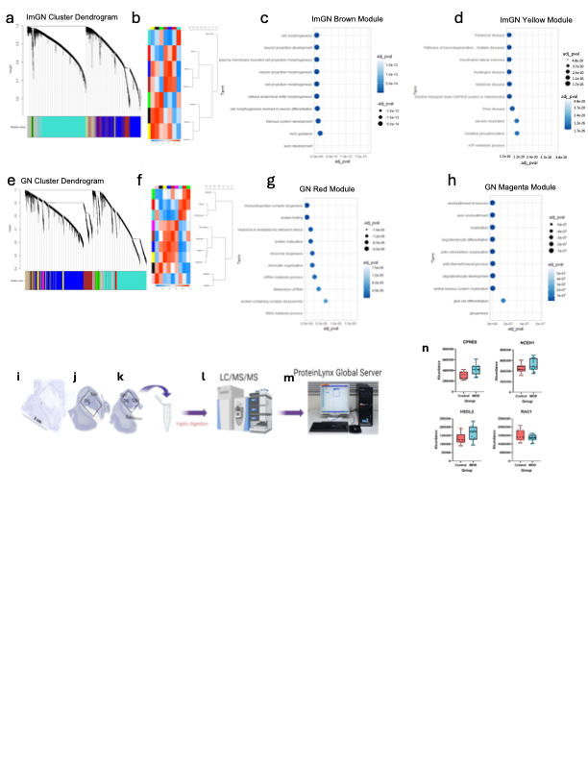

Extended Data Fig 9 | Further characterization of pathway dysregulation and protein expression in MDD. a. Weighted gene co-expression network analysis (WGCNA) module dendrogram for ImGN cell type. b. WGCNA eigengene adjacency heatmap. c. Gene Ontology (GO) analysis of top 10 Biological Processes and Pathways in the ImGN brown module. d. GO analysis of ImGN yellow module. e. WGCNA module dendrogram of GN cell type. f. WGCNA eigengene adjacency heatmap. g. GO analysis of ImGN red module. h. GO analysis on ImGN magenta module. i-m. Schematic of the proteomic workflow including (i) the anterior hippocampus tissue area used for proteomics including dentate gyrus and hilus from three sections at 2-mm intervals through the anterior (j) and mid (k) hippocampus. l. Liquid chromatography double mass spectrometry (LC/MS/MS) was conducted and analyzed with MS^{E}/Identity^{E} algorithm (PLGS software Version 2.5 RC9). m. Mass spectrometry data were processed using ProteinLynx Global Server (PLGS 2.2.25, Waters Corp.), and analyzed with Elucidator Protein Expression Analysis System (V 4.4.4.2.3.1, Ceiba Solutions). n. CPNE8, NCEH1, HSDL2 and RAC1 were differentially expressed at both the gene and the protein level. Error bars represent one standard deviation. Center line represents median, box limits are first and third quartiles, and the whiskers go down to the minimum and up to the maximum value.

