Supplementary material

Supplementary Table 1 (e-Table 1). Patient characteristics according to the intubated vs tracheostomized group.
 | Intubated  (N=33, 71.2%) | Tracheostomized  (N=13, 28.8%)
Age (years), mean (DS) | 62.5 (11.3) | 62.6 (11.4)
BMI (kg/m²), median (IQR) | 28.6 (24.4-31.7) | 26.0 (22.6-33.2)
Male (N, %), mean (DS) | 24 (70.0) | 6 (50.0)
ICU admission SOFA score, median (IQR) | 4 (4-8) | 6 (4-8)
Comorbidities (N, %)
No comorbidity | 7 (21.2) | 3 (23.1)
One comorbidity | 12 (36.4) | 2 (15.4)
Two comorbidities | 6 (18.2) | 4 (30.8)
Three comorbidities | 8 (24.2) | 4 (30.8)
TF_{abs} (%), median (IQR) | 0.9 (0.7-1.4) | 0.9 (0.7-1.5)
Reason for admission (N, %)
Trauma | 2 (6.1) | 1 (7.6)
Respiratory failure | 6 (18.2) | 1 (7.6)
Sepsis | 3 (9.1) | 1 (7.6)
Brain injury | 2 (6.1) | 1 (7.6)
COVID-19 ARDS | 18 (54.5) | 9 (69.2)
Other | 2 (6.1) | 0 (0.0)
Presence of ICUAW (N, %) | 14 (42.4) | 12 (92.3)
Presence of DD (N, %) | 14 (42.4) | 7 (53.8)
Presence of AMW (N, %) | 24 (72.8) | 10 (76.9)
WIND class (N, %)
Short weaning | 20 (60.6) | 3 (23.0)
Difficult weaning | 10 (30.3) | 0 (0.0)
Prolonged weaning | 0 (0.0) | 4 (30.7)
Weaning failure | 3 (9.0) | 6 (46.1)
Weaning >7 days (before disconnection) | 0 (0.0) | 8 (61.5)
Duration of MV (before disconnection) | 5.0 (3.0-7.0) | 14.0 (5.7-17.0)
WF at 48 hrs (N, %) | 7 (21.2) | 9 (69.2)
WF at 7 days (N, %) | 7 (21.2) | 11 (84.6)
ICU LOS (days), median (IQR) | 10.0 (6.0-12.3) | 21.0 (14.7-28.3)
H LOS (days), median (IQR) | 28.0 (17.0-43.7) | 29.0 (22.0-39.0)
ICU mortality (N, %) | 4 (12.1) | 8 (615)
H mortality (N, %) | 2 (6.6) | 0 (0.0)

Abbreviations: WF: weaning failure; BMI: body mass index; ICU: intensive care unit; SOFA: sequential organ failure assessment; TF_{abs}: the sum of the thickening fraction during cough of the rectus abdominis, transversus abdominis and internal oblique; ARDS: acute respiratory distress syndrome; ICUAW: intensive care unit acquired weakness; DD: diaphragm dysfunction; AMW: Abdominal Muscle Weakness; WIND definition: Weaning according to a New Definition; Weaning >7 days: more than 7 days of mechanical ventilation from the first SBT to the disconnection attempt; Duration of MV: duration of ventilation before the first disconnection attempt; ICU LOS: ICU length of stay; H LOS: hospital length stay; N: number of non-missing values. N: number of nonmissing values. Based on their distribution and types of variables, the data are presented as the median (interquartile range, IQR), mean (standard deviation, DS) or number (percentage).

Supplementary Table 2 (e-Table 2). Difference in the prevalence of AMW among patients affected by ICUAW or DD.
 | Presence of AMW  (N=33, 71.7%) | No AMW  (N=13, 28.3%) | p
Presence of ICUAW (N; %) | 16 (48.4) | 9 (69.2) | 0.28
Presence of DD (N; %) | 15 (45.4) | 6 (46.1) | 0.97
Abbreviations AMW: Abdominal Muscle Weakness; ICUAW: Intensive Care Unit Acquired Weakness; DD: Diaphragm Dysfunction. CI, 95%Confidence Interval. Pearson’s Chi-square test.

Supplementary Table 3 (e-Table 3). Results from the competing risk regression. The Subdistribution Hazard Ratio (SRH), the 95% CI and the p-values are shown for each variable included in the model.
Predictors |  | SHR | 95% CI | p
Presence of AMW |  | 0.50 | 0.18 – 1.36 |  | 0.18
Presence of DD |  | 1.18 | 0.64 – 2.20 |  | 0.59
Presence of ICUAW |  | 0.23 | 0.12 – 0.44 |  | <0.01
Age (years) |  | 0.99 | 0.96 – 1.01 |  | 0.26
BMI (kg/m2) |  | 1.01 | 0.95 - 1.06 |  | 0.89
Admission SOFA |  | 1.01 | 0.87 - 1.17 |  | 0.91
Abbreviations: BMI: Body Max Index; SOFA: Sequential Organ Failure Assessment; AMW: Abdominal Muscle Weakness; ICUAW: Intensive Care Unit Acquired Weakness; DD: Diaphragm Dysfunction. 95% CI Confidence Interval.

Supplementary Table 4 (e-Table 4). Multimodal logistic regression on the presence or absence of AMW based on weaning class group according to the WIND definition. The presence of AMW was considered the independent variable; weaning groups were considered dependent variables (short weaning group as reference).
WIND Group |  | Predictors |  | p |  | Odds-Ratio |  |  | IC
Difficult weaning - Short weaning |  | Presence of AMW |  |  | 0.12 |  | 5.78 |  |  | 0.62 – 53.76
Prolonged weaning - Short weaning |  | Presence of AMW |  |  | 0.59 |  | 1.92 |  |  | 0.17- 21.53
Weaning failure - Short weaning |  | Presence of AMW |  |  | 0.37 |  | 2.25 |  |  | 0.37 - 13.35
Abbreviations: WIND definition: Weaning according to a New Definition.BMI; Body Max Index; SOFA: Sequential Organ Failure Assessment; AMW: Abdominal Muscle Weakness; CI, 95% Confidence Interval.

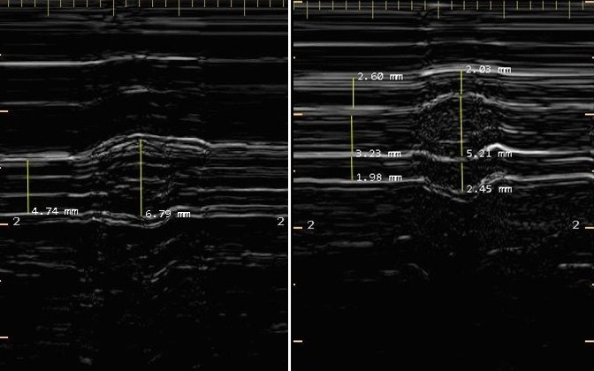
Supplementary Figure 1 (e-Figure 1). M-mode images of abdominal muscles during cough. (1a) Ultrasound image of the rectus abdominis muscle (RA), obtained with the probe placed 2–3 cm above the umbilicus and 2–3 cm from the midline. (1b) Ultrasound image of the external oblique muscles (EO), internal oblique muscle (IO) and transversus abdominis muscle (TrA) obtained with the probe placed midway between the costal margin and the iliac crest along the anterior axillary line. The thickness of each abdominal muscle was measured between the two internal layers, excluding the aponeurosis. The thickening fraction during cough (TF_{cough}) was calculated as the difference between the peak expiration during cough (Th_{peak}, at peak contractile effort) and thickness between end-inspiration (Th_{ei}, when the muscles are most relaxed), divided for Th_{peak}. The percent change was defined as the thickening fraction (TF_{cough}) for each muscle. Thus, the global thickening fraction during cough (TF_{abs}) was defined as the sum of the TF during cough of RA, TrA and IO; TF_{abs} =TF_{cough, RA} + TF_{cough, TrA} + TF_{cough, IO}. Thus, abdominal muscle weakness (AMW) was defined as TF_{abs} less than 127%, as described in a previous study.¹⁵

Supplementary Figure 2 (e-Figure 2). Report on the total number of patients screened and enrolled, including details of exclusions and reasons. Abbreviations: SBT: Spontaneous Breathing Trial.

