Supplemental
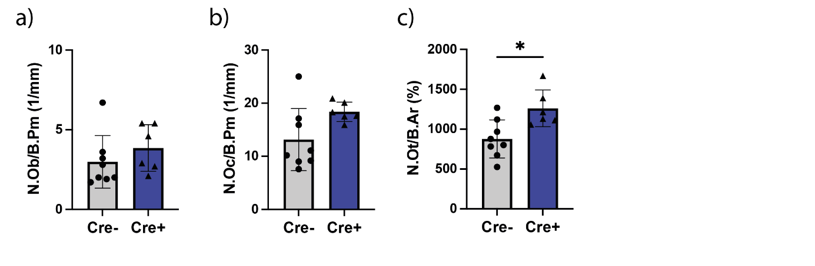
Supp.Fig. 1: Femoral osteoblast, osteoclast and osteocyte analysis. a) Number of osteoblasts per bone perimeter in 1/mm. b) Number of osteoclasts per bone perimeter in 1/mm. c) Number of osteocytes per bone area in %. Statistical significance was determined by unpaired t-test (comparison Cre⁻ vs. Cre⁺). *P < 0.05, **P < 0.01, ***P < 0.001, ****P < 0.0001. (N=6-8; males)

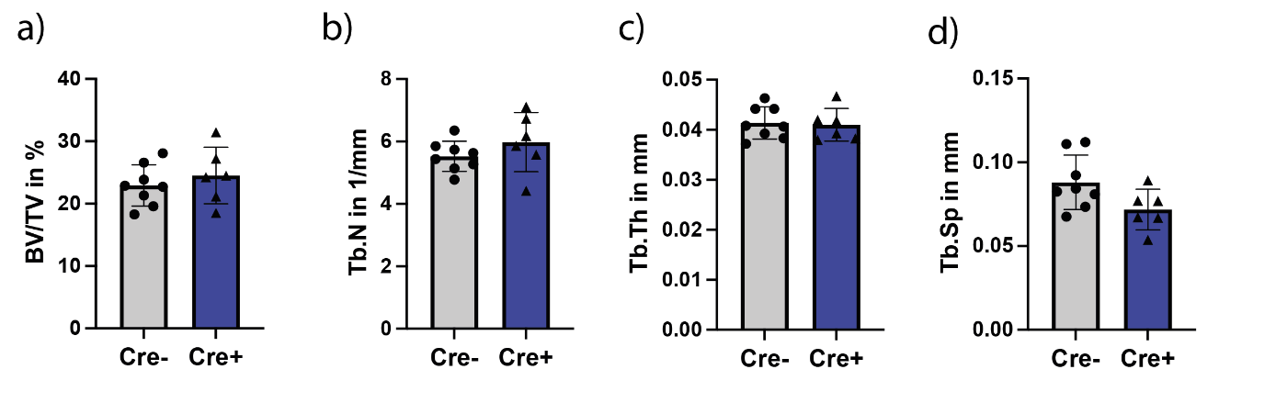
Supp.Fig. 2: Spine phenotyping of 12 week old male Ly6G-Cre/Adrb2-flox KO mice using µCT analysis. a) Spine BV/TV in %. b) Spine trabecular number in 1/mm. c) Spine trabecular thickness in mm. d) Spine trabecular separation in mm. Statistical significance was determined by unpaired t-test (comparison Cre⁻ vs. Cre⁺). *P < 0.05, **P < 0.01, ***P < 0.001, ****P < 0.0001. (N=6-8; males)

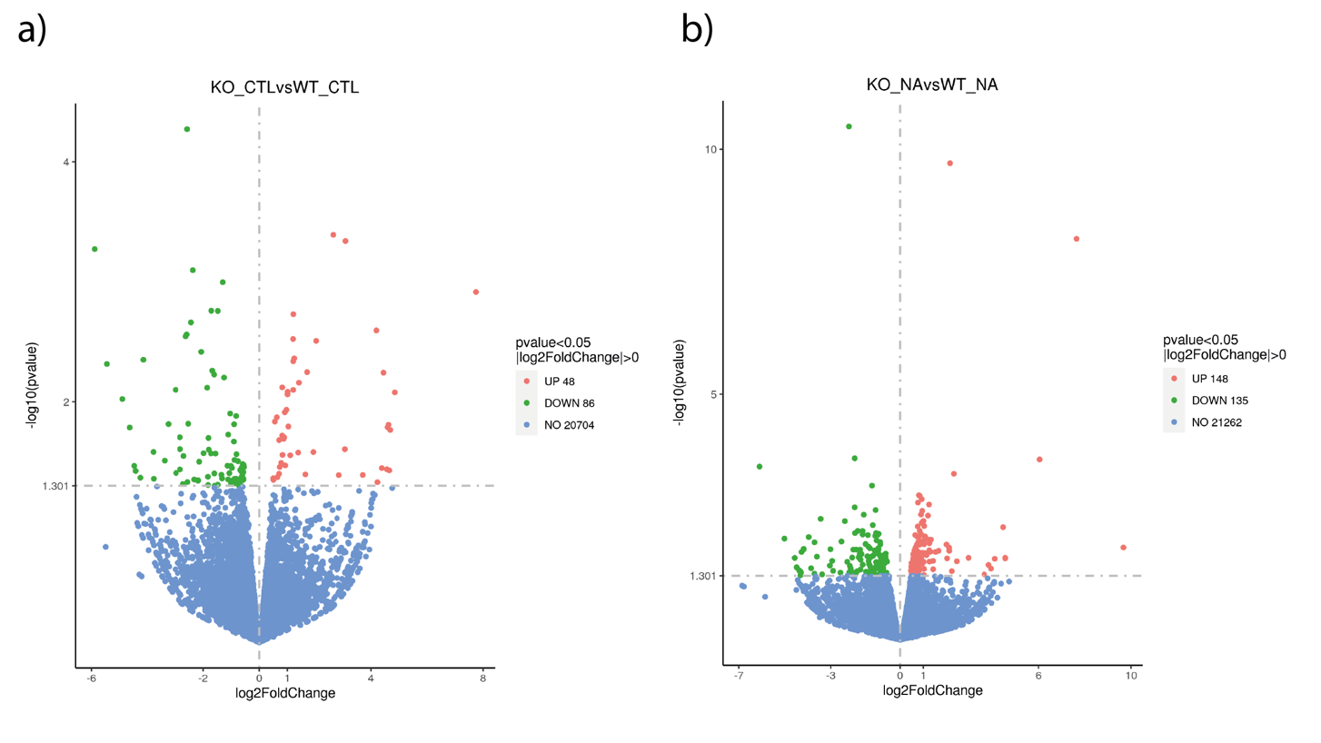

Supp.Fig. 3: Overview of all up- and downregulated genes in unstimulated and stimulated Cre+ neutrophils. a) Comparison of Cre- and Cre+ unstimulated neutrophils. b) Comparison of Cre- and Cre+ stimulated neutrophils.

