Supplementary Information

Chip on a fiber toward the e-textile computing platform

Sunbin Hwang^{1†}, Minji Kang^{2†}, Aram Lee¹, Sukang Bae¹, Seoung-Ki Lee¹, Sang Hyun Lee³, Takhee Lee⁴, Gunuk Wang⁵ and Tae-Wook Kim^{2,*}

¹Functional Composite Materials Research Center, Korea Institute of Science and Technology, Jeollabuk-do, 55324, Republic of Korea
²Department of Flexible and Printable Electronics, Jeonbuk National University, 567 Baekje-daero, Deokjin-gu, Jeonju 54896, Republic of Korea
³School of Chemical Engineering, Chonnam National University, 77 Yongbong-ro, Buk-gu, Gwangju 61186, Republic of Korea
⁴Department of Physics and Astronomy, and Institute of Applied Physics, Seoul National University, Seoul, 08826, Republic of Korea
⁵KU-KIST Graduate School of Converging Science and Technology, Korea University, 145 Anam-ro, Seongbuk-gu, Seoul, 02841, Republic of Korea

KEYWORDS: E-Textiles, Wearable electronics, Transistors, Photodetectors, Temperature sensors,

†These authors contributed equally.
*Author to whom correspondence should be addressed. E-mail: twk@jbnu.ac.kr

Bending test
The engineering strain of the fiber (e), which is presented as the ratio of the total deformation to the initial state under applied mechanical input, is calculated through the below equation,

$e=\frac{d_{s}+d_{f}}{2R}\frac{(1+2η+χη^{2})}{(1+η)(1+χη)}≈\frac{d_{s}+d_{f}}{2R}$,

where, η = d_{f}/d_{s} and χ = Y_{f}/Y_{s}. d_{s} and d_{f} are the thicknesses of the substrate (square shaped-glass fiber, 150 μm) and active layer (IGZO, 15 nm), respectively. Y_{s} (glass, 50-90 GPa) and Y_{f} (Oxide, > 100 GPa) are Young’s modulus of the substrate and active layer, respectively. R is the bending radius. In simplified formula under the premise that the substrate is much thicker than the active layer and there is a relatively small difference between Y_{s} and Y_{f}, e within the active layer on the bent substrate can be roughly obtained as the right term of the equation.¹
Fig. 2G shows transfer curves of driver transistor that composes n-MOS depletion-load inverter fabricated on a square-shaped fiber substrate when concave and convex strains are applied to the fiber. Field-effect mobility (μ), threshold voltage (V_{th}) and drain current at on-state (I_{D, On}) are estimated from Fig. 2G and summarized in Fig. 2H. There was no significant change in either convex or concave strain below 0.7% which is the similar results with other references that using IGZO as an active layer for flexible transistors.^{1,2}

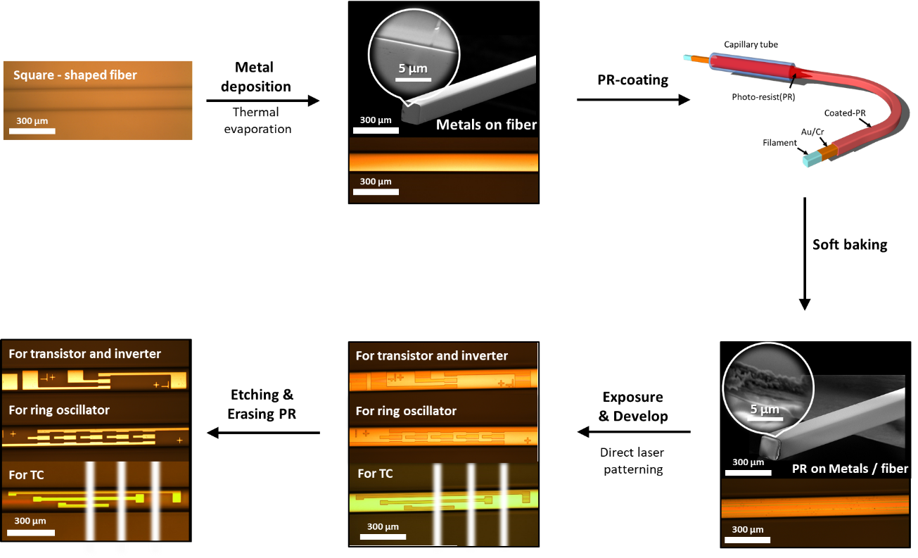

Fig. S1. Preparation of metal electrode pattern. Optical image showing the CTAC setup used for coating photoresist on a metal-deposited fiber substrate. SEM images showing an as-deposited PR film with a zoomed-in SEM image.

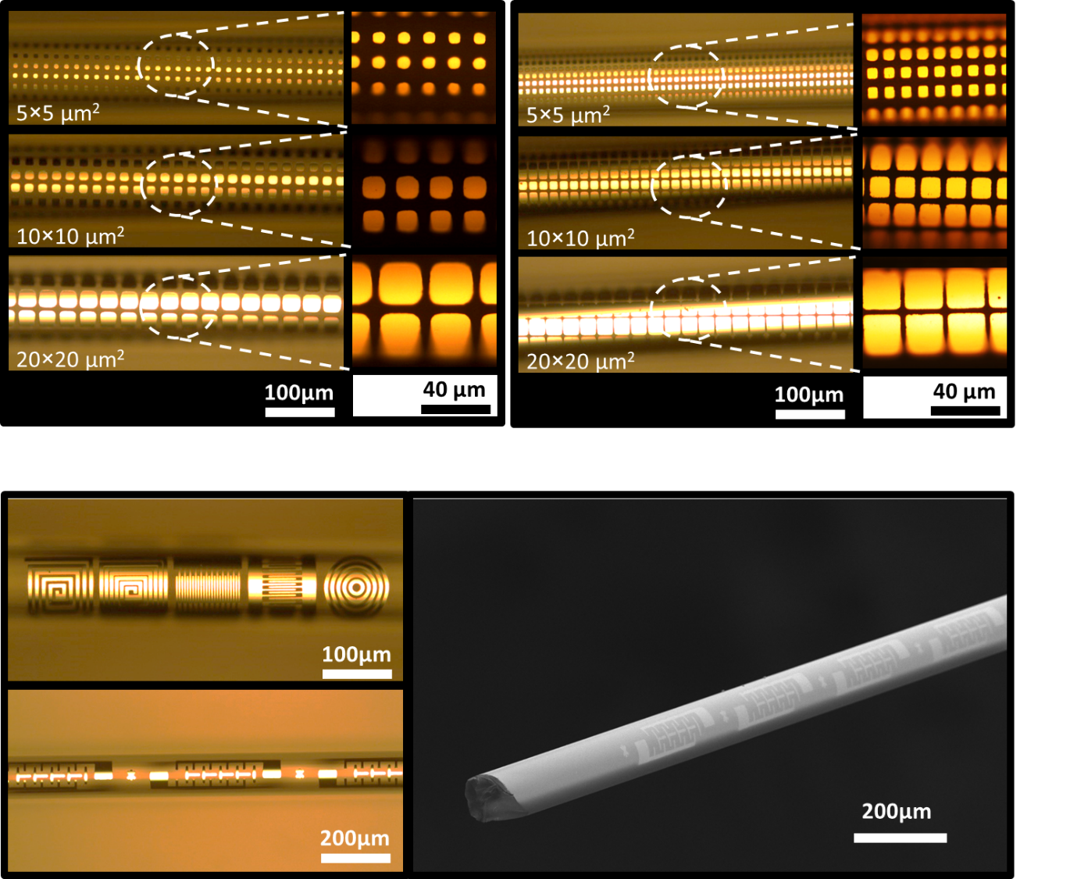

Fig. S2. Top: The optical microscope images of square electrode pattern arrays having various sizes (5 × 5, 10 × 10, 20 × 20 μm²) and pitches fabricated on cylindrical glass fiber (φ 125 μm). Bottom: The optical microscope and SEM images of various patterned metal electrodes on cylindrical glass fiber.
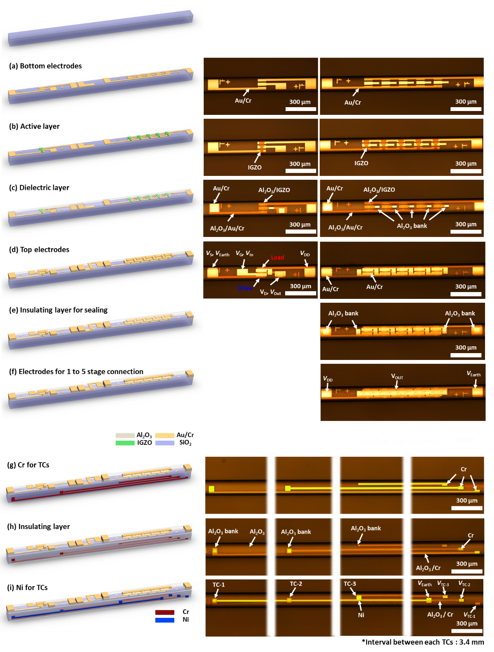
Fig. S3. The schematic illustrations and optical microscope images of the device fabrication procedure based on the method. (a) Gold/chromium (Au/Cr) bottom electrodes. (b) IGZO active layer for transistor, inverter, and ring oscillator. (c) Al₂O₃ dielectric layer contained via holes. (d) Au/Cr top electrodes. (e) Al₂O₃ insulating layer contained via holes for a transistor, an inverter, and a ring-oscillator. (f) Au/Cr short electrode to connecting the 1st and 5th stages of inverters for ring-oscillator. (g) Cr electrodes on the side of the fiber, which are used as one of the thermocouple (TC) components. (h) Al₂O₃ insulating layer contained via holes on the side of the fiber for the TC column. (i) Nickel (Ni) electrodes on the side of fiber, which are used as one of the TC components. (The interval between each TCs consisting of the TC column as shown in illustrations is 3.4 mm, which is drawn in a reduced size for presentation with all other TCs.)

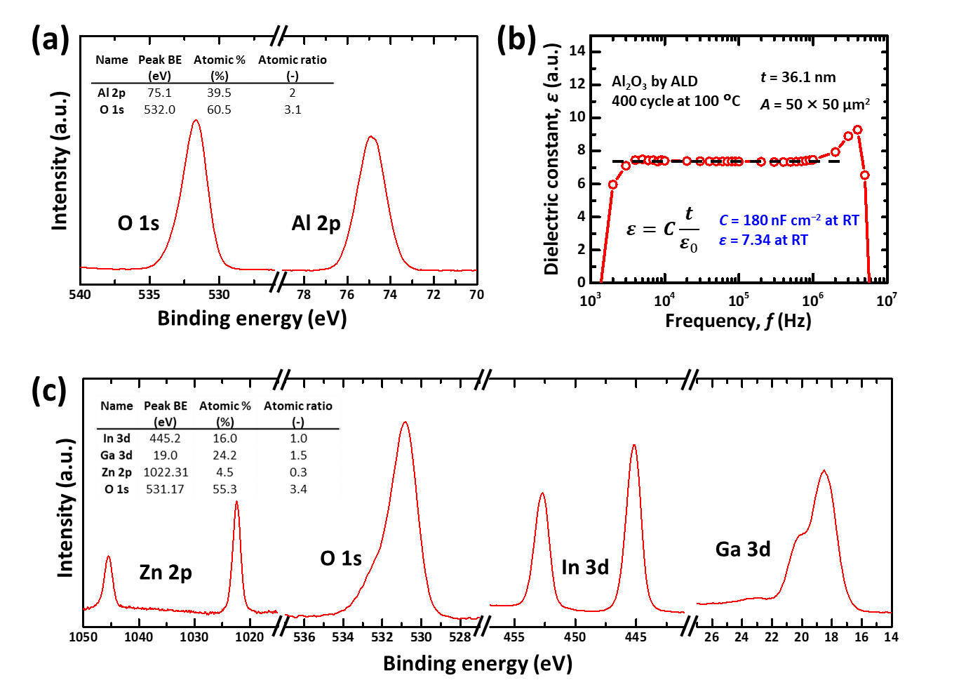
Fig. S4. (a) X-ray photoelectron spectroscopy (XPS) narrow scan spectra of Al₂O₃ thin film fabricated by atomic layer deposition (ALD). (b) Dielectric constant (ε) versus frequency (f) characteristic of metal/dielectric layer/metal capacitor. (c) XPS spectra of IGZO thin film fabricated by a sputter. The inset tables in Fig. S4(a) and S4(c) show the peak binding energy, atomic percent, and the ratio of each atom compose each thin film.
The basic properties of the materials used in this study are described in Fig. S4. The chemical features of IGZO and Al₂O₃ thin films were identified by XPS. The relative quantifications of atomic percent (at%) were estimated from the major XPS peaks and analyzed using Avantage software (Thermo Fisher Scientific, Ltd.), which applies the XPS peak intensity taken by the area via the so-called first principles model and the elemental sensitivity factor methods. To estimate dielectric constant (ε) of Al₂O₃ thin film fabricated by atomic layer deposition (ALD), the capacitance measurement was performed using a semiconductor parameter analyzer (Keithley 4200 SCS). A capacitor composed of metal/dielectric/metal layers was fabricated on a square-shaped glass fiber, and the capacitance density (C) was measured as a function of the frequency (f). The C was converted to ε by using the below equation,

$ε=C\frac{t}{ε_{0}}$,

Where ε_{o} is vacuum permittivity. The surface of a capacitor was 50 × 50 μm² and the thickness (t) of Al₂O₃ thin film was 36.1 nm (ALD 400 cycle at 100 °C). Fig. S4(b) shows the ε versus f characteristics of the capacitors with the Cr/Au/Al₂O₃ /Au/Cr structure (30 nm of Au, 15 nm of Cr thickness for the bottom and top electrodes) and exhibited a relatively high ε of 7.34 (C = 180 nF cm⁻² at 10 kHz and room temperature), which is advantageous to lower the operating voltage of the device.³

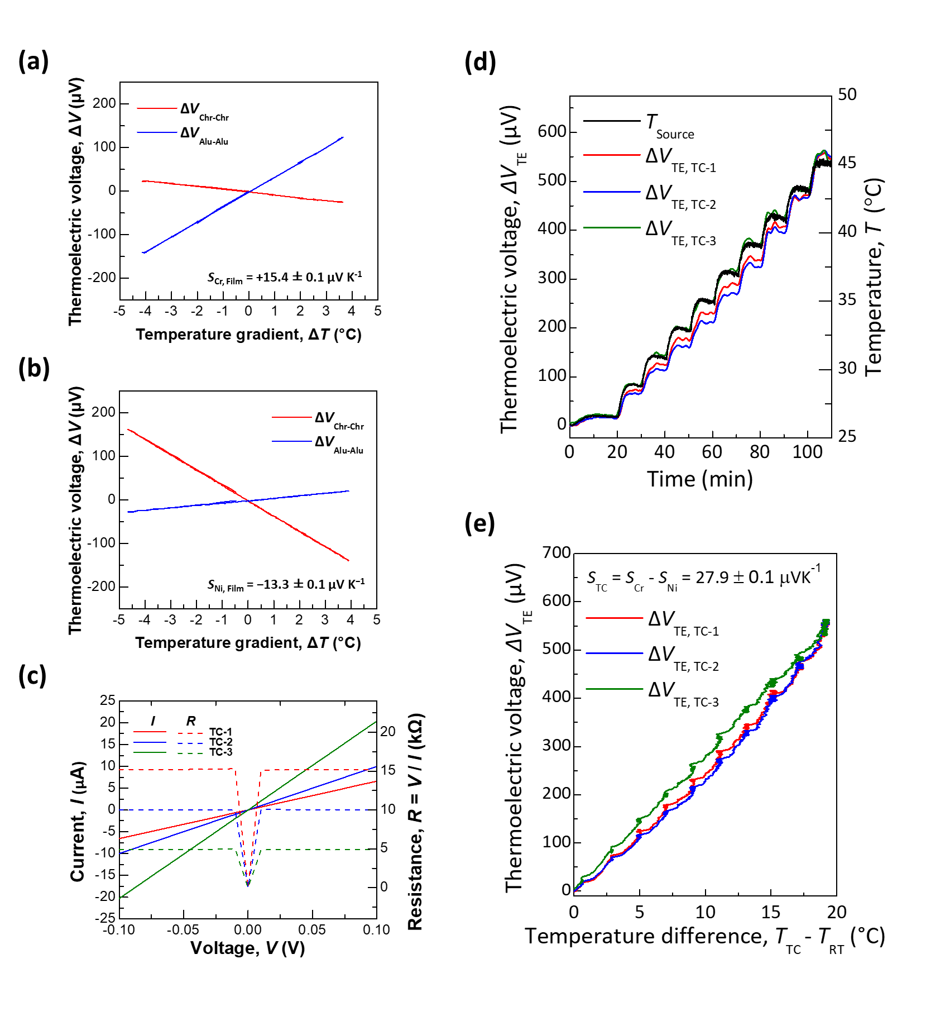
Fig. S5. Thermoelectric voltage (∆V_{TE}) curves versus temperature gradient (∆T) applied to (a) Chromium (Cr) and (b) Nickel (Ni) thin films. (c) Current (I) – voltage (V) curves and the calculated resistances of each thermocouple consisting of Cr and Ni thin film fabricated on the square-shaped glass fiber. (d) A plot of thermoelectric voltage versus time for the Cr−Al₂O₃−Ni thermocouples measured during a gradual increase in temperature. (e) Thermoelectric voltage as a function of temperature difference.
Seebeck coefficient (S) of chromium (Cr) and nickel (Ni) thin films were measured with a homemade setup as described in our previous reports.^{4,5} To determine S, it is necessary to apply a temperature gradient (∆T) across the sample and measure the thermoelectric voltage (∆V_{TE}) and ∆T. Fine chromel and alumel wires (φ 50 μm, Nilaco) were used to resolve these problems. Chromel and alumel are alloys with known S and well-known as materials for forming K-type thermocouples. When ∆T is applied to the sample, the temperatures at the hot and cold sides can be measured at the same time in addition to ∆V_{TE} generated from the sample. A typical ∆V_{TE} versus ∆T curve when measuring Cr and Ni thin films (3 mm of width, 23 mm of length, 30 nm of thickness) are shown in Fig. S5(a) and S5(b). From the blow equation, S_{χ} can be evaluated using either the chromel-chromel or alumel-alumel wire pair or both. Here, S_{χ, Chr-Chr} and S_{χ, Alu-Alu} are the S_{χ} estimated through the inner two chromel-chromel and alumel-alumel wire pairs, respectively.

$S_{χ, Chr‐Chr }=\frac{∆V_{Chr‐Chr}}{∆T}+S_{Chr}$,
$S_{χ, Alu‐Alu}=-\frac{∆V_{Alu‐Alu}}{∆T}+S_{Alu}$,
$S_{χ}=S_{χ, Chr‐Chr }=S_{χ, Alu‐Alu}=\frac{∆V_{Chr‐Chr}-∆V_{Alu‐Alu}}{2∆T}+\frac{S_{Chr}+S_{Alu}}{2}$

15.4 ± 0.1 µV K⁻¹ and −13.3 ± 0.1 µV K⁻¹ were obtained as S of Cr and Ni thin films (S_{Cr, film} and S_{Ni, film}), respectively, from the linear slopes of the line fit to each ∆V_{TE}−∆T curves and the equation, which matches well as S of thermocouple consisting of Ni and Cr (S_{Cr, film}−S_{Ni, film}) as discussed below. The $S$ values of other reference samples were also measured to further confirm the accuracy of the measurement system. The previously reported S of chromel, gold, nickel, and platinum was 21.9 ± 0.2 µV K⁻¹, 2.0 ± 0.4 µV K⁻¹, −19.3 ± 0.4 µV K⁻¹, and −0.9 ± 0.65 µV K⁻¹, respectively. More detail about the schematic of the system, reference measurement, and theory can be found in previous reports.^{4,5}

The quantity of heat flow (Q) across a temperature gradient can be expressed by Fourier’s law as,

$Q=-Aκ\frac{∂T}{∂L}$ Equation 3, Fourier's law,

where A is the cross-section area of the material, κ is the material’s thermal conductivity, T is the temperature gradient as a function of the distance from a thermal source (L), as shown in Fig 4B. As discussed in Fig. S5(d) and S5(e), T at each TC junctions can be reversely calculated by using S of each TCs and ΔV_{TE} generated from each TCs, (See Equation 4).

$T=\frac{ΔV_{TE}}{S_{Cr} - S_{Ni}}+T_{RT}$ Equation 4

. T at each TCs as plotted in Fig. 4C was converted from ΔV_{TE} and Eq. 4 and showed a lower temperature in order away from the thermal source (T_{Source} > T_{TC-1} > T_{TC-2} > T_{TC-3}). The temperature distribution from the heat source at each sensor, as described in Fig. 4D, showed exponential decay due to heat loss from air convection instead of linear decay following Fourier's law. The temperature output of the thermoresistive TC column sensors fabricated on the 1D fiber indicates that it can be applied as a distributed temperature sensor.

References

- Zhang, Y.-H., Mei, Z.-X., Liang, H.-L. & Du, X.-L. Review of flexible and transparent thin-film transistors based on zinc oxide and related materials. Chinese Phys. B 26, 047307 (2017).
- Yoon, J., Jeong, Y., Kim, H., Yoo, S., Jung, H. S., Kim, Y., Hwang, Y., Hyun, Y., Hong, W. K., Lee, B. H. & Choa, S.H. Robust and stretchable indium gallium zinc oxide-based electronic textiles formed by cilia-assisted transfer printing. Nat. Commun. 7, 1–10 (2016).
- Wu, C.-H. et al. Characteristics of IGZO TFT prepared by atmospheric pressure plasma jet using PE-ALD Al2O3 gate dielectric. IEEE Electron Device Lett. 33, 552–554 (2012).
- Hwang, S. et al. Solution-processed organic thermoelectric material exhibiting doping-concentration-dependent polarity. Phys. Chem. Chem. Phys. 18, 29199–29207 (2016).
- Hwang, S., Potscavage, W. J., Nakamichi, R. & Adachi, C. Processing and doping of thick polymer active layers for flexible organic thermoelectric modules. Org. Electron. 31, 31–40 (2016).

