Supplementary Materials
Supplementary Table 1: Component matrix from principal component analysis
 | Social/non-social attention (factor 1) | Efficiency of exploration (factor 2)
Fixation count (%) - social | 0.88 | -0.099
Fixation count (%) - non-social | -0.917 | -0.027
Dwell time (%) - social | 0.853 | -0.196
Dwell time (%) - non-social | -0.88 | 0.065
Regressive fixations (%) - social | 0.879 | -0.099
Regressive fixations (%) - non-social | -0.921 | -0.006
Perseverative fixations (%) - social* | 0.606 | 0.027
Perseverative fixations (%) - non-social* | -0.604 | 0.048
Transition: Social to non-social (%) | -0.684 | -0.138
Transition: Non-social to social (%) | -0.679 | -0.145
Transition: Social to social (%) | 0.941 | 0.084
Transition: Non-social to non-social (%) | -0.728 | 0.097
Fixation spatial distribution/coverage - 5 x 4 (larger) | -0.277 | -0.63
Fixation spatial distribution/coverage - 10 x 8 (smaller) | -0.223 | -0.501
Fixation rate (exploration) AOI (fix/s) - social | -0.112 | 0.858
Fixation rate (exploration) AOI (fix/s) - non-social | 0.189 | 0.366
Fixation rate (exploration) | -0.11 | 0.901
First fixation duration (s) | -0.061 | -0.313
*Bold values indicate variables conceptualized under each component (factor)
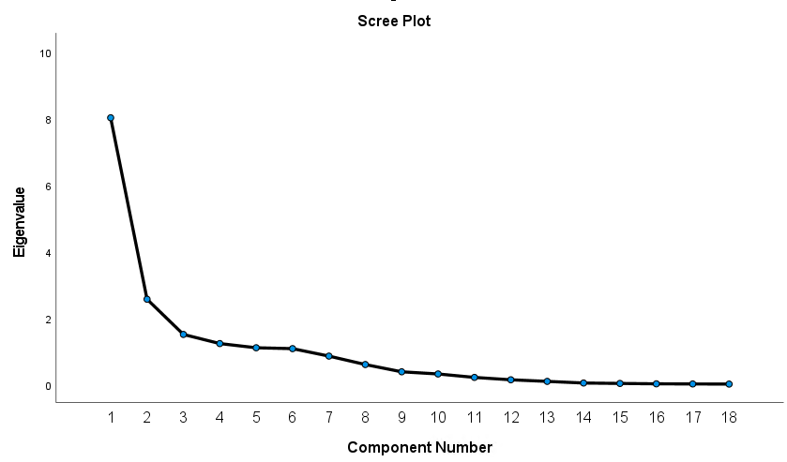
Supplementary Figure 1. Scree plot from the principal component analysis. Arrow indicates the “elbow” determining 2 components.
Component Number
Eigenvalue

