Supplementary
Appendix 1. Full Search Strategy
Appendix 2. Introduction of Therapy 10
Appendix 3. Study Characteristics 11
Appendix 4. Risk of Bias 15
Appendix 5. Certainty of evidence 16
Appendix 6. Comparison of network meta-analysis 17
Appendix 7. Inconsistency test for direct and indirect evidence 19
Appendix 8. Results of the comparison-adjusted funnel plot 22

Appendix 1. Full Search Strategy
Table 1. Search strategy for Pubmed.
No. | Search terms | Results
#1 | "stroke"[MeSH Terms] OR "stroke"[All Fields] OR "strokes"[All Fields] OR "strokes"[All Fields] OR ("stroke"[MeSH Terms] OR "stroke"[All Fields] OR "strokes"[All Fields] OR "stroke s"[All Fields]) OR ("stroke"[MeSH Terms] OR "stroke"[All Fields] OR ("cerebrovascular"[All Fields] AND "accident"[All Fields]) OR "cerebrovascular accident"[All Fields]) OR ("stroke"[MeSH Terms] OR "stroke"[All Fields] OR ("cerebrovascular"[All Fields] AND "accidents"[All Fields]) OR "cerebrovascular accidents"[All Fields]) OR ("stroke"[MeSH Terms] OR "stroke"[All Fields] OR "cva"[All Fields]) OR ("stroke"[MeSH Terms] OR "stroke"[All Fields] OR ("cerebrovascular"[All Fields] AND "apoplexy"[All Fields]) OR "cerebrovascular apoplexy"[All Fields]) OR ("stroke"[MeSH Terms] OR "stroke"[All Fields] OR ("brain"[All Fields] AND "vascular"[All Fields] AND "accident"[All Fields]) OR "brain vascular accident"[All Fields]) OR ("stroke"[MeSH Terms] OR "stroke"[All Fields] OR ("brain"[All Fields] AND "vascular"[All Fields] AND "accidents"[All Fields]) OR "brain vascular accidents"[All Fields]) OR ("apoplexies"[All Fields] OR "stroke"[MeSH Terms] OR "stroke"[All Fields] OR "apoplexy"[All Fields]) OR ("stroke"[MeSH Terms] OR "stroke"[All Fields] OR ("cerebral"[All Fields] AND "stroke"[All Fields]) OR "cerebral stroke"[All Fields]) OR ("stroke"[MeSH Terms] OR "stroke"[All Fields] OR ("cerebral"[All Fields] AND "strokes"[All Fields]) OR "cerebral strokes"[All Fields]) OR ("stroke"[MeSH Terms] OR "stroke"[All Fields] OR ("acute"[All Fields] AND "cerebrovascular"[All Fields] AND "accident"[All Fields]) OR "acute cerebrovascular accident"[All Fields]) OR ("stroke"[MeSH Terms] OR "stroke"[All Fields] OR ("acute"[All Fields] AND "cerebrovascular"[All Fields] AND "accidents"[All Fields]) OR "acute cerebrovascular accidents"[All Fields]) OR ("cerebral infarction"[MeSH Terms] OR ("cerebral"[All Fields] AND "infarction"[All Fields]) OR "cerebral infarction"[All Fields]) OR ("cerebral infarction"[MeSH Terms] OR ("cerebral"[All Fields] AND "infarction"[All Fields]) OR "cerebral infarction"[All Fields] OR ("cerebral"[All Fields] AND "infarctions"[All Fields]) OR "cerebral infarctions"[All Fields]) OR ("hemorrhagic stroke"[MeSH Terms] OR ("hemorrhagic"[All Fields] AND "stroke"[All Fields]) OR "hemorrhagic stroke"[All Fields] OR ("hemorrhagic"[All Fields] AND "strokes"[All Fields]) OR "hemorrhagic strokes"[All Fields]) OR ("ischemic stroke"[MeSH Terms] OR ("ischemic"[All Fields] AND "stroke"[All Fields]) OR "ischemic stroke"[All Fields]) OR ("ischemic stroke"[MeSH Terms] OR ("ischemic"[All Fields] AND "stroke"[All Fields]) OR "ischemic stroke"[All Fields] OR ("ischemic"[All Fields] AND "strokes"[All Fields]) OR "ischemic strokes"[All Fields]) OR ("embolic stroke"[MeSH Terms] OR ("embolic"[All Fields] AND "stroke"[All Fields]) OR "embolic stroke"[All Fields]) OR ("thrombotic stroke"[MeSH Terms] OR ("thrombotic"[All Fields] AND "stroke"[All Fields]) OR "thrombotic stroke"[All Fields]) OR ("cerebral infarction"[MeSH Terms] OR ("cerebral"[All Fields] AND "infarction"[All Fields]) OR "cerebral infarction"[All Fields] OR ("cerebral"[All Fields] AND "infarct"[All Fields]) OR "cerebral infarct"[All Fields]) OR ("cerebral infarction"[MeSH Terms] OR ("cerebral"[All Fields] AND "infarction"[All Fields]) OR "cerebral infarction"[All Fields] OR ("cerebral"[All Fields] AND "infarcts"[All Fields]) OR "cerebral infarcts"[All Fields]) | 533,854
#2 | "hemiplegia"[MeSH Terms] OR "hemiplegia"[All Fields] OR "hemiplegias"[All Fields] OR ("hemiplegia"[MeSH Terms] OR "hemiplegia"[All Fields] OR "hemiplegias"[All Fields]) OR ("paresis"[MeSH Terms] OR "paresis"[All Fields] OR "hemiparesis"[All Fields]) OR ("hemiparetic"[All Fields] OR "hemiparetics"[All Fields]) OR ("hemiplegia"[MeSH Terms] OR "hemiplegia"[All Fields] OR ("spastic"[All Fields] AND "hemiplegia"[All Fields]) OR "spastic hemiplegia"[All Fields]) OR ("Post-Stroke"[All Fields] AND ("hemiplegia"[MeSH Terms] OR "hemiplegia"[All Fields] OR "hemiplegias"[All Fields])) OR ("paralysing"[All Fields] OR "paralysis"[MeSH Terms] OR "paralysis"[All Fields] OR "paralyse"[All Fields] OR "paralysed"[All Fields] OR "paralyses"[All Fields]) OR ("hemiplegia"[MeSH Terms] OR "hemiplegia"[All Fields] OR ("flaccid"[All Fields] AND "hemiplegia"[All Fields]) OR "flaccid hemiplegia"[All Fields]) | 159,767
#3 | "lower extremity"[MeSH Terms] OR ("lower"[All Fields] AND "extremity"[All Fields]) OR "lower extremity"[All Fields] OR ("lower"[All Fields] AND "limb"[All Fields]) OR "lower limb"[All Fields] OR ("lower extremity"[MeSH Terms] OR ("lower"[All Fields] AND "extremity"[All Fields]) OR "lower extremity"[All Fields] OR ("lower"[All Fields] AND "limbs"[All Fields]) OR "lower limbs"[All Fields]) OR ("lower extremity"[MeSH Terms] OR ("lower"[All Fields] AND "extremity"[All Fields]) OR "lower extremity"[All Fields]) OR ("lower extremity"[MeSH Terms] OR ("lower"[All Fields] AND "extremity"[All Fields]) OR "lower extremity"[All Fields] OR ("lower"[All Fields] AND "extremities"[All Fields]) OR "lower extremities"[All Fields]) OR ("leg"[MeSH Terms] OR "leg"[All Fields]) OR ("leg"[MeSH Terms] OR "leg"[All Fields] OR "legs"[All Fields]) OR (("lower"[All Fields] OR "lowered"[All Fields] OR "lowering"[All Fields] OR "lowerings"[All Fields] OR "lowers"[All Fields]) AND ("appendage"[All Fields] OR "appendages"[All Fields])) OR (("lower"[All Fields] OR "lowered"[All Fields] OR "lowering"[All Fields] OR "lowerings"[All Fields] OR "lowers"[All Fields]) AND ("appendage"[All Fields] OR "appendages"[All Fields])) OR (("inferior"[All Fields] OR "inferiors"[All Fields]) AND ("extremities"[MeSH Terms] OR "extremities"[All Fields] OR "limb"[All Fields])) OR ("digit"[All Fields] OR "digit s"[All Fields] OR "digits"[All Fields]) OR ("toes"[MeSH Terms] OR "toes"[All Fields] OR "toe"[All Fields]) OR ("knee"[MeSH Terms] OR "knee"[All Fields] OR "knee joint"[MeSH Terms] OR ("knee"[All Fields] AND "joint"[All Fields]) OR "knee joint"[All Fields]) OR ("ankle"[MeSH Terms] OR "ankle"[All Fields] OR "ankle joint"[MeSH Terms] OR ("ankle"[All Fields] AND "joint"[All Fields]) OR "ankle joint"[All Fields] OR "ankles"[All Fields] OR "ankle s"[All Fields]) OR ("foot"[MeSH Terms] OR "foot"[All Fields]) OR ("thigh"[MeSH Terms] OR "thigh"[All Fields] OR "thighs"[All Fields] OR "thigh s"[All Fields]) | 845,559
#4 | "acupunctural"[All Fields] OR "acupuncture"[MeSH Terms] OR "acupuncture"[All Fields] OR "acupuncture therapy"[MeSH Terms] OR ("acupuncture"[All Fields] AND "therapy"[All Fields]) OR "acupuncture therapy"[All Fields] OR "acupuncture s"[All Fields] OR "acupunctured"[All Fields] OR "acupunctures"[All Fields] OR "acupuncturing"[All Fields] OR ("electroacupuncture"[MeSH Terms] OR "electroacupuncture"[All Fields] OR "electroacupuncturing"[All Fields]) OR ("massage"[MeSH Terms] OR "massage"[All Fields] OR "massages"[All Fields] OR "massaged"[All Fields] OR "massager"[All Fields] OR "massagers"[All Fields] OR "massaging"[All Fields]) OR ("moxibustion"[MeSH Terms] OR "moxibustion"[All Fields]) OR ("tai ji"[MeSH Terms] OR ("tai"[All Fields] AND "ji"[All Fields]) OR "tai ji"[All Fields] OR "taijiquan"[All Fields]) OR ("extracorporeal shockwave therapy"[MeSH Terms] OR ("extracorporeal"[All Fields] AND "shockwave"[All Fields] AND "therapy"[All Fields]) OR "extracorporeal shockwave therapy"[All Fields] OR ("extracorporeal"[All Fields] AND "shock"[All Fields] AND "wave"[All Fields] AND "therapy"[All Fields]) OR "extracorporeal shock wave therapy"[All Fields]) OR (("vibrate"[All Fields] OR "vibrated"[All Fields] OR "vibrates"[All Fields] OR "vibrating"[All Fields] OR "vibration"[MeSH Terms] OR "vibration"[All Fields] OR "vibrations"[All Fields] OR "vibrational"[All Fields] OR "vibrator"[All Fields] OR "vibrators"[All Fields]) AND ("therapeutics"[MeSH Terms] OR "therapeutics"[All Fields] OR "therapies"[All Fields] OR "therapy"[MeSH Subheading] OR "therapy"[All Fields] OR "therapy s"[All Fields] OR "therapys"[All Fields])) OR ("whole-body"[All Fields] AND ("vibrate"[All Fields] OR "vibrated"[All Fields] OR "vibrates"[All Fields] OR "vibrating"[All Fields] OR "vibration"[MeSH Terms] OR "vibration"[All Fields] OR "vibrations"[All Fields] OR "vibrational"[All Fields] OR "vibrator"[All Fields] OR "vibrators"[All Fields]) AND ("education"[MeSH Subheading] OR "education"[All Fields] OR "training"[All Fields] OR "education"[MeSH Terms] OR "train"[All Fields] OR "train s"[All Fields] OR "trained"[All Fields] OR "training s"[All Fields] OR "trainings"[All Fields] OR "trains"[All Fields])) OR ("Kinesio"[All Fields] AND ("tape s"[All Fields] OR "taped"[All Fields] OR "tapes"[All Fields] OR "taping"[All Fields] OR "tapings"[All Fields])) OR ("mirror movement therapy"[MeSH Terms] OR ("mirror"[All Fields] AND "movement"[All Fields] AND "therapy"[All Fields]) OR "mirror movement therapy"[All Fields] OR ("mirror"[All Fields] AND "therapy"[All Fields]) OR "mirror therapy"[All Fields]) OR (("virtual reality"[MeSH Terms] OR ("virtual"[All Fields] AND "reality"[All Fields]) OR "virtual reality"[All Fields]) AND ("reflect"[All Fields] OR "reflectance"[All Fields] OR "reflectances"[All Fields] OR "reflected"[All Fields] OR "reflecting"[All Fields] OR "reflection"[All Fields] OR "reflections"[All Fields] OR "reflective"[All Fields] OR "reflectively"[All Fields] OR "reflectiveness"[All Fields] OR "reflectives"[All Fields] OR "reflectivities"[All Fields] OR "reflectivity"[All Fields] OR "reflects"[All Fields]) AND ("therapeutics"[MeSH Terms] OR "therapeutics"[All Fields] OR "therapies"[All Fields] OR "therapy"[MeSH Subheading] OR "therapy"[All Fields] OR "therapy s"[All Fields] OR "therapys"[All Fields])) OR ("virtual reality"[MeSH Terms] OR ("virtual"[All Fields] AND "reality"[All Fields]) OR "virtual reality"[All Fields]) OR ("video s"[All Fields] OR "videoed"[All Fields] OR "videotape recording"[MeSH Terms] OR ("videotape"[All Fields] AND "recording"[All Fields]) OR "videotape recording"[All Fields] OR "video"[All Fields] OR "videos"[All Fields]) OR ("constraint induced movement therapy"[MeSH Terms] OR ("constraint"[All Fields] AND "induced"[All Fields] AND "movement"[All Fields] AND "therapy"[All Fields]) OR "constraint induced movement therapy"[All Fields]) OR (("constraint"[All Fields] OR "constraints"[All Fields]) AND ("induce"[All Fields] OR "induced"[All Fields] OR "inducer"[All Fields] OR "inducers"[All Fields] OR "induces"[All Fields] OR "inducibilities"[All Fields] OR "inducibility"[All Fields] OR "inducible"[All Fields] OR "inducing"[All Fields]) AND ("therapeutics"[MeSH Terms] OR "therapeutics"[All Fields] OR "therapies"[All Fields] OR "therapy"[MeSH Subheading] OR "therapy"[All Fields] OR "therapy s"[All Fields] OR "therapys"[All Fields])) OR ("constraint induced movement therapy"[MeSH Terms] OR ("constraint"[All Fields] AND "induced"[All Fields] AND "movement"[All Fields] AND "therapy"[All Fields]) OR "constraint induced movement therapy"[All Fields] OR ("forced"[All Fields] AND "therapy"[All Fields]) OR "forced use therapy"[All Fields]) OR "CIMT"[All Fields] OR ("video games"[MeSH Terms] OR ("video"[All Fields] AND "games"[All Fields]) OR "video games"[All Fields]) OR ("vis resour"[Journal] OR "proc ieee virtual real conf"[Journal] OR "vr"[All Fields]) OR ("electric stimulation therapy"[MeSH Terms] OR ("electric"[All Fields] AND "stimulation"[All Fields] AND "therapy"[All Fields]) OR "electric stimulation therapy"[All Fields]) OR ("transcranial direct current stimulation"[MeSH Terms] OR ("transcranial"[All Fields] AND "direct"[All Fields] AND "current"[All Fields] AND "stimulation"[All Fields]) OR "transcranial direct current stimulation"[All Fields]) OR ("transcranial direct current stimulation"[MeSH Terms] OR ("transcranial"[All Fields] AND "direct"[All Fields] AND "current"[All Fields] AND "stimulation"[All Fields]) OR "transcranial direct current stimulation"[All Fields] OR "tdcs"[All Fields]) OR ("transcranial direct current stimulation"[MeSH Terms] OR ("transcranial"[All Fields] AND "direct"[All Fields] AND "current"[All Fields] AND "stimulation"[All Fields]) OR "transcranial direct current stimulation"[All Fields] OR ("cathodal"[All Fields] AND "stimulation"[All Fields] AND "transcranial"[All Fields] AND "direct"[All Fields] AND "current"[All Fields])) OR ("transcranial direct current stimulation"[MeSH Terms] OR ("transcranial"[All Fields] AND "direct"[All Fields] AND "current"[All Fields] AND "stimulation"[All Fields]) OR "transcranial direct current stimulation"[All Fields] OR ("repetitive"[All Fields] AND "transcranial"[All Fields] AND "electrical"[All Fields] AND "stimulation"[All Fields]) OR "repetitive transcranial electrical stimulation"[All Fields]) OR ("vagus nerve stimulation"[MeSH Terms] OR ("vagus"[All Fields] AND "nerve"[All Fields] AND "stimulation"[All Fields]) OR "vagus nerve stimulation"[All Fields]) OR ("transcutaneous electric nerve stimulation"[MeSH Terms] OR ("transcutaneous"[All Fields] AND "electric"[All Fields] AND "nerve"[All Fields] AND "stimulation"[All Fields]) OR "transcutaneous electric nerve stimulation"[All Fields]) OR ("transcranial magnetic stimulation"[MeSH Terms] OR ("transcranial"[All Fields] AND "magnetic"[All Fields] AND "stimulation"[All Fields]) OR "transcranial magnetic stimulation"[All Fields] OR "rtms"[All Fields]) OR ("transcutaneous electric nerve stimulation"[MeSH Terms] OR ("transcutaneous"[All Fields] AND "electric"[All Fields] AND "nerve"[All Fields] AND "stimulation"[All Fields]) OR "transcutaneous electric nerve stimulation"[All Fields] OR ("transcutaneous"[All Fields] AND "electrical"[All Fields] AND "nerve"[All Fields] AND "stimulation"[All Fields]) OR "transcutaneous electrical nerve stimulation"[All Fields]) OR ("brain computer interfaces"[MeSH Terms] OR ("brain computer"[All Fields] AND "interfaces"[All Fields]) OR "brain computer interfaces"[All Fields] OR ("brain"[All Fields] AND "computer"[All Fields] AND "interface"[All Fields]) OR "brain computer interface"[All Fields]) OR ("2 benzylidene 3 cyclohexylamino 2 3 dihydro 1h inden 1 one"[Supplementary Concept] OR "2 benzylidene 3 cyclohexylamino 2 3 dihydro 1h inden 1 one"[All Fields] OR "bci"[All Fields]) OR (("transcutaneous"[All Fields] OR "transcutaneously"[All Fields]) AND ("electricity"[MeSH Terms] OR "electricity"[All Fields] OR "electric"[All Fields] OR "electrical"[All Fields] OR "electrically"[All Fields] OR "electrics"[All Fields]) AND ("acupoint s"[All Fields] OR "acupuncture points"[MeSH Terms] OR ("acupuncture"[All Fields] AND "points"[All Fields]) OR "acupuncture points"[All Fields] OR "acupoint"[All Fields] OR "acupoints"[All Fields]) AND ("stimulate"[All Fields] OR "stimulated"[All Fields] OR "stimulates"[All Fields] OR "stimulating"[All Fields] OR "stimulation"[All Fields] OR "stimulations"[All Fields] OR "stimulative"[All Fields] OR "stimulator"[All Fields] OR "stimulator s"[All Fields] OR "stimulators"[All Fields])) OR (("transcranial"[All Fields] OR "transcranially"[All Fields]) AND ("pulse"[MeSH Terms] OR "pulse"[All Fields] OR "heart rate"[MeSH Terms] OR ("heart"[All Fields] AND "rate"[All Fields]) OR "heart rate"[All Fields] OR "pulses"[All Fields] OR "pulse s"[All Fields] OR "pulsed"[All Fields] OR "pulsing"[All Fields]) AND ("current"[All Fields] OR "current s"[All Fields] OR "currently"[All Fields] OR "currents"[All Fields]) AND ("stimulate"[All Fields] OR "stimulated"[All Fields] OR "stimulates"[All Fields] OR "stimulating"[All Fields] OR "stimulation"[All Fields] OR "stimulations"[All Fields] OR "stimulative"[All Fields] OR "stimulator"[All Fields] OR "stimulator s"[All Fields] OR "stimulators"[All Fields])) OR ("transcranial magnetic stimulation"[MeSH Terms] OR ("transcranial"[All Fields] AND "magnetic"[All Fields] AND "stimulation"[All Fields]) OR "transcranial magnetic stimulation"[All Fields] OR "rtms"[All Fields]) OR ("transcutaneous electric nerve stimulation"[MeSH Terms] OR ("transcutaneous"[All Fields] AND "electric"[All Fields] AND "nerve"[All Fields] AND "stimulation"[All Fields]) OR "transcutaneous electric nerve stimulation"[All Fields] OR ("transcutaneous"[All Fields] AND "electrical"[All Fields] AND "nerve"[All Fields] AND "stimulation"[All Fields]) OR "transcutaneous electrical nerve stimulation"[All Fields]) OR "NMES"[All Fields] OR (("transcutaneous"[All Fields] OR "transcutaneously"[All Fields]) AND "auricular"[All Fields] AND ("vagus nerve stimulation"[MeSH Terms] OR ("vagus"[All Fields] AND "nerve"[All Fields] AND "stimulation"[All Fields]) OR "vagus nerve stimulation"[All Fields])) OR "tcVNS"[All Fields] OR "FES"[All Fields] OR ("robot"[All Fields] OR "robot s"[All Fields] OR "robotically"[All Fields] OR "robotics"[MeSH Terms] OR "robotics"[All Fields] OR "robotic"[All Fields] OR "robotization"[All Fields] OR "robotized"[All Fields] OR "robots"[All Fields]) OR (("robot"[All Fields] OR "robot s"[All Fields] OR "robotically"[All Fields] OR "robotics"[MeSH Terms] OR "robotics"[All Fields] OR "robotic"[All Fields] OR "robotization"[All Fields] OR "robotized"[All Fields] OR "robots"[All Fields]) AND ("assistances"[All Fields] OR "assistant s"[All Fields] OR "assistants"[All Fields] OR "assisted"[All Fields] OR "assisting"[All Fields] OR "assistive"[All Fields] OR "dental assistants"[MeSH Terms] OR ("dental"[All Fields] AND "assistants"[All Fields]) OR "dental assistants"[All Fields] OR "assistant"[All Fields] OR "helping behavior"[MeSH Terms] OR ("helping"[All Fields] AND "behavior"[All Fields]) OR "helping behavior"[All Fields] OR "assist"[All Fields] OR "assistance"[All Fields] OR "assists"[All Fields]) AND ("gait"[MeSH Terms] OR "gait"[All Fields]) AND ("education"[MeSH Subheading] OR "education"[All Fields] OR "training"[All Fields] OR "education"[MeSH Terms] OR "train"[All Fields] OR "train s"[All Fields] OR "trained"[All Fields] OR "training s"[All Fields] OR "trainings"[All Fields] OR "trains"[All Fields])) OR ("Robot-assisted"[All Fields] AND ("gait"[MeSH Terms] OR "gait"[All Fields]) AND ("rehabilitant"[All Fields] OR "rehabilitants"[All Fields] OR "rehabilitate"[All Fields] OR "rehabilitated"[All Fields] OR "rehabilitates"[All Fields] OR "rehabilitating"[All Fields] OR "rehabilitation"[MeSH Terms] OR "rehabilitation"[All Fields] OR "rehabilitations"[All Fields] OR "rehabilitative"[All Fields] OR "rehabilitation"[MeSH Subheading] OR "rehabilitation s"[All Fields] OR "rehabilitational"[All Fields] OR "rehabilitator"[All Fields] OR "rehabilitators"[All Fields])) OR (("robot"[All Fields] OR "robot s"[All Fields] OR "robotically"[All Fields] OR "robotics"[MeSH Terms] OR "robotics"[All Fields] OR "robotic"[All Fields] OR "robotization"[All Fields] OR "robotized"[All Fields] OR "robots"[All Fields]) AND ("locomotor"[All Fields] OR "locomotors"[All Fields]) AND ("education"[MeSH Subheading] OR "education"[All Fields] OR "training"[All Fields] OR "education"[MeSH Terms] OR "train"[All Fields] OR "train s"[All Fields] OR "trained"[All Fields] OR "training s"[All Fields] OR "trainings"[All Fields] OR "trains"[All Fields])) OR (("robot"[All Fields] OR "robot s"[All Fields] OR "robotically"[All Fields] OR "robotics"[MeSH Terms] OR "robotics"[All Fields] OR "robotic"[All Fields] OR "robotization"[All Fields] OR "robotized"[All Fields] OR "robots"[All Fields]) AND ("assistances"[All Fields] OR "assistant s"[All Fields] OR "assistants"[All Fields] OR "assisted"[All Fields] OR "assisting"[All Fields] OR "assistive"[All Fields] OR "dental assistants"[MeSH Terms] OR ("dental"[All Fields] AND "assistants"[All Fields]) OR "dental assistants"[All Fields] OR "assistant"[All Fields] OR "helping behavior"[MeSH Terms] OR ("helping"[All Fields] AND "behavior"[All Fields]) OR "helping behavior"[All Fields] OR "assist"[All Fields] OR "assistance"[All Fields] OR "assists"[All Fields]) AND ("locomotor"[All Fields] OR "locomotors"[All Fields]) AND ("education"[MeSH Subheading] OR "education"[All Fields] OR "training"[All Fields] OR "education"[MeSH Terms] OR "train"[All Fields] OR "train s"[All Fields] OR "trained"[All Fields] OR "training s"[All Fields] OR "trainings"[All Fields] OR "trains"[All Fields])) OR (("rehabilitant"[All Fields] OR "rehabilitants"[All Fields] OR "rehabilitate"[All Fields] OR "rehabilitated"[All Fields] OR "rehabilitates"[All Fields] OR "rehabilitating"[All Fields] OR "rehabilitation"[MeSH Terms] OR "rehabilitation"[All Fields] OR "rehabilitations"[All Fields] OR "rehabilitative"[All Fields] OR "rehabilitation"[MeSH Subheading] OR "rehabilitation s"[All Fields] OR "rehabilitational"[All Fields] OR "rehabilitator"[All Fields] OR "rehabilitators"[All Fields]) AND ("robot"[All Fields] OR "robot s"[All Fields] OR "robotically"[All Fields] OR "robotics"[MeSH Terms] OR "robotics"[All Fields] OR "robotic"[All Fields] OR "robotization"[All Fields] OR "robotized"[All Fields] OR "robots"[All Fields])) OR (("exoskeleton"[All Fields] OR "exoskeleton s"[All Fields] OR "exoskeletons"[All Fields]) AND ("rehabilitant"[All Fields] OR "rehabilitants"[All Fields] OR "rehabilitate"[All Fields] OR "rehabilitated"[All Fields] OR "rehabilitates"[All Fields] OR "rehabilitating"[All Fields] OR "rehabilitation"[MeSH Terms] OR "rehabilitation"[All Fields] OR "rehabilitations"[All Fields] OR "rehabilitative"[All Fields] OR "rehabilitation"[MeSH Subheading] OR "rehabilitation s"[All Fields] OR "rehabilitational"[All Fields] OR "rehabilitator"[All Fields] OR "rehabilitators"[All Fields]) AND ("robot"[All Fields] OR "robot s"[All Fields] OR "robotically"[All Fields] OR "robotics"[MeSH Terms] OR "robotics"[All Fields] OR "robotic"[All Fields] OR "robotization"[All Fields] OR "robotized"[All Fields] OR "robots"[All Fields])) OR (("wearability"[All Fields] OR "wearable"[All Fields] OR "wearables"[All Fields]) AND ("exoskeleton device"[MeSH Terms] OR ("exoskeleton"[All Fields] AND "device"[All Fields]) OR "exoskeleton device"[All Fields] OR ("robotic"[All Fields] AND "exoskeleton"[All Fields]) OR "robotic exoskeleton"[All Fields])) OR ("exercise"[MeSH Terms] OR "exercise"[All Fields] OR "exercises"[All Fields] OR "exercise therapy"[MeSH Terms] OR ("exercise"[All Fields] AND "therapy"[All Fields]) OR "exercise therapy"[All Fields] OR "exercising"[All Fields] OR "exercise s"[All Fields] OR "exercised"[All Fields] OR "exerciser"[All Fields] OR "exercisers"[All Fields]) OR ("core"[All Fields] AND ("muscle s"[All Fields] OR "muscles"[MeSH Terms] OR "muscles"[All Fields] OR "muscle"[All Fields]) AND ("education"[MeSH Subheading] OR "education"[All Fields] OR "training"[All Fields] OR "education"[MeSH Terms] OR "train"[All Fields] OR "train s"[All Fields] OR "trained"[All Fields] OR "training s"[All Fields] OR "trainings"[All Fields] OR "trains"[All Fields])) OR (("core stability"[MeSH Terms] OR ("core"[All Fields] AND "stability"[All Fields]) OR "core stability"[All Fields]) AND ("exercise"[MeSH Terms] OR "exercise"[All Fields] OR "exercises"[All Fields] OR "exercise therapy"[MeSH Terms] OR ("exercise"[All Fields] AND "therapy"[All Fields]) OR "exercise therapy"[All Fields] OR "exercising"[All Fields] OR "exercise s"[All Fields] OR "exercised"[All Fields] OR "exerciser"[All Fields] OR "exercisers"[All Fields])) OR (("treadmill"[All Fields] OR "treadmill s"[All Fields] OR "treadmills"[All Fields]) AND ("education"[MeSH Subheading] OR "education"[All Fields] OR "training"[All Fields] OR "education"[MeSH Terms] OR "train"[All Fields] OR "train s"[All Fields] OR "trained"[All Fields] OR "training s"[All Fields] OR "trainings"[All Fields] OR "trains"[All Fields])) OR ("physical therapy modalities"[MeSH Terms] OR ("physical"[All Fields] AND "therapy"[All Fields] AND "modalities"[All Fields]) OR "physical therapy modalities"[All Fields]) OR ("hydrotherapy"[MeSH Terms] OR "hydrotherapy"[All Fields] OR ("water"[All Fields] AND "therapy"[All Fields]) OR "water therapy"[All Fields]) OR ("task-oriented"[All Fields] AND ("education"[MeSH Subheading] OR "education"[All Fields] OR "training"[All Fields] OR "education"[MeSH Terms] OR "train"[All Fields] OR "train s"[All Fields] OR "trained"[All Fields] OR "training s"[All Fields] OR "trainings"[All Fields] OR "trains"[All Fields])) OR ("bobath"[All Fields] OR "bobath s"[All Fields]) | 1,450,186
#5 | "randomized controlled trial"[Publication Type] OR "randomized controlled trials as topic"[MeSH Terms] OR "randomized controlled trial"[All Fields] OR "randomised controlled trial"[All Fields] OR "randomized controlled trial"[Publication Type] OR "randomized controlled trials as topic"[MeSH Terms] OR "randomized controlled trials"[All Fields] OR "randomised controlled trials"[All Fields] OR "RCT"[All Fields] OR "placeboes"[All Fields] OR "placebos"[Supplementary Concept] OR "placebos"[All Fields] OR "placebo"[All Fields] OR "placebos"[MeSH Terms] | 1,094,414
#6 | #1 AND #2 AND #3 AND #4AND #5 | 1389

Table 2. Search strategy for Web of Science.
No. | Search terms | Results
#1 | TS=(Stroke OR Strokes OR Cerebrovascular Accident OR Cerebrovascular Accidents OR CVA OR Cerebrovascular Apoplexy OR Brain Vascular Accident OR Brain Vascular Accidents OR Apoplexy OR Cerebral Stroke OR Cerebral Strokes OR Acute Cerebrovascular Accident OR Acute Cerebrovascular Accidents OR Cerebral Infarction OR Cerebral Infarctions OR Hemorrhagic Strokes OR Ischemic Stroke OR Ischemic Strokes OR Embolic Stroke OR Thrombotic Stroke OR Cerebral Infarct OR Cerebral Infarcts) | 1,002,688
#2 | TS=(Hemiplegia OR Hemiplegias OR Hemiparesis OR Hemiparetic OR Spastic Hemiplegia OR Post-Stroke hemiplegia OR Paralysis OR flaccid hemiplegia) | 158,266
#3 | TS=(Lower Limb OR Lower Limbs OR Lower Extremity OR Lower Extremities OR Leg OR Legs OR Lower Appendage OR Lower Appendages OR Inferior Limb OR digit OR toe OR knee OR ankle OR foot OR thigh) | 2,911,321
#4 | TS=(Acupuncture OR Electroacupuncture OR massage OR Moxibustion OR Taijiquan OR Electric Stimulation Therapy OR Transcranial Direct Current Stimulation OR tDCS OR Cathodal Stimulation Transcranial Direct Current Stimulation OR Repetitive Transcranial Electrical Stimulation OR Vagus Nerve Stimulation OR Transcutaneous Electric Nerve Stimulation OR rTMS OR Transcutaneous Electrical Nerve Stimulation OR Brain-Computer interface OR BCI OR Transcutaneous Electrical Acupoint Stimulation OR Transcranial Pulse Current Stimulation OR Extracorporeal Shock Wave Therapy OR Mirror Therapy OR Robots OR Robot assisted gait training OR Robot-assisted gait rehabilitation OR Robotic locomotor training OR Robot assisted locomotor training OR Kinesio Taping OR Vibration Exercise OR Virtual Reality Reflection Therapy OR Virtual reality OR Video OR Constraint Induced Movement Therapy OR Constraint Induced therapy OR forced use therapy OR CIMT OR Water Exercise Therapy OR Home-based exercise OR MOTOmed Intelligent Exercise OR Exercise OR core muscle training OR core stability exercises OR treadmill training OR Physical Therapy Modalities OR non-pharmacological OR Yoga OR music therapy ) | 5,298,120
#5 | TS=(Randomized Controlled Trial OR Randomized Controlled Trials OR RCT OR placebo) | 1.059,686
#6 | #1 AND #2 AND #3 AND #4AND #5 | 472

Table 3. Search strategy for EMBASE
No. | Search terms | Results
#1 | 'stroke' OR 'strokes' OR 'cerebrovascular accident' OR 'cerebrovascular accidents' OR 'cva' OR 'cerebrovascular apoplexy' OR 'brain vascular accident' OR 'brain vascular accidents' OR 'apoplexy' OR 'cerebral stroke' OR 'cerebral strokes' OR 'acute cerebrovascular accident' OR 'acute cerebrovascular accidents' OR 'cerebral infarction' OR 'cerebral infarctions' OR 'hemorrhagic strokes' OR 'ischemic stroke' OR 'ischemic strokes' OR 'embolic stroke' OR 'thrombotic stroke' OR 'cerebral infarct' OR 'cerebral infarcts' | 844,745
#2 | hemiplegia OR hemiplegias OR hemiparesis OR hemiparetic OR 'spastic hemiplegia' OR 'post-stroke hemiplegia' OR paralysis OR 'flaccid hemiplegia' | 223,564
#3 | 'Lower Limb' OR 'Lower Limbs' OR 'Lower Extremity' OR 'Lower Extremities' OR Leg OR Legs OR 'Lower Appendage' OR 'Lower Appendages' OR 'Inferior Limb' OR digit OR toe OR knee OR ankle OR foot OR thigh | 1,186,810
#4 | Acupuncture OR Electroacupuncture OR massage OR Moxibustion OR Taijiquan OR 'Extracorporeal Shock Wave Therapy' OR 'vibration therapy' OR 'whole-body vibration training' OR 'Kinesio Taping' OR 'Mirror Therapy' OR 'Virtual Reality Reflection Therapy' OR 'Virtual reality' OR Video OR 'Constraint Induced Movement Therapy' OR 'Constraint Induced therapy' OR 'forced use therapy' OR CIMT OR 'Video Games' OR VR OR 'Electric Stimulation Therapy' OR 'Transcranial Direct Current Stimulation' OR tDCS OR 'Cathodal Stimulation Transcranial Direct Current Stimulation' OR 'Repetitive Transcranial Electrical Stimulation' OR 'Vagus Nerve Stimulation' OR 'Transcutaneous Electric Nerve Stimulation' OR rTMS OR 'Transcutaneous Electrical Nerve Stimulation' OR 'Brain-Computer interface' OR BCI OR 'Transcutaneous Electrical Acupoint Stimulation' OR 'Transcranial Pulse Current Stimulation' OR rTMS OR 'Transcutaneous Electrical Nerve Stimulation' OR NMES OR 'transcutaneous auricular vagus nerve stimulation' OR tcVNS OR FES OR Robots OR 'Robot assisted gait training' OR 'Robot-assisted gait rehabilitation' OR 'Robotic locomotor training' OR 'Robot assisted locomotor training' OR 'rehabilitation robot' OR 'exoskeleton rehabilitation robot' OR 'wearable robotic exoskeleton' OR Exercise OR 'core muscle training' OR 'core stability exercises' OR 'treadmill training' OR 'Physical Therapy Modalities' OR non-pharmacologica OR 'water therapy' | 1,365,399
#5 | 'Randomized Controlled Trial' OR 'Randomized Controlled Trials' OR RCT OR placebo | 1,841,362
#6 | #1 AND #2 AND #3 AND #4AND #5 | 463

Table 4. Search strategy for Cochrane Library
No. | Search terms | Results
#1 | Stroke OR Strokes OR Cerebrovascular Accident OR Cerebrovascular Accidents OR CVA OR Cerebrovascular Apoplexy OR Brain Vascular Accident OR Brain Vascular Accidents OR Apoplexy OR Cerebral Stroke OR Cerebral Strokes OR Acute Cerebrovascular Accident OR Acute Cerebrovascular Accidents OR Cerebral Infarction OR Cerebral Infarctions OR Hemorrhagic Strokes OR Ischemic Stroke OR Ischemic Strokes OR Embolic Stroke OR Thrombotic Stroke OR Cerebral Infarct OR Cerebral Infarcts | 85,141
#2 | Hemiplegia OR Hemiplegias OR Hemiparesis OR Hemiparetic OR Spastic Hemiplegia OR Post-Stroke hemiplegia OR Paralysis OR flaccid hemiplegia | 16,500
#3 | Lower Limb OR Lower Limbs OR Lower Extremity OR Lower Extremities OR Leg OR Legs OR Lower Appendage OR Lower Appendages OR Inferior Limb OR digit OR toe OR knee OR ankle OR foot OR thigh | 151,799
#4 | Acupuncture OR Electroacupuncture OR massage OR Moxibustion OR Taijiquan OR Extracorporeal Shock Wave Therapy OR vibration therapy OR whole-body vibration training OR Kinesio Taping OR Mirror Therapy OR Virtual Reality Reflection Therapy OR Virtual reality OR Video OR Constraint Induced Movement Therapy OR Constraint Induced therapy OR forced use therapy OR CIMT OR Video Games OR VR OR Electric Stimulation Therapy OR Transcranial Direct Current Stimulation OR tDCS OR Cathodal Stimulation Transcranial Direct Current Stimulation OR Repetitive Transcranial Electrical Stimulation OR Vagus Nerve Stimulation OR Transcutaneous Electric Nerve Stimulation OR rTMS OR Transcutaneous Electrical Nerve Stimulation OR Brain-Computer interface OR BCI OR Transcutaneous Electrical Acupoint Stimulation OR Transcranial Pulse Current Stimulation OR rTMS OR Transcutaneous Electrical Nerve Stimulation OR NMES OR transcutaneous auricular vagus nerve stimulation OR tcVNS OR FES OR Robots OR Robot assisted gait training OR Robot-assisted gait rehabilitation OR Robotic locomotor training OR Robot assisted locomotor training OR rehabilitation robot OR exoskeleton rehabilitation robot OR wearable robotic exoskeleton OR Exercise OR core muscle training OR core stability exercises OR treadmill training OR Physical Therapy Modalities OR non-pharmacologica OR water therapy OR task-oriented training OR Bobath | 293,663
#5 | Randomized Controlled Trial OR Randomized Controlled Trials OR RCT OR placebo | 1,120,772
#6 | #1 AND #2 AND #3 AND #4AND #5 | 747

Appendix 2. Introduction of Therapy
Table 5. Introduction of Each Therapy.
Number | Intervention Measures | Definition
code | Intervention measures
A | Conventional Therapy (CT) | Standard stroke nursing care、Standard Stroke Pharmacotherapy、Routine Rehabilitation Training、Neurodevelopmental Treatment
B | Acupuncture (ACPU) | Acupuncture, guided by the principles of traditional Chinese medicine, involves the insertion of fine needles into specific points on the body at precise angles. Through techniques such as twisting, lifting, and thrusting the needles, these targeted areas are stimulated to achieve therapeutic effects and treat various ailments.
C | Vibration therapy (VT) | Vibration therapy is a noninvasive intervention that applies mechanical vibratory stimulation to the body or specific muscle groups to enhance neuromuscular activation, improve circulation, and promote functional recovery.
D | Mirror therapy (MT) | Mirror therapy is a rehabilitation technique that uses visual feedback from the reflection of the unaffected limb in a mirror to stimulate cortical reorganization and improve motor function in the affected limb.
E | Constraint-induced movement therapy (CIMT) | Constraint-induced movement therapy (CIMT) is a rehabilitation approach that restricts the use of the unaffected limb while engaging the affected limb in intensive, task-oriented training to promote motor recovery and functional reorganization.
F | Virtual reality therapy (VR) | Virtual reality (VR) therapy uses computer-generated three-dimensional environments that provide visual, auditory, and tactile stimulation, allowing patients to perform movement tasks within an immersive virtual setting to facilitate rehabilitation while enhancing engagement and mood through interactive games and music.
G | intermittent theta burst stimulation (iTBS) | Intermittent Theta Burst Stimulation (iTBS) is a form of transcranial magnetic stimulation that delivers rapid bursts of magnetic pulses to specific brain areas, mimicking the brain's natural theta rhythm. It is used to treat conditions like depression and stroke rehabilitation, promoting brain plasticity and requiring shorter treatment times compared to traditional TMS.
H | Functional electrical stimulation (FES) | FES is a rehabilitation technique that applies low-frequency electrical currents to peripheral nerves or muscles to elicit controlled contractions, thereby improving motor function, enhancing muscle activation, and facilitating functional movement.
I | Repetitive Transcranial Magnetic Stimulation (rTMS) | rTMS is a noninvasive neuromodulation technique that uses repeated magnetic pulses applied to specific cortical regions to modulate neuronal excitability and promote functional recovery.
J | Transcranial Direct Current Stimulation (tDCS) | Transcranial direct current stimulation (tDCS) is a noninvasive neuromodulation technique that applies low-intensity direct electrical currents to the scalp to alter cortical excitability and support functional recovery.
K | Robot-assisted rehabilitation (RAR) | Robot-assisted rehabilitation is a technology-supported therapy that uses robotic devices to deliver repetitive, intensive, and task-specific movement training, thereby enhancing motor relearning and functional recovery.
L | Water therapy (WT) | Water therapy is a rehabilitation approach that utilizes the buoyancy, resistance, and thermal properties of water to reduce joint load, enhance movement control, and facilitate functional recovery.
M | sham | Participants received sham interventions that mimicked the active treatment procedures, such as sham stimulation or placebo versions of the therapeutic techniques.
FK | VR+RAR | Virtual therapy combined with robotic rehabilitation is an innovative treatment method that promotes the restoration of motor function by integrating virtual reality technology with robotic rehabilitation systems. Virtual therapy provides an immersive and interactive training environment, enhancing patient adherence and active participation, while robotic rehabilitation systems offer task-oriented training to help patients perform high-intensity, frequent exercises. The combination of these two approaches not only improves the rehabilitation experience but also increases the diversity and effectiveness of training, making it particularly suitable for the rehabilitation of stroke patients with hemiplegia or other motor function disorders.
KH | RAR+FES | Robotic therapy combined with functional electrical stimulation (FES) is a method that promotes neural rehabilitation by integrating robotic rehabilitation training and electrical stimulation technology. Robotic therapy provides high-intensity, repetitive task-oriented training to help patients restore motor functions, while FES enhances muscle contractions by electrically stimulating damaged nerves and muscles, improving motor control and functional recovery. This combined treatment can more comprehensively activate nerves and muscles, enhancing the patient's motor abilities, especially showing significant effectiveness in the rehabilitation of stroke patients with hemiplegia.
DH | MT+FES | Mirror therapy combined with functional electrical stimulation (FES) is a rehabilitation approach that integrates visual feedback and electrical stimulation technology. Mirror therapy stimulates the brain's motor control of the impaired limb by allowing the patient to observe the movement of the healthy limb, while FES promotes muscle contractions and motor function recovery through electrical stimulation of the impaired limb's muscles. The combination of these two methods enhances neural plasticity and improves the motor abilities of the affected limb, particularly showing significant effectiveness in the rehabilitation of stroke patients with hemiplegia.

Appendix 3. Study Characteristics
Table 6. Study Characteristics of Included RCTs.
Studies |  |  | Subjects |  |  |  |  |  | Interventions
Author | year | Country | Number of case | Sex (male/female) | Age | Type (Cerebral Infarction: Cerebral Hemorrhage) | Paretic side (R/L) | Disease course | Treatment group | Control group | Treatment duration | Outcome
Hai-Qiao Wang | 2020 | China | A: B=67:67 | A: 46:21 B: 41:26 | A: 55.76 ± 7.66 B: 57.69 ± 7.9 | A: 0:67  B: 0:67 | NA | A:57.07 ± 17.8 B:53.36 ± 15.54 | ACPU | CT | 4Wks | FMA-LE、MBI
Hai-Qiao Wang | 2019 | China | A: B=30:29 | A: 19:11 B: 16:13 | A: 56.7 ± 7.02 B: 59 ± 7 51 | A: 0:30  B: 0:29 | NA | A:59.53±17.49 B:55.72±15.78 | ACPU | CT | 4Wks | FMA-LE、MBI
Wang Ning | 2015 | China | A: B=30:30 | A: 18:12 B: 17:13 | A: 54 ± 20 B: 53 ± 21 | A: 24:6 B: 22:8 | NA | A:253.4±167.43 B:247.4±171.13 | ACPU | CT | 30d | FMA-LE
Bai Yulong | 2013 | China | A: B=39:41 | A: 29:10 B: 30:11 | A: 63.69 ± 8.70 B: 59.30 ± 9.66 | A: 39:0 B: 41:0 | A: 21:18 B: 18:23 | A:37.13 ± 21.34 B:40.54 ± 21.44 | ACPU | CT | 4Wks | FMA-LE、MBI
Giuseppe Annino | 2025 | Italy | A: B=19:18 | A: 14:5 B: 15:3 | A: 67.8 ± 8.3 B: 69.4 ± 10.4 | NA | A: 9:10 B: 10:8 | NA | VT | CT | 8Wks | MBI、BBS
Dong-Kyu Lee | 2018 | Korea | A: B=11:11 | A: 5:6 B: 6:5 | A: 69.2 ± 4.6 B: 68.4 ± 3.7 | NA | NA | NA | VT | CT | 4Wks | BBS、TUG
Jin Wan Kim | 2021 | Korea | A: B=20:18 | A: 8:12 B: 7:11 | A: 57.20 ± 11.00 B: 55.70 ± 10.40 | A: 15:0 B: 10:8 | A: 11:9 B: 7:11 | A:31.60 ± 15.18 B:28.00 ± 8.72 | VT | CT | 2Wks | BBS、TUG、FAC
Eon-Tak Choi | 2016 | Korea | A: B=11:11 | A: 8:3  B: 7:4 | A: 50.9 ± 8.2 B: 52.2 ± 12.3 | NA | A: 7:4 B: 4:7 | A:12.3 ± 10.1 B:10.6 ± 6.8 | VT | CT | 4Wks | TUG
Ilgın SADE | 2019 | Turkey | A: B=26:17 | A: 12:14 B: 8:9 | A: 46.8 ± 15 B: 51.6 ± 10 | A: 21:5 B: 11:6 | A: 17:9 B: 11:6 | A:34.5±25 B:35.5±20 | VT | CT | 3Wks | BBS、TUG
Ning Wei | 2022 | China | A: B=26:26 | NA | A: 72.42 ± 5.89 B: 71.85 ± 6.03 | A: 11:15 B: 11:15 | A: 12:14 B: 16:10 | A:33.65 ± 15.75 B:31.23 ± 19.33 | VT | CT | 2Wks | BBS、TUG
Ning Wei2 | 2022 | China | A: B=26:26 | NA | A:70.19±5.07 B: 71.85 ± 6.03 | A: 9:17 B: 11:15 | A: 13:13 B: 16:10 | A:36.69 ± 20.32 B:31.23 ± 19.33 | VT | CT | 2Wks | BBS、TUG
Dong-Hoon Kim | 2021 | Korea | A: B=20:20 | A: 12:8 B: 9:11 | A: 56.05 ± 14.43 B: 57.45 ± 5.27 | A: 11:9 B: 5:7 | A: 9:11 B: 10:10 | NA | MT+FES | MT | 8Wks | BBS
Dong-Hoon Kim2 | 2021 | Korea | A: B=20:20 | A: 9:11 B: 10:10 | A: 57.45 ± 5.27 B: 59.70 ± 8.65 | A: 5:15 B: 8:12 | A: 10:10  B: 9:11 | NA | MT | CT | 8Wks | BBS
Kamal Narayan Arya | 2017 | India | A: B=19:17 | A: 15:4 B: 15:2 | A: 48.16 ± 8.36 B:44.53 ± 6.09 | A: 15:4 B: 12:5 | A: 10:9 B: 10:7 | NA | MT | CT | 3Ms | FMA-LE
Hatice İkizler May | 2020 | Turkey | A: B=21:21 | A: 15:6 B: 10:11 | A: 57.2 ± 7.6 B: 58.8 ± 9.8 | A: 19:2 B: 16:5 | A: 13:8 B: 12:9 | NA | MT | CT | 4Wks | BBS、FAC
Donggeon LEE | 2019 | Korea | A: B=15:15 | A: 11:4 B: 10:5 | A: 50.80±9.00 B:50.13±6.53 | A: 10:5 B: 10:5 | A: 5:10 B: 8:7 | A:41.33±30.61 B:44.87±31.32 | MT+FES | sham | 4Wks | BBS
Donggeon LEE | 2016 | Korea | A: B=14:13 | A: 7:7 B: 7:6 | A: 55.71 ± 6.70 B:53.62 ± 6.29 | A: 3:11 B: 4:9 | A: 8:6 B: 11:2 | A:36.79 ± 26.07 B:16.40 ± 2.31 | MT+FES | CT | 4Wks | BBS、TUG
Uthra Mohan | 2013 | India | A: B=11:11 | A: 4:7 B: 8:3 | A: 62.64±17.3 B: 63.27±7.63 | A: 7:4 B: 7:4 | A: 9:2 B: 7:4 | A:7.09±3.18 B:5.73±3.47 | MT | CT | 2Wks | FMA-LE
Wei Cui | 2022 | China | A: B=16:16 | A: 9:7 B: 8:8 | A: 61.5 ± 9.93 B: 58.5 ± 11.15 | A: 16:0 B: 16:0 | A: 5:11 B: 7:9 | A:21.38 ± 5.19 B:20.06 ± 4.42 | MT | CT | 3Wks | FMA-LE、BBS、MBI
Elaine Menezes-Olivei | 2024 | Brazil | A: B=13:13 | A: 11:10 B: 7:14 | A: 54.15 ± 12.94 B: 53.24 ± 13.05 | A: 13:8 B: 13:8 | A: 13:8 B: 13:8 | A:22.62 ± 15.45 B:37.67 ± 28.72 | CIMT | CT | 15d | TUG
Saleh M. Aloraini | 2022 | Saudi Arabia | A:B=19:19 | A: 10:9 B: 9:10 | A: 60.1 ± 10.8 B: 59.3 ± 11.4 | A: 13:6 B: 11:8 | A: 16:3 B: 15:4 | A:30.2 ± 13.9 B:36.8 ± 19.5 | CIMT | CT | 2Wks | FMA-LE、BBS
Ho-Suk Choi | 2017 | Korea | A: B=12:12 | A: 7:5 B: 8:4 | A: 61.25 ± 5.59 B: 61.92 ± 6.08 | NA | A: 7:5 B: 4:8 | A:13.75 ± 3.86 B:14.25 ± 4.81 | CIMT | CT | 4Wks | TUG
Luciana BarcaLa | 2013 | Brazil | A: B=10:10 | A: 5:5 B: 4:6 | A: 65.2 ± 12.5 B:63.5 ± 14.5 | A: 9:1 B: 9:1 | A: 12:9 B: 16:5 | A:12.3 ± 7.1 B:15.2 ± 6.6 | VR | CT | 5Wks | BBS、TUG
Daniel McEwen | 2014 | Canada | A: B=30:29 | A: 16:14 B: 16:13 | A: 62.2±14.1 B: 66.0±15.8 | A: 23:7 B: 25:4 | A: 12:15 B: 9:16 | A:30.1±18.9 B:39.6±17.8 | VR | CT | 3Wks | TUG
Gozde IyIGun yatar | 2015 | Turkey | A: B=15:15 | A: 6:9 B: 7:8 | A: 62.80 ± 10.87 B:56.60 ± 16.42 | NA | A: 8:7 B: 7:8 | A:3.70 ± 4.42 B:4.23 ± 4.86 | VR | CT | 4Wks | BBS、TUG
Taesung In | 2016 | Korea | A: B=13:12 | A: 8:5 B: 7:5 | A: 57.31 ± 10.53 B:54.42 ± 11.44 | A: 8:5 B: 8:4 | A: 7:6 B: 5:7 | A:12.54 ± 4.14 B:13.58 ± 5.28 | VR | sham | 4Wks | BBS、TUG
Dae-Sung Park | 2017 | Korea | A: B=10:10 | A: 5:5 B: 5:5 | A: 62.00 ± 17.14 B:65.30 ± 10.51 | A: 8:2 B: 5:5 | A: 6:4 B: 3:7 | A:10.78 ± 7.06 B:14.10 ± 7.73 | VR | CT | 6Wks | FMA-LE、BBS、TUG
Chen Shiqing | 2021 | China | A: B=15:15 | A: 9:6 B: 9:6 | A: 61 ± NA B:60 ± NA | A: 8:7 B: 9:6 | A: 6:9 B: 8:7 | A:2.5 ± NA B:1.5 ± NA | VR | CT | 4Wks | BBS、TUG、FAC
Bian Minjie | 2022 | China | A: B=18:16 | A: 14:4 B: 13:3 | A: 53.25 ± 8.72 B:55.00 ± 10.27 | A: 18:0 B:1 6:0 | A: 10:8 B: 6:10 | NA | VR | CT | 3Wks | FMA-LE、BBS
Fatıma Yaman | 2022 | Turkey | A: B=30:30 | A: 15:15 B: 19:11 | A: 63.50 ± NA B:64.50 ± NA | A: 24:6 B: 24:6 | A: 18:12 B: 17:13 | A:30 ± NA B:21 ± NA | VR | CT | 6Wks | FMA-LE、BBS
Vitor Antônio dos Santos Junior | 2019 | Brazil | A: B=11:15 | A: 6:5 B: 8:7 | A:55.5 ± 9.6 B:58.2 ± 7.7 | A: 9:2 B: 13:2 | A: 8:3 B: 9:6 | A: 87.964.7 B:95.8±99.4 | VR | CT | 8Wks | FMA-LE
Nasir Sultan | 2023 | Pakistan | A: B=20:20 | A: 15:5 B: 16:4 | A: 58.6 ± 3.3 B:58.1 ± 4.3 | A: 18:2 B: 18:2 | A: 14:6 B: 13:7 | A:7.2 ±1.8 B:6.3 ± 2.1 | VR | CT | 8Wks | BBS、TUG
Yan Xu | 2025 | China | A: B=15:15 | A: 13:2 B: 15:0 | A: 48.27 ± 19.71 B: 51.40 ± 14.83 | NA | A: 11:4 B: 9:6 | A:8.80 ± 8.80 B:10.13 ± 8.20 | VR | CT | 3Wks | BBS、TUG
Yan Xu | 2025 | China | A: B=18:18 | A: 15:3 B: 18:0 | A: 49 ± 18.41 B:51.11 ± 14.74 | NA | A: 12:6 B: 11:7 | A:14.06 ± 17.60 B:14.06 ± 17.60 | VR | CT | 3Wks | BBS、TUG
Lu Shan | 2025 | China | A: B=19:19 | A: 14:5 B: 14:5 | A: 64.47 ± 9.01 B: 65.84 ± 6.90 | A: 16:3 B: 17:2 | NA | A:4.65±2.20 B:3.80±1.96 | rTMS | sham | 4Wks | FMA-LE、MBI
Lu Shan2 | 2025 | China | A: B=19:19 | A: 14:5  B: 14:5 | A: 65.37 ± 6.09 B: 65.84 ± 6.90 | A: 17:2 B: 17:2 | NA | A:4.05±1.39 B:3.80±1.96 | rTMS | sham | 4Wks | FMA-LE、MBI
Yen-Nung Lin | 2015 | China | A: B=16:16 | A: 10:6 B: 11:5 | A: 58.3 ± 10.8 B: 62.3 ± 11.7 | A: 12:4 B: 10:6 | A: 6:10 B: 9:7 | A:40.6±29.1 B:33.5±23.8 | rTMS | sham | 2Wks | FMA-LE、MBI、
Yu-Zhou Guan | 2017 | China | A: B=21:21 | A: 19:11 B: 16:13 | A: 59.7 ± 6.8 B: 57.4 ± 14.0 | A: 21:0 B: 21:0 | A: 11:10 B: 12:9 | A: 3.8 ± 3.4 B: 4.8 ± 4.1 | rTMS | sham | 1Y | FMA-LE、MBI
Ying-Zu Huang | 2018 | China | A: B=18:20 | A: 10:8 B: 13:7 | A: 62.2 ± 13.4 B: 61.9 ± 9.4 | A: 13:5 B: 12:8 | A: 7:11 B: 10:10 | A: 31.3 ±25.5 B: 25.9± 18.1 | rTMS | sham | 3Wks | FMA-LE、MBI
Xiao-Hua Zhang | 2021 | China | A: B=61:61 | A: 43:18 B: 38:23 | A: 58.18 ± 11.70 B: 56.11 ± 12.01 | A: 42:19 B: 39:22 | A: 34:27 B: 31:30 | A: 43.45 ± 5.66 B: 42.45 ± 4.75 | FES | tDCS | 8Wks | FMA-LE、MBI、FAC
Qian Duan | 2023 | China | A: B=46:45 | A: 24:22 B: 17:28 | A: 65.83 ± 8.8 B: 66.58 ± 10.3 | A: 46:0 B: 45:0 | NA | NA | tDCS | sham | 1M | FMA-LE、TUG
Hussein Youssef | 2023 | Turkey | A: B=13:11 | A: 9:4 B: 7:4 | A: 56.0 (47.5 ± 64) B: 66.0 (62 ± 69) | A: 13:0 B: 11:0 | NA | NA | tDCS | sham | 4Wks | FMA-LE、BBS
Min Cheol Chang | 2015 | Korea | A: B=12:12 | NA | A: 59.9 ± 10.2 B: 65.8 ± 10.6 | A: 12:0  B: 12:0 | A: 6:6 B: 7:5 | A:16 ± 6.2 B:16.6± 5.2 | tDCS | sham | 2Wks | FMA-LE、BBS、FAC
Likai WANG | 2024 | China | A: B=27:20 | A: 11:16 B: 6:14 | A: 60.95 ± 4.11 B: 60.34 ± 6.07 | A: 19:8 B: 14:6 | A: 15:12 B: 9:11 | A:12.37 ± 6.15 B:15.86 ± 6.59 | rTMS | CT | 6Wks | FMA-LE、BBS、MBI
Likai WANG2 | 2024 | China | A: B=27:25 | A: 11:16 B: 8:17 | A: 60.95 ± 4.11 B :61.76 ± 5.04 | A: 19:8 B: 16:9 | A: 15:12 B: 12:13 | A:12.37 ± 6.15 B:16.42 ± 4.71 | rTMS | sham | 6Wks | FMA-LE、BBS、MBI
Shuji Matsumoto | 2023 | Japan | A: B=92:92 | A: 70:22 B: 68:24 | A: 63.5 ± 10.5 B: 64.3 ± 11.8 | A: 50:42 B: 52:40 | NA | A:59.5 ± 32.6 B:63.7 ± 30.4 | FES | CT | 8Wks | FMA-LE、TUG
Yangjin Lee | 2022 | Korea | A: B=17:17 | A: 7:10  B: 7:10 | A: 62.24 ± 11.39 B: 53.24 ± 7.04 | A: 7:10 B: 10:7 | A: 11:6 B: 8:9 | A:9.24 ± 2.02 B:9 ± 1.54 | FES | sham | 4Wks | FMA-LE
Zhang Xiaohua | 2021 | China | A: B=33:33 | A: 20:13 B: 18:15 | A: 55.76±11.78 B: 57.31±10.53 | A: 28:5 B: 25:8 | A: 20:13 B: 17:16 | A:43.45 ± 5.66 B:42.45 ± 4.75 | FES | CT | 8Wks | FMA-LE、MBI
Min-Kwon Cho | 2015 | Korea | A: B=10:11 | A: 7:3 B: 5:6 | A: 57.0 ± 9.1 B: 57.8 ± 7.9 | A: 4:6 B: 5:6 | A: 4:6 B: 6:5 | A:22.5 ±12.6 B:21.6 ± 6.7 | FES | CT | 4Wks | BBS
Min-Kwon Cho2 | 2015 | Korea | A: B=10:11 | A: 7:3 B: 5:6 | A: 53.3 ± 9.2 B: 57.8 ± 7.9 | A: 5:5 B: 5:6 | A: 5:5 B: 6:5 | A:22.5 ±14.1 B:21.6 ± 6.7 | FES | CT | 4Wks | BBS
Petra Bauer | 2015 | Austria | A: B=19:18 | A: 12:9 B: 9:9 | A: 59 ± 14 B: 64 ± 11 | A: 15:4 B: 10:8 | A: 5:14 B: 10:8 | A:62 ± 43 B:42 ± 45 | FES | CT | 4Wks | FAC
Tan Zhimei | 2014 | China | A: B=16:15 | A: 8:8 B: 8:7 | A: 63.4 ± 10.6 B: 67.0 ± 9.0 | NA | NA | A:41.3 ± 29.4 B:41.5 ± 20.4 | FES | sham | 3Wks | FMA-LE、MBI、BBS、FAC
Tan Zhimei2 | 2014 | China | A: B=14:15 | A: 8:6 B: 8:7 | A: 64.6 ± 8.3 B: 67.0 ± 9.0 | NA | NA | A:41.6 ± 22.1 B:41.5 ± 20.4 | FES | sham | 3Wks | FMA-LE、MBI、BBS、FAC
Lee H-J | 2013 | Korea | A: B=15:15 | A: 12:3 B: 10:5 | A: 52.47 ± 9.41 B: 56.73 ± 7.24 | A: 10:5 B: 12:3 | A: 8:7 B: 7:8 | A:4.0 ± 0.41 B:4.07 ±1.03 | FES | CT | 4Wks | BBS、TUG
Tao Fan | 2025 | China | A: B=11:11 | A: 9:2 B: 7:4 | A: 48.64 ± 11.33 B: 51.55 ± 11.65 | A: 7:4 B: 5:6 | NA | A:83.1 ± 48.1 B:106.7 ± 50.8 | RAR | CT | 4Wks | FMA-LE
Tian Haolin | 2024 | China | A: B=25:25 | A: 20:5 B: 22:3 | A: 59 ± 10 B: 58 ± 12 | A: 20:5 B: 22:3 | A: 12:13 B: 10:15 | A:8 ± 8 B:7 ± 4 WKS | RAR | CT | 2Wks | FMA-LE、MBI、BBS
Chen Lingjing | 2025 | China | A: B=20:20 | A: 6:14 B: 5:15 | A: 52.8 ± 11.5 B: 57.8 ± 13.1 | A: 8:12 B: 10:10 | A: 13:7 B: 12:8 | NA | VR+RAR | CT | 4Wks | FMA-LE、FAC、BBS、MBI
Jin Ying | 2024 | China | A: B=46:46 | A: 36:10 B: 26:20 | A: 58.8 ± 10.3 B: 60.8 ± 10.9 | NA | NA | A:15.6 ± 7.5 B:15.1 ± 7.9 | RAR | CT | 21d | BBS
Zhang Huihua | 2023 | China | A: B=18:16 | A: 14:4 B: 13:3 | A: 56:88 ± 10:99 B: 60:81 ± 9:61 | NA | A: 7:11 B: 8:8 | A: 2:50 ± 4:00 B: 3:50 ± 3:00 | RAR | CT | 4Wks | FMA-LE、FAC
Yijung Chung | 2018 | Korea | A: B=12:16 | A: 7:5 B: 9:7 | A: 55.58 ± 10.42 B: 57.50 ± 9.90 | A: 9:3 B: 7:9 | A: 3:9 B: 8:8 | A:7.33 ± 1.15 B:7.75 ± 1.77 | VR+RAR | CT | 6Wks | MBI、BBS、FMA-LE
Dong-Hoon Kim | 2022 | Korea | A: B=20:20 | A: 8:12 B: 10:10 | A: 56.8 ± 12.78 B: 56.75 ± 13.31 | A: 10:10 B: 9:11 | A: 13:7 B: 12:8 | NA | RAR | CT | 8Wks | BBS
Ji Hong Min | 2020 | Korea | A: B=19:19 | A: 11:8 B: 13:6 | A: 61.47 ± 11.15 B: 56.36 ± 9.16 | A: 14:5 B: 11:8 | A: 8:11 B: 7:12 | A:921.52±1762.0 B:788.73±999.24 | RAR | CT | 4Wks | FMA-LE、FAC、BBS、MBI、TUG
JaYoung Kim | 2019 | Korea | A: B=25:23 | A: 20:5 B: 13:10 | A: 57.7 ± 12.9 B: 60.4 ± 13.2 | A: 14:11 B: 18:5 | A: 11:14 B: 9:14 | A:2.0±2.4 B:2.6±3.1 | RAR | CT | 3Wks | FAC、BBS、MBI
Dong-Xia Li | 2021 | China | A: B=17:15 | A: 15:2 B: 14:1 | A: 50.53 ± 12.26 B: 50.13 ± 9.49 | A: 14:3 B: 10:5 | A :12:5 B: 6:9 | A:3.38±1.19 B:2.53±1.33 | RAR | CT | 4Wks | FMA-LE、FAC
Won Hyuk Chang | 2012 | Korea | A: B=20:17 | A: 13:7 B: 10:7 | A: 55.5 (12.0, 27-76) B: 59.7 (12.1, 37-79) | A: 12:8 B: 11:6 | A: 6:14 B: 6:11 | A:16.1± 4.9 B:18.2 ± 5 | RAR | CT | 2Wks | FMA-LE、FAC
Hwang-Jae Lee | 2019 | Korea | A: B=14:13 | A: 7:7 B: 7:5 | A: 61.85 ± 7.87 B: 62.25 ± 8.95 | A: 10:4 B: 8:4 | A: 5:9 B: 6:6 | A:1486 (264.12) B:1536 (311.54) | RAR | CT | 4Wks | FMA-LE、BBS
Soo-Yeon Kim | 2015 | Korea | A: B=13:13 | A: 9:4 B: 10:3 | A: 54.1 ± 12.6 B: 50 ± 16.2 | A: 8:5 B: 5:8 | A: 8:5 B: 10:3 | A:80.1± 60.2 B:119.5 ± 84.3 | RAR | CT | 4Wks | FAC、BBS
Susanne Palmcrantz | 2021 | Sweden | A: B=16:17 | A: 11:5 B: 11:6 | A: 62.25 ± 7.9 B: 61.65± 8.59 | A: 12:4 B: 9:8 | A: 6:10 B: 4:13 | A:21.00 (24.75) B:38.00 (34.50) | RAR | CT | 6Wks | FMA-LE、BBS
Yeon-Gyo NAM | 2020 | Korea | A: B=18:20 | A: 8:10 B: 14:6 | A: 60 ± 11.48 B: 57.3 ± 8.71 | A: 13:5 B: 12:8 | NA | A:600.45± 505.62 B:545.67 ± 295.94 | RAR | CT | 2Wks | FAC、BBS
Karla Bustamante Valles | 2016 | USA | A: B=10:10 | A: 3:7 B: 4:6 | NA | NA | NA | NA | RAR | CT | 6–8 Wks | FMA-LE、TUG
Dennis R. Louie | 2021 | Canada | A: B=19:17 | A: 16:3 B: 10:7 | A: 59.6 ± 15.8 B: 55.3 ± 10.6 | A: 12:7 B: 13:14 | A: 11:8 B: 10:7 | A:36.7± 19 B:40.9 ± 19.8 | RAR | CT | 8Wks | FMA-LE、BBS、FAC
Huo Congcong | 2024 | China | A: B=14:16 | A: 10:4  B: 9:5 | A: 57.93 ± 11.47 B: 55.25 ± 11.16 | A: 8:6 B: 13:3 | NA | A: 68.07±35.67 B:74±33.29 | RAR | CT | 4Wks | FMA-LE、MBI、FAC、BBS
Meng Guilin | 2022 | China | A: B=62:61 | A: 33:29 B: 35:26 | A: 59.36 ± 1.65 B: 60.12 ± 1.73 | A: 62:0 B: 61:0 | A: 34:28 B: 26:35 | NA | RAR | CT | 4Wks | FAC、TUG
Miran Yoo | 2023 | Korea | A: B=14:15 | A:10:4 B: 10:5 | A: 61.86 ± 7.10 B: 65 ± 5.31 | A: 8:6 B: 10:5 | A: 5:9 B: 8:7 | A: 11.57±7.49 B:15.80±7.14 | RAR | CT | 4Wks | BBS、FAC
Mitsuhiro Ochi | 2015 | Japan | A: B=13:13 | A: 11:2 B: 9:4 | A:61.8 ± 7.5 B:65.5 ± 12.1 | A: 5:8 B: 5:8 | A: 7:6 B: 8:5 | A: 22.9 ± 7.4 B:26.1 ± 8.0 | RAR | CT | 4Wks | FMA-LE、FAC
Yuting Zhang | 2024 | China | A: B=12:12 | A: 10:2 B: 8:4 | A: 63.50 ± 8.97 B: 63.83 ± 8.28 | A: 5:7 B: 7:5 | A: 6:6 B: 7:5 | A:46.67±24.62 B:52.50±28.96 | RAR | CT | 4Wks | FMA-LE、MBI、BBS
Büşra KAYABINAR | 2021 | Turkey | A: B=15:15 | A: 10:5 B: 8:7 | A: 58.80 ± 5.03 B: 57.06 ± 6.75 | A: 14:1 B: 13:2 | A: 4:11 B: 5:10 | NA | VR+RAR | RAR | 6Wks | BBS
Jaeho Park | 2025 | Korea | A: B=22:24 | A: 10:12 B: 12:12 | A: 55.36 ± 6.39 B: 57.40 ± 6.88 | A: 14:8 B: 14:10 | A: 10:12 B: 10:14 | A:8.25 ± 1.72 B:8.88 ± 1.72 | FES+RAR | CT | 6Wks | FMA-LE、BBS、TUG、MBI
Jaeho Park2 | 2025 | Korea | A: B=23:24 | A: 13:10 B: 12:12 | A: 57.50 ± 8.20 B: 57.40 ± 6.88 | A: 13:10 B: 14:10 | A: 9:14 B: 10:14 | A:9.15 ± 1.77 B:8.88 ± 1.72 | VR+RAR | CT | 6Wks | FMA-LE、BBS、TUG、MBI
Young-hYeon Bae | 2014 | Korea | A: B=10:10 | A: 6:4 B: 7:3 | A: 45.4 ± 19.7 B: 52.0 ± 16.1 | NA | A: 5:5 B: 8:2 | A: 9.8 ± 6.0 B:11.5 ± 5.1 | FES+RAR | CT | 5Wks | BBS、TUG
Zhizhong Zhu | 2015 | China | A: B=14:14 | A: 12:2 B: 10:4 | A:56.6 ± 6.9 B: 57.1 ± 8.6 | A: 10:4 B: 11:3 | A: 6:8 B: 3:11 | A:247.4± 56.6 B:262.1 ± 55.4 | WT | CT | 4Wks | BBS、TUG
Nuran Eyvaz | 2018 | Turkey | A: B=30:30 | A: 12:18 B: 17:13 | A: 58.5 ± 6.27 B: 58.3 ± 5.43 | A: 27:3 B: 23:7 | A: 12:18 B: 16:14 | A:23.4 ± 15.1 B:24.2 ± 15.1 | WT | CT | 6Wks | BBS、TUG
Florian Tripp | 2014 | Germany | A: B=14:16 | A: 9:5 B: 10:6 | A: 64.8 ± 15.0 B: 65.0 ± 15.1 | A: 12:2 B: 15:1 | A: 10:4 B: 10:6 | A: 51.9 ± 37.7 B:39.0 ± 27.9 | WT | CT | 2Wks | BBS 、FAC
Kyoung Kim | 2015 | Korea | A: B=10:10 | A: 5:5 B: 5:5 | A: 65.9 ± 6.2 B: 64.1 ± 3.6 | NA | A: 5:5 B: 5:5 | A: 11.3±1.1 B:12.3±1.3 | WT | CT | 6Wks | BBS、TUG
Kyoung Kim | 2016 | Korea | A: B=10:10 | A: 5:5 B: 5:5 | A: 69.1 ± 3.2 B: 68.0 ± 3.1 | NA | A: 5:5  B: 5:5 | A: 10.5±1.1 B:11.3±1.1 | WT | CT | 6Wks | BBS、TUG
Jaeho Park | 2018 | Korea | A: B=12:15 | A: 9:3 B: 9:6 | A:56.9 ± 4.42 B: 57 ± 10.9 | A: 4:8 B: 6:9 | A: 8:4 B: 7:8 | A:7.1 ± 1.85 B:7.8 ± 1.76 | WT | CT | 6Wks | BBS、TUG
Yun-Juan Xie | 2021 | China | A: B=18:18 | A: 13:5 B: 11:7 | A: 52.35 ± 8.62 B: 54.41 ± 7.01 | A: 10:8 B: 10:8 | A: 11:7 B: 12:6 | A:2.22 ±1.7 B:2.91±1.96 | iTBS | sham | 2Wks | FMA-LE、TUG
ping-an Zhu | 2024 | China | A: B=18:18 | A: 14:4 B: 13:5 | A: 58.67 ± 7.24 B: 2.33 ± 8.78 | A: 5:13 B: 3:15 | A: 9:9  B: 7:11 | A:61.89 ±46.72 B:52.00 ±48.56 | iTBS | sham | 2Wks | FMA-LE、BBS、TUG、MBI
Giacomo Koch | 2018 | Italy | A: B=17:17 | A: 13:4 B: 10:7 | NA | A: 17:0 B: 17:0 | A: 11:6 B: 9:8 | NA | iTBS | sham | 3Wks | BBS
A: Treatment group; B: Control group; ACPU: Acupuncture; VT: Vibration therapy; MT: Mirror therapy; CIMT: Constraint-induced movement therapy; VR: Virtual reality therapy; RAR: Robot-assisted rehabilitation; FES: Functional electrical stimulation; rTMS: Repetitive Transcranial Magnetic Stimulation; tDCS: Transcranial Direct Current Stimulation; iTBS: intermittent Theta Burst Stimulation; WT: Water therapy; CT: Conventional Therapy

Appendix 4. Risk of Bias
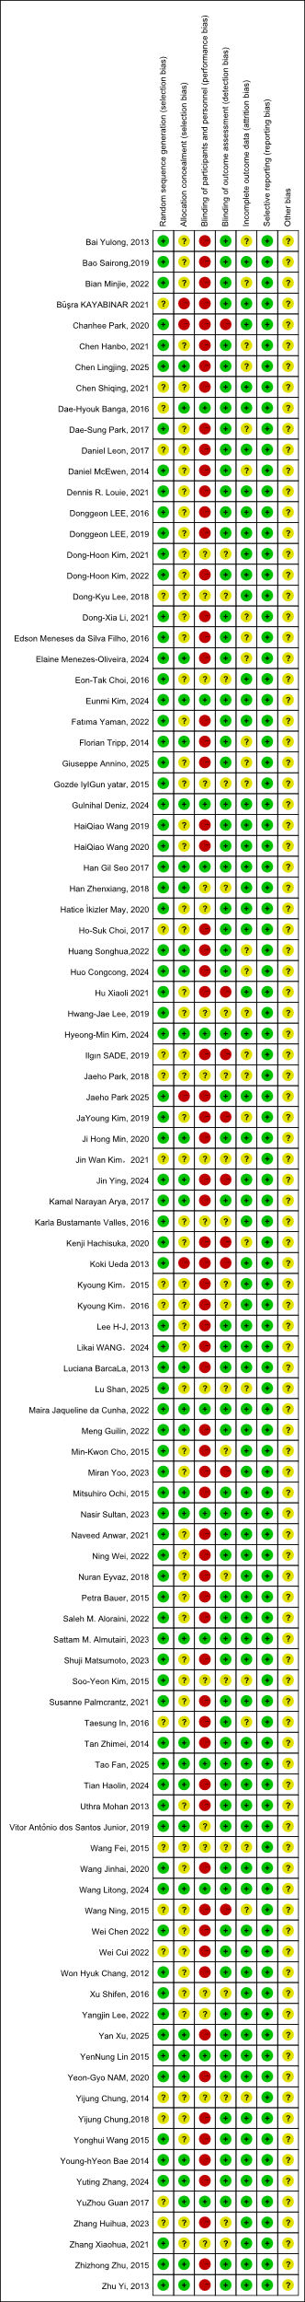
Fig.1. Risk of bias graph of included randomized controlled trials.

Appendix 5. Certainty of evidence
Fig. 3. Results of evidence assessment using GRADE quality.

Appendix 6. Comparison of network meta-analysis
Table 7. Results of network meta-analysis of FMA-LE.

Table 8. Results of network meta-analysis of BBS.

Table 9. Results of network meta-analysis of MBI.

Table 10. Results of network meta-analysis of FAC.

Table 11. Results of network meta-analysis of TUG.

Appendix 7. Inconsistency test for direct and indirect evidence
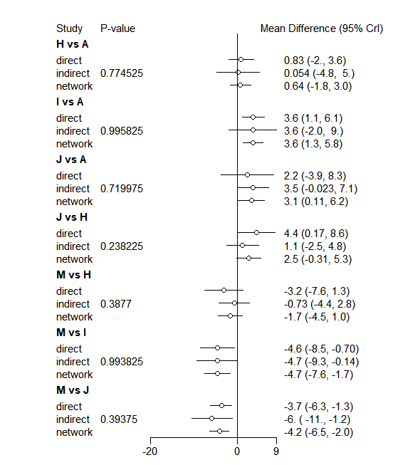
Fig. 4. Inconsistency Test Results for FMA-LE.

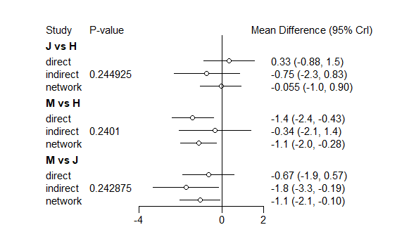
Fig. 5. Inconsistency Test Results for FAC.

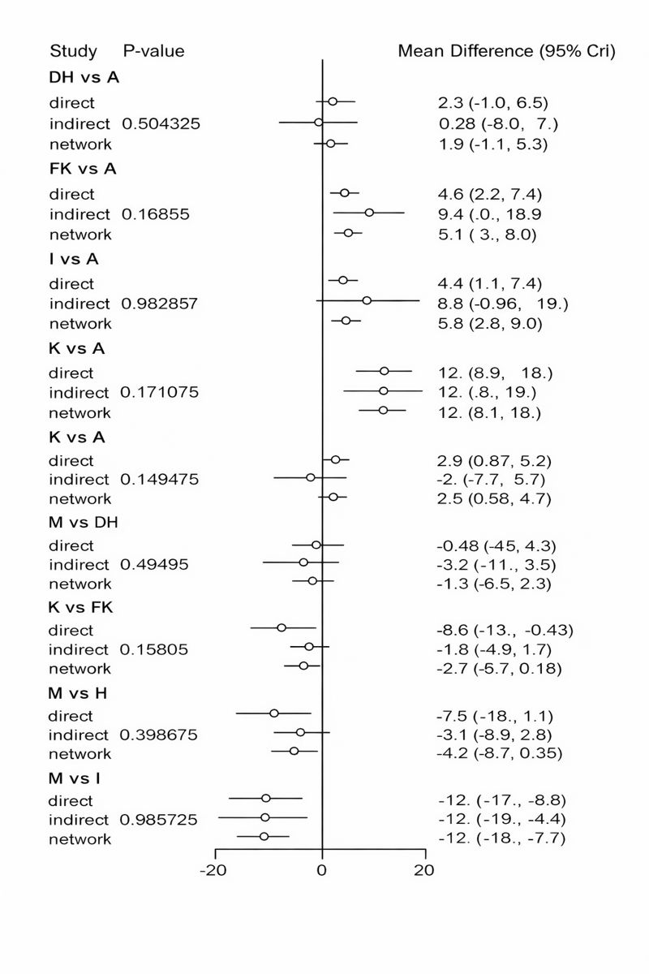
Fig. 6. Inconsistency Test Results for BBS.

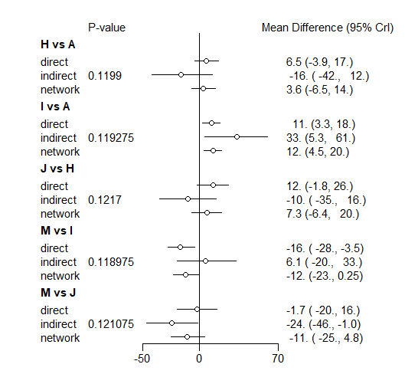
Fig. 7. Inconsistency Test Results for MBI.

Appendix 8. Results of the comparison-adjusted funnel plot
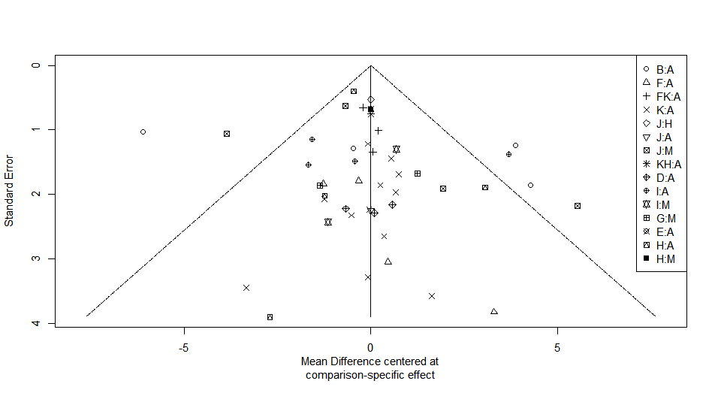
Fig. 8. The funnel plot of FMA-LE.

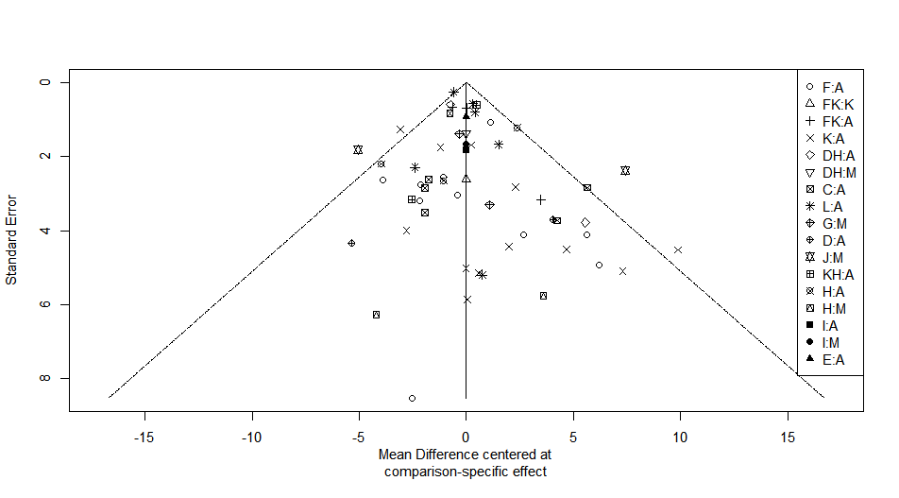
Fig. 9. The funnel plot of BBS.

\
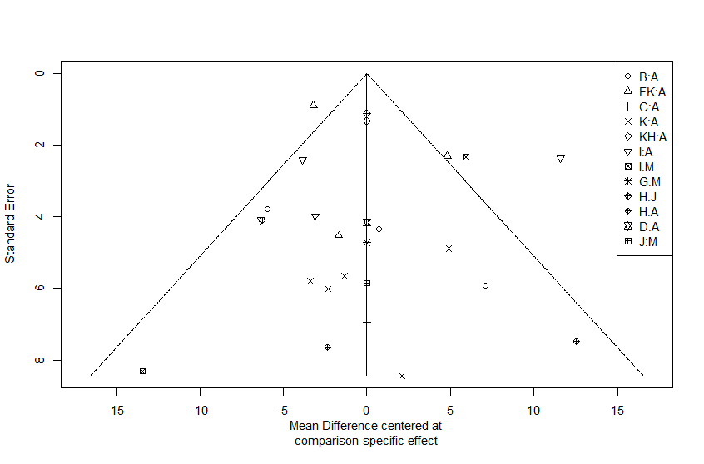
Fig. 10. The funnel plot of MBI.

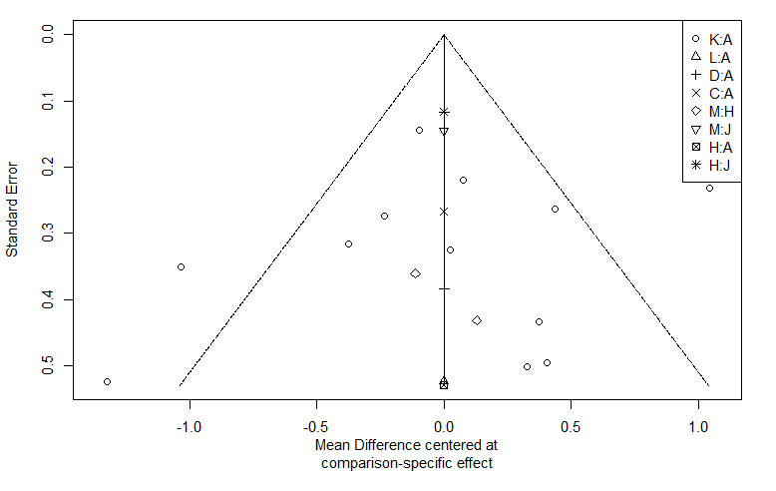
Fig. 11. The funnel plot of FAC.

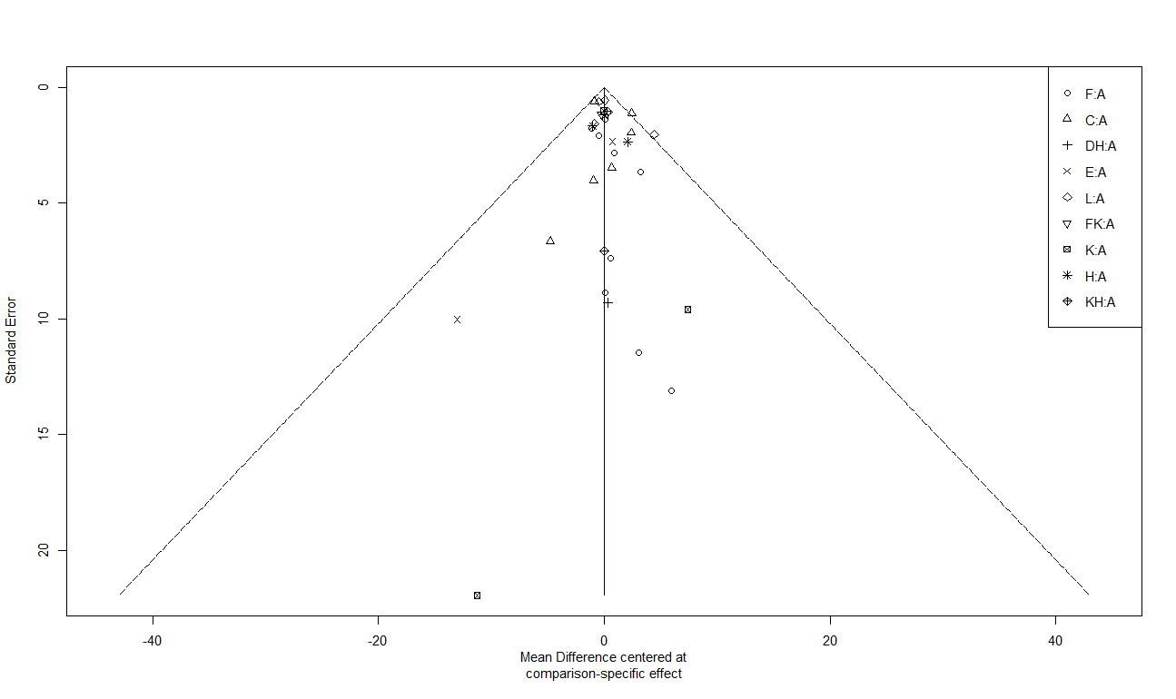
Fig. 12. The funnel plot of TUG.

