SUPPLEMENTARY MATERIALS
Degradation of a leather-dye by the combination of depolymerised wood-chip biochar adsorption and solid-state fermentation with Trametes villosa SCS-10

S. Ortiz-Monsalve,2,3*, M. Gutterres², J. Plácido^{1,4}, S. Bustamante-López^{1,4}, P. Valente⁵, D. Kelly¹ and S.L. Kelly^{1*}

1. Institute of Life Science (ILS 1), Swansea University Medical School, Swansea University, Swansea, Wales, UK.
2. Departamento de Engenharia Química, Laboratório de Estudos em Couro e Meio Ambiente, Universidade Federal do Rio Grande do Sul, Porto Alegre, Brasil.
3. Grupo de investigación en Micología (GIM), Facultad de Ciencias, Universidad Santiago de Cali, Cali, Colombia.
4. VEDAS Corporación de Investigación e Innovación (VEDAS CII), Medellín, Colombia.
5. Departamento de Microbiologia, Imunologia e Parasitologia, Laboratório de Micologia, Universidade Federal do Rio Grande do Sul, Porto Alegre, Brasil.

LIST OF TABLES AND FIGURES
Table 1. Physical and chemical characteristics of the leather-dye AB₁₆₁.
Table 2. Analyse of Variance (ANOVA) of the obtained model for dye removal.
Table 3. Analyse of Variance (ANOVA) and Duncan's multiple range test for dye removal by adsorption.
Table 4. Analyse of Variance (ANOVA) and Duncan's multiple range test for the desorption assays.
Table 5. Analyse of Variance (ANOVA) and Duncan's multiple range test for fungal growth.
Table 6. Analyse of Variance (ANOVA) and Duncan's multiple range test for the laccase activity.

Figure 1. Calibration curve: absorbance vs. concentration of AB₁₆₁.

Table 1 Physical and chemical characteristics of the leather-dye AB₁₆₁
Dye (CI)ª | CAS number ª | λ_{Max} (nm) ^{b} | MW (g mol⁻¹) ^{c} | Chemical structure
Acid Blue 161 (C.I. 15706) | 12392-64-2 | 578 | 394.40 | C₂₀H₁₃N₂O₅SNaCr_{x}
ª Colour Index International Classification, ^{b} CAS: Chemical Abstracts Service number; ^{c} Wavelength of maximum absorbance; ^{d} Molecular weight

Table 2. Analyse of Variance (ANOVA) of the obtained model for dye removal.
Source | Sum of Squares | df | Mean square | F value | p-value | Significance
Model | 4081.32 | 9 | 453.48 | 1729.90 | < 0.0001 | *
X₁ – pH | 147.92 | 1 | 147.92 | 564.27 | < 0.0001 | *
X₂ – Dye concentration | 3026.42 | 1 | 3026.42 | 11544.93 | < 0.0001 | *
X₃ – Sorbent dosage | 38.72 | 1 | 38.72 | 147.71 | < 0.0001 | *
X₁X₂ | 54.02 | 1 | 54.02 | 206.08 | < 0.0001 | *
X₁X₃ | 12.60 | 1 | 12.60 | 48.07 | 0.0002 | –
X₂X₃ | 1.82 | 1 | 1.82 | 6.95 | 0.0336 | –
X₁² | 44.13 | 1 | 44.13 | 168.35 | < 0.0001 | *
X₂² | 646.11 | 1 | 646.11 | 2464.71 | < 0.0001 | *
X₃² | 58.82 | 1 | 58.82 | 224.37 | < 0.0001 | *
Residual | 1.83 | 7 | 0.26 |  |  | –
Lack of Fit | 1.49 | 3 | 0.50 | 5.86 | 0.0602
Pure Error | 0.34 | 4 | 0.09
Cor Total | 4083.16 | 16
(*) Significant; (–) Not significant.

Table 3. ANOVA and Duncan's multiple range test for dye removal by adsorption
Treatments: (4) AC, KWB, NWB, WB
Source |  | Sum of Squares |  |  | df | Mean Square |  | F Value | Pr > F
Model |  | 0.11627833 |  |  | 3 | 0.03875944 |  | 484.63 | <.0001
Error |  | 0.00063982 |  |  | 8 | 0.00007998
Corrected Total |  | 0.11691816 |  |  | 11
R-Square |  | 0.994528
Source | Type |  |  |  | df | Mean Square |  | F Value | Pr > F
Treatments | Type I: 0.11627833 |  |  |  | 3 | 0.03875944 |  | 484.63 | <.0001
Treatments | Type III: 0.11627833 |  |  |  | 3 | 0.03875944 |  | 484.63 | <.0001
Level of treatment |  |  | N | Mean (Response) |  |  | Std Dev
AC |  |  | 3 | 0.47925463 |  |  | 0.01493833
KWB |  |  | 3 | 0.43886977 |  |  | 0.00367603
NWB |  |  | 3 | 0.30493719 |  |  | 0.00793799
WB |  |  | 3 | 0.23599899 |  |  | 0.00449805
Alpha |  |  | 0.05 | 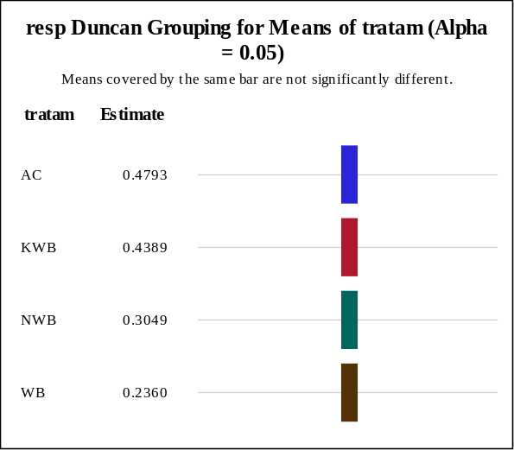
Error Degrees of Freedom |  |  | 8
Error Mean Square |  |  | 0.00008

Table 4. ANOVA and Duncan's multiple range test for desorption assays
Treatments: (7) CH₃COOH, Ethanol, HCl, Methanol, NaCl, NaOH and Water
Source | Sum of Squares |  |  | df | Mean Square |  | F Value | Pr > F
Model | 0.61609128 |  |  | 6 | 0.10268188 |  | 151.34 | <.0001
Error | 0.00949899 |  |  | 14 | 0.00067850
Corrected Total | 0.62559027 |  |  | 20
R-Square | 0.984816
Source | Type |  |  | df | Mean Square |  | F Value | Pr > F
Treatments | Type I: 0.61609128 |  |  | 6 | 0.10268188 |  | 151.34 | <.0001
Treatments | Type III: 0.61609128 |  |  | 6 | 0.10268188 |  | 151.34 | <.0001
Level of treatment |  | N | Mean (Response) |  |  | Std Dev
CH₃COOH |  | 6 | 0.04198430 |  |  | 0.00990222
Ethanol |  | 6 | 0.49294566 |  |  | 0.04789024
HCl |  | 6 | 0.02586378 |  |  | 0.00246508
Methaol |  | 6 | 0.37836050 |  |  | 0.04005863
NaCl |  | 6 | 0.18794901 |  |  | 0.00924390
NaOH |  | 6 | 0.21207961 |  |  | 0.02543235
Water |  | 6 | 0.02003271 |  |  | 0.00386553
Alpha |  | 0.05 | 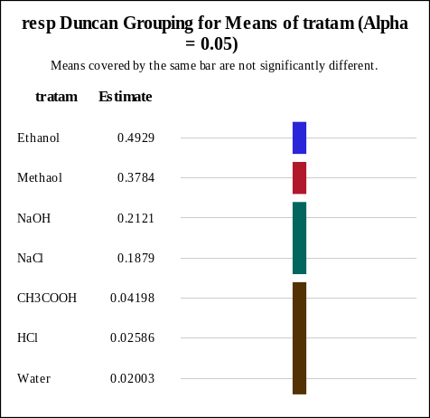
Error Degrees of Freedom |  | 14
Error Mean Square |  | 0.000678

Table 5. ANOVA and Duncan's multiple range test for fungal growth
Treatments: (4) T₁, T₂, T₃ and T₄
Source | Sum of Squares |  |  | df | Mean Square |  | F Value | Pr > F
Model | 1.00992710 |  |  | 3 | 0.33664237 |  | 4122.42 | <.0001
Error | 0.00065329 |  |  | 8 | 0.00008166
Corrected Total | 1.01058039 |  |  | 11
R-Square | 0.999354
Source | Type |  |  | df | Mean Square |  | F Value | Pr > F
Treatments | Type I: 1.00992710 |  |  | 3 | 0.33664237 |  | 4122.42 | <.0001
Treatments | Type III: 1.00992710 |  |  | 3 | 0.33664237 |  | 4122.42 | <.0001
Level of treatment |  | N | Mean (Response) |  |  | Std Dev
T₁ |  | 3 | 0.90134962 |  |  | 0.00397649
T₂ |  | 3 | 0.86761648 |  |  | 0.00760943
T₃ |  | 3 | 0.52659507 |  |  | 0.01222805
T₄ |  | 3 | 0.18704728 |  |  | 0.01016880
Alpha |  | 0.1 | 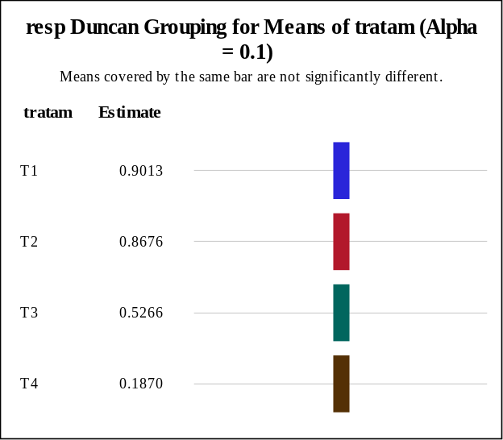
Error Degrees of Freedom |  | 8
Error Mean Square |  | 0.000082

Table 6. ANOVA and Duncan's multiple range test for laccase activity.
Treatments: (4) T₁, T₂, T₃ and T₄
Source | Sum of Squares |  |  | df | Mean Square |  | F Value | Pr > F
Model | 469462.4228 |  |  | 3 | 156487.4743 |  | 80.30 | <.0001
Error | 15590.3292 |  |  | 8 | 1948.7912
Corrected Total | 485052.7521 |  |  | 11
R-Square | 0.967858
Source | Type |  |  | df | Mean Square |  | F Value | Pr > F
Treatments | Type I: 469462.4228 |  |  | 3 | 156487.4743 |  | 80.30 | <.0001
Treatments | Type III: 469462.4228 |  |  | 3 | 156487.4743 |  | 80.30 | <.0001
Level of treatment |  | N | Mean (Response) |  |  | Std Dev
T₁ |  | 3 | 621.851852 |  |  | 62.2751098
T₂ |  | 3 | 758.703704 |  |  | 51.7005066
T₃ |  | 3 | 466.296296 |  |  | 16.4835621
T₄ |  | 3 | 226.296296 |  |  | 31.1821280
Alpha |  | 0.1 | 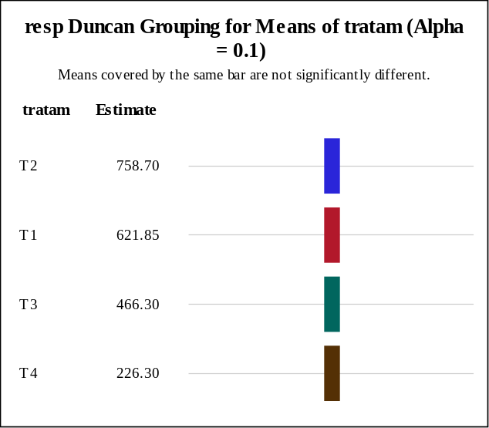
Error Degrees of Freedom |  | 8
Error Mean Square |  | 1948.791

Figure 1. Calibration curve: absorbance vs. concentration of AB₁₆₁

* Corresponding author Address: Institute of Life Science 1, Medical School, Swansea University, Swansea SA2 8PP, UK Phone : +44 1792 503430 Fax : +44 1792 503430 Correspondence e-mail: santiago.ortiz@ufrgs.br; s.l.kelly@swansea.ac.uk

