Supplementary Information for

Rapid and quantitative analysis of bacteriophage infectivity via fully-automated droplet digital PCR

Yanfei Liu^{1,2}, Huiwei Zhao^{2,3,}*, Xinyue Cao^{3,6}, Shize Jiang², Jun Fu⁵, Junjing Xue^{2,6}, Caiming Li⁷, Zhangrun Xu^{1,}*, Ming Li^{2,3,6,}*, Wenbin Du^{2,4,6,}*

¹ Research Center for Analytical Sciences, Department of Chemistry, College of Sciences, Northeastern University, Shenyang, Liaoning 110819, China
² State Key Laboratory of Microbial Diversity and Innovative Utilization, Institute of Microbiology, Chinese Academy of Sciences, Beijing 100101, China
³ Department of Microbial Physiological & Metabolic Engineering, Institute of Microbiology, Chinese Academy of Sciences, Beijing 100101, China
⁴ China General Microbiological Culture Collection Center, Institute of Microbiology, Chinese Academy of Sciences, Beijing 100101, China
⁵ Maccura Biotechnology Co., Ltd Chengdu 611730, China
⁶ College of Life Sciences and Medical School, University of Chinese Academy of Sciences, Beijing 100049, China
⁷ Institute for Health Innovation and Technology (iHealthtech), National University of Singapore, Singapore 117599, Singapore

*e-mail: zhaohw@im.ac.cn; xuzr@mail.neu.edu.cn; lim_im@im.ac.cn; wenbin@im.ac.cn

Table of Contents
Supplementary Figures S1-S16.
Supplementary Tables S1-S2.

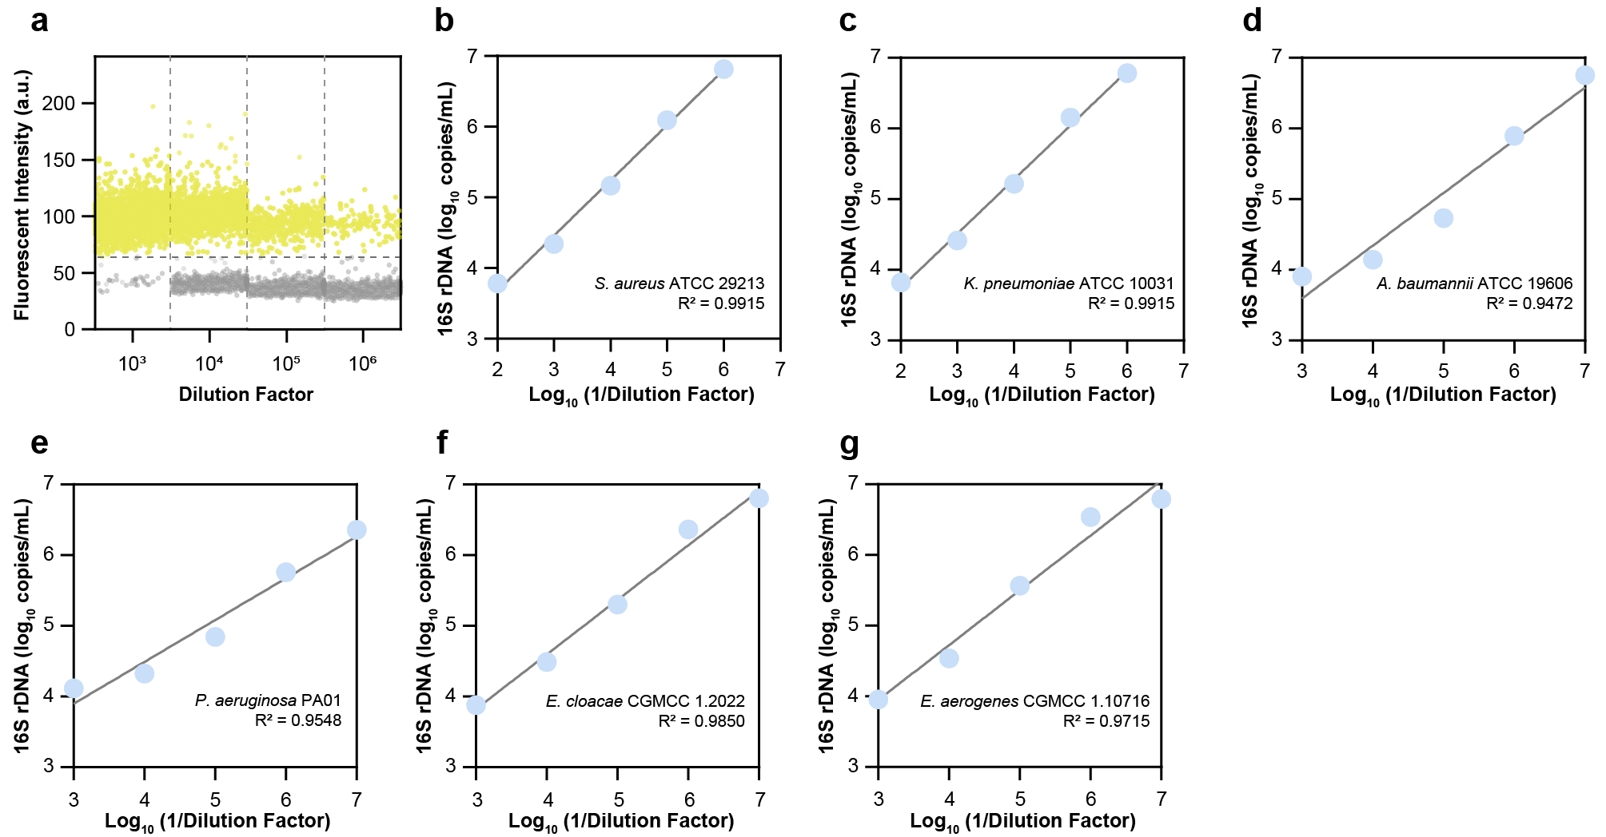
Supplementary Fig. 1. Linearity of the universal ddPCR assay across ESKAPE reference strains. a, Representative 1D fluorescence amplitude plot of E. coli MG1655 genomic DNA serially diluted 10-fold, demonstrating clear separation between positive (yellow) and negative (grey) droplets. b–g, Linear regression analyses comparing dilution factors against measured 16S rRNA gene copy numbers for representative ESKAPE pathogens: S. aureus ATCC29213 (b), K. pneumoniae ATCC10031 (c), A. baumannii ATCC19606 (d), P. aeruginosa PAO1 (e), E. cloacae CGMCC1.2022 (f), and E. aerogenes CGMCC1.10716 (g). The high coefficient of determination (R²) values displayed in each panel confirm the assay’s robust linearity and consistent performance across diverse bacterial species.

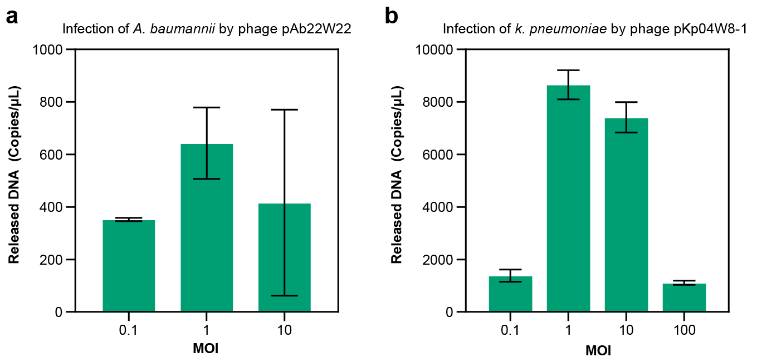
Supplementary Fig. 2. Optimization of Multiplicity of Infection (MOI) for dPST of Acinetobacter baumannii and Klebsiella pneumoniae. Quantification of phage-induced 16S rRNA release across varying MOIs to determine optimal infection conditions. a, A. baumannii challenged with phage pAb22W22 at MOIs of 0.1, 1, and 10. b, K. pneumoniae challenged with phage pKp04W8-1 at MOIs ranging from 0.1 to 100. In both phage–host models, an MOI of 1 yielded the maximal genomic DNA release, establishing it as the standard condition for subsequent assays. Error bars represent the standard deviation of replicates (n ≥ 3).
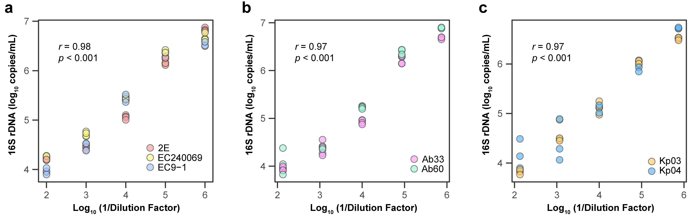
Supplementary Fig. 3. Linearity of 16S rRNA quantification across representative clinical isolates. Linear regression analysis comparing serial dilution factors against ddPCR-measured 16S rRNA copy numbers for clinical isolates of a, E. coli (n = 3), b, A. baumannii (n = 2), and c, K. pneumoniae (n = 2). The high coefficient of determination (r) and statistical significance (p < 0.001) displayed in each panel confirm the assay’s robust linear performance across diverse clinical isolates.

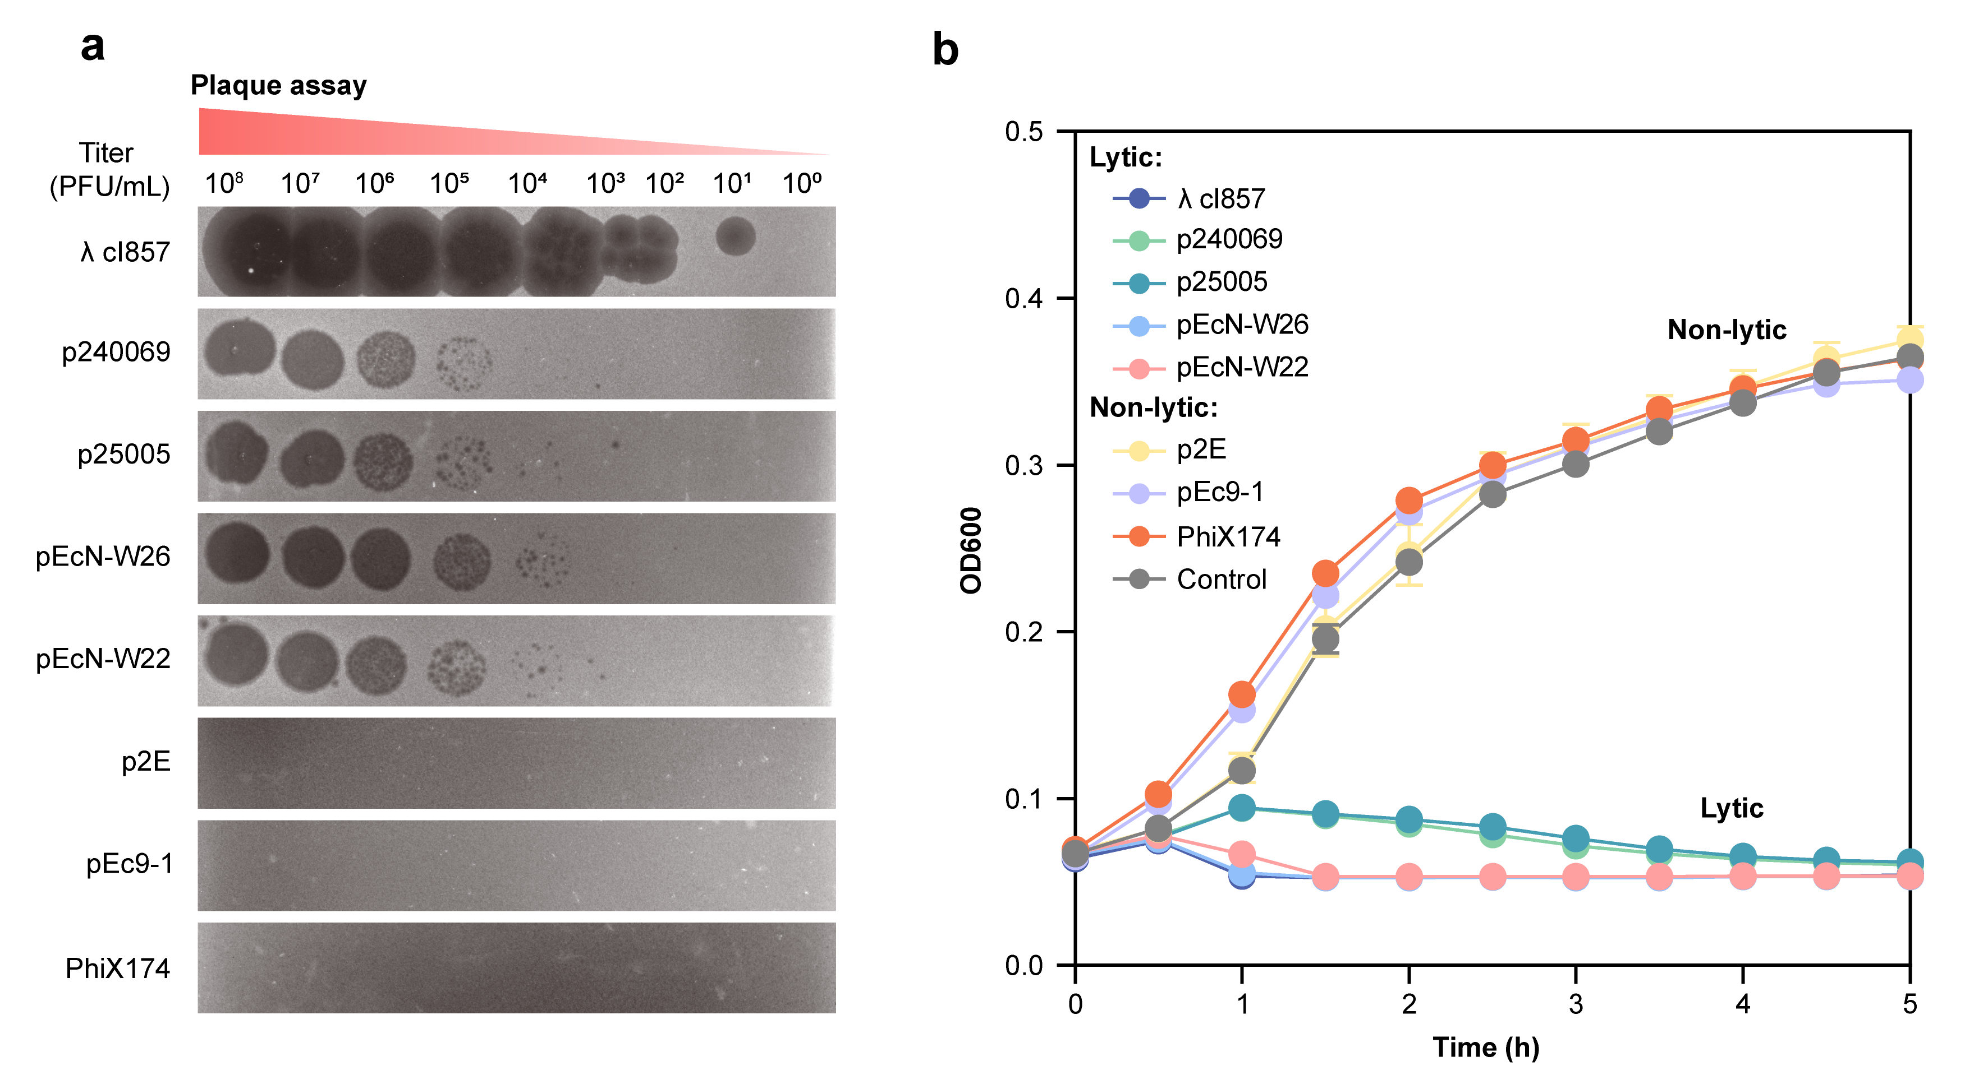
Supplementary Fig. 4. Evaluation of phage susceptibility via conventional phenotypic assays.
a, Representative images of double-layer agar plaque assays performed with 10-fold serial dilutions. While high titers produce visible lysis, lower titers often yield indistinct plaques that complicate manual enumeration. b, Time-resolved growth kinetics (OD600) monitored over 5 h. Although the assay effectively separates lytic from non-lytic groups, it fails to resolve kinetic nuances among productive phages, which cluster indistinguishably near the baseline. Data represent mean ± s.d. (n = 3).

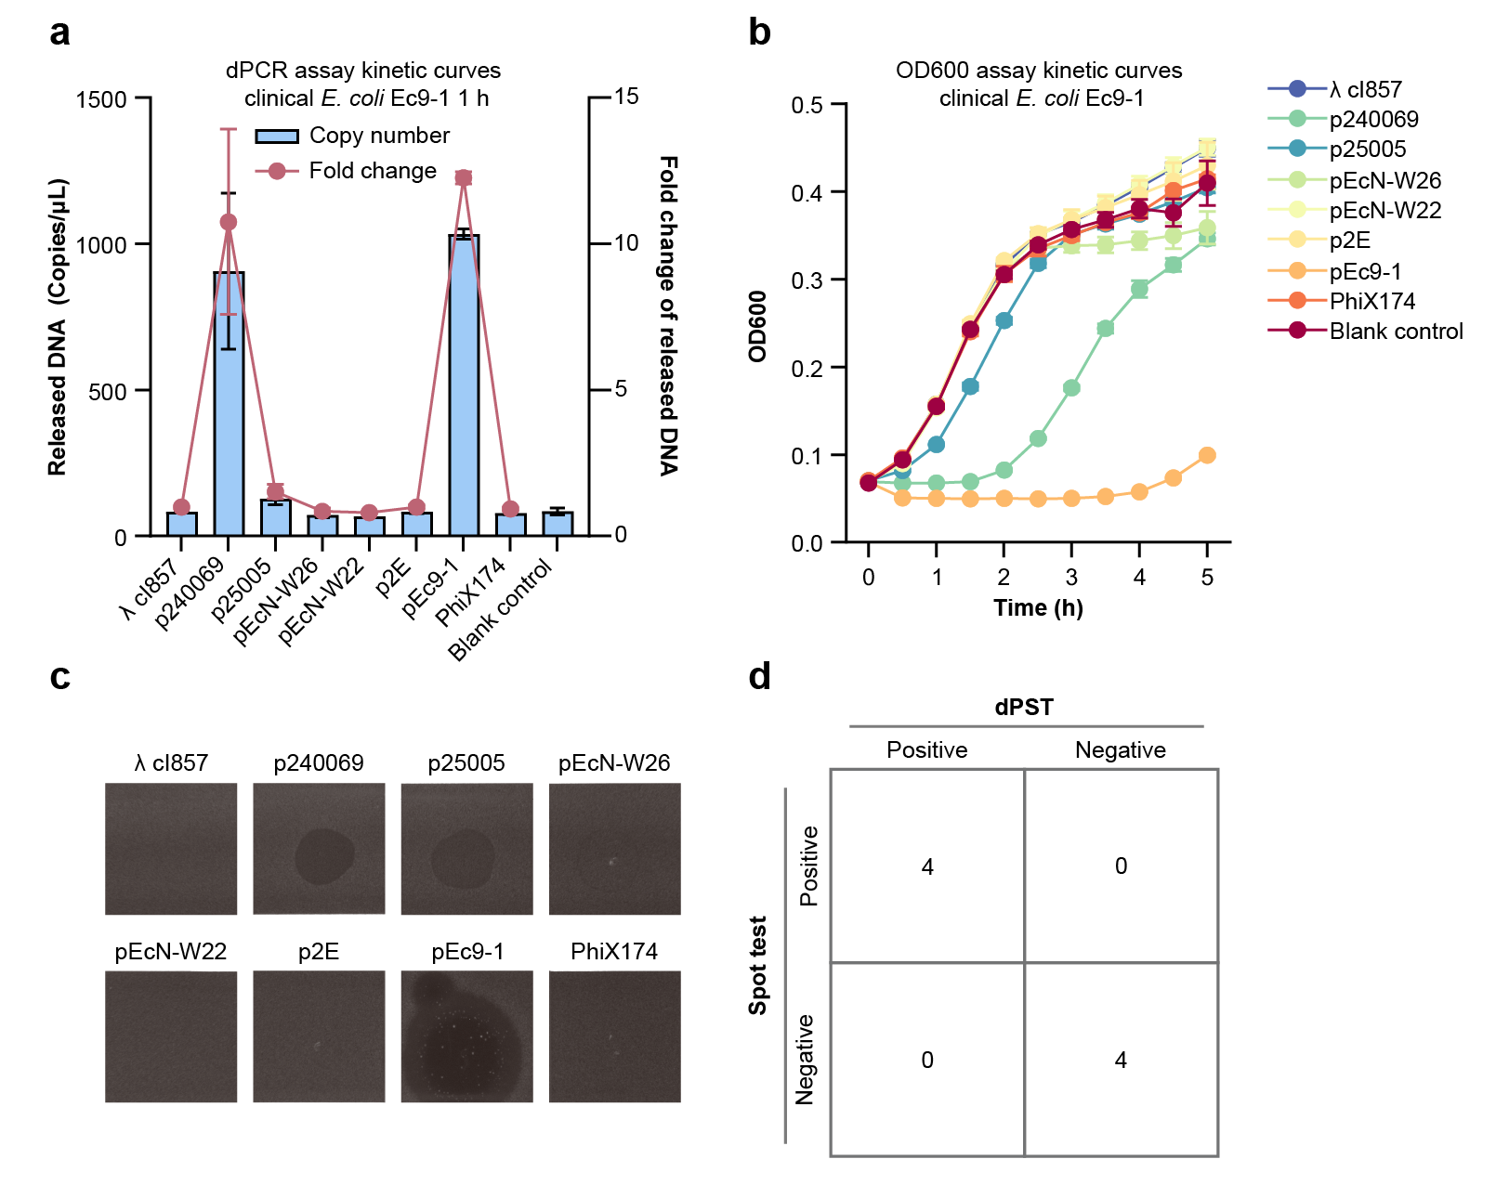
Supplementary Fig. 5. Comparative profiling of phage–host interactions for clinical E. coli isolate Ec9-1.
a, dPST quantification of released genomic DNA (blue bars) and corresponding fold-change values (red line) following 1 h of phage co-incubation. b, Real-time bacterial growth kinetics (OD600) monitored over 5 h. c, Representative spot test images validating lytic phenotypes. d, Consistency matrix demonstrating complete concordance between dPST classifications and spot test results. Data represent mean ± s.d. (n = 3).
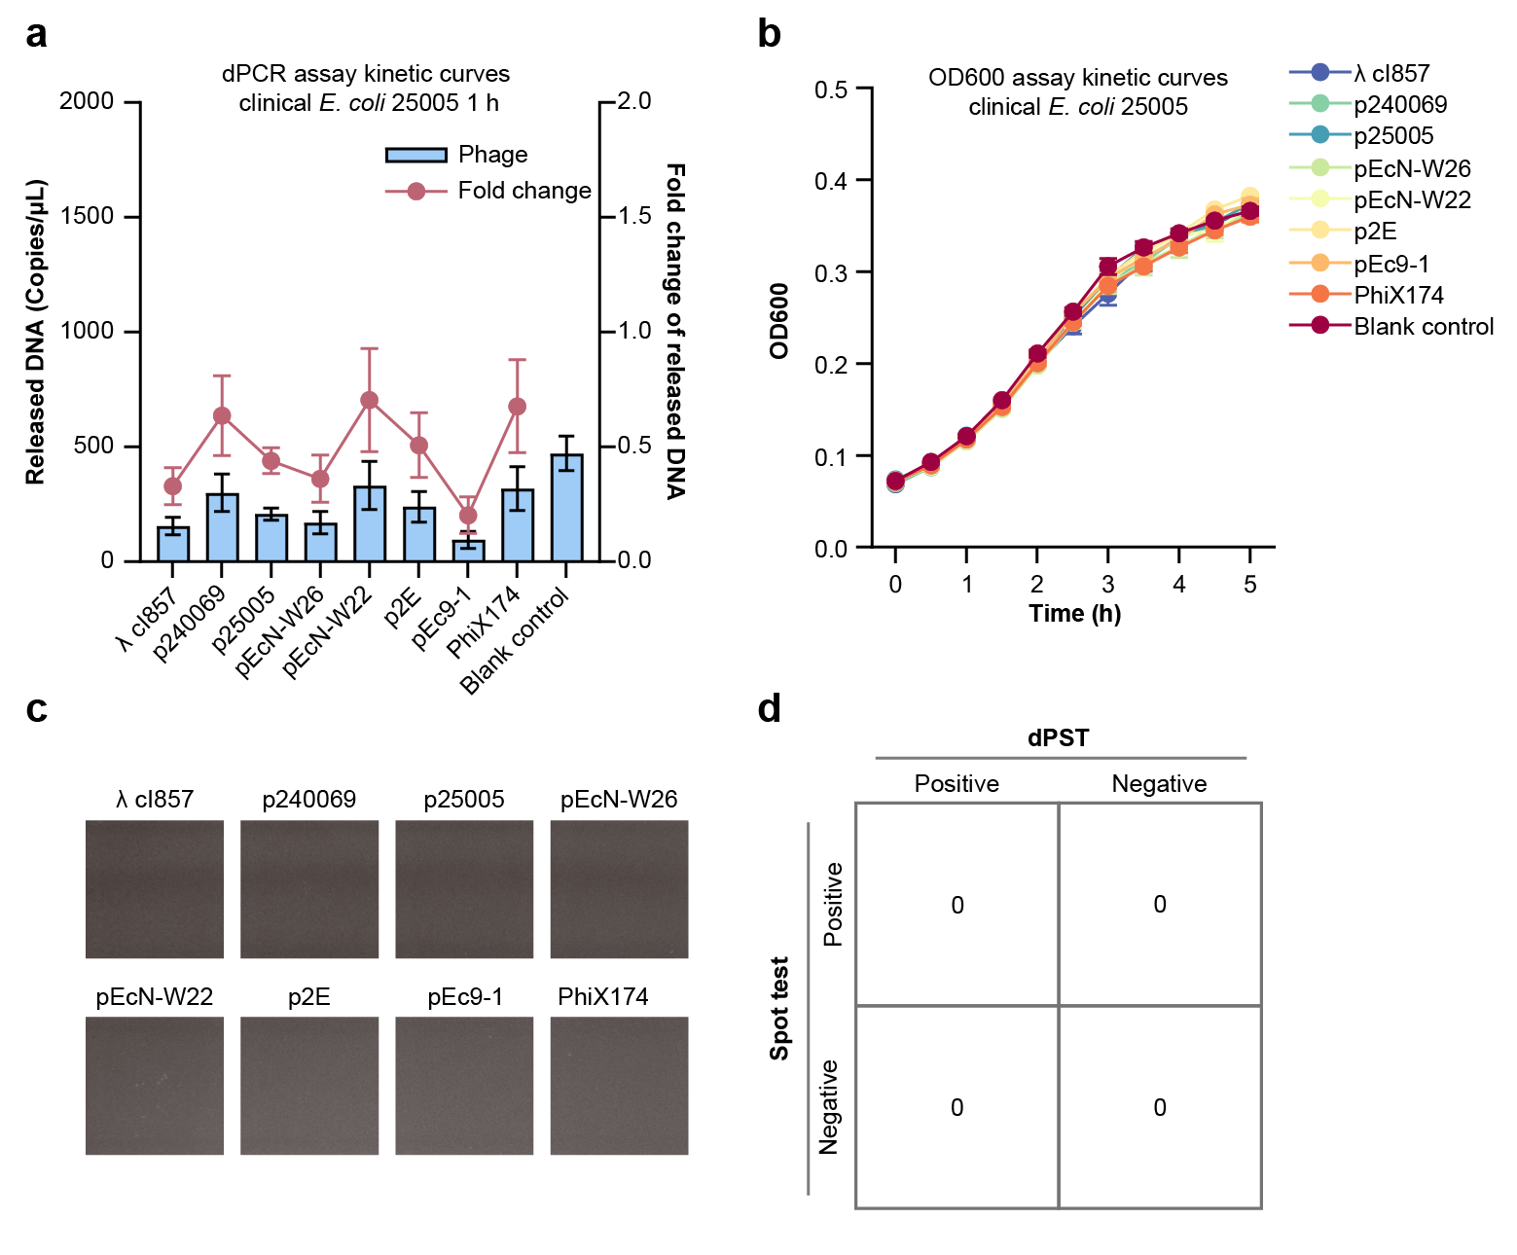
Supplementary Fig. 6. Comparative profiling of phage–host interactions for clinical E. coli isolate 25005.
a, dPST quantification of released genomic DNA (blue bars) and corresponding fold-change values (red line) following 1 h of phage co-incubation. b, Real-time bacterial growth kinetics (OD600) monitored over 5 h. c, Representative spot test images validating lytic phenotypes. d, Consistency matrix demonstrating complete concordance between dPST classifications and spot test results. Data represent mean ± s.d. (n = 3).

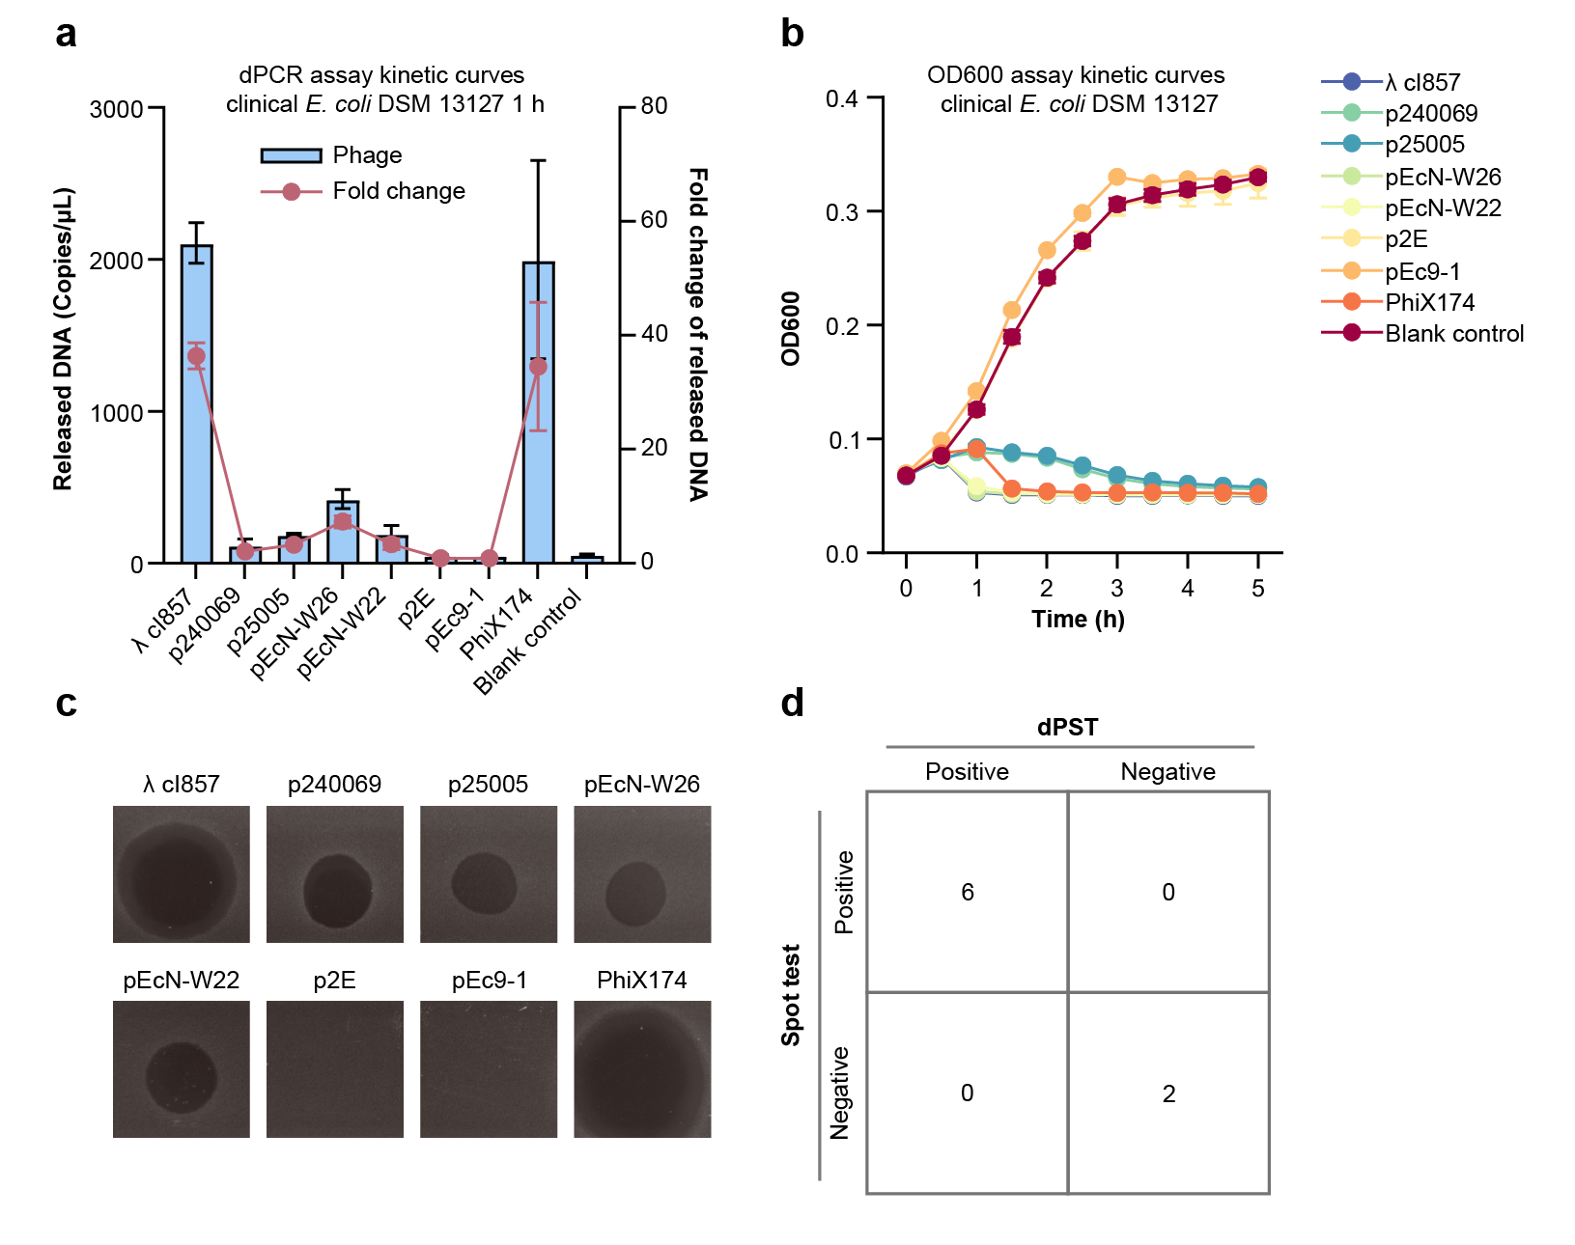
Supplementary Fig. 7. Comparative profiling of phage–host interactions for clinical E. coli strain DSM 13127.
a, dPST quantification of released genomic DNA (blue bars) and corresponding fold-change values (red line) following 1 h of phage co-incubation. b, Real-time bacterial growth kinetics (OD600) monitored over 5 h. c, Representative spot test images validating lytic phenotypes. d, Consistency matrix demonstrating complete concordance between dPST classifications and spot test results. Data represent mean ± s.d. (n = 3).

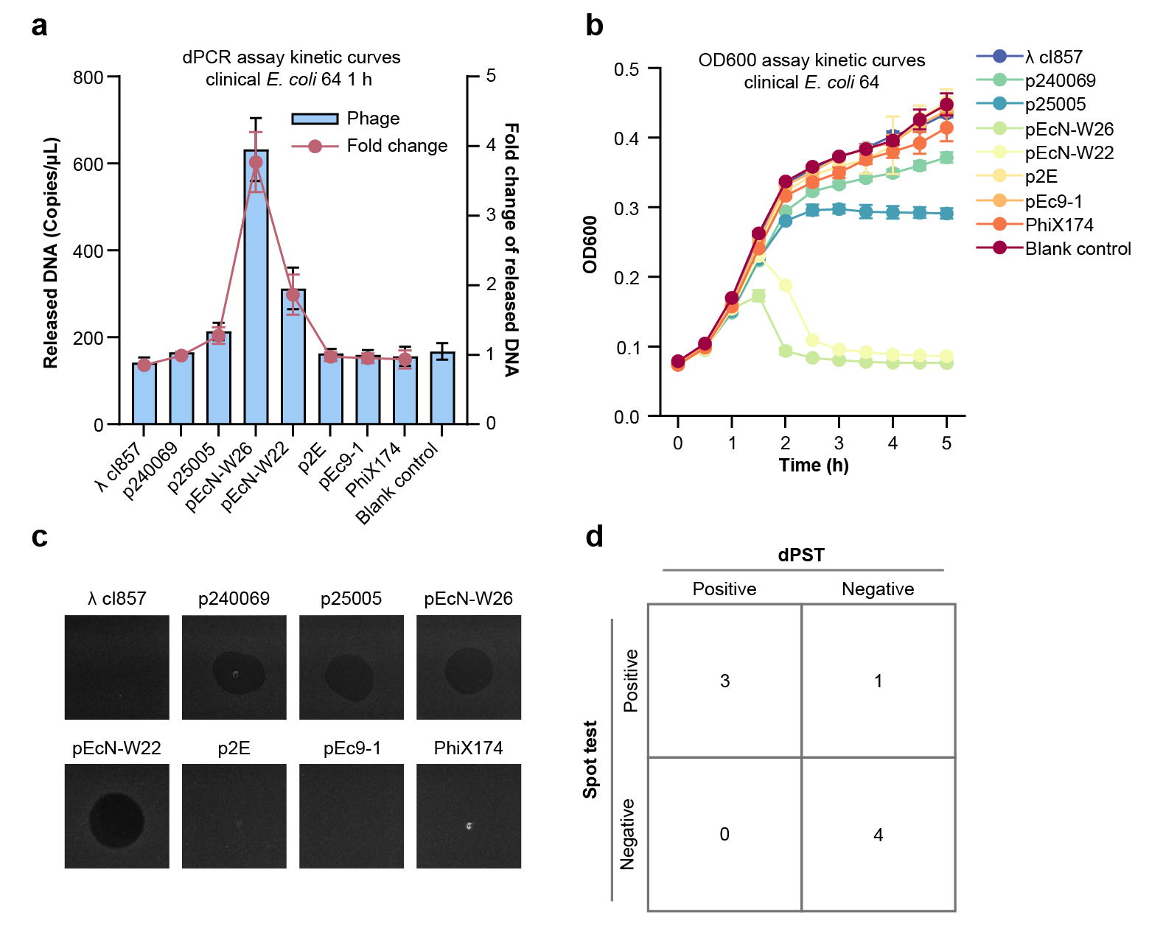
Supplementary Fig. 8. Comparative profiling of phage–host interactions for clinical E. coli isolate 64.
a, dPST quantification of released genomic DNA (blue bars) and corresponding fold-change values (red line) following 1 h of phage co-incubation. b, Real-time bacterial growth kinetics (OD600) monitored over 5 h. c, Representative spot test images validating lytic phenotypes. d, Consistency matrix demonstrating complete concordance between dPST classifications and spot test results. Data represent mean ± s.d. (n = 3).

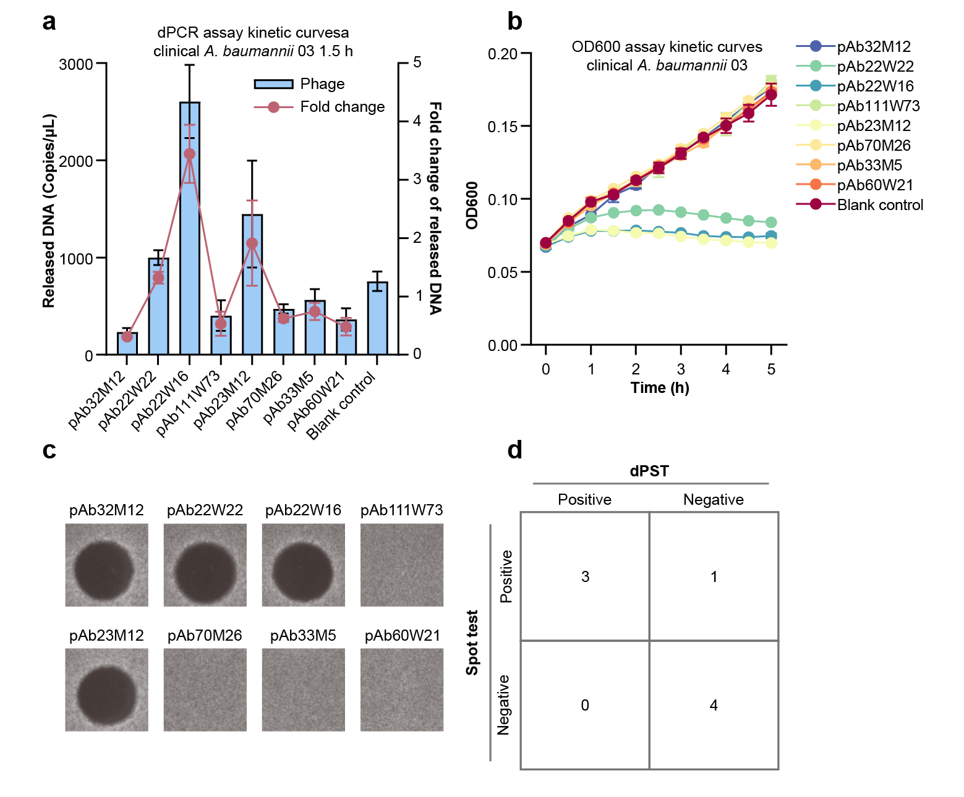
Supplementary Fig. 9. Comparative profiling of phage–host interactions for clinical A. baumannii isolate Aba03.
a, dPST quantification of released genomic DNA (blue bars) and corresponding fold-change values (red line) following 1.5 h of phage co-incubation. b, Real-time bacterial growth kinetics (OD600) monitored over 5 h. c, Representative spot test images validating lytic phenotypes. d, Consistency matrix comparing dPST classifications with spot test outcomes. Data represent mean ± s.d. (n = 3).
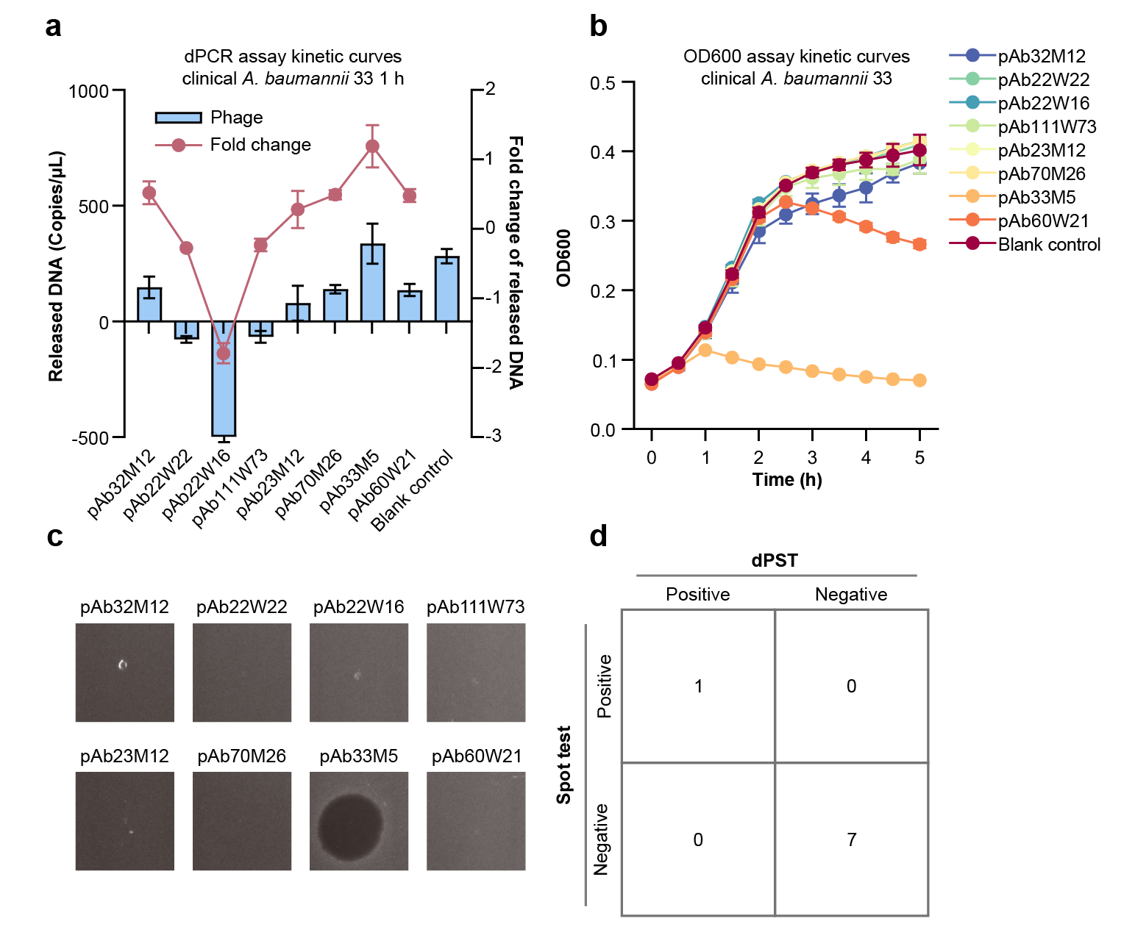
Supplementary Fig. 10. Comparative profiling of phage–host interactions for clinical A. baumannii isolate Aba33.
a, dPST quantification of released genomic DNA (blue bars) and corresponding fold-change values (red line) following 1.5 h of phage co-incubation. b, Real-time bacterial growth kinetics (OD600) monitored over 5 h. c, Representative spot test images validating lytic phenotypes. d, Consistency matrix comparing dPST classifications with spot test outcomes. Data represent mean ± s.d. (n = 3).

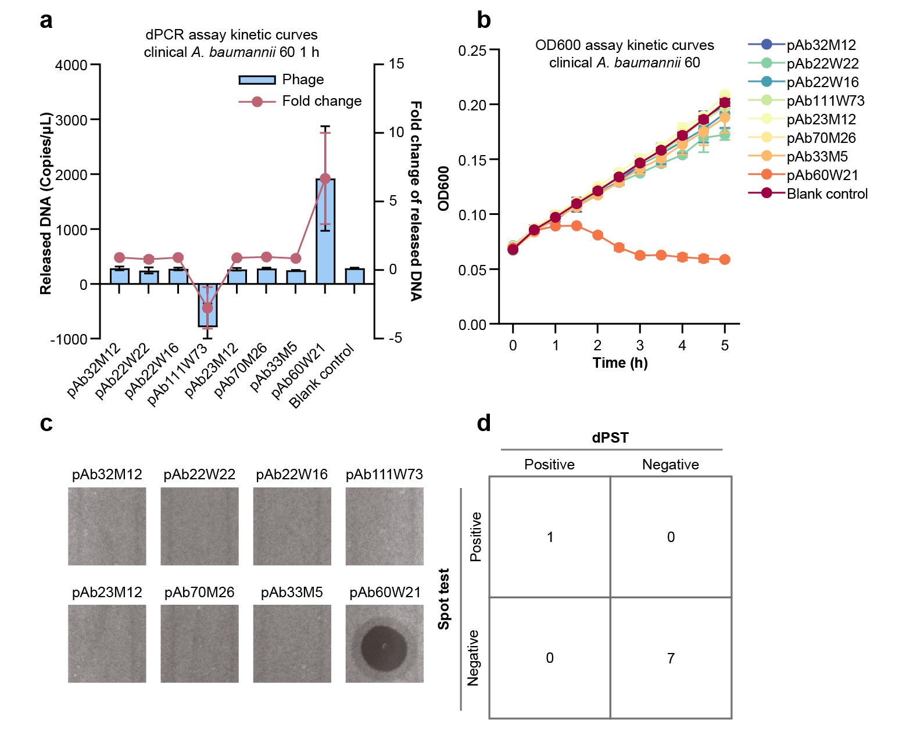
Supplementary Fig. 11. Comparative profiling of phage–host interactions for clinical A. baumannii isolate Aba60.
a, dPST quantification of released genomic DNA (blue bars) and corresponding fold-change values (red line) following 1.5 h of phage co-incubation. b, Real-time bacterial growth kinetics (OD600) monitored over 5 h. c, Representative spot test images validating lytic phenotypes. d, Consistency matrix comparing dPST classifications with spot test outcomes. Data represent mean ± s.d. (n = 3).

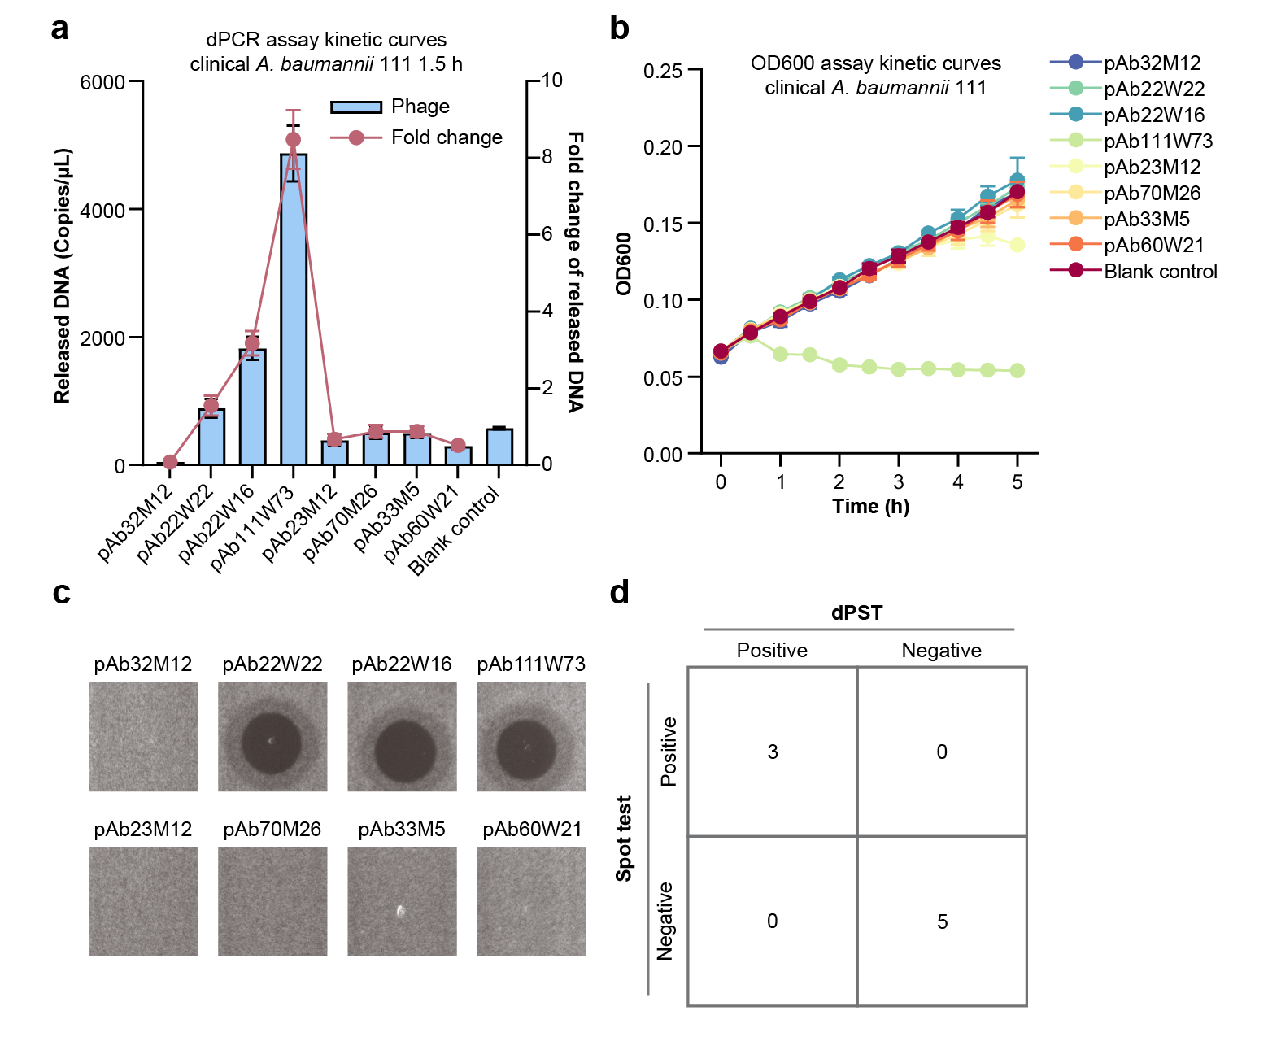
Supplementary Fig. 12. Comparative profiling of phage–host interactions for clinical A. baumannii isolate Aba111.
a, dPST quantification of released genomic DNA (blue bars) and corresponding fold-change values (red line) following 1.5 h of phage co-incubation. b, Real-time bacterial growth kinetics (OD600) monitored over 5 h. c, Representative spot test images validating lytic phenotypes. d, Consistency matrix comparing dPST classifications with spot test outcomes. Data represent mean ± s.d. (n = 3).

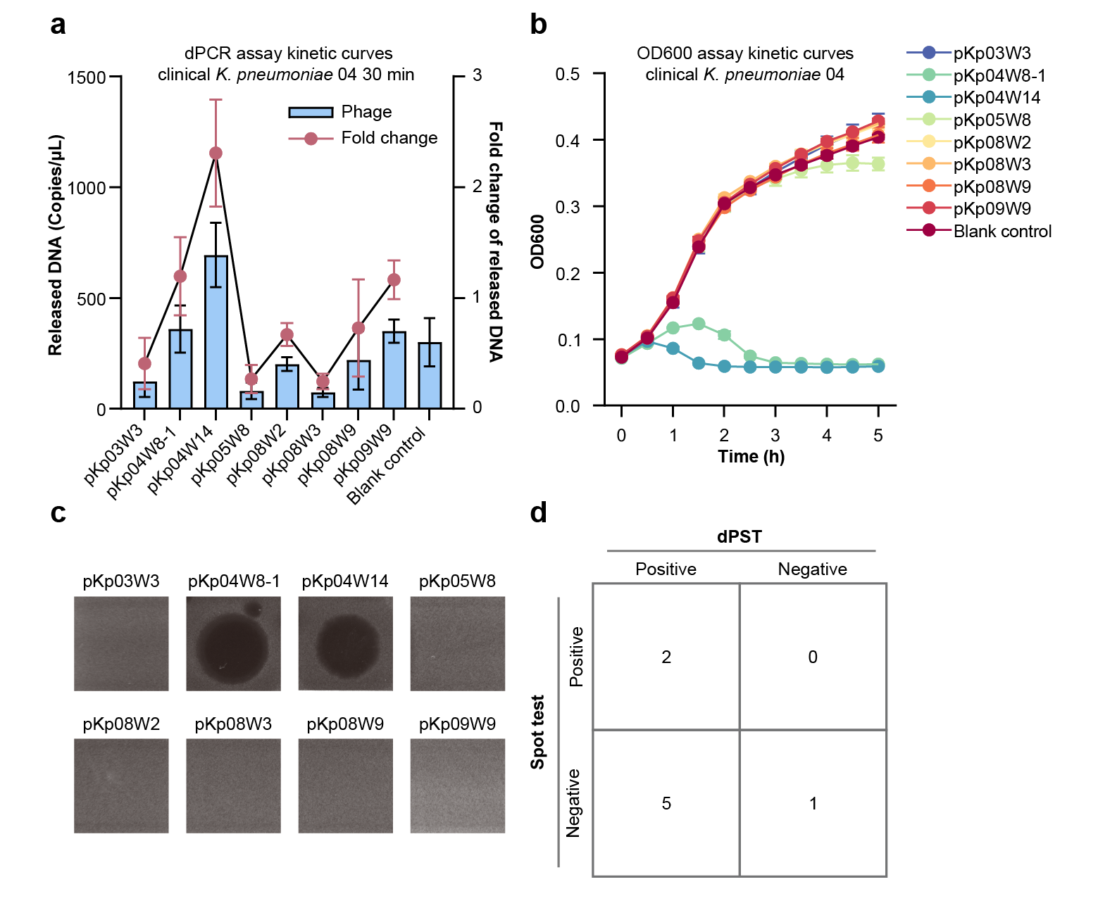
Supplementary Fig. 13. Comparative profiling of phage–host interactions for clinical K. pneumoniae isolate Kpn04.
a, dPST quantification of released genomic DNA (blue bars) and corresponding fold-change values (red line) following 30 min of phage co-incubation. b, Real-time bacterial growth kinetics (OD600) monitored over 5 h. c, Representative spot test images determining lytic phenotypes. d, Consistency matrix comparing dPST classifications with spot test outcomes. Data represent mean ± s.d. (n = 3).

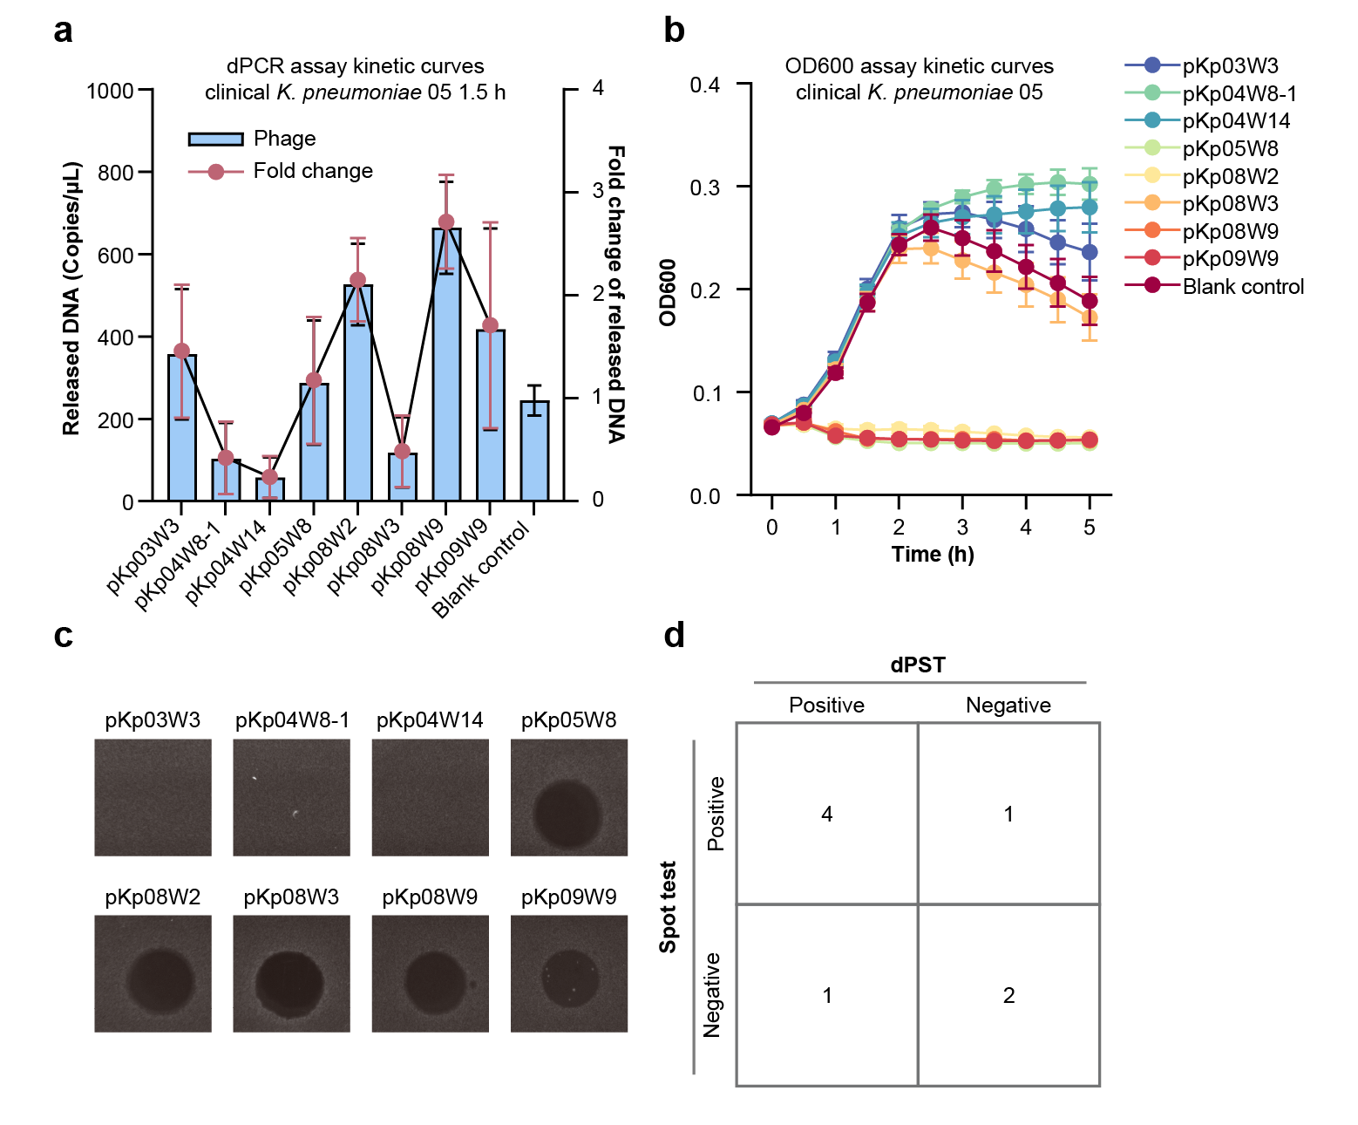
Supplementary Fig. 14. Comparative profiling of phage–host interactions for clinical K. pneumoniae isolate Kpn05.
a, dPST quantification of released genomic DNA (blue bars) and corresponding fold-change values (red line) following 30 min of phage co-incubation. b, Real-time bacterial growth kinetics (OD600) monitored over 5 h. c, Representative spot test images determining lytic phenotypes. d, Consistency matrix comparing dPST classifications with spot test outcomes. Data represent mean ± s.d. (n = 3).

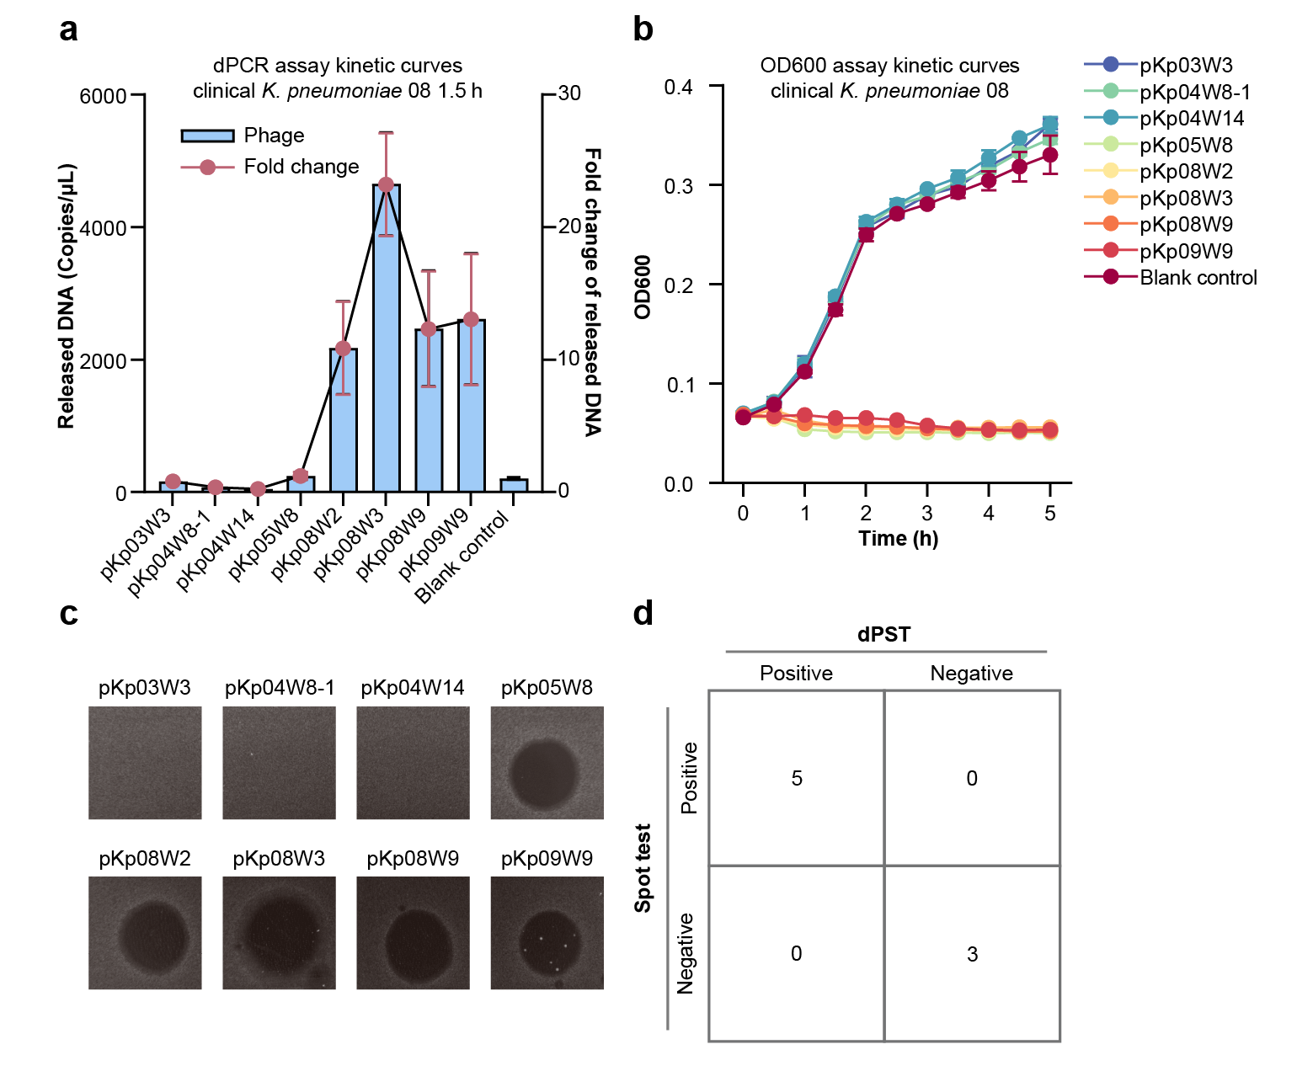
Supplementary Fig. 15. Comparative profiling of phage–host interactions for clinical K. pneumoniae isolate Kpn08.
a, dPST quantification of released genomic DNA (blue bars) and corresponding fold-change values (red line) following 30 min of phage co-incubation. b, Real-time bacterial growth kinetics (OD600) monitored over 5 h. c, Representative spot test images determining lytic phenotypes. d, Consistency matrix comparing dPST classifications with spot test outcomes. Data represent mean ± s.d. (n = 3).

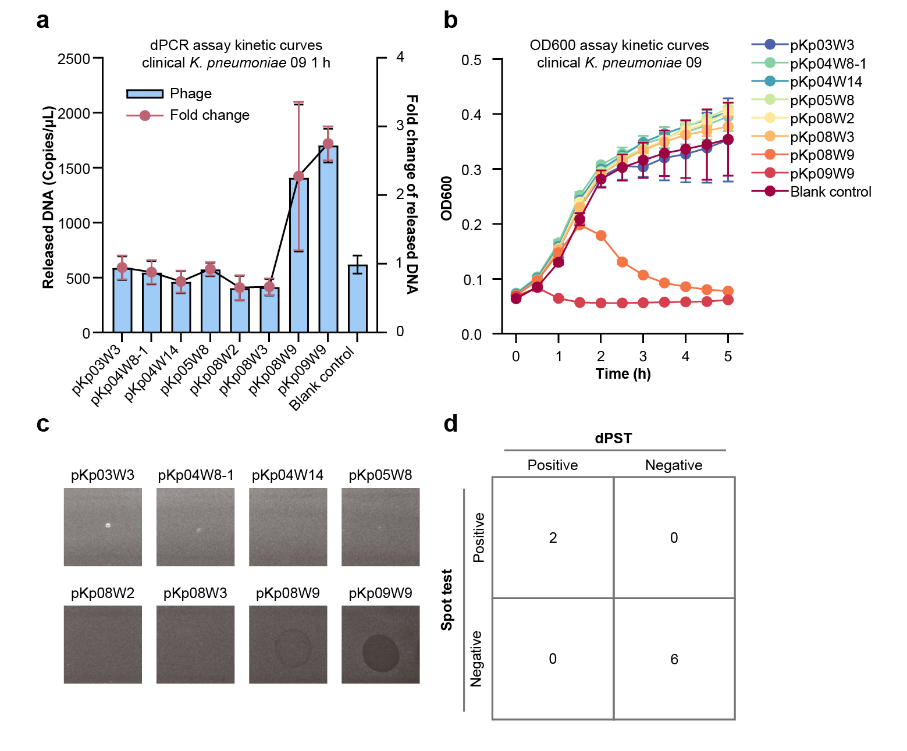
Supplementary Fig. 16. Comparative profiling of phage–host interactions for clinical K. pneumoniae isolate Kpn09.
a, dPST quantification of released genomic DNA (blue bars) and corresponding fold-change values (red line) following 30 min of phage co-incubation. b, Real-time bacterial growth kinetics (OD600) monitored over 5 h. c, Representative spot test images determining lytic phenotypes. d, Consistency matrix comparing dPST classifications with spot test outcomes. Data represent mean ± s.d. (n = 3).

