Supporting information

Localized Heat Induces ERK Signaling and Intercellular Communication in Solid Tumors

Farsai Taemaitree^{a,b,c,‡}, Yuta Takano^{a,d,‡,}*, Daisuke Yamaguchi^{b}, Kazushi Yamaguchi^{b}, Yudai Yamashita^{b}, Motosuke Tsutsumi^{e,f}, Chentao Wen^{g,h}, Kohei Otomo^{e,f,i}, Kenji Hirai^{a,b}, James Hutchison^{j}, Indra Van Zundert^{k}, Sandra Krzyzowska^{k}, Maria Bravo^{k,j}, Sayuki Hirano^{m}, Koutarou D Kimura^{g}, Kazuhiro Aoki^{e,l,m}, Susana Rocha^{k}, Tomomi Nemoto^{e,f}*, Beatrice Fortuni^{k}* and Hiroshi Uji-i^{a,b,k,n}*

- Research Institute for Electronic Science, Hokkaido University, N20, W10, Sapporo 001-0020, Japan.
- Graduate School of Information Science and Technology, Hokkaido University, N14, W9, Sapporo 060-0813, Japan.
- Institute of Multidisciplinary Research for Advanced Materials (IMRAM), Tohoku University, 2–1–1 Katahira, Aoba–Ward, Sendai, 980–8577 Japan
- Graduate School of Environmental Science, Hokkaido University, N10, W5, Sapporo 060-0814, Japan.
- Exploratory Research Center on Life and Living Systems, National Institute of Natural Sciences, Higashiyama 5-1, Myodaiji, Okazaki, Aichi 444-8787, Japan
- National Institute for Physiological Sciences, National Institutes of Natural Sciences, Higashiyama 5-1, Myodaiji, Okazaki, Aichi 444-8787, Japan.
- Graduate School of Science, Nagoya City University, Nagoya 467-8501, Japan
- RIKEN Center for Biosystems Dynamics Research, Kobe 650-0047, Japan.
- Graduate School of Medicine, Juntendo University, 2-1-1 Hongo, Tokyo 113-8421, Japan
- ARC Centre of Excellence in Exciton Science, School of Chemistry, University of Melbourne, Parkville, VIC 3010, Australia
- Molecular Imaging and Photonics, Department of Chemistry, KU Leuven, Celestijnenlaan 200F, Heverlee 3001, Belgium
- National Institute for Basic Biology, National Institutes of Natural Sciences, Okazaki, Aichi 444-8585, Japan.
- Graduate School of Biostudies, Kyoto University, Sakyo-ku, Kyoto 606-8315, Japan.
- Institute for Integrated Cell-Material Science (WPI-iCeMS), Kyoto University, Yoshida, Sakyo-ku, Kyoto 606-8501, Japan.

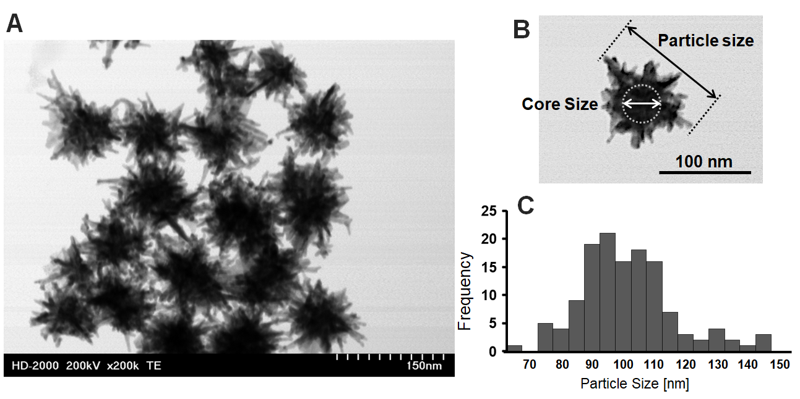
Figure S1. (A) STEM image of AuNS-Cys. (B) Schematic representation of the diameter calculation for the core and the particle: the particle diameter was estimated as the maximum Euclidean distance value between any two points on the AuNS-Cys perimeter. The particle core diameter was obtained from the darkest area from the shading of the STEM image. (C) Particle size distribution profile extracted from STEM images: mean particle diameter ± standard deviation was 101.3 ± 15.0 nm (n = 131) and the mean core diameter ± standard deviation was 37.8 ± 6.5 nm (n = 131).

Photothermal conversion efficiency (PCE)
The photo-thermal conversion (η) was determined according to the previously described method³⁰;
$$η= \frac{hS\left(T_{Max}- T_{Surr}\right)- Q_{Dis}}{I\left(1- {10}^{-A_{700}}\right)} eq \left(1\right)$$
where h is the heat transfer coefficient, S is the surface area of the container, and hS is determined from Equation (2). T_{Max} is the maximum temperature achieved by illumination, and T_{Surr} is the temperature of the surroundings. Q_{Dis} represents the heat dissipated from the laser, mediated by the solvent and container. I corresponds to the intensity of the power source (700 nm laser at 0.030 W), and A₇₀₀ represents the absorbance of the sample solution at 700 nm.
$$hs= \frac{m_{D} C_{D}}{τ_{s}} eq(2)$$
m_{D} and C_{D} are the mass and heat capacity of deionized water, respectively, and τ_{s} is the sample system time constant, which is determined according to Equation (3) and the slope shown in Figure. S7.
$$t= -τ_{s} In(θ) eq(3)$$
θ is a dimensionless parameter, known as the driving force temperature, as calculated using equation (4)
$$θ = \frac{T- T_{surr}}{T_{max}- T_{surr}} eq(4)$$

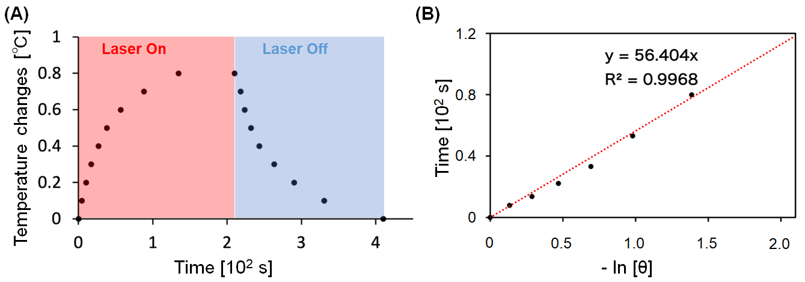
Figure S2. (A) Heating-cooling experiment under 30 mW 700 nm CW laser irradiation to determine the photothermal conversion efficiency (PCE). The laser was switched off after the sample reached a steady-state temperature of 220 s. (B) Linear fitting for the time and -ln θ plot. Linear time data versus -ln θ obtained from the cooling period in panel (A).

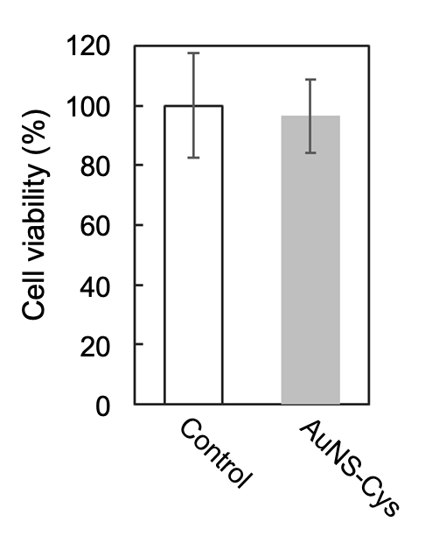
Figure S3. Dark cytotoxicity assay showing the viability of #T-HeLa cells with or without treatment with AuNS-Cys after 48 h incubation at 37ºC.

Figure S4. Maximum intensity z-projection (y-z) of the spheroids corresponding to Figure 2I-J (A and B, respectively), with the white arrows indicating the PL of AuNS-Cys. Photoluminescence intensity of AuNS-Cys over time upon irradiation with an 850 nm fs-pulsed laser, 22 mW mm⁻² (B).

Figure S5. Untreated spheroid cell death assay using sulforhodamine B (SRB) staining. Confocal xy fluorescence images extracted from z-stacks of untreated #T-Hela spheroids (without AuNS-Cys) pre-irradiated for 3 s at 25 and 75 mW mm⁻², then imaged using 1.5 mW mm⁻² at 0 min (first scan), 2 min, and 10 min (A-C and D-F, respectively). Scale bar = 100 µm.

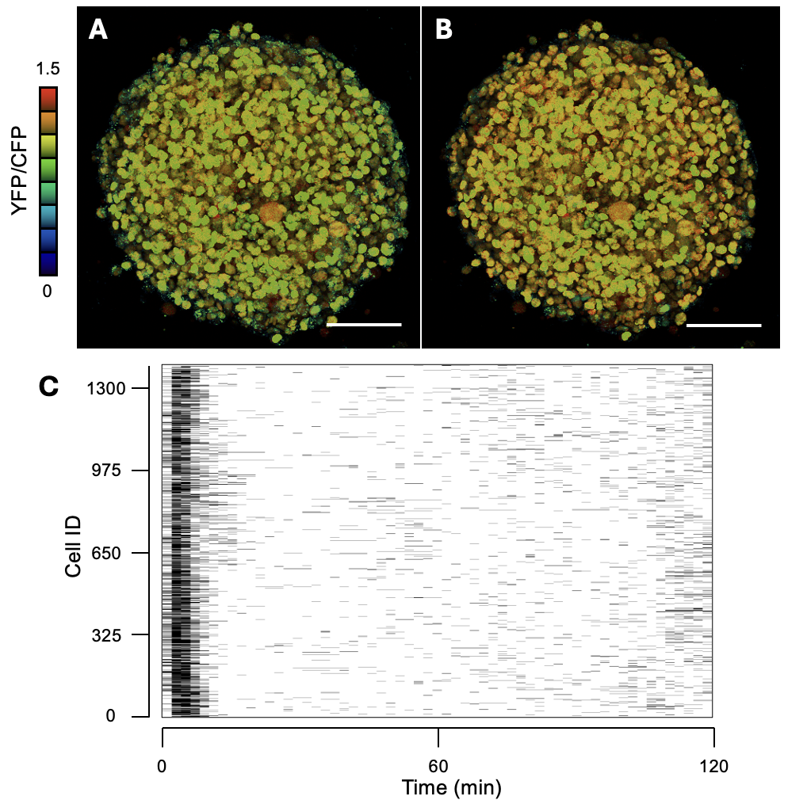
Figure S6. Ratiometric maximum intensity z-projections of #T-HeLa spheroids incubated with AuNS-Cys (two-photon excitation at 850 nm, 25 mW mm⁻²) at (A) 0 min and (B) 2 min. (C) Raster plots obtained from the 3DeeCellTracker analysis showing the timing of ERK activation in single cells as a function of time. The black horizontal lines indicate the ERK-activated state, determined by the FRET efficiency of YFP/CFP exceeding the mean of the control +2 SD, and the duration of each black line is 2 min. Scale bar = 100 µm.

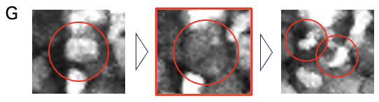
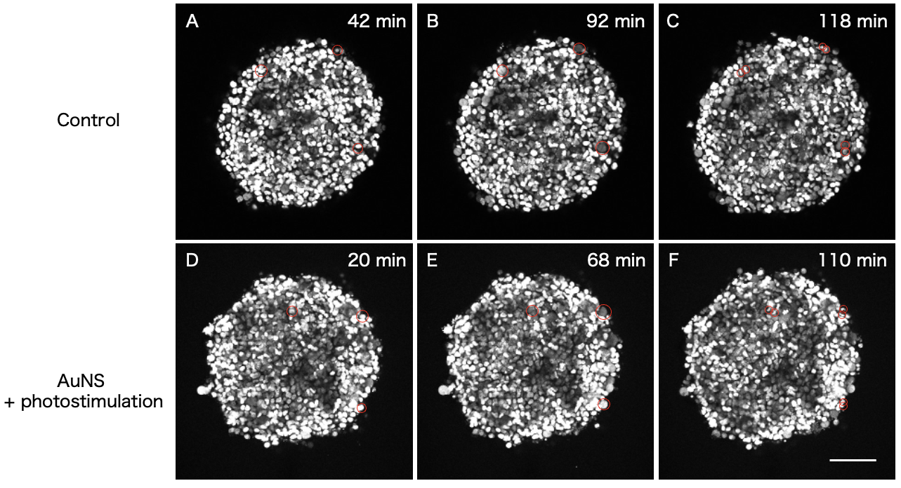

Figure S7. Maximum fluorescence intensity z-projection of #T-HeLa spheroids (control) (A-C) and of #T-HeLa spheroids incubated with AuNSs (D-F) scanned at 1.5 mW mm⁻² (normal conditions). Red circles indicate points of cell division. The bottom insets show zoomed-in sections extracted from (D-F). Scale bar = 100 µm.

