Supplementary Material
Table S1 Hector-derived noise characteristics and trend uncertainties for regional Arctic GIC mass anomalies (Eq. 1)
Region | Trend_white (Gt yr⁻¹) | Trend_corr (Gt yr⁻¹) | Scale Factor | Power law (%) | Spectral index $κ$
Alaska | -68 ± 6 | -69 ± 20 | 3.3 | 99.99 | -1.70
Arctic Canada North | -37 ± 3 | -35 ± 10 | 3.3 | 100 | -1.69
Arctic Canada South | -26 ± 5 | -24 ± 6 | 1.2 | 48.87 | -1.68
Iceland | -7 ± 2 | -7 ± 2 | 1.0 | 100 | -1.12
Svalbard | -19 ± 3 | -20 ± 6 | 2.0 | 100 | -1.50
Scandinavia | 0.7 ± 1 | 0.7 ± 0 | 0 | 100 | -0.82
Russian Arctic | -16 ± 4 | -16 ± 6 | 1.5 | 24.56 | -1.70
Notes: Trend_white denotes the linear mass-change rate estimated under a pure white-noise assumption, whereas Trend_corr is the corresponding trend when time-correlated (power-law + white) noise is accounted for. Scale factor is the multiplicative factor by which the formal white-noise uncertainty must be inflated to obtain the corrected trend uncertainty. Power law gives the percentage of total noise variance attributed to the power-law component in the stochastic model. Spectral index $κ$ is the spectral slope of the power-law noise, where more negative $κ$ indicates stronger low-frequency correlation. All reported trend uncertainties correspond to the 95% confidence interval.
Table S2 Hector-derived noise characteristics and trend uncertainties for regional Arctic GIC mass anomalies after removing ${NAO}_{∑}$ and ${PDO}_{∑}$ contributions (Eq. 4)
Region | Trend_white (Gt yr⁻¹) | Trend_corr (Gt yr⁻¹) | Scale Factor | Power law (%) | Spectral index $κ$
Alaska | -88 ± 6 | -90 ± 21 | 3.5 | 99.99 | -1.70
Arctic Canada North | -27 ± 3 | -24 ± 8 | 2.7 | 100 | -1.56
Arctic Canada South | -23 ± 6 | -22 ± 4 | 0.7 | 87.38 | -1.31
Iceland | -6 ± 2 | -6 ± 1 | 0.5 | 99.99 | -0.95
Svalbard | -17 ± 3 | -19 ± 6 | 2.0 | 100 | -1.44
Scandinavia | 0.4 ± 1 | 0.4 ± 0 | 0 | 99.99 | -0.81
Russian Arctic | -14 ± 4 | -14 ± 1 | 0.3 | 99.99 | -0.83
Notes: Trend_white denotes the linear mass-change rate estimated under a pure white-noise assumption, whereas Trend_corr is the corresponding trend when time-correlated (power-law + white) noise is accounted for. Scale factor is the multiplicative factor by which the formal white-noise uncertainty must be inflated to obtain the corrected trend uncertainty. Power law gives the percentage of total noise variance attributed to the power-law component in the stochastic model. Spectral index $κ$ is the spectral slope of the power-law noise, where more negative $κ$ indicates stronger low-frequency correlation. All reported trend uncertainties correspond to the 95% confidence interval.
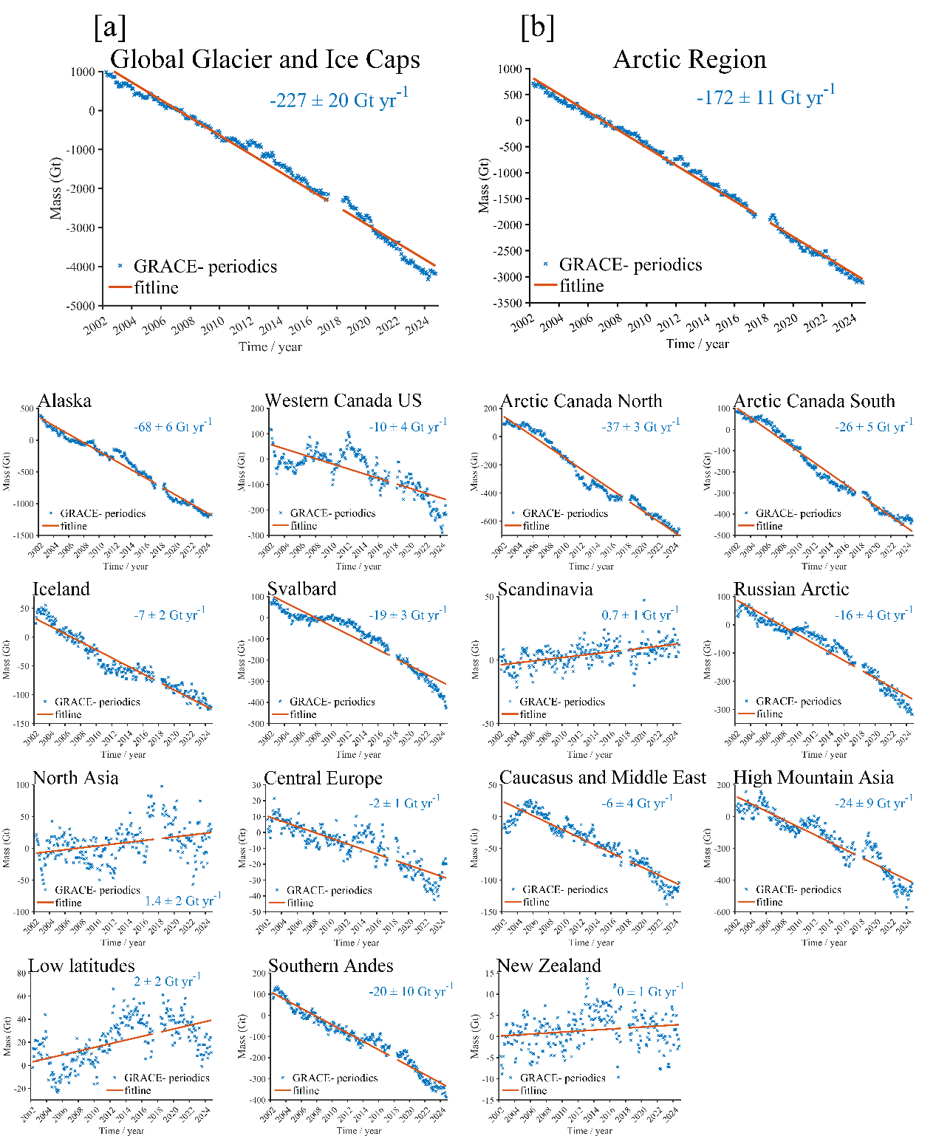
Figure S1 Annual mean glacier mass change from April 2002 to October 2024. Shown are the annual mean glacier mass changes for 17 glacier regions since 2002. The annual mean rate (upper right of each panel, in Gt yr⁻¹) is indicated. Blue curves represent the regional glacier mass time series after removal of the seasonal component, and orange lines denote the linear trends estimated using least-squares fitting.
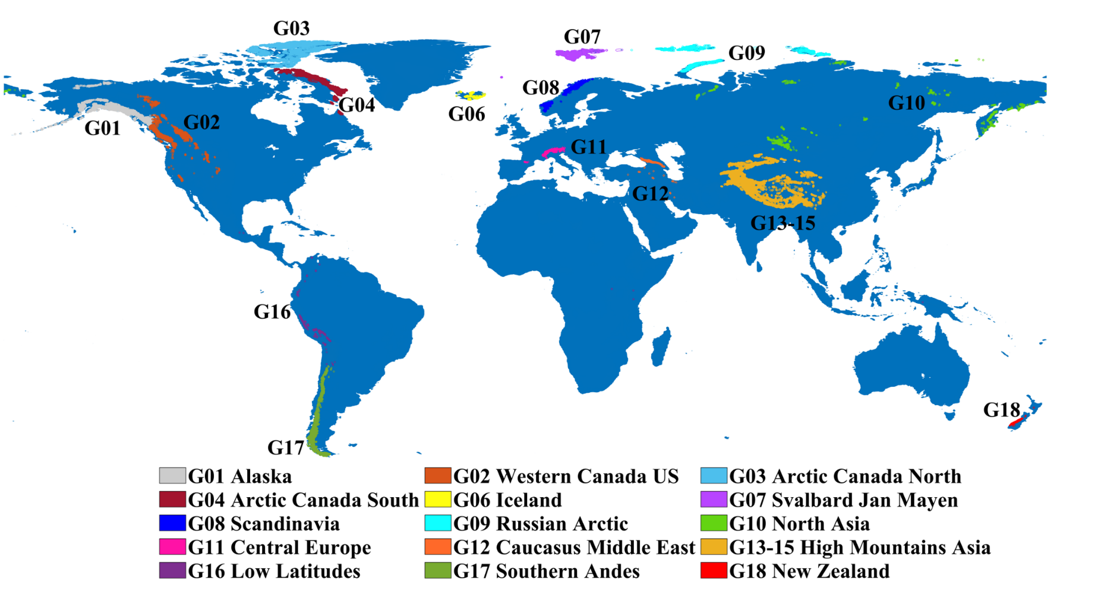
Figure S2 Locations of glaciers and ice caps from the Randolph Glacier Inventory version 7.0. Glaciers and ice caps are divided into 17 regions, with Central Asia (G13), South Asia West (G14), and South Asia East (G15) combined into a single region, High Mountain Asia (G13–15).
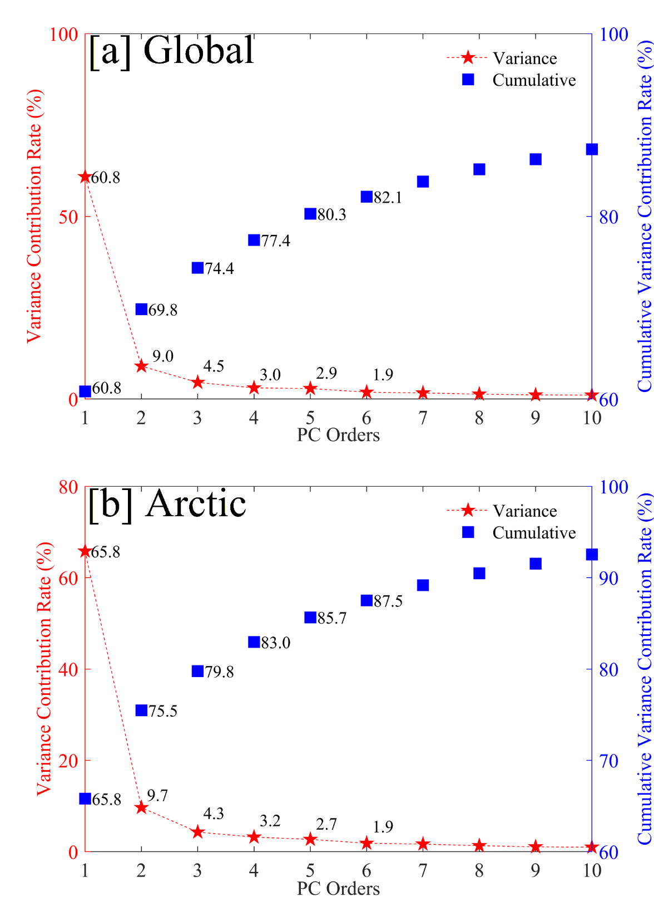
Figure S3 Variance contributions of the first ten principal components at global and Arctic scales. The upper panels show the variance explained by the first ten principal components (PCs) of global glaciers and ice caps (GICs). The individual variance contribution (left y-axis, %) is indicated by red pentagrams and dashed lines, while the cumulative variance contribution (right y-axis, %) is shown by blue squares. The lower panels present the corresponding individual and cumulative variance contributions for the Arctic GIC time series.
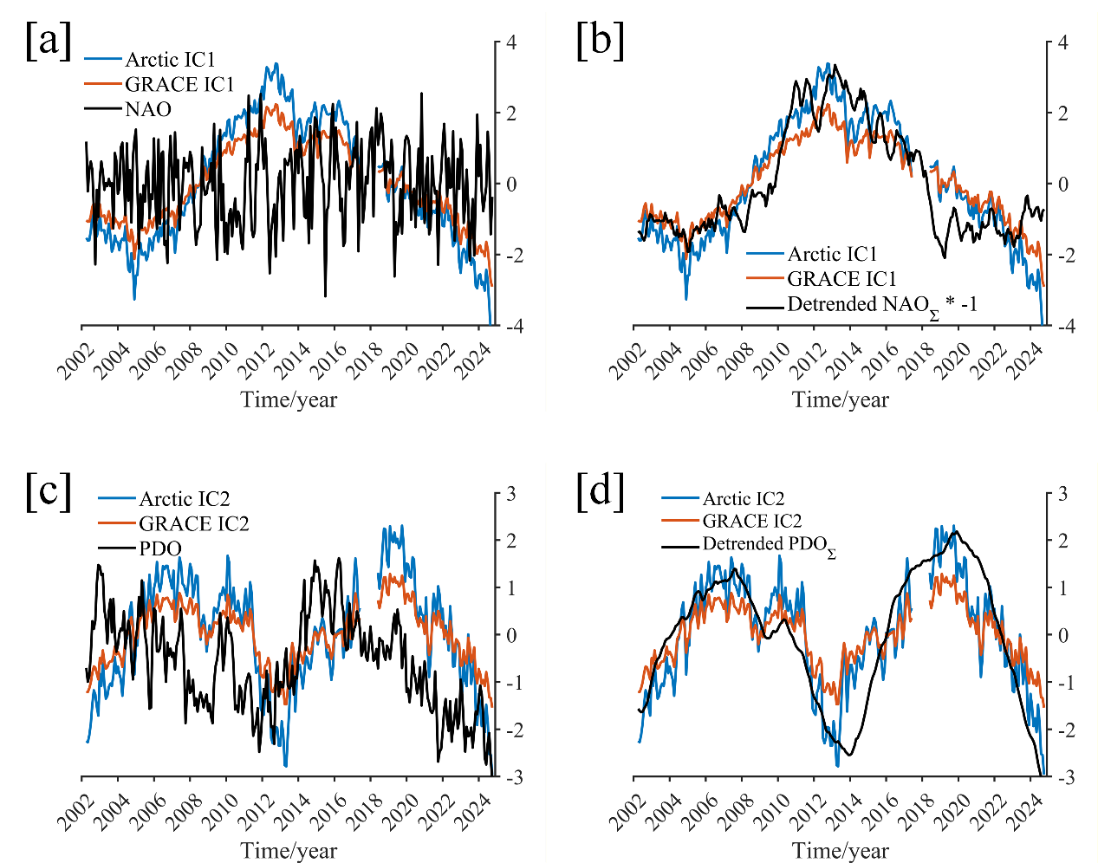
Figure S4 Comparison between ICA-derived temporal components and climate indices before and after cumulative summation. Panels (a–b) compare the first independent component (IC) of interannual glacier mass anomalies obtained from ICA decomposition, GRACE IC1 (global) and Arctic IC1 (Arctic), with both the original and cumulative NAO index time series. Panels (c–d) similarly compare GRACE IC2 and Arctic IC2 with the original and cumulative PDO index time series.
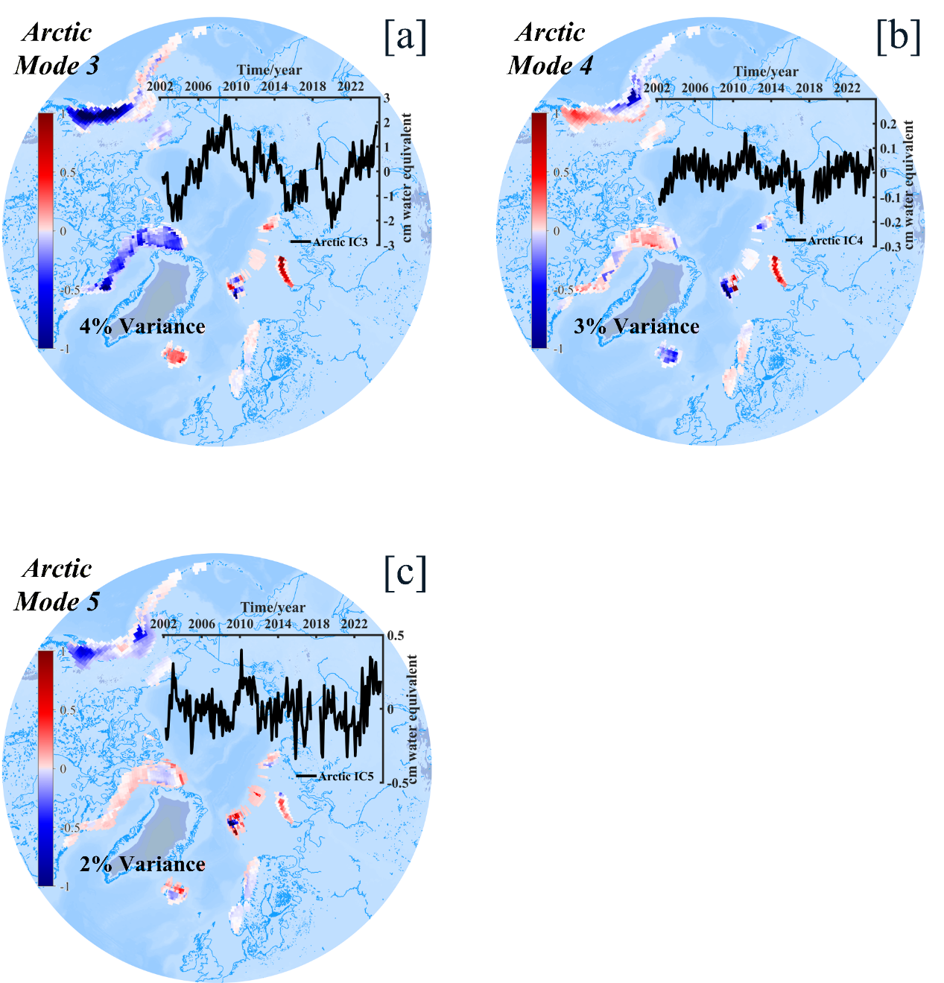
Figure S5 Secondary modes of Arctic glacier mass variability. Panels (a–c) show the third to fifth independent components (IC3–IC5) extracted from the detrended time series of glacier and ice cap (GIC) mass changes across seven Arctic regions, along with the corresponding variance contribution of each component.
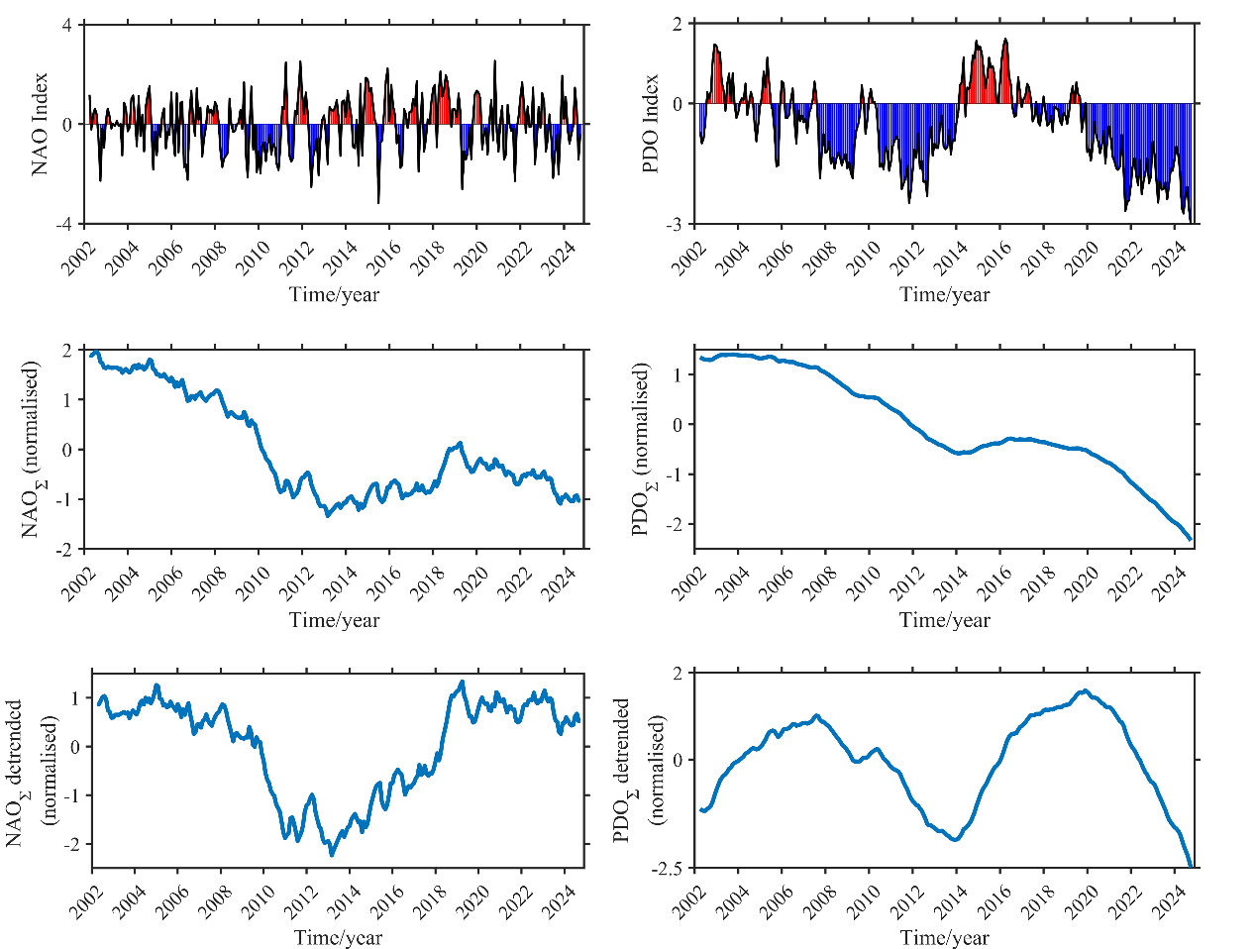
Figure S6 Comparative analysis of PDO and NAO climate indices. The first row shows the original standardized versions of each index during the GRACE observation period. The second row presents the cumulatively summed indices, and the third row depicts their detrended and normalized forms. The climatological reference period is 1971–1999.
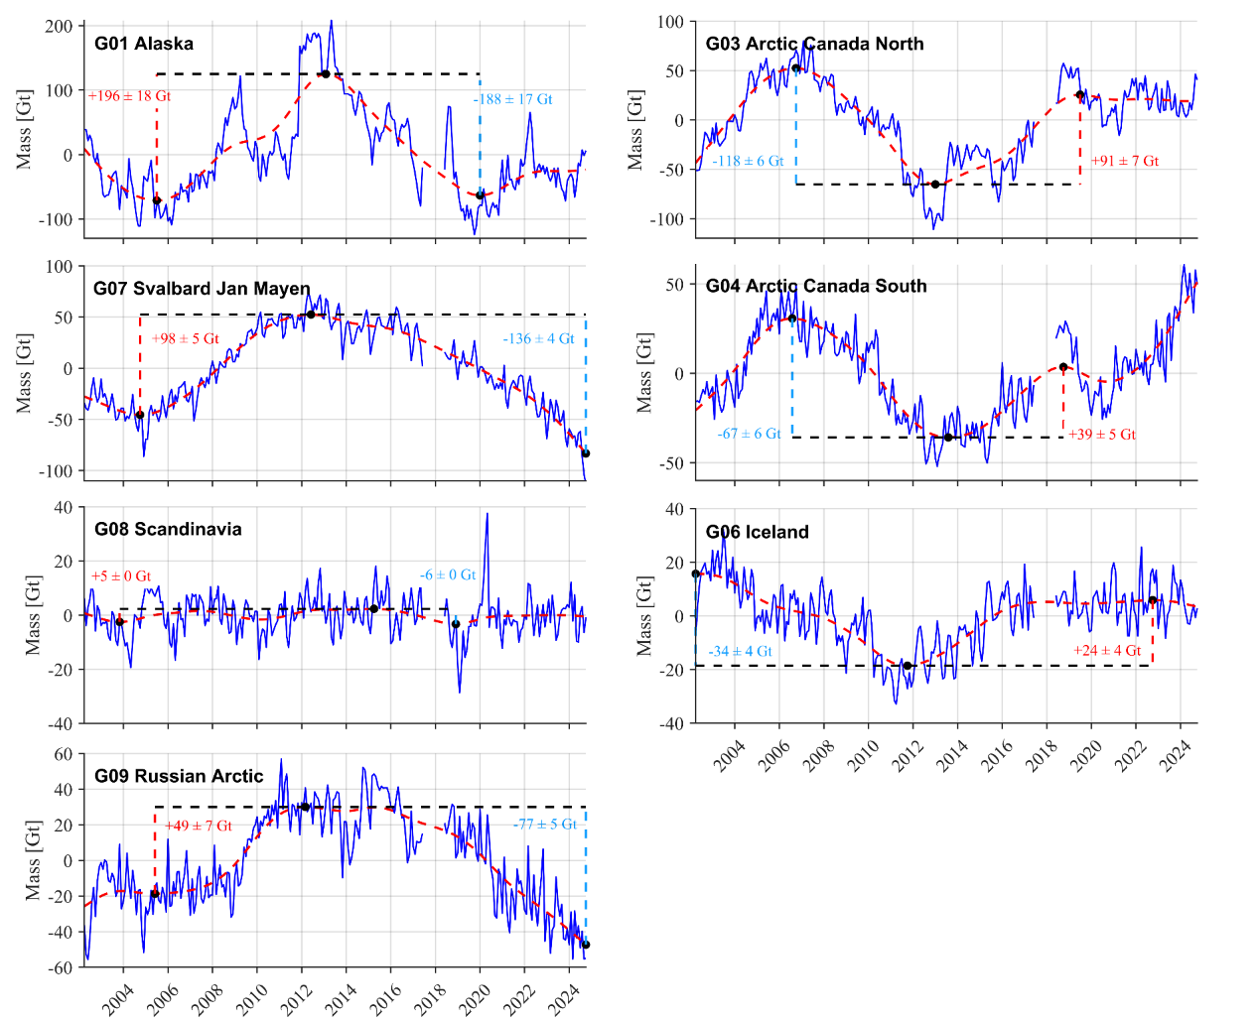
Figure S7 Interannual glacier mass variability across the Arctic. The detrended and deseasonalized time series of seven glacier and ice cap (GIC) regions in the Arctic were smoothed using a Hodrick–Prescott low-pass filter to extract the interannual component of glacier mass variability.
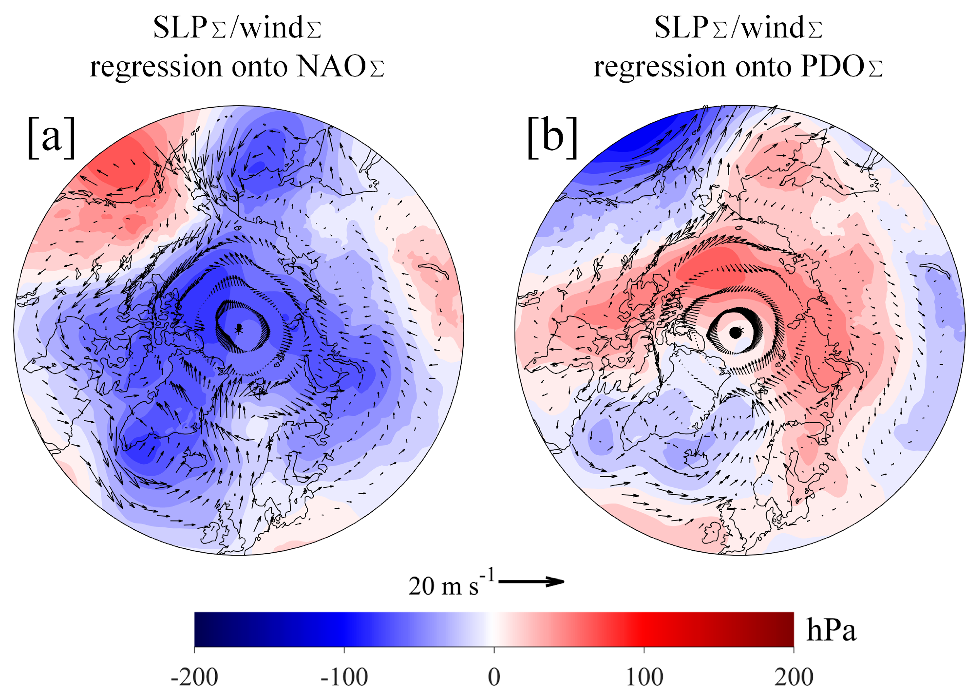
Figure S8 Decadal variability in wind. Maps show the regression relationships between the cumulative North Atlantic Oscillation (${NAO}_{∑}$) and Pacific Decadal Oscillation (${PDO}_{∑}$) indices and the cumulative anomalies of sea level pressure (${SLP}_{∑}$), and 10 m winds (${wind}_{∑}$) from ERA5 reanalysis. The climatological reference period is 1971–1999.
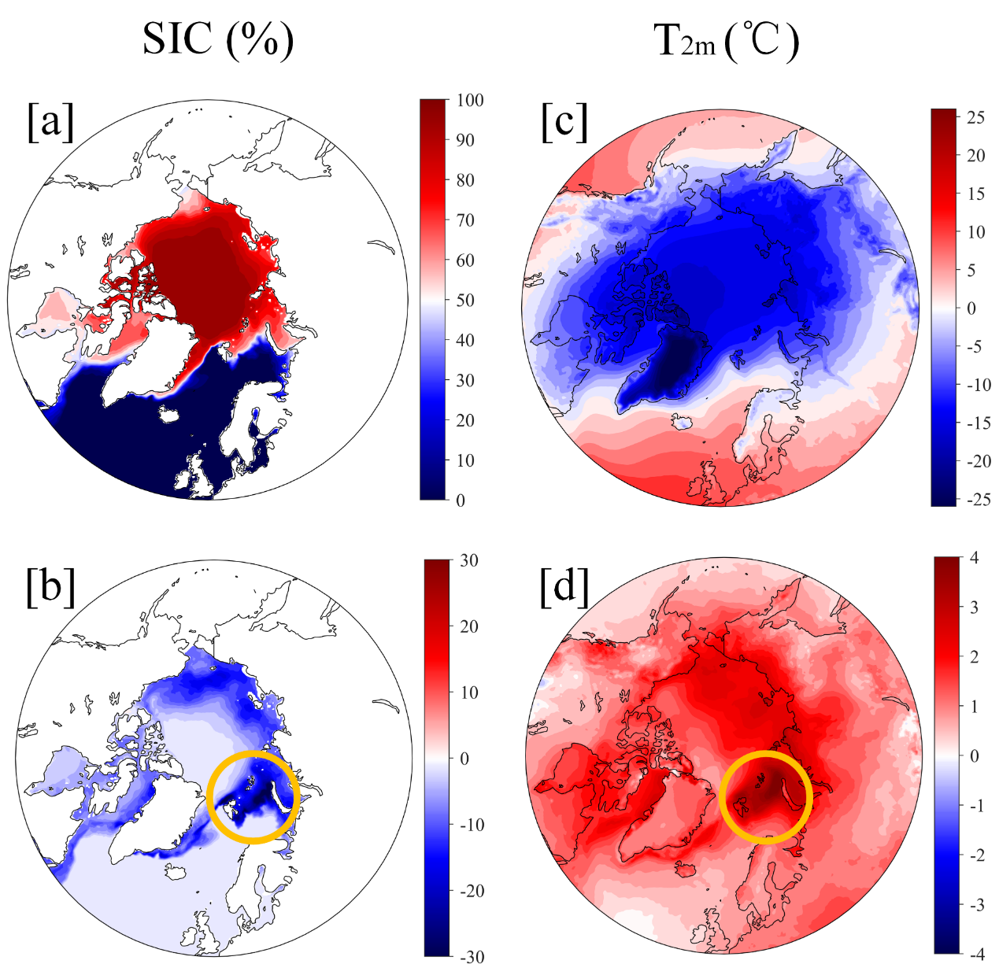
Figure S9 Arctic climate forcing anomalies. Panel (a) presents the climatological mean SIC for the baseline period 1991–1999, while panel (c) shows the climatological mean $T_{2m}$ for the baseline period 1971–1999. Panels (b) and (d) show anomalies of sea ice concentration (SIC)and surface air temperature ($T_{2m}$) during the GRACE observation period (2002–2024). The orange circles in panels (b) and (d) highlight the Barents and Kara Seas region.
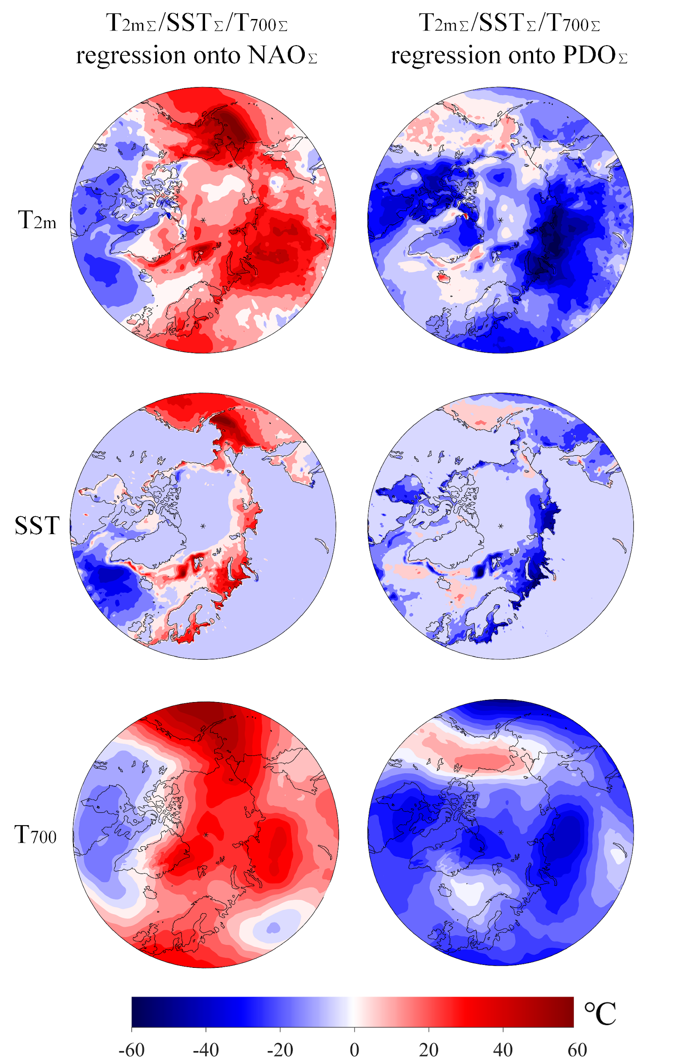
Figure S10 Decadal variability in temperature. Maps show the regression relationships between the cumulative North Atlantic Oscillation (${NAO}_{∑}$) and Pacific Decadal Oscillation (${PDO}_{∑}$) indices and the cumulative anomalies of surface air temperature (${T_{2m}}_{∑}$), sea surface temperature (${SST}_{∑}$), and 700-hPa air temperature (${T_{700}}_{∑}$) from ERA5 reanalysis. The climatological reference period is 1971–1999.
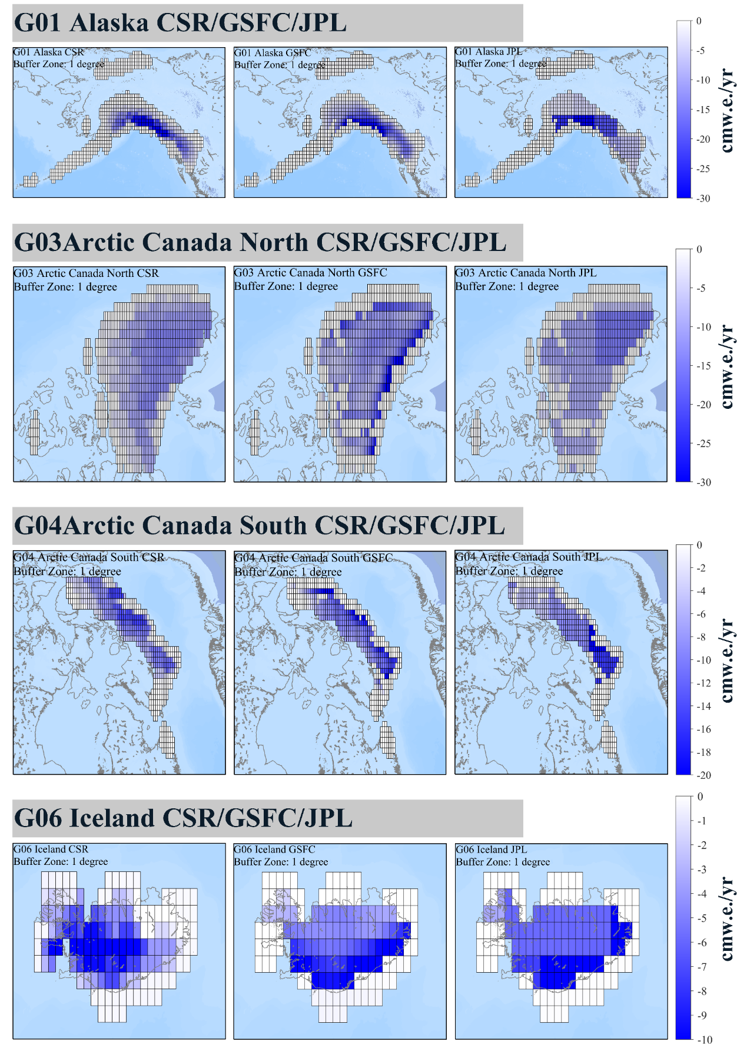
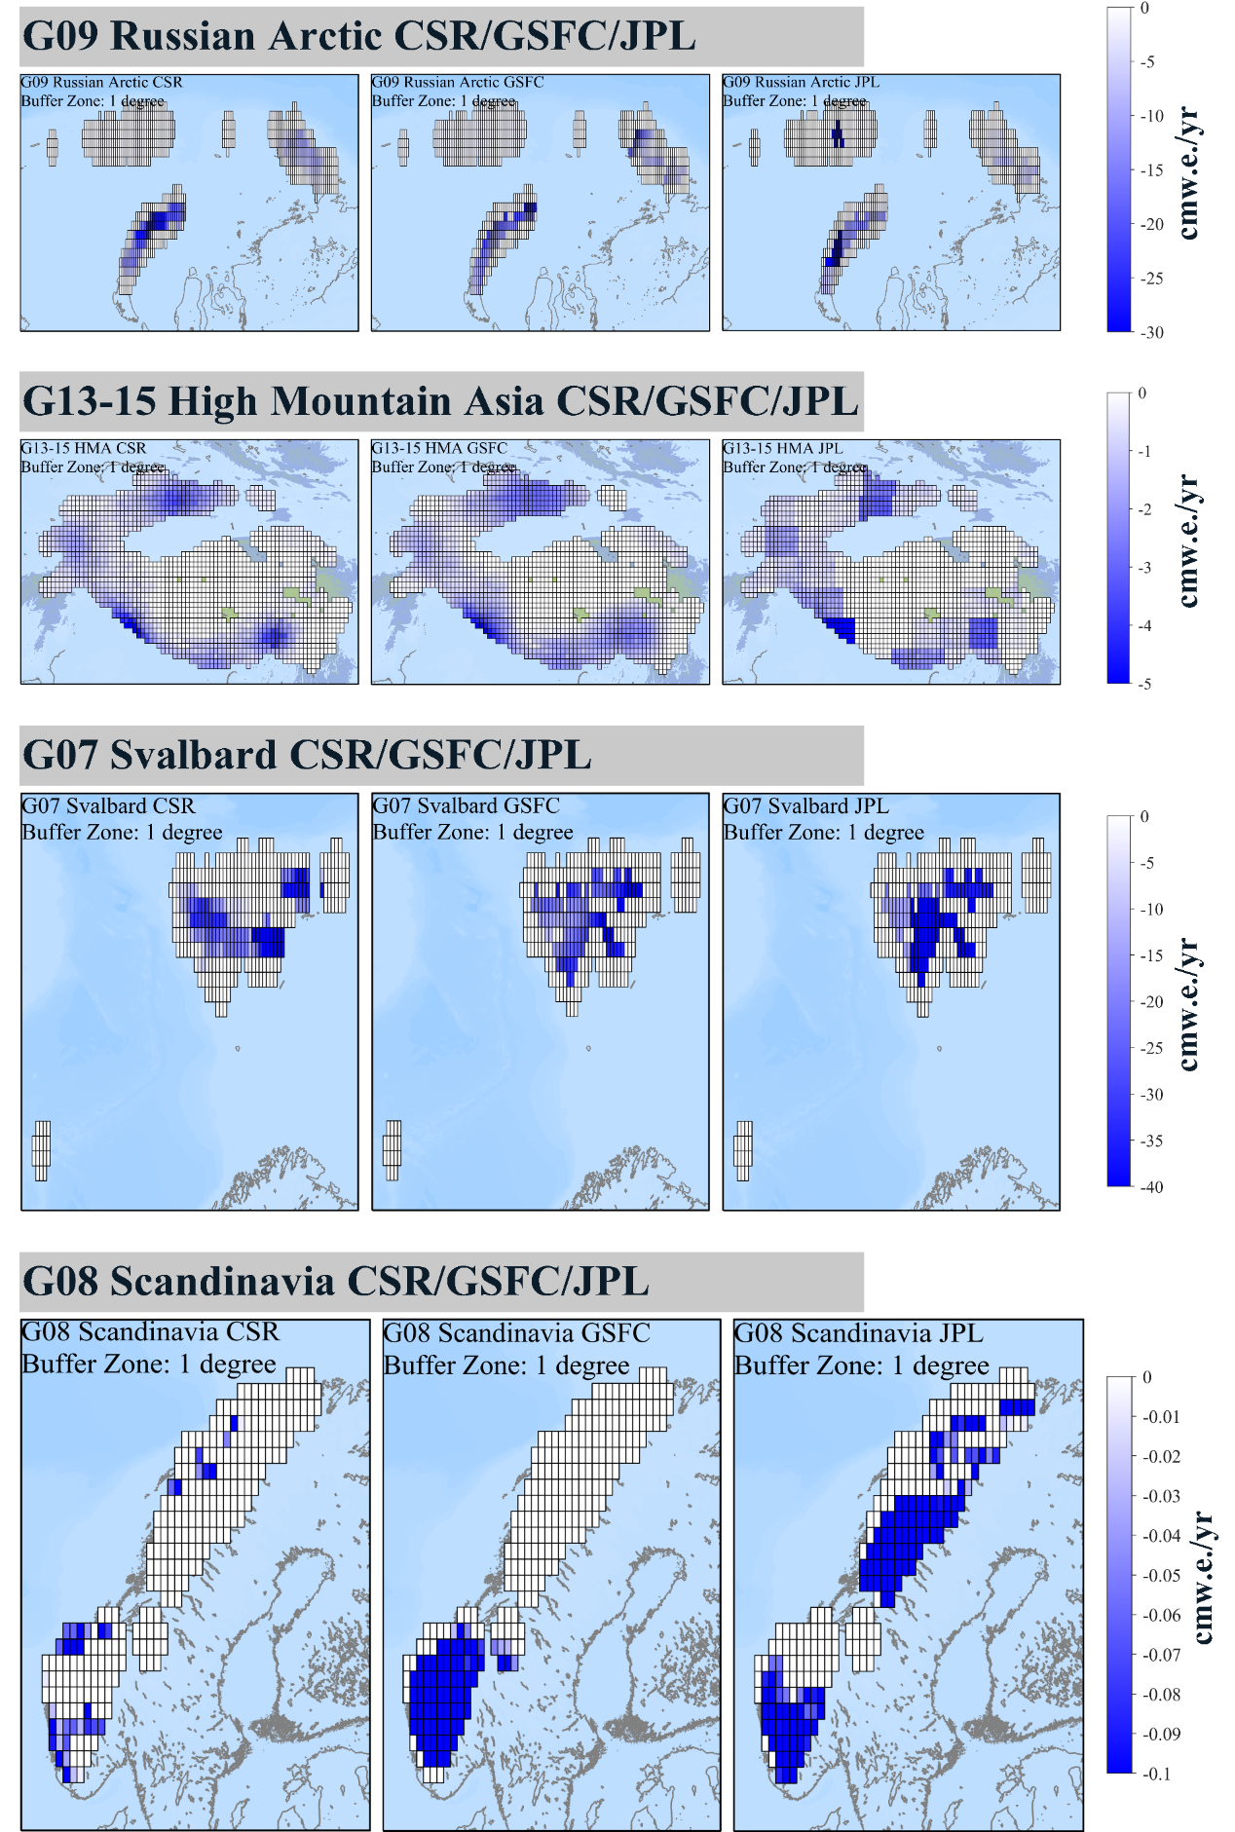
Figure S11 Spatial trends of GRACE Mascon solutions across selected glacier and ice-cap regions. Shown are the spatial masks used to delineate the major global glacier and ice-cap complexes, including the Arctic regions (G01, G03, G04, G06–G09) and High Mountain Asia (HMA, G13–15). Based on the Randolph Glacier Inventory version 7.0, a 1° buffer was applied to define the final glacier-specific regional masks. Blue shading indicates glacier-covered grid cells, with color intensity representing the trend in glacier mass change observed during the GRACE observation period.
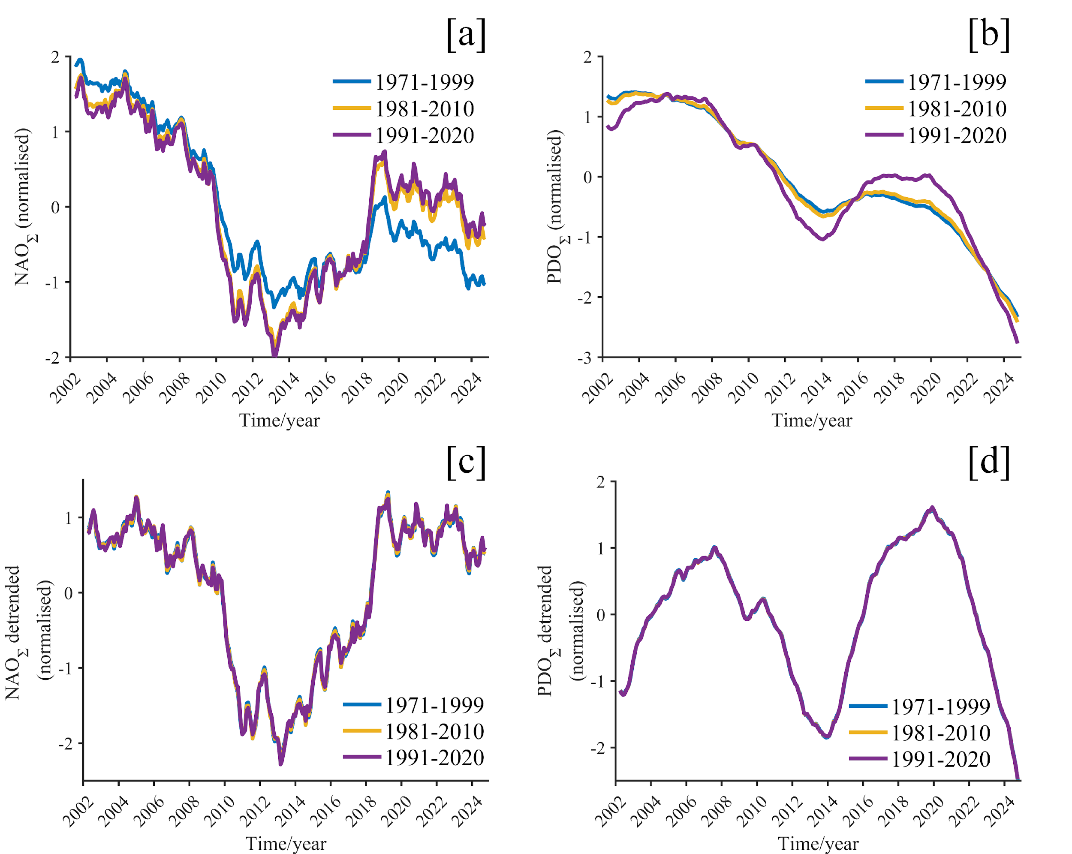
Figure S12 Sensitivity of cumulative NAO and PDO indices to the choice of climatological reference period. Panels a–b show the cumulative NAO (a, ${NAO}_{∑}$) and PDO (b, ${PDO}_{∑}$) indices normalised over the GRACE/GRACE-FO era (2002–2024) for three different climatological baselines (1971–1999, 1981–2010, 1991–2020). Panels c–d show the corresponding detrended and renormalised ${NAO}_{∑}$ (c) and ${PDO}_{∑}$ (d). Coloured curves denote the different reference periods.
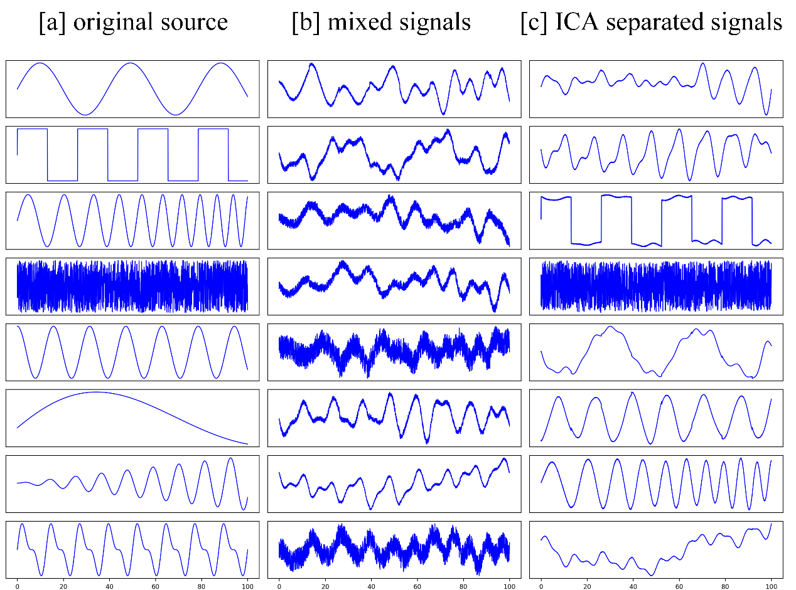
Figure S13 Demonstration of ICA decomposition. (a) Eight independent source signals used for simulation. (b) Linearly mixed observations derived from the sources. (c) Independent components reconstructed using the Fast-ICA method.

