Tests were carried out at different powers: 60, 100 and 140W for 30 seconds. In order to determine the influence of time on wetting properties, contact angles were determined immediately after treatment and after 4 hours. On the other hand, we also wanted to determine the influence of the treatment time using a power for 30, 60 and 90 seconds. The power will be chosen which, by analyzing the results, will maintain the best hydrophilic conditions for the biological behavior.

Studies on surface wettability were conducted to determine the optimal treatment conditions for subsequent tests involving bacterial adhesion and viability.
Two tests were performed:
- Modifying the treatment power (60, 100 and 140 W) for 30 seconds measuring their wettability immediately and after 4 h.
- Modifying the treatment duration at 30, 60 and 90 seconds at a fixed power of 100 W. Wettability was measured immediately and after 4 h.
The results of the variation of the plasma power can be seen in Figure 2. It shows that the variation of the power does not cause statistically significant differences in the wettability values on the surfaces of the four materials studied. It can be observed that the wettability measurements performed immediately after the treatment have a significantly higher hydrophilic behavior than the surfaces on which the measurement was performed four hours after the treatment.
The samples showing the most pronounced hydrophilic and superhydrophilic behavior is titanium, although all of them show a lower contact angle with respect to the control. The 4-hour stay before the contact angle measurement causes a loss of hydrophilicity with respect to the measurement immediately but in all cases the contact angle is lower than the samples without plasma treatment.

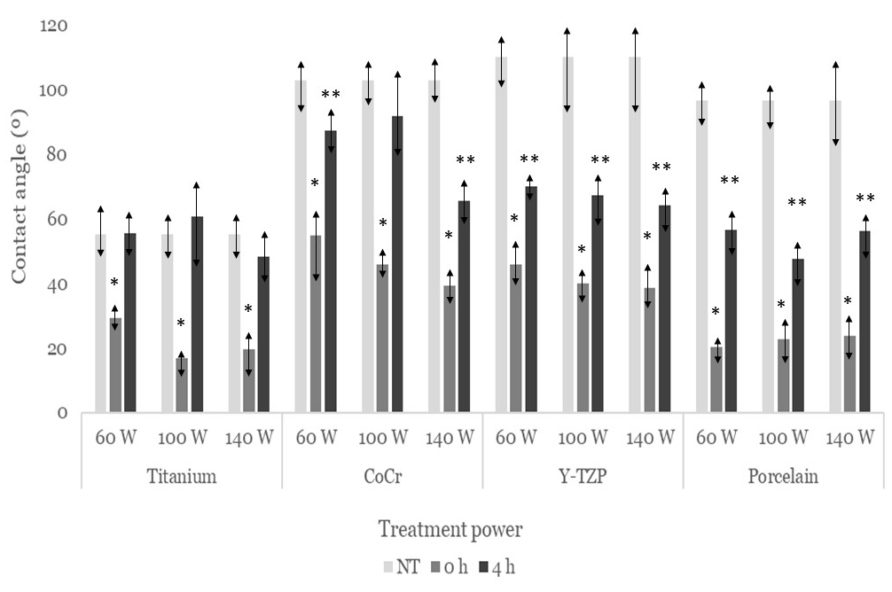
Figure 2. Contact angle comparison of non-treated (NT) and treated at different power measured at two time points: immediately after the treatment is applied (0 h) and 4 hours post-treatment (4 h). The comparison is performed across four different biomaterials with varying treatment power. Values marked with an asterisk (*) indicate statistically significant differences (p < 0.05) compared to those without an asterisk. When the asterisk is double (**) it means that the results have statistically significant differences with respect to those without an asterisk (*) or those with only one asterisk, with a p < 0.05.

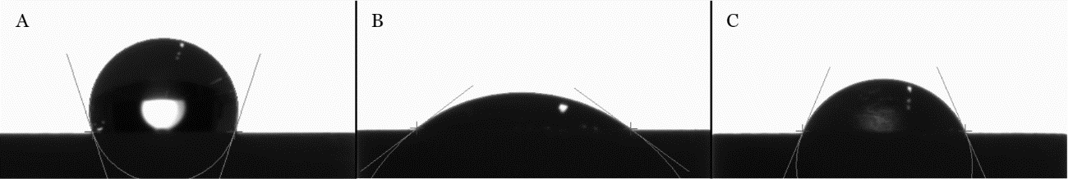
As an example, in Figure 3 can be observed the variations in contact angles with the time at constant power 140 W in zirconia samples.

Figure 3. Example of contact angle decrease after 140 W treatment for 30 seconds on a Y-TZP disc. A) Non-treated sample: 108’03º, B) Treated sample (0 h): 36’30º, C) Treated sample (4 h): 66’67º.

Although, as we have seen, the differences in power are not statistically significant differences with p < 0.05, an analysis of the results between the maintenance of the hydrophilic capacity with the plasma treatment time leads to the conclusion that the most suitable plasma treatment is 60 W. This potential will be maintained constant and the treatment will be carried out for 30 seconds. In addition, since the power is lower, the treatment is more economical.
A similar trend is observed when the power is constant 60W varying the duration of oxygen plasma treatment (30, 60 and 90 seconds) (Figure 4). There is a significant decrease in contact angle immediately after treatment. An important increase in the contact angle after 4 hours. In ceramic materials, this increase causes greater hydrophobicity than the untreated material.

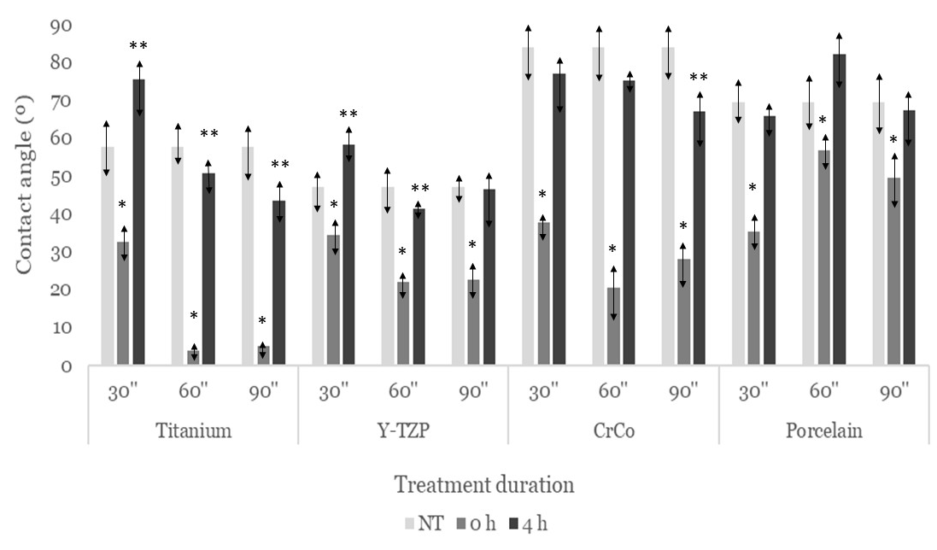
Figure 4. Contact angle comparison of non-treated (NT) and treated samples at two time points: immediately after the treatment is applied (0 h) and 4 hours post-treatment (4 h). The comparison is conducted across four different biomaterials with varying treatment durations. Values marked with an asterisk (*) indicate statistically significant differences (p < 0.05) compared to those without an asterisk. When the asterisk is double (**) it means that the results have statistically significant differences with respect to those without an asterisk (*) or those with only one asterisk, with a p < 0.05.
In the case of titanium, very low contact angle values are observed, reaching superhydrophilic values when measurements are made up to 90 seconds after treatment at 60W. It can be observed that the treatments after 4 hours do not reach the hydrophilic values as in the previous case although a decrease in the contact angle between 10 and 20° is appreciated. It is noteworthy that the plasma treatment after 4 hours and after 30 seconds there is an increase in the contact angles, this fact also occurs in the yttria and for the case of CrCo and porcelain the differences in wettability do not present statistically significant differences with respect to the control.
For yttria, a greater hydrophilic capacity is also observed in the treatments at 60 and 90 seconds after the plasma treatment. In the same way that titanium when the measurement is 4 hours this capacity decreases. This same behavior is observed in Cr Co alloy and porcelain. That is, when the contact angle measurement is performed in the first 90 seconds, a significant increase in hydrophilicity is observed, especially in titanium where the behavior can be considered superhydrophilic. It can also be appreciated that if the plasma treatment is measured at 4 hours the previous hydrophilicity values are not reached although there is a decrease in the contact angle values with respect to the untreated samples.
After these results, the optimum treatment was obtained by analyzing the results with respect to the maintenance of wettability, and this was the plasma treatment with oxygen for 30 seconds at a power of 60W and a measurement time of 60 seconds.
- Samples treated: 12 samples × 4 materials × 3 powers × 2 times of treatments × 3 times of wettability measurements = 864 samples treated
- Samples untreated: 14 samples × 4 materials = 56 samples as a control.
Total: 920 samples.

