Supplementary Material

A. B.
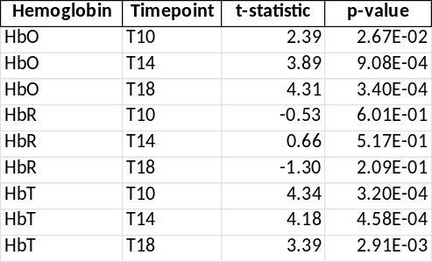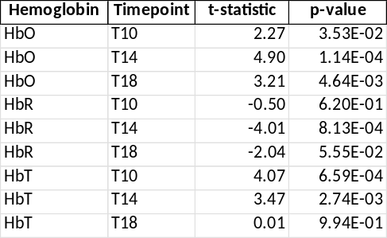
Table S1. Paired t-test results comparing baseline and visual stimulation conditions in the circadian modulation group.
The tables report the results of paired t-tests assessing differences in HbO, HbR, and HbT amplitudes between baseline and visual stimulation conditions. For each hemoglobin metric and corresponding timepoint, t-statistics and multiple-comparison. Corrected p-values are reported for same-day recordings (A) and multi-day recordings (B). Significant effects indicate that visual stimulation produced reliable hemodynamic changes across participants, confirming the effectiveness of the paradigm in evoking canonical occipital activation.

A.
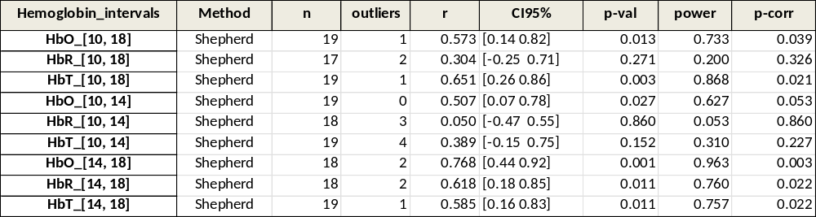
B. 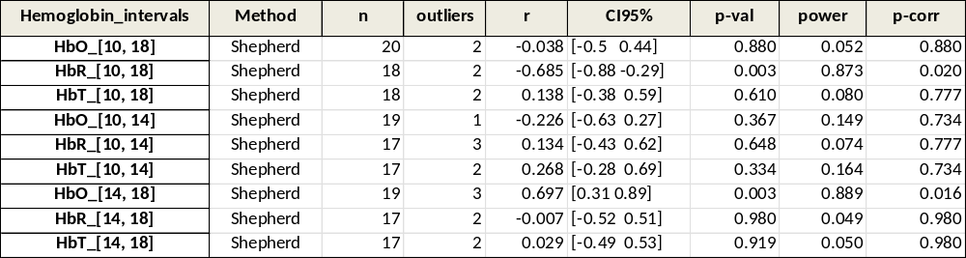
Table S2. Correlation analysis of hemodynamic response amplitudes for same-day and multi-day recordings.
The tables summarize Shepherd correlation analyses assessing the test-retest consistency of visually evoked hemodynamic response amplitudes (HbO, HbR, and HbT). Correlations are shown for recordings acquired within the same day (A) and across different days (B). For each hemoglobin metric and interval comparison, the table includes the number of included participants (n) with removed outliers, the correlation coefficient (r), the 95% confidence interval (CI95%), the associated p-value, statistical power, and the p-value corrected for multiple comparisons (p-corr). Higher correlation coefficients indicate stronger within-subject stability of the fNIRS-measured visual response across time, providing a quantitative measure of longitudinal reliability.

A. B.
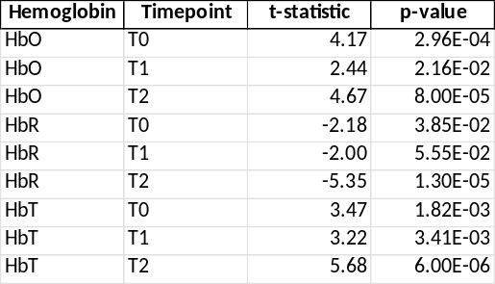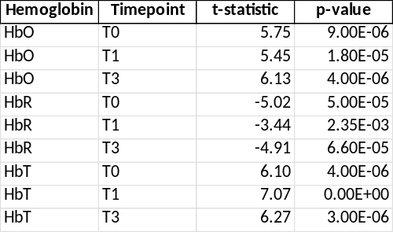
Table S3. Paired t-test results comparing baseline and visual stimulation conditions in the interval group.
The tables report paired t-tests assessing differences in HbO, HbR, and HbT amplitudes between baseline and visual stimulation at each timepoint. Results are shown separately for the mid-term interval group (A) and the long-term interval group (B), including t-statistics and p-values corrected for multiple comparisons. Across all timepoints, visual stimulation elicited significant and consistent hemodynamic responses, confirming the robustness of occipital cortex activation induced by the paradigm.
Timepoint legend: T0= first recording, T1= recording after 5 minutes, T2= recording after 2 months, T3= recording after 2 years.

A. 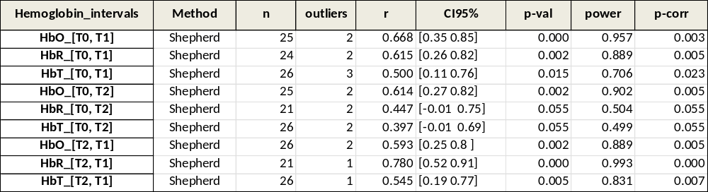
B. 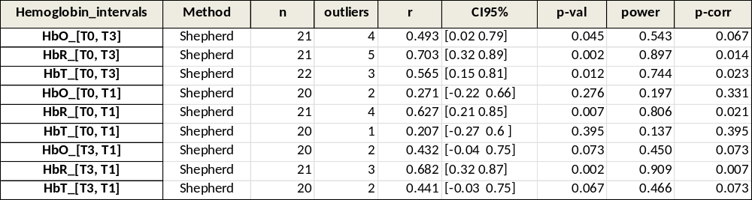
Table S4. Correlation analysis of hemodynamic response amplitudes across testing intervals in the two groups.
The tables summarize Shepherd correlation coefficients assessing the consistency of visually evoked hemodynamic amplitudes (HbO, HbR, and HbT) across short- and mid-term intervals (A), and short- and long-term intervals (B). For each hemoglobin metric and interval comparison, the table reports the method, the number of participants (n) with removed outliers, the correlation coefficient (r), the 95% confidence interval (CI95%), the associated p-value, the estimated statistical power, and the p-value corrected for multiple comparisons (p-corr).

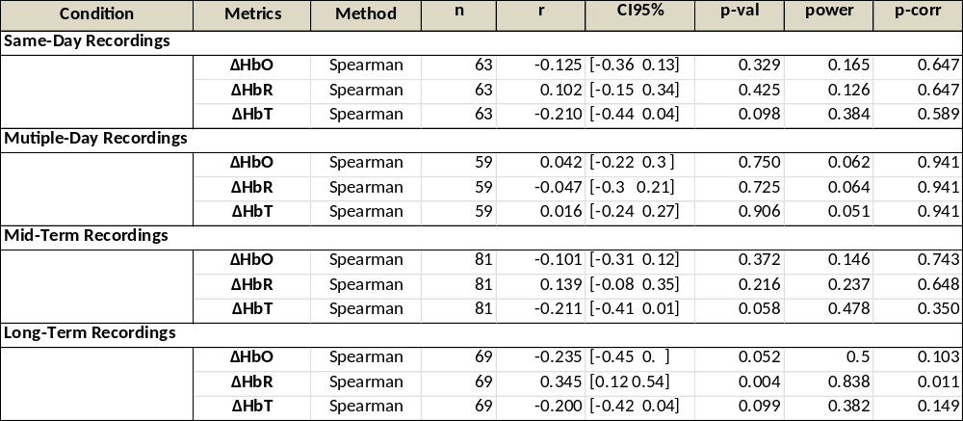
Table S5. Correlation analysis of Δ hemodynamic response amplitudes with age across all recordings.
The table reports correlation analyses examining the relationship between participants’ age and visually evoked Δ-peak amplitudes of the hemodynamic response across all recording conditions. For each hemoglobin metric (HbO, HbR, HbT), the correlation method (Spearman), sample size (n), correlation coefficient (r), 95% confidence interval (CI95%), uncorrected p-value (p-val), achieved statistical power, and multiple-comparison–corrected p-value (p-corr) are provided.

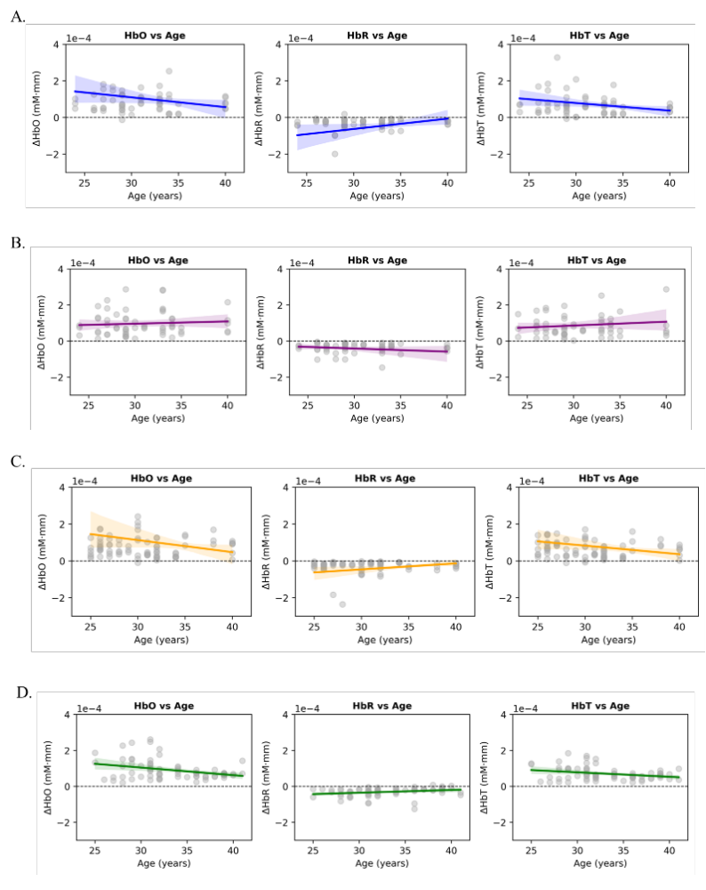
Figure S1. Correlation of visually evoked hemodynamic response amplitudes with age across recording conditions.
Scatter plots illustrate Spearman correlations between visually evoked Δ-peak hemodynamic amplitudes and participants’ age for HbO, HbR and HbT across all experimental sessions: same-day (A), multi-day (B), mid-term (C) and long-term recordings (D). Each dot represents an individual participant; solid lines indicate linear regression fits, and shaded bands denote the corresponding 95% confidence intervals. For all panels, values in the y-axis are scaled by 10^4. For detailed statistical results, refer to Table S5.

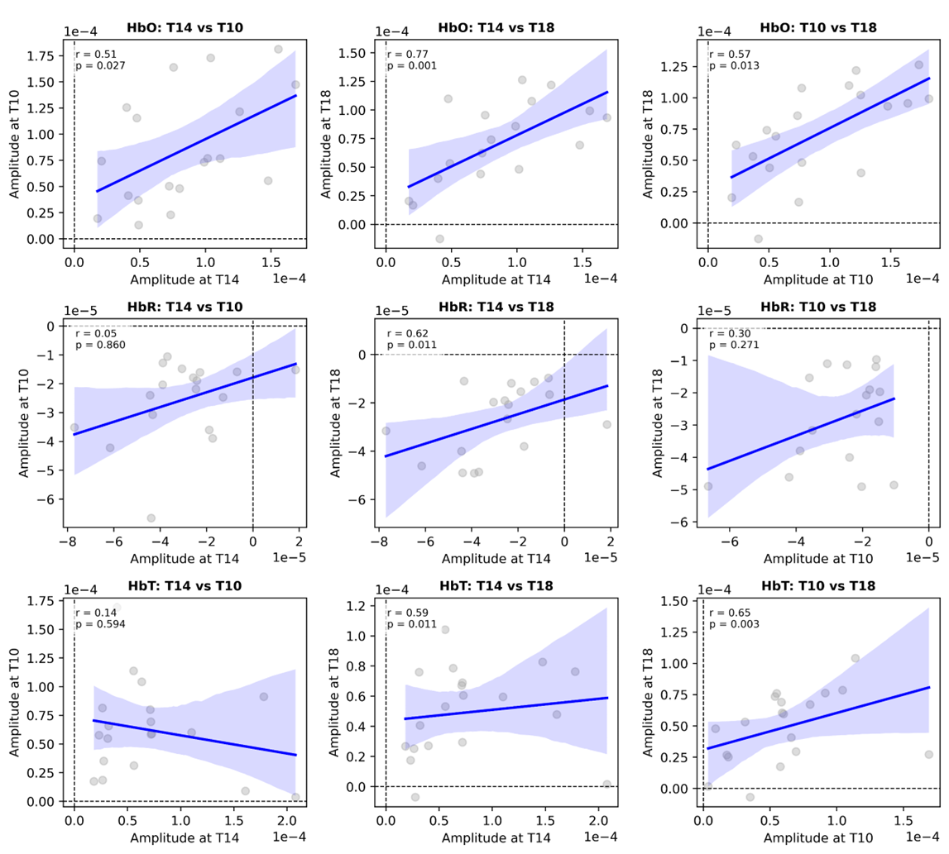
Figure S2. Delta Hb Amplitude Correlations across timepoints in same-day recordings.
Scatter plots depict pairwise Spearman correlations of visually evoked HDR amplitudes across circadian time points (T10, T14, T18) for HbO, HbR and HbT. Each dot represents an individual participant; solid blue lines indicate linear regression fits, with shaded areas showing the corresponding 95% confidence intervals. Shepherd correlation coefficients (r) and associated p-values are reported within each panel. Dashed horizontal and vertical lines indicate zero amplitude. Significant positive correlations across multiple comparisons demonstrate strong within-subject reliability of visually evoked fNIRS responses across the day, supporting the temporal stability of the hemodynamic signal across circadian phases. For detailed statistical results, see Table S2.

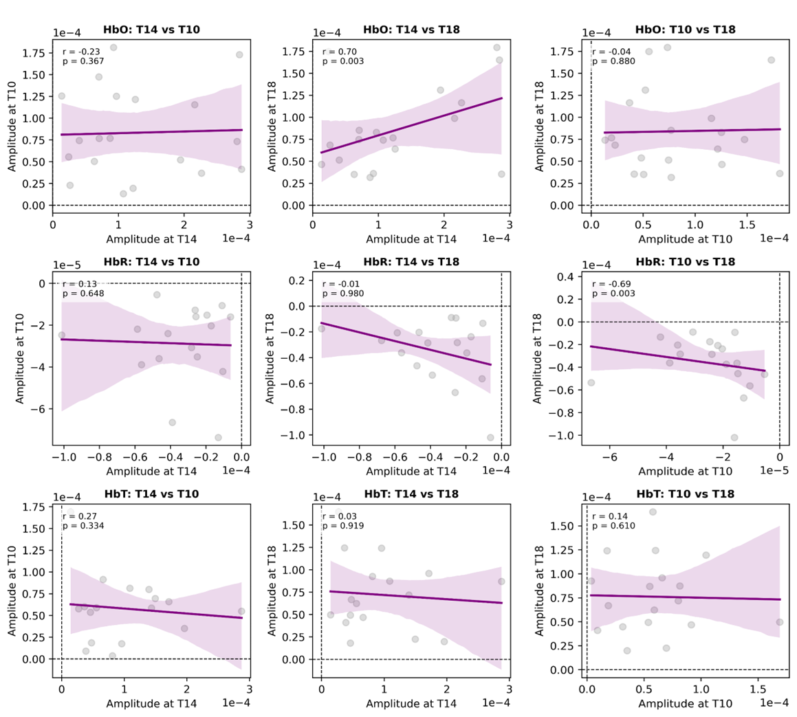
Figure S3. Delta Hb Amplitudes Correlations across timepoints in multi-day recordings.
Scatter plots illustrate pairwise correlations of visually evoked HDR amplitudes across circadian time points (T10, T14, T18) for HbO, HbR and HbT. Each dot represents an individual participant; solid purple lines indicate linear regression fits, with shaded areas denoting the corresponding 95% confidence intervals. Shepherd correlation coefficients (r) and associated p-values are reported in each panel. Dashed horizontal and vertical lines indicate zero amplitude. Significant positive correlations across multiple comparisons demonstrate strong within-subject reliability of visually evoked fNIRS responses across different days, supporting the temporal stability of the hemodynamic signal across circadian phases. For detailed statistical results, refer to Table S2.

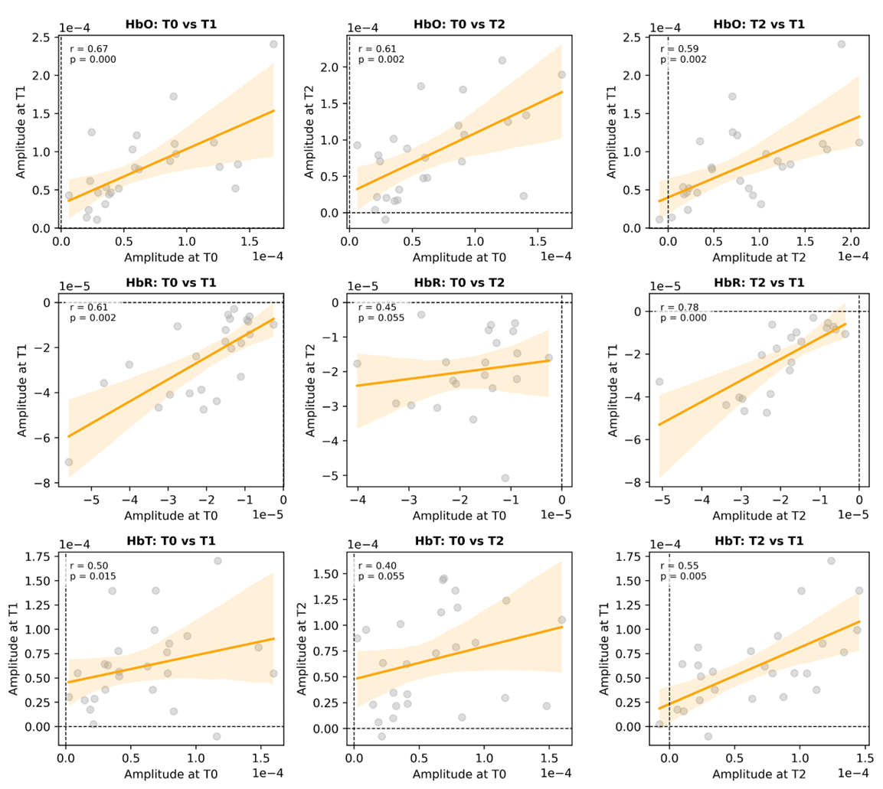
Figure S4. Delta Hb Amplitudes Correlations across timepoints in mid-term interval recordings.
Scatter plots show pairwise correlations of visually evoked HDR amplitudes across recording intervals (T0, T1, T2) for HbO, HbR and HbT. Each dot represents an individual participant; solid orange lines indicate linear regression fits, with shaded areas indicating the corresponding 95% confidence intervals. Shepherd correlation coefficients (r) and associated p-values are reported in each panel. Dashed horizontal and vertical lines indicate zero amplitude. Significant positive correlations across multiple comparisons demonstrate strong within-subject reliability of visually evoked fNIRS responses across interval repetitions, supporting the temporal stability of the hemodynamic signal across short and mid-term retest sessions. For detailed statistical results, refer to Table S4.

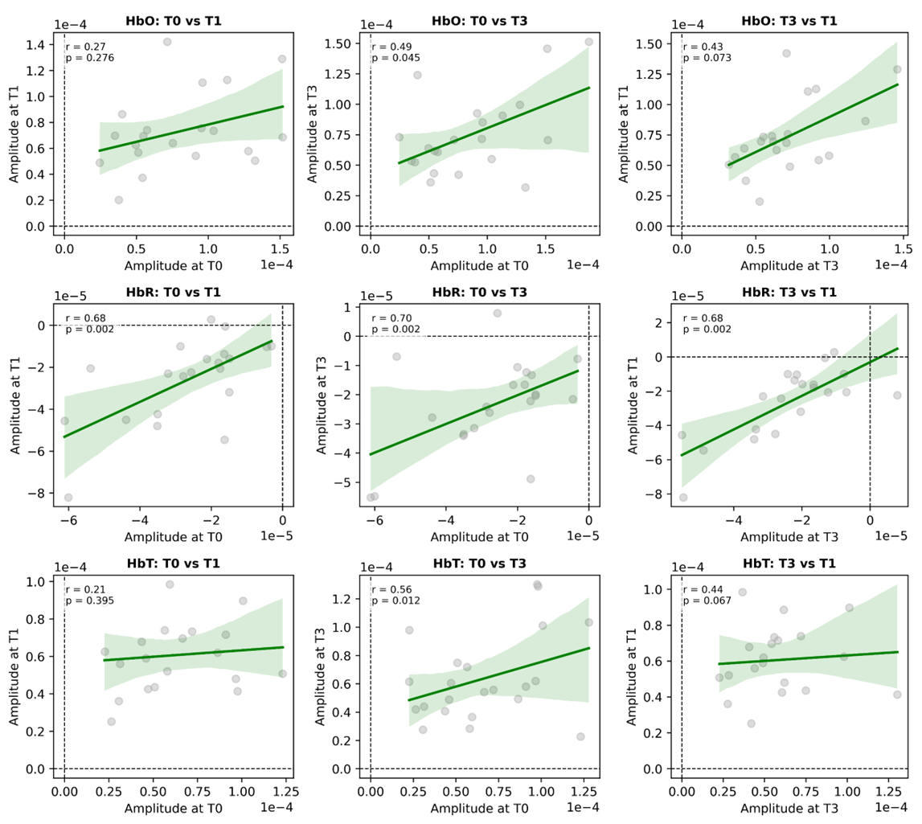
Figure S5. Delta Hb Amplitudes Correlations across Timepoints in long-term interval recordings.
Scatter plots illustrate pairwise correlations of visually evoked HDR amplitudes across intervals (T0, T1, T3) for HbO, HbR and HbT. Each dot represents an individual participant; solid green lines indicate linear regression fits, with shaded areas showing the corresponding 95% confidence intervals. Shepherd correlation coefficients (r) and associated p-values are reported in each panel. Dashed horizontal and vertical lines indicate zero amplitude. Significant positive correlations across multiple comparisons demonstrate strong within-subject reliability of visually evoked fNIRS responses, supporting the long-term temporal stability of the hemodynamic signal across sessions separated by years. For detailed statistical results, refer to Table S4.

