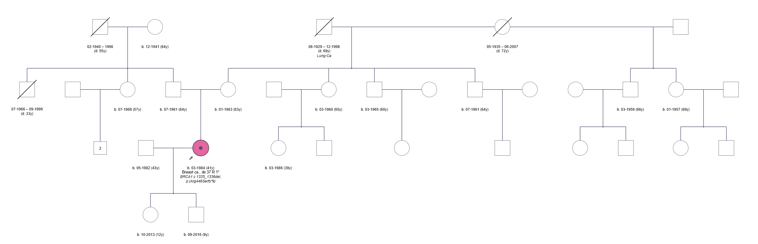
Supplementary Material
Figure S1: Pedigree of the affected individual (pink circle, indicated with an arrow); circles indicate females, squares indicate male family members, year of birth included wherever information was available.

