Supplementary Figures:
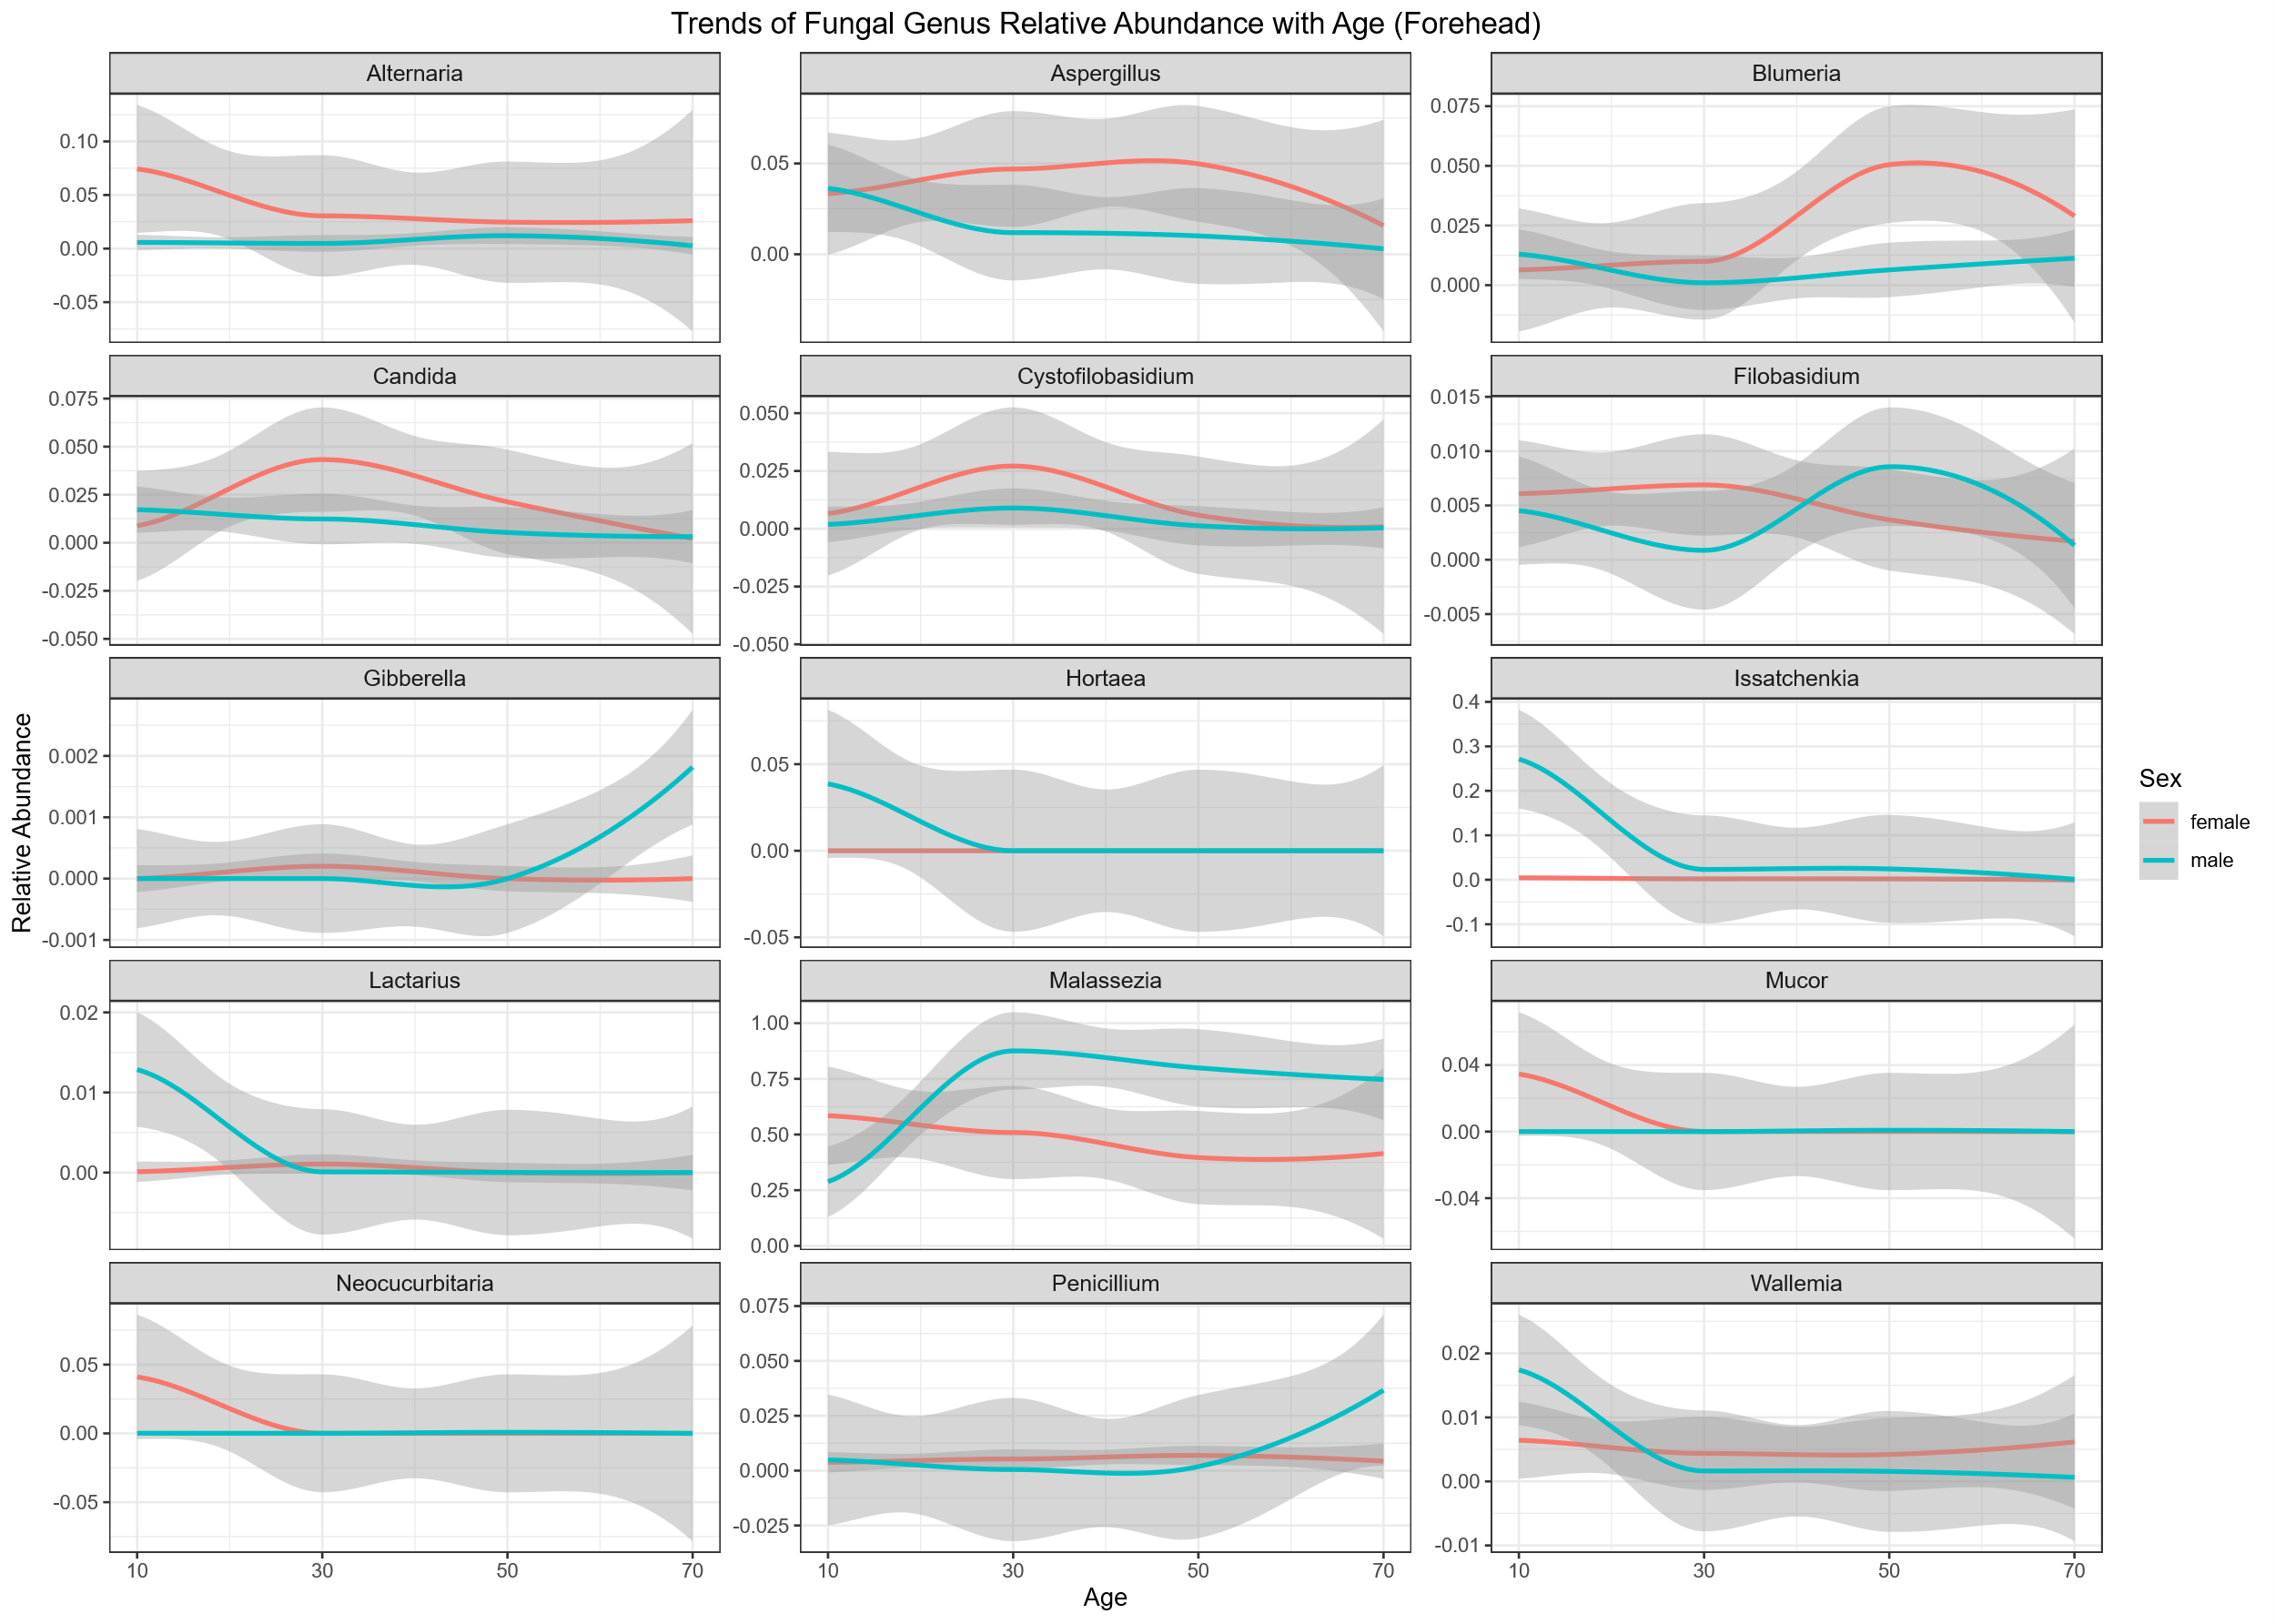
Supplementary Figure S1. Sex-stratified age-related changes in the top 15 fungal genera(Alternaria, Aspergillus, Blumeria, Candida, Cystofilobasidium, Filobasidium, Gibberella, Hortaea, Issatchenkia, Lactarius, Malassezia, Mucor, Neocucurbitaria, Penicillium and Wallemia) on the forehead.
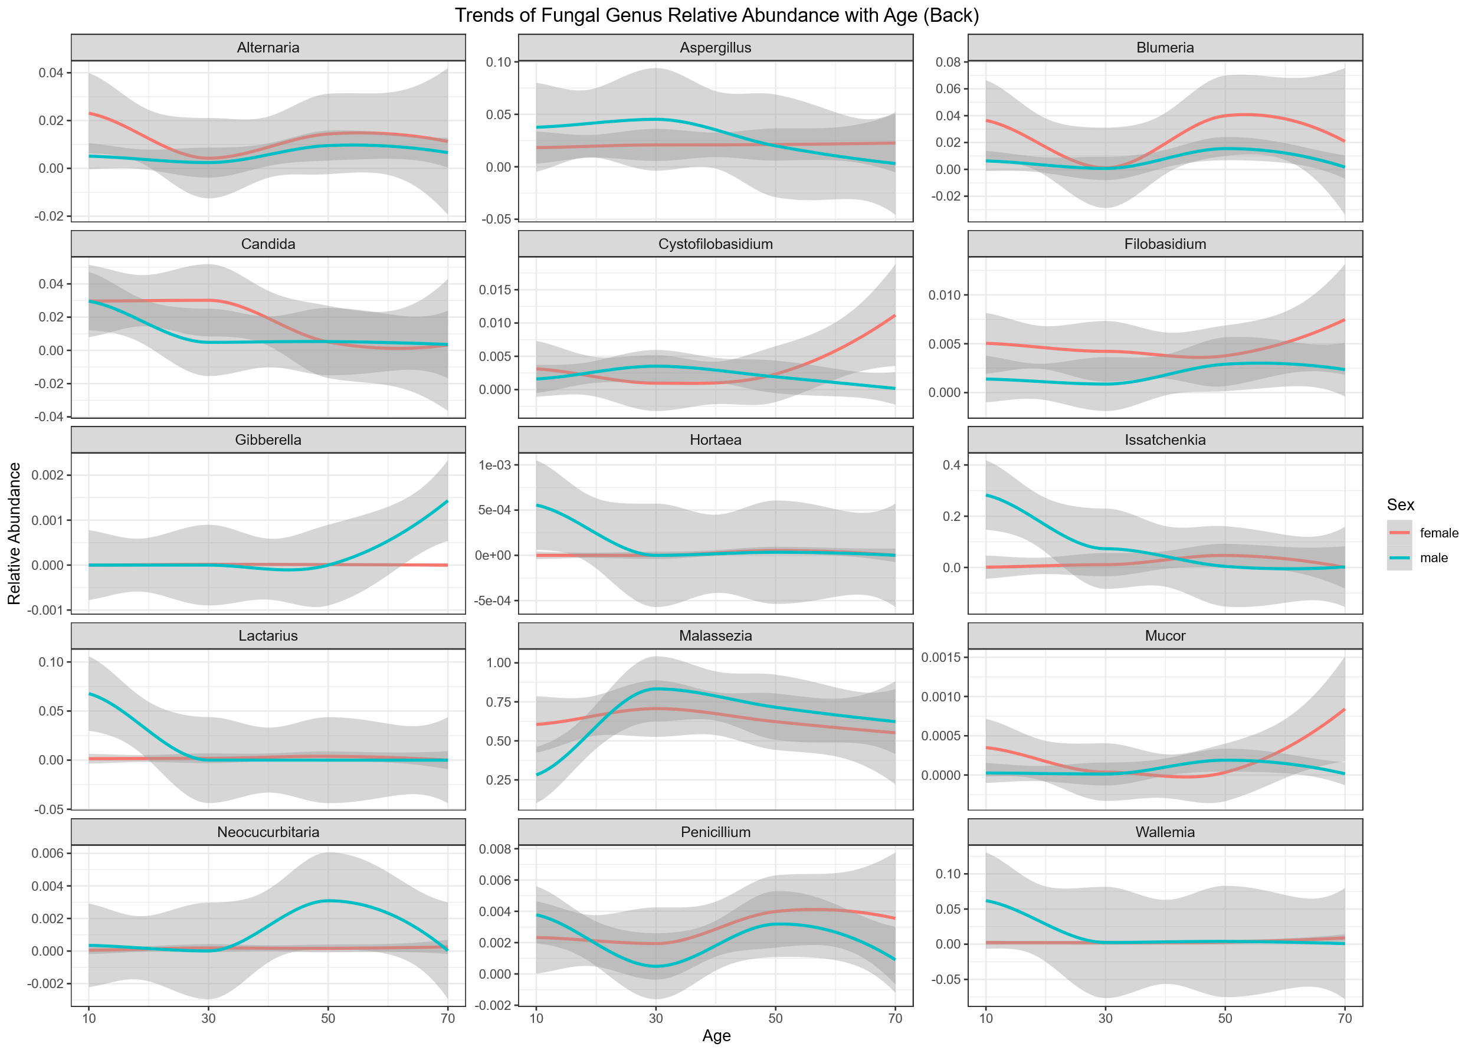
Supplementary Figure S2. Sex-stratified age-related changes in the top 15 fungal genera(Alternaria, Aspergillus, Blumeria, Candida, Cystofilobasidium, Filobasidium, Gibberella, Hortaea, Issatchenkia, Lactarius, Malassezia, Mucor, Neocucurbitaria, Penicillium and Wallemia) on the back.
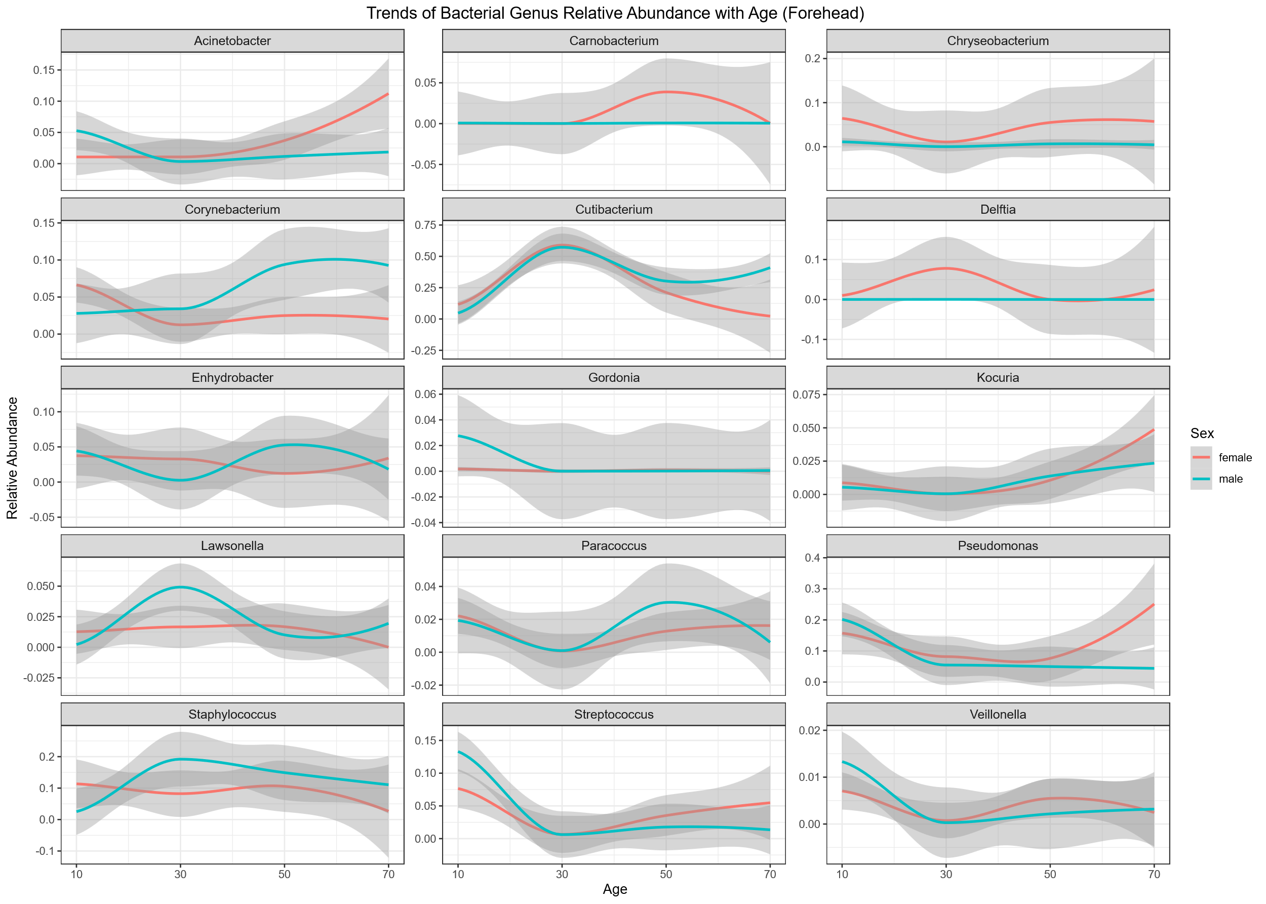
Supplementary Figure S3. Sex-stratified age-related changes in the top 15 bacterial genera(Acinetobacter, Carnobacterium, Chryseobacterium, Corynebacterium, Cutibacterium, Delftia, Enhydrobacter, Gordonia, Kocuria, Lawsonella, Paracoccus, Pseudomonas, Staphylococcus, Streptococcus and Veillonella) on the forehead.
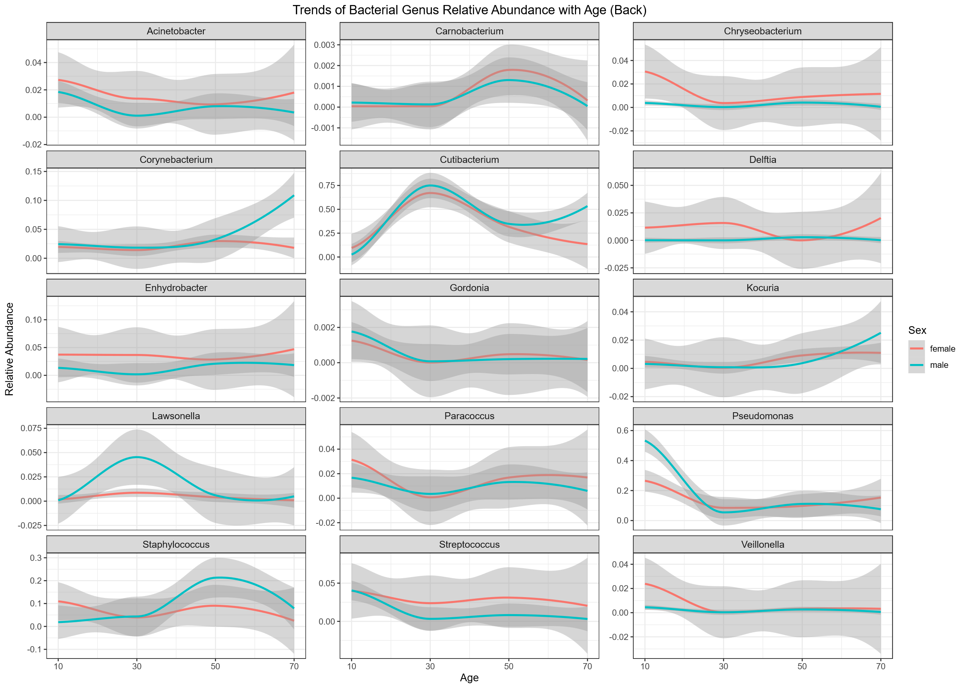
Supplementary Figure S4. Sex-stratified age-related changes in the top 15 bacterial genera(Acinetobacter, Carnobacterium, Chryseobacterium, Corynebacterium, Cutibacterium, Delftia, Enhydrobacter, Gordonia, Kocuria, Lawsonella, Paracoccus, Pseudomonas, Staphylococcus, Streptococcus and Veillonella) on the back.

