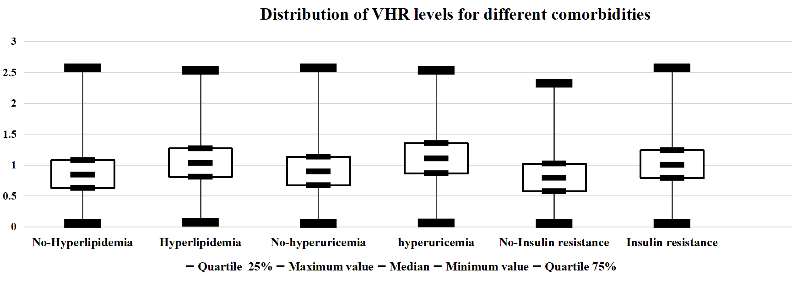
Supplementary Figure 2. Distribution of VHR levels for different comorbidities

