Appendix
Appendix A: Supplementary methods
Table A1. Dates and temperature fluctuations for experimental rounds.
Start – end dates of experimental rounds | Water temperature [ºC] mean±SD
16.05. - 25.05. 2023 | 10.3 ± 1.5
26.05. - 04.06. 2023 | 10.1 ± 2.3
06.06. - 15.06.2023 | 8.4 ± 0.6
16.06. - 25.06.2023 | 8.8 ± 0.8
27.06 - 06.07.2023 | 9.3 ± 0.6
18.07. - 27.07. 2023 | NA
28.07. - 06.08. 2023 | 10.9 ± 0.7
08.08. - 17.08.2023 | 11.9 ± 0.5
18.08. - 27.08.2023 | 12.2 ± 0.6

Table A2. Most common taxa of benthic macroinvertebrates used for inoculation of the flumes.
Taxa
Hydropsyche sp.
Sericostoma sp.
Micrasema minimum
Glossosoma sp./Agapetus sp.
Epeorus sp.
Ecdyonurus sp.
Baetis sp.
Rhithrogena sp.
Protonemura sp.
Amphinemura sp.
Habroleptoides sp.
Gammarus fossarum
Atherix ibis
Tabanus sp.
Tipulidae Gen. sp.
Ancylus fluviatilis

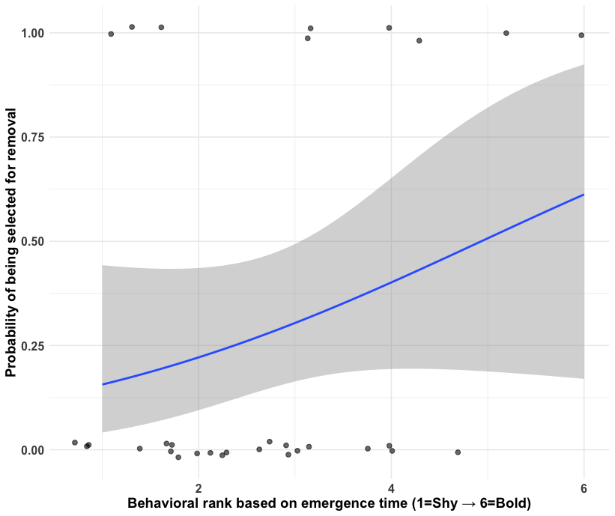
Figure A1. A generalized linear model was employed examining the relationship between behavioural rank (relative median emergence time within enclosure and round) and probability of being selected for removal on day 7 for brook trout. This revealed a positive but non-significant association (β = 0.428, p = 0.175, n = 31). The intercept was significantly negative (β = -2.113, p = 0.038), indicating that the shyest brook trout individuals (rank 1, with longest emergence time) had a low baseline removal probability, while the boldest individuals (rank 6, with shortest emergence times) have a substantially higher predicted removal probabilities based on the positive slope.
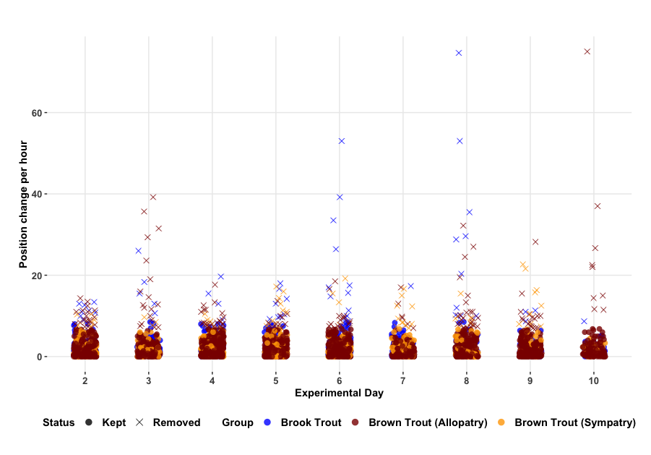
Figure A2. Plot displaying the kept and removed data points after extracting the interquartile range for the analysis of activity (average antenna switches per hours). Passive RFID antenna systems are especially prone to noise bursts and artifacts due to factors such as electromagnetic interference and between-reader interference. This is difficult to detect as it occurs as the data is collected passively but becomes obvious in certain instances when looking at the data. The IQR method resists this distortion.

