Supplementary information
A Fully Integrated Magnetofluidic System Enabled by a Wax Phase Barrier for Automated Multiplex Meat Adulteration Detection
Tianping Zhou^{a,b},Changding Li^{a,b}, Deyong Chen^{a,b,c}, Junbo Wang ^{a,b,c*} and Nan Li^{a*}
ª State Key Laboratory of Transducer Technology, Aerospace Information Research Institute, Chinese Academy of Sciences, Beijing 100190, China
^{b} School of Electronic, Electrical and Communication Engineering, University of Chinese Academy of Sciences, Beijing 100049, China
^{c} School of Future Technology, University of Chinese Academy of Sciences, Beijing 100049, China
* Co-Corresponding Author E-mail: linan2022@aircas.ac.cn, jbwang@mail.ie.ac.cn
Supplementary information contents:
Figure S1. Schematic and design details of the Magtect chip.
Figure S2. The results of temperature calibration of the Magtect system.
Figure S3. The results of the fluorescence calibration of the Magtect system.
Figure S4. Screenshots of the four interfaces of the companion mobile application.
Figure S5. Assembly process of the Magtect chip.
Figure S6. Ultrasonic field simulation settings and results for chips with varying chamber numbers and diameters.
Figure S7. Time-dependent bead resuspension results in chips with varying chamber numbers and diameters.
Figure S8. Magnetic field simulation results for magnet arrays of varying diameters.
Figure S9. Time-dependent magnetic bead aggregation in a six-chamber chip for magnet arrays of varying diameters.
Figure S10. Magnetic bead resuspension, aggregation, and transfer results for chips with varying chamber numbers and diameters.
Figure S11. Impact of elution method on amplification efficiency.
Figure S12. Workflow of the Magtect system.
Figure S13. Actual picture of the simulated adulterated sample.
Table S1. The sequence information of each PCR primer.
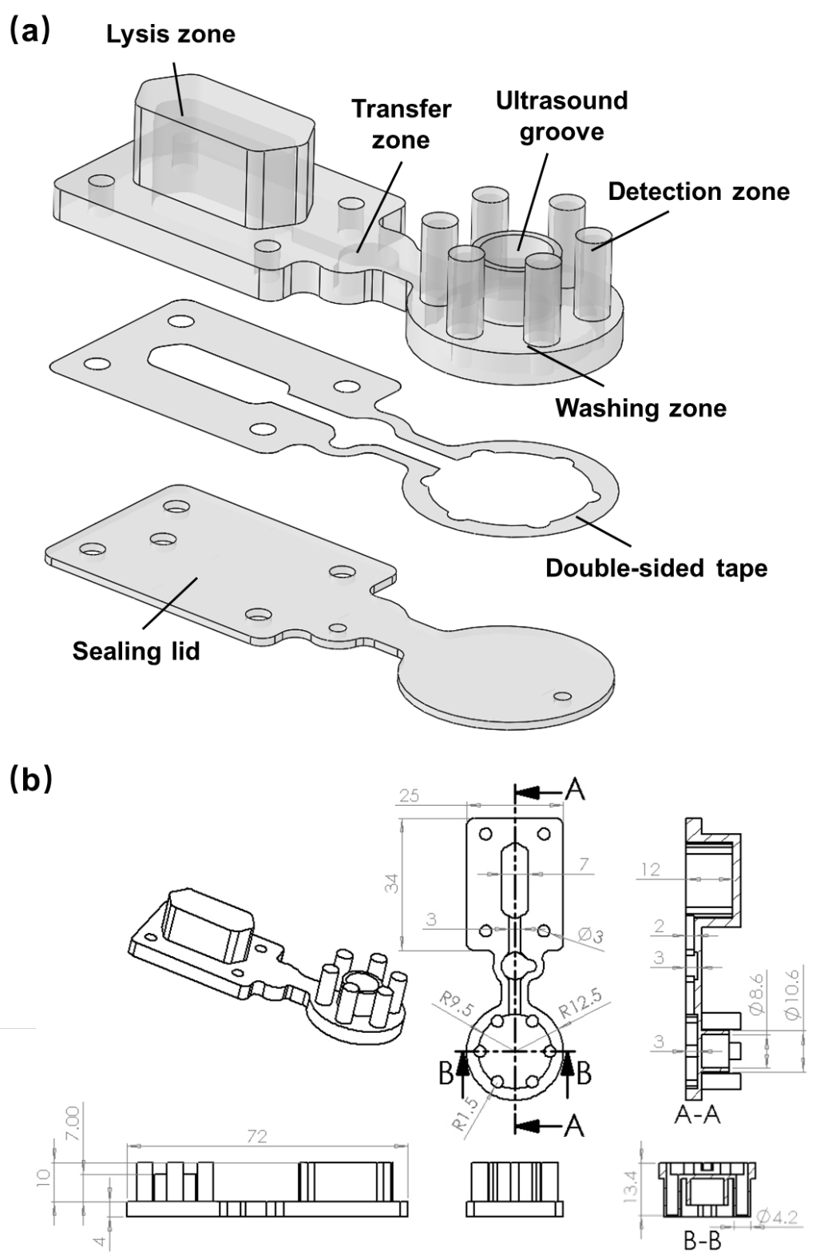
Figure S1. Schematic and design details of the Magtect chip. (a) Explosive structural view of the Magtect chip, illustrating the assembly of the main polycarbonate body and the sealing lid (PMMA). (b) Detailed dimensional layout and key design parameters of the chip, highlighting the functional zones (lysis, transfer, washing, and six detection chambers) and critical features such as the ultrasonic groove.
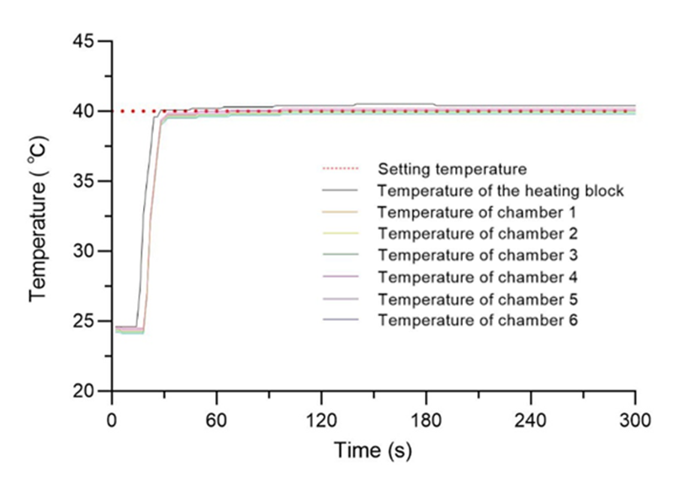
Figure S2. The results of temperature calibration of the Magtect system. A multiplex temperature recorder (MT-X16, Shenzhen Shenhua Electronics, Shenzhen, China) was used to evaluate performance of the heating module at room temperature (24℃). A thermocouple (T-type, Shenzhen Shenhua Electronics, Shenzhen, China) was embedded in each reaction chamber, which was filled with silicone grease (K-5211, Guangdong Hengda New Materials, Huizhou, China). The figure showed the setting temperature, the temperature of the heating block and six reaction chambers as functions of time during the heating process. It took less than 30 seconds for six chambers to reach the setting 40°C and the temperature fluctuations were less than 0.1°C, which could guarantee the success of RPA reaction.
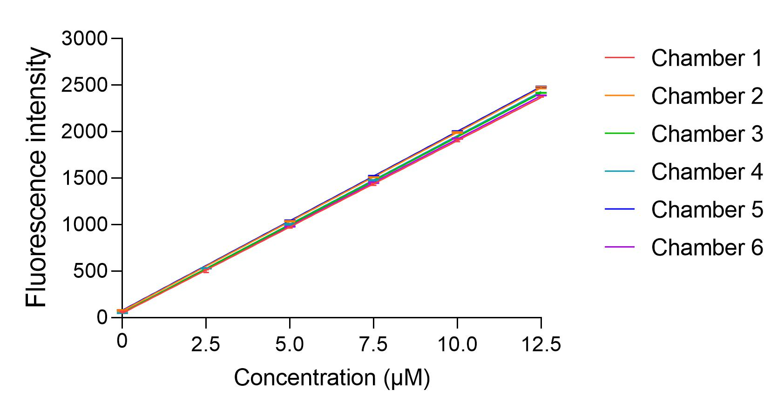
Figure S3. The results of the fluorescence calibration of the Magtect system. For characterization of the optical fibre detection module, a series of FAM calibration fluorescent probe solution (AKSDFT001, BiOligo, Shanghai, China) with varying concentrations (2.5, 5, 7.5, 10, and 12.5 μM) were prepared and pipetted into all six reaction chambers of the chip. The fluorescence signal intensity after nucleic acid amplification was generally lower than that of the 12.5 μM FAM calibration fluorescent probe solution. Signal intensity of each concentration was measured ten times. The figure showed the linear relationship between the measured fluorescence intensity and the concentration of FAM calibration fluorescent probe solution in the chambers. The error bars represented the variations of signal intensities over repeated measurements.
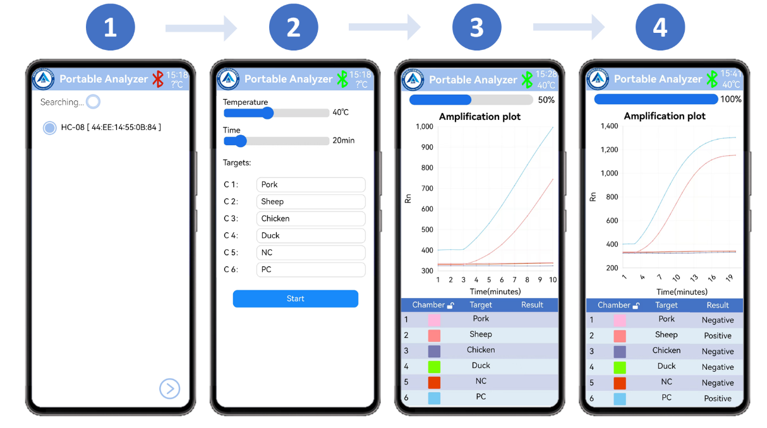
Figure S4. Screenshots of the four interfaces of the mobile application. (1) Connection interface: after finding the device, tap the next button to connect via Bluetooth. (2) Setup interface: users can set reaction parameters such as temperature, time and detection target label. Then tap the start button to launch the system. (3) Monitoring interface: the interface displays real-time amplification curves for the six reaction chambers during the RPA reaction. (4) Results interface: upon completion of the program, the results (negative or positive) are shown in the results field.
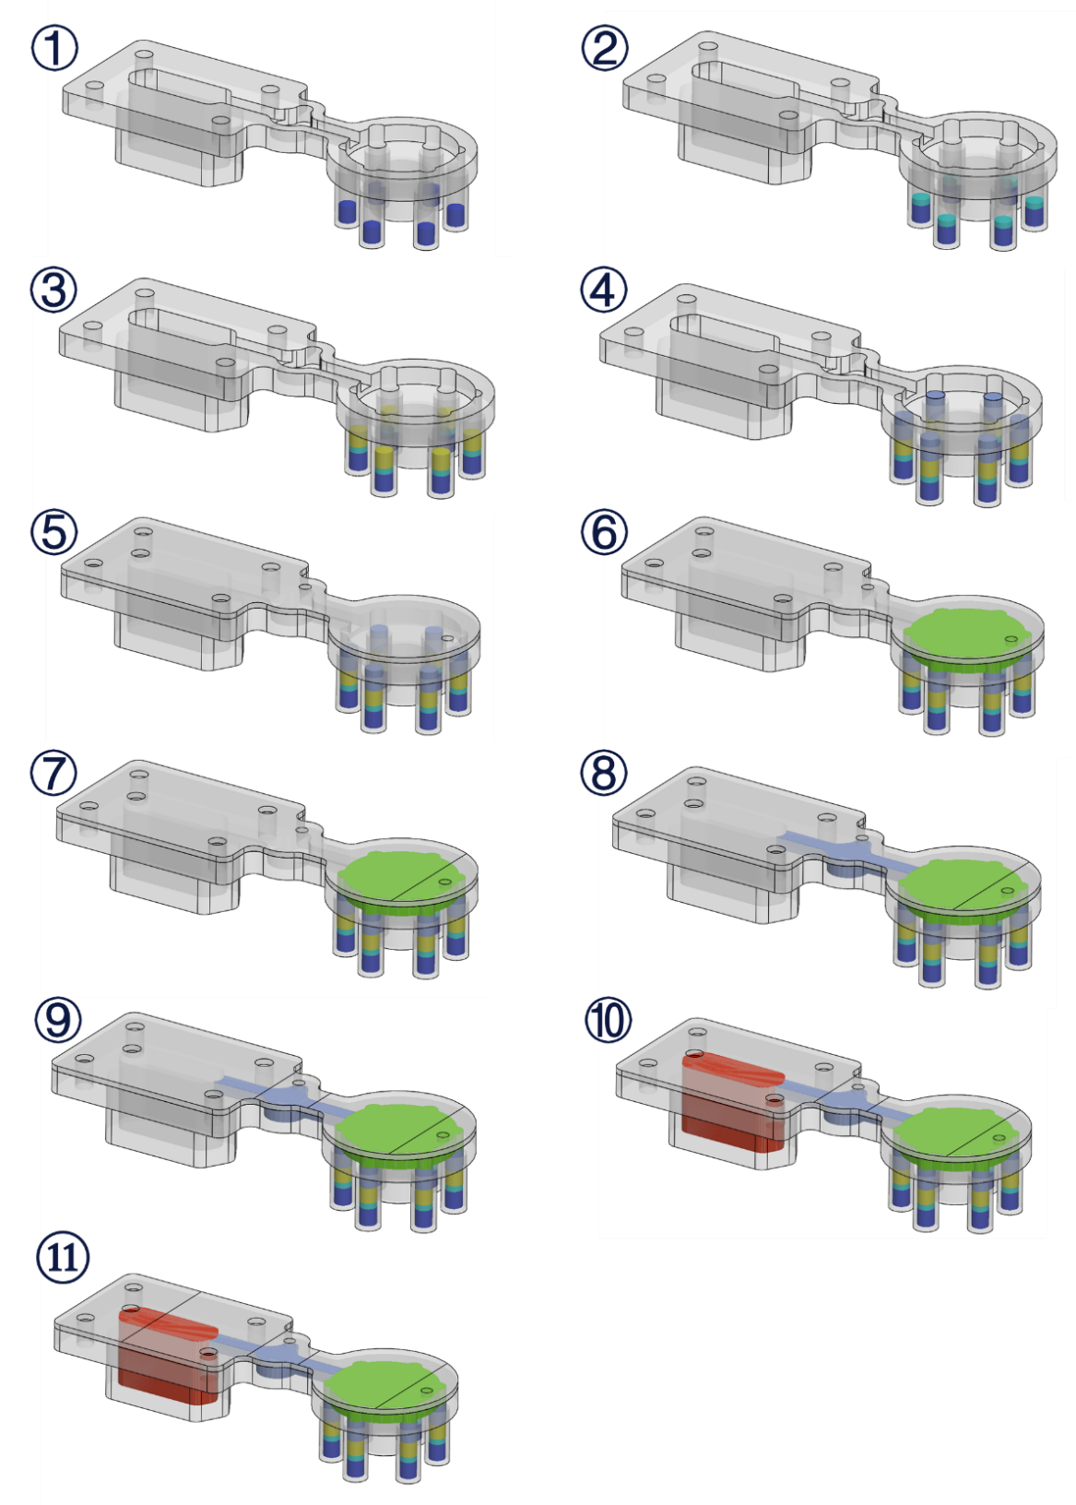
Figure S5. Assembly process of the Magtect chip. (1) Add the reaction mixture. (2) Add paraffin wax. (3) Add the elution buffer. (4) Add silicone oil. (5) Secure the cover plate. (6) Add the washing buffer. (7) Seal the sampling hole. (8) Inject silicone oil. (9) Seal the sampling hole. (10) Add the lysis buffer, magnetic beads and samples. (11) Seal the sampling hole.
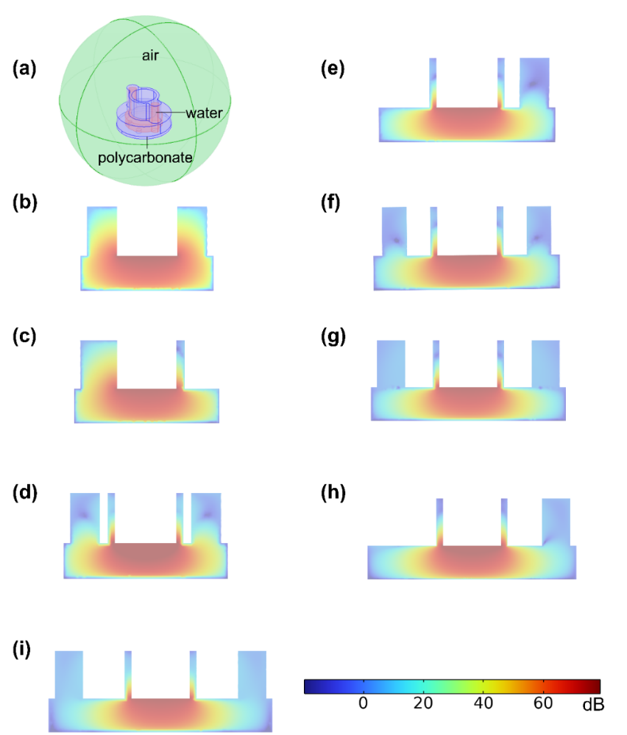
Figure S6. Ultrasonic field simulation settings and results for chips with varying chamber numbers and diameters. (a) Simulation settings: 3D simulation setup and generated acoustic field of the cassette model in COMSOL. The model is constructed with a polycarbonate cassette containing an internal water cavity and enclosed within an air domain. Using the Pressure Acoustics, Frequency Domain (acpr) interface coupled with Solid Mechanics via an Acoustic-Structure Boundary, a plane wave radiation condition with constant pressure amplitude is applied in the (0, 0, -1) direction, while the cassette structure is defined as a linear elastic material. The visualized result at 28 kHz shows a cross-sectional slice of the field restricted to the liquid cavity domain. Simulation results: (b) 13 mm and 2 chambers. (c) 15 mm and 3 chambers. (d) 17 mm and 4 chambers. (e) 19 mm and 5 chambers. (f) 21 mm and 6 chambers. (g) 23 mm and 8 chambers. (h) 25 mm and 9 chambers. (i) 27 mm and 10 chambers.
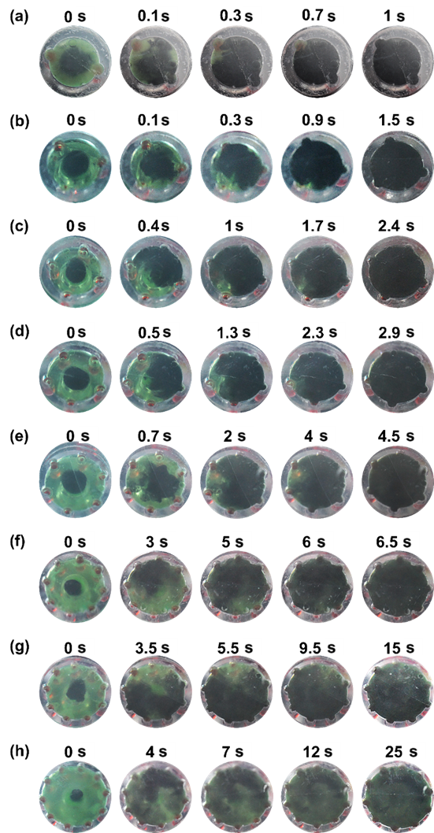
Figure S7. Time-dependent bead resuspension results in chips with varying chamber diameters and numbers. (a) 13 mm and 2 chambers. (b) 15 mm and 3 chambers. (c) 17 mm and 4 chambers. (d) 19 mm and 5 chambers. (e) 21 mm and 6 chambers. (f) 23 mm and 8 chambers. (g) 25 mm and 9 chambers. (h) 27 mm and 10 chambers.
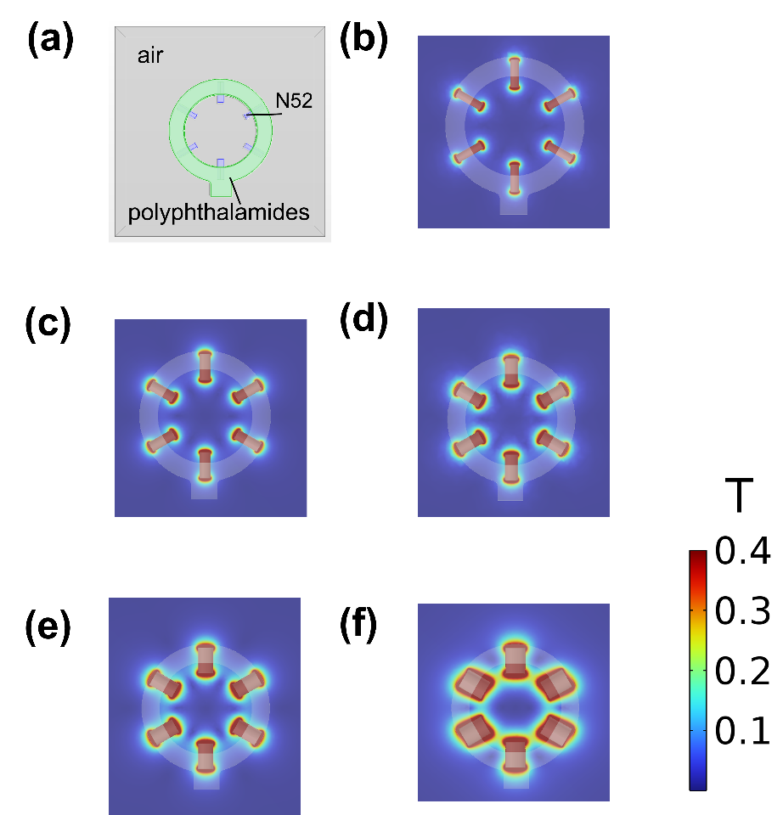
Figure S8. Magnetic field simulation results for magnet arrays of varying diameters. (a) 3D simulation setup and generated magnetic field of the annular magnetic array in COMSOL. The model is constructed with N52 grade magnets supported by a polymer structure and enclosed within an air domain. Using the Magnetic Fields, No Currents (mfnc) interface, the magnets are defined with recoil permeability and remanent flux density derived from material properties. The magnetization direction for each magnet segment is set according to the vector definition ($\cos\left(-\frac{π}{2}+n∙\frac{π}{3}\right), sin⁡(-\frac{π}{2}+n∙\frac{π}{3})$, 0), where n=0, 1, …, 5. The steady-state magnetic field distribution is visualized via a central cross-sectional slice, with the magnetic field magnitude color scale set to a maximum range of 0.4 T. Simulation results: (b) 3 mm. (c) 4 mm. (d) 5 mm. (e) 6 mm. (f) 8 mm.
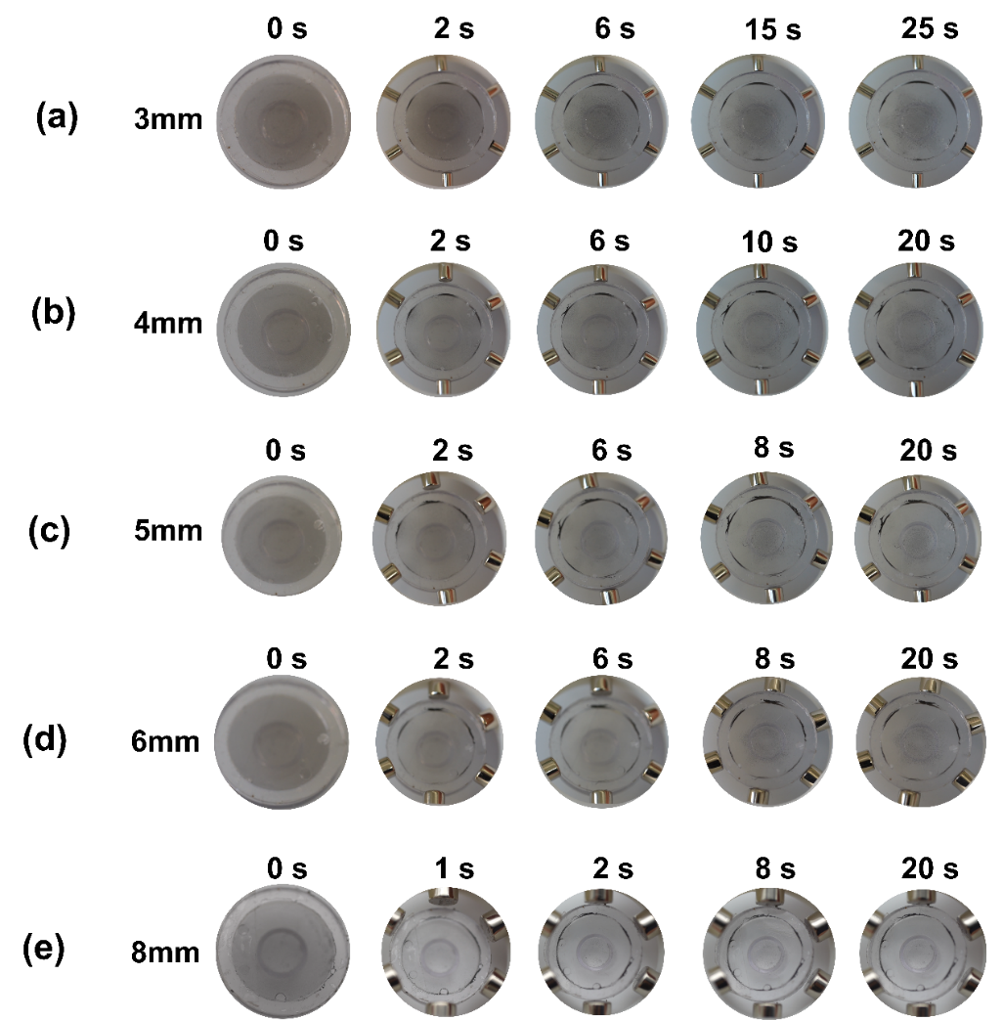
Figure S9. Time-dependent magnetic bead aggregation in a six-chamber chip using a magnetic array composed of magnets with varying diameters. (a) 3 mm. (b) 4 mm. (c) 5 mm. (d) 6 mm. (e) 8 mm.
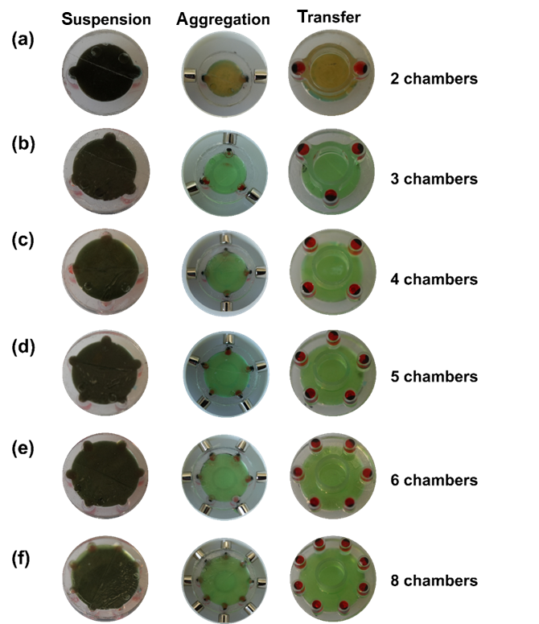
Figure S10. Magnetic bead resuspension, aggregation, and transfer results for chips with varying chamber diameters and numbers. (a) 13 mm and 2 chambers. (b) 15 mm and 3 chambers. (c) 17 mm and 4 chambers. (d) 19 mm and 5 chambers. (e) 21 mm and 6 chambers. (f) 23 mm and 8 chambers.
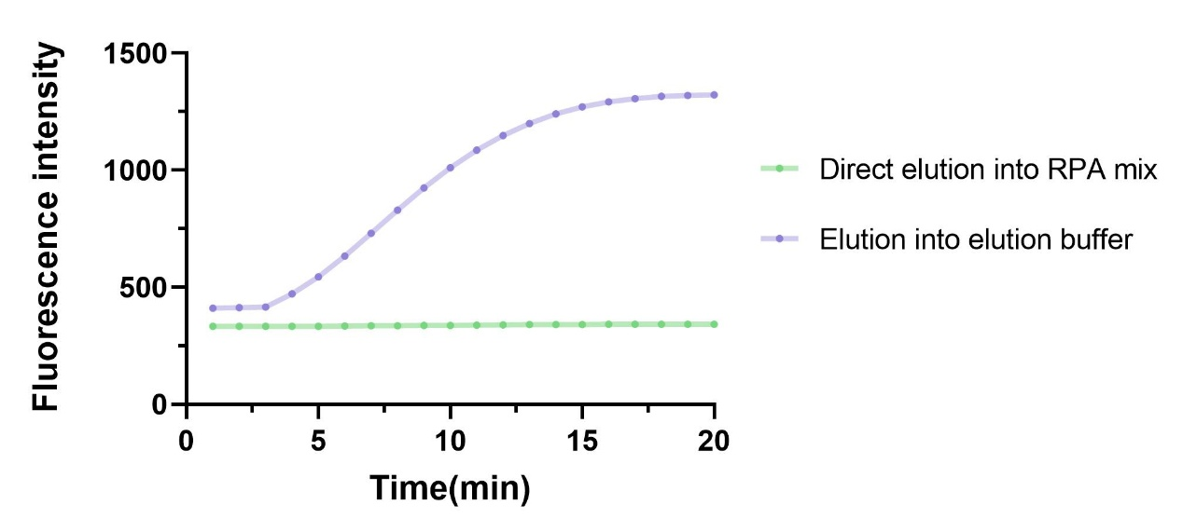
Figure S11. Impact of elution method on amplification efficiency. Comparison of real-time amplification performance using two different elution approaches for nucleic acids bound to magnetic beads: Elution into an elution buffer resulted in successful amplification, whereas direct elution into the RPA mix led to complete amplification failure. This direct comparison demonstrates that the inclusion of a separate elution step is critical to achieve detectable amplification in the Magtect system.
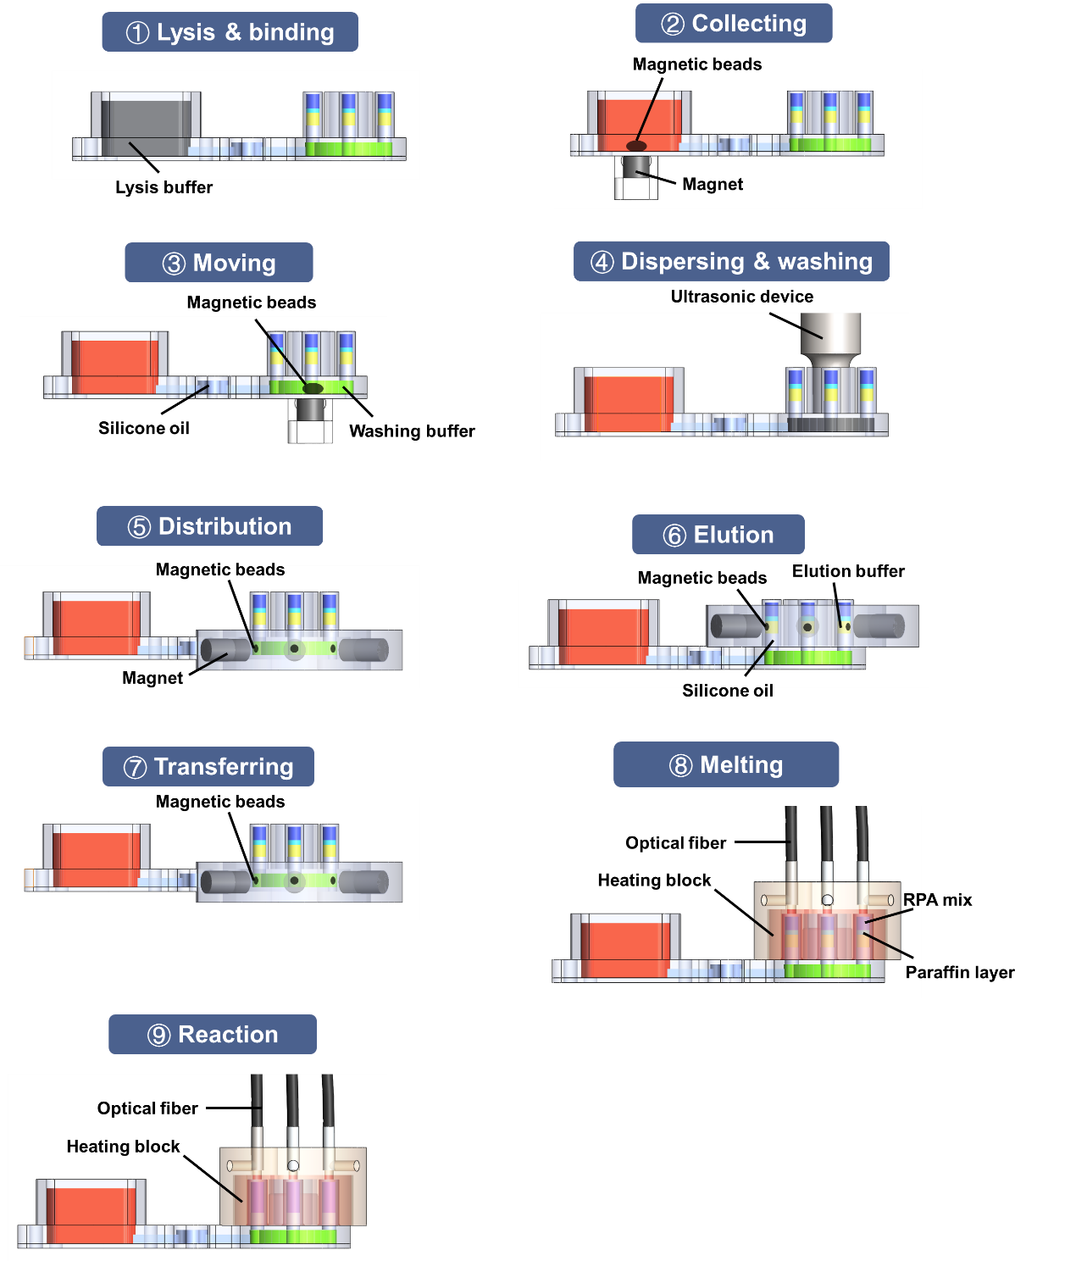
Figure S12. Workflow of the Magtect system. Schematic illustration of the automated “sample-to-answer” process, detailing nine sequential steps: (1) Lysis & binding: Samples are lysed within the lfysis zone, releasing nucleic acids that bind to magnetic beads. (2) Collecting: Beads are captured against the base of the lysis zone by a fixed magnet. (3) Moving: The chip is translated horizontally, transferring the bead aggregate through the transfer zone into the washing zone. (4) Dispersing & washing: An ultrasonic transducer disperses and thoroughly washes the beads in the washing buffer. (5) Distribution: An annular magnet array partitions the dispersed beads into six distinct clusters. (6) Elution: Each bead cluster is lowered into its designated elution buffer within a detection compartment. (7) Transferring: After elution, the beads are magnetically withdrawn from the detection compartments. (8) Melting: The chip is heated, melting the paraffin wax barrier that initially separates the elution buffer from the RPA reagents. (9) Reaction: The eluted nucleic acids mix with the RPA reagents, initiating isothermal amplification, with real-time fluorescence signals acquired from all six detection compartments.
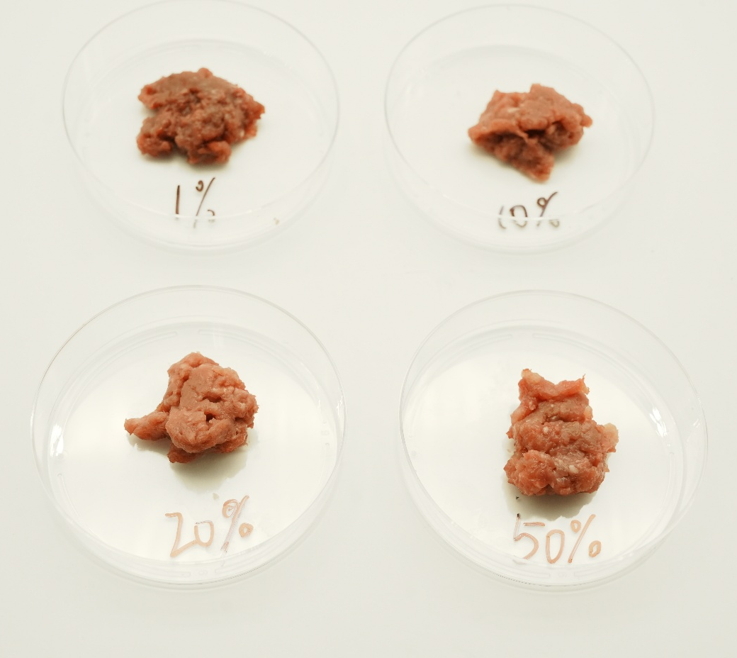
Figure S13. Actual picture of the simulated adulterated sample.
Table S1. The sequence information of each PCR primer.
Species | Name | Sequence (5′→3′)
Pork  Sheep  Chicken | F | ACCCAGACGAACTGCTCAA
Pork  Sheep  Chicken | R | TGGCGTCACTGATAGGTAAAT
Pork  Sheep  Chicken | P | FAM- TCACAGGCGTGGGCTTTCTGC -BHQ1
Pork  Sheep  Chicken | F | CTGACACACGGGACACMTCTCC
Pork  Sheep  Chicken | R | AAGCTAAACATGGACCCACAT
Pork  Sheep  Chicken | P | FAM- TAAGCCAGCCTTGTGCGTGTGGTCCC -BHQ1
Pork  Sheep  Chicken | F | GGCTGCAAGTCACCGTGGTA
Pork  Sheep  Chicken | R | CCGCTAGCCAGAAGCTCAGC
Pork  Sheep  Chicken | P | FAM- CAGGAGCCACGTGAGCAGCACAG -BHQ1
 | F | GGAGCACCTCTATCAGAGAAAGACA
Duck | R | GTGTGTAGAGCTCAAGATCAATCCC
 | P | FAM- TGGGAACAAGCATGAATGTAAGTGGATGGT -BHQ1

