Supplementary material

Generating acetylene gas

Acetylene gas (1 L) and acetylene-enriched seawater (1 L) were freshly generated for use in the assays the day prior. In brief, 12.5 g of calcium carbide (CaC₂) was reacted with 100 ml of MilliQ water in an Erlenmeyer flask sealed with a rubber stopper. The acetylene gas generated from the reaction, passed via silicone tubing into the first Duran gas washing bottle filled with 1 L of MilliQ water, and then subsequently passed into the second 1 L Duran gas washing bottle filled with 1 L of seawater. Remaining gas then passed via silicone tubing into a gas collection bag (Tedlar 1 L sampling bags with polypropylene valve, RESTEK). The 1 L of acetylene-enriched seawater and 1 L of acetylene gas were used to set up the acetylene assays.

Microsensor technical details

It consisted of a Clark-type microelectrode with a tip size of 50 µm (N₂O-NP-804195, Unisense A/S, Aarhus, Denmark) connected to a high-sensitivity picoampermeter (PA 2000, Unisense A/S, Aarhus, Denmark). A voltage of - 0.8 V was applied between the cathode and the internal reference anode, whilst N₂O was driven by the external partial pressure to pass through the sensor membrane at the tip (silicone membrane), then it was reduced at the metal cathode surface, while the picoampermeter converted the resulting current to a signal representing the N₂O concentration. Prior to any measurement, the sensor was pre-activated by applying a voltage of -1.3 V for 30 minutes and pre-polarized at -0.8 V for 12 hours until the signal became stable. The sensor was equipped with a front guard made of an ascorbate solution to scavenge incoming O₂ that may interfere with the measuring cathode.

Using the microsensor and handling the data

To minimise the signal to noise ratio, the N₂O microsensor was fixed in a stable and stationary position using a clamp. The septa of the gas vials were individually pierced by the microsensor, and once no drift in the sensor signal was observed, 5 replicate readings were recorded in mV and were automatically converted into μmol/L using the calibration curve. Between each sample, the microsensor tip was rinsed with MiliQ water and dried off (Kimwipes, Kimtech Science). Following this, there was a waiting period of variable length (~ 5 – 15 min) while the signal re-stabilised and showed no drift, before the next sample was measured. Gas measurements were subsequently normalised to account for the solubility of N₂O in the MilliQ water of the storage vial and seawater of the beaker, and additionally the volume of the beaker (step by step equations 3-8). Following this, T0 values were subtracted from T12 values to obtain values of N₂O per 12 h. Values were then divided by 12 to be expressed per hour. Following this, the average of five controls were subtracted, to account for background N2O production potentially from microorganisms in the water. As a next step, values were normalised to surface area (cm⁻²), which was determined by wax dipping the skeleton of the fragment, post-incubation. Values were then converted to N, by multiplying by two and converted to nanomoles. Therefore, denitrification rates were expressed as nmol N cm⁻² h⁻¹.

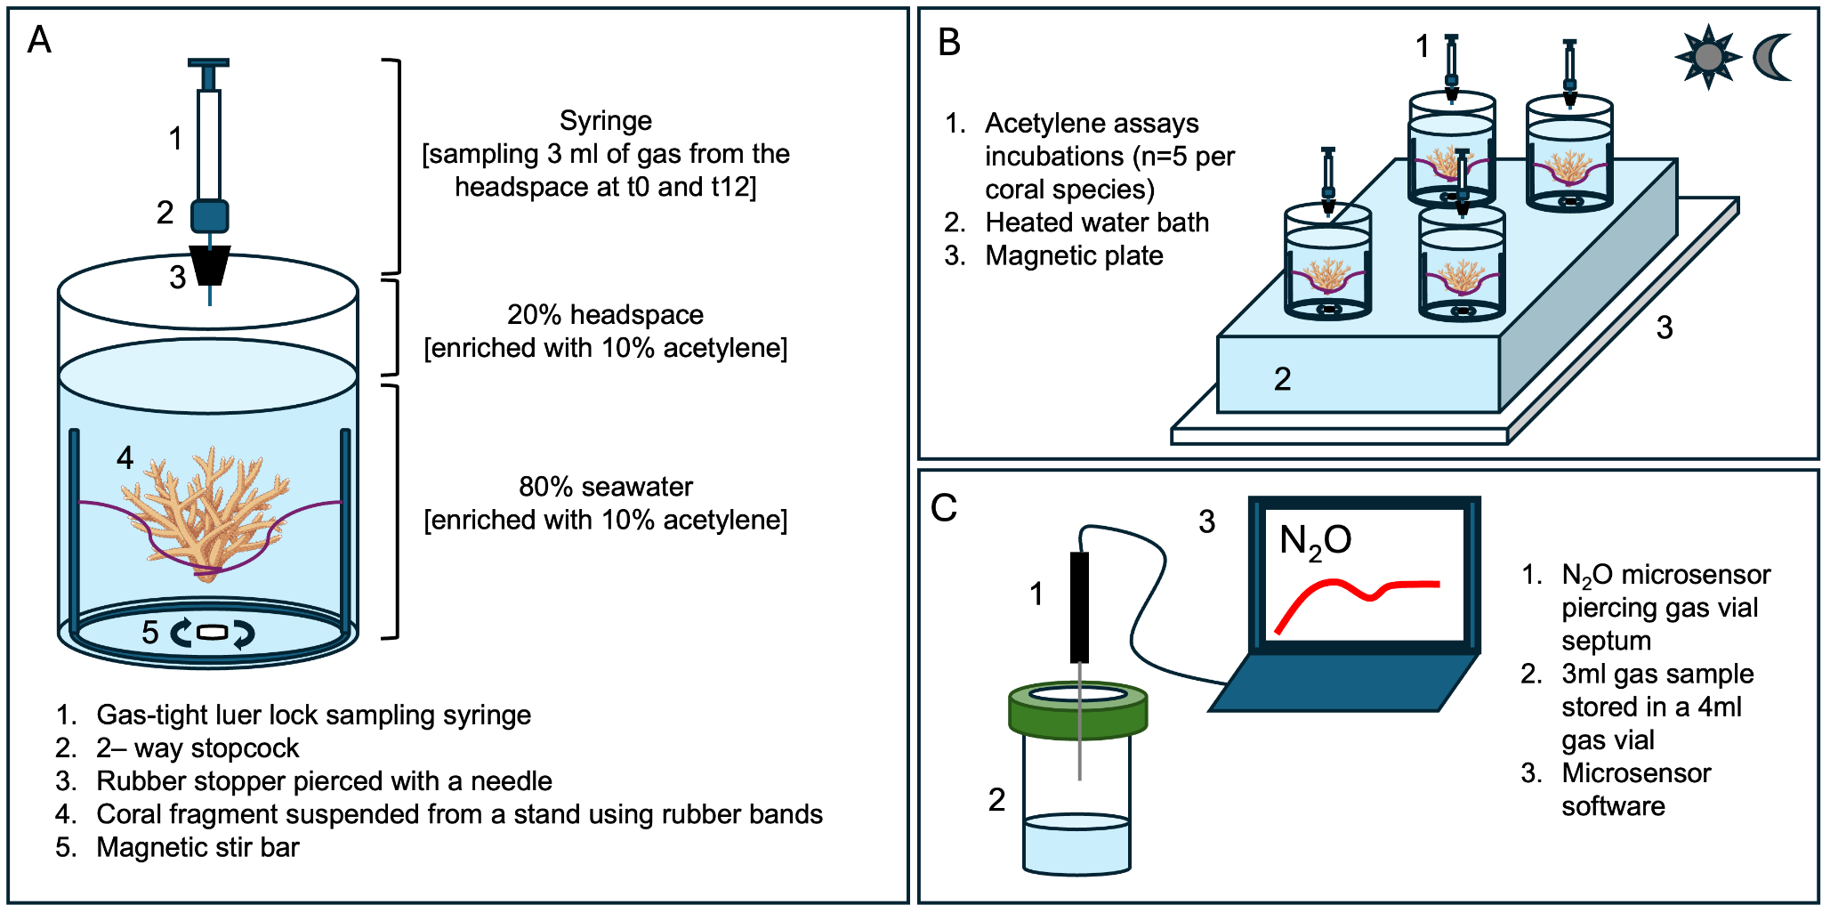
Figure S1 Overview of the quantification of denitrification. A] The acetylene assay setup per coral fragment. Assays were set up in the same manner for controls, just excluding the coral fragment. B] The acetylene assay incubations, performed for 12 hours in the light and 12 hours in the dark. C] Use of a microsensor to measure nitrous oxide (N₂O) of the gas samples generated from the acetylene assay.

Step by step N₂O normalisation equations

[S^{HS(M)}] Moles of N₂O in the storage vial headspace (μmol):

$$MV*S^{HS\left(V\right)}=S^{HS(M)}$$

[S^{W(M)}] Moles of N₂O in the storage vial water: (μmol):

$$MV*BC*S^{W\left(V\right)}=S^{W(M)}$$

[B^{HS(C)}] Concentration of N₂O in the beaker headspace: (μmol L⁻¹):

$$\frac{S^{HS(M)}+ S^{W(M)}}{S^{HS(V)}}=B^{HS(C)}$$

[B^{HS(M)}] Moles of N₂O in the beaker headspace (μmol):

$$B^{HS(C)}*B^{HS \left(V\right)}=B^{HS(M)}$$

[B^{W(M)}] Moles of N₂O in the beaker water (μmol):

$$B^{HS(C)}*BC* B^{W \left(V\right)}= B^{W(M)}$$

[B^{T(M)}] Total moles of N₂O in the whole beaker (μmol):

$$B^{HS(M)}+ B^{W(M)}$$

Abbreviations used in above equations:

[MV] Microsensor value (μmol L⁻¹)
[S^{HS(V)}] Storage vial headspace volume (L)
[S^{HS(M)}] Storage vial headspace moles (μmol)
[BC] Bunsen solubility coefficient*

*The Bunsen solubility coefficient used varied according to the temperature and salinity. These conditions differed between the storage vial (room temperature of 21°C / salinity of 0) and the beaker (variable temperature dependent on the sampling month and salinity of 39). The coefficient can be determined using a table in ⁹⁶.

[S^{W(V)}] Storage vial water volume (L)
[S^{W(M)}] Storage vial water moles (μmol)
[B^{HS(C)}] Beaker headspace concentration (μmol L⁻¹)
[B^{HS(V)}] Beaker headspace volume (L)
[B^{HS(M)}] Beaker headspace moles (μmol)
[B^{W(V)}] Beaker water volume (L)
[B^{W(M)}] Beaker water moles (μmol)
[B^{T(M)}] Beaker total moles (μmol)

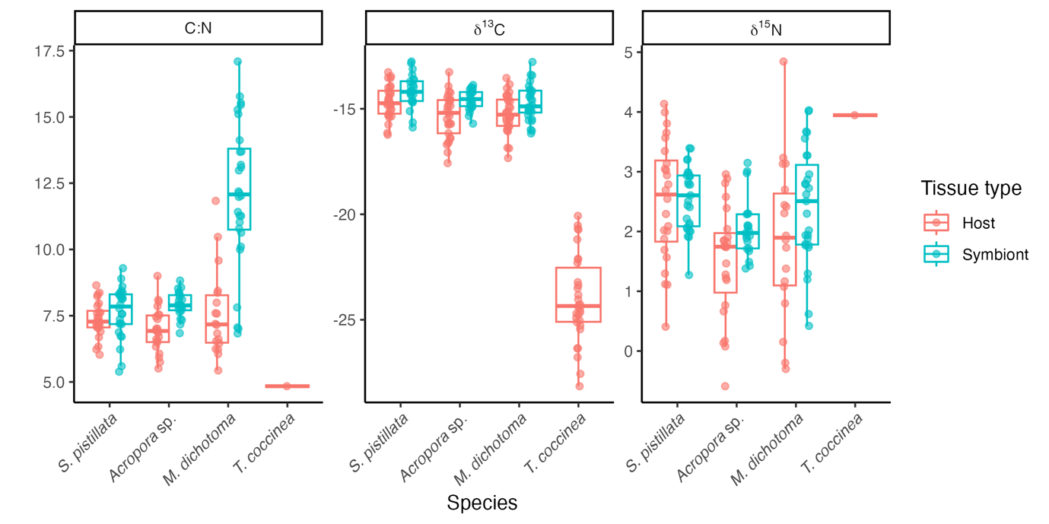

Figure S2 Biogeochemical signatures of each coral Stylophora pistillata, Acropora sp., Millepora dichotoma and Tubastrea coccinea over the sampling year (April 2022 – February 2023), including elemental C:N, δ¹³C and δ¹⁵N split by the host (pink) and symbiont (blue) fractions. For Tubastrea coccinea, the symbiont fraction is not shown as this coral is azooxanthellate.
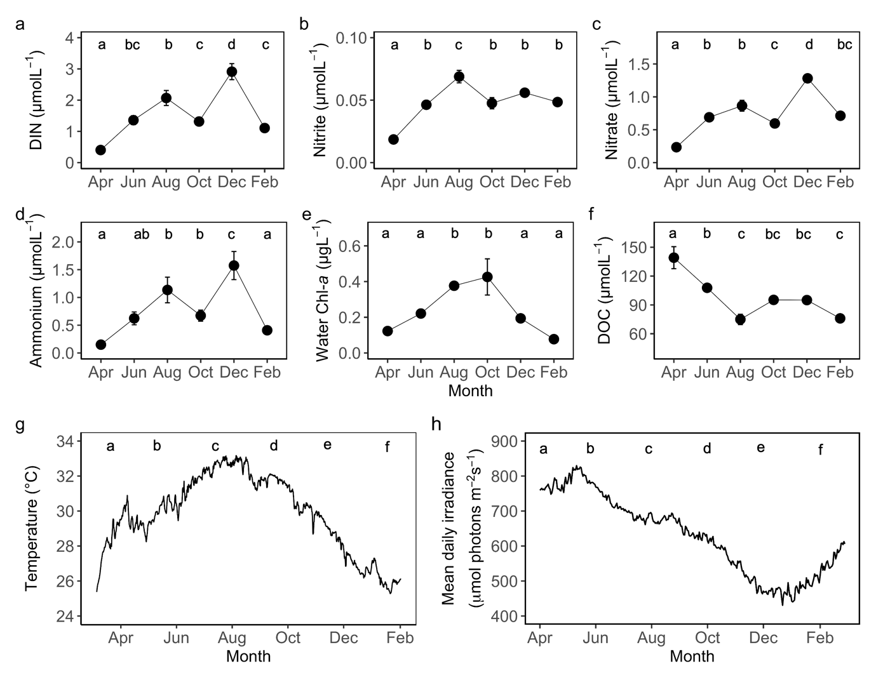
Figure S3 In situ environmental parameters monitored throughout the sampling year from April 2022 to February 2023, including average values ± standard error of a) dissolved inorganic nitrogen (DIN), b) nitrite, c) nitrate, d) ammonium e) water chlorophyll a, f) dissolved organic carbon (DOC) and a smooth averaged of g ) temperature and h) light. Letters are used to denote statistical significance, with the same letter indicating no significant difference and different letters indicating a significant difference.

