Supplementary Materials for

Metastable CeZrO₄ polymorph for high-sensitivity nitrogen dioxide detection

Xichao Mo et al.

Corresponding author: Minghui Yang, myang@dlut.edu.cn

This document includes:

Supplementary Text
Figs. S1 to S38
Tables S1 to S18
References (1 to 36)

Table of Contents

Section 1. Materials and Methods ............................................................................................. S3
Section 2. Morphology and Structural Characterization........................................................ S5
Section 3. Gas Sensing Properties ............................................................................................. S22
Section 4. Comparison of NO₂ Sensing Materials and Gas Sensors for Various Fields....... S25
Section 5. Spectroscopic Characterization .............................................................................. S30
Section 6. DFT Calculation........................................................................................................ S31
Section 7. Wireless NO₂ Sensing and Detection System…………………………….............. S32
Section 8. ML-Assisted Processing of Exhaust Signals .......................................................... S36
Section 9. Supplementary References ...................................................................................... S42
Section 1. Materials and Methods
Materials
Ce(NO₃)₃·6H₂O (99.99%), Zr(NO₃)₄·5H₂O (99.99%), and anhydrous citric acid were purchased from Aladdin Industrial Corporation. XC-72R carbon black, Nafion and Nafion N115 membrane were purchased from CABOT, U.S.A. Ethylene glycol (C₂H₆O₂, AR, ≥ 99.0%) and isopropanol (C₃H₈O, AR) were purchased from Tianjin Fuyu Fine Chemical Co., Ltd. H₂SO₄ was purchased from Sinochem Reagent Co., Ltd. All reagents were used as received without further purification. Ultrapure water (18.2 MΩ·cm) from a Milli-Q system was used in all aqueous preparations.
Electrochemical sensor testing
Gas detection tests were carried out using a static chamber method. A defined volume of standard NO₂ gas was injected into a 250 mL gas collection cylinder using a precision gas-tight syringe to obtain the desired concentration. For instance, to prepare a 10 ppm NO₂ mixture, 12.5 mL of 200 ppm NO₂ standard gas was injected into the sealed 250 mL chamber and allowed to equilibrate for 3 min before measurement. The same approach was employed to generate NO₂, NO, CH₃OH, H₂S, C₂H₅OH, CO, NH₃, and CH₃COCH₃ atmospheres for selectivity analysis.
The calibration formula for gas concentration is detailed below
All analytes were introduced from commercially certified standard gas mixtures supplied by Dalian Kerui Gas Co., Ltd. (China), each with a nominal concentration of 200 ppm (balance N₂). The analytes tested included hydrogen sulfide (H₂S), ammonia (NH₃), methanol (CH₄O), ethanol (C₂H₆O), nitric oxide (NO), acetone (C₃H₆O) and nitrogen dioxide (NO₂).
Target concentrations were prepared using a static injection method with constant-volume replacement in a 250 mL gas-mixing bottle. Specifically, a defined volume $V_{inj}$of the standard mixture was injected while an equal volume of gas was simultaneously vented, keeping the total chamber volume constant; thus, the target concentration was calculated by
$$C_{target}=C_{std}×\frac{V_{inj}}{V_{ch}}$$
where$C_{target}$ (ppm) is the target analyte concentration in the mixing bottle, $C_{std}$ (ppm) is the certified concentration of the standard gas mixture (200 ppm), $V_{inj}$ (mL) is the injected volume of the standard mixture, and $V_{ch}$ (mL) is the bottle volume (250 mL). During preparation, an equal volume of gas was vented while injecting $V_{inj}$, so that $V_{ch}$ remains constant and the above relation is valid. Air was used as the background gas during sensing measurements.
Tests were performed under laboratory conditions (22±2 °C, 45±3% RH) using a multichannel potentiostat (CHI1030C, Shanghai Chenhua Instrument Co., Ltd.) in “i-t” mode. Long-term stability tests were conducted at room temperature (22±2 °C). We maintained the laboratory at room temperature before performing stability and other tests. We define the response current ΔI as the difference between the current values before and after exposure to the target gas: ΔI = I₂ - I₁, where I₁ is the current value before contact with the gas and I₂ is the current value after contact with the gas. The 90% value of ΔI was used to characterize the response and recovery times for adsorption and desorption. The slope obtained from a linear fit of ΔI and concentration indicated the sensitivity of the sensor. The saturated solutions of LiCl, MgCl₂, Mg(NO₃)₂, NaCl, KCl, and KNO₃ resulted in relative humidity (RH) of 11%, 33%, 54%, 75%, 85%, and 95%, respectively.

Section 2. Morphology and Structural Characterization

X-ray diffraction (XRD) analysis revealed a systematic evolution in crystallographic structure with increasing quenching temperature. The magnified view shows that the peak near 42° first intensifies and then weakens with increasing quenching temperature, indicating a change in the phase composition.
As shown in the magnified view of Figure S11, characteristic peaks of the tetragonal phase are clearly observed around 41.8° and 41.9°. The peak intensity is highest at 600 °C, indicating the maximum tetragonal phase content at this temperature, which further validates the refinement results obtained from XRD and NPD analyses. These results support the interpretation that the metastable tetragonal phase is maximally stabilized at this temperature. The temperature-dependent phase transition underscores the critical role of kinetic arrest via rapid quenching in accessing and preserving nonequilibrium phase configurations.
High-resolution XPS analysis of the Ce 3d region revealed characteristic peaks of both Ce³⁺ and Ce⁴⁺ oxidation states, with the Ce³⁺ related features centered at 885.4 and 903.9 eV. Notably, CeZrO₄-600 exhibited a distinct shift of the Ce³⁺ peak toward lower binding energy, suggesting a modified electronic environment associated with increased oxygen vacancy concentration¹. This is attributed to the formation of oxygen vacancies, which reduce neighboring Ce⁴⁺ ions to Ce³⁺ to maintain charge neutrality². Oxygen vacancies can significantly influence the catalytic and electrical properties of materials³. The peaks at 529.3 eV (O_{L}), 530.1 eV (O_{V}), and 531.7 eV (O_{C}) correspond to lattice oxygen, oxygen-deficient regions, and chemisorbed oxygen species, respectively⁴.
Nitrogen adsorption-desorption isotherms (Figure S15) showed minimal variation in BET surface area across all samples, indicating that the performance enhancement conferred by the quenching strategy arises not from increased surface area, but rather from the stabilization of metastable phases and associated lattice strain.

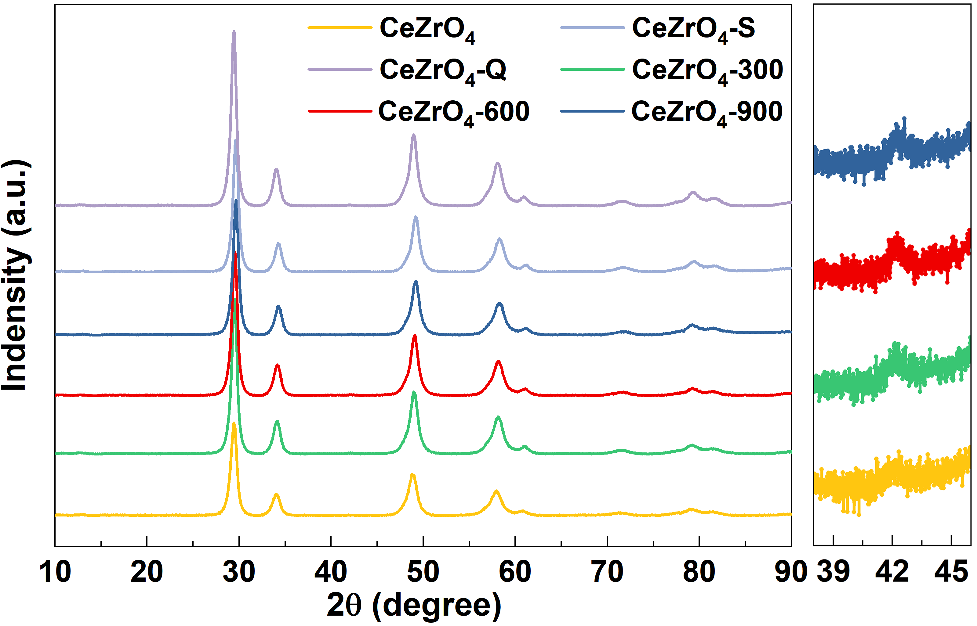
Figure S1. X-ray diffraction patterns of CeZrO₄, CeZrO₄-S, CeZrO₄-Q, CeZrO₄-300, CeZrO₄-600, and CeZrO₄-900. The magnified view is shown on the right.

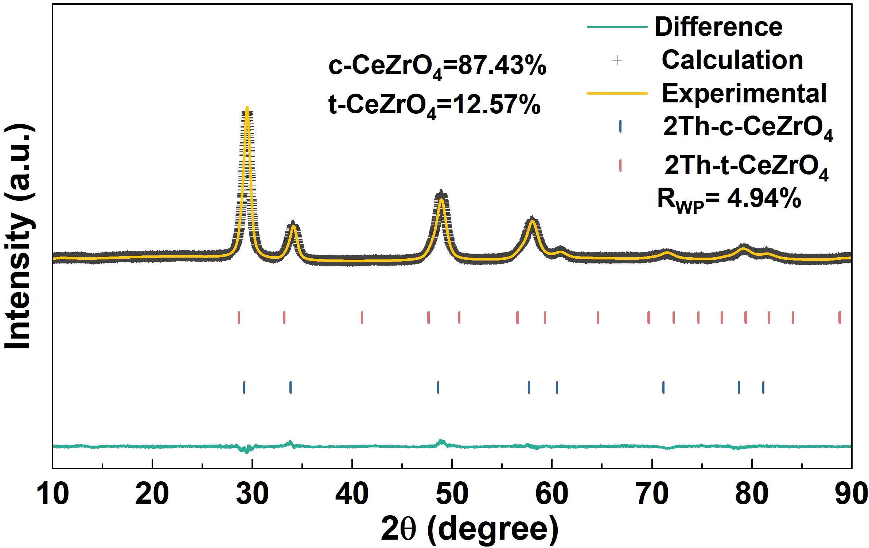
Figure S2. The Rietveld fitted powder X-ray diffraction pattern of CeZrO₄.

Table S1
XRD Refined Structural Parameters of c-CeZrO₄
Atom | Site | x, y, z | Beq (Å²) | Occupancy
Ce  Zr  O | 4a  4a  8c | 0, 0, 0  0, 0, 0  0.25, 0.25, 0.25 | 2.1(1)  2.1(1)  1.1(1) | 0.5  0.5  1
a = b = c = 5.2922(1) Å

Table S2
XRD Refined Structural Parameters of t-CeZrO₄
Atom | Site | x, y, z | Beq (Å²) | Occupancy
Ce  Zr  O | 4a  4a  8c | 0, 0, 0  0, 0, 0  0, 0.5, 0.150(5) | 0.5(1)  0.5(1)  1.7(8) | 0.5  0.5  1
a = b = 3.8190(1) Å c = 5.3660(5) Å

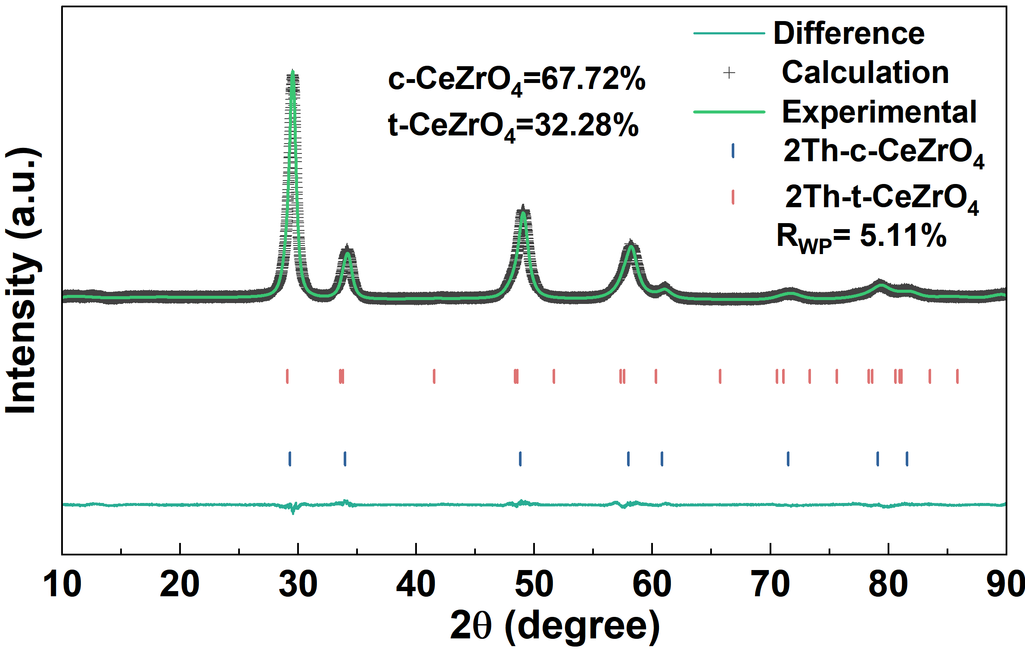
Figure S3. The Rietveld fitted powder X-ray diffraction pattern of CeZrO₄-300.

Table S3
XRD Refined Structural Parameters of c-CeZrO₄ of CeZrO₄-300
Atom | Site | x, y, z | Beq (Å²) | Occupancy
Ce  Zr  O | 4a  4a  8c | 0, 0, 0  0, 0, 0  0.25, 0.25, 0.25 | 2.2(1)  2.2(1)  2.3(2) | 0.5  0.5  1
a = b = c = 5.2728(7) Å

Table S4
XRD Refined Structural Parameters of t-CeZrO₄ of CeZrO₄-300
Atom | Site | x, y, z | Beq (Å²) | Occupancy
Ce  Zr  O | 2a  2a  4d | 0, 0, 0  0, 0, 0  0, 0.5, 0.209(2) | 0.4(1)  0.4(1)  0.5(3) | 0.5  0.5  1
a = b = 3.7466(1) Å c = 5.3353(1) Å

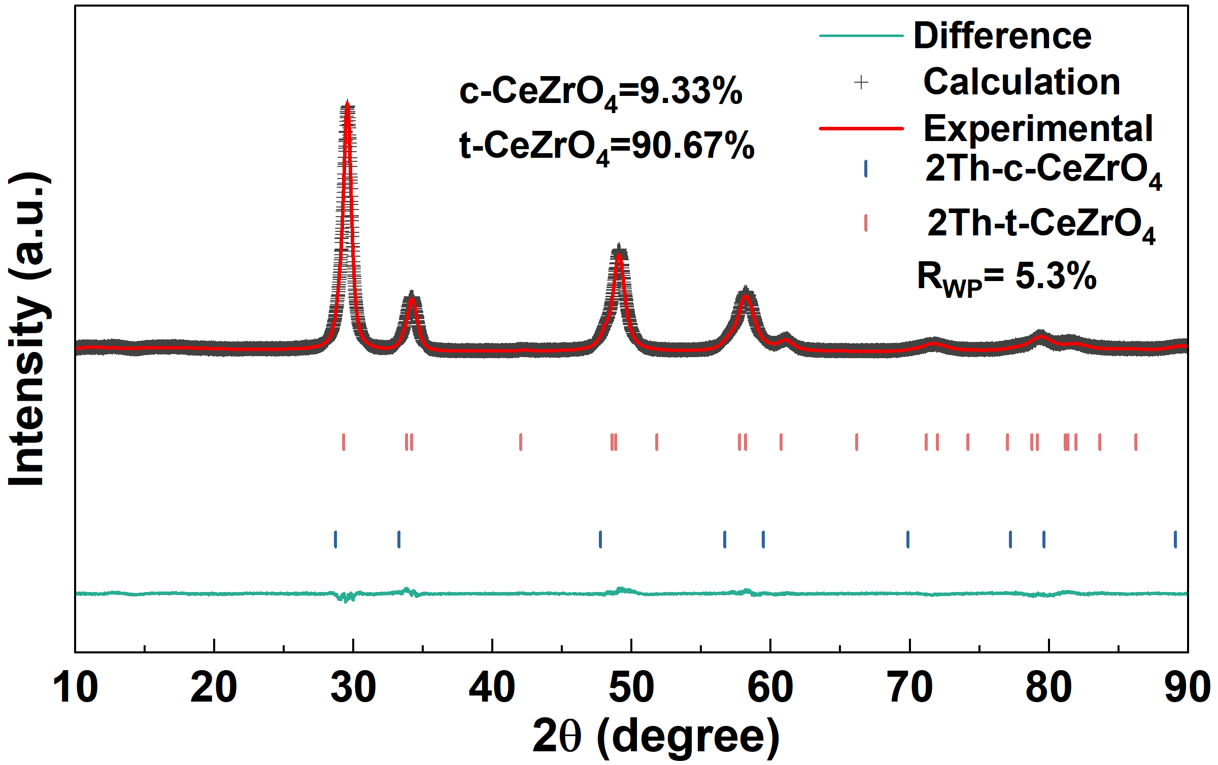
Figure S4. The Rietveld fitted powder X-ray diffraction pattern of CeZrO₄-600.

Table S5
XRD Refined Structural Parameters of c-CeZrO₄ of CeZrO₄-600
Atom | Site | x, y, z | Beq (Å²) | Occupancy
Ce  Zr  O | 4a  4a  8c | 0, 0, 0  0, 0, 0  0.25, 0.25, 0.25 | 0.5(1)  0.5(1)  2.3(4) | 0.5  0.5  1
a = b = c = 5.3798(8) Å

Table S6
XRD Refined Structural Parameters of t-CeZrO₄ of CeZrO₄-600
Atom | Site | x, y, z | Beq (Å²) | Occupancy
Ce  Zr  O | 2a  2a  4d | 0, 0, 0  0, 0, 0  0, 0.5, 0.222(1) | 1.7(1)  1.7(1)  1.7(1) | 0.5  0.5  1
a = b = 3.7439(4) Å c = 5.2424(6) Å

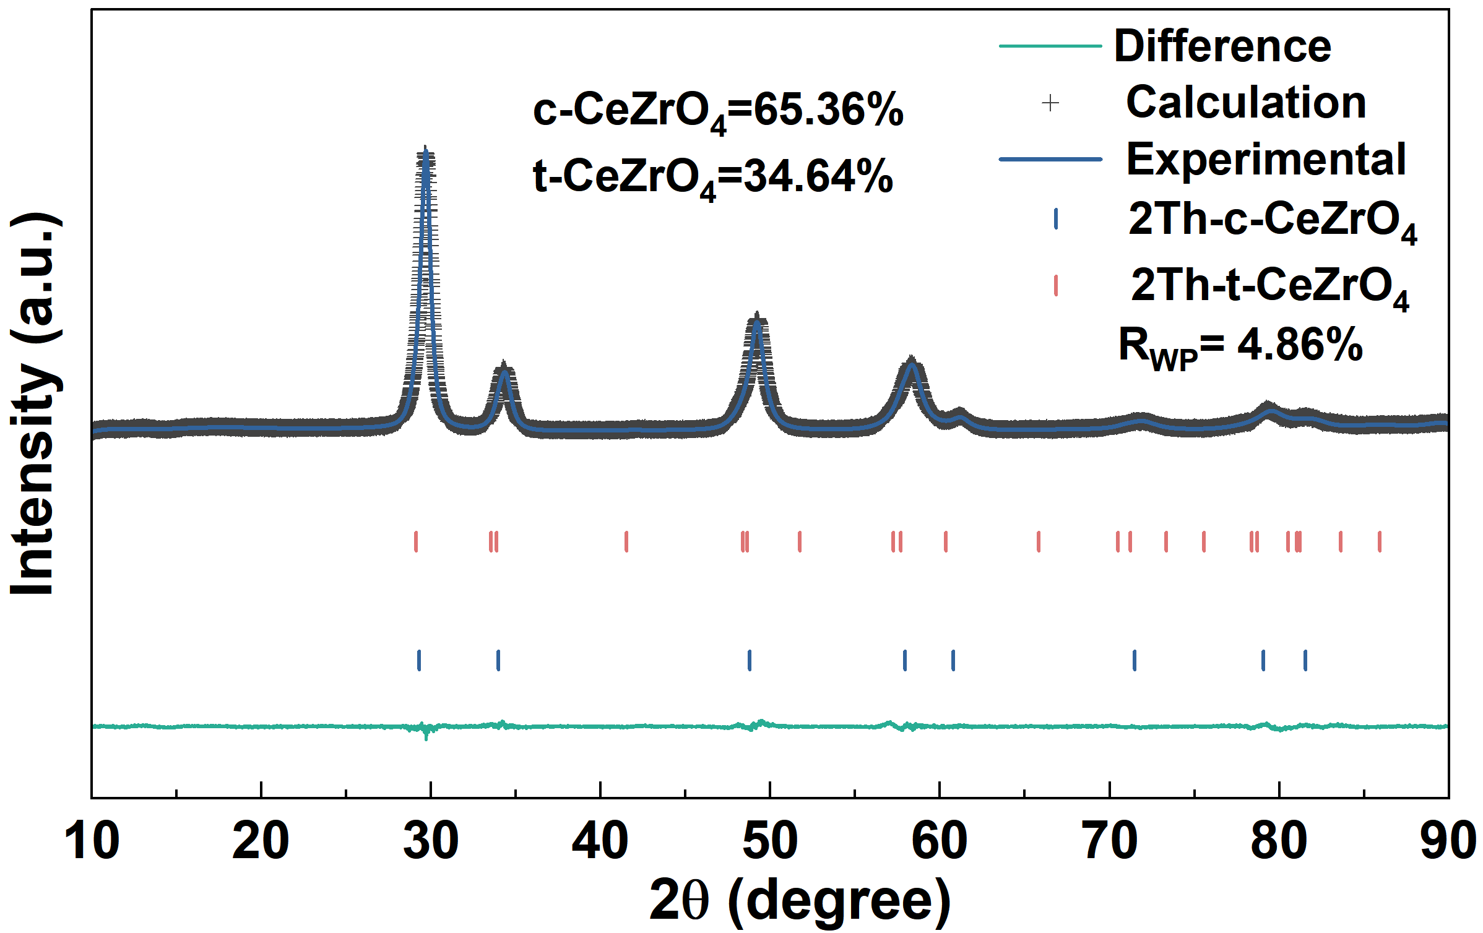
Figure S5. The Rietveld fitted powder X-ray diffraction pattern of CeZrO₄-900.

Table S7
XRD Refined Structural Parameters of c-CeZrO₄ of CeZrO₄-900
Atom | Site | x, y, z | Beq (Å²) | Occupancy
Ce  Zr  O | 4a  4a  8c | 0, 0, 0  0, 0, 0  0.25, 0.25, 0.25 | 2.0(1)  2.0(1)  2.3(2) | 0.5  0.5  1
a = b = c = 5.2764(5) Å

Table S8
XRD Refined Structural Parameters of t-CeZrO₄ of CeZrO₄-900
Atom | Site | x, y, z | Beq (Å²) | Occupancy
Ce  Zr  O | 2a  2a  4d | 0, 0, 0  0, 0, 0  0, 0.5, 0.205(2) | 0.3(1)  0.3(1)  0.8(4) | 0.5  0.5  1
a = b = 3.7455(1) Å c = 5.3391(1) Å

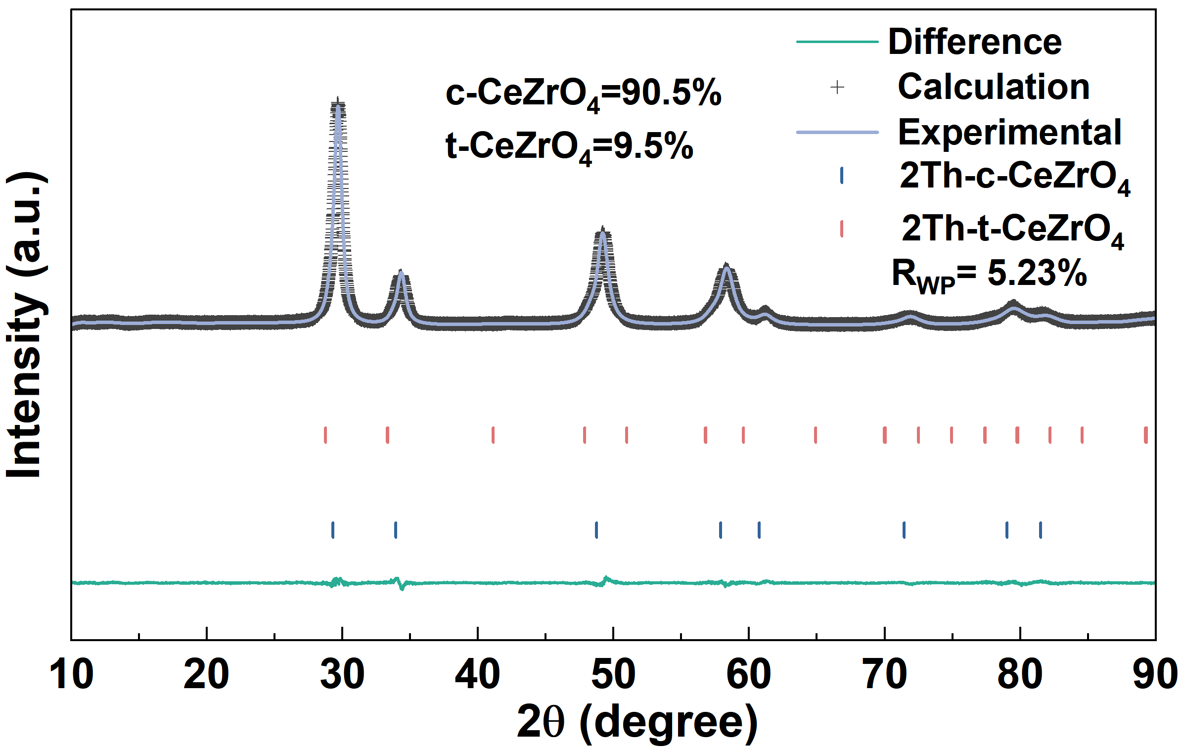
Figure S6. The Rietveld fitted powder X-ray diffraction pattern of CeZrO₄-S.

Table S9
XRD Refined Structural Parameters of c-CeZrO₄ of CeZrO₄-S
Atom | Site | x, y, z | Beq (Å²) | Occupancy
Ce  Zr  O | 4a  4a  8c | 0, 0, 0  0, 0, 0  0.25, 0.25, 0.25 | 1.2(1)  1.2(1)  1.0(1) | 0.5  0.5  1
a = b = c = 5.2772(4) Å

Table S10
XRD Refined Structural Parameters of t-CeZrO₄ of CeZrO₄-S
Atom | Site | x, y, z | Beq (Å²) | Occupancy
Ce  Zr  O | 2a  2a  4d | 0, 0, 0  0, 0, 0  0, 0.5, 0.219(3) | 0.4(2)  0.4(2)  2.3(5) | 0.5  0.5  1
a = b = 3.7964(4) Å c = 5.3733(5) Å

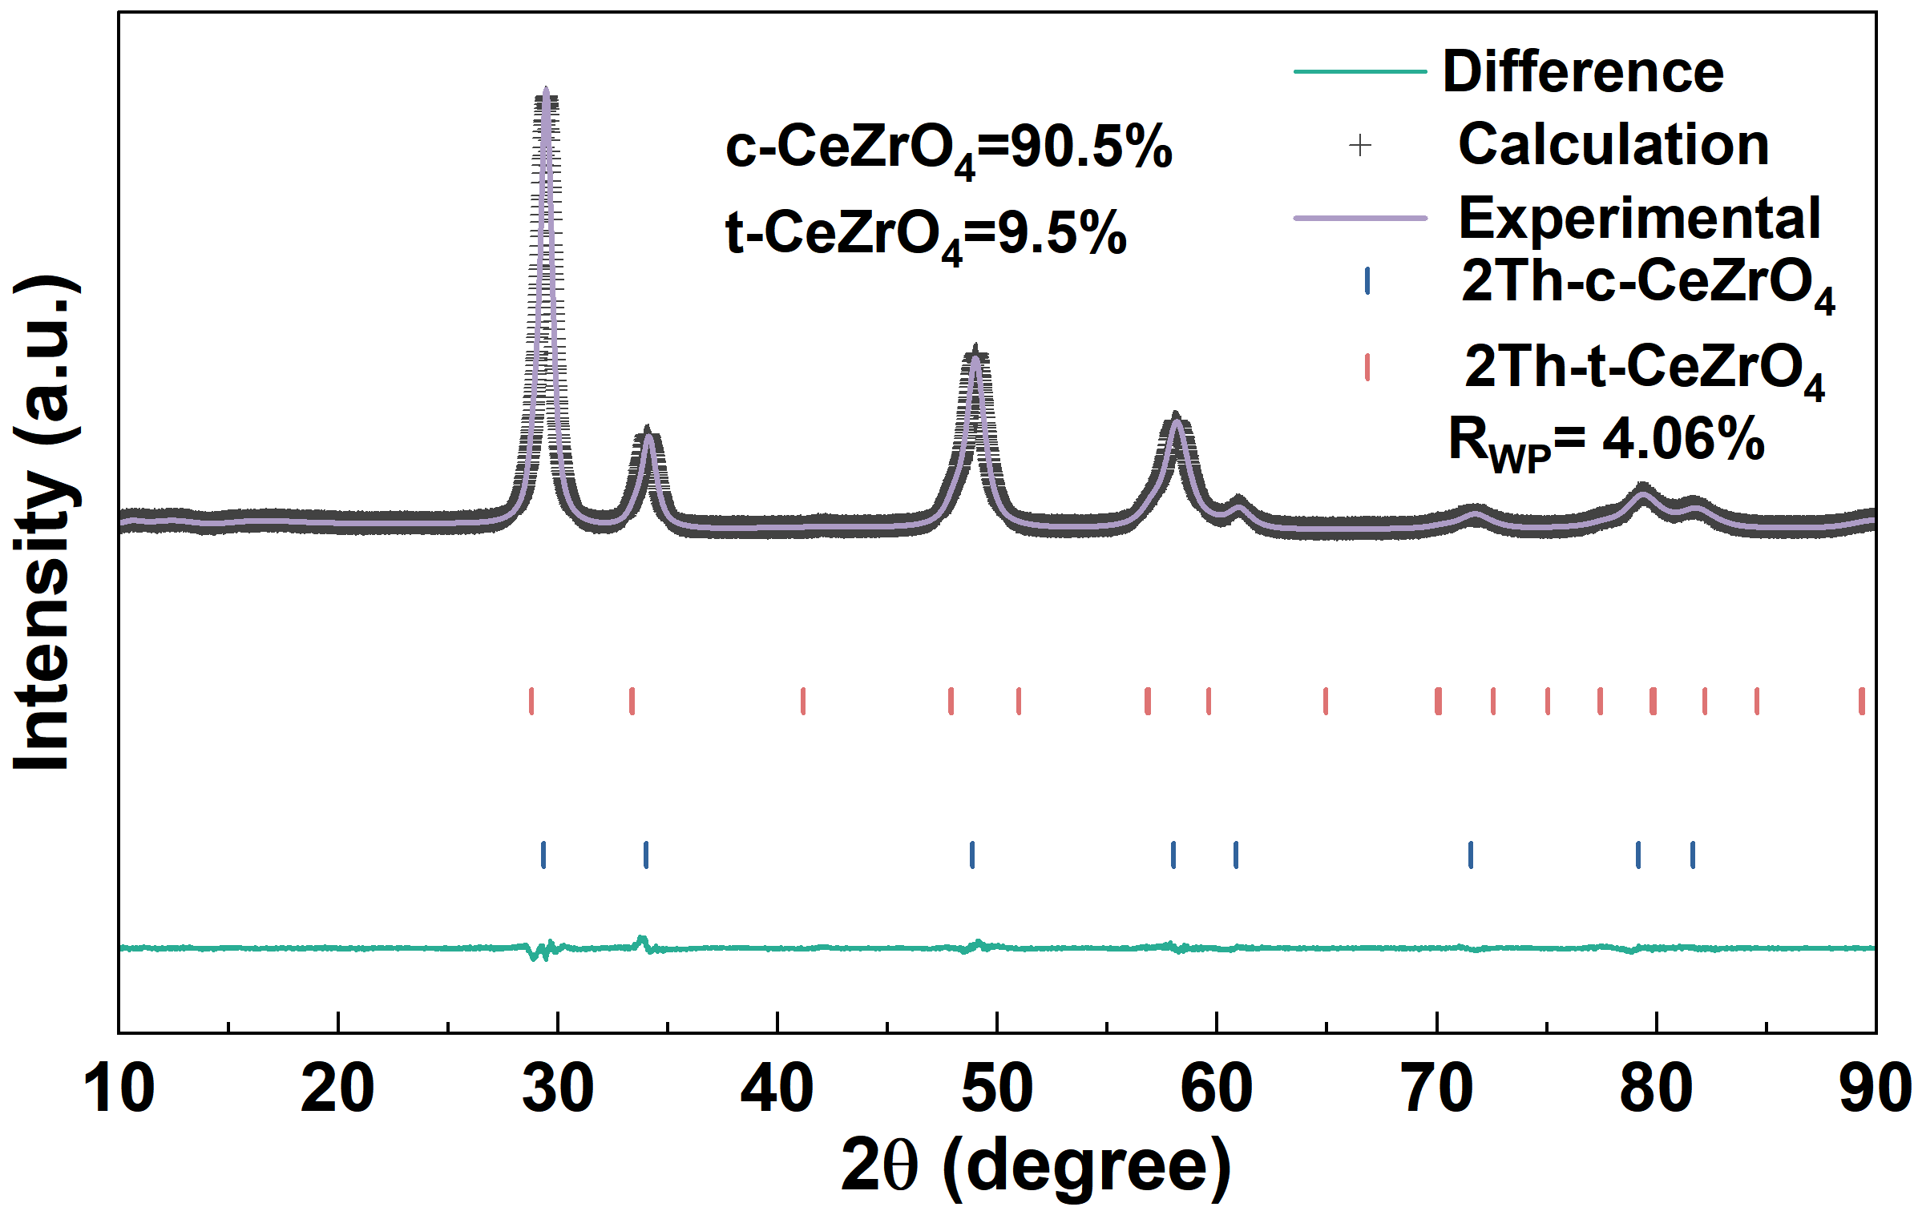
Figure S7. The Rietveld fitted powder X-ray diffraction pattern of CeZrO₄-Q

Table S11
XRD Refined Structural Parameters of c-CeZrO₄ of CeZrO₄-Q
Atom | Site | x, y, z | Beq (Å²) | Occupancy
Ce  Zr  O | 4a  4a  8c | 0, 0, 0  0, 0, 0  0.25, 0.25, 0.25 | 1.2(1)  1.2(1)  1.7(1) | 0.5  0.5  1
a = b = c = 5.2699(6) Å

Table S12
XRD Refined Structural Parameters of t-CeZrO₄ of CeZrO₄-Q
Atom | Site | x, y, z | Beq (Å²) | Occupancy
Ce  Zr  O | 2a  2a  4d | 0, 0, 0  0, 0, 0  0, 0.5, 0.244(5) | 0.6(1)  0.6(1)  1.0(6) | 0.5  0.5  1
a = b = 3.7955(5) Å c = 5.3744(1) Å
Table S13
NPD Refined Structural Parameters of c-CeZrO₄ of CeZrO₄-600
Atom | Site | x, y, z | Beq (Å²) | Occupancy
Ce  Zr  O | 4a  4a  8c | 0, 0, 0  0, 0, 0  0.25, 0.25, 0.25 | 1.2(6)  1.2(6)  0.8(4) | 0.5  0.5  0.991(4)
a = b = c = 5.3077(1) Å

Table S14
NPD Refined Structural Parameters of t-CeZrO₄ of CeZrO₄-600
Atom | Site | x, y, z | Beq (Å²) | Occupancy
Ce  Zr  O | 2a  2a  4d | 0, 0, 0  0, 0, 0  0, 0.5, 0.217(1) | 0.4(1)  0.4(1)  1.1(1) | 0.5  0.5  0.991(4)
a = b = 3.6861(1) Å c = 5.2349(1) Å

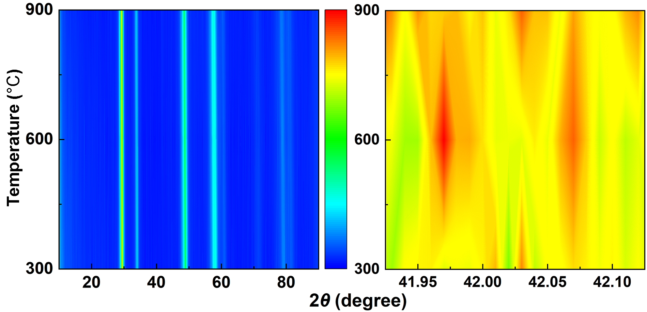
Figure S8. Variable temperature X-ray diffraction (VT-XRD) patterns of CeZrO₄-600.

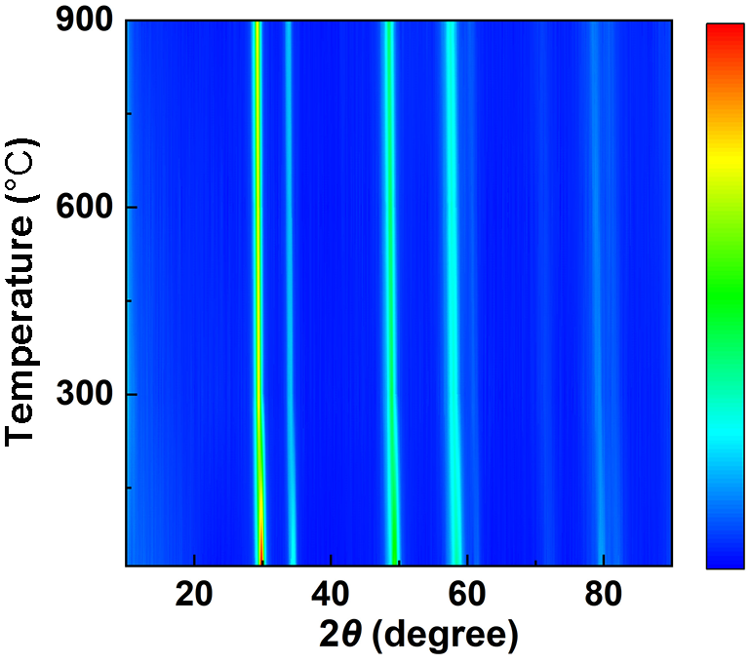
Figure S9. VT-XRD patterns of CeZrO₄-600.

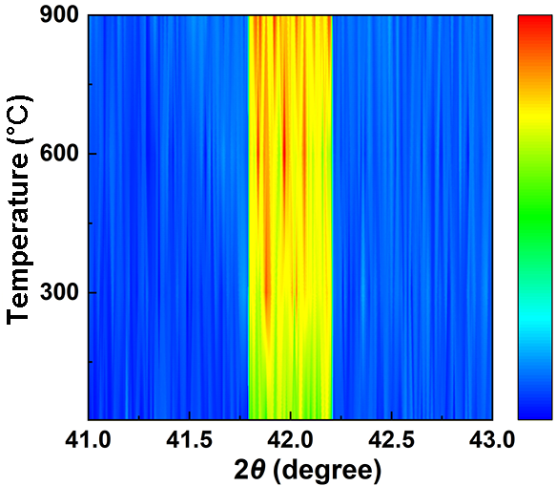
Figure S10. VT-XRD local magnified patterns of CeZrO₄-600.

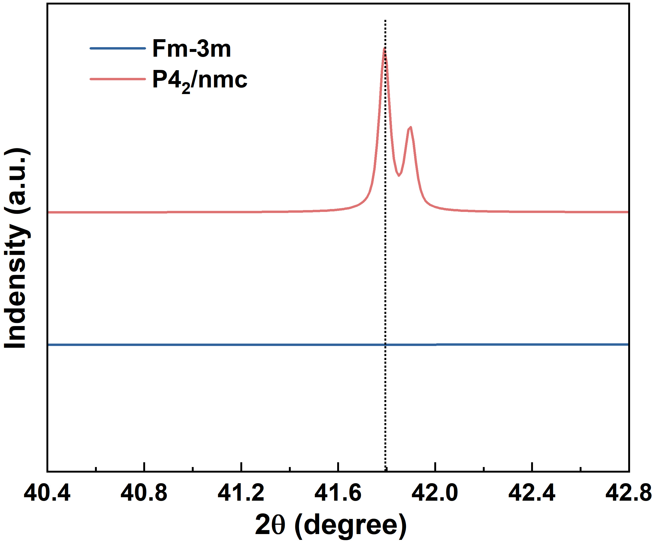
Figure S11. Peak position difference chart between cubic c-CeZrO₄ (Fm-3m) and tetragonal t-CeZrO₄ (P4₂/nmc) of CeZrO₄-600.

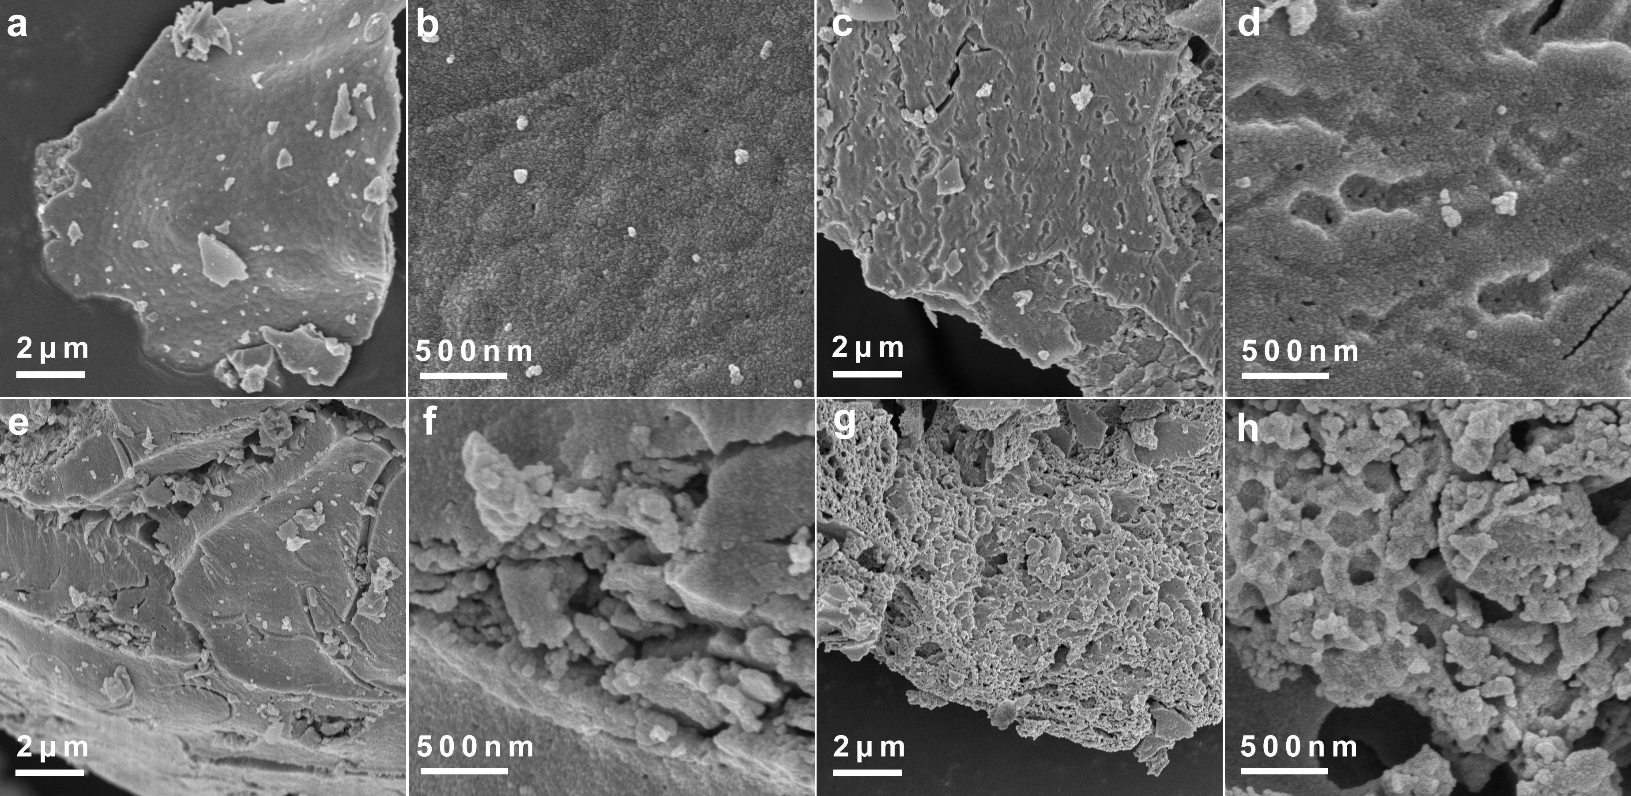
Figure S12. Scanning electron microscopy (SEM) images of (a), (b) CeZrO₄; (c), (d) CeZrO₄-300; (e), (f) CeZrO₄-600; (g), (h) CeZrO₄-900.

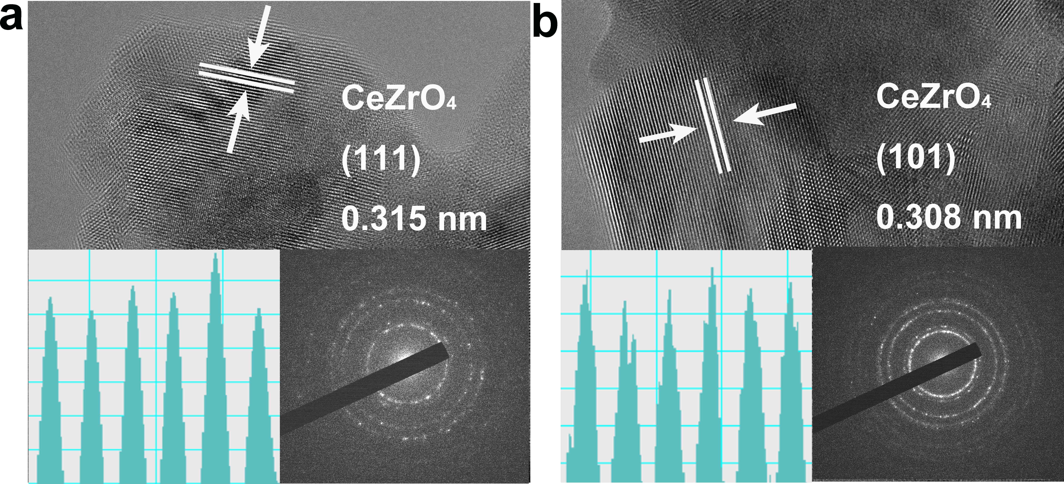
Figure S13. Transmission electron microscopy (TEM) of (a) CeZrO₄, (b) CeZrO₄-600. The inset image is obtained using high-angle annular dark-field scanning transmission electron microscopy (HAADF-STEM).

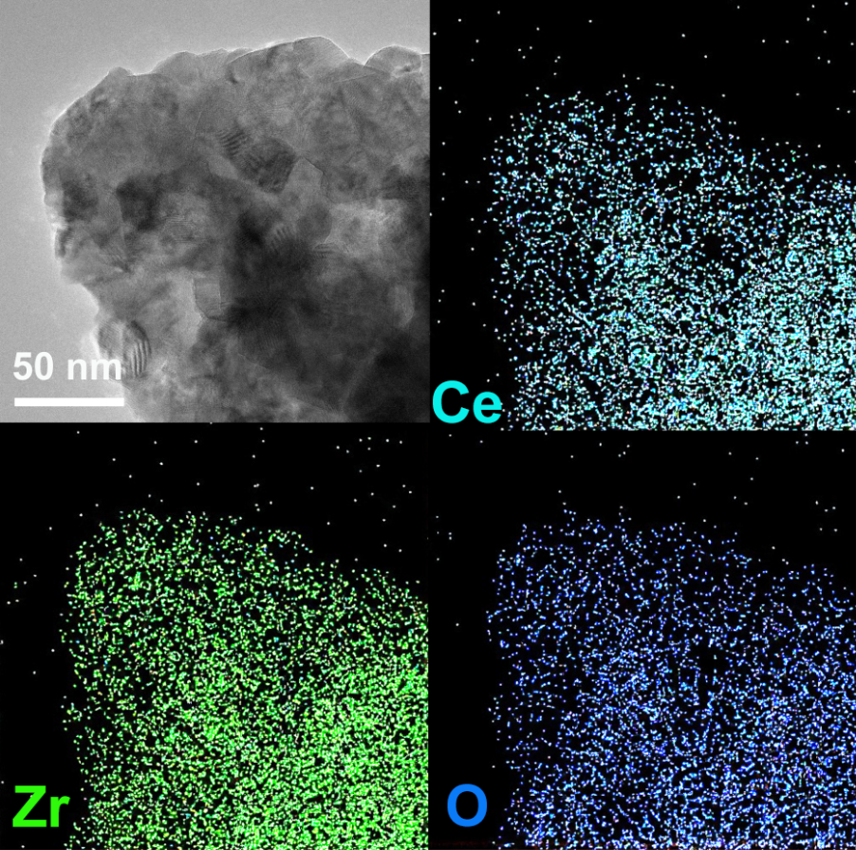
Figure S14. Energy Dispersive X-ray Spectroscopy (EDS) mapping of CeZrO₄-600.
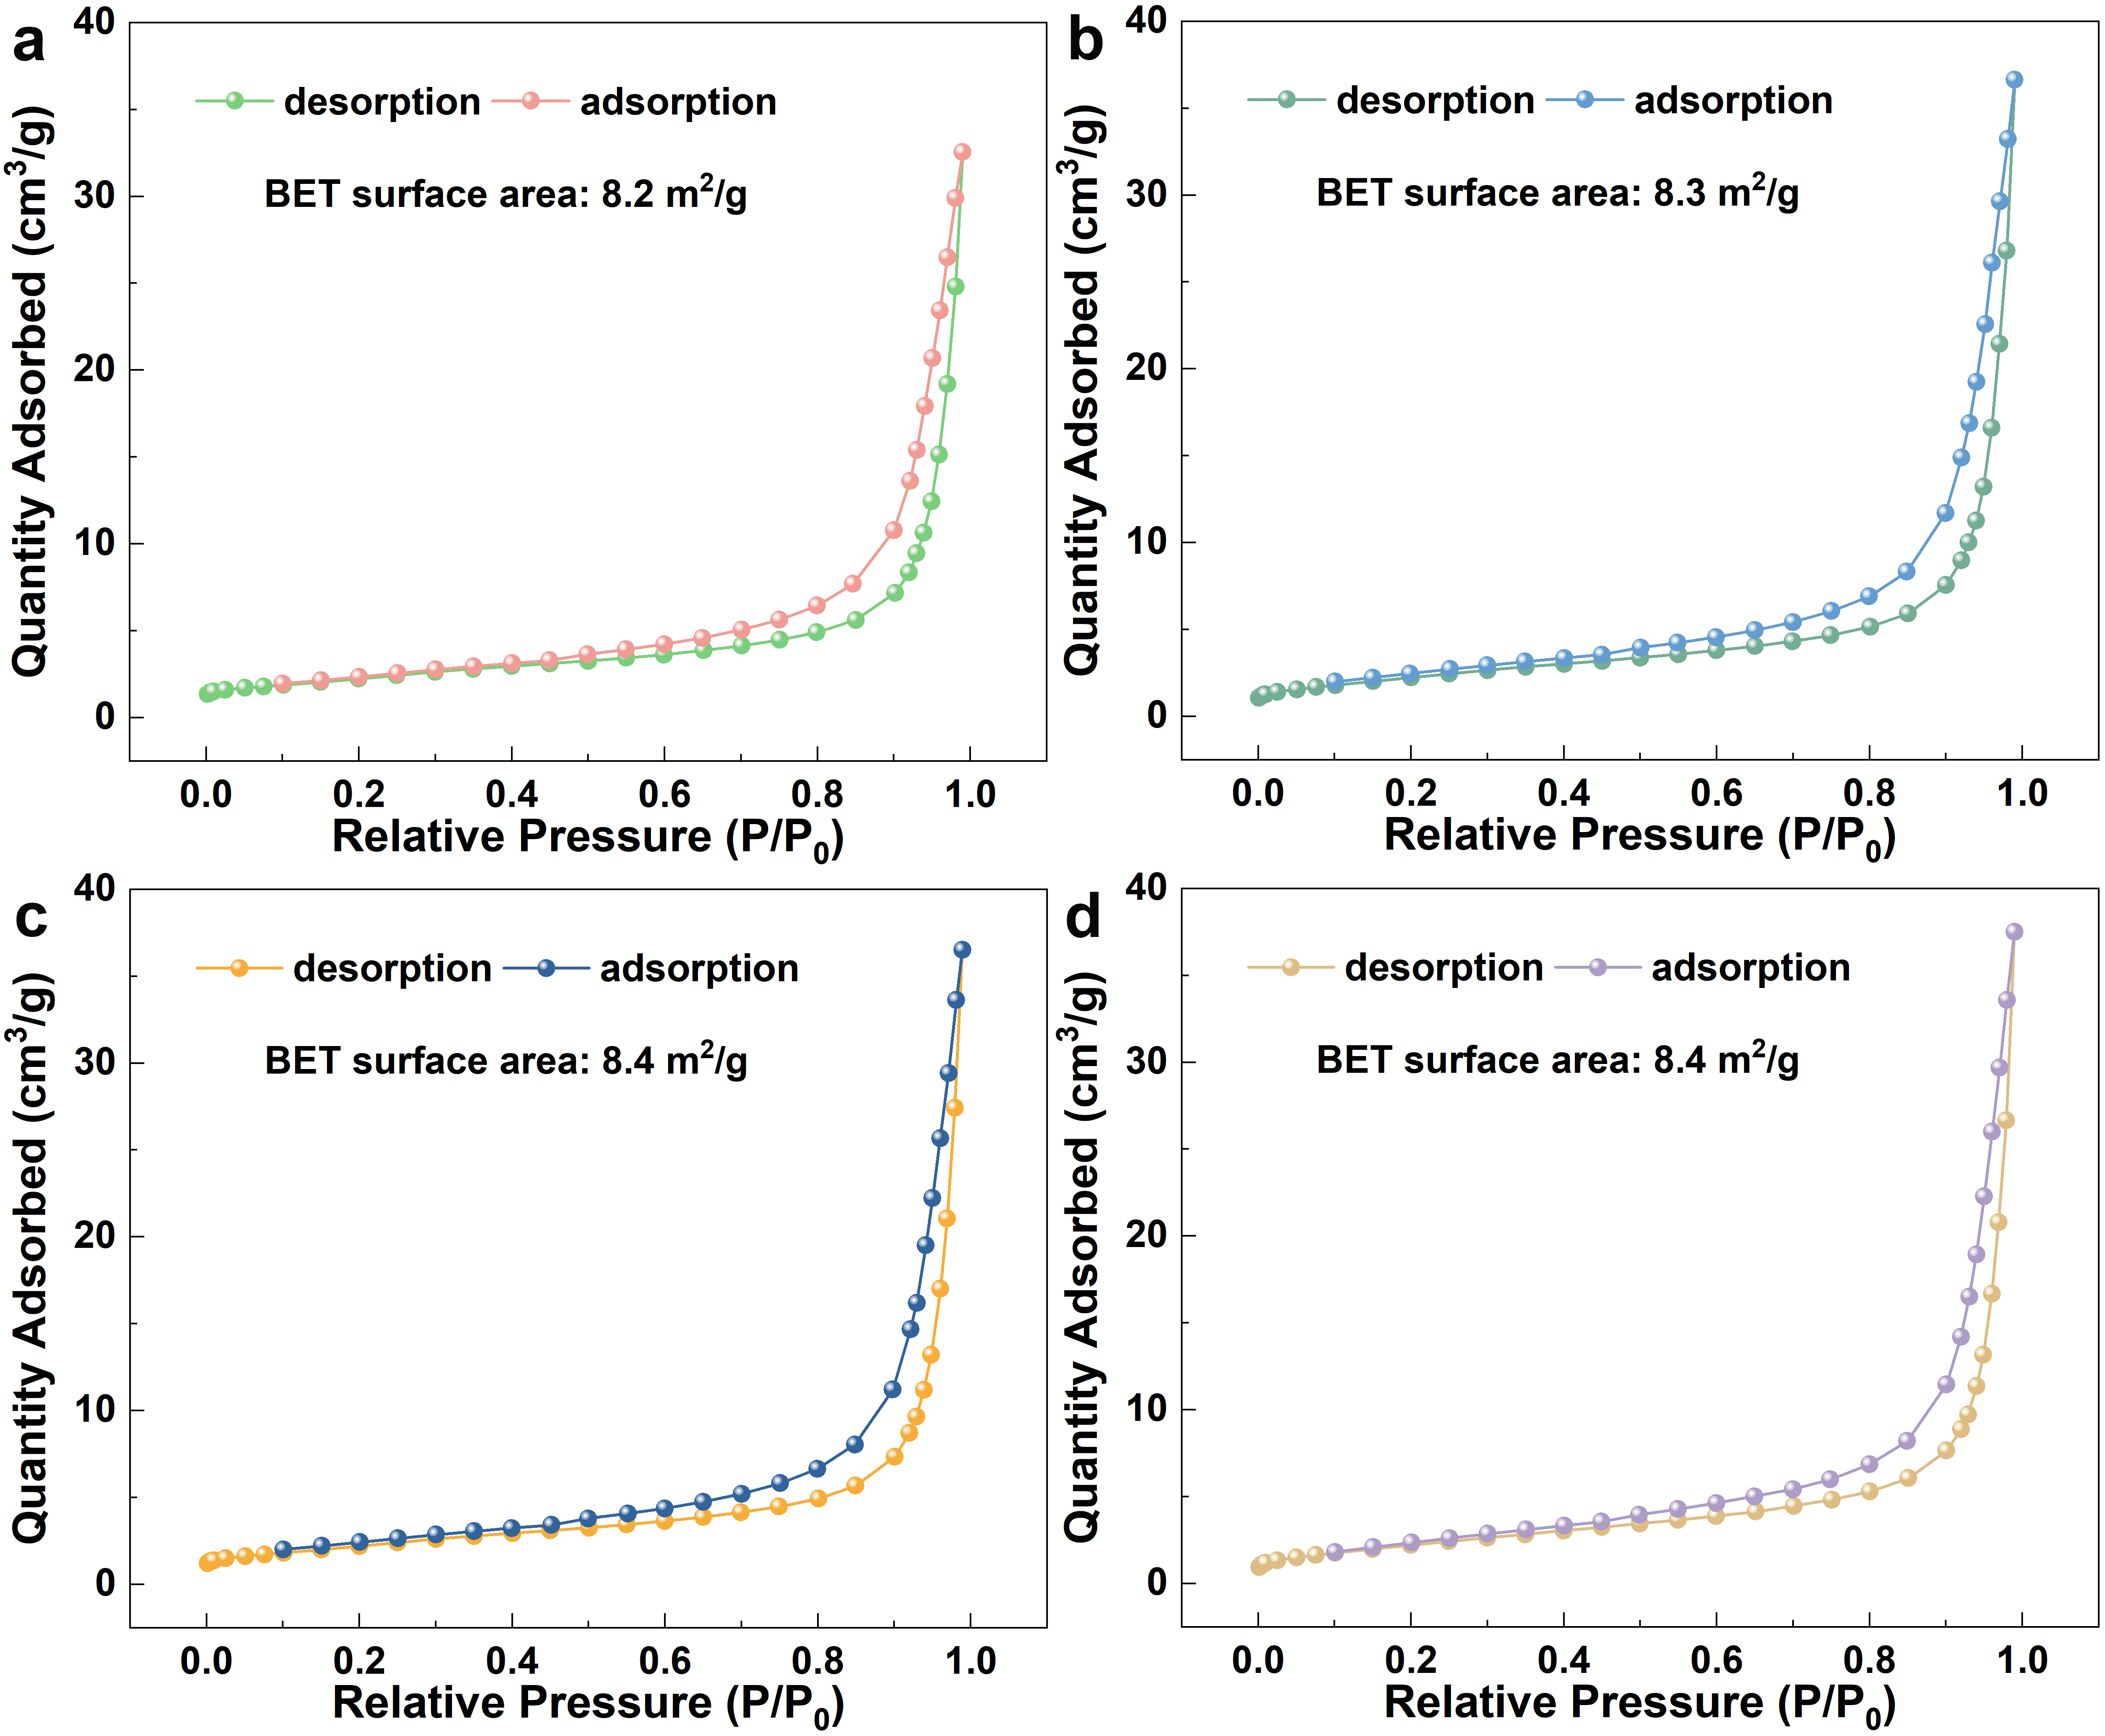
Figure S15. N₂ sorption isotherms and Brunauer–Emmett–Teller (BET) surface area of (a) CeZrO₄; (b) CeZrO₄-300; (c) CeZrO₄-600; (d) CeZrO₄-900.

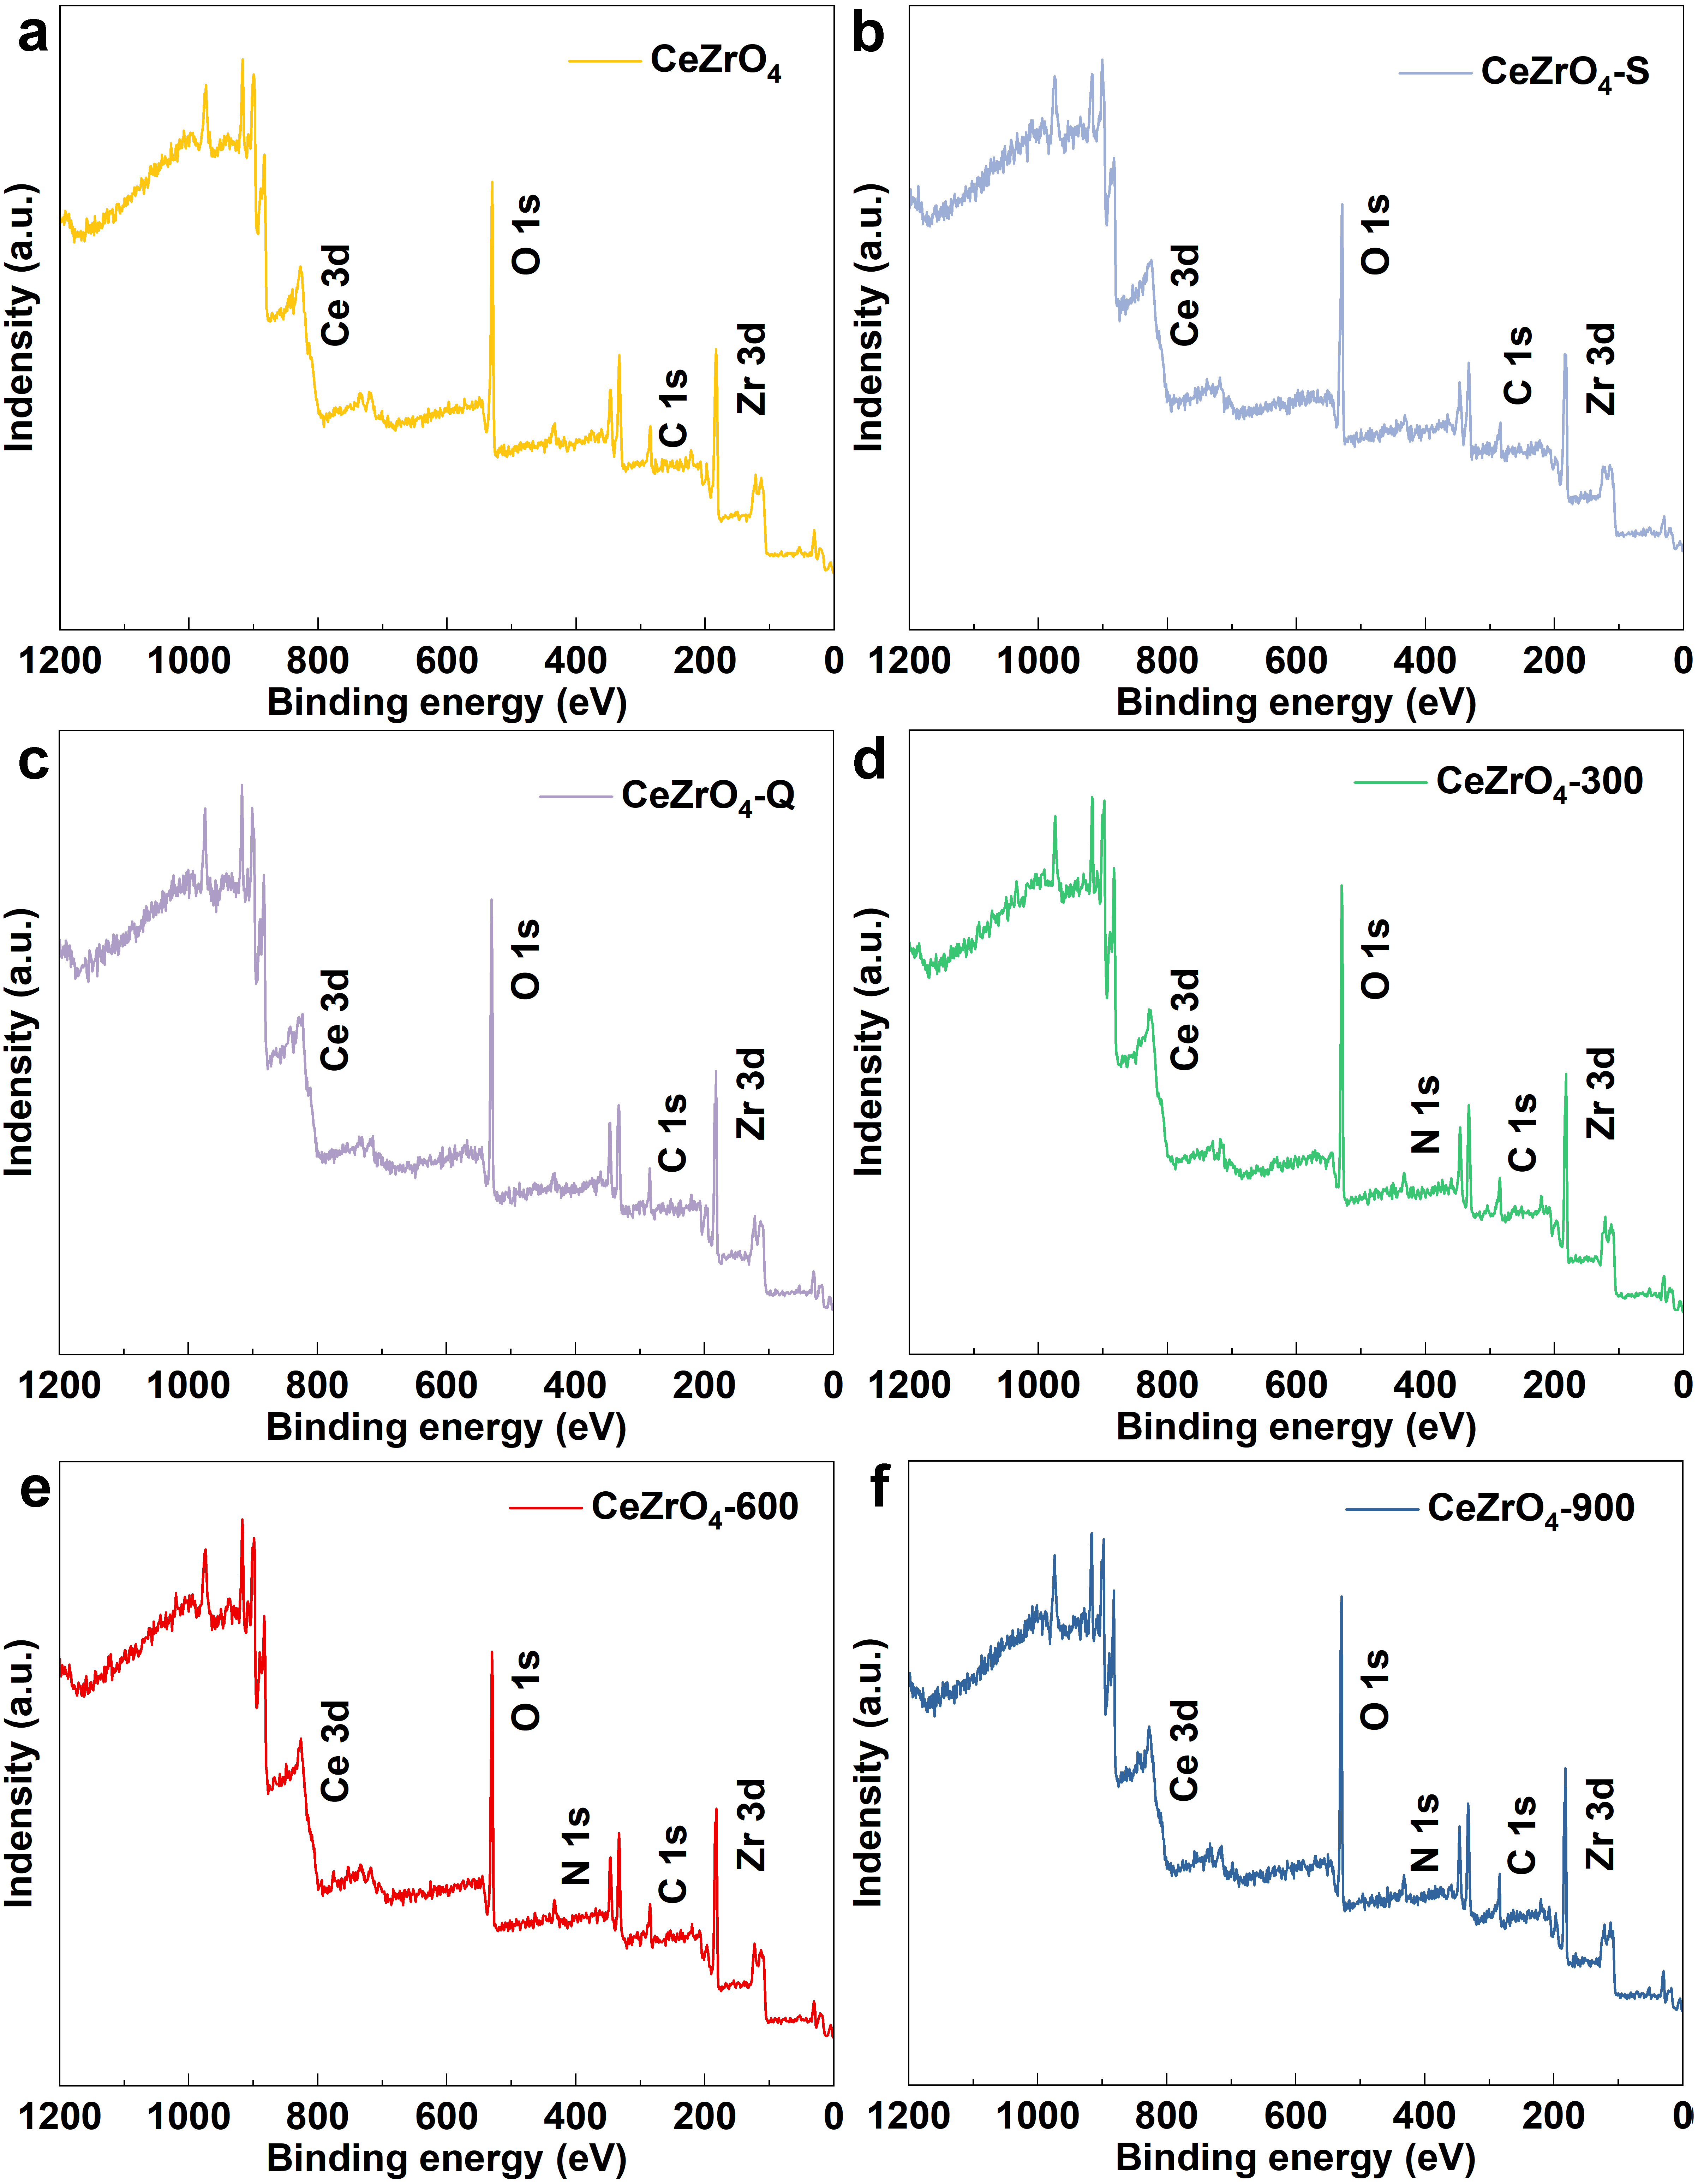
Figure S16. XPS survey spectrum of (a) CeZrO₄; (b) CeZrO₄-S, (c) CeZrO₄-Q, (d) CeZrO₄-300, (e) CeZrO₄-600, (f) CeZrO₄-900.

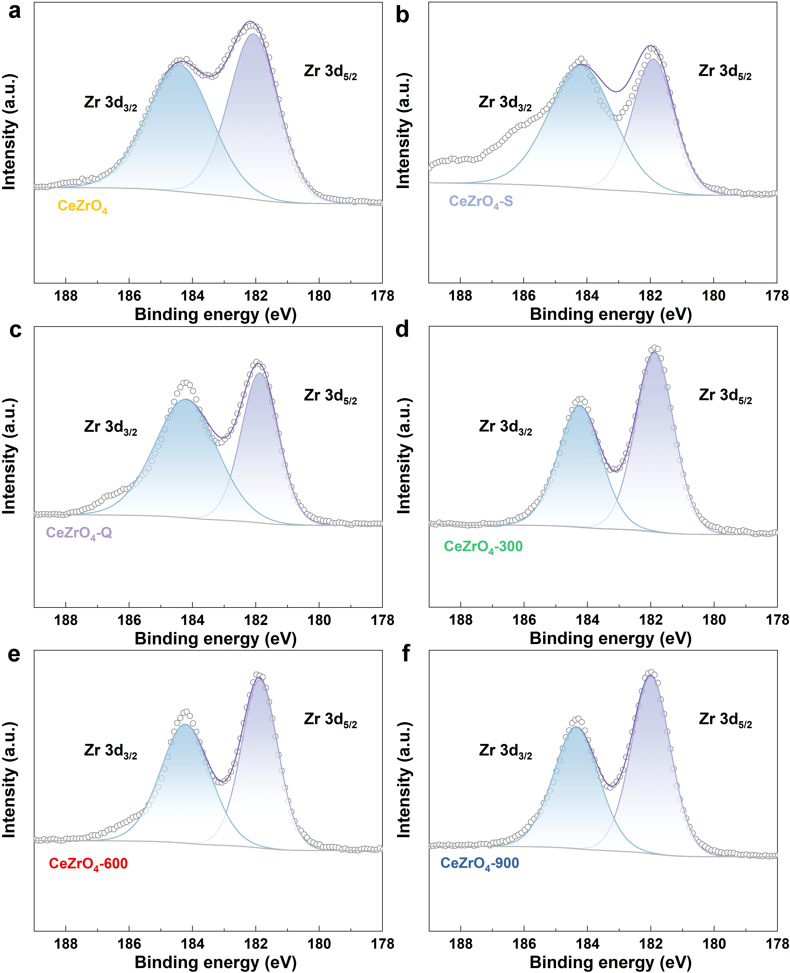
Figure S17. XPS high-resolution Zr 3d spectra of (a) CeZrO₄; (b) CeZrO₄-S, (c) CeZrO₄-Q, (d) CeZrO₄-300, (e) CeZrO₄-600, (f) CeZrO₄-900.

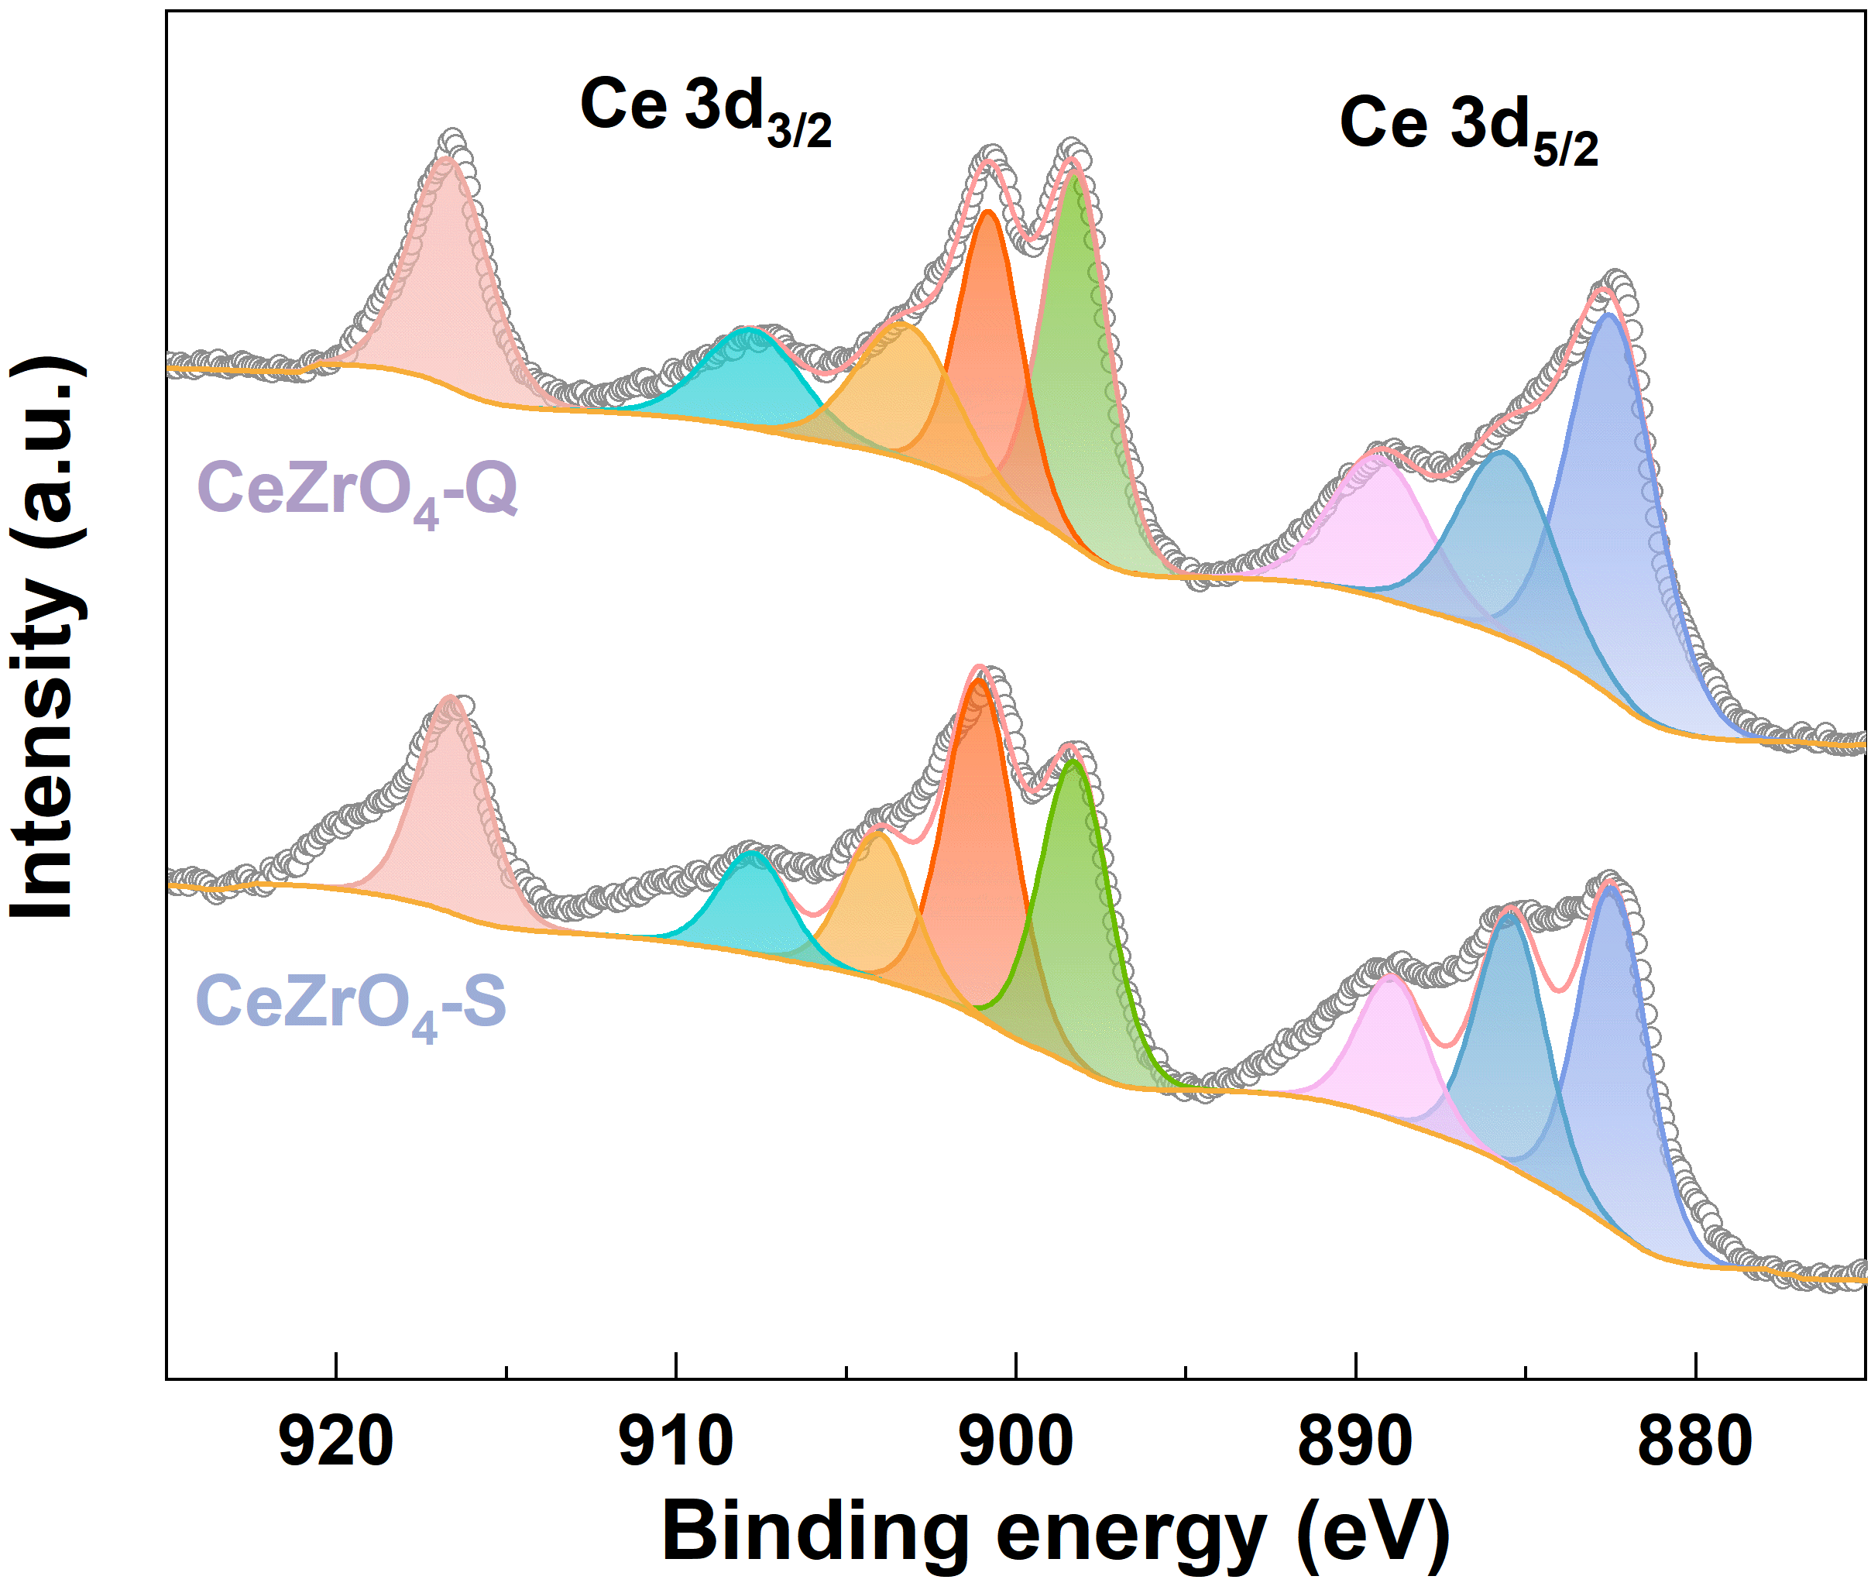
Figure S18. XPS high-resolution Ce 3d spectra of CeZrO₄-Q and CeZrO₄-S.

Table S15
The surface distribution of Ce³⁺ and Ce⁴⁺ in the sample
Sample | Ce³⁺/ Ce⁴⁺
CeZrO₄ | 0.1575
CeZrO₄-300  CeZrO₄-600  CeZrO₄-900  CeZrO₄-Q  CeZrO₄-S | 0.1677  0.2629  0.1924  0.1639  0.1751

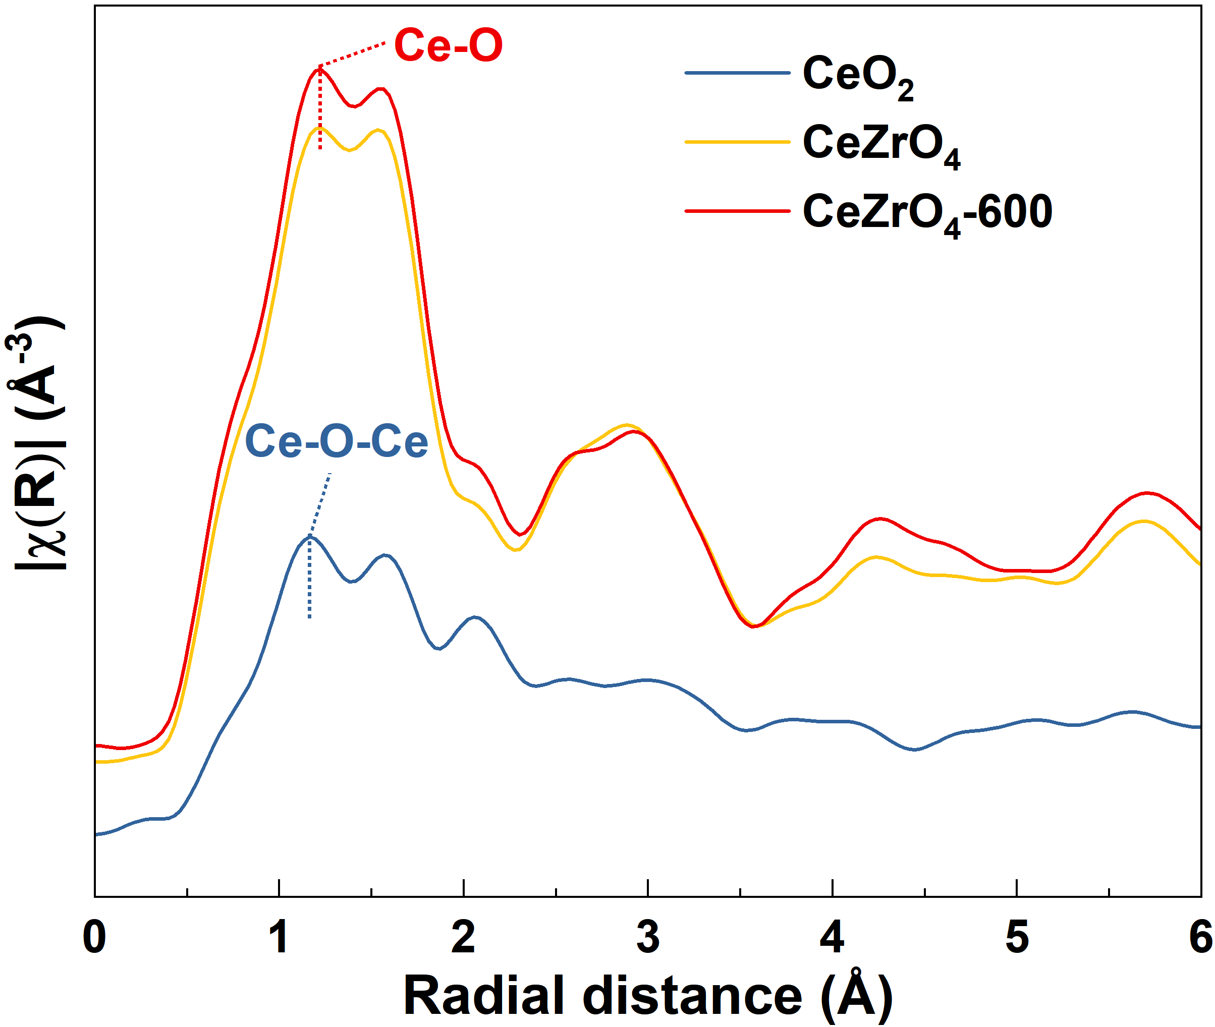
Figure S19. The Fourier transform spectra of the Ce L₃-edge in R space for CeZrO₄ and CeZrO₄-600.

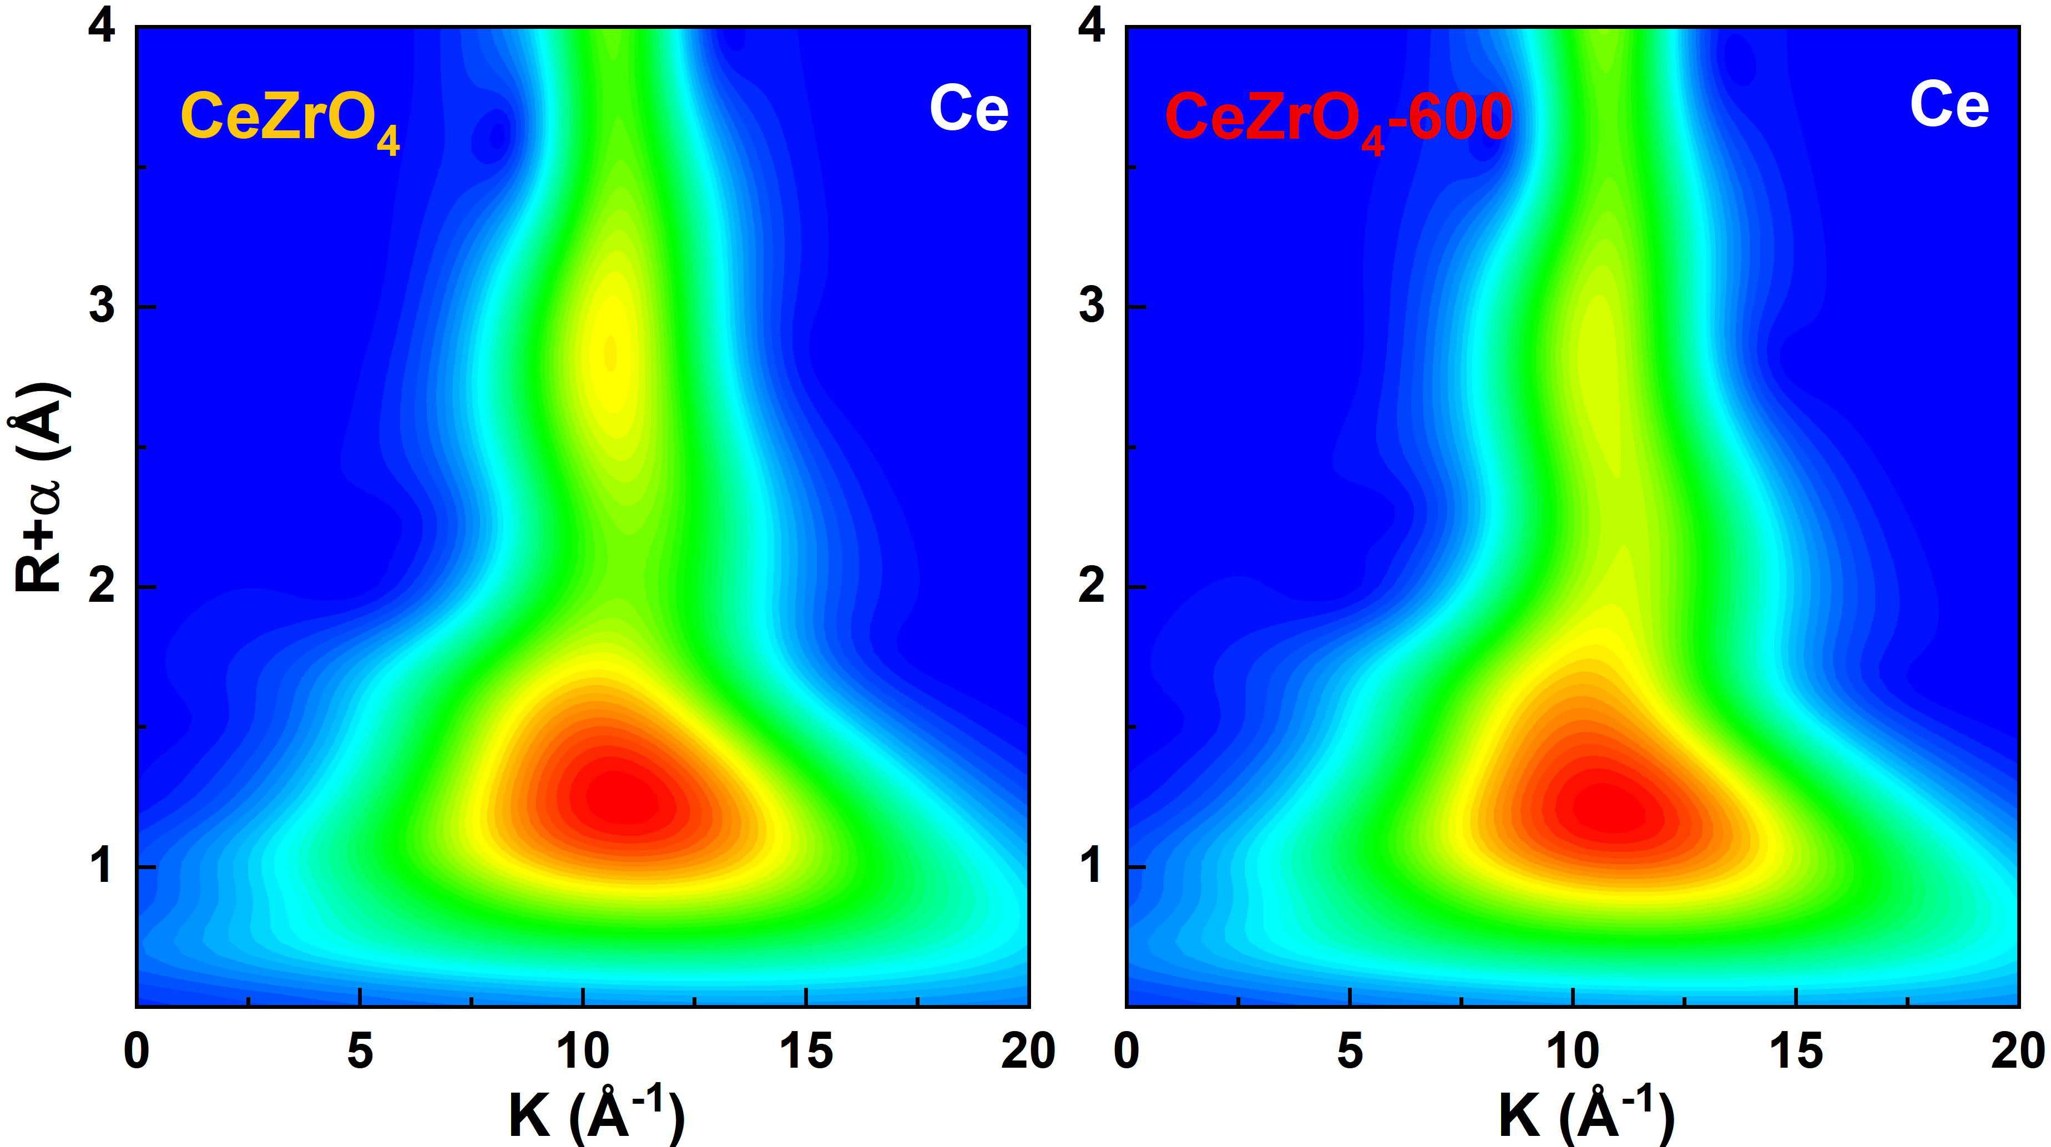
Figure S20. Wavelet transform contour plots of Ce for CeZrO₄ and CeZrO₄-600.

Section 3. Gas Sensing Properties

As shown in Figure 2a, exposure to 5 ppm NO₂ induced markedly different current responses across the sensor series, with the CeZrO₄-600 sensor exhibiting the highest response of 2926 nA. Additionally, response time, a critical factor in determining the detection efficiency of gas sensors, is highlighted in Figure 2a. CeZrO₄-600 sensor shows rapid response/recovery times of 7/8 seconds. As shown in Figures 2c and S24, the sensor treated at 600 °C exhibited the best performance, with a response to 100 ppm NO₂ that was ten times greater than that of the untreated CeZrO₄.
The electrochemical response of CeZrO₄-600 for 3 ppm NO₂ detection exhibits remarkable stability across a broad temperature range, demonstrating minimal temperature dependence. As the temperature varies from -25 °C to 75 °C, the response current shows only slight fluctuations, with a maximum deviation of 13.03% from the initial response at -25 °C. The slight decrease in current at 75 °C can be attributed to the partial evaporation of water, which impacts proton transport within the electrochemical cell, as typically observed in proton-conducting materials at elevated temperatures. However, this effect is minimal, and the sensor maintains robust performance even at 75 °C. The minimal variation in sensor response highlights the exceptional thermal stability of CeZrO₄-600, ensuring reliable NO₂ detection across a broad temperature range. The response remains stable, with a relative current change of less than 15%, demonstrating that temperature fluctuations have a negligible impact on performance. This stability is attributed to the high structural integrity of the material and the absence of significant degradation at elevated temperatures, as well as robust ionic conductivity of the sensors, which minimizes the influence of thermal effects. Such stability is vital for applications where consistent sensor performance is required in varying environmental conditions.
Selectivity is a key criterion for practical gas sensors (Figure 3b). Sensors based on CeZrO₄, CeZrO₄-300, CeZrO₄-600, and CeZrO₄-900 were tested against a range of potential interfering gases, including nitrogen dioxide (1 ppm NO₂), nitric oxide (200 ppm NO), methanol (200 ppm CH₃OH), hydrogen sulfide (200 ppm H₂S), ethanol (200 ppm C₂H₅OH), carbon monoxide (200 ppm CO), ammonia (200 ppm NH₃), and acetone (200 ppm CH₃COCH₃).

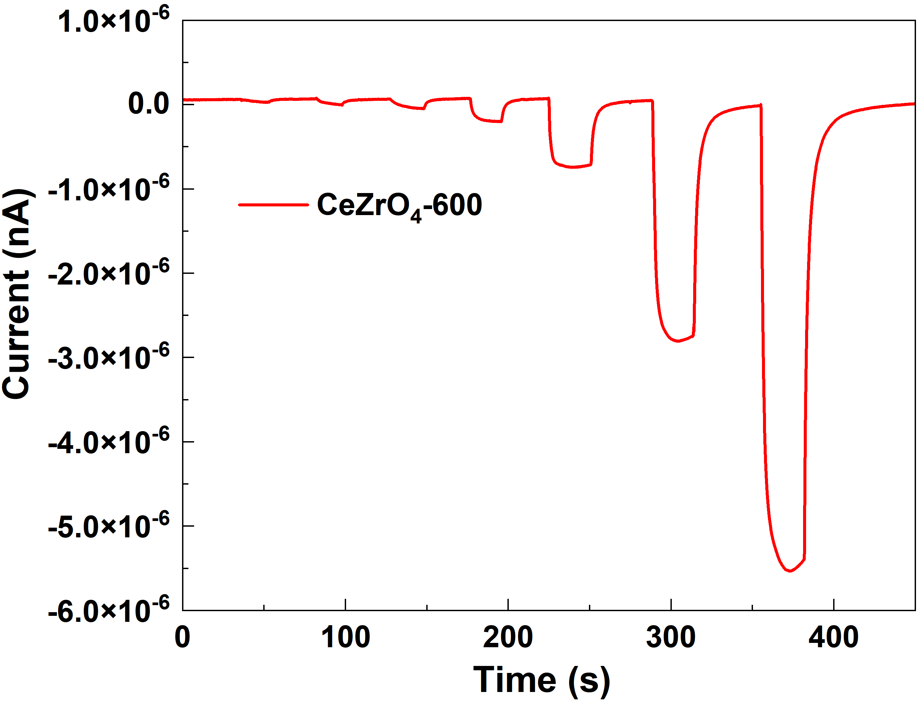
Figure S21. Baseline and current variation of CeZrO₄-600 sensors after exposure to 0.05-10 ppm NO₂.

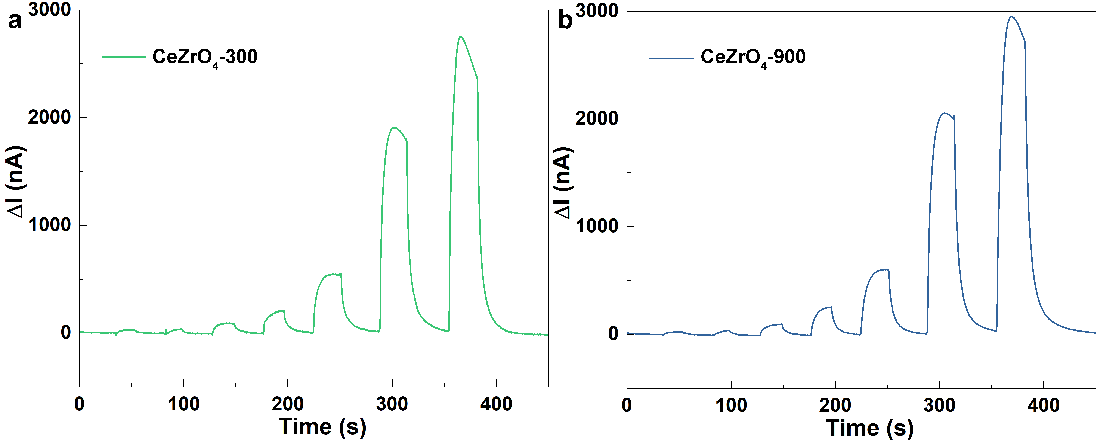
Figure S22. The continuous response and recovery curves to NO₂ in the range of 0.05-10 ppm NO₂.

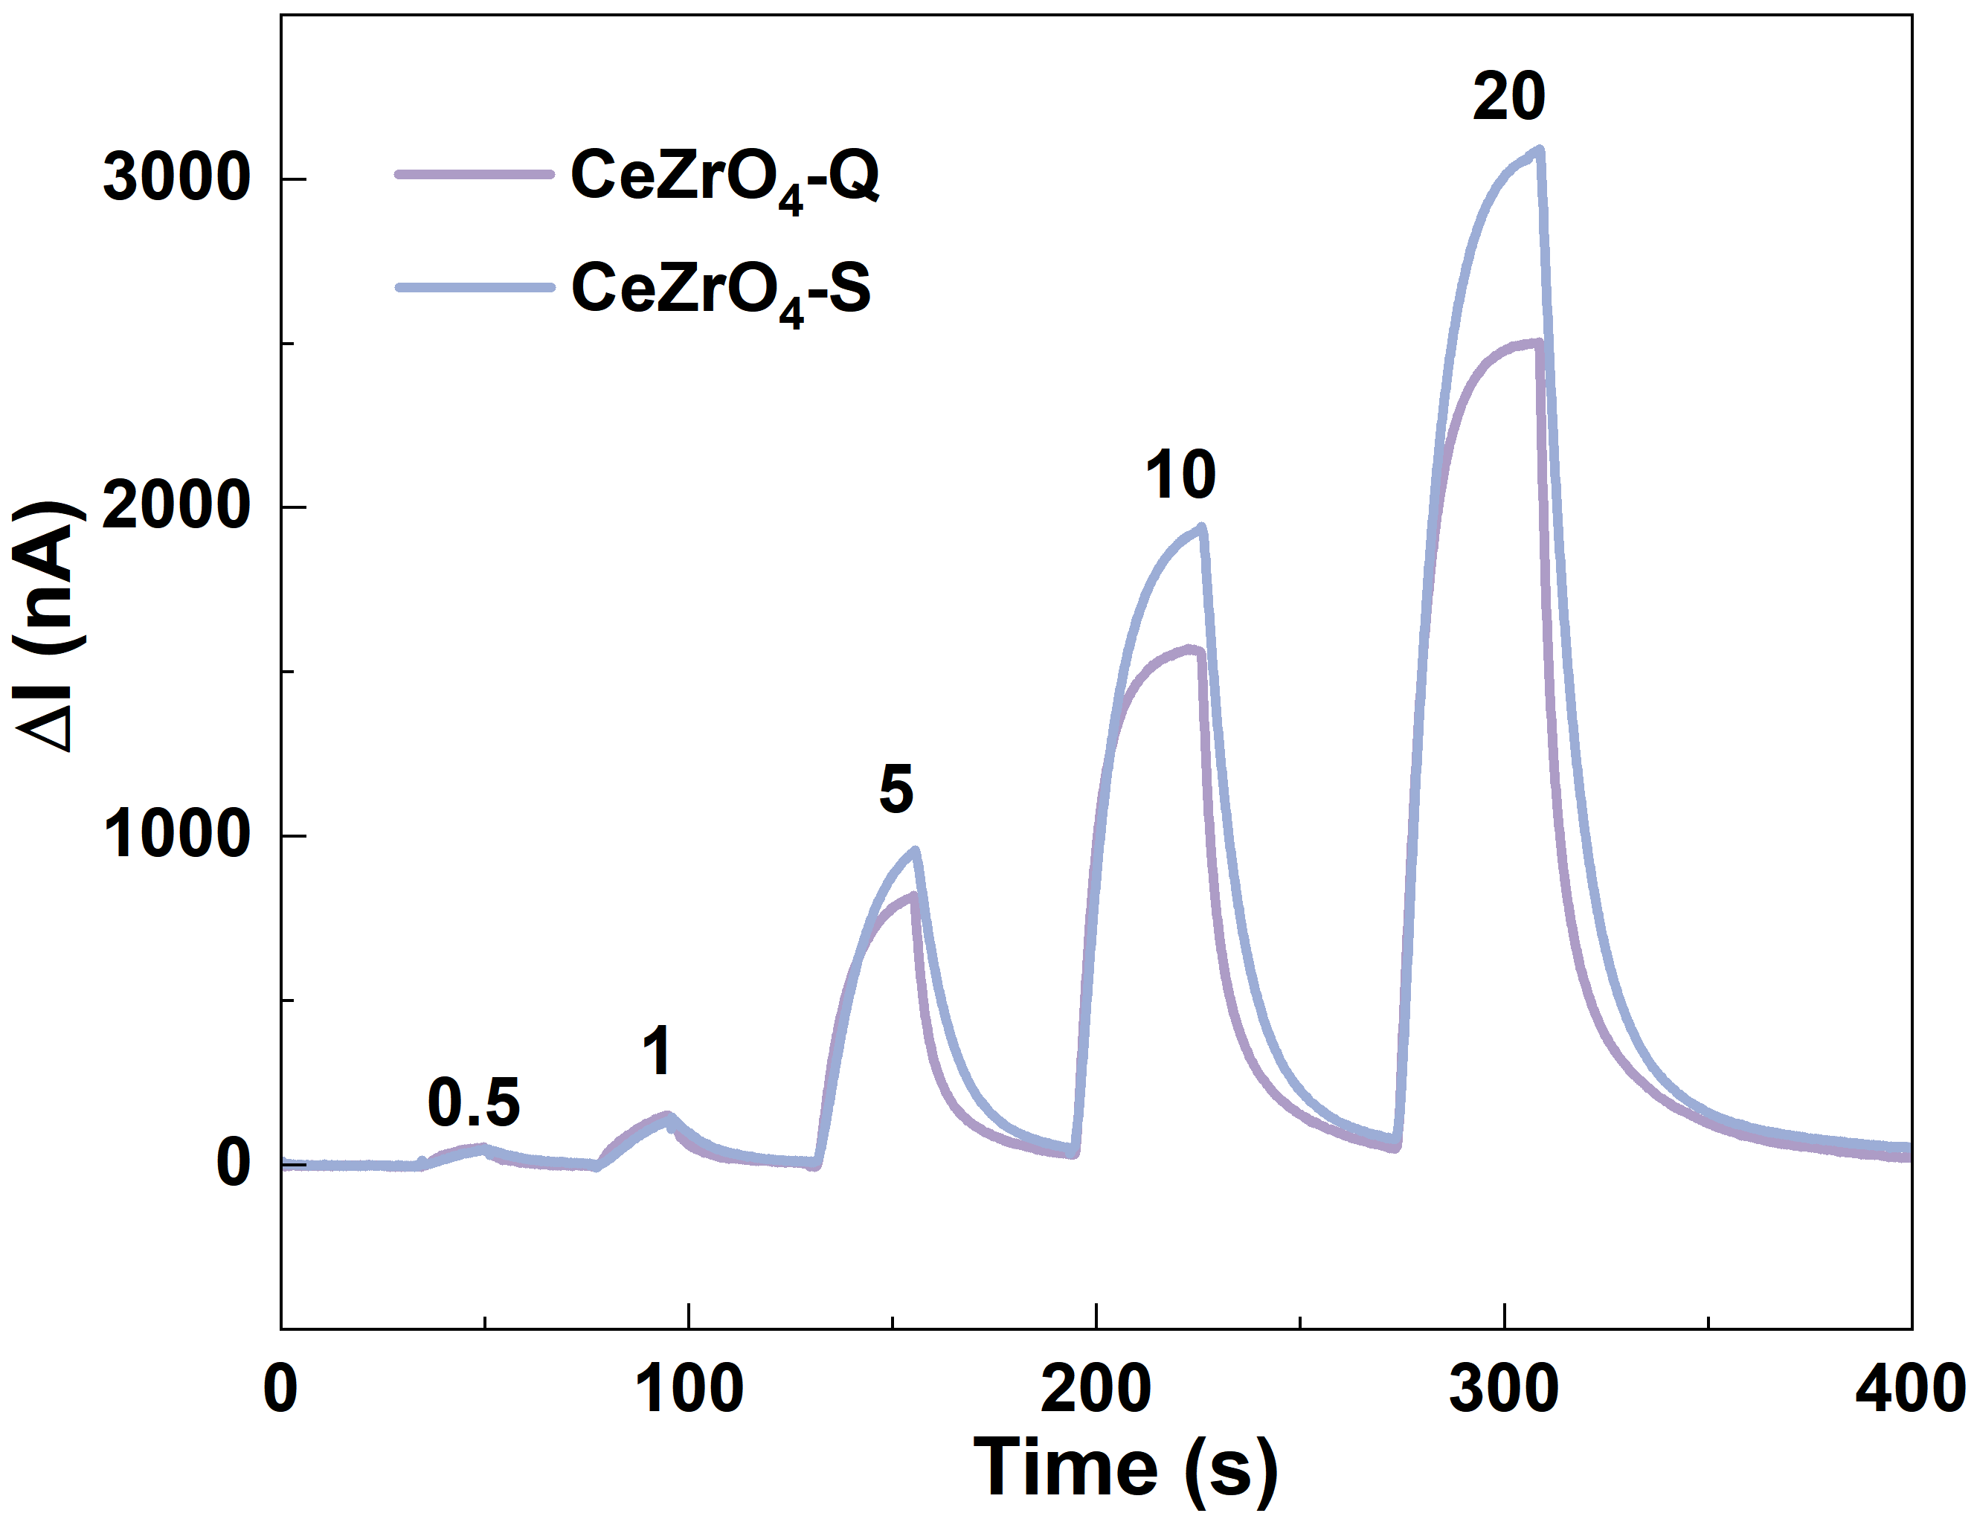
Figure S23. The continuous response and recovery curves to NO₂ in the range of 0.5-20 ppm.

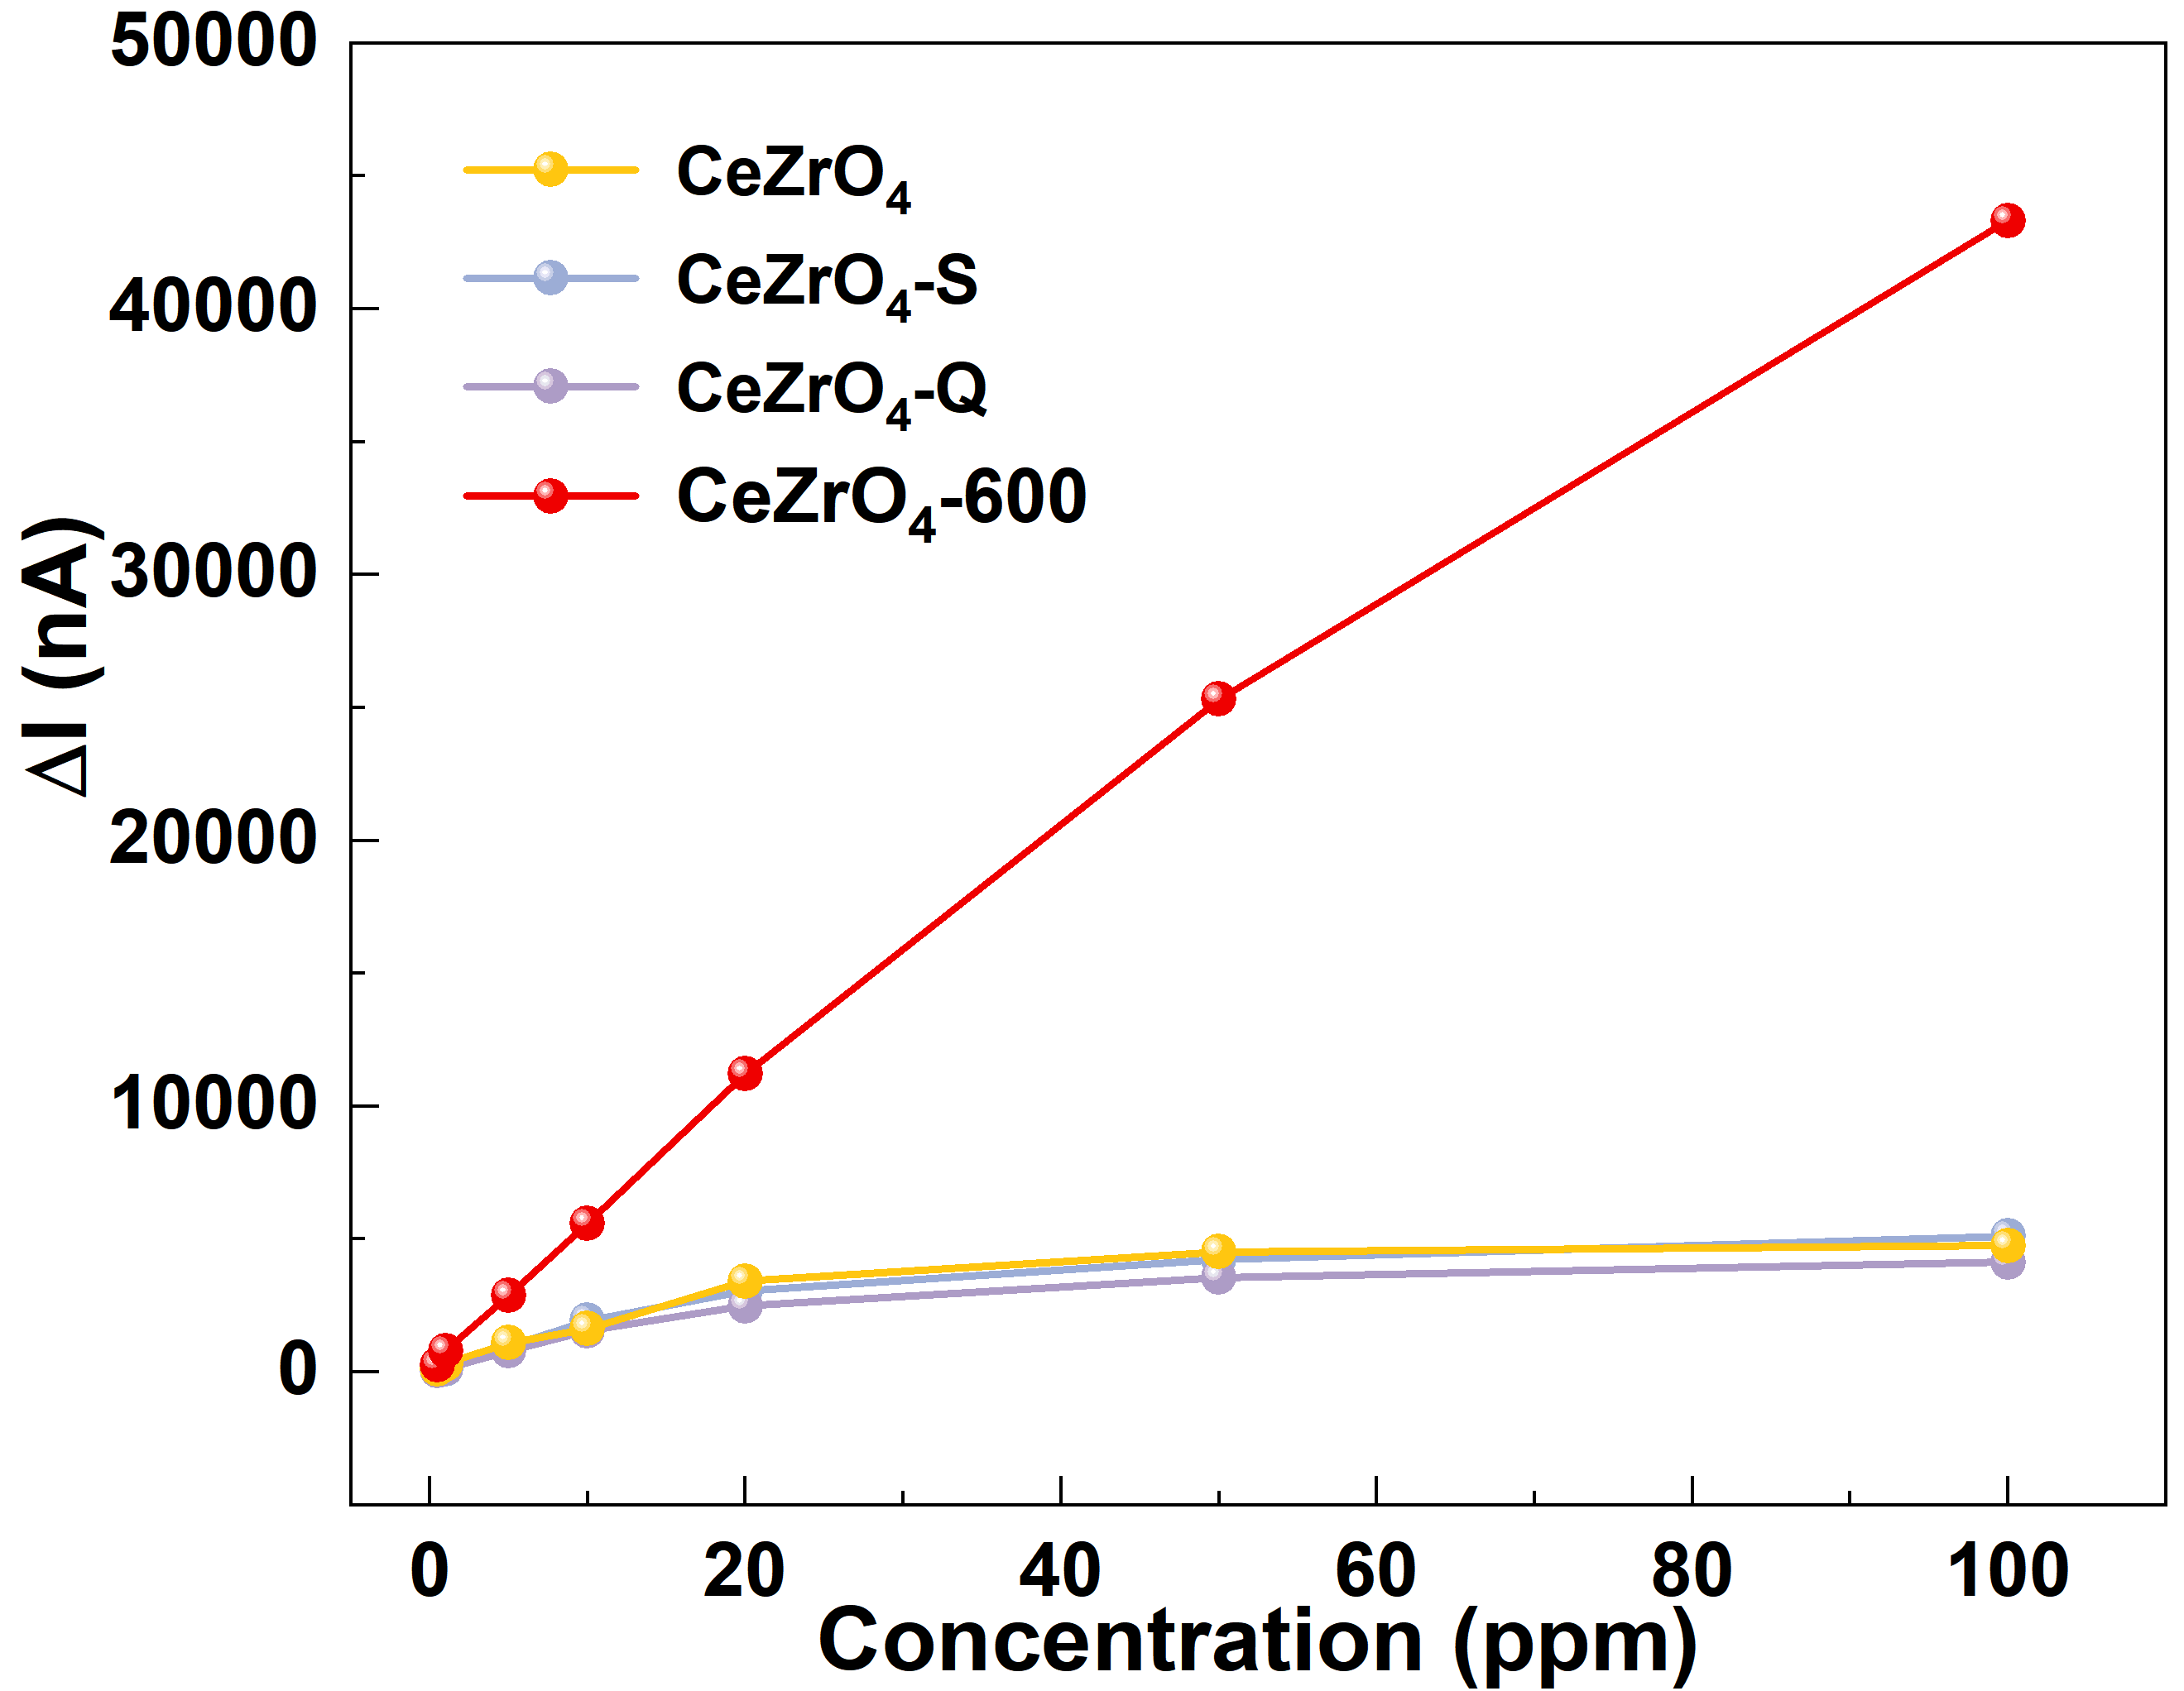
Figure S24. The relationship between response and the change of gas concentration of the sensors.

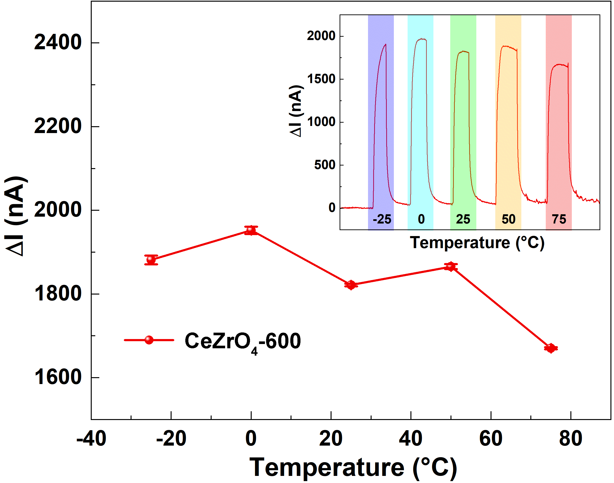
Figure S25. Temperature-dependent response of CeZrO₄-600 sensor for 3 ppm NO₂ detection

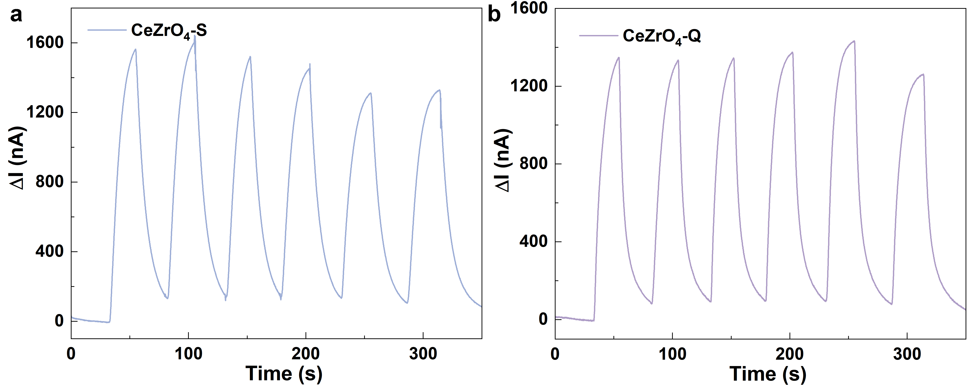
Figure S26. 6-cycle dynamic sensing response of CeZrO₄-S and CeZrO₄-Q when exposed to 10 ppm NO₂ at room temperature.
Section 4. Comparison of NO₂ Sensing Materials and Gas Sensors for Various Fields

Table S16
Comparison of the reported NO₂ sensing materials at room temperature
Sensing type | Sensing  material | Detection range (ppm) |  | Response*  (5 ppm) | Stability  98% (days) | Tempera  -ture (℃) | LOD  (ppb) | Ref.
electrochemical  sensor | CeZrO₄-600 | 0.05-100 |  | 2926 | 90 | RT | 10 | This work
electrochemical  sensor | TiN | 0.05-50 |  | 631 | 180 | RT | 2 | ⁵
electrochemical  sensor | In₂O₃ N-40min | 0.1-10 |  | 350 | 30 | RT | 10 | ⁶
electrochemical  sensor | C-SiO₂-PTFE | 5-100 |  | 17.5 | 21 | RT | 4300 | ⁷
chemiresistive  sensor | TiO_{x}-In₂O₃ |  | 1-5 | 35.8 | 14 | RT | 1000 | ⁸
chemiresistive  sensor | SiO₂-SnS₂-SiO₂/SiO₂ |  | 0.1-15 | 30 | 28 | RT | 25 | ⁹
chemiresistive  sensor | Pt_{NR}-CeO₂ |  | 0.5-40 | 6 | 30 | 30 | 20 | ¹⁰
chemiresistive  sensor | SWCNT |  | 0.01-3 | 41.2 | 180 | 150 | 0.16 | ¹¹
chemiresistive  sensor | Au-Bi_{x}-In_{2-x}O₃ |  | 0.1-1 | 640 | 14 | RT | 100 | ¹²
chemiresistive  sensor | HIOTP-Ni |  | 1-100 | 202.5 | 10 | RT | 210 | ¹³
chemiresistive  sensor | TiO₂@NH₂-MIL-125 |  | 0.1-100 | 150 | 90 | RT | 1 | ¹⁴
chemiresistive  sensor | MoS₂/MXene |  | 2-20 | 3 | 14 | RT | 500 | ¹⁵
chemiresistive  sensor | In₂O₃/PPy |  | 5-30 | 60 | 30 | RT | 500 | ¹⁶

Note: The table lists representative studies on advanced NO₂ sensing materials published within the past three years. The limit of detection (LOD) was estimated as LOD = 3σ/S, where σ is the baseline noise and S is the sensitivity (slope).
Response*: Owing to the different calculation methods of response values in electrochemical and chemiresistive gas sensors. To more intuitively compare the response value differences between the two, for electrochemical sensors, the response* is defined as I_{gas} /I_{air}. Given that the baseline currents of different electrochemical devices are inherently distinct, normalization was performed to enable consistent comparison across devices. In contrast, the response of semiconductor sensors is calculated as R_{gas} / R_{air} or R_{air} / R_{gas.} Both types of sensors evaluate changes induced by exposure to the target gas, with electrochemical sensors measuring current variation and semiconductor sensors tracking resistance changes.

Table S17
Comparison of the reported NO₂ gas sensors across different fields
Working principle | Sensor types | Response time  (s) | LOD  (ppb) | Ref.
Optical | BBCEAS | 30 | 0.007 | ¹⁷
Optical | TD-CEAS | 6 | 0.09 | ¹⁸
Optical | LED-PA | 70 | 1 | ¹⁹
Optical | QEPAS | 0.1 | 9 | ²⁰
Optical | QCLAS | 150 | 0.02 | ²¹
Optical | LSPR | 600 | 3.1 | ²²
Optical | CAPS | 40 | 0.04 | ²³
Optical | DOAS | 300 | 0.1 | ²⁴
Optical | SERS | 5 | 1000 | ²⁵
Optical | FOS | 360 | 50 | ²⁶
Mass/Acoustic | QCM | 30 | 41 | ²⁷
Mass/Acoustic | SAW | 80 | 7.5 | ²⁸
Electrical/Electrochemical | MOF | 120 | 500 | ²⁹
Electrical/Electrochemical | FET | 240 | 1.4 | ³⁰
Electrical/Electrochemical | PADs | 300 | 80 | ³¹
Electrical/Electrochemical | EGS (CeZrO₄-600) | 7 | 10 | This work

Note: BBCEAS (Broadband Cavity-Enhanced Absorption Spectroscopy), TD-CEAS (Thermal Dissociation Cavity Enhanced Absorption Spectroscopy), LED-PA (Light-Emitting Diode-based Photoacoustic Spectroscopy), QEPAS (Quartz-Enhanced Photoacoustic Spectroscopy), QCLAS (Quantum Cascade Laser-based Spectrometer), LSPR (Localized Surface Plasmon Resonance), CAPS (Cavity Attenuated Phase Shift), DOAS (Differential Absorption Spectroscopy), SERS (Surface-Enhanced Raman Spectroscopy), FOS (‌Fiber Optic Sensor), QCM (Quartz Crystal Microbalance), SAW (Surface Acoustic Wave Sensor), MOF (Metal–Organic Framework), FET (Field-Effect Transistor), PADs (Paper-based Analytical Devices), EGS (Electrochemical Gas Sensor).
NO₂ gas sensors can be broadly categorized according to their signal transduction mechanisms. Optical sensors (such as BBCEAS, TD-CEAS, LED-PA, QEPAS, QCLAS, LSPR, CAPS, DOAS, SERS, and FOS) rely on absorption, scattering, or photoacoustic effects to achieve ultralow detection limits and high selectivity, and have demonstrated outstanding performance in laboratory studies and atmospheric monitoring. However, their widespread deployment is hindered by system complexity and high cost. Mass and acoustic sensors (QCM, SAW) detect frequency or wave-propagation shifts induced by molecular adsorption, offering structural simplicity and good reproducibility, though with limitations in sensitivity and resistance to environmental interference. In contrast, electrochemical and electronic sensors (EGS, FET, MOF, PADs) directly convert molecular interactions with active materials into electrical signals, enabling rapid response, low power consumption, and facile integration into compact platforms. Among them, electrochemical gas sensors (EGS) have already been widely adopted in environmental monitoring and portable detection systems, and stand out as the most practically viable technology owing to their combined advantages in long-term stability, selectivity, and cost-effectiveness.
Figure 3c data for optical analyzers were obtained from commercial BBCEAS instruments. The data cost of the electrochemical sensors encompasses the combined expenses associated with material preparation, sensor assembly, and backend hardware as detailed in this study. The volume and power consumption characteristics of the system are determined by the final backend wireless sensing module.

Table S18
Comparison of the reported NO₂ gas sensors across different fields
Working principle | Sensor types | Cost  (USD) |  | Volume  (cm³) | Power  (W) | Comprehensive Factor
Optical | BBCEAS |  | 50,000 | 18,000 | 35 | 0.907701
Optical | TD-CEAS |  | 28,000 | 330,000 | 300 | 0.377108
Optical | LED-PA |  | 20,415 | 90 | 15 | 0.968259
Optical | QEPAS |  | 52,326 | 6,250 | 20 | 0.931475
Optical | QCLAS |  | 3,049 | 36,000 | 75 | 0.889861
Optical | LSPR |  | 487,600 | 30,000 | 20 | 0.552736
Optical | CAPS |  | 72,000 | 45,907 | 80 | 0.819279
Optical | DOAS |  | 14,000 | 9439 | 40 | 0.940023
Optical | SERS |  | 21,900 | 62.868 | 0.1 | 0.981965
Mass | QCM |  | 5,500 | 108 | 0.00018 | 0.995480
Electrical/Electrochemical | MOF |  | 69,000 | 43,720 | 230 | 0.673729
Electrical/Electrochemical | FET |  | 21,731 | 13,029 | 22 | 0.948416
Electrical/Electrochemical | EGS (CeZrO₄-600) |  | 100 | 9.8 | 0.05 | 1

Comprehensive Factor Calculation for Sensor Comparison
To compare the performance of different NO₂ gas sensors, a comprehensive factor is introduced, incorporating key parameters such as cost, volume, and power. This factor enables a multi-dimensional assessment of sensor performance, with a focus on cost-effectiveness, compactness, and low power consumption. The following steps outline the calculation method used to derive the comprehensive factor, which is plotted on the z-axis of the 3D comparison plot, with response time and limit of detection (LOD) plotted on the x- and y-axes, respectively.
1. Normalization of Key Parameters
Each sensor parameter (cost, volume, power) is first normalized to remove unit differences and ensure comparability across sensors. The normalization is done using the following formula:
$$χ_{normalized​}=\frac{χ_{max​}-χ}{χ_{max​}-χ_{min​}}$$
In the equation, $χ$ is the parameter value (cost, volume, or power consumption) for each sensor. $χ_{max​}$
and $χ_{min​}$ represent the maximum and minimum values for that parameter across all sensors in the comparison set. Since lower cost, smaller volume, and lower power consumption are preferable, this formula effectively reverses the scaling, ensuring that better performing sensors (with lower cost, smaller size, and lower power) receive higher normalized values.
2. Weighted Average Calculation
Once the parameters are normalized, a weighted sum is used to calculate the comprehensive factor, which quantifies the overall performance of each sensor. The formula is as follows:
$$Comprehensive Factor=ω_{1}×{Cost}_{normalized}+ω_{2}×{Volume}_{normalized}+ω_{3}×{Power}_{normalized}$$
In the equation, $ω_{1}$, $ω_{2}$, $ω_{3}$ are the weights assigned to cost, volume, and power, respectively. In this study, the weights are set as:
$$ω_{1}=0.4 (Cost)$$
$$ω_{2}=0.3 (Volume)$$
$$ω_{3}=0.3 (Power)$$
3. Calculation of Comprehensive Factor
The comprehensive factor is calculated for each sensor by applying the normalized values for cost, volume, and power along with the assigned weights. The sensor with the lowest cost, smallest volume, and lowest power consumption will have the highest comprehensive factor, indicating superior overall performance in terms of both performance and practical deployment.
4. Result
For the sensors evaluated, the EGS (CeZrO₄-600) sensor achieves the highest comprehensive factor (1.0000), placing it at the top of the 3D comparison plot. Other sensors show lower values, which reflect their relatively inferior performance based on cost, volume, and power considerations.

Section 5. Spectroscopic Characterization

To probe the molecular-level sensing mechanism, in situ Fourier transform infrared (In situ FTIR) spectroscopy was conducted during NO₂ exposure (Figure 4a, b). The characteristic absorption band at 1918 cm⁻¹ corresponds to NO stretching vibrations, while peaks near 1339 cm⁻¹ are assigned to ionic nitrite species³².

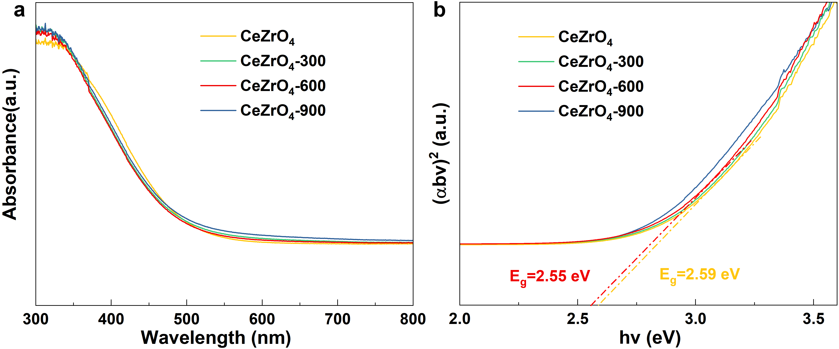
Figure S27. (a) UV–vis diffuse reflectance spectra (UV–vis–DRS) of CeZrO₄, CeZrO₄-300, CeZrO₄-600, and CeZrO₄-900. (b) Tauc plots of CeZrO₄, CeZrO₄-300, CeZrO₄-600, and CeZrO₄-900.

Section 6. DFT Calculation

Method
All Density Functional Theory (DFT) calculations were performed using the Vienna Ab initio Simulation Package (VASP)^{33,34}. The exchange correlation functional was described by the Perdew-Burke-Ernzerhof (PBE) functional method. It is based on the generalized gradient approximation (GGA). The cutoff energy base on the plane wave was set to 400 eV. Using K-point grids with densities of 2 × 2 × 1 for structure relaxations. A vacuum layer of 20 Å was introduced to avoid interlayer interactions. When the force on each atom is less than 0.01 eV/Å, the geometric optimization is terminated, and the energy convergence criterion was set to 1 × 10⁻⁵ eV. Moreover, the adsorption energy (E_{ads}) was defined by the equation (1).
$E_{ads}=E_{gas+slab}-E_{gas}-E_{slab}$ (1)
Among them, E_{ads}, E_{gas+slab}, E_{slab} and E_{gas} respectively represent the total system energy of adsorption energy, adsorbing gas cubic (Fm-3m) and tetragonal (P4₂/nmc) phases of CeZrO₄, energy of Fm-3m and P4₂/nmc, and the energy before adsorption of NO₂ molecules. Bader’s quantum theory of atoms in molecules (QTAIM) was used to calculate electron transfer in the system. The electron transfer (Δρ) was defined by the equation (2).
$∆ρ={∆ρ}_{gas+slab}-(ρ_{gas}+ρ_{slab})$ (2)

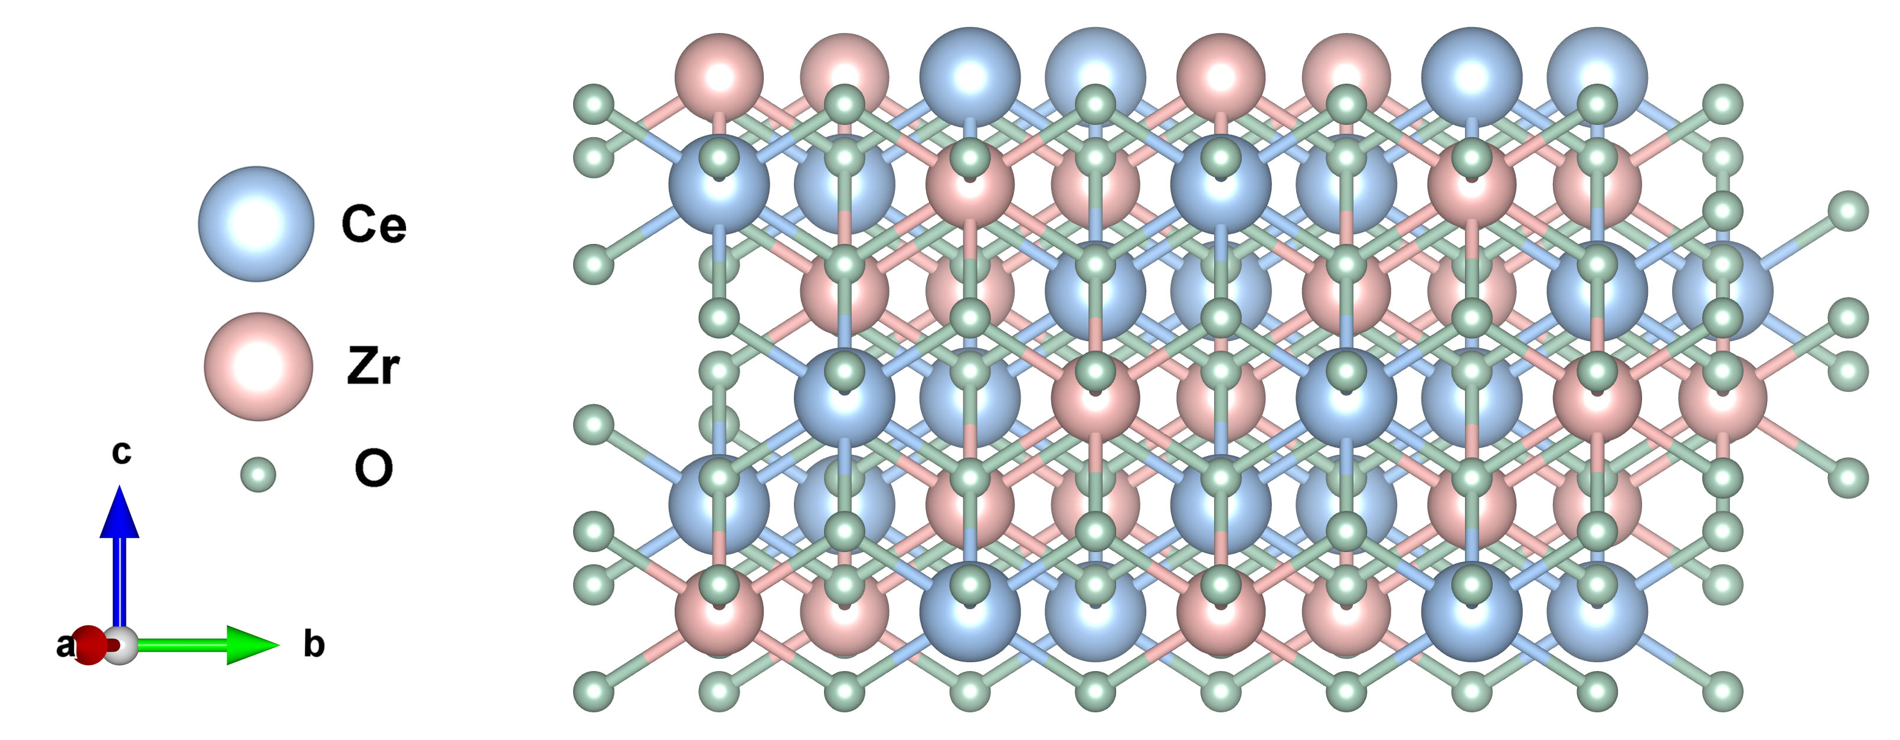
Figure S28. Cubic (Fm-3m) c-CeZrO₄ molecular model.

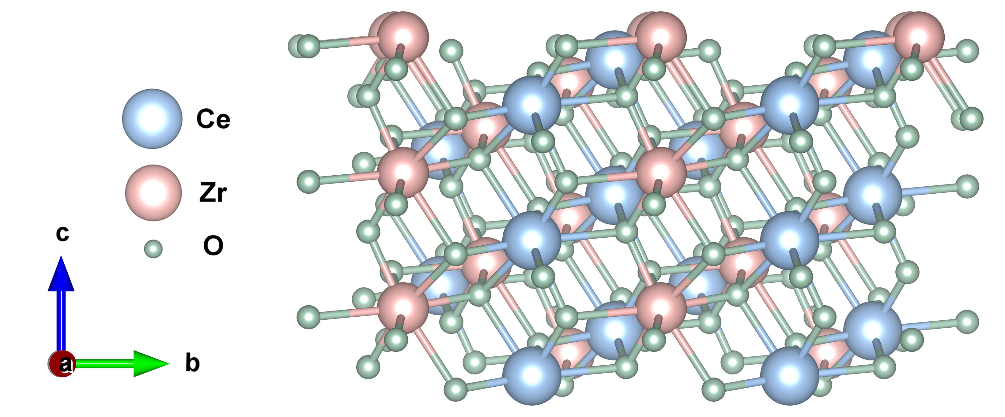
Figure S29. Tetragonal (P4₂/nmc) t-CeZrO₄ molecular model.
Section 7. Wireless NO₂ Sensing and Detection System

Method
To assess the practical performance of the portable CeZrO₄-600-based NO₂ sensor under real-world conditions, field tests were conducted near vehicle exhaust outlets. The sensor was integrated with a compact back-end circuit, transmitting NO₂ concentration, temperature, and relative humidity data at 1 Hz via Bluetooth to a custom smartphone application for real-time monitoring. A commercially available, manufacturer-calibrated portable NO₂ analyzer was used as a reference, with its sampling inlet positioned approximately 5-10 cm from the exhaust to evaluate dilution effects. Prior laboratory calibration ensured accurate sensor response, and interference tests confirmed negligible cross-sensitivity to other common exhaust gases. Measurements captured both cold-start and post-acceleration idle conditions, enabling assessment of dynamic NO₂ fluctuations and the robustness of sensors under fluctuating temperature and humidity.
Correlation to Euro 7 Emission Limits
The observed exhaust NO₂ concentration (3–30 ppm) falls within the range relevant to Euro 7 real-driving emission (RDE) monitoring, where on-road nitrogen oxides (NO_{x}, mainly nitric oxide (NO) and nitrogen dioxide (NO₂)) are tightly regulated to ensure compliance with next-generation emission standards (≤60 mg km⁻¹ for gasoline and ≤80 mg km⁻¹ for diesel vehicles)^{35,36}. In typical vehicle exhaust, NO constitutes approximately 70–90% of total NO_{x}, while NO₂ accounts for the remaining fraction. However, since NO is rapidly oxidized to NO₂ upon exposure to oxygen and sunlight in the exhaust plume, direct NO₂ monitoring provides a more reliable indicator of atmospheric impact and regulatory compliance. Translating these regulatory limits into concentration ranges under realistic exhaust flow and dilution conditions yields typical NO₂ levels of several ppm to tens of ppm during transient driving or idling phases. Therefore, the detection range and precision of the CeZrO₄-600 sensor are well aligned with the Euro 7 RDE regime, confirming its suitability for compliance-oriented diagnostics and potential integration into onboard or portable emission monitoring systems designed for real-world conditions.
Calculation of Relative Error
The relative error (RE) of the NO₂ sensor was calculated to evaluate measurement accuracy, using the following equation:
$$\text{RE}\left(\text{\%}\right)\text{=}\frac{\text{|}{\text{C}}_{\text{measured}}\text{-}{\text{C}}_{\text{reference}}\text{|}}{{\text{C}}_{\text{reference}}}\text{×100}$$
where C_{measured} is the NO₂ concentration obtained from the wireless sensing system, and C_{reference} is the known or nominal concentration during calibration. This metric provides a quantitative assessment of the sensor's precision across the tested concentration range.
The wireless module integrates a NO₂ sensor with temperature and humidity sensors. A programmable controller discriminates among the sensor signals, which are processed through a signal conversion system and the STM32 F microcontroller. Data are then transmitted via a Bluetooth module (XY-MB-026 A) for real-time display on a mobile device, enabling accurate and instantaneous monitoring of environmental conditions.

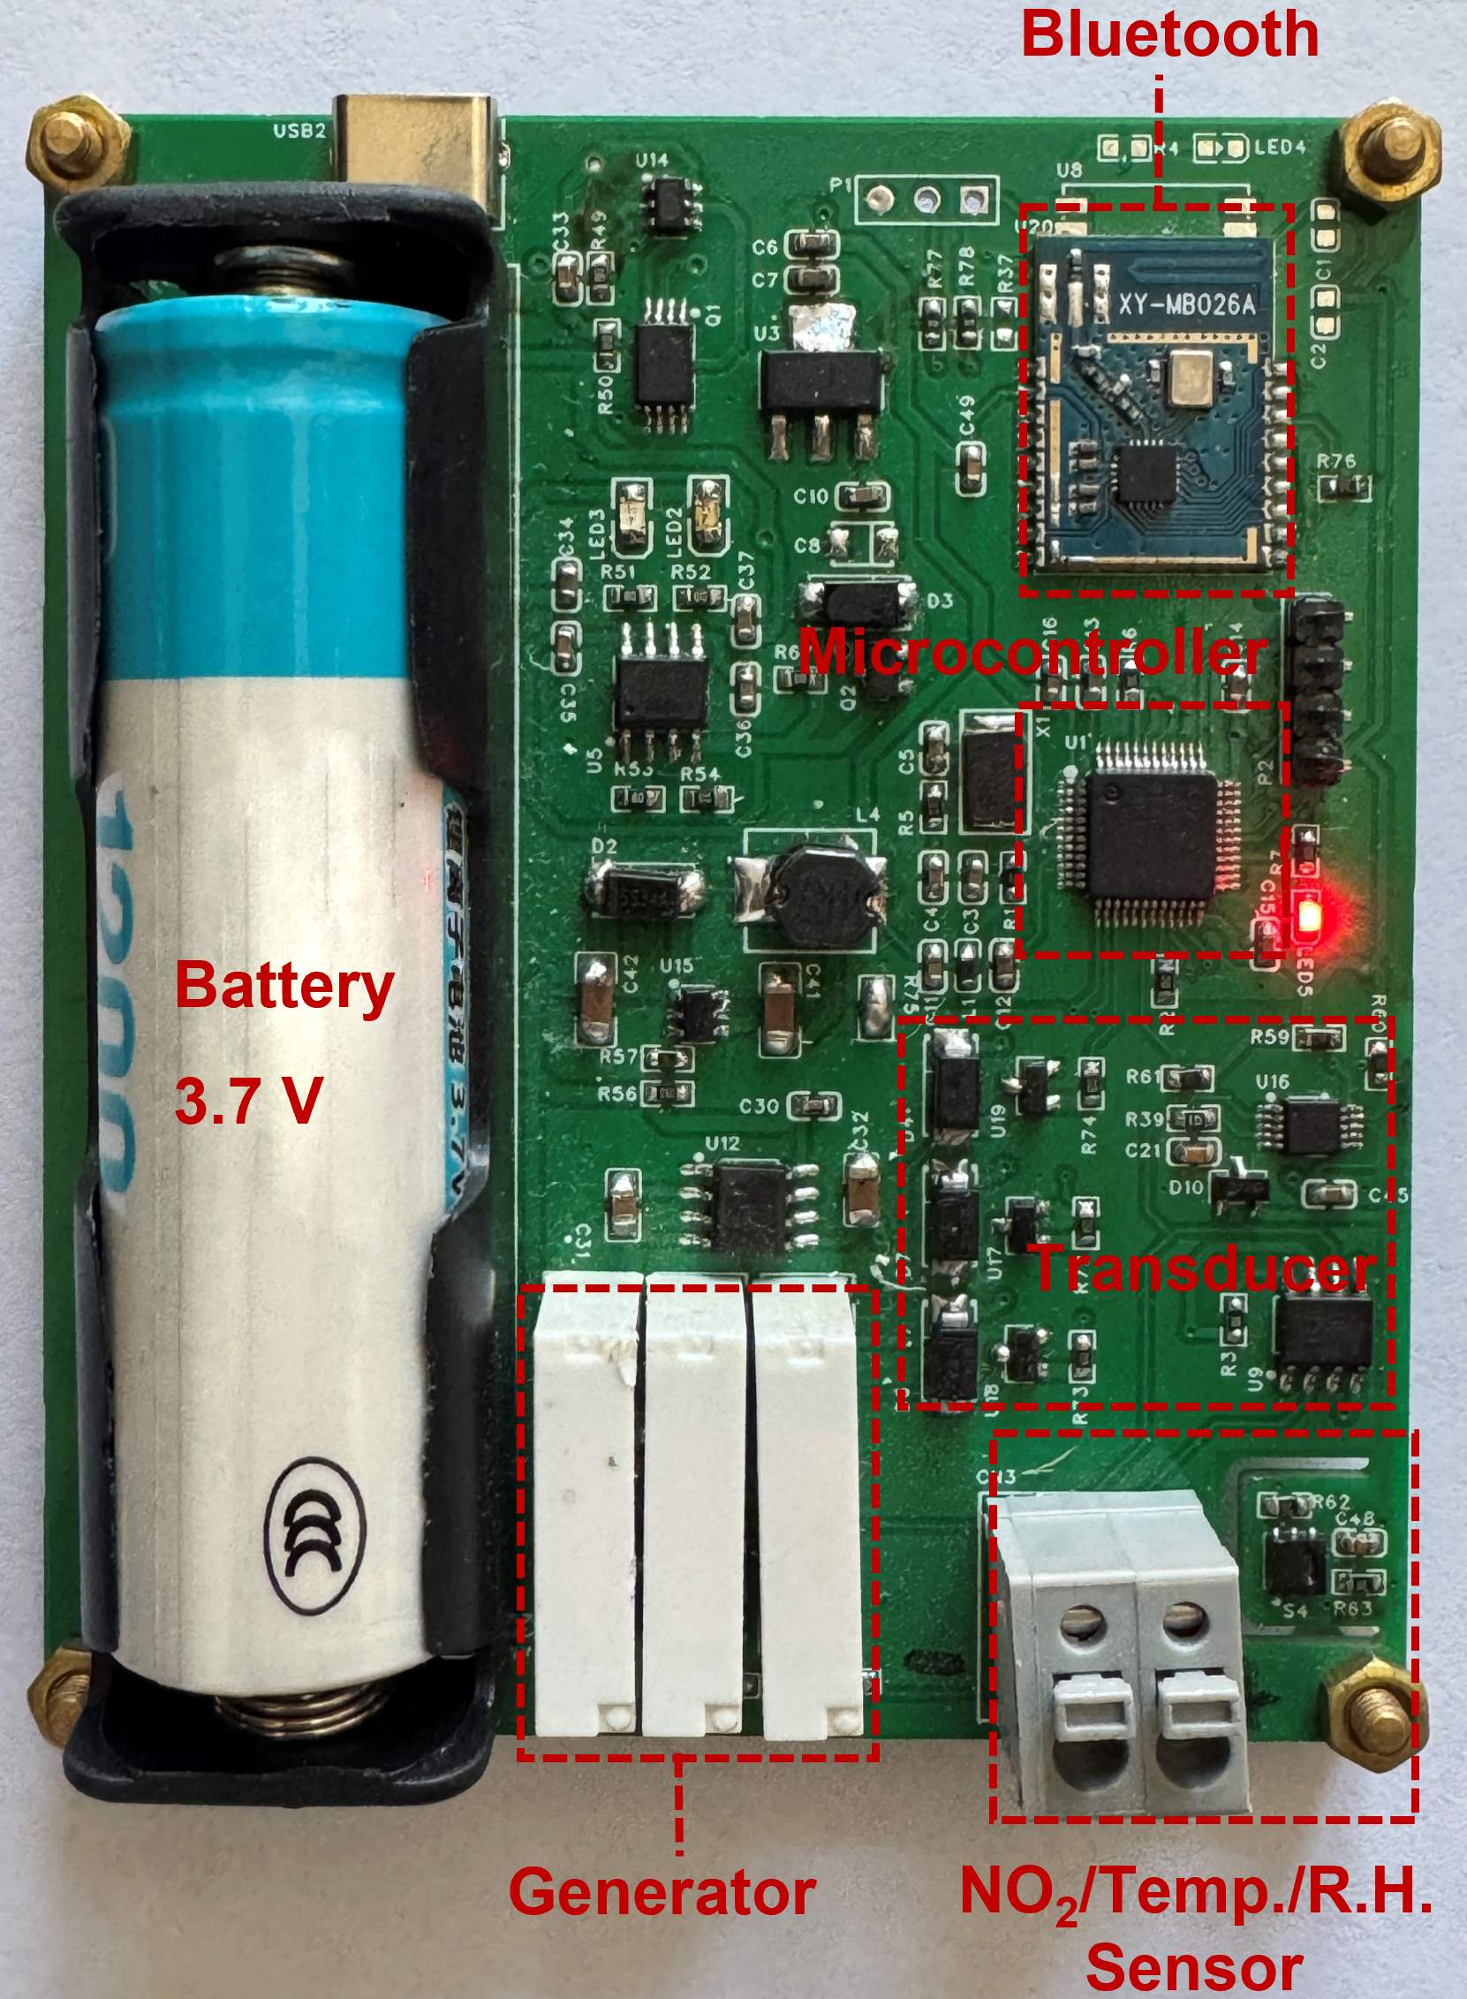
Figure S30. Photograph of the wireless NO₂ sensing module.

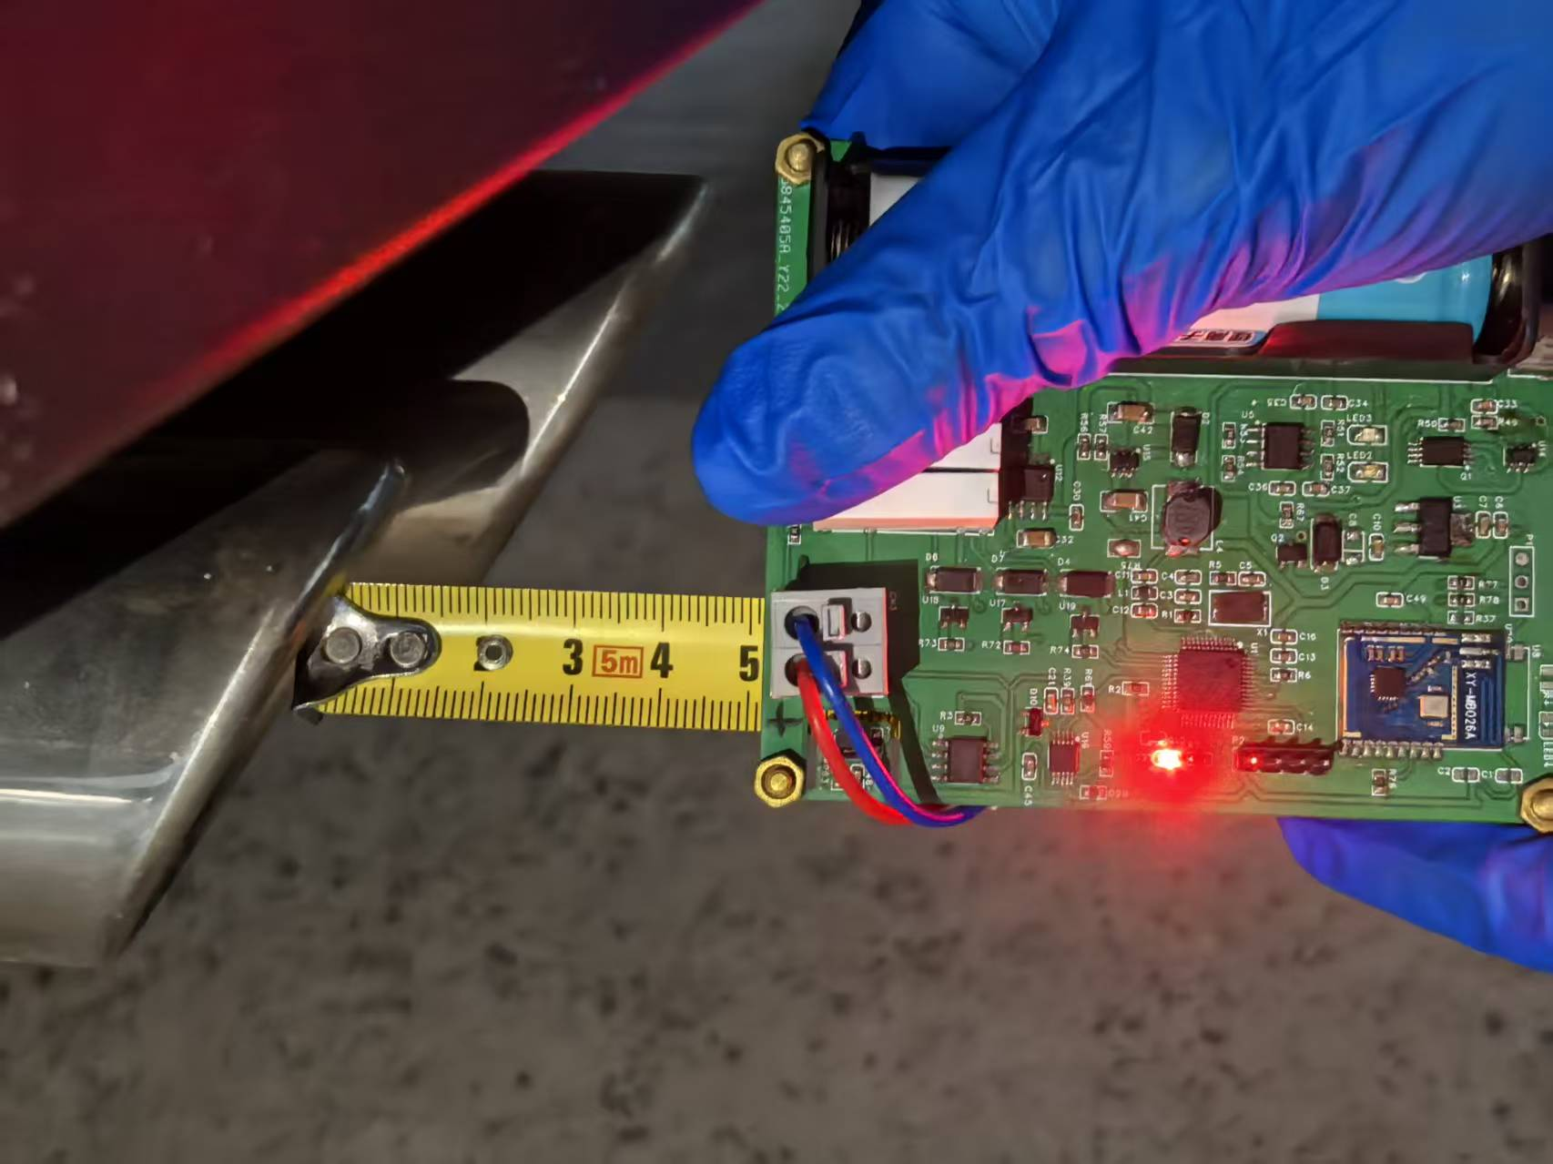
Figure S31. Photograph of real-time on-site vehicle exhaust monitoring using the wireless NO₂ sensing system.

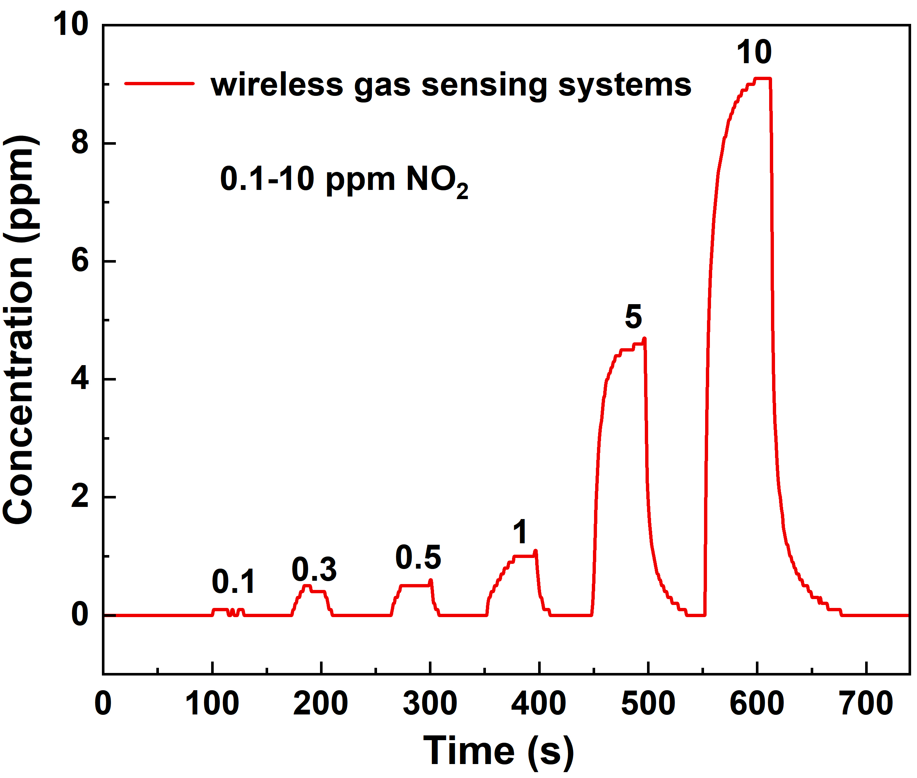
Figure S32. Dynamic response curves of the wireless NO₂ detection system based on CeZrO₄-600 over a concentration range of 0.1 to 10 ppm.

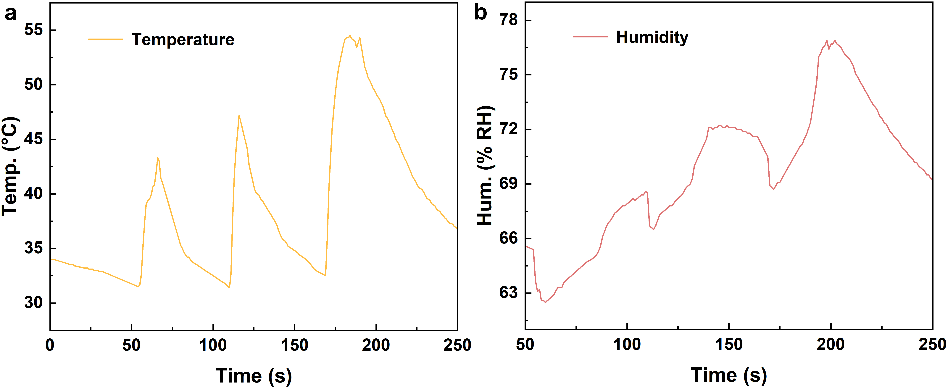
Figure S33. a) Temperature and b) humidity variation curves under three different revolutions per minute (RPM) conditions.

Section 8. ML-Assisted Processing of Exhaust Signals

Method
We process NO₂ concentration time series from sensor readings. Raw signals often contain impulsive spikes and high-frequency noise. To mitigate these issues before model training, we apply a two-stage preprocessing approach. First, we use a sliding-window Hampel filter to replace samples deviating significantly from the local median, which helps suppress impulsive noise while preserving underlying trends. Second, we apply IQR Winsorization to clip values outside a specified range, reducing the impact of rare, extreme excursions without distorting the central tendency. The preprocessed data are then standardized for model input.
Since clean ground truth is unavailable, we generate a pseudo-reference curve by applying a 4th-order Butterworth low-pass filter, followed by Savitzky-Golay smoothing. This smooth curve captures low-frequency components while filtering out high-frequency fluctuations, serving as weak supervision for model training. To enhance model stability and generalization, we standardize the time series using a global StandardScaler, then slice the signals into overlapping windows. Only training windows undergo augmentation, which includes additive Gaussian noise, small amplitude scaling, linear trend perturbation, weak sinusoidal perturbation, and random spikes. The last run is reserved for validation, while the rest is used for training.
We employ a residual Temporal Convolutional Network (TCN) to predict the noise component$r\left(x\right)$from the input $x$, yielding a denoised output $y=x-r(x)$. The network consists of an input convolution projecting to 64 channels, followed by eight residual blocks with 1D convolutions and dilation rates. After applying GELU activation, dropout, GroupNorm, and residual connections, a final convolution outputs the noise estimate. This architecture is designed to predict the noise rather than the clean signal, thus helping balance low and high-frequency components. The model is trained with a weighted sum of multiple loss functions: Smooth L1 loss between the model output and pseudo-reference, spectral consistency in the low-frequency band, DC consistency, low-frequency sliding consistency, peak consistency, and gradient consistency. The Adam optimizer is used, and training runs for up to 90 epochs with early stopping and gradient clipping to stabilize convergence. For postprocessing, we apply a three-stage approach to refine the denoised output. A rolling quantile baseline is computed to remove any residual baseline drift, followed by soft thresholding to suppress small noise while preserving weak signals. A hybrid gain calibration is applied to adjust for any amplitude discrepancies, and a soft-clipping function ensures that extreme values are not over-amplified. Finally, any negative values are clamped to zero to maintain physically plausible concentration levels.
To evaluate the performance of the model, we use several metrics, including Signal-to-Noise Ratio (SNR) for both the raw and denoised signals, frequency-domain SNR, event detection measures (e.g., precision, recall), and error distributions. These metrics provide a comprehensive understanding of the performance of model across various dimensions. All experiments are implemented in Python using NumPy, SciPy, scikit-learn, and PyTorch. Random seeds are fixed for reproducibility, and automatic mixed precision (AMP) is enabled when available.
Discussion and Analysis
The comparison of the cumulative distribution functions (CDF) and error histograms between the raw and denoised data demonstrates the substantial improvement brought by the machine learning (ML) algorithm in processing the exhaust signals (Figure S35). The CDF comparison reveals a clear distinction in the data distribution between the raw and denoised datasets, emphasizing the algorithm's effectiveness. Specifically, the denoised data exhibits a smoother CDF curve compared to the raw data, suggesting that the ML algorithm has successfully mitigated large error values and noise. This results in a more concentrated data distribution, indicating a significant reduction in noise while retaining key signal features, which is crucial for precise NO₂ quantification.
In the error histograms, the denoised data shows a marked reduction in the frequency of extreme error values, especially in error intervals associated with large negative errors. This visual evidence confirms that the ML algorithm effectively identifies and corrects for errors introduced by environmental noise, sensor fluctuations, or transient disturbances. Furthermore, in error intervals with smaller errors, the denoised data demonstrates an increased frequency, signifying that the algorithm preserves actual signal fluctuations that were previously obscured by noise. This balanced approach improves the signal-to-noise ratio (SNR) without distorting the true sensor response, ensuring more accurate and reliable NO₂ detection.
These improvements in error distribution directly enhance the performance of sensors under the stringent conditions outlined by Euro 7 emission regulations. A cleaner and more accurate error profile leads to more reliable NO₂ quantification, ensuring that the sensor meets regulatory standards and performs effectively in real-world dynamic exhaust environments.

The scatter plot intuitively illustrates the relationship between the original reference values and the denoised values obtained through the machine learning algorithm (Figure S36). Despite some degree of data dispersion, the points exhibit a clear linear trend, indicating the stability and consistency of the algorithm in signal processing. The fitted line has a slope of 1.08, an intercept of -1.03, and a coefficient of determination (R²) of 0.87. The high R² value confirms that the model accurately captures the correlation between the reference and denoised signals, suggesting that the algorithm effectively suppresses environmental noise while preserving key signal features. As discussed in the main text, this ensures that transient characteristics remain intact while the overall signal quality is markedly enhanced.
A slope greater than unity may imply slight amplification during denoising to emphasize critical signal components, whereas the negative intercept reflects a baseline offset possibly arising from model initialization or its treatment of specific noise patterns.This machine-learning–assisted signal reconstruction approach directly addresses the challenge of achieving high-precision NO₂ detection under dynamic exhaust conditions.

The short-time Fourier transform (STFT) power spectra in Figure S37 highlight the ML capability of algorithm for frequency-domain noise suppression—essential for preserving transient NO₂ features under dynamic exhaust conditions. In the raw spectrum, scattered high-power artifacts appear predominantly above 0.2 Hz, corresponding to mechanical and vibrational noise from engine operation. These components mask the low-frequency (~0.01–0.1 Hz) bands that encode genuine NO₂ concentration dynamics, such as the transient 15 ppm peak observed during engine start (Fig. 5f).
After denoising, the high-frequency noise is markedly attenuated, while the low-frequency signal power remains well preserved. This frequency-selective refinement exemplifies the advantage of the ML approach: unlike conventional smoothing methods that blur transient signatures, the algorithm enhances the signal-to-noise ratio (SNR) from 2.6 dB to 11 dB without compromising temporal fidelity.
Such capability is transformative for Euro 7 RDE testing, where the CeZrO₄-600 sensor successfully resolves rapid NO₂ transients—from ignition peaks to steady-state levels—and sustains accurate performance under fluctuating humidity (~70% RH) and temperature (~35 °C) conditions that typically challenge commercial detectors.

Under the Euro 7 emission regulations, stringent performance requirements are imposed on NO₂ sensors, making detection accuracy of paramount importance (Figure S38). The precision–recall (P–R) curve serves as a key metric for evaluating model performance. By comparing the P–R curves before and after denoising, deeper insights can be gained into the role of the machine-learning algorithm in enhancing the signal processing capability of the sensor.
As shown in the P–R plots, distinct differences are observed between the raw and denoised curves, indicating that the machine-learning algorithm substantially improves model performance. When the denoised curve lies above the raw one, it signifies that, at the same recall rate, the denoised model achieves higher precision. For NO₂ sensing, this translates to a greater proportion of true NO₂ signals among detected events, thereby reducing false positives and enhancing reliability.
In practical exhaust monitoring, raw signals are often distorted by complex and variable noise, leading to misclassification of NO₂ events. After denoising, the model can more effectively extract true signal features from background interference, improving overall detection accuracy. In regions of high recall, the pronounced increase in precision after denoising likely stems from the ability of the algorithm to eliminate non–NO₂-related disturbances, allowing more accurate recognition of genuine NO₂ emissions.
Together with the findings presented in the main text, these results confirm that the machine-learning–assisted denoising process not only enhances signal quality but also enables high-precision quantitative NO₂ detection. This capability directly supports compliance with the demanding Euro 7 standards, offering a robust technical foundation for next-generation exhaust emission monitoring and control systems.

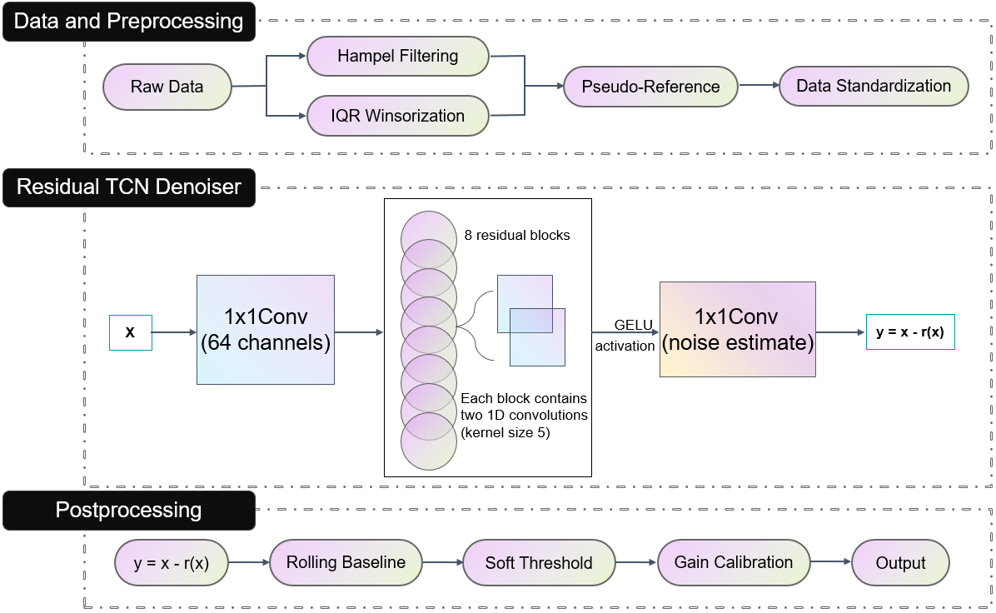
Figure S34. Schematic of the machine learning workflow

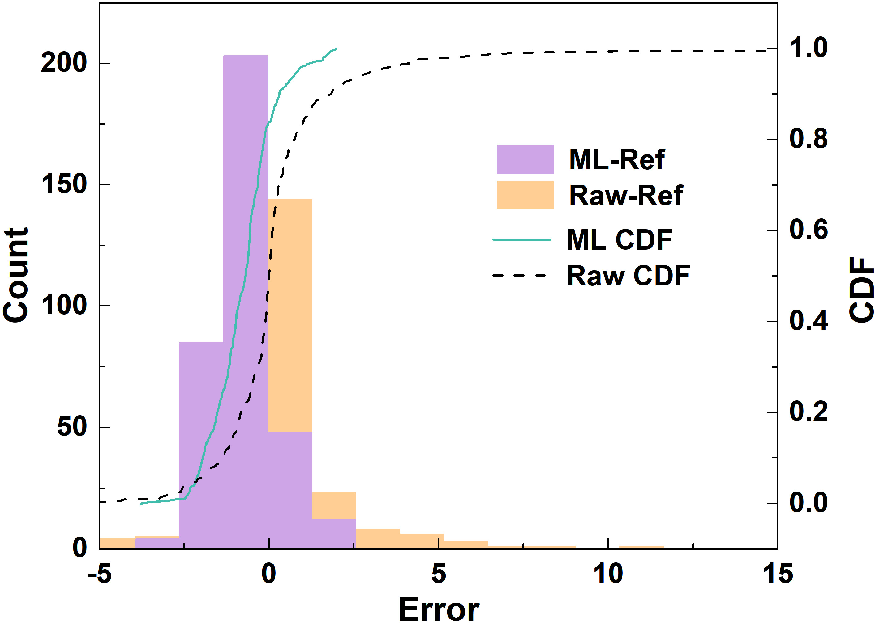
Figure S35. Histogram and empirical cumulative distribution function (CDF) of the residuals for Raw-Ref and Denoised-Ref.

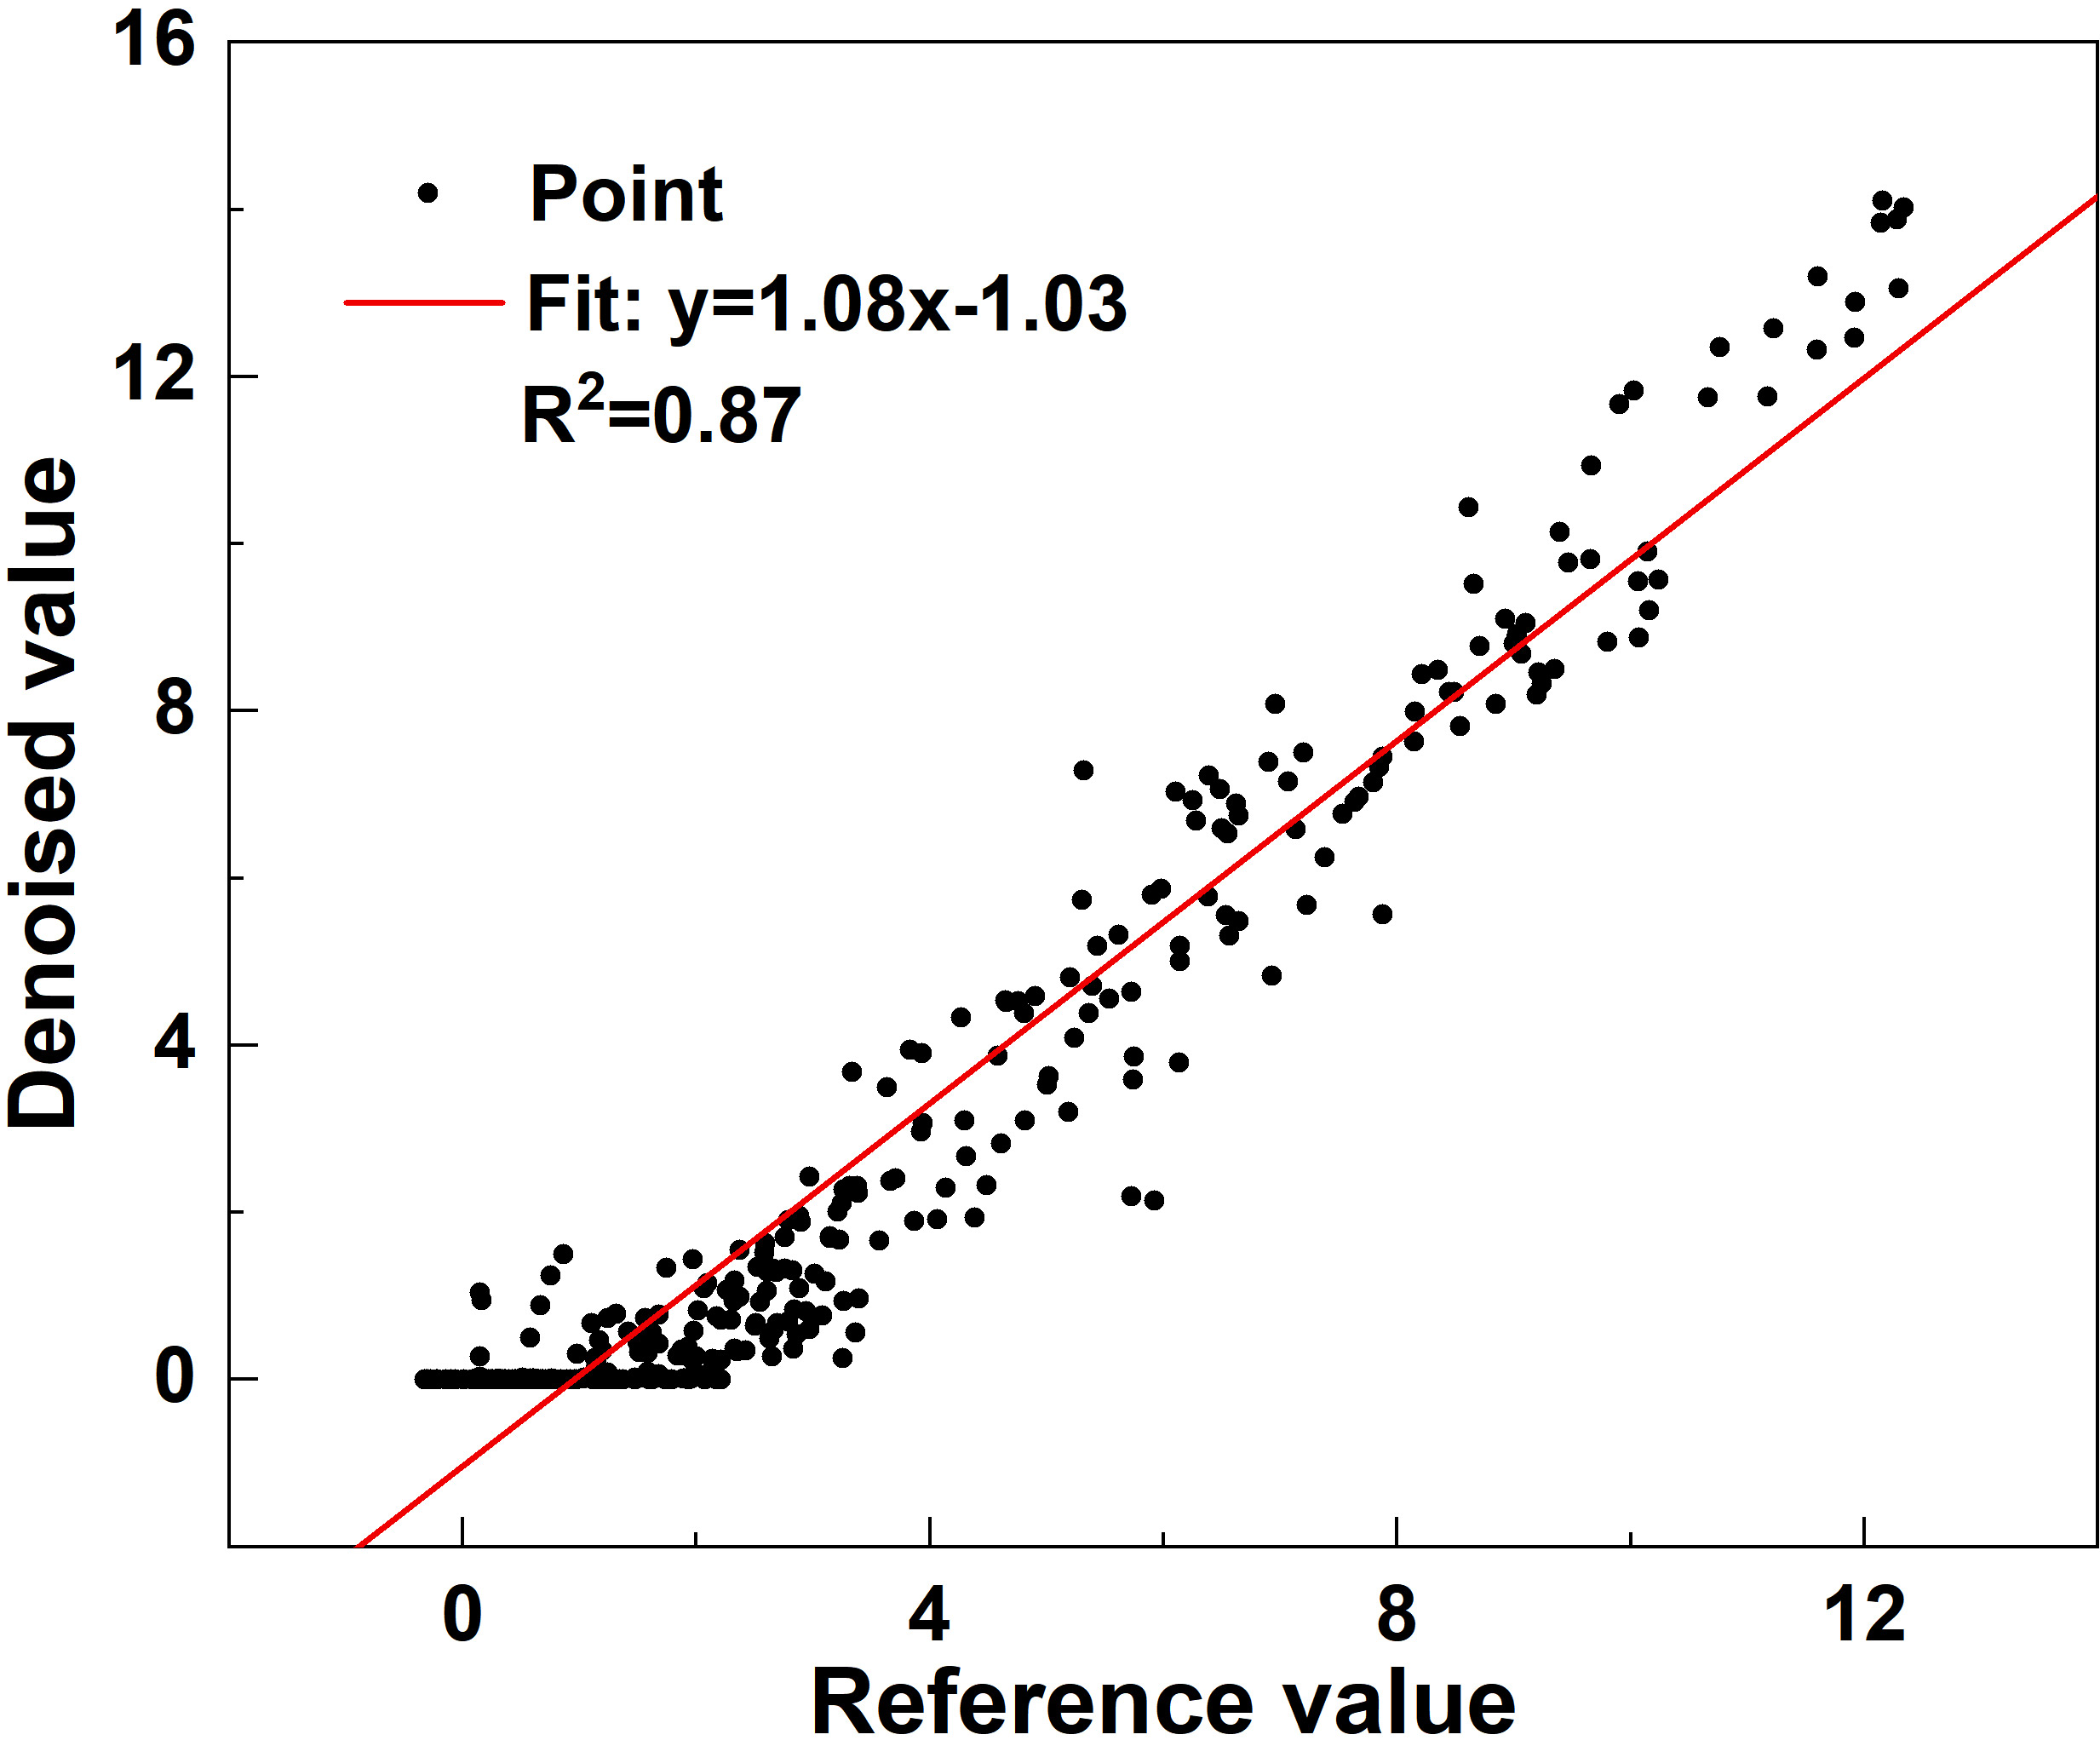
Figure S36. Calibration scatter plot.

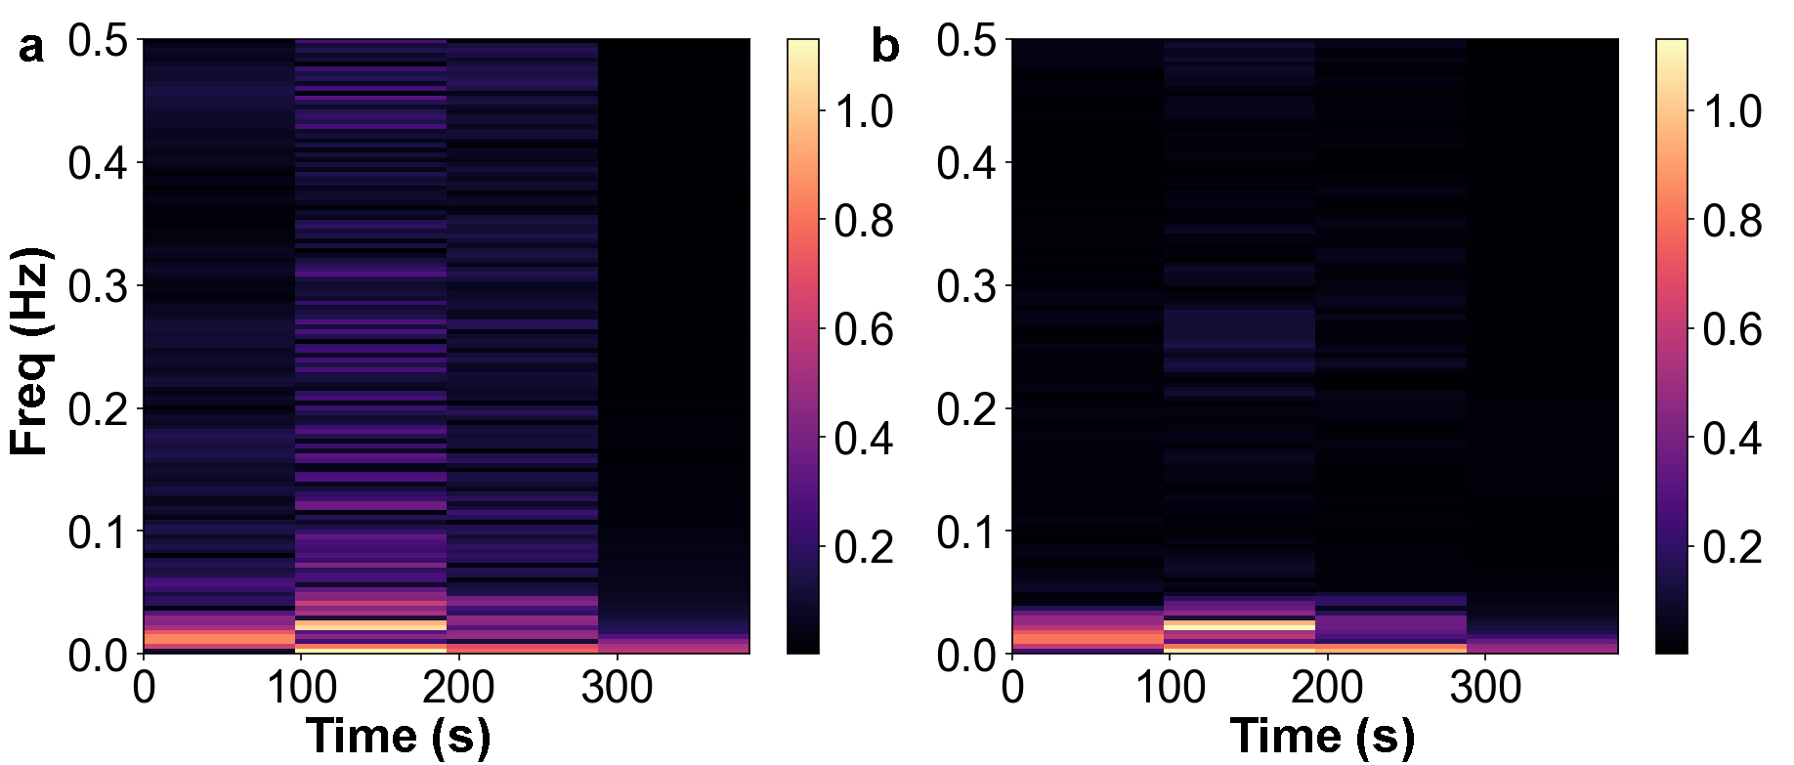
Figure S37. Short-Time Fourier Transform (STFT) Power Spectra of a) Raw and b) Denoised NO₂ Signals
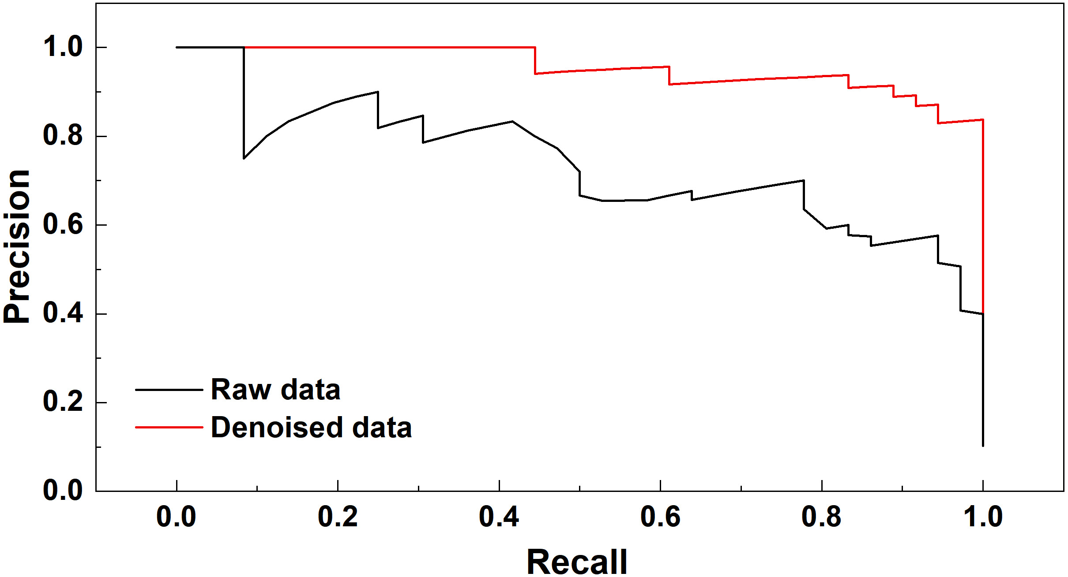
Figure S38. Comparison of Precision - Recall (P - R) Curves of Raw and Denoised Data.

Section 9. Supplementary References

1 Liu, Y., Cen, S., Cao, X. & Bu, C. Syngas production via Ce_{0.8}Zr_{0.2}O₂-based thermochemical co-splitting of H₂O and CO₂ and partial oxidation of methane: Achieving a 2:1 H₂/CO ratio. Chem. Eng. J. 497, 154598 (2024).
2 Zhou, H. et al. Boosting the efficient combustion of plastic wastes via tailoring the oxygen vacancies of Ce-Zr solid solution. Chem. Eng. J. 488, 150911 (2024).
3 Hou, W. et al. Catalytic Mechanism of Oxygen Vacancies in Perovskite Oxides for Lithium–Sulfur Batteries. Adv. Mater. 34, 2202222 (2022).
4 Huang, Z.-F. et al. Chemical and structural origin of lattice oxygen oxidation in Co–Zn oxyhydroxide oxygen evolution electrocatalysts. Nat. Energy 4, 329-338 (2019).
5 Zhao, X. et al. Titanium nitride sensor for selective NO₂ detection. Nat. Commun. 16, 182 (2025).
6 Mo, X. et al. Nitrogen-Doped Indium Oxide Electrochemical Sensor for Stable and Selective NO₂ Detection. Adv. Mater. 36, 2409294 (2024).
7 Gao, F. et al. Low-cost and high-stable C-SiO₂-PTFE gas diffusion membrane for ultrafast electrochemical NO₂ sensor. Sens. Actuators, B 425, 136997 (2025).
8 Park, S. et al. Imparting Metal Oxides with High Sensitivity Toward Light-Activated NO₂ Detection Via Tailored Interfacial Chemistry. Adv. Funct. Mater. 33, 2214008 (2023).
9 Liu, J. et al. Flexible, Breathable and Hydrophobic SnO₂–SnS₂–SiO₂/SiO₂All-Inorganic Self-Supporting Nanofiber Membrane for Ultralow-Concentration NO₂ Sensing Under High Humidity. Adv. Funct. Mater. 35, 2410833 (2025).
10 Ou, Y. et al. Strong Metal–Support Interaction Induces Dual Reaction Sites for Ultrasensitive and Stable NO₂ Detection in Extreme Environments. Adv. Funct. Mater. 35, 2416605 (2025).
11 Kim, S. et al. Aerosol-Synthesized Surfactant-Free Single-Walled Carbon Nanotube-Based NO₂ Sensors: Unprecedentedly High Sensitivity and Fast Recovery. Adv. Mater. 36, 2313830 (2024).
12 Park, S. et al. Dual-Photosensitizer Synergy Empowers Ambient Light Photoactivation of Indium Oxide for High-Performance NO₂ Sensing. Adv. Mater. 36, 2313731 (2024).
13 Wei, S. et al. A Self-Powered Portable Nanowire Array Gas Sensor for Dynamic NO₂ Monitoring at Room Temperature. Adv. Mater. 35, 2207199 (2023).
14 Deng, W.-H., Zhang, M.-Y., Li, C.-S., Yao, M.-S. & Xu, G. Energy-Level Alignment at TiO₂@NH₂-MIL-125 Interface for High-Performance Gas Sensing. Angew. Chem. Int. Ed. 64, e202419195 (2025).
15 Kim, S. et al. Three-Dimensional MoS₂/MXene Heterostructure Aerogel for Chemical Gas Sensors with Superior Sensitivity and Stability. ACS Nano 17, 19387-19397 (2023).
16 Zhang, H. et al. Eco-friendly triboelectric nanogenerator for self-powering stacked In₂O₃ nanosheets/PPy nanoparticles-based NO₂ gas sensor. Nano Energy 128, 109978 (2024).
17 Womack, C. C. et al. A lightweight broadband cavity-enhanced spectrometer for NO₂ measurement on uncrewed aerial vehicles. Atmos. Meas. Tech. 15, 6643-6652 (2022).
18 Li, C. et al. Thermal dissociation cavity-enhanced absorption spectrometer for measuring NO₂, RO₂NO₂, and RONO₂ in the atmosphere. Atmos. Meas. Tech. 14, 4033-4051 (2021).
19 Karhu, J., Hieta, T., Manoocheri, F., Vainio, M. & Ikonen, E. LED-Based Photoacoustic NO₂ Sensor with a Sub-ppb Detection Limit. ACS Sens. 6, 3303-3307 (2021).
20 Patimisco, P. et al. Quartz-Enhanced Photoacoustic Sensor Based on a Multi-Laser Source for In-Sequence Detection of NO₂, SO₂, and NH₃. Sensors 23 (2023).
21 Sobanski, N. et al. Advances in High-Precision NO₂ Measurement by Quantum Cascade Laser Absorption Spectroscopy. Applied Sciences 11 (2021).
22 Tanyeli, I. et al. Nanoplasmonic NO₂ Sensor with a Sub-10 Parts per Billion Limit of Detection in Urban Air. ACS Sens. 7, 1008-1018 (2022).
23 Landis, M. S. & Edgerton, E. S. Field intercomparison of continuous ambient FRM and FEM NO₂ instruments in the Athabasca Oil Sands Region, Alberta, Canada and the potential impact on ambient regulatory compliance. Journal of the Air & Waste Management Association 74, 11-24 (2024).
24 Al-Jalal, A., Al-Basheer, W., Gasmi, K. & Romadhon, M. S. Measurement of low concentrations of NO₂ gas by differential optical absorption spectroscopy method. Measurement 146, 613-617 (2019).
25 Awada, C., Shaalan, N. M., Dab, C. & Ruffino, F. Detection of hot electron-driven photochemical reaction of steady- state NO₂ gas molecules by surface–enhanced Raman spectroscopy. Appl. Surf. Sci. 604, 154577 (2022).
26 Debliquy, M. et al. Optical Fibre NO₂ Sensor Based on Lutetium Bisphthalocyanine in a Mesoporous Silica Matrix. Sensors 18 (2018).
27 Rianjanu, A., Fauzi, F., Triyana, K. & Wasisto, H. S. Electrospun Nanofibers for Quartz Crystal Microbalance Gas Sensors: A Review. ACS Appl. Nano Mater. 4, 9957-9975 (2021).
28 Cruz, C. et al. Carbon SH-SAW-Based Electronic Nose to Discriminate and Classify Sub-ppm NO₂. Sensors 22 (2022).
29 Small, L. J. et al. Near-Zero Power MOF-Based Sensors for NO₂ Detection. Adv. Funct. Mater. 30, 2006598 (2020).
30 Ikuta, T. et al. Electrical detection of ppb region NO₂ using Mg-porphyrin-modified graphene field-effect transistors. Nanoscale Adv. 3, 5793-5800 (2021).
31 Malik, S. et al. Paper-based sensors: affordable, versatile, and emerging analyte detection platforms. Anal. Methods 16, 2777-2809 (2024).
32 Zhang, R., Luo, N., Yang, W., Liu, N. & Chen, B. Low-temperature selective catalytic reduction of NO with NH₃ using perovskite-type oxides as the novel catalysts. J. Mol. Catal. A: Chem. 371, 86-93 (2013).
33 Hu, H. et al. An ultra-low Pt metal nitride electrocatalyst for sustainable seawater hydrogen production. Energy Environ. Sci. 16, 4584-4592 (2023).
34 Zhang, Z. et al. Enhanced Room-Temperature NO₂ Sensing through Deep Functional Group Hybridization in Nitrogen-Doped Monolayer Ti₃C₂Tx. ACS Sens. 9, 4134-4142 (2024).
35 Official Journal of the European Union. Commission Implementing Regulation (EU) 2025/1706 of 25 July 2025; https://eur-lex.europa.eu/legal-content/EN/TXT/?uri=CELEX:32025R1706 (accessed 22 Nov 2025).
36 European Commission. The European Green Deal, COM (2019) 640 final; https://eur-lex.europa.eu/legal-content/EN/TXT/?uri=CELEX:52019DC0640 (accessed 22 Nov 2025).

