Supplementary Materials
Genotype-Phenotype of Patients with PRPH2-Associated Retinal Dystrophy: Novel Insights on Foveal Structure and Visual Outcomes

Supplementary Figure 1. Four phenotypic groups in PRPH2-IRD.
Supplementary Figure 2. Phenotype-specific methodology for measuring CMT and EZ thickness.
Supplementary Table 1. Causative PRPH2 variants in the study cohort.
Supplementary Table 2. Phenotypic and genotypic analysis of the study cohort.
Supplementary Table 3. Characteristics of PRPH2-IRD patients included in the CMT thickness quantitative analysis.
Supplementary Table 4. Characteristics of PRPH2-IRD patients included in the EZ thickness quantitative analysis.

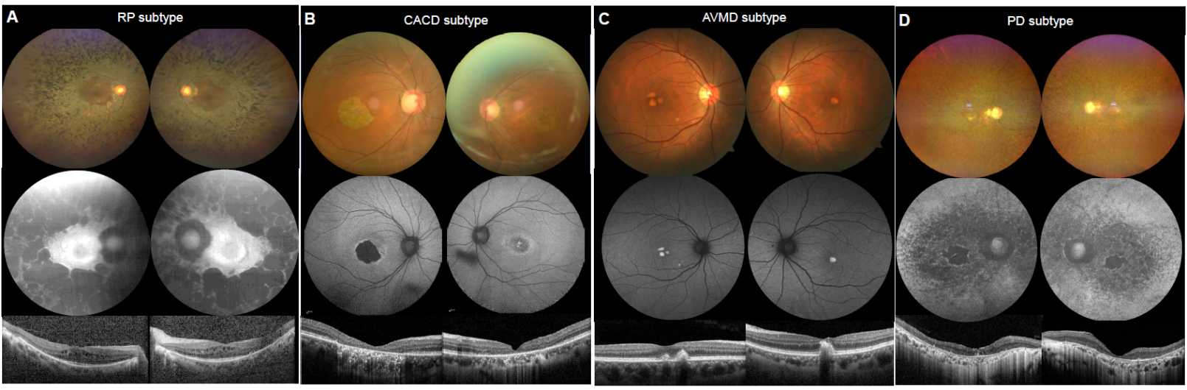

Supplementary Figure 1. Four phenotypic groups in PRPH2-IRD. (A) RP subtype: peripheral-to-central progression featuring mid-peripheral outer retinal thinning with foveal sparing. (B) CACD subtype: macular-predominant degeneration with RPE-choroid atrophy, and EZ loss. (C) AVMD subtype: progressive EZ-RPE elevation in OCT. Bilateral foveal yellow and round lesions in CFP. (D) PD subtype: Bilateral irregular lesions with decreased FAF in the fovea.
Abbreviation: IRD, inherited retinal dystrophy, RP, retinitis pigmentosa; CACD, central areolar choroidal dystrophy; AVMD, adult vitelliform macular dystrophy; PD, pattern dystrophy; RPE, retinal pigment epithelium; EZ, ellipsoid zone; OCT, optical coherence tomography; CFP, color fundus photograph; FAF, fundus autofluorescence.

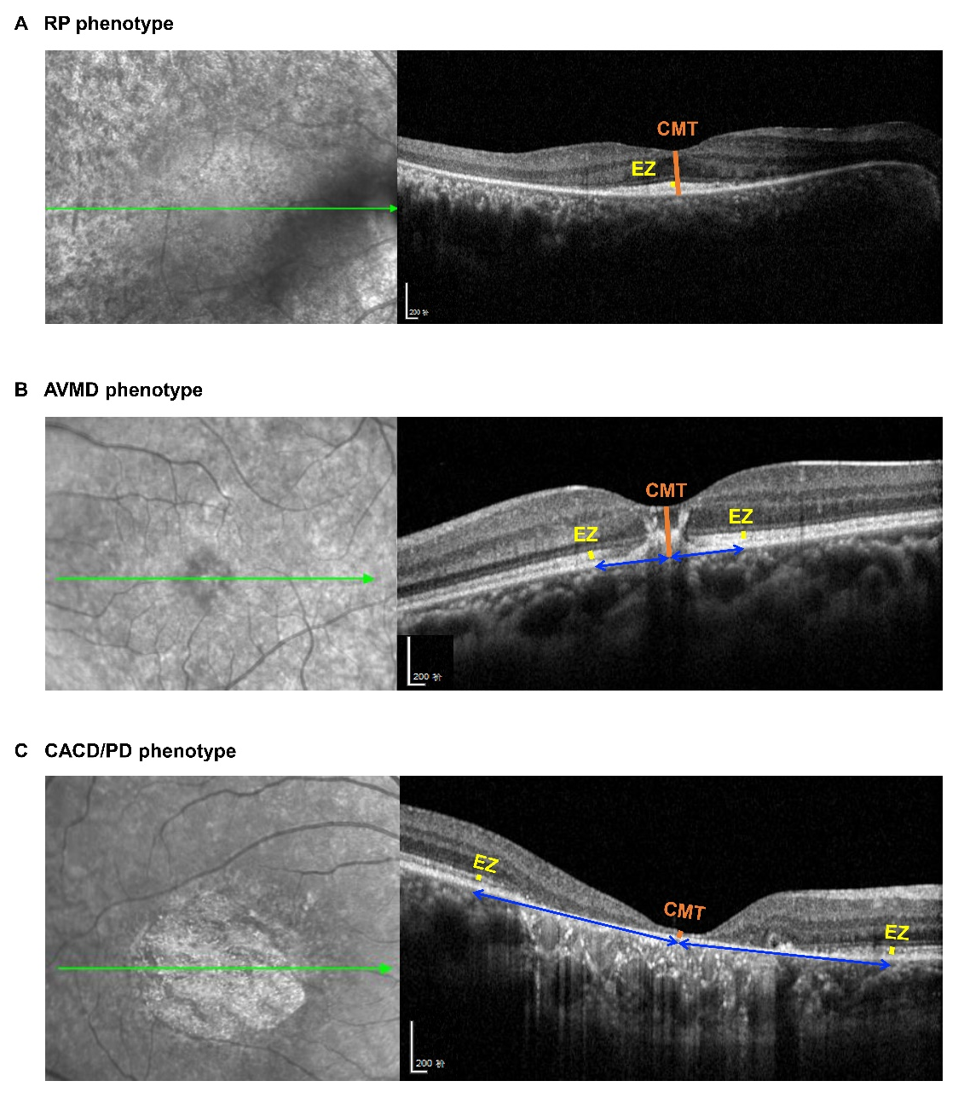
Supplementary Figure 2. Phenotype-specific methodology for measuring CMT and EZ thickness.
(A) In RP, the CMT and EZ thickness were measured at the center of the fovea.
(B) In AVMD with central involvement, EZ thickness measurements were taken in the nearest unaffected macular regions bilaterally symmetric to the fovea, and the average was calculated. The CMT was measured in the central macular.
(C) In CACD/PD with geographic atrophy, EZ thickness measurements were obtained from preserved macular areas located symmetrically outside the margin of atrophy, and the bilateral mean was used for analysis. The CMT was measured in the central macular.
Abbreviation: CMT, central macular thickness; EZ, ellipsoid zone; RP, retinitis pigmentosa; AVMD, adult vitelliform macular dystrophy; CACD, central areolar choroidal dystrophy; PD, pattern dystrophy.

Supplementary Table 1. Causative PRPH2 variants in the study cohort.

ID | Diagnosis | Nucleotide change | Protein changes | Type | Co-Seg | Exon | Mutation |  |  |  | Source
 |  |  |  |  |  |  | SIFT | Polyphen2 | Mutation taster | CADD | Source
01 | RP | c.595_607dup | p.R203Qfs*19 | Frameshift | NA | 2 | NA | NA | DC | NA | Novel
02 | AVMD | c.692C>A | p.S231X | Nonsense | NA | 2 | NA | NA | DC | 28.1 | Known
03 | PD | c.424C>T | p.R142W | Missense | NA | 1 | Deleterious | Probably damaging | DC | 8.5 | Known
04 | CACD | c.777del | p.S259Rfs*4 | Frameshift | NA | 2 | NA | NA | DC | NA | Novel
06 | AVMD | c.28C>T | p.Q10X | Nonsense | NA | 1 | NA | NA | DC | 20.6 | Known
10 | RP | c.458A>G | p.K153R | Missense | NA | 1 | Deleterious | Probably damaging | DC | 26.6 | Known
1001 | RP | c.458A>G | p.K153R | Missense | NA | 1 | Deleterious | Probably damaging | DC | 26.6 | Known
12 | RP | c.643A>C | p.N215H | Missense | NA | 2 | Deleterious | Possibly damaging | DC | 25.8 | Known
13 | CACD | c.603_620dup | p.R203_G208dup | Nonframeshift insertion | NA | 2 | NA | NA | DC | NA | Novel
15 | RP | c.911_912dup | p.G305Rfs*20 | Frameshift | NA | 3 | NA | NA | DC | NA | Novel
17 | AVMD | c.578_579del | p.K193Rfs*24 | Frameshift | NA | 1 | NA | NA | DC | NA | Known
19 | CACD | c.533A>G | p.Q178R | Missense | NA | 1 | Deleterious | Probably damaging | DC | 25.1 | Known
21 | CACD | c.424C>T | p.R142W | Missense | NA | 1 | Deleterious | Probably damaging | DC | 8.5 | Known
22 | RP | c.508G>A | p.G170S | Missense | NA | 1 | Tolerated | Benign | DC | 26.4 | Known
24 | CACD | c.568A>G | p.K190E | Missense | NA | 1 | Tolerated | Benign | DC | 24.1 | Novel
25 | RP | c.206T>C | p.V69A | Missense | NA | 1 | Tolerated | Benign | DC | 21.1 | Novel
26 | CACD | c.698A>G | p.H233R | Missense | NA | 2 | Deleterious | Probably damaging | DC | 25.1 | Known
29 | PD | c.647C>G | p.P216R | Missense | NA | 2 | Deleterious | Probably damaging | DC | 29.3 | Known
30 | RP | c.136C>T | p.R46X | Nonsense | NA | 1 | NA | NA | DC | 37 | Known
31 | RP | c.702C>G | p.Y234X | Nonsense | NA | 2 | NA | NA | DC | 38 | Novel
32 | RP | c.469G>A | p.D157N | Missense | NA | 1 | Deleterious | Probably damaging | DC | 29.6 | Known
33 | CACD | c.789del | p.S264Pfs*14 | Frameshift | NA | 2 | NA | NA | DC | NA | Novel
3301 | AVMD | c.789del | p.S264Pfs*14 | Frameshift | NA | 2 | NA | NA | DC | NA | Novel
36 | AVMD | c.826G>T | p.E276X | Nonsense | NA | 2 | NA | NA | DC | 43 | Known
37 | RP | c.367C>T | p.R123W | Missense |  | 1 | Deleterious | Benign | DC | 22.4 | Known
38 | RP | c.533A>G | p.Q178R | Missense | NA | 1 | Deleterious | Probably damaging | DC | 26.6 | Known
40 | PD | c.599T>A | p.V200E | Missense |  | 2 | Deleterious | Possibly damaging | DC | 32 | Known
4001 | CACD | c.599T>A | p.V200E | Missense |  | 2 | Deleterious | Possibly damaging | DC | 32 | Known
41 | CACD | c.920_921insCTTGAGGAATCTGAGAGCGAGAGCCAGGGCTGGCT | p.E309Rfs*27 | Frameshift | NA | 3 | NA | NA | DC | NA | Novel
42 | CACD | c.643A>C | p.N215H | Missense | NA | 2 | Deleterious | Possibly damaging | DC | 28.1 | Known
43 | RP | c.646C>T | p.P216S | Missense | NA | 2 | Deleterious | Possibly damaging | DC | 28.3 | Known
44 | RP | c.646C>G | p.P216A | Missense | NA | 2 | Deleterious | Possibly damaging | DC | 27.3 | Known
45 | RP | c.595_607dup | p.R203Qfs*19 | Frameshift | NA | 2 | NA | NA | DC | NA | Novel
46 | PD | c.920_921insCTTGAGGAATCTGAGAGCGAGAGCCAGGGCTGGCT | p.E309Rfs*27 | Frameshift | NA | 2 | NA | NA | DC | NA | Novel
Abbreviation: Co-Seg, Co-Segregation; RP, retinitis pigmentosa; AVMD, adult vitelliform macular dystrophy; PD, pattern dystrophy; CACD, central areolar choroidal dystrophy; NA, none available; DC, disease causing.

Supplementary Table 2. Phenotypic and genotypic analysis of the study cohort.
Characteristics | RP related mutations  (Protein domain) | CACD/PD related mutations  (Protein domain) | AVMD related mutations  (Protein domain)
Nonsense | p.R46X (LD*) | \ | p.Q10X (CD)
Nonsense | p.Y234X (LD) | \ | p.S231X (LD)
Nonsense |  | \ | p.E276X (TM)
Missense | p.V69A (TM) | p.R142W (LD) | \
 | p.R123W (TM) | p.Q178R (LD)
 | p.K153R (LD) | p.K190E (LD)
 | p.G170S (LD) | p.V200E (LD)
 | p.Q178R (LD) | p.N215H (LD)
 | p.N215H (LD) | p.P216R (LD)
 | p.P216S (LD)  p.P216A (LD) | p.H233R (LD)
Frameshift | p.R203Qfs*19 (LD) | p.S259Rfs*4 (LD) | p.K193Rfs*24 (LD)
 | p.G305Rfs*20 (CD) | p.S264Pfs*14 (LD) | p.S264Pfs*14 (LD)
 |  | p.E309Rfs*27 (CD)
Non-frameshift insertion | \ | p.R203_G208dup (LD) | \
Abbreviation: RP, retinitis pigmentosa; CACD, central areolar choroidal dystrophy; PD, pattern dystrophy; AVMD, adult vitelliform macular dystrophy; BPD, butterfly pattern dystrophy; LD, lumenal domain; TD, transmembrane domain; CD, cytoplasmic domain.

Supplementary Table 3. Characteristics of PRPH2-IRD patients included in the CMT thickness quantitative analysis.
 | Total | RP | AVMD | CACD | PD
Patients, n (%) | 32 (100%) | 14 (43.8%) | 4 (12.5%) | 9 (28.1%) | 5 (15.6%)
Eyes, n (%) | 59 (100%) | 26 (44.1%) | 8 (13.6%) | 16 (27.1%) | 9 (15.2%)
Age, y, mean±SD, range | 50.4±16.5 (22-73) | 51.6±11.8 (27-73) | 46.5±8.7 (35-56) | 55.9±11.4 (35-72) | 40.2±13.2 (22-55)
Gender, n (%)
Male | 19 (59.4%) | 8 (57.1%) | 2 (50.0%) | 5 (55.6%) | 4 (80.0%)
Female | 13 (40.6%) | 6 (42.9%) | 2 (50.0%) | 4 (44.4%) | 1 (20.0%)
Age of onset, y, mean±SD, range | 27.7±14.5 (1-60) | 21.3±12.9 (1-35) | 40.7±9.7 (30-49) | 27.0±19.2 (7-60) | 27.7±15.3 (16-45)
Disease duration, y, mean±SD, range | 23.1±16.4 (0-55) | 28.9±13.2 (6-52) | 2.7±2.5 (0-5) | 29.3±17.2 (12-55) | 9.7±3.5 (6-13)
Mean BCVA, logMAR, mean±SD | 1.00±0.73 | 0.73±0.77 | 0.48±0.23 | 1.56±0.65 | 0.63±0.49
CMT thickness, Mean (SD) | 214.1 (63.6) | 239.4 (61.5) | 219.1 (53.1) | 97.9 (66.6) | 134.8 (73.6)
Abbreviation: CMT, central macular thickness; RP, retinitis pigmentosa; AVMD, adult vitelliform macular dystrophy; CACD, central areolar choroidal dystrophy; PD, pattern dystrophy; logMAR, logarithm of the minimum angle of resolution.

Supplementary Table 4. Characteristics of PRPH2-IRD patients included in the EZ thickness quantitative analysis.
 | Total | RP | AVMD | CACD/PD
Patients, n (%) | 19 (100%) | 11 (58.0%) | 4 (21.0%) | 4 (21.0%)
Eyes, n (%) | 34 (100%) | 19 (55.9%) | 8 (23.5%) | 7 (20.6%)
Age, y, mean±SD, range | 49.0±14.0 (22-73) | 51.0±12.2 (27-73) | 46.5±8.7 (35-56) | 44.5±15.8 (22-62)
Gender, n (%)
Male | 9 (100%) | 5 (%) | 2 (50.0%) | 2 (50.0%)
Female | 10 (100%) | 6 (%) | 2 (50.0%) | 2 (50.0%)
Age of onset, y, mean±SD, range | 27.6±12.2 (7-49) | 25.2±8.5 (7-35) | 40.7±9.7 (30-49) | 21.0±17.1 (7-40)
Disease duration, y, mean±SD, range | 20.9±16.8 (0-55) | 25.9±5.4 (6-52) | 2.7±2.5 (0-5) | 25.7±25.9 (6-55)
Mean BCVA, logMAR, mean±SD | 0.46±0.28 | 0.32±0.22 | 0.48±0.23 | 0.69±0.26
EZ thickness, Mean (SD) | 23.5 (5.4) | 21.8 (3.1) | 30.2 (4.4) | 21.6 (2.2)
Abbreviation: EZ, ellipsoid zone; RP, retinitis pigmentosa; AVMD, adult vitelliform macular dystrophy; CACD, central areolar choroidal dystrophy; PD, pattern dystrophy; logMAR, logarithm of the minimum angle of resolution.

