Plasma Phosphorylated Tau 217, Plasma Phosphorylated Tau 181 and Aβ42/40 to Predict Early Brain Aβ Accumulation in People Without Cognitive Impairment
Supplementary Materials
Rui Bao, MBBS^{*,1}; Hongbo Bao, MD, PhD*^{,2,5}; Zhenzhen Yan, MD, PhD*^{,3}; Tonghua Zhang, MD, PhD^{*,1}; Xueying Li, MD, PhD^{*,4}; Wencai Ding, MD, PhD^{*,1}; for the A4 and LEARN Study
*Corresponding Author:
Wencai Ding, MD, PhD
The Second Affiliated Hospital of Wannan Medical College Wuhu, 241000, China
E-mail: dingneurology@gmail.com
Xueying Li, MD, PhD
Department of Neurology, The First Affiliated Hospital of Dalian Medical University, Dalian, 116011, China.
E-mail: xueyingli0616@163.com
Tonghua Zhang, MD, PhD
The Second Affiliated Hospital of Wannan Medical College Wuhu, 241000, China
E-mail: zth7607@163.com
Affiliations:
1. The Second Affiliated Hospital of Wannan Medical College, Wuhu, 241000, China
- Department of Neurosurgery, Beijing Tiantan Hospital, Capital Medical University, Beijing, 100070, China.
- The fourth affiliated hospital zhejiang university school of medicine, Jinhua, 322023, China
- Department of Neurology, The First Affiliated Hospital of Dalian Medical University, Dalian, 116011, China.
- Department of Neurosurgery, Harbin Medical University Cancer Hospital, Harbin, 150001, China

eMethods
Cognition
The Preclinical Alzheimer’s Cognitive Composite (PACC) was the primary efficacy end point of the A4 trial^{1,2}. All participants underwent a comprehensive neuropsychological assessment that included the PACC³, a composite measure integrating performance across 4 cognitive domains: global cognitive status (Mini-Mental State Examination)⁴, episodic memory (Free and Cued Selective Reminding Test total score)⁵, processing speed and executive function (Digit Symbol Coding Test)⁶, and verbal memory (Logical Memory IIa subtest of the Wechsler Memory Scale)^{7,8}. Each component score was standardized to z scores based on the baseline distribution, and the total PACC score was calculated as the sum of these standardized scores. Eligibility criteria included a global Clinical Dementia Rating score of 0, Mini-Mental State Examination scores ranging from 25 to 30, and Wechsler Memory Scale–Revised Logical Memory Delayed Recall scores between 6 and 18.

eReferences
1. Sperling RA, Donohue MC, Raman R, et al. Trial of Solanezumab in Preclinical Alzheimer's Disease. N Engl J Med. Sep 21 2023;389(12):1096-1107. doi:10.1056/NEJMoa2305032
2. Donohue MC, Sperling RA, Salmon DP, et al. The preclinical Alzheimer cognitive composite: measuring amyloid-related decline. JAMA Neurol. Aug 2014;71(8):961-70. doi:10.1001/jamaneurol.2014.803
3. Sperling RA, Donohue MC, Raman R, et al. Association of Factors With Elevated Amyloid Burden in Clinically Normal Older Individuals. JAMA Neurol. Jun 1 2020;77(6):735-745. doi:10.1001/jamaneurol.2020.0387
4. Folstein MF, Folstein SE, McHugh PR. "Mini-mental state". A practical method for grading the cognitive state of patients for the clinician. J Psychiatr Res. Nov 1975;12(3):189-98. doi:10.1016/0022-3956(75)90026-6
5. Grober E, Hall CB, Lipton RB, Zonderman AB, Resnick SM, Kawas C. Memory impairment, executive dysfunction, and intellectual decline in preclinical Alzheimer's disease. J Int Neuropsychol Soc. Mar 2008;14(2):266-78. doi:10.1017/s1355617708080302
6. Wechsler D, Scale-Revised WAI. The psychological corporation. San Antonio, TX. 1997;1:2011-2014.
7. Wechsler D. WAIS-3. WMS-3: Wechsler adult intelligence scale, Wechsler memory scale: Technical manual. 1997;
8. Morris J, Swier-Vosnos A, Woodworth C, Umfleet LG, Czipri S, Kopald B. Development of alternate paragraphs for the Logical Memory subtest of the Wechsler Memory Scale-IV. Appl Neuropsychol Adult. 2014;21(2):143-7. doi:10.1080/09084282.2013.780172

Table S1. Receiver Operating Characteristic Statistics for Individual Plasma Biomarkers, Biomarker Ratios, and the Combined Model
Biomarker | AUC (95%CI) | Cut-off | Sensitivity | Specificity | PPV | NPV | Accuracy
Aβ42 | 0.627 (0.60 - 0.66) | 3.090 | 75.39 | 46.46 | 74.84 | 47.19 | 66.10
Aβ42/40 | 0.731 (0.70 - 0.76) | 4.570 | 68.80 | 71.24 | 83.48 | 51.94 | 69.58
P-tau181 | 0.722 (0.69 - 0.75) | 0.219 | 60.84 | 74.78 | 83.60 | 47.47 | 65.32
P-tau181/Aβ42 | 0.737 (0.71 - 0.77) | -2.776 | 66.81 | 71.02 | 82.96 | 50.31 | 68.16
P-tau217 | 0.852 (0.83 - 0.87) | -1.701 | 71.73 | 85.84 | 91.50 | 58.97 | 76.26
P-tau217/Aβ42 | 0.820 (0.79 - 0.84) | -4.697 | 76.34 | 77.43 | 87.73 | 60.76 | 76.69
Combined Model | 0.873 (0.85 - 0.89) | 0.691 | 77.07 | 86.28 | 92.23 | 64.04 | 80.03
Note: Cutoffs were derived using the Youden index. All plasma biomarkers were log-transformed before analysis. The combined model included p-tau217, p-tau181, and Aβ42; all models included age, sex, and APOE ε4 allele status as covariates.
Abbreviations: Aβ, amyloid-β; AUC, area under the curve; CI, confidence interval; NPV, negative predictive value; PPV, positive predictive value; p-tau, phosphorylated tau.

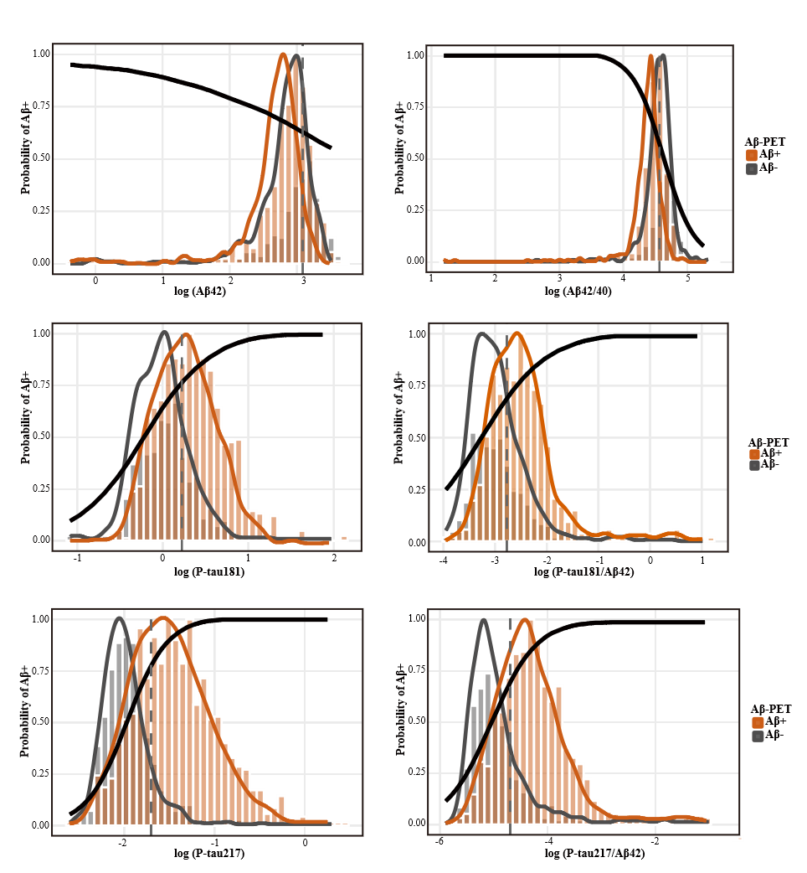
Figure S1. Density plots show log-transformed plasma biomarker values in relation to the predicted probability of Aβ PET positivity (Aβ+). Panels show Aβ42, Aβ42/40 ratio, p-tau181, p-tau181/Aβ42 ratio, p-tau217, and p-tau217/Aβ42 ratio. The vertical dashed line in each panel indicates the optimal single cutoff value determined using the Youden index. The solid black curve represents the predicted probability of Aβ PET positivity derived from a linear regression model. Colored density curves depict the distribution of biomarker values stratified by Aβ PET status, with gray shading indicating Aβ PET–negative participants and orange shading indicating Aβ PET–positive participants.
Abbreviations: Aβ, amyloid-β; PET, positron emission tomography; p-tau, phosphorylated tau.
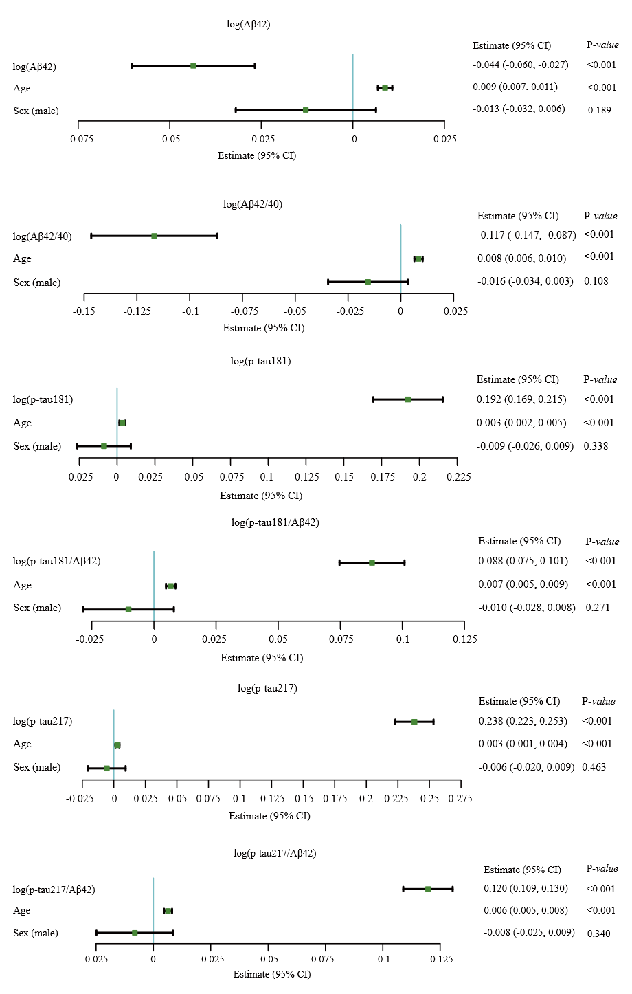
Figure S2. Associations Between Plasma Biomarkers and Aβ-PET
Estimates and 95% Cis from linear regression models including continuous measures of Aβ42, Aβ42/40, p-tau181, p-tau181/Aβ42, p-tau217, p-tau217/ Aβ42, as well as age and sex as predictors and Aβ-PET as outcome. Log-transformedand plasma biomarkers were used in all regression models.

