Supplemental Materials
STROBE Statement for the Study on Mental Disorders Rehabilitation Needs in Global (1990–2021) 3
1. Title and Abstract 3
1.1 Title 3
1.2 Abstract 3
2. Introduction 3
2.1 Background 3
2.2 Objectives 3
3. Methods 4
3.1 Study Design 4
3.2 Setting and Participants 4
3.3 Variables 4
3.4 Data Sources 4
3.5 Statistical Methods 4
4. Results 4
4.1 Participants 5
4.2 Descriptive Data 5
4.3 Outcome Data 5
4.4 Other Analyses 5
5. Discussion 5
5.1 Key Results 5
5.2 Interpretation 5
5.3 Limitations 6
6. Other Information 6
6.1 Funding 6
6.2 Ethical Approval 6
Additional Results in tables and Figures 7
Table S1. Global Burden of Mental Disorders and Related Conditions Among Both Sexes, 1990–2021.95% UI=95% uncertainty interval. 95% CI=95% confidence interva. 7
Table S2. Different GBD Region Burden of Mental Disorders and Related Conditions Among Both Sexes, 1990–2021.95% UI=95% uncertainty interval. 95% CI=95% confidence interval. 8
Figure 1. Trends by Gender and Age Group,2021. (A)Prevalence of Mental disorders. (B) YLDs of Mental disorders. 13
Figure 2. Trends by Gender and Age Group,2021. (A)Prevalence of Developmental Intellcetual Disability. (B) YLDs of Developmental Intellcetual Disability. 14
Figure 3. Trends by Gender and Age Group,2021. (A)Prevalence of Schizophrenia. (B) YLDs of Schizophrenia. 15
Figure 4. Trends by Gender and Age Group,2021. (A)Prevalence of Autism Spectrum Disorders. (B) YLDs of Prevalence of Autism Spectrum Disorders. 16
Figure 5. Different GBD Region Burden of Mental Disorders and Related Conditions Among Both Sexes, 1990–2021. (A)ASR Prevalence of Mental Disorders. (B)ASR YLDs of Mental Disorders. 17
Figure 6. Country-Level Variations and Differences of Mental Disorders,2021. (A)ASR Prevalence of Mental Disorders. (B)ASR YLDs of Mental Disorders. (C)ASR Prevalence EAPC of Mental Disorders.(D)ASR YLDs EAPC of Mental Disorders. 18
Figure 7. Country-Level Variations and Differences of Developmental Intellcetual Disability,2021.(A)ASR Prevalence of Developmental Intellcetual Disability. (B)ASR YLDs of Developmental Intellcetual Disability. (C)ASR Prevalence EAPC of Developmental Intellcetual Disability.(D)ASR YLDs EAPC of Developmental Intellcetual Disability. 20
Figure 8. Country-Level Variations and Differences of Schizophrenia,2021.(A)ASR Prevalence of Schizophrenia. (B)ASR YLDs of Schizophrenia. (C)ASR Prevalence EAPC of Schizophrenia.(D)ASR YLDs EAPC of Schizophrenia. 22
Figure 9. Country-Level Variations and Differences of Autism Spectrum Disorders,2021.(A)ASR Prevalence of Autism Spectrum Disorders. (B)ASR YLDs of Autism Spectrum Disorders. (C)ASR Prevalence EAPC of Autism Spectrum Disorders.(D)ASR YLDs EAPC of Autism Spectrum Disorders. 24
Figure 10. Association Between Mental Disorders and SDI. (A)ASR Prevalence of Mental Disorders. (B)ASR YLDs of Mental Disorders. 26
Figure 11. Association Between Developmental Intellcetual Disability and SDI. (A)ASR Prevalence of Developmental Intellcetual Disability. (B)ASR YLDs of Developmental Intellcetual Disability. 27
Figure 12. Association Between Schizophrenia and SDI. (A)ASR Prevalence of Schizophrenia. (B)ASR YLDs of Schizophrenia. 28
Figure 13. Association Between Autism Spectrum Disorders and SDI. (A)ASR Prevalence of Autism Spectrum Disorders. (B)ASR YLDs of Autism Spectrum Disorders. 29

STROBE Statement for the Study on Mental Disorders Rehabilitation Needs in Global (1990–2021)
- Title and Abstract

1.1 Title
Global Trends in Rehabilitation Needs for Mental Disorders in 204 Countries and Territories, 1990–2021: A Cross-sectional Analysis of the Global Burden of Disease Study 2021

1.2 Abstract
This study analyzes the global burden of mental disorders and rehabilitation needs based on the Global Burden of Disease Study 2021, focusing on prevalence, Years Lived with Disability (YLDs), and Estimated Annual Percentage Change (EAPC) across 204 countries and territories from 1990 to 2021. Major disorders examined include developmental intellectual disability, schizophrenia, and autism spectrum disorders, with correlations to Socio-Demographic Index (SDI) evaluated using Spearman analysis. Findings revealed a 34.8% increase in the absolute number of individuals requiring mental health rehabilitation globally, despite slight declines in age-standardized rates (-0.19% EAPC). Rehabilitation needs were particularly prominent among elderly women and young men, with the greatest burdens observed in low- and middle-income countries. SDI correlations highlighted disparities in resource distribution and regional improvements, with developmental intellectual disability showing strong negative associations with SDI, and schizophrenia and autism spectrum disorders exhibiting positive associations. These findings emphasize the need for targeted resource allocation, SDI-based strategies, and international collaboration to address inequities and meet rising rehabilitation demands worldwide.
- Introduction

2.1 Background
The prevalence of mental disorders has been steadily rising due to aging populations, rapid urbanization, and social structural changes, posing significant public health challenges globally. Despite advances in pharmacological treatments, limited social functionality, high relapse risk, and adaptation difficulties persist in patients with mental disorders, emphasizing the critical need for rehabilitation services.

2.2 Objectives
This study analyzes the global burden of mental disorders and associated rehabilitation needs from 1990 to 2021, analyze trends in prevalence and years lived with disability (YLD), and identify the primary drivers of these needs.
- Methods

3.1 Study Design
Observational study using modeled estimates from the GBD 2021 data.

3.2 Setting and Participants
This study was conducted based on data from the Global Burden of Disease (GBD) 2021 study, which systematically assessed 371 diseases and injuries across 204 countries and territories, including seven super-regions and 811 subnational locations. Participants in this analysis encompassed all age groups and genders globally, with major mental disorders evaluated including developmental intellectual disability, schizophrenia, autism spectrum disorders, and other mental illnesses, excluding substance use disorders. Data were extracted to analyze age-standardized prevalence rates, Years Lived with Disability (YLDs), and Estimated Annual Percentage Change (EAPC) to identify trends and disparities across diverse socio-demographic and geographic contexts.

3.3 Variables
The study focused on multiple variables related to the burden of mental disorders, including age-standardized prevalence rates (ASR), Years Lived with Disability (YLDs), and Estimated Annual Percentage Change (EAPC). Rehabilitation needs were assessed for major mental disorders, including developmental intellectual disability, schizophrenia, and autism spectrum disorders, with comparisons across socio-demographic groups and global regions. Correlations with the Socio-Demographic Index (SDI) were also analyzed to evaluate disparities in burden and improvement rates.

3.4 Data Sources
Data were extracted from the Global Burden of Disease (GBD) Study 2021, which comprehensively assessed 371 diseases and injuries across 204 countries and territories. This study utilized the standardized methodology of the GBD project for estimating disease prevalence, disability weights, and measures of health loss. Additional statistical data were obtained to construct 95% uncertainty intervals (UI) through random sampling procedures.

3.5 Statistical Methods
Age-standardized prevalence rates (ASR) and YLDs were calculated to ensure comparability across populations using an established formula:ASR=∑(αi⋅wi)/A,where αi represents age-specific rates,wi denotes the standard population weight for the i-th age group, and A indicates the total number of age groups. EAPC trends were assessed through linear regression models,using y=α+βx+ϵy=α+βx+ϵ, where y=ln(ASR) and x=calendar year. EAPC was calculated as 100×[exp⁡(β)−1], with 95% confidence intervals (CI) provided to interpret trends. Spearman correlation analysis was performed to evaluate the strength of associations between SDI and rehabilitation needs for mental disorders. All data analyses and visualizations were conducted using Microsoft Excel (version 2019) and R (version 4.2.1).

- Results

4.1 Participants
The study analyzed data from the Global Burden of Disease (GBD) Study 2021, encompassing participants from 204 countries and territories across all age groups and genders. Major mental disorders assessed included developmental intellectual disability, schizophrenia, autism spectrum disorders, among others, excluding substance use disorders.

4.2 Descriptive Data
The global prevalence of mental disorders increased from 166.18 million (95% UI, 130.93–201.49) in 1990 to 224.02 million (95% UI, 183.52–265.15) in 2021. The age-standardized prevalence rate (ASR) decreased from 3028.75 per 100,000 (95% UI, 2406.38–3656.49) in 1990 to 2869.83 per 100,000 (95% UI, 2340.49–3405.24) in 2021, while YLDs rose from 24.44 million (95% UI, 19.22–29.64) in 1990 to 36.58 million (95% UI, 29.10–44.15) by 2021.

4.3 Outcome Data
Analysis revealed a significant increase in rehabilitation needs, with a 34.8% rise in the number of people requiring services for mental health conditions globally. The Estimated Annual Percentage Change (EAPC) for ASR was -0.19% (95% UI, -0.22 to -0.16), indicating a slight decline in relative prevalence. Contrastingly, developmental intellectual disability demonstrated a strong negative correlation with Socio-Demographic Index (SDI), while schizophrenia and autism spectrum disorders showed positive correlations, highlighting disparities in rehabilitation demands.

4.4 Other Analyses
Further examination of data highlighted the disparity in resource allocation and access to rehabilitation services, particularly among elderly women and young men, with pronounced needs in low- and middle-income countries. Spearman correlation analysis confirmed varied associations between SDI and mental health rehabilitation needs, emphasizing the socio-economic impacts on mental disorder structures. This study underscores the importance of targeted policies and interventions to address these inequities.
- Discussion

5.1 Key Results
The analysis of the Global Burden of Disease Study 2021 reveals a substantial rise in mental disorder rehabilitation needs, with the global prevalence increasing by 34.8% from 1990 to 2021. Despite a slight decline in age-standardized rates (ASR), the overall burden in Years Lived with Disability (YLDs) heightened, indicating growing challenges in addressing mental health worldwide.

5.2 Interpretation
This study highlights socio-demographic disparities, underscoring significant rehabilitation needs, particularly among vulnerable groups such as elderly women and young men in low- and middle-income countries. The positive correlations between Socio-Demographic Index (SDI) and certain mental disorders reflect the implications of socio-economic development on mental health infrastructure. Integrated approaches targeting Universal Health Coverage (UHC) and SDI-specific strategies are essential in mitigating the global rehabilitation burden.

5.3 Limitations
Despite utilizing comprehensive data from the Global Burden of Disease Study, limitations include potential biases in data collection and the exclusion of substance use disorders, which may impact the overall representation of mental health rehabilitation needs. Additionally, the reliance on specific indices such as SDI may not fully capture local variations, necessitating nuanced studies to better understand region-specific dynamics.
- Other Information

6.1 Funding
The study was supported by the National Natural Science Foundation of China (Grants No. 82272612, 82202787) and the 2024 Pujiang Talents Program (24PJA065). Funders had no role in study design, analysis, or reporting.

6.2 Ethical Approval
Ethical approval was not required for this study as it used publicly available, anonymized data from the GBD 2021 study.

Additional Results in tables and Figures

Table S1. Global Burden of Mental Disorders and Related Conditions Among Both Sexes, 1990–2021.95% UI=95% uncertainty interval. 95% CI=95% confidence interva.
Characteristic | Prevalence |  |  |  |  | YLDs
Characteristic | 1990 | 2021 | 1990 | 2021 | EAPC | 1990 | 2021 | 1990 | 2021 | EAPC
Characteristic | Number (95%UI)(millions) | Number (95%UI)(millions) | Rate (95%UI)(per 100,000) | Rate (95%UI)(per 100,000) | Rate Chage(95%CI) | Number (95%UI)(millions) | Number (95%UI)(millions) | Rate (95%UI)(per 100,000) | Rate (95%UI)(per 100,000) | Rate Chage(95%CI)
Mental disorders | 166.18 (130.93, 201.49) | 224.02 (183.52, 265.15) | 3028.75 (2406.38, 3656.49) | 2869.83 (2340.49, 3405.24) | -0.19  (-0.22, -0.16) | 24.44 (19.22, 29.64) | 36.58 (29.10, 44.15) | 460.92 (364.63, 557.87) | 457.78 (365.21, 554.03) | -0.02  (-0.03, -0.01)
Developmental intellectual disability | 112.05 (77.92, 147.58) | 140.95 (99.97, 183.23) | 2005.72 (1398.07, 2639.37) | 1828.31 (1294.77, 2378.37) | -0.34  (-0.38, -0.29) | 7.81 (4.96, 11.41) | 10.21 (6.58, 14.68) | 139.79 (88.80, 204.00) | 132.47 (85.31, 190.44) | -0.19  (-0.23, -0.16)
Schizophrenia | 13.61 (11.32, 16.15) | 23.16 (19.19, 27.39) | 275.51 (229.77, 323.59) | 277.43 (229.61, 328.61) | 0.03 (0.02, 0.04) | 8.76 (6.48, 11.26) | 14.82 (10.93, 19.10) | 176.61 (130.85, 226.02) | 177.75 (131.51, 228.80) | 0.04 (0.03, 0.05)
Autism spectrum disorders | 41.80 (35.25, 49.44) | 61.62 (51.93, 72.44) | 770.79 (649.60, 911.18) | 785.80 (662.03, 923.71) | 0.07 (0.07, 0.08) | 7.87 (5.35, 11.07) | 11.54 (7.84, 16.29) | 144.51 (98.30, 203.28) | 147.56 (100.21, 208.16) | 0.08 (0.08, 0.09)

Table S2. Different GBD Region Burden of Mental Disorders and Related Conditions Among Both Sexes, 1990–2021.95% UI=95% uncertainty interval. 95% CI=95% confidence interval.
location | Characteristic | Prevalence |  |  |  |  | YLDs
location | Characteristic | 1990 | 2021 | 1990 | 2021 | EAPC | 1990 | 2021 | 1990 | 2021 | EAPC
location | Characteristic | Number (95%UI)(millions) | Number (95%UI)(millions) | Rate (95%UI) | Rate (95%UI) | Rate Chage(95%CI) | Number (95%UI)(millions) | Number (95%UI)(millions) | Rate (95%UI) | Rate (95%UI) | Rate Chage(95%CI)
African Region | Mental disorders | 12.81 (10.59, 15.22) | 29.86 (25.21, 34.88) | 2357.11 (1981.97, 2772.93) | 2443.54 (2084.27, 2838.19) | 0.04 (0.00, 0.07) | 1.92 (1.53, 2.38) | 4.68 (3.72, 5.73) | 393.73 (315.54, 480.00) | 413.63 (331.43, 502.72) | 0.15 (0.13, 0.16)
African Region | Developmental intellectual disability | 7.39 (5.25, 9.70) | 17.29 (12.59, 22.05) | 1280.31 (923.46, 1680.05) | 1351.08 (987.89, 1724.89) | 0.02 (-0.04, 0.08) | 0.52 (0.34, 0.76) | 1.34 (0.88, 1.90) | 89.80 (58.76, 130.49) | 104.30 (69.20, 148.60) | 0.36 (0.28, 0.43)
African Region | Schizophrenia | 0.82 (0.65, 1.03) | 2.06 (1.63, 2.57) | 224.90 (182.46, 275.25) | 227.11 (183.29, 278.58) | 0.05 (0.04, 0.06) | 0.52 (0.37, 0.70) | 1.32 (0.95, 1.76) | 142.20 (101.06, 188.57) | 144.08 (103.76, 190.77) | 0.08 (0.06, 0.09)
African Region | Autism spectrum disorders | 4.68 (3.93, 5.51) | 10.71 (9.03, 12.55) | 868.21 (730.15, 1025.17) | 882.76 (743.33, 1032.97) | 0.05 (0.05, 0.06) | 0.88 (0.60, 1.24) | 2.02 (1.38, 2.85) | 161.72 (111.33, 226.63) | 165.25 (112.85, 232.38) | 0.08 (0.08, 0.09)
Region of the Americas | Mental disorders | 8.70 (7.39, 10.14) | 12.75 (11.15, 14.66) | 2035.45 (1735.09, 2362.06) | 2034.21 (1776.16, 2341.58) | -0.01 (-0.02, 0.01) | 1.49 (1.19, 1.81) | 2.44 (1.96, 2.96) | 370.69 (296.03, 448.85) | 377.80 (301.41, 456.89) | 0.08 (0.07, 0.08)
Region of the Americas | Developmental intellectual disability | 4.88 (3.54, 6.17) | 6.73 (5.17, 8.39) | 1100.05 (798.63, 1392.84) | 1090.97 (838.84, 1361.11) | -0.04 (-0.07, -0.01) | 0.37 (0.24, 0.54) | 0.55 (0.37, 0.77) | 83.79 (54.74, 120.60) | 89.25 (59.89, 125.41) | 0.23 (0.19, 0.27)
Region of the Americas | Schizophrenia | 0.86 (0.69, 1.06) | 1.66 (1.35, 2.01) | 243.31 (197.21, 295.21) | 243.88 (198.40, 295.68) | 0.01 (0.00, 0.02) | 0.55 (0.40, 0.73) | 1.05 (0.76, 1.38) | 154.89 (112.15, 204.49) | 154.97 (112.11, 204.27) | 0.02 (0.01, 0.03)
Region of the Americas | Autism spectrum disorders | 3.01 (2.53, 3.58) | 4.45 (3.74, 5.27) | 704.57 (593.14, 837.62) | 711.83 (598.85, 843.32) | 0.04 (0.03, 0.04) | 0.57 (0.39, 0.80) | 0.83 (0.56, 1.17) | 132.01 (91.31, 185.35) | 133.59 (90.13, 188.20) | 0.04 (0.04, 0.05)
South-East Asia Region | Mental disorders | 68.20 (49.36, 87.49) | 85.16 (64.59, 106.22) | 4955.95 (3609.68, 6331.18) | 4093.25 (3100.51, 5111.22) | -0.65 (-0.68, -0.61) | 7.49 (5.60, 9.63) | 11.16 (8.55, 13.80) | 573.36 (434.44, 726.46) | 527.58 (404.01, 652.99) | -0.27 (-0.28, -0.26)
South-East Asia Region | Developmental intellectual disability | 56.40 (37.77, 75.80) | 65.20 (44.84, 86.62) | 4035.67 (2714.93, 5420.31) | 3147.24 (2163.95, 4181.77) | -0.84 (-0.88, -0.79) | 3.74 (2.27, 5.62) | 4.41 (2.70, 6.55) | 266.65 (161.71, 400.49) | 212.87 (130.46, 316.37) | -0.76 (-0.79, -0.72)
South-East Asia Region | Schizophrenia | 3.16 (2.57, 3.79) | 6.36 (5.23, 7.59) | 283.73 (233.66, 338.01) | 291.44 (240.80, 346.50) | 0.11 (0.08, 0.14) | 2.02 (1.49, 2.63) | 4.07 (3.00, 5.32) | 180.36 (133.09, 234.15) | 185.91 (137.27, 242.82) | 0.13 (0.11, 0.16)
South-East Asia Region | Autism spectrum disorders | 9.21 (7.72, 10.90) | 14.29 (12.03, 16.77) | 677.85 (568.58, 802.02) | 687.42 (579.00, 807.00) | 0.04 (0.03, 0.05) | 1.73 (1.19, 2.44) | 2.68 (1.81, 3.76) | 126.34 (86.96, 177.59) | 128.79 (87.30, 180.99) | 0.06 (0.06, 0.07)
European Region | Mental disorders | 9.39 (7.91, 11.02) | 9.63 (8.27, 11.15) | 2529.63 (2127.00, 2970.87) | 2476.04 (2109.03, 2870.39) | -0.15 (-0.22, -0.08) | 1.53 (1.22, 1.85) | 1.68 (1.34, 2.04) | 407.38 (324.16, 493.58) | 412.22 (328.56, 499.16) | 0.05 (0.03, 0.06)
European Region | Developmental intellectual disability | 5.41 (3.93, 6.82) | 5.23 (3.87, 6.61) | 1465.56 (1064.92, 1848.32) | 1391.23 (1026.15, 1759.94) | -0.31 (-0.45, -0.18) | 0.41 (0.27, 0.60) | 0.40 (0.27, 0.57) | 111.26 (72.13, 161.44) | 107.03 (71.30, 152.15) | -0.20 (-0.30, -0.10)
European Region | Schizophrenia | 0.79 (0.64, 0.96) | 1.00 (0.82, 1.20) | 206.46 (167.55, 250.21) | 217.35 (176.40, 261.99) | 0.21 (0.18, 0.25) | 0.50 (0.37, 0.66) | 0.64 (0.47, 0.83) | 131.72 (96.80, 172.07) | 138.72 (101.90, 180.80) | 0.23 (0.20, 0.27)
European Region | Autism spectrum disorders | 3.26 (2.75, 3.84) | 3.47 (2.90, 4.10) | 875.73 (738.83, 1032.09) | 885.15 (740.95, 1044.92) | 0.05 (0.04, 0.06) | 0.61 (0.42, 0.86) | 0.65 (0.44, 0.91) | 164.40 (112.04, 231.25) | 166.47 (113.24, 234.20) | 0.06 (0.05, 0.07)
Eastern Mediterranean Region | Mental disorders | 12.85 (9.65, 16.17) | 24.58 (18.73, 30.54) | 3444.57 (2619.28, 4293.86) | 3418.35 (2620.45, 4231.77) | -0.08 (-0.10, -0.06) | 1.58 (1.21, 1.97) | 3.24 (2.49, 3.99) | 463.32 (361.18, 565.78) | 464.29 (360.50, 568.92) | -0.02 (-0.03, -0.01)
Eastern Mediterranean Region | Developmental intellectual disability | 9.63 (6.45, 12.91) | 18.02 (12.09, 23.93) | 2502.51 (1675.47, 3349.64) | 2470.09 (1660.76, 3278.69) | -0.12 (-0.15, -0.09) | 0.64 (0.39, 0.96) | 1.22 (0.75, 1.82) | 166.39 (101.66, 248.70) | 167.50 (102.06, 248.58) | -0.05 (-0.08, -0.02)
Eastern Mediterranean Region | Schizophrenia | 0.68 (0.54, 0.84) | 1.65 (1.32, 2.04) | 256.81 (208.19, 312.09) | 255.69 (206.67, 312.04) | -0.02 (-0.03, -0.01) | 0.44 (0.32, 0.58) | 1.06 (0.77, 1.41) | 163.72 (119.93, 215.61) | 162.39 (119.14, 215.42) | -0.02 (-0.03, -0.02)
Eastern Mediterranean Region | Autism spectrum disorders | 2.63 (2.21, 3.12) | 5.10 (4.28, 6.04) | 712.05 (597.59, 845.00) | 718.88 (602.56, 851.84) | 0.03 (0.02, 0.03) | 0.50 (0.34, 0.69) | 0.96 (0.65, 1.35) | 133.21 (91.73, 186.31) | 134.40 (91.30, 188.59) | 0.03 (0.03, 0.04)
Western Pacific Region | Mental disorders | 27.91 (23.16, 32.75) | 32.59 (28.66, 37.30) | 2017.87 (1684.52, 2362.37) | 1941.29 (1692.14, 2237.88) | -0.13 (-0.15, -0.12) | 5.32 (4.23, 6.43) | 7.32 (5.83, 8.74) | 390.92 (312.48, 468.83) | 404.82 (325.45, 486.30) | 0.11 (0.10, 0.12)
Western Pacific Region | Developmental intellectual disability | 15.57 (10.87, 20.33) | 15.50 (11.54, 19.59) | 1110.35 (776.26, 1451.41) | 979.18 (725.09, 1238.18) | -0.42 (-0.45, -0.39) | 1.10 (0.72, 1.61) | 1.21 (0.81, 1.72) | 78.62 (51.00, 114.38) | 76.54 (51.11, 108.42) | -0.06 (-0.10, -0.02)
Western Pacific Region | Schizophrenia | 3.96 (3.39, 4.57) | 6.20 (5.36, 7.09) | 299.39 (257.81, 343.49) | 309.95 (266.58, 356.41) | 0.07 (0.05, 0.10) | 2.59 (1.96, 3.27) | 4.02 (2.99, 5.08) | 194.81 (146.98, 244.27) | 202.31 (150.90, 255.78) | 0.09 (0.07, 0.11)
Western Pacific Region | Autism spectrum disorders | 8.54 (7.14, 10.12) | 11.09 (9.27, 13.17) | 620.43 (517.26, 734.37) | 663.97 (554.98, 787.95) | 0.25 (0.23, 0.27) | 1.62 (1.10, 2.29) | 2.09 (1.41, 2.94) | 117.49 (79.88, 165.56) | 125.97 (85.26, 177.25) | 0.25 (0.24, 0.27)
World Bank High Income | Mental disorders | 25.44 (22.21, 29.32) | 28.62 (25.25, 32.87) | 2571.89 (2240.25, 2973.57) | 2486.55 (2190.34, 2862.45) | -0.10 (-0.11, -0.08) | 4.98 (4.02, 5.97) | 5.89 (4.74, 7.10) | 484.51 (388.99, 581.33) | 479.82 (384.03, 579.82) | -0.00 (-0.02, 0.02)
World Bank High Income | Developmental intellectual disability | 12.18 (9.09, 15.36) | 12.52 (9.67, 15.66) | 1264.47 (943.71, 1593.08) | 1157.91 (888.08, 1452.24) | -0.27 (-0.29, -0.26) | 0.99 (0.66, 1.41) | 1.05 (0.71, 1.48) | 103.16 (68.48, 146.36) | 97.27 (65.70, 136.93) | -0.17 (-0.19, -0.14)
World Bank High Income | Schizophrenia | 3.25 (2.72, 3.83) | 4.10 (3.47, 4.79) | 290.78 (242.68, 342.41) | 288.23 (240.77, 340.23) | 0.01 (-0.02, 0.04) | 2.07 (1.54, 2.65) | 2.58 (1.91, 3.27) | 185.82 (138.40, 238.16) | 183.26 (136.62, 235.26) | 0.00 (-0.03, 0.04)
World Bank High Income | Autism spectrum disorders | 10.21 (8.63, 11.99) | 12.22 (10.27, 14.41) | 1037.19 (876.11, 1217.07) | 1059.72 (891.16, 1244.68) | 0.08 (0.07, 0.10) | 1.91 (1.31, 2.67) | 2.26 (1.56, 3.16) | 195.52 (134.34, 273.32) | 199.28 (137.41, 278.07) | 0.08 (0.06, 0.09)

Figure 1. Trends by Gender and Age Group,2021. (A)Prevalence of Mental disorders. (B) YLDs of Mental disorders.
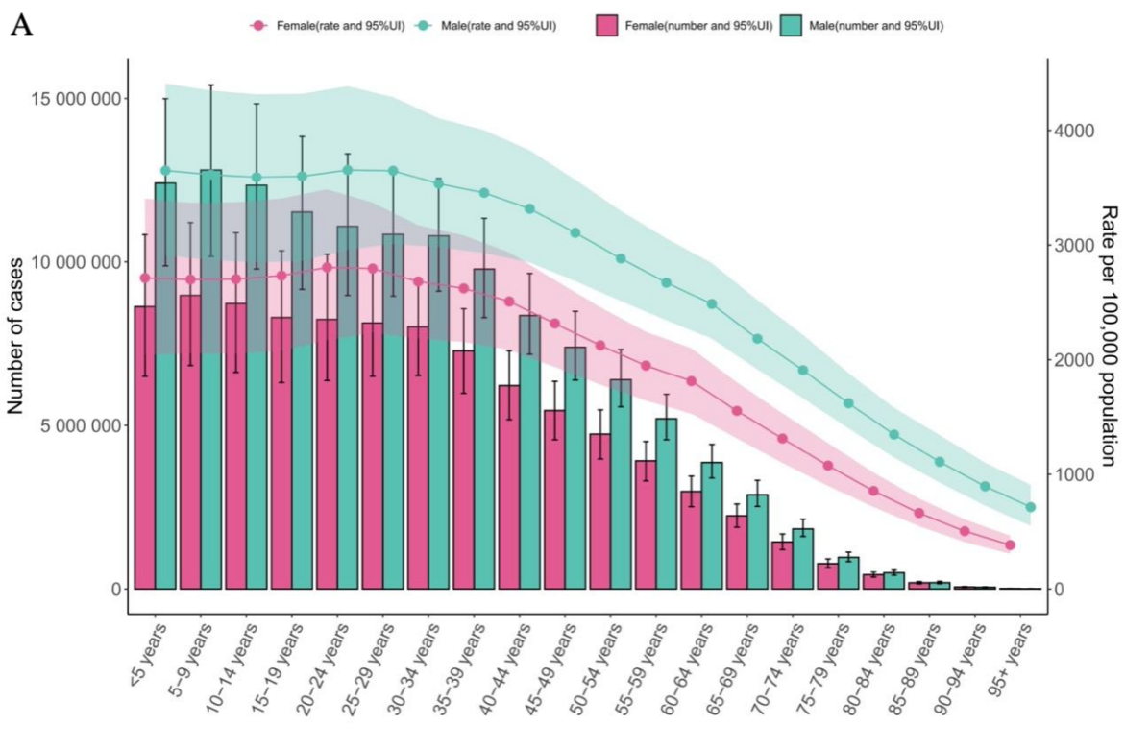
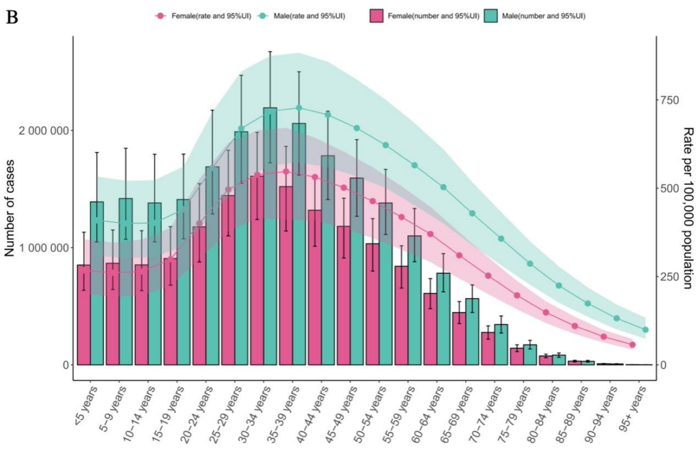

Figure 2. Trends by Gender and Age Group,2021. (A)Prevalence of Developmental Intellcetual Disability. (B) YLDs of Developmental Intellcetual Disability.
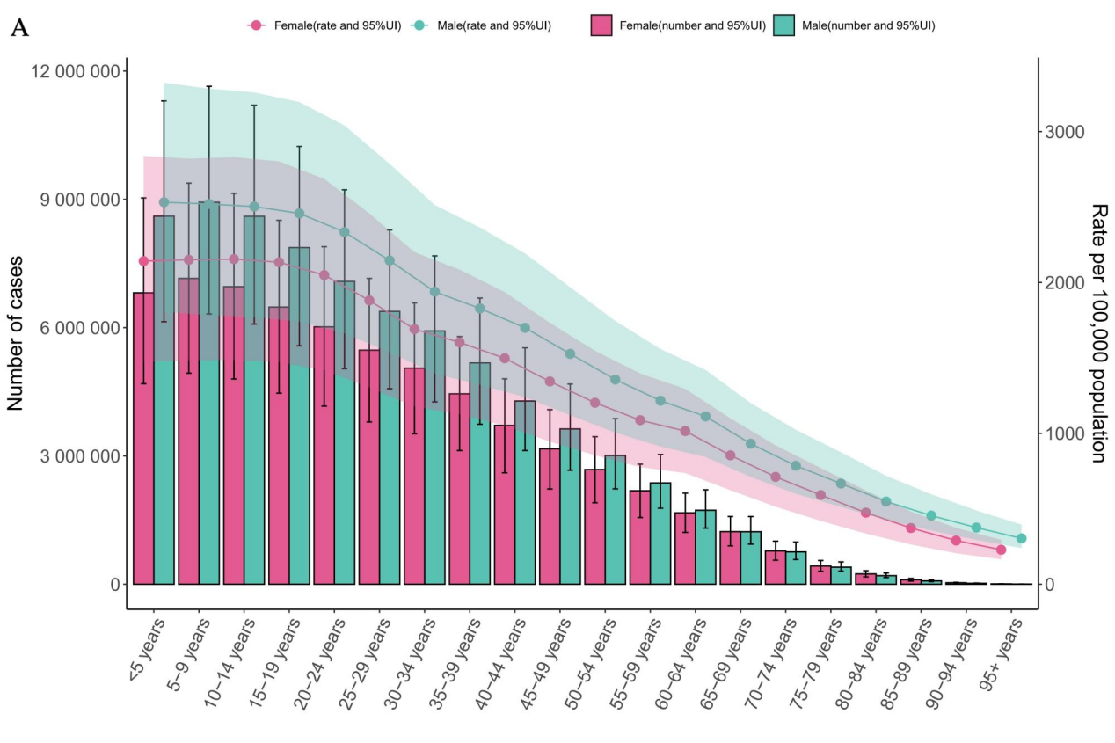
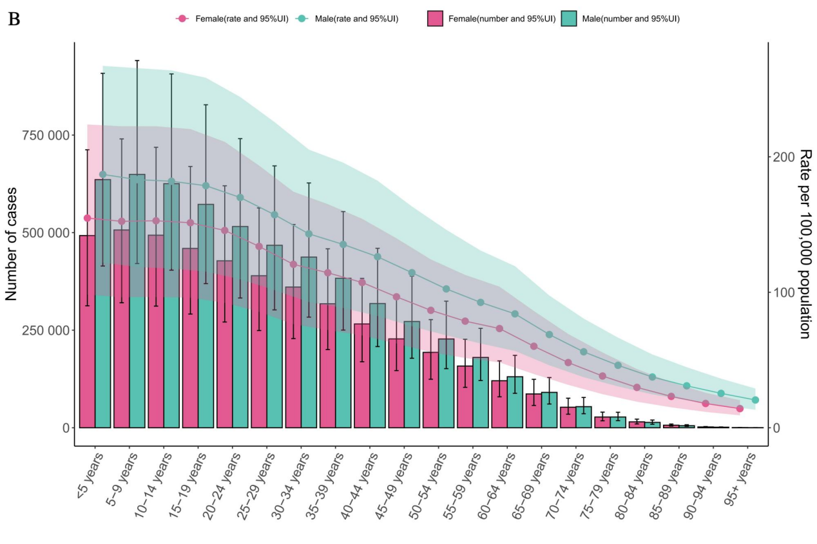

Figure 3. Trends by Gender and Age Group,2021. (A)Prevalence of Schizophrenia. (B) YLDs of Schizophrenia.
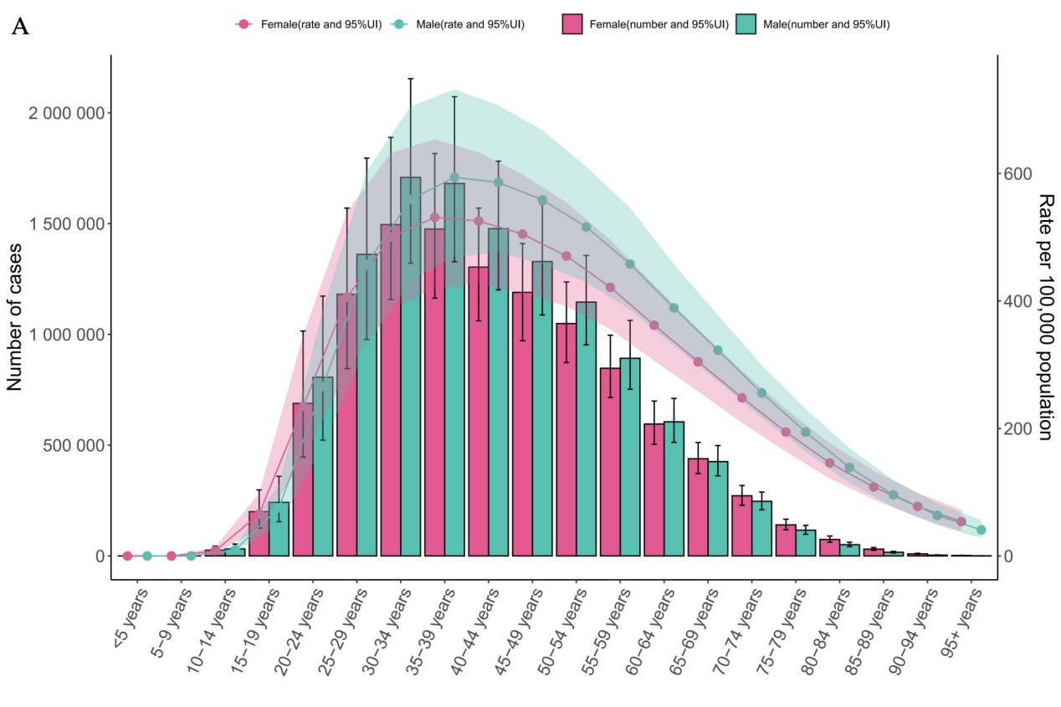
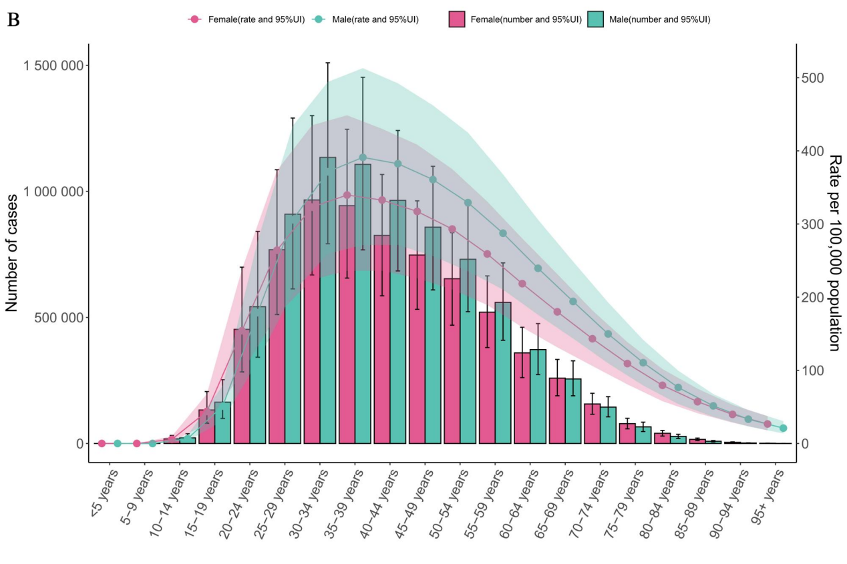

Figure 4. Trends by Gender and Age Group,2021. (A)Prevalence of Autism Spectrum Disorders. (B) YLDs of Prevalence of Autism Spectrum Disorders.
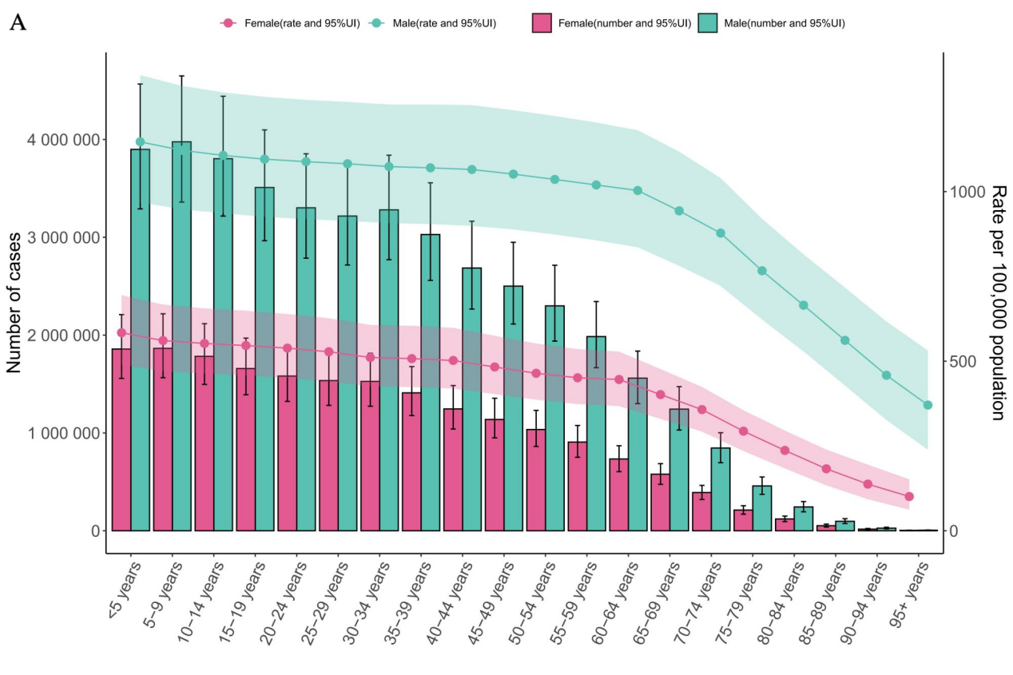
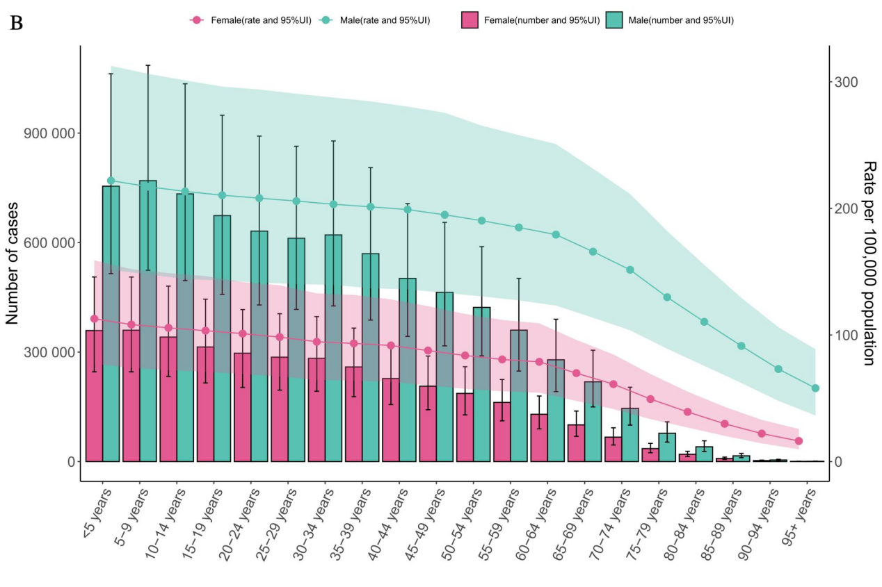

Figure 5. Different GBD Region Burden of Mental Disorders and Related Conditions Among Both Sexes, 1990–2021. (A)ASR Prevalence of Mental Disorders. (B)ASR YLDs of Mental Disorders.
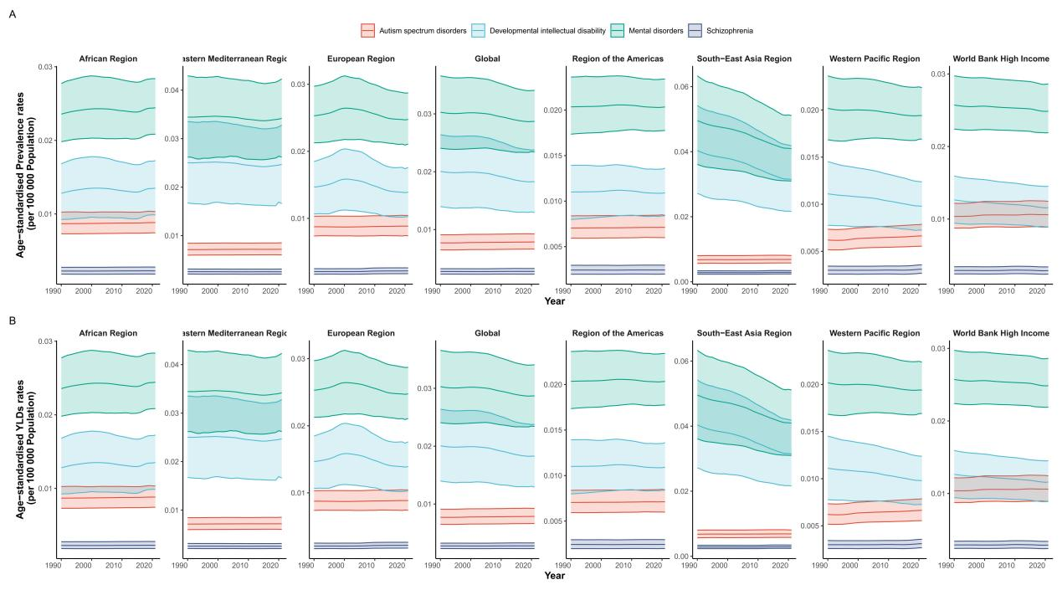

Figure 6. Country-Level Variations and Differences of Mental Disorders,2021. (A)ASR Prevalence of Mental Disorders. (B)ASR YLDs of Mental Disorders. (C)ASR Prevalence EAPC of Mental Disorders.(D)ASR YLDs EAPC of Mental Disorders.
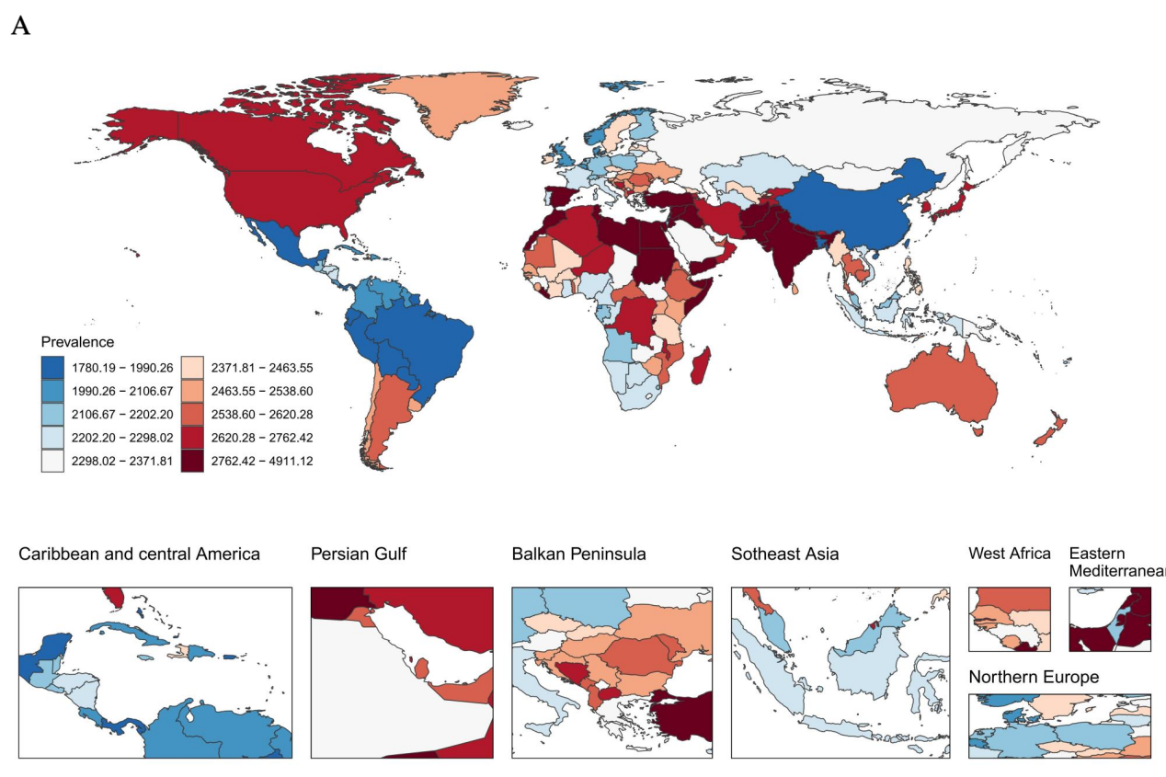
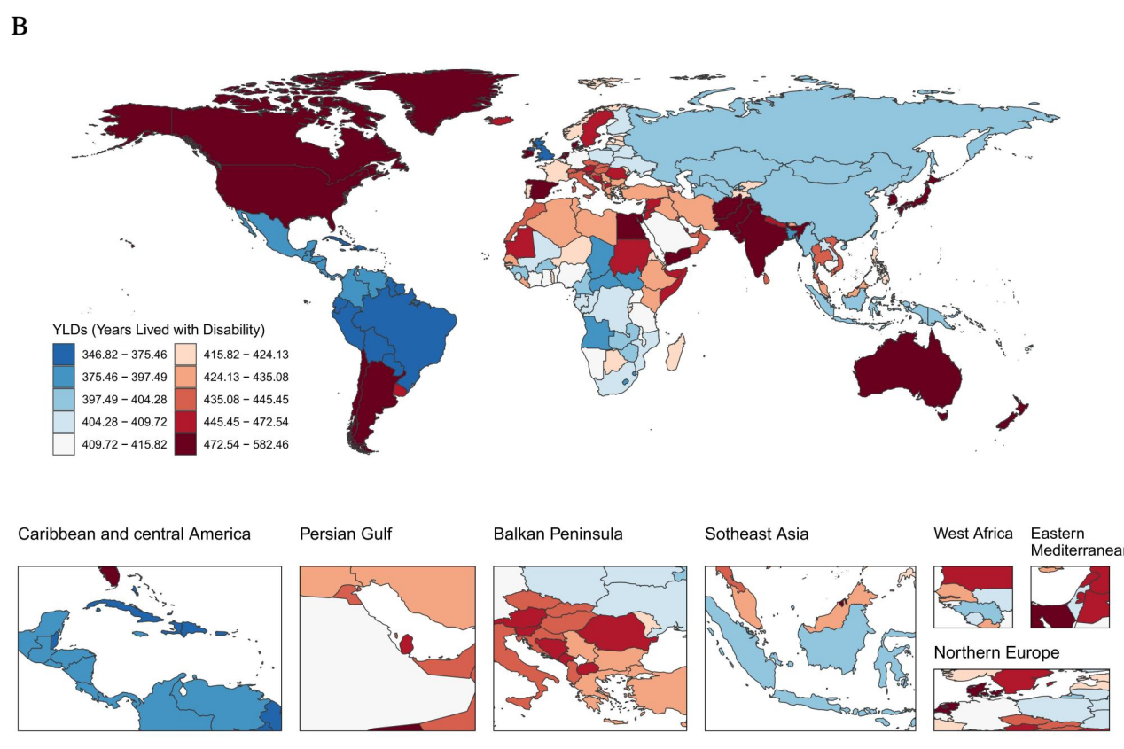
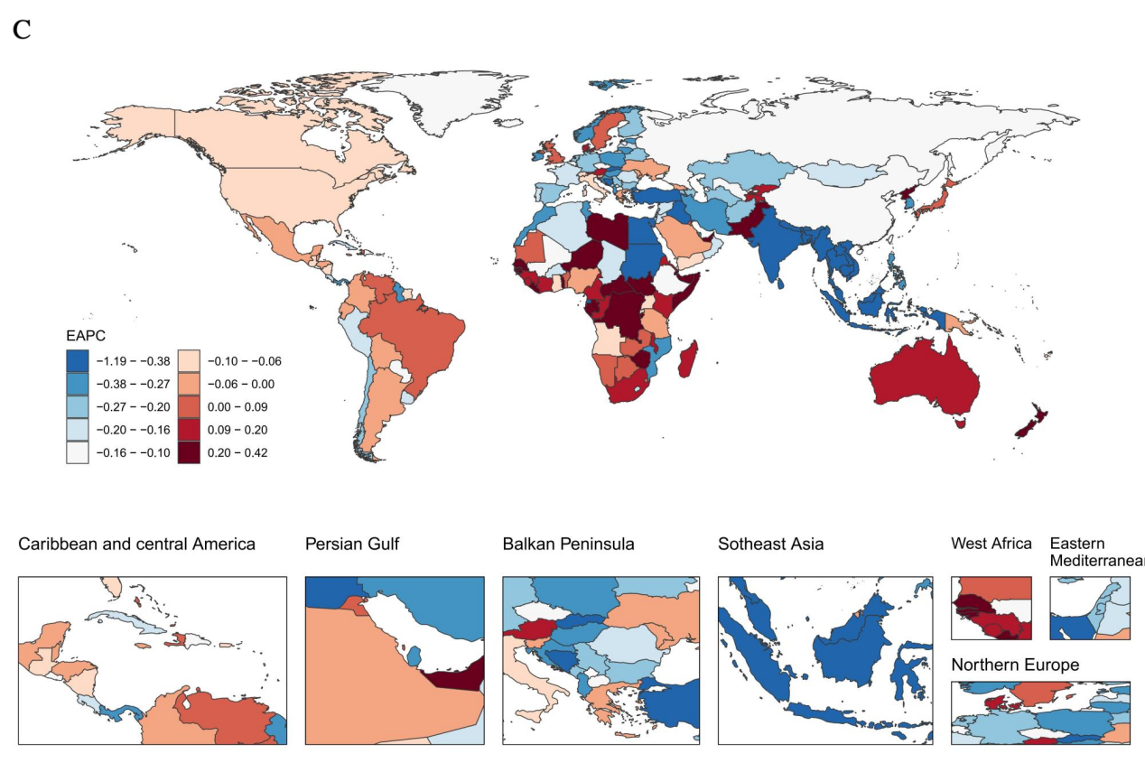
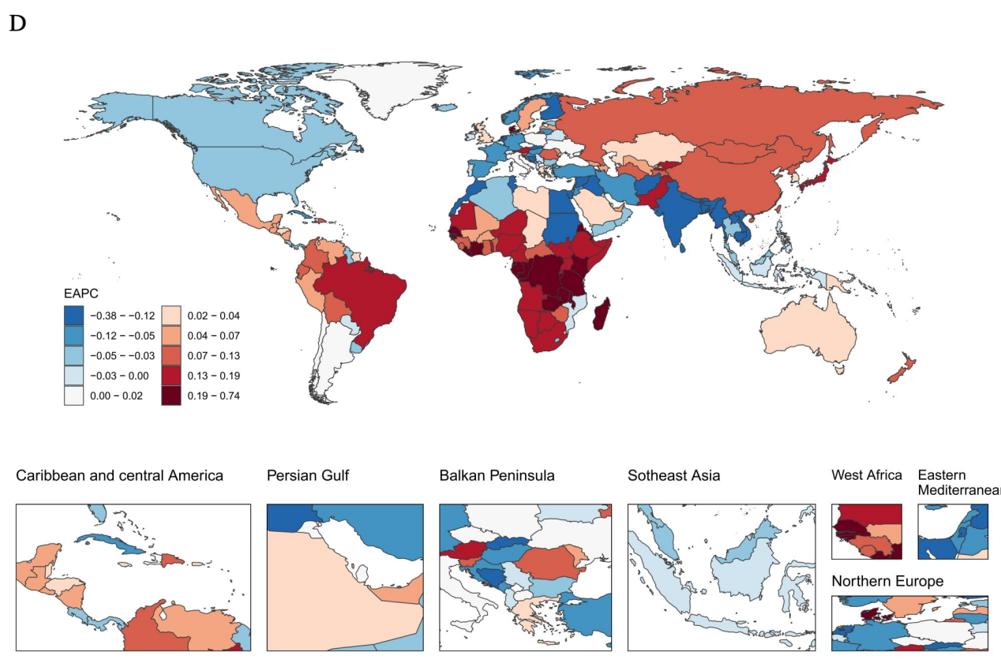

Figure 7. Country-Level Variations and Differences of Developmental Intellcetual Disability,2021.(A)ASR Prevalence of Developmental Intellcetual Disability. (B)ASR YLDs of Developmental Intellcetual Disability. (C)ASR Prevalence EAPC of Developmental Intellcetual Disability.(D)ASR YLDs EAPC of Developmental Intellcetual Disability.
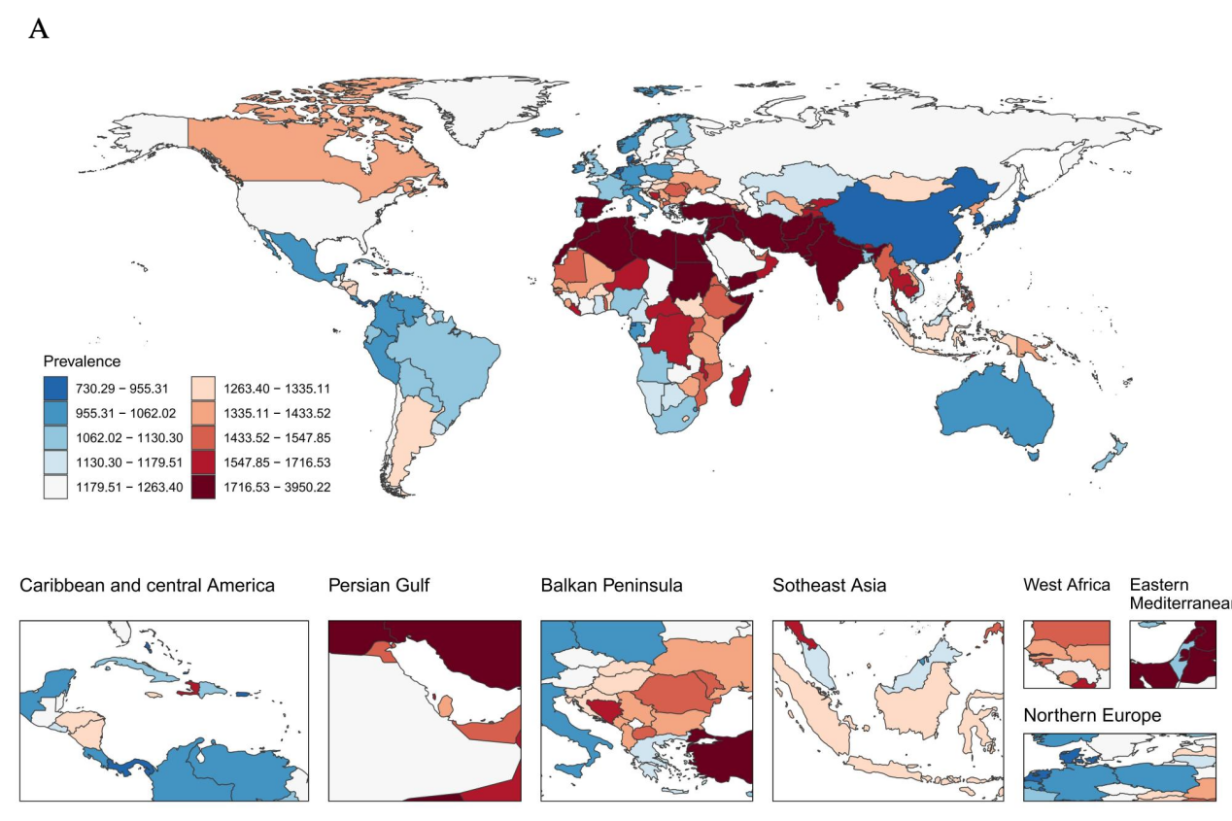
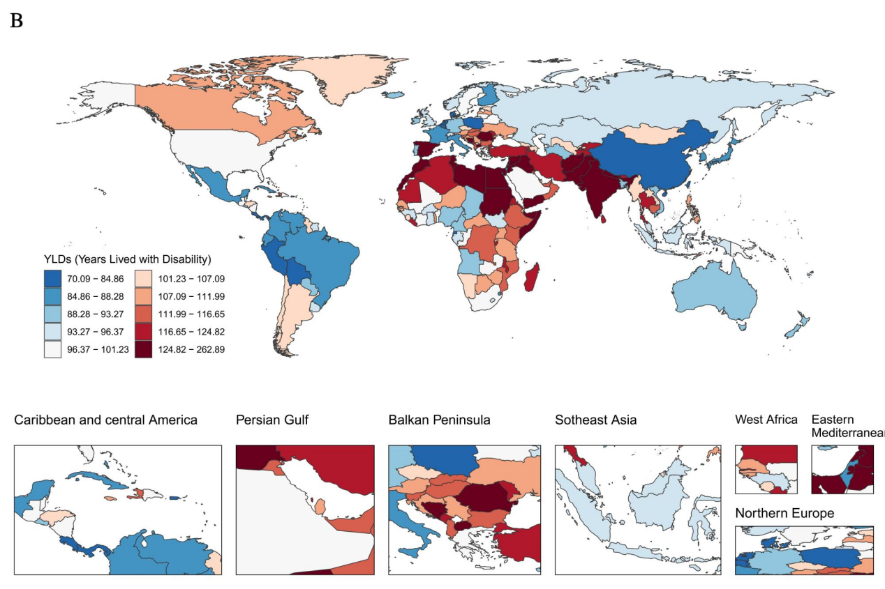
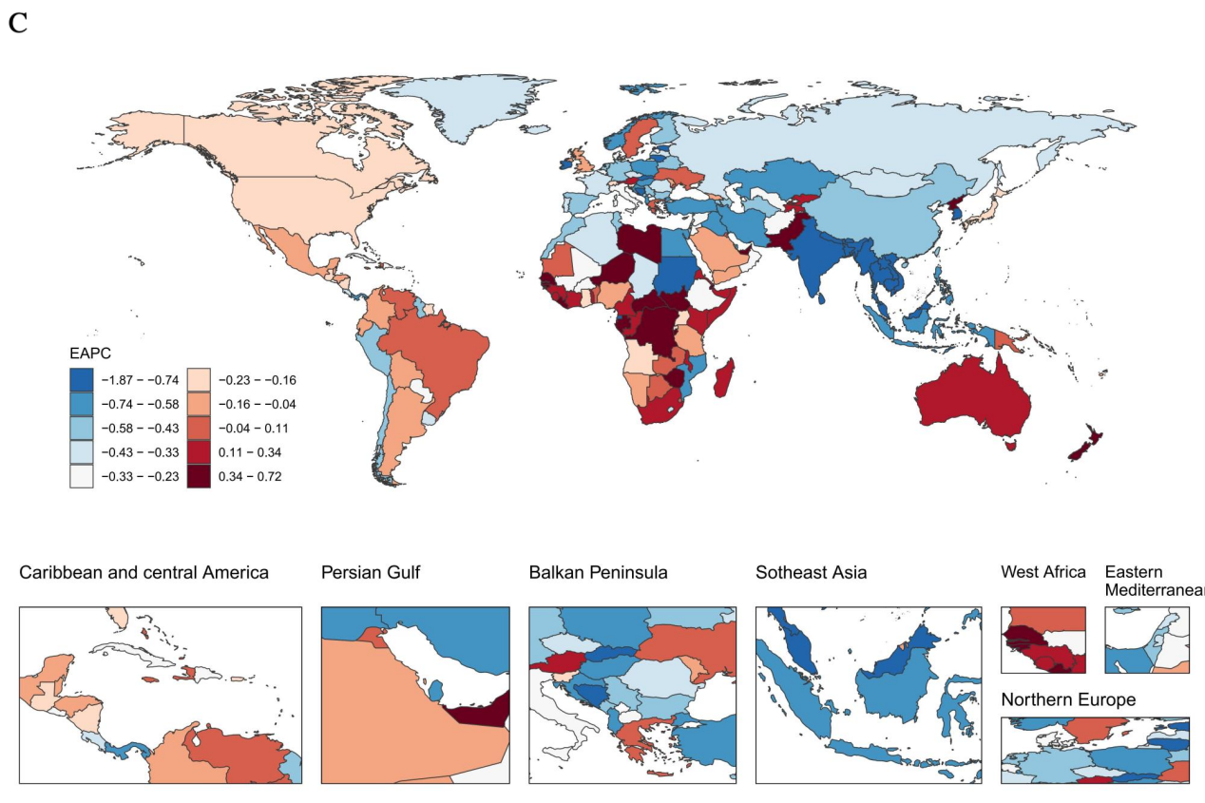
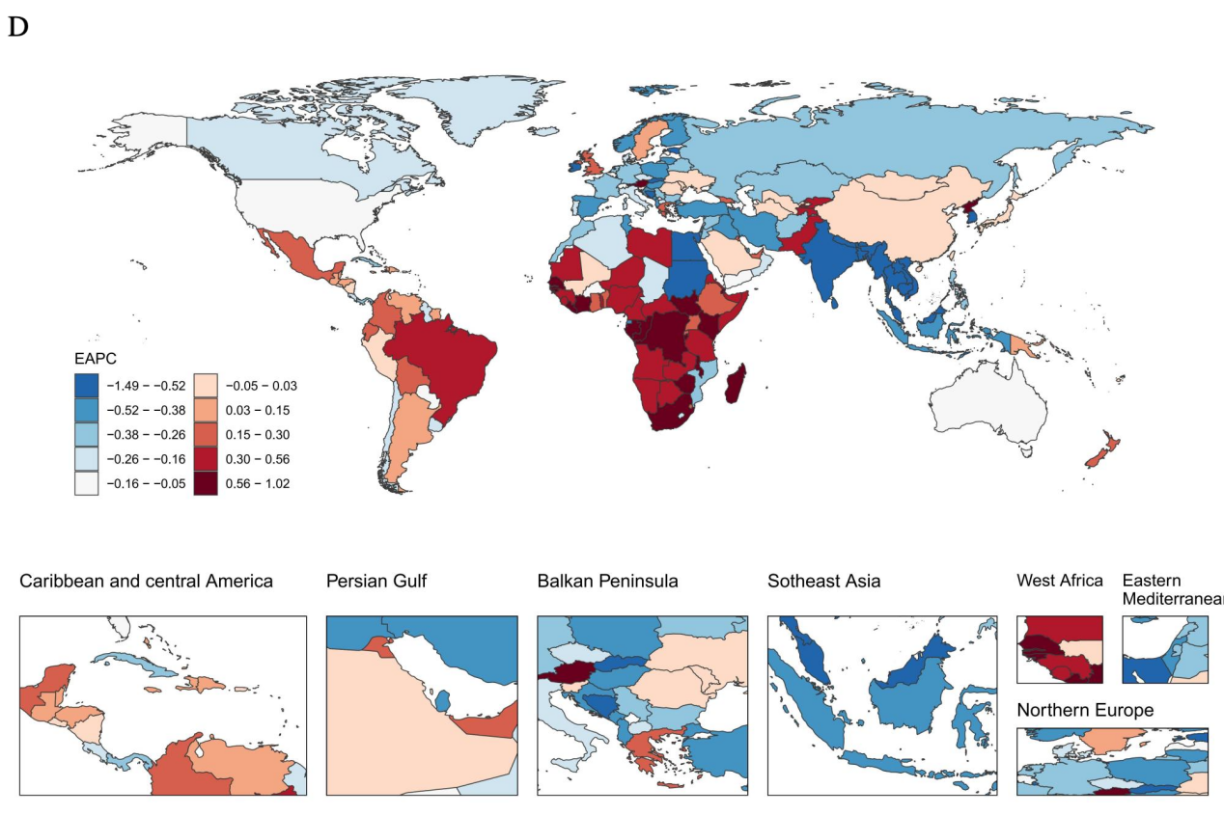

Figure 8. Country-Level Variations and Differences of Schizophrenia,2021.(A)ASR Prevalence of Schizophrenia. (B)ASR YLDs of Schizophrenia. (C)ASR Prevalence EAPC of Schizophrenia.(D)ASR YLDs EAPC of Schizophrenia.
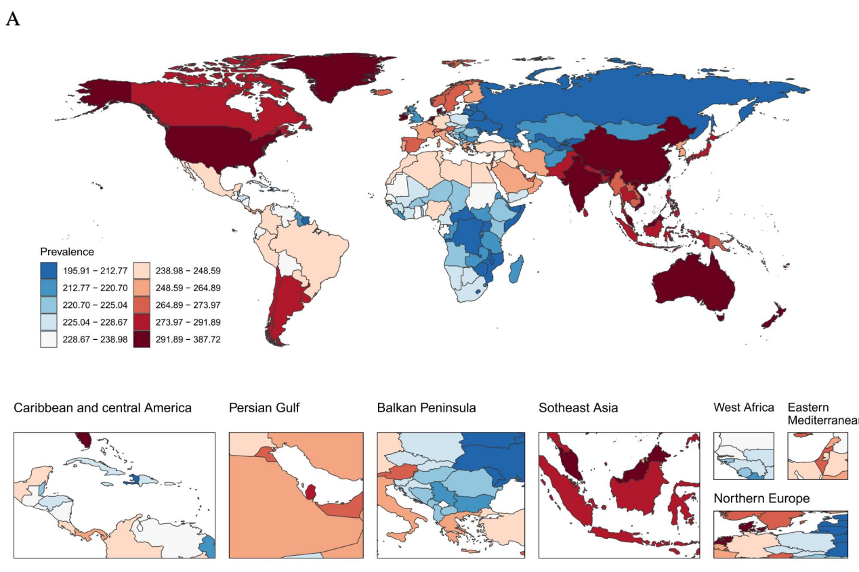
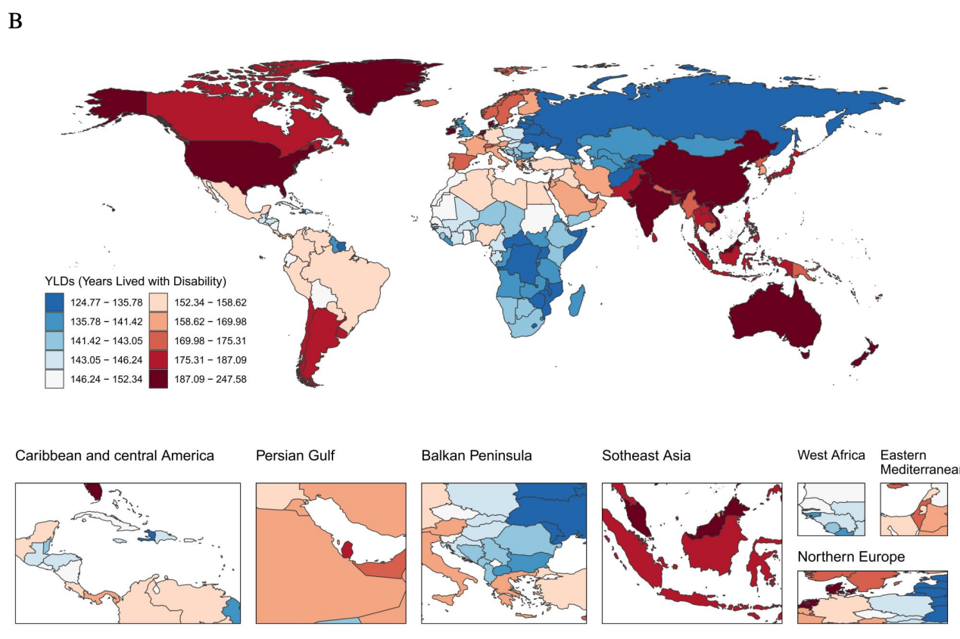
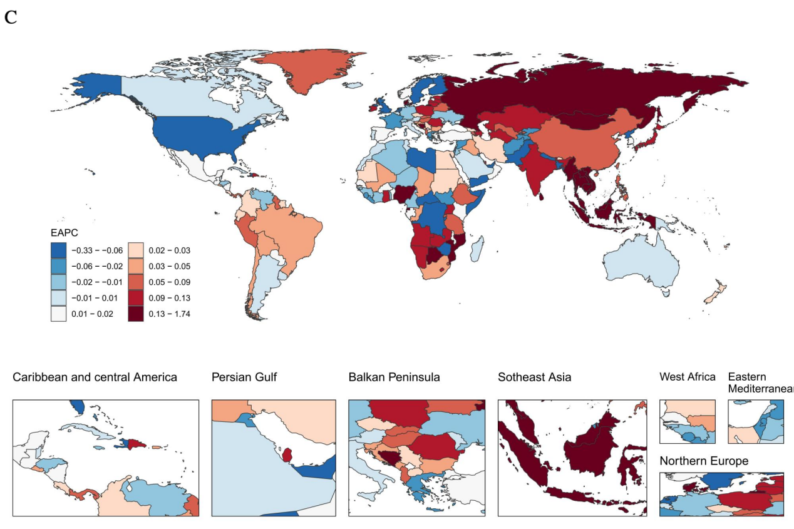
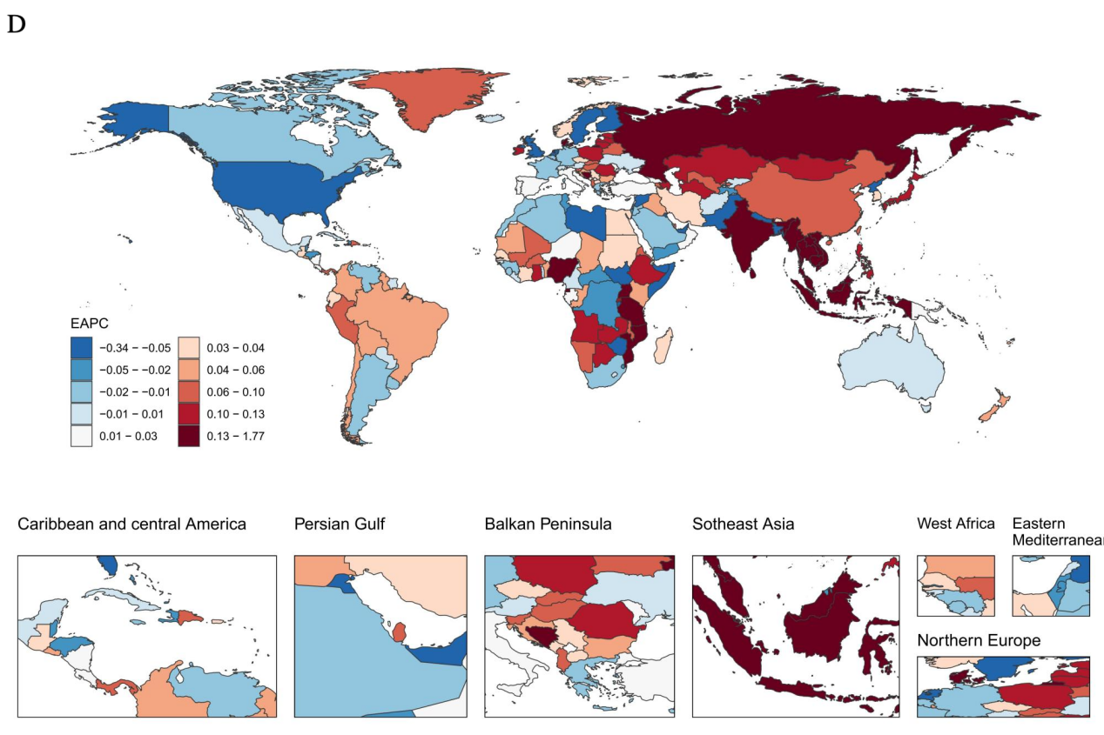

Figure 9. Country-Level Variations and Differences of Autism Spectrum Disorders,2021.(A)ASR Prevalence of Autism Spectrum Disorders. (B)ASR YLDs of Autism Spectrum Disorders. (C)ASR Prevalence EAPC of Autism Spectrum Disorders.(D)ASR YLDs EAPC of Autism Spectrum Disorders.
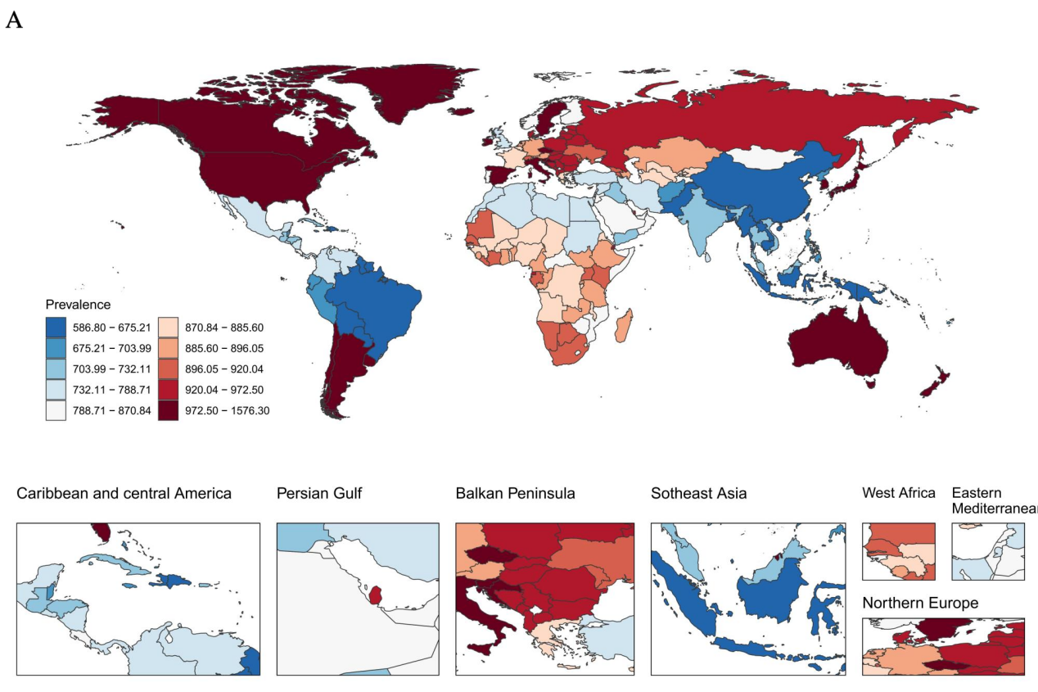
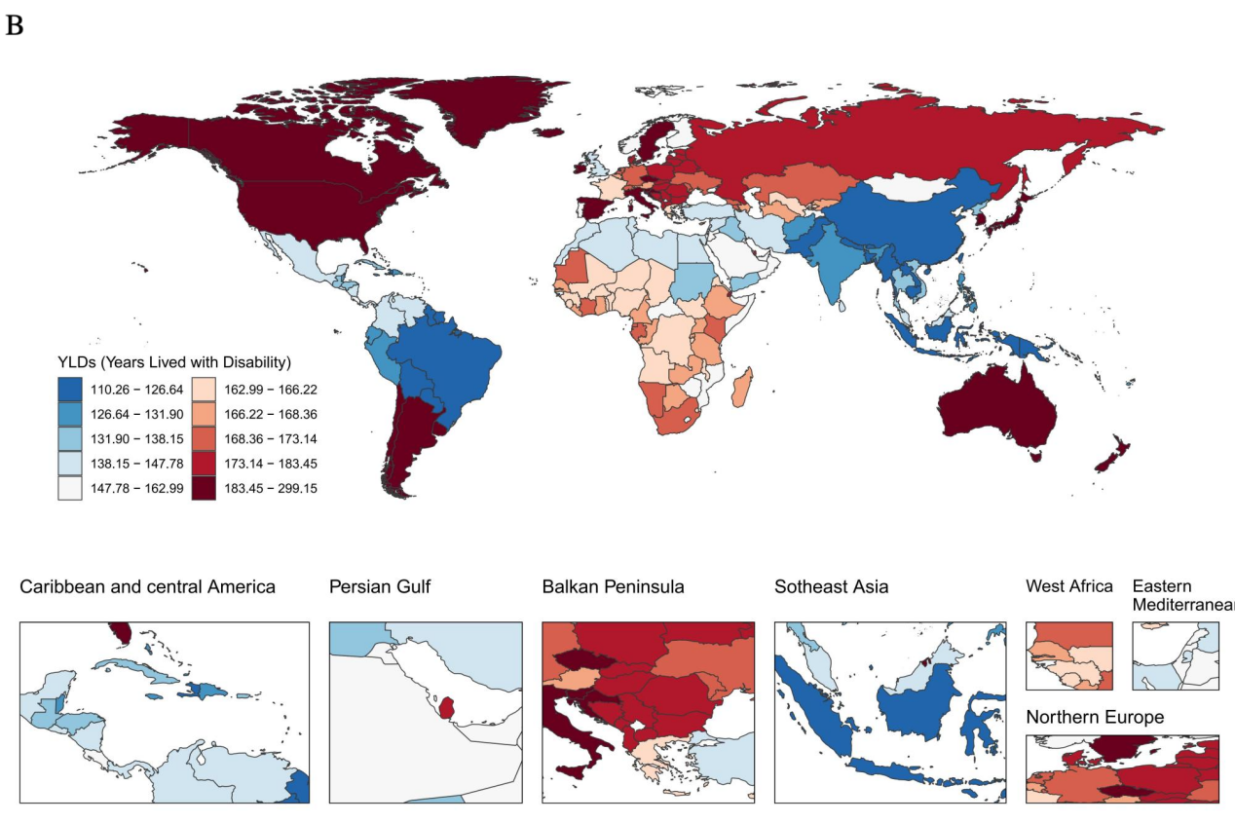
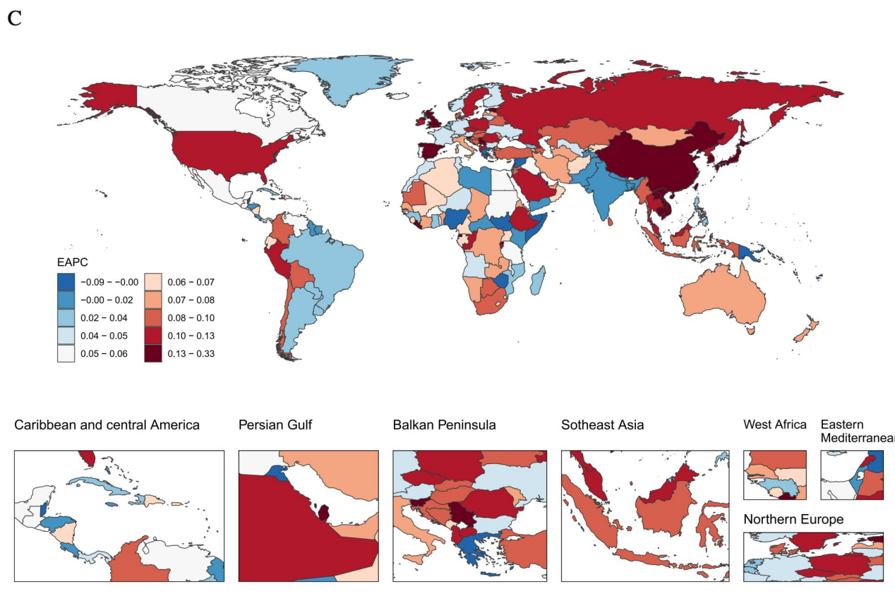
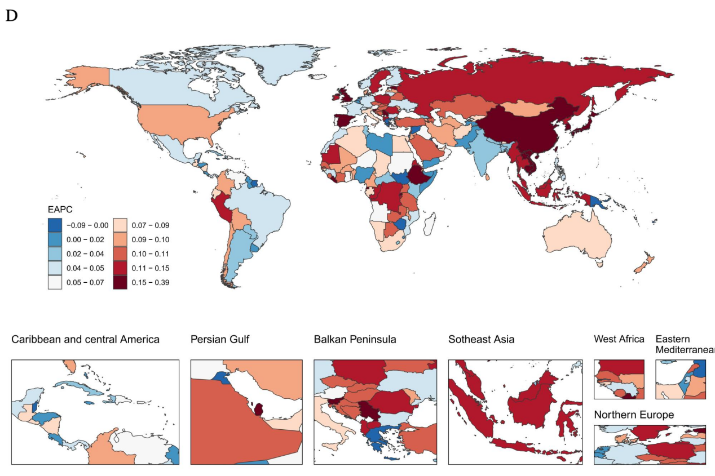

Figure 10. Association Between Mental Disorders and SDI. (A)ASR Prevalence of Mental Disorders. (B)ASR YLDs of Mental Disorders.
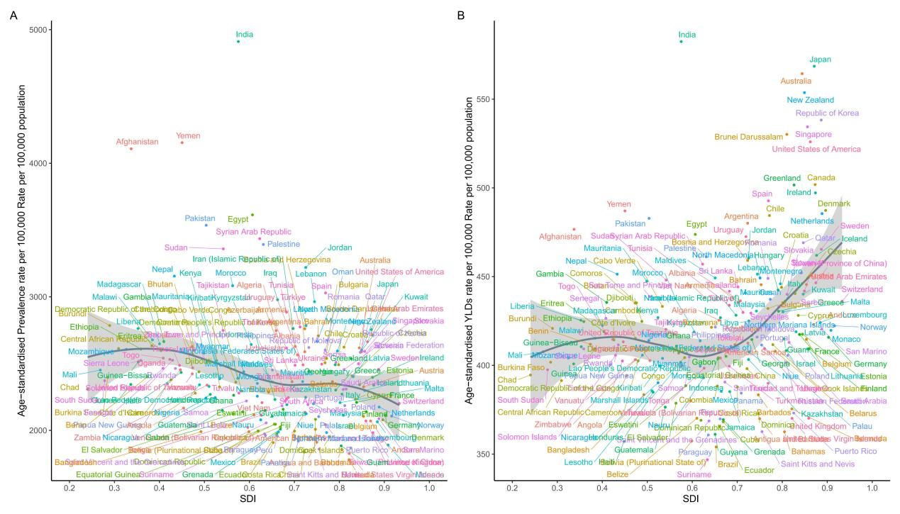

Figure 11. Association Between Developmental Intellcetual Disability and SDI. (A)ASR Prevalence of Developmental Intellcetual Disability. (B)ASR YLDs of Developmental Intellcetual Disability.
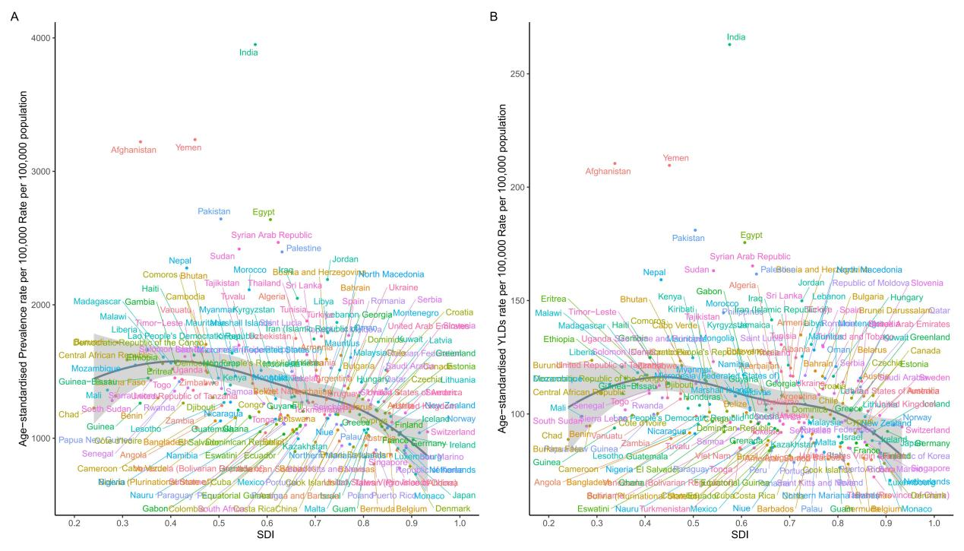

Figure 12. Association Between Schizophrenia and SDI. (A)ASR Prevalence of Schizophrenia. (B)ASR YLDs of Schizophrenia.
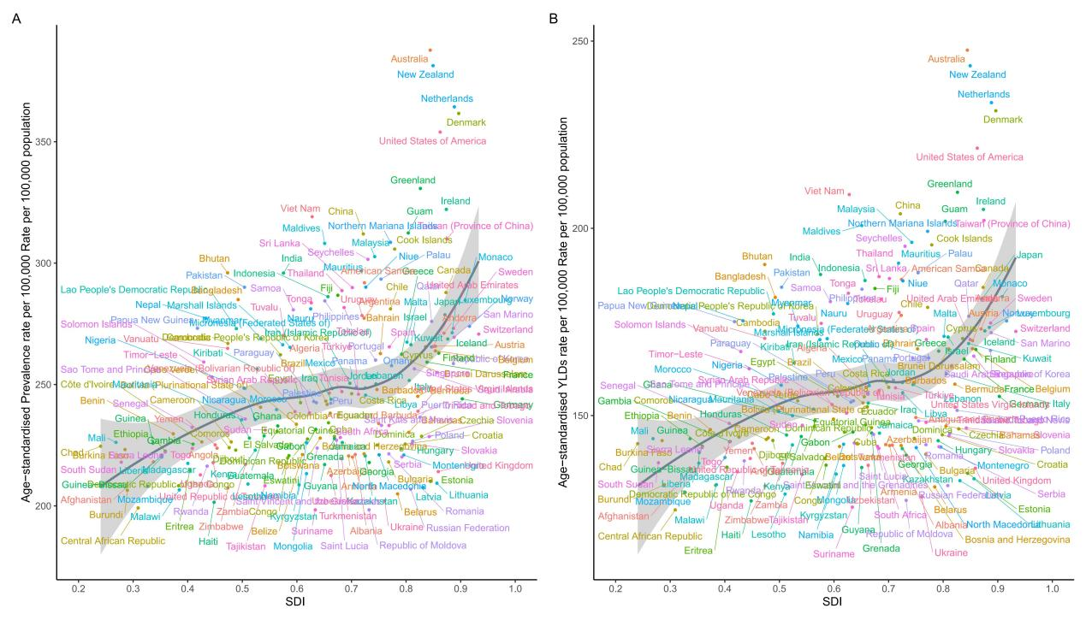

Figure 13. Association Between Autism Spectrum Disorders and SDI. (A)ASR Prevalence of Autism Spectrum Disorders. (B)ASR YLDs of Autism Spectrum Disorders.
