Supplementary Materials for
The Protective Role of Memory Suppression in Psychological Resilience among Young Adults with Childhood Trauma

This PDF file includes:
Figs.S1-S4
Tables.S1-S3
Supplementary Materials and methods
Think/No-think task
Our TNT paradigm had three phases: learning phase, TNT phase, and final test phase. The stimuli used in TNT task were three series of lists of 72 picture pairs composed of emotional pictures (neutral and negative) selected from Chinese Affective Picture System (CAPS). The lists of pairs were presented in counterbalanced order across the three series, the four conditions and the three groups of participants and matched on different properties that may influence performance to the task. The lists of neutral and negative pictures were matched on salience of the cues, the emotional valence and arousing nature. Three series of four lists of 18 pairs assigned to four conditions (think, no-think, baseline, and unprimed) were created¹². Stimuli were presented using the E-prime 2.0 (Psychology Software Tools).
Learning phase. Participants learned 72 neutral-negative picture pairs that were presented for 5 s each. After the presentation of all pairs, the neutral cue for a given pair was presented on the screen for up to 4 s, and participants were asked whether they could recall and fully visualize the paired negative picture. If so, three negative pictures then appeared on the screen (one correct and two foils), and participants had up to 4 s to select which negative one was associated with the neutral picture. After each test, participants were shown the correct picture pair again for 2500ms on the screen, as feedback to increase encoding. The testing cycled through all items repeatedly until participants reached a set criterion of at least 90% correct responses (all succeeded within six cycles). When participants reached the learning criterion, a final test cycle (without giving any feedback on the response) assessed including all pairs assessed which pairs had been learned.
TNT phase. In this phase, pairs were divided into three lists of 18 pairs assigned to think, no-think, and baseline conditions for the think/no-think task (TNT)¹². Participants were given the instructions before MRI acquisition to familiarize them to the task. Before TNT task begins, the complete list of learned pairs was presented once again to reinforce the learning of the pairs (5 s for each pair). After this reminder of the pairs, participants performed the TNT task, which was divided into four sessions of ~10 min each. In each session, the 18 think and 18 no-think items were presented twice¹². Neutral picture cues appeared for 3 s on the screen and were written either in green for think trials or in red for no-think trials. During the TNT practice session, participants were provided with a direct suppression strategy for no-think trials. This strategy instructed them to actively prevent the associated negative picture from entering their mind, while fixating on and concentrating solely on the presented cue. Participants were instructed to suppress thoughts of the negative picture by blanking their mind, rather than substituting the object with alternative thoughts or mental images. If the object image came to mind anyway, they were asked to push it out of mind. During the think trials, participants were told to actively visualize the associated picture with maximal detail. After the end of each of the think or no-think trial cues, participants reported whether the associated picture had entered awareness by pressing one of two buttons corresponding to “yes” (i.e., even if the associated object pops very briefly into their mind) or “no”. Although participants had up to 3600ms to make this intrusion rating, they were instructed to make it quickly without thinking and dwelling too much on the associated object. The rating instruction was presented for up to 1 s on the screen and followed by a jittered fixation cross (1400, 1800, 2000, 2200, or 2600ms).
Final test phase. Participants performed perceptual identification task about 8 min to test whether previous attempts at suppression affected repetition priming. Each item, including think, no-think, baseline, and unprimed, was presented on one trial in a 500 pixel by 500 pixel frame centered on a gray background, and trials were separated by a fixation cross. A single item in each trial was gradually presented using a phase unscrambling procedure. Participants’ instruction was to watch carefully as the negative picture was progressively unscrambled and to press the button as fast as possible when they were able to see and name this picture. Unscrambling continued until a complete image appeared, irrespective of when and whether participants pressed a button. Random noise was added to the phase spectrum starting from 100% and was decreased by 5% steps until 0% (i.e., intact picture) was reached. The picture was presented at each level of noise for 150ms, yielding a total stimulus duration of 3.15 s. Between trials, there was a 2.4-s average inter stimuli interval. In the end, participants were required to recall details of the associated negative picture when they viewed the cue image.

Brain activity analysis and functional connectivity analysis
Preprocessed fMRI time series were high-pass filtered with a cutoff period of 128 s to remove low-frequency drift. Using a general linear model (GLM) implemented in SPM12, blood oxygenation level-dependent (BOLD) responses were modeled at each voxel. Task-related regressors for the Think and No-Think conditions were generated by convolving stimulus onsets with the canonical hemodynamic response function (HRF). Nuisance regressors included six head motion parameters from realignment. Temporal autocorrelation was modeled using a first-order autoregressive [AR(1)] model, with GLM parameters estimated via restricted maximum likelihood (ReML).
First-level contrast maps for the Think vs. No-Think conditions were generated for each participant and entered into second-level random-effects models in SPM12. Task-specific effects were examined using one-sample t-tests for the No-Think minus Think (NT-T) contrast in the Think/No-Think (TNT) task. For whole-brain analyses, statistical parametric maps (SPMs) were thresholded at a voxel-level family-wise error (FWE) correction with a significance threshold of P_{FWE} < 0.05, based on random field theory. For further analyses, such as between-group comparisons of NT-T activation differences, we examined predefined regions of interest (ROIs) derived from the whole-brain analysis. These analyses used an initial uncorrected threshold of P_{uncorr} < 0.001 to identify significant clusters within the ROIs.

Functional connectivity analysis
Preprocessed and normalized functional images were imported into the CONN toolbox (v.21.h) using CONN toolbox⁴² (22.v2407) for seed-to-voxel functional connectivity analysis. Data were denoised using CONN’s standard pipeline, regressing out confounding effects, including five CompCor components each for white matter and cerebrospinal fluid (CSF) time series, six motion parameters, session and task effects with their first-order derivatives (four factors), and linear trends (two factors) within each run. A high-pass filter (>0.008 Hz) was applied to the BOLD time series to remove low-frequency drift.
Task-specific functional connectivity was analyzed using a generalized psychophysiological interaction (gPPI) model, with a predefined ROI as the seed region. For each participant, the gPPI model included the seed’s BOLD time series as the physiological factor, boxcar functions for the Think and No-Think conditions of the Think/No-Think task (convolved with the canonical hemodynamic response function) as psychological factors, and their product as the psychophysiological interaction term. Connectivity changes were quantified as Fisher-transformed semipartial correlation coefficients of the interaction terms for the No-Think vs. Think contrast, assessing connectivity between the seed region and all other whole-brain voxels.
Group-level analyses were conducted using a general linear model (GLM) in CONN. For each voxel, a GLM was estimated with first-level gPPI connectivity measures as dependent variables (one sample per participant per condition) and group identifiers as independent variables. Voxel-level effects were evaluated using multivariate parametric statistics, assuming random effects across participants and sample covariance estimation across conditions. Cluster-level inferences were based on parametric statistics derived from Gaussian Random Field theory. Results were thresholded using a voxel-level threshold of p < 0.001 (uncorrected) and a cluster-level false discovery rate (FDR)-corrected threshold of p < 0.05.

Fig. S1. Flow chart of online survey
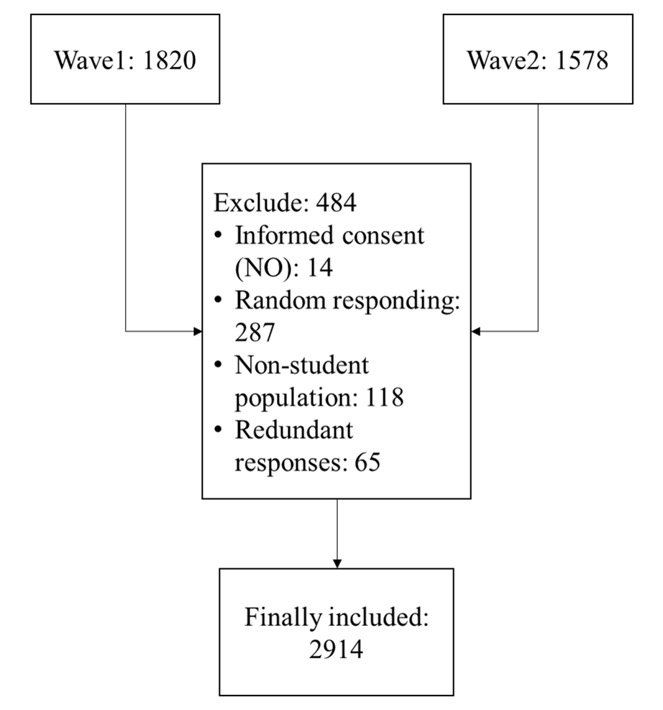
Flow chat of questionnaires. This survey yielded respectively 1,820 in wave1and 1,578 valid questionnaires in wave2. The dates of wave1 and wave2 are March 2021 and September 2021. Finally, 2914 questionnaires were included.

Fig. S2. The relationship among childhood trauma, resilience and memory suppression in Non-Trauma group
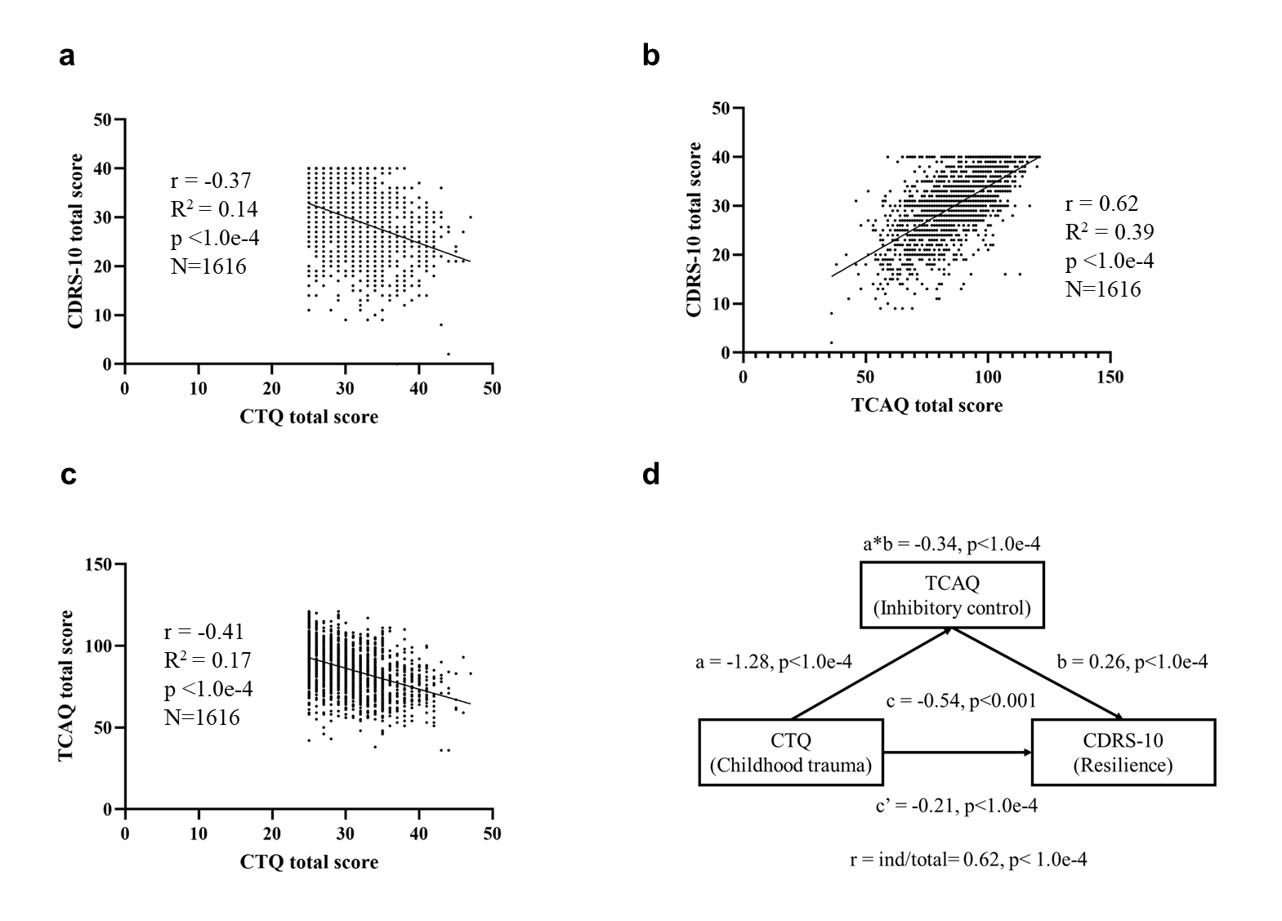
In Non-Trauma group, there were 1616 questionnaires. Connor-Davidson Resilience Scale (CDRS-10) assessed resilience was significantly negatively related to the Childhood Trauma Questionnaire (CTQ) total scores (a), CDRS-10 assessed resilience was significantly positively related to CTQ scores (b), Thought Control Ability Questionnaire (TCAQ)-assessed memory suppression was significantly negatively related to CTQ scores (c). Mediation model among memory suppression, childhood trauma and resilience (d). The model indicated memory suppression partial mediated the association between childhood trauma and resilience.

Fig. S3. The relationship among childhood trauma, resilience and memory suppression in Trauma group
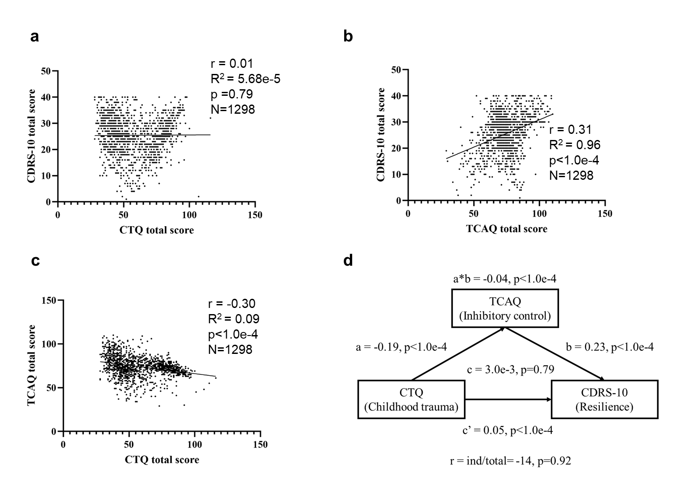
In Trauma group, there were 1298 questionnaires. Connor-Davidson Resilience Scale (CDRS-10) assessed resilience was positively related to the Childhood Trauma Questionnaire (CTQ) total scores, but it was not statistically significant (a). CDRS-10 assessed resilience was significantly positively related to CTQ scores (b), Thought Control Ability Questionnaire (TCAQ)-assessed memory suppression was significantly negatively related to CTQ scores (c). Mediation model among memory suppression, childhood trauma and resilience (d). A weak mediating relationship among memory suppression, childhood trauma and resilience.

Fig. S4. The relationship between childhood trauma and psychological resilience in trauma-exposed individuals with CTQ>70
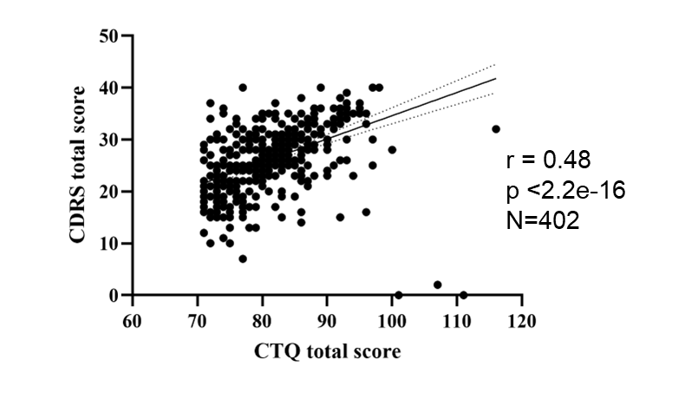
In trauma-exposed individuals with CTQ>70, there were 402 questionnaires. A significant positive correlation was found between resilience, as assessed by the Connor-Davidson Resilience Scale (CDRS-10), and the total score on the Childhood Trauma Questionnaire (CTQ).

Table S1. Multiple Comparisons of accuracy among high-resilience trauma, low-resilience trauma and trauma- naïve healthy controls Groups
Comparison | Mean Difference | SE | p-value | 95% Confidence Interval
LSD
HR vs LR | 18.56 | 55.07 | 0.74 | -90.90 to 128.01
HR vs HC | 110.22 | 55.51 | 0.05 | -0.11 to 220.55
LR vs HC | 91.66 | 54.59 | 0.097 | -16.84 to 200.17
Bonferroni
HR vs LR | 18.56 | 55.07 | 1 | -115.87 to 152.99
HR vs HC | 110.22 | 55.51 | 0.15 | -25.29 to 245.73
LR vs HC | 91.66 | 54.59 | 0.29 | -41.60 to 224.93
HR: high-resilience trauma; LR: low-resilience trauma; HC: trauma- naïve healthy controls; SE: standard error. The error term is Mean Square (Error) = 45436.204.

Table S2. Activation and Deactivation of the Brain during the Think/No-Think Task
Anatomical description | Cluster size | MNI coordinates |  |  | T | Z | p_{fwe}
Anatomical description | Cluster size | x | y | z | T | Z | p_{fwe}
No-think > Think
Right insula | 3079 | 48 | 18 | -3 | 12.94 | Inf | < 0.001
Right pre-supplementary motor area |  | 9 | 9 | 54 | 12.69 | Inf | < 0.001
Right pre-supplementary motor area |  | 12 | 18 | 54 | 12.38 | Inf | < 0.001
Right superior temporal gyrus | 422 | 60 | -36 | 21 | 11.04 | Inf | < 0.001
Right supramarginal gyrus |  | 60 | -42 | 27 | 10.25 | Inf | < 0.001
Left insula | 495 | -39 | 15 | -6 | 10.92 | Inf | < 0.001
Left inferior frontal gyrus, opercular part |  | -51 | 12 | 3 | 9.73 | Inf | < 0.001
Left inferior frontal gyrus, orbital part |  | -33 | 27 | -12 | 8.59 | 7.21 | < 0.001
Left supramarginal gyrus | 188 | -63 | -51 | 24 | 9.98 | Inf | < 0.001
Right caudate | 157 | 18 | 9 | 6 | 8.82 | 7.35 | < 0.001
Right pallidum |  | 18 | 3 | -3 | 8.14 | 6.93 | < 0.001
Right putamen |  | 18 | 12 | -3 | 8.13 | 6.92 | < 0.001
Left middle frontal gyrus | 171 | -27 | 48 | 15 | 8.78 | 7.32 | < 0.001
Left cerebellar hemisphere, crus I | 124 | -33 | -60 | -36 | 8.57 | 7.2 | < 0.001
Left cerebellar hemisphere, lobule VIII |  | -42 | -57 | -51 | 5.78 | 5.27 | 0.005
Right middle temporal gyrus | 127 | 48 | -21 | -12 | 8.28 | 7.02 | < 0.001
Right middle temporal gyrus |  | 57 | -36 | -3 | 7.16 | 6.28 | < 0.001
Left inferior occipital gyrus | 146 | -42 | -69 | -12 | 8.28 | 7.01 | < 0.001
Left inferior occipital gyrus |  | -45 | -78 | -9 | 8.23 | 6.98 | < 0.001
Left middle occipital gyrus |  | -45 | -84 | 0 | 7.18 | 6.29 | < 0.001
Left intraparietal sulcus | 75 | -33 | -57 | 48 | 7.25 | 6.34 | < 0.001
Right red nucleus | 34 | 9 | -21 | -6 | 7.08 | 6.22 | < 0.001
Right ventral lateral thalamus |  | 12 | -9 | -3 | 6.95 | 6.13 | < 0.001
Left pallidum | 20 | -15 | 3 | -6 | 6.33 | 5.69 | < 0.001
Right fusiform | 20 | 45 | -48 | -21 | 6.29 | 5.65 | 0.001
Right inferior temporal gyrus |  | 45 | -57 | -15 | 5.4 | 4.97 | 0.018
Right inferior parietal gyrus | 23 | 27 | -51 | 42 | 5.99 | 5.43 | 0.002
Left inferior temporal gyrus | 4 | -51 | -27 | -9 | 5.83 | 5.31 | 0.004
Right cerebellar hemisphere, crus I | 13 | 33 | -57 | -39 | 5.72 | 5.22 | 0.006
Right calcarine fissure | 1 | 9 | -99 | 0 | 5.16 | 4.78 | 0.043
Left inferior temporal gyrus | 1 | -45 | -9 | -39 | 5.15 | 4.77 | 0.044
Right inferior temporal gyrus | 1 | 45 | -6 | -45 | 5.14 | 4.77 | 0.045
Right inferior temporal gyrus | 1 | 42 | 0 | -42 | 5.11 | 4.74 | 0.049
Think > No-think
Right precuneus | 3061 | 12 | -54 | 9 | 16.79 | Inf | < 0.001
Left calcarine |  | -12 | -57 | 9 | 15.01 | Inf | < 0.001
Left fusiform |  | -27 | -39 | -18 | 14.55 | Inf | < 0.001
Right fusiform |  | 24 | -36 | -21 | 11.64 | Inf | < 0.001
Left middle occipital gyrus | 278 | -36 | -81 | 27 | 11.03 | Inf | < 0.001
Left superior frontal gyrus | 259 | -21 | 27 | 39 | 9.42 | 7.7 | < 0.001
Left middle frontal gyrus |  | -30 | 21 | 48 | 8.14 | 6.93 | < 0.001
Left superior frontal gyrus |  | -15 | 42 | 45 | 5.96 | 5.41 | 0.002
Right cerebellar hemisphere, lobule IX | 50 | 6 | -54 | -51 | 9.31 | 7.64 | < 0.001
Left cerebellar hemisphere, lobule IX |  | -6 | -54 | -51 | 6.32 | 5.67 | < 0.001
Vermis, lobule IX |  | 0 | -51 | -42 | 5.41 | 4.98 | 0.018
Left superior frontal gyrus, medial orbital | 379 | -3 | 66 | -15 | 9.16 | 7.55 | < 0.001
Left superior frontal gyrus |  | -15 | 69 | 0 | 8.54 | 7.18 | < 0.001
Right superior frontal gyrus, medial orbital |  | 6 | 72 | -3 | 8.33 | 7.05 | < 0.001
Left lingual | 516 | -9 | -87 | -12 | 8.85 | 7.37 | < 0.001
Right lingual |  | 15 | -84 | -18 | 8.44 | 7.12 | < 0.001
Right cerebellar hemisphere, lobule VI |  | 24 | -75 | -21 | 7.43 | 6.46 | < 0.001
Right postcentral gyrus | 142 | 21 | -45 | 60 | 8.2 | 6.96 | < 0.001
Right postcentral gyrus |  | 18 | -36 | 66 | 6.15 | 5.55 | 0.001
Left Rolandic operculum | 220 | -39 | -9 | 15 | 7.73 | 6.66 | < 0.001
Left Heschl’s gyrus |  | -39 | -24 | 12 | 7.14 | 6.26 | < 0.001
Left insula |  | -39 | -6 | -6 | 6.78 | 6.01 | < 0.001
Right superior frontal gyrus | 43 | 21 | 30 | 39 | 6.43 | 5.75 | < 0.001
Right middle frontal gyrus |  | 33 | 21 | 51 | 5.24 | 4.85 | 0.032
Right postcentral gyrus | 26 | 57 | -15 | 48 | 5.93 | 5.38 | 0.002
Right postcentral gyrus |  | 63 | -9 | 39 | 5.45 | 5.01 | 0.016
Left paracentral lobule | 38 | -12 | -33 | 75 | 5.89 | 5.35 | 0.003
Left superior parietal gyrus |  | -21 | -45 | 60 | 5.88 | 5.35 | 0.003
Left postcentral gyrus |  | -15 | -39 | 69 | 5.47 | 5.02 | 0.015
Right middle cingulate | 4 | 6 | -9 | 39 | 5.78 | 5.27 | 0.005
Left superior temporal gyrus | 7 | -60 | -12 | 6 | 5.76 | 5.25 | 0.005
Right cerebellar hemisphere, lobule IX | 3 | 9 | -45 | -60 | 5.69 | 5.2 | 0.006
Left superior frontal gyrus, medial | 8 | 0 | 51 | 45 | 5.65 | 5.16 | 0.008
Right middle cingulate | 2 | 9 | -33 | 48 | 5.56 | 5.1 | 0.01
Right superior frontal gyrus | 5 | 21 | 39 | 51 | 5.48 | 5.03 | 0.014
Right calcarine fissure | 1 | 27 | -72 | 3 | 5.39 | 4.96 | 0.019
Right postcentral gyrus | 3 | 48 | -24 | 57 | 5.34 | 4.92 | 0.023
Left postcentral gyrus | 1 | -33 | -36 | 69 | 5.32 | 4.91 | 0.025
Right superior temporal gyrus | 1 | 69 | -15 | 3 | 5.31 | 4.9 | 0.025
Left middle temporal gyrus | 1 | -60 | -3 | -21 | 5.29 | 4.88 | 0.027
Right postcentral gyrus | 3 | 63 | -3 | 27 | 5.2 | 4.81 | 0.038
Right middle frontal gyrus | 1 | 30 | 18 | 42 | 5.13 | 4.76 | 0.046
Peak coordinates of the regions showing a difference in activity between Think and No-Think trials in all participants at p_{voxel-fwe} < 0.05.
Table S3. Functional Connectivity Differences of the Left Intraparietal Sulcus (IPS) with Whole-Brain Voxels in the No-Think vs. Think (NT-T) Contrast
Anatomical description | MNI coordinates |  |  | Cluster size | T value | size p-FDR | size p-unc
Anatomical description | x | y | z
Left frontal pole | -8 | 62 | 6 | 829 | -6.20 | <1.0×10⁻⁶ | <1.0×10⁻⁶
Left middle temporal gyrus | -54 | -40 | 0 | 671 | -6.82 | <1.0×10⁻⁶ | <1.0×10⁻⁶
Right occipital fusiform gyrus | 34 | -84 | -4 | 603 | 5.81 | <1.0×10⁻⁶ | <1.0×10⁻⁶
Anterior cingulate gyrus | 6 | 14 | 36 | 531 | 6.13 | <1.0×10⁻⁶ | <1.0×10⁻⁶
Right middle temporal gyrus | 58 | -46 | -6 | 236 | -5.49 | 2.7×10⁻⁵ | 2.0×10⁻⁶
Left occipital fusiform gyrus | -18 | -94 | -6 | 198 | 5.61 | 9.5×10⁻⁵ | 9.0×10⁻⁶
Left occipital pole | -6 | -96 | -16 | 113 | 5.16 | 3.0×10⁻³ | 3.4×10⁻⁴
Left posterior cingulate gyrus | -12 | -46 | 26 | 64 | -4.72 | 3.3×10⁻² | 4.2×10⁻³
Left middle temporal gyrus, posterior division | -68 | -12 | -10 | 56 | -5.37 | 4.7×10⁻² | 6.8×10⁻³
This table summarizes the gPPI analysis results, showing functional connectivity differences between the left intraparietal sulcus (IPS) and whole-brain voxels during the No-Think vs. Think (NT-T) contrast in the TNT task. Significant regions and their T-values are listed, thresholded at p_{cluster-fdr} < 0.05.

