Supplementary Information for
Temperature regimes shape similarity of life-history strategies between native and non-native freshwater fishes
Supplementary Figures
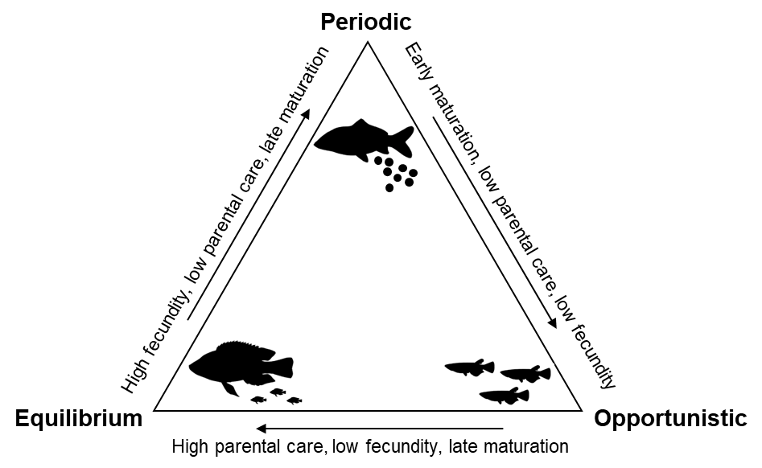
Fig. S1. Conceptual figure describing the typical traits of three life-history strategies of freshwater fish species. The EPO model classifies fish life-history strategies into three adaptive types based on trade-offs among juvenile survival, fecundity, and generation time in response to environmental regimes. Equilibrium strategists occur in stable environments and have intermediate body size, low fecundity, late maturation, and high parental investment. Periodic strategists dominate in seasonal environments and are typically large-bodied, high fecundity, and late maturation with low parental care. Opportunistic strategists prevail in frequently disturbed systems and are small-bodied, short-lived, early maturation, low parental care, low fecundity, and rely on rapid population turnover.
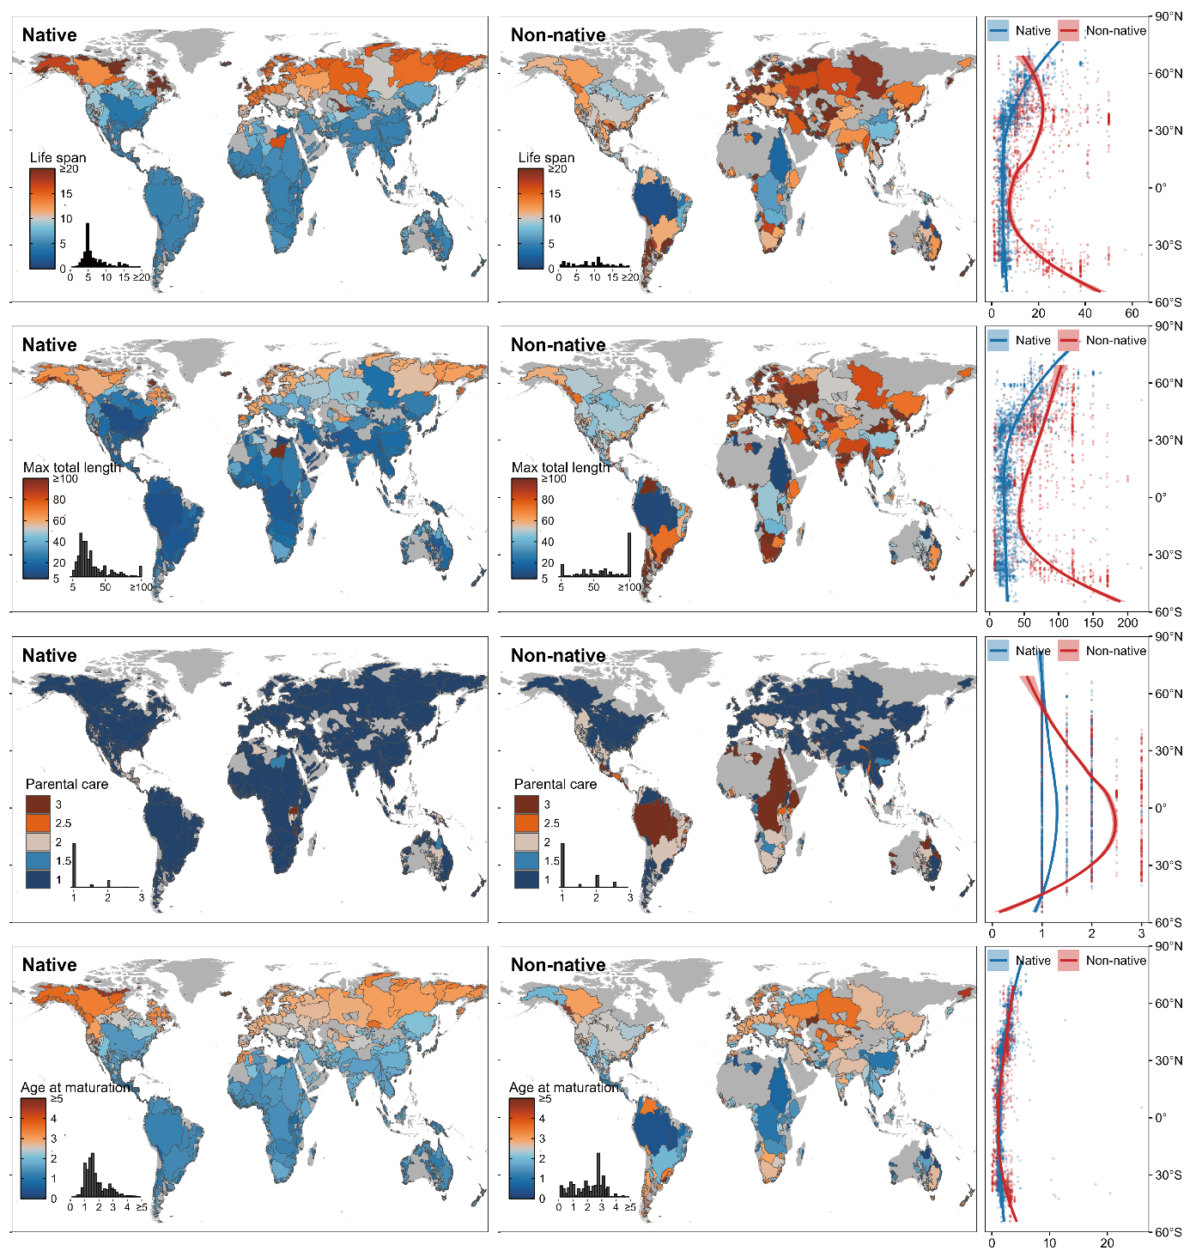
Fig. S2. Global distributions and latitudinal trends in median values of four life-history traits (life span, maximum total length, parental care, and age at maturation) of native and non-native freshwater fishes at the river-basin scale. Curves in the right-hand panels represent the corresponding fitted latitudinal trends for native and non-native fishes based on LOESS smoothing. All error bands represent 95% confidence intervals.
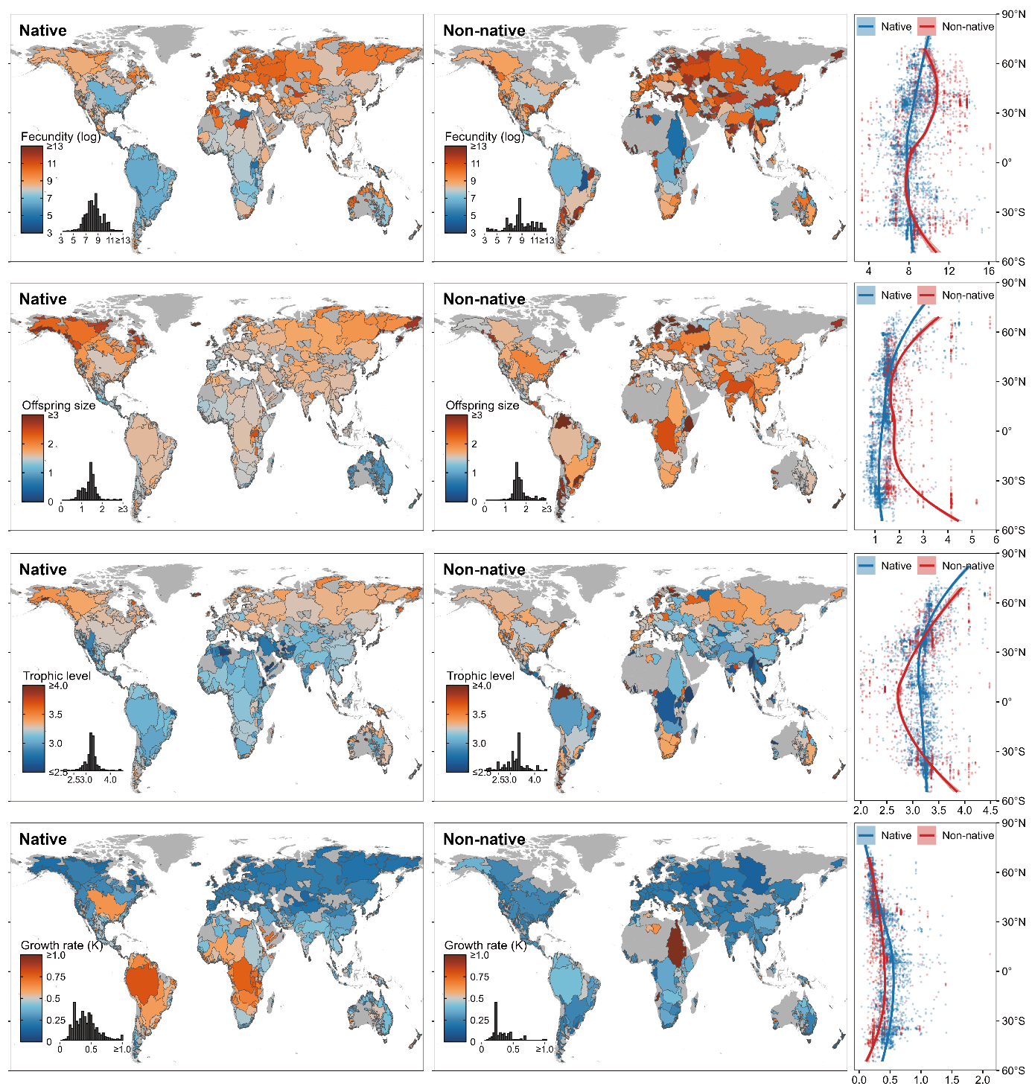
Fig. S3. Global distributions and latitudinal trends in median values of another four life-history traits (fecundity, offspring size, trophic level, and K) of native and non-native freshwater fishes at the river-basin scale. Curves in the right-hand panels represent the corresponding fitted latitudinal trends for native and non-native fishes based on LOESS smoothing. All error bands represent 95% confidence intervals.
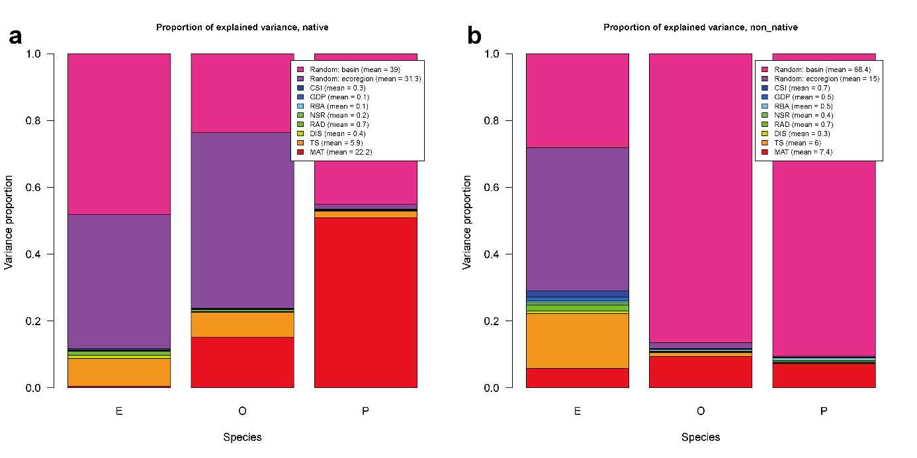
Fig. S4. Partitioning of the overall explained variance of the data into the different model components. (a) Native fish. (b) Non-native fish. E, equilibrium; O, opportunistic; P, periodic.
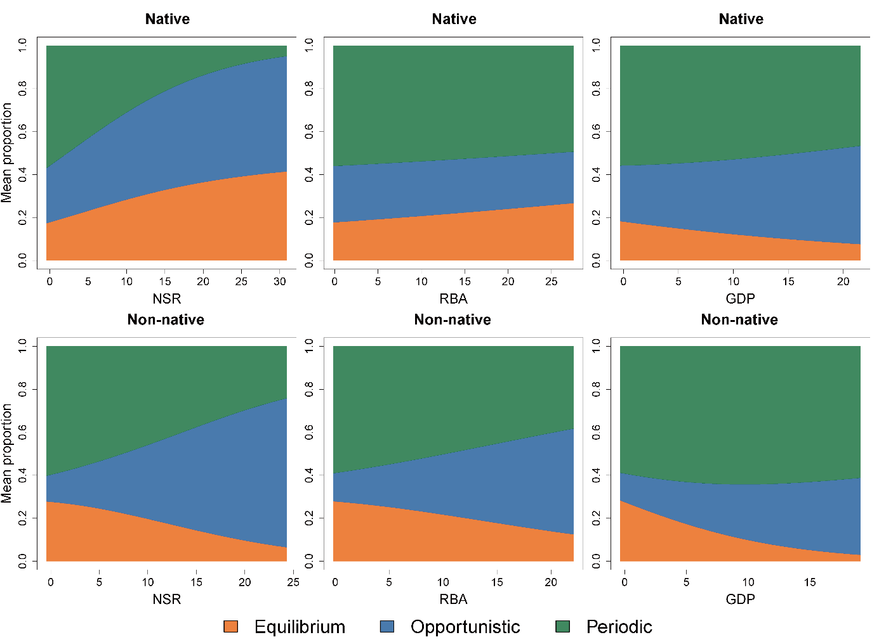
Fig. S5. Effect of environmental and anthropogenic covariates on the three life-history strategies in global native and non-native fishes. NSR, native species richness; RBA, river basin area; GDP, gross domestic product.
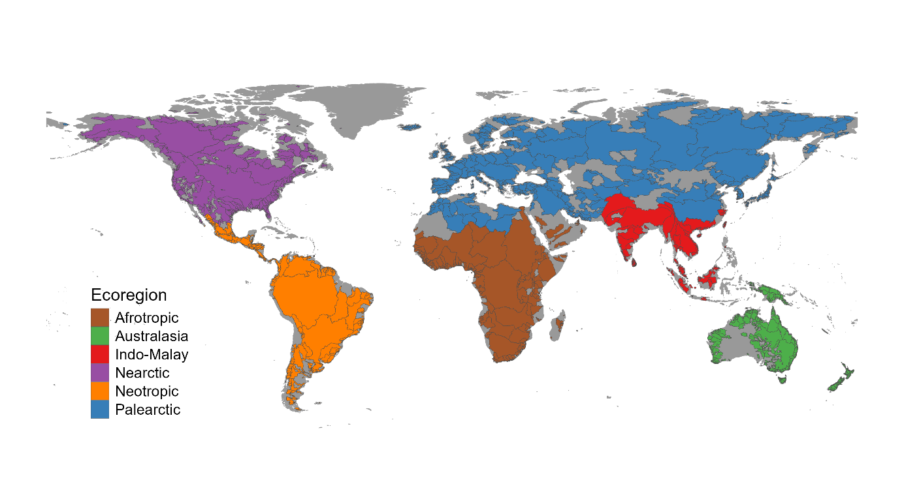
Fig. S6. Global distribution of the six biogeographical realms. Oceania was merged with Australasia for analysis in this study.
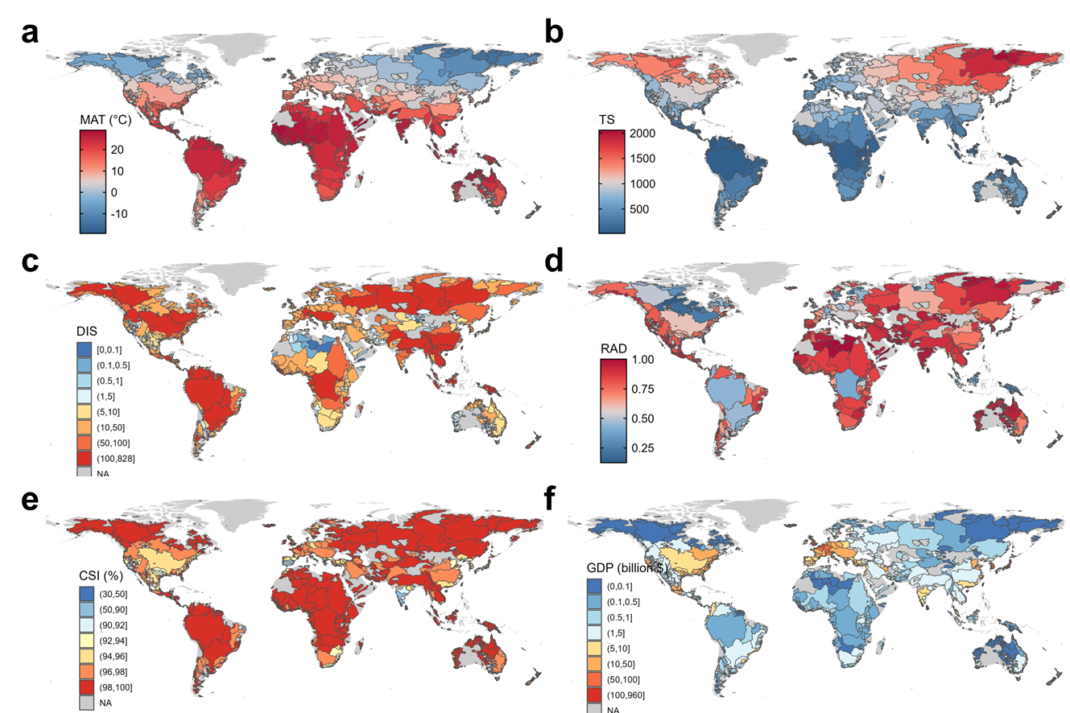
Fig. S7. The main environmental and anthropogenic predictors at the river basin scale. (a) Mean annual temperature (MAT). (b) temperature seasonality (TS). (c) natural discharge (DIS). (d) relative amplitude of natural discharge (RAD). (e) connectivity status index of river reaches (CSI). (f) gross domestic product (GDP).
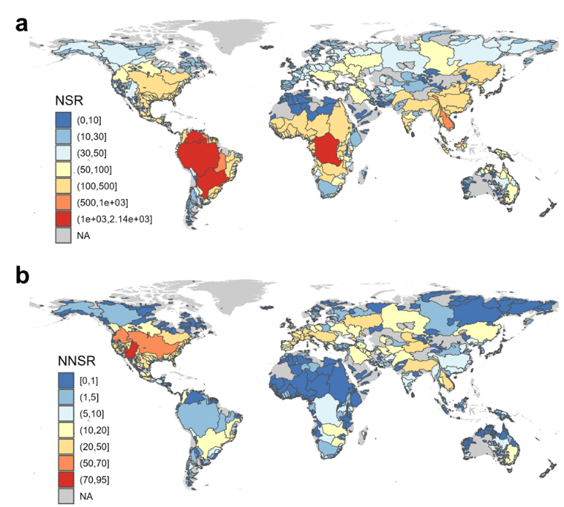
Fig. S8. Global geographical distribution of native and non-native freshwater fish species across the 3,118 basins. (a) Geographical pattern of native fish richness (NSR). (b) Geographical pattern of non-native fish richness (NNSR).
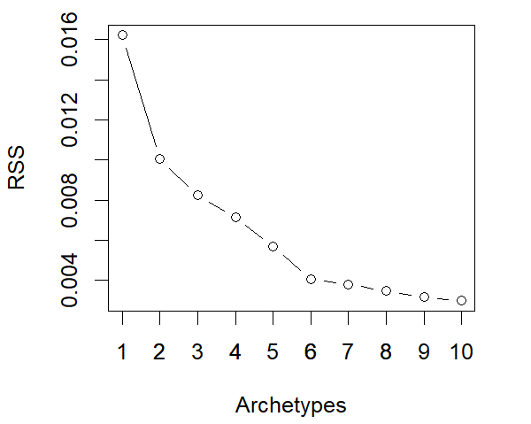
Fig. S9. Residual sum of squares as a function of the number of strategies. Residuals sum of squares (RSS), i.e. quality of fit, of 10 archetypal analysis iterations as a function of the numbers of extreme points (k) used to encompass the trait space representing the life-history strategies endpoint.
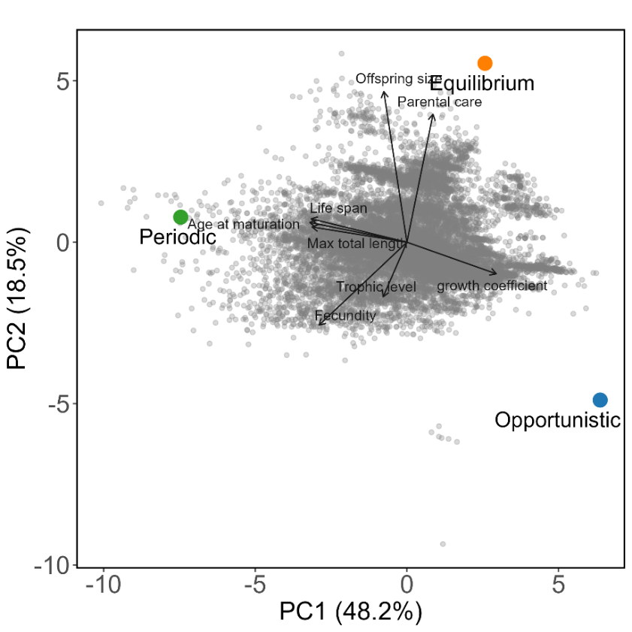
Fig. S10. Principal component analysis (PCA) of the eight life-history traits and life-history strategy endpoints identified based on archetypal analysis (AA). The proportions of the three life-history strategies for each species add to one.
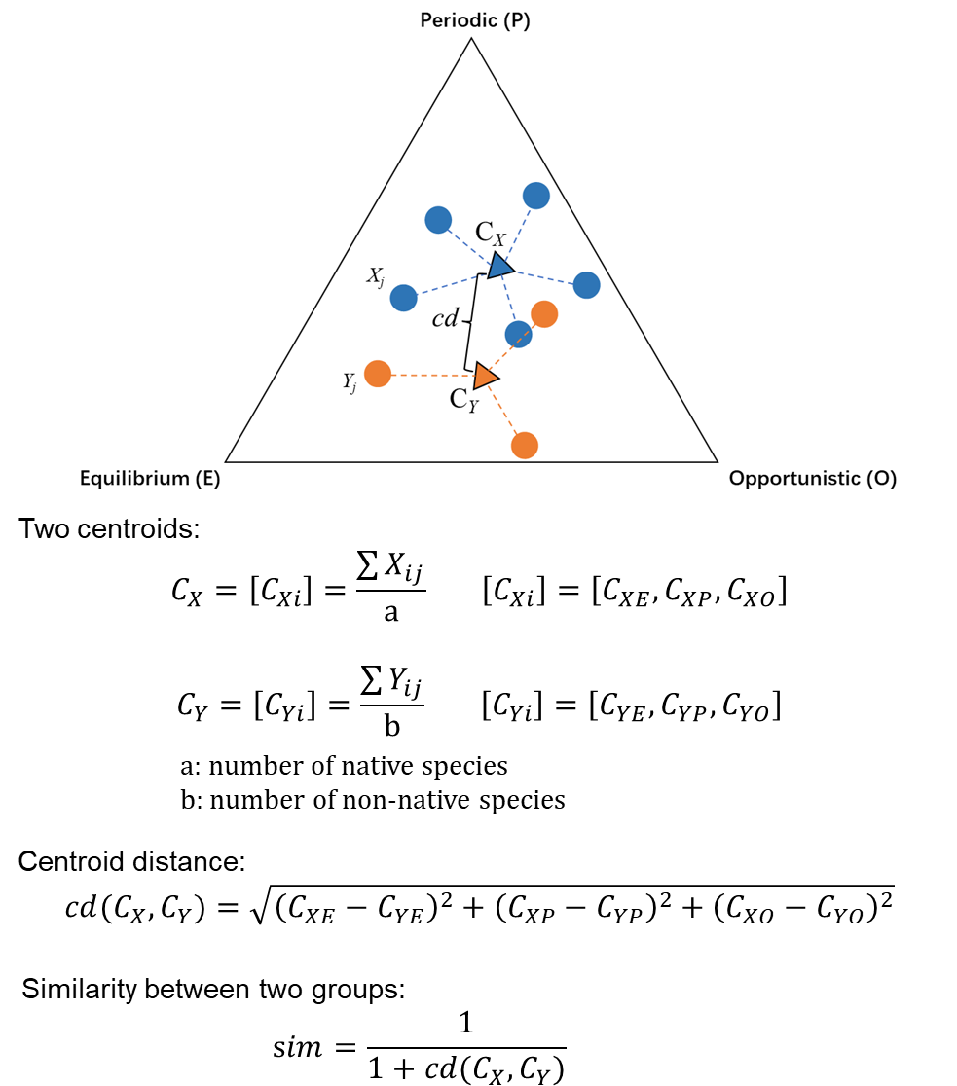
Fig. S11. An example illustrating the computation of similarity between native and non-native fishes. The life-history triangle represents the proportions of life-history strategies within each basin, estimated based on the distance of the species to the three end-points of the life-history triangle defined by eight traits: equilibrium (E), opportunistic (O), and periodic (P) strategies. Blue and orange circles denote individual native and non-native species, respectively. Vector Y_{j} represents the position of non-native species j and vector X_{j} is the position of native species j. C_{X} and C_{Y} (triangles) are the centroids of native and non-native fishes, with [C_{Xi}] and [C_{Yi}] representing their coordinates in ternary space. cd is the distance between the centroids for native (C_{X}) and non-native (C_{Y}) centroids. sim is the similarity.
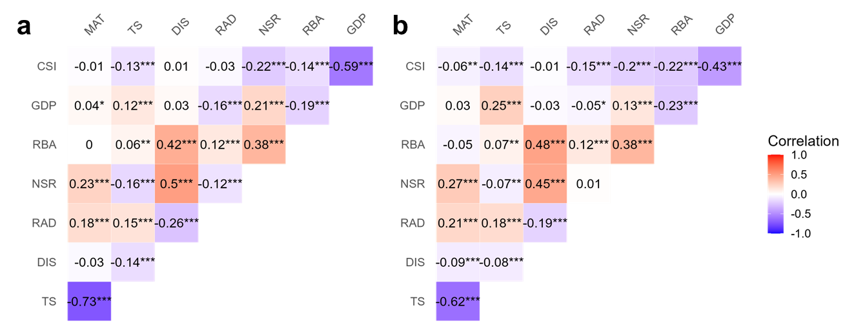
Fig. S12. Spearman correlation between the eight environmental and anthropogenic variables of the world river basins. (a) Correlations among predictors for the 3,032 basins included in the HMSC model of native life‐history strategy composition. (b) Correlations among predictors for the 1,691 basins included in the HMSC model of non‐native life‐history strategy composition. Abbreviations: MAT, mean annual temperature; TS, temperature seasonality; DIS, natural discharge; RAD, relative amplitude of natural discharge; NSR, native species richness; RBA, river basin area; GDP, gross domestic product; CSI, connectivity status index of river reaches. *p < 0.05; **p < 0.01; ***p < 0.001.

Supplementary Tables
Table S1. Linear regression of basin-level mean life-history strategy proportions against absolute latitude for native and non-native fishes. Statistically significant p values (≤ 0.05) are given in bold.
Status | Strategy | n | Intercept | slope | p
Native | Equilibrium | 3115 | 0.211 | −0.002 | < 0.001
Native | Opportunistic | 3115 | 0.418 | −0.004 | < 0.001
Native | Periodic | 3115 | 0.371 | 0.006 | < 0.001
Non-native | Equilibrium | 1723 | 0.484 | −0.007 | < 0.001
Non-native | Opportunistic | 1723 | 0.222 | −0.003 | < 0.001
Non-native | Periodic | 1723 | 0.293 | 0.010 | < 0.001

Table S2 Results of Kruskal–Wallis tests of differences in mean life-history strategy proportions among native and non-native fishes at the basin scale across biogeographical realms and globally. Statistically significant p values (≤ 0.05) are given in bold.
Status | Global/Ecoregion | Strategy1 | Strategy2 | n1; n2 | statistic | p
Native | Global | Equilibrium | Opportunistic | 3115; 3115 | 31.0 | < 0.001
 | Global | Equilibrium | Periodic |  | 76.9 | < 0.001
 | Global | Opportunistic | Periodic |  | 45.9 | < 0.001
Non-native | Global | Equilibrium | Opportunistic | 1723; 1723 | -16.8 | < 0.001
 | Global | Equilibrium | Periodic |  | 29.4 | < 0.001
 | Global | Opportunistic | Periodic |  | 46.2 | < 0.001
Native | Afrotropic | Equilibrium | Opportunistic | 281; 281 | 13.3 | < 0.001
 | Afrotropic | Equilibrium | Periodic |  | 19.6 | < 0.001
 | Afrotropic | Opportunistic | Periodic |  | 6.2 | < 0.001
 | Australasia | Equilibrium | Opportunistic | 742; 742 | 25.6 | < 0.001
 | Australasia | Equilibrium | Periodic |  | 40.2 | < 0.001
 | Australasia | Opportunistic | Periodic |  | 14.6 | < 0.001
 | Indo-Malay | Equilibrium | Opportunistic | 340; 340 | 15.0 | < 0.001
 | Indo-Malay | Equilibrium | Periodic |  | 29.5 | < 0.001
 | Indo-Malay | Opportunistic | Periodic |  | 14.5 | < 0.001
 | Nearctic | Equilibrium | Opportunistic | 296; 296 | -1.3 | 0.186
 | Nearctic | Equilibrium | Periodic |  | 20.1 | < 0.001
 | Nearctic | Opportunistic | Periodic |  | 21.4 | < 0.001
 | Neotropic | Equilibrium | Opportunistic | 426; 426 | 10.0 | < 0.001
 | Neotropic | Equilibrium | Periodic |  | 20.8 | < 0.001
 | Neotropic | Opportunistic | Periodic |  | 10.8 | < 0.001
 | Palearctic | Equilibrium | Opportunistic | 1030; 1030 | 8.7 | < 0.001
 | Palearctic | Equilibrium | Periodic |  | 43.4 | < 0.001
 | Palearctic | Opportunistic | Periodic |  | 34.7 | < 0.001
Non-native | Afrotropic | Equilibrium | Opportunistic | 100; 100 | -6.8 | < 0.001
 | Afrotropic | Equilibrium | Periodic |  | 4.6 | < 0.001
 | Afrotropic | Opportunistic | Periodic |  | 11.5 | < 0.001
 | Australasia | Equilibrium | Opportunistic | 403; 403 | -9.0 | < 0.001
 | Australasia | Equilibrium | Periodic |  | 8.5 | < 0.001
 | Australasia | Opportunistic | Periodic |  | 17.5 | < 0.001
 | Indo-Malay | Equilibrium | Opportunistic | 237; 237 | -13.5 | < 0.001
 | Indo-Malay | Equilibrium | Periodic |  | 2.6 | < 0.001
 | Indo-Malay | Opportunistic | Periodic |  | 16.1 | < 0.001
 | Nearctic | Equilibrium | Opportunistic | 164; 164 | -5.9 | < 0.001
 | Nearctic | Equilibrium | Periodic |  | 11.2 | < 0.001
 | Nearctic | Opportunistic | Periodic |  | 17.1 | < 0.001
 | Neotropic | Equilibrium | Opportunistic | 169; 169 | -9.3 | < 0.001
 | Neotropic | Equilibrium | Periodic |  | 2.1 | < 0.05
 | Neotropic | Opportunistic | Periodic |  | 11.4 | < 0.001
 | Palearctic | Equilibrium | Opportunistic | 650; 650 | -5.3 | < 0.001
 | Palearctic | Equilibrium | Periodic |  | 26.4 | < 0.001
 | Palearctic | Opportunistic | Periodic |  | 31.7 | < 0.001

Table S3. Results of Wilcoxon rank sum tests of differences in mean life-history strategy composition between native and non-native fishes at the basin scale across biogeographical realms and globally. Statistically significant p values (≤ 0.05) are given in bold.
Global/Ecoregion | Life-history strategy
Global/Ecoregion | Equilibrium |  |  | Opportunistic |  |  | Periodic
Global/Ecoregion | n (native; non-native) | statistic | p | n (native; non-native) | statistic | p | n (native; non-native) | statistic | p
Global | (3115;1723) | 1995053 | < 0.001 | (3115;1723) | 4416154 | < 0.001 | (3115;1723) | 1946265 | < 0.001
Afrotropic | (281; 100) | 8754 | < 0.001 | (281; 100) | 26179 | < 0.001 | (281; 100) | 9611 | < 0.001
Australasia | (742; 403) | 35733 | < 0.001 | (742; 403) | 248267 | < 0.001 | (742; 403) | 110682 | < 0.001
Indo-Malay | (340; 237) | 13099 | < 0.001 | (340; 237) | 74818 | < 0.001 | (340; 237) | 51593 | < 0.001
Nearctic | (296; 164) | 27137 | < 0.05 | (296; 164) | 34418 | < 0.001 | (296; 164) | 16453 | < 0.001
Neotropic | (426; 169) | 25065 | < 0.001 | (426; 169) | 62357 | < 0.001 | (426; 169) | 30345 | < 0.01
Palearctic | (1030; 650) | 328183 | 0.498 | (1030; 650) | 510221 | < 0.001 | (1030; 650) | 214787 | < 0.001

Table S4. Comparison of three generalized linear mixed models examining the effects of environmental and anthropogenic factors on similarity between native and non-native freshwater fishes at basin scale. Model 1 includes only fixed predictors, whereas Models 2 to 4 additionally incorporate interaction terms. The interaction TS × DIS was excluded from the model 2 to 4 because its variance inflation factor (VIF) exceeded 8; all remaining predictors had VIF < 4. Abbreviations for explanatory variables are MAT: mean annual temperature; TS: temperature seasonality; DIS: natural discharge; RAD: relative amplitude of natural discharge; NSR: native species richness; RBA: river basin area; GDP: gross domestic product; CSI: connectivity status index of river reaches. Statistically significant p values (≤ 0.05) are given in bold.
Model 1: MAT + TS + DIS + RAD + NSR + RBA + CSI + GDP |  |  |  | AIC= −4022.2
Model 2: MAT + TS + DIS + RAD + NSR + RBA + CSI + GDP + MAT*TS + DIS*RAD + MAT*DIS + MAT*RAD + TS*RAD |  |  |  | AIC = −4021.0
Model 3: MAT + TS + DIS + RAD + NSR + RBA + CSI + GDP + DIS*RAD + MAT*DIS + MAT*RAD + TS*RAD |  |  |  | AIC = −4021.8
Model 4: MAT + TS + DIS + RAD + NSR + RBA + CSI + GDP + MAT*TS + MAT*DIS + MAT*RAD + TS*RAD |  |  |  | AIC = −4022.5
Variables | Estimate | SE | z | p
Intercept | 1.177 | 0.097 | 12.158 | < 0.001
MAT | −0.117 | 0.044 | −2.652 | < 0.01
TS | 0.137 | 0.063 | 2.177 | 0.029
DIS | 0.032 | 0.022 | 1.448 | 0.148
RAD | −0.037 | 0.022 | −1.687 | 0.092
NSR | 0.082 | 0.024 | 3.416 | < 0.001
RBA | −0.026 | 0.021 | −1.262 | 0.207
CSI | −0.019 | 0.010 | −1.872 | 0.061
GDP | 0.056 | 0.016 | 3.586 | < 0.001
MAT × TS | 0.030 | 0.027 | 1.122 | 0.262
MAT × DIS | −0.040 | 0.016 | −2.452 | 0.014
MAT × RAD | −0.035 | 0.027 | −1.306 | 0.191
TS × RAD | −0.040 | 0.028 | −1.444 | 0.149
Number of basins (N = 1691) with all predictors complete
Marginal R² = 0.22
Conditional R² = 0.99

Table S5. Percentage of missing values among the eight traits of entire dataset (n = 14,679 species).
Trait | % missing values
Life span | 25.19%
Fecundity | 25.23%
Parental care | 25.60%
Age at maturation | 25.23%
Offspring size | 25.64%
K | 13.21%
Maximum total length | 0.00%
Trophic level | 0.00%
Average | 17.51%

Table S6. Akaike Information criterion for Brownian motion, Ornstein-Uhlenbeck, Early-Burst and Pagel’s models.
Phylogenetic model | AIC | ∆AIC
Brownian motion | 162298 | 0
Early-Burst | 244875 | 82577
Pagel’s | 285749 | 123451
Ornstein-Uhlenbeck | 36102575 | 35940277

Table S7. Comparison of the accuracy of the two approaches used for imputation of the missing species trait values. Accuracy tested by randomly removing and imputing 20% of traits on all species with complete trait information (n = 9,691). Accuracy was then assessed via Spearman correlation between imputed and original trait values with the final reported values corresponding to the mean correlation after 100 repetitions. The Brownian motion model was selected as the best phylogenetically informed predictive model, while the average trait method is the classical method of using the average trait value of closely related species (by genera) (see Methods for details).
Trait | Method | mean R² | SD | Method | mean R² | SD
Life span | Brownian motion model | 0.880 | 0.015 | Average trait | 0.886 | 0.009
Fecundity |  | 0.949 | 0.007 | Average trait | 0.954 | 0.004
Parental care |  | 0.955 | 0.005 | Average trait | 0.939 | 0.006
Age at maturation |  | 0.927 | 0.006 | Average trait | 0.922 | 0.005
Offspring size |  | 0.964 | 0.006 | Average trait | 0.987 | 0.002
K |  | 0.951 | 0.005 | Average trait | 0.841 | 0.008
Average |  | 0.938 | 0.007 |  | 0.921 | 0.006

Table S8. Results of generalized linear mixed model examining whether the main anthropogenic driver modifies ecological relationships between main environmental factors and the similarity between native and non-native freshwater fishes at the basin scale. The interaction TS × DIS was excluded from the final models because its variance inflation factor (VIF) exceeded 8; all remaining predictors had VIF < 5. Abbreviations for explanatory variables are MAT: mean annual temperature; TS: temperature seasonality; DIS: natural discharge; RAD: relative amplitude of natural discharge; NSR: native species richness; RBA: river basin area; GDP: gross domestic product; CSI: connectivity status index of river reaches. Statistically significant p values (≤ 0.05) are given in bold.
Model: MAT + TS + DIS + RAD + NSR + RBA + CSI + GDP + MAT*TS + MAT*DIS + MAT*RAD + TS*RAD + MAT*GDP+ TS*GDP |  |  |  | AIC = −4021.3
Variables | Estimate | SE | z |  | p
Intercept | 1.179 | 0.097 | 12.151 |  | < 0.001
MAT | −0.132 | 0.045 | -2.950 |  | < 0.01
TS | 0.124 | 0.063 | 1.954 |  | 0.051
DIS | 0.032 | 0.022 | 1.424 |  | 0.154
RAD | −0.038 | 0.022 | -1.739 |  | 0.082
NSR | 0.080 | 0.024 | 3.333 |  | < 0.001
RBA | −0.025 | 0.021 | -1.196 |  | 0.232
CSI | −0.020 | 0.010 | -1.984 |  | 0.047
GDP | 0.058 | 0.024 | 2.435 |  | 0.015
MAT × TS | 0.027 | 0.026 | 1.033 |  | 0.302
MAT × DIS | −0.041 | 0.016 | -2.477 |  | 0.013
MAT × RAD | −0.037 | 0.027 | -1.357 |  | 0.175
TS × RAD | −0.041 | 0.028 | -1.474 |  | 0.141
MAT × GDP | −0.075 | 0.050 | -1.519 |  | 0.129
TS × GDP | −0.027 | 0.036 | -0.758 |  | 0.449

